# REALTIONAL DATABASE MANAGEMENT SYSTEM

# (MINI _PROJECT)

# HOSPITAL MANAGEMENT

BY :

Simoni Jain - 1411019

Purvak Lapsiya – 1411028

SE _ COMPS A

STAFF :

CREATE TABLE Staff (

Staff_id INT,

Fname VARCHAR(30) NOT NULL,

Mname VARCHAR(30) NOT NULL,

Lname VARCHAR(30) NOT NULL,

Salary INT NOT NULL,

DOB DATE,

Address VARCHAR(40),

Shifts INT,

Join_date DATE,

PRIMARY KEY (Staff_id)

);

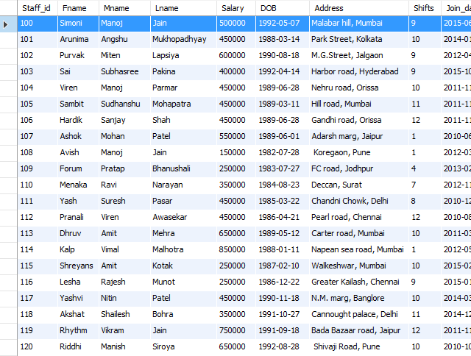

PATIENT:

CREATE TABLE Patient (

PID INT,

Pfname VARCHAR(25),

Pmname VARCHAR(25),

Plname VARCHAR(25),

Doc_incharge VARCHAR(20),

DOB DATE,

admit_date DATE,

Address VARCHAR(40),

Lab_id INT,

Ro_No INT,

PRIMARY KEY (PID)

);

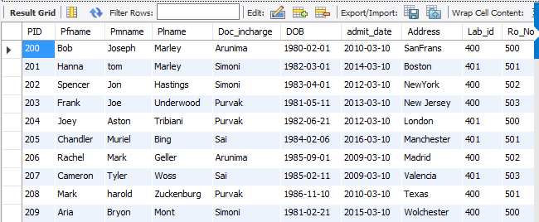

MEDICINE

CREATE TABLE Medicine (

Med_name VARCHAR(25) UNIQUE,

DOE DATE,

DOM DATE,

Doc_id INT,

Pat_id INT,

PRIMARY KEY (Med_name),

FOREIGN KEY (Doc_id)

REFERENCES Doctor (Staff_id),

FOREIGN KEY (Pat_id)

REFERENCES Patient (PID)

);

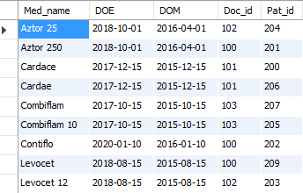

DOCTOR :

CREATE TABLE Doctor (

Staff_id INT,

AoS VARCHAR(20),

Desg VARCHAR(20),

PRIMARY KEY (Staff_id)

);

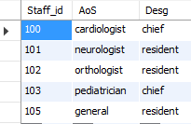

RECEPTIONIST

CREATE TABLE Receptionist (

Staff_id INT,

PRIMARY KEY (Staff_id)

);

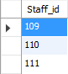

ACCOUNTANT :

CREATE TABLE Accountant (

Staff_id INT PRIMARY KEY

);

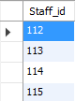

ROOM :

CREATE TABLE ROOM (

Room_no INT,

Room_incharge VARCHAR(25),

Rec_id INT,

PRIMARY KEY (Room_no),

FOREIGN KEY (Rec_id)

REFERENCES Receptionist (Staff_id)

);

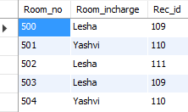

RECORD :

CREATE TABLE Record (

Record_No INT,

Rec_of_pat INT,

DOF DATE,

Re_id INT,

PRIMARY KEY (Record_No),

FOREIGN KEY (Re_id)

REFERENCES Receptionist (Staff_id),

FOREIGN KEY (Rec_of_pat)

REFERENCES Patient (PID)

);

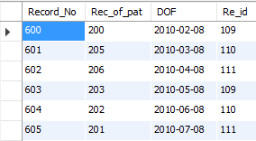

TREATS :

CREATE TABLE Treats (

PID INT,

Staff_id INT,

PRIMARY KEY (PID , Staff_id),

FOREIGN KEY (PID)

REFERENCES Patient (PID),

FOREIGN KEY (Staff_id)

REFERENCES Doctor (Staff_id)

);

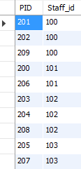

TRANSACTIONS :

CREATE TABLE transactions (

TID INT PRIMARY KEY,

DOT DATE,

type VARCHAR(20)

);

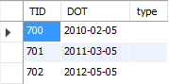

HANDLES :

CREATE TABLE Handles (

Staff_id INT,

TID INT,

PRIMARY KEY (Staff_id , TID),

FOREIGN KEY (Staff_id)

REFERENCES Accountant (Staff_id),

FOREIGN KEY (TID)

REFERENCES Transactions (TID)

);

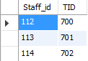

LABORTORIST :

CREATE TABLE Laboratorist (

Staff_id INT,

PRIMARY KEY (Staff_id),

FOREIGN KEY (Staff_id)

REFERENCES Staff (Staff_id)

);

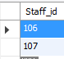

Laboratory :

CREATE TABLE Laboratory (

Lab_id INT PRIMARY KEY,

labor_id INT,

FOREIGN KEY (labor_id)

REFERENCES Laboratorist (Staff_id)

);

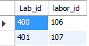

Nurse :

CREATE TABLE Nurse (

Staff_id INT,

Room_n INT,

PRIMARY KEY (Staff_id),

FOREIGN KEY (Staff_id)

REFERENCES Staff (Staff_id)

);



P_phoneno:

CREATE TABLE P_Phoneno (

PID INT,

P_phone_no INT,

primary key(PID,P_phone_no)

);

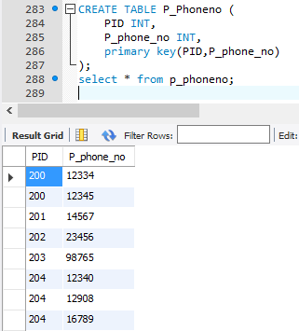

S_phone_no :

CREATE TABLE S_Phone_N0 (

Staff_id INT,

S_phone_no INT,

PRIMARY KEY (S_phone_no,Staff_id),

FOREIGN KEY (Staff_id)

REFERENCES Staff (Staff_id)

);

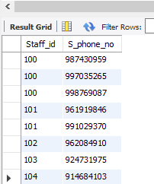

TRIGGERS:

1 .

CREATE TRIGGER upd_check BEFORE insert ON transactions

FOR EACH ROW

INSERT INTO trigger_time values(NOW());

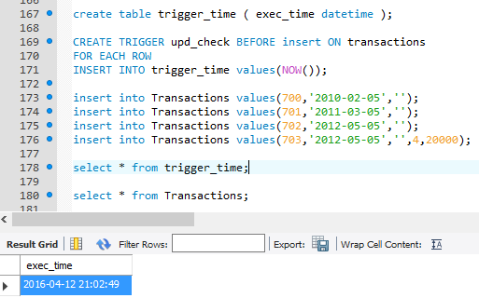

2 .

DELIMITER $$

CREATE TRIGGER before_staff_update

BEFORE UPDATE ON staff

FOR EACH ROW

BEGIN

INSERT INTO staff_audit

SET action = 'update',

staff_id = OLD.staff_id,

fname = OLD.fname,

changedat = NOW();

END$$

DELIMITER ;

DELIMITER $$

CREATE PROCEDURE sp8 (x VARCHAR(10))

BEGIN

declare varaccno int default 701;

DECLARE vartamt int default 1500;

DEclare varcurrbal int;

START TRANSACTION ;

savepoint withd;

update Transactions set currbal = currbal + vartamt

where tid = varaccno;

select currbal into varcurrbal from transactions where tid = varaccno;

if varcurrbal > 500000 then

rollback to savepoint withd;

else

commit;

end if;

END;

$$

DELIMITER ;

call sp8('trans');

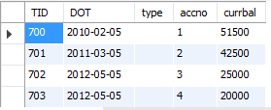

QUERIES:

