**System Architecture Diagram**

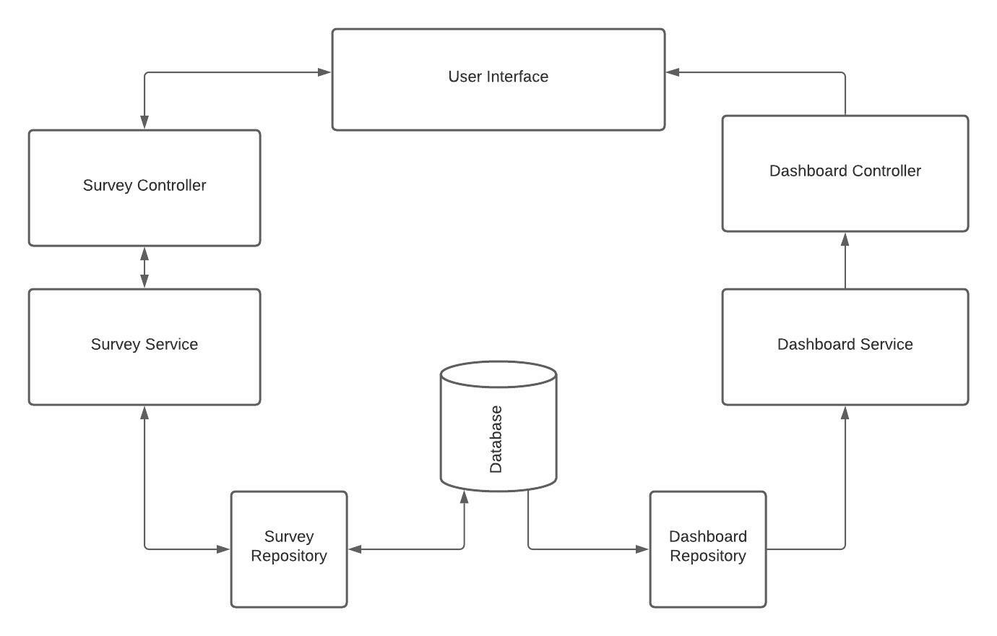

**Api Documentation Link:**

<https://backend-dot-grads-coding-challenge-group-6.uc.r.appspot.com/swagger-ui.html#>

**WireFraming Diagrams:**

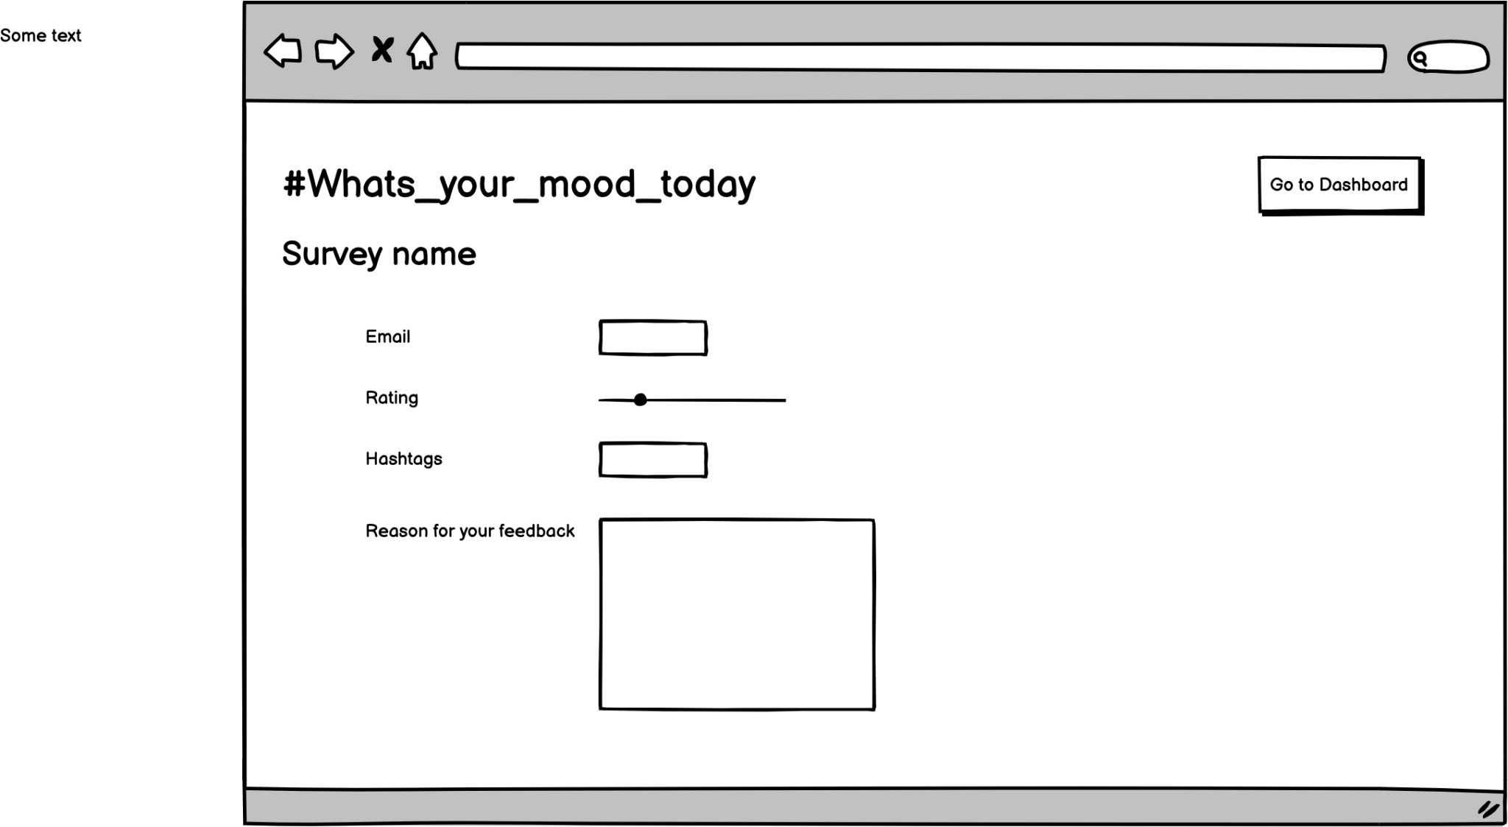

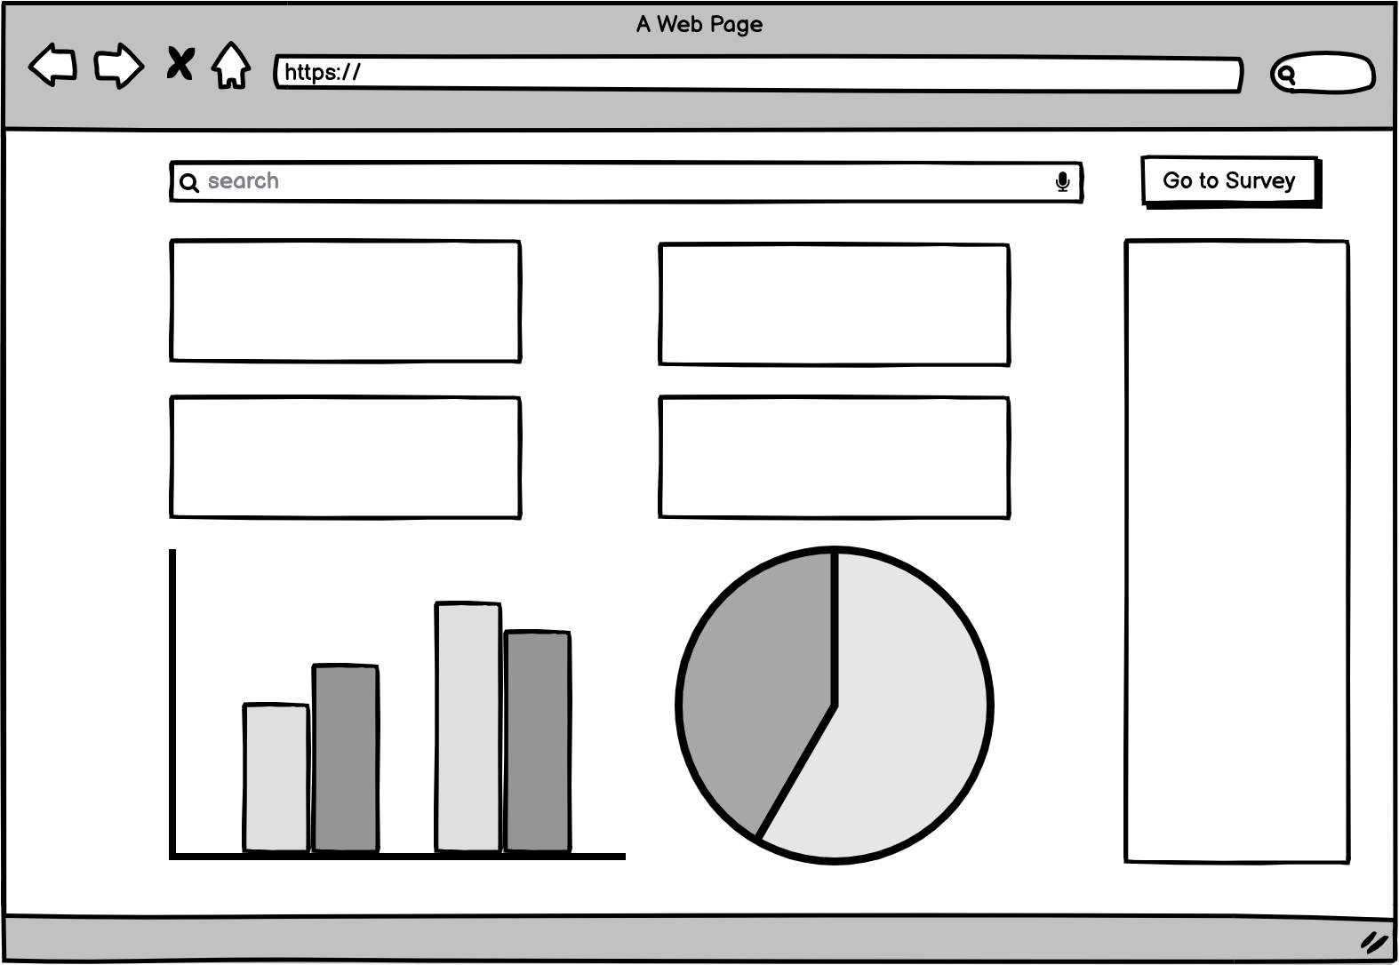

**Key highlights for backend system:**

* Interface based programming approach
* Microservices architecture
* Api is documented proper