Tech Assessment: Weather Trend Forecasting
DATA SCIENCE ASSESSMENT
Objective
Analyze the "Global Weather Repository.csv" dataset to forecast future weather trends and showcase data science skills through both basic and advanced techniques. This dataset provides Daily weather information for cities around the world. This dataset offers a comprehensive set of features that reflect the weather conditions worldwide. It includes over 40 features.
Weather Trend Forecasting — Project Report
PM Accelerator · Data Scientist Assessment
Author: Purvansh Dave
Date: 22nd March 2026

PM Accelerator Mission
By making industry-leading tools and education available to individuals from all backgrounds, we level the playing field for future PM leaders. This is the PM Accelerator motto, as we grant aspiring and experienced PMs what they need most – Access. We introduce you to industry leaders, surround you with the right PM ecosystem, and discover the new world of AI product management skills.

1. Executive Summary
This project builds a complete data science pipeline on the Global Weather Repository dataset (130,783 rows, 41 features) to forecast global mean daily temperature. The pipeline covers data cleaning, exploratory data analysis, anomaly detection, time-series forecasting with three models, and two unique analyses (feature importance and spatial mapping).
Key Finding: Facebook Prophet achieved the best forecasting performance with a MAE of 1.006°C and MAPE of 8.17%, outperforming both ARIMA and XGBoost on the 135-day test set.

2. Dataset Overview
- Source: Global Weather Repository (Kaggle)
- Rows: 130,783
- Features: 41 columns including temperature, precipitation, wind, humidity, pressure, air quality metrics, and celestial data
- Date Range: May 16, 2024 → March 21, 2026
- Countries: 200+ worldwide locations

3. Data Cleaning & Preprocessing
Step | Details
Missing Values | Zero nulls found after loading; median imputation applied as safeguard
Outlier Detection | IQR method on temperature, precipitation, wind speed
Outliers Flagged | 28,134 rows (21.5%) — not dropped, preserved for anomaly detection
Normalization | StandardScaler on 26 numeric features (scaler saved as .pkl)
Output | cleaned_weather.csv (scaled) and cleaned_weather_unscaled.csv (original)

4. Exploratory Data Analysis
Six publication-quality visualizations were produced:
- Daily Global Mean Temperature — Line plot showing seasonal oscillation with ~10°C amplitude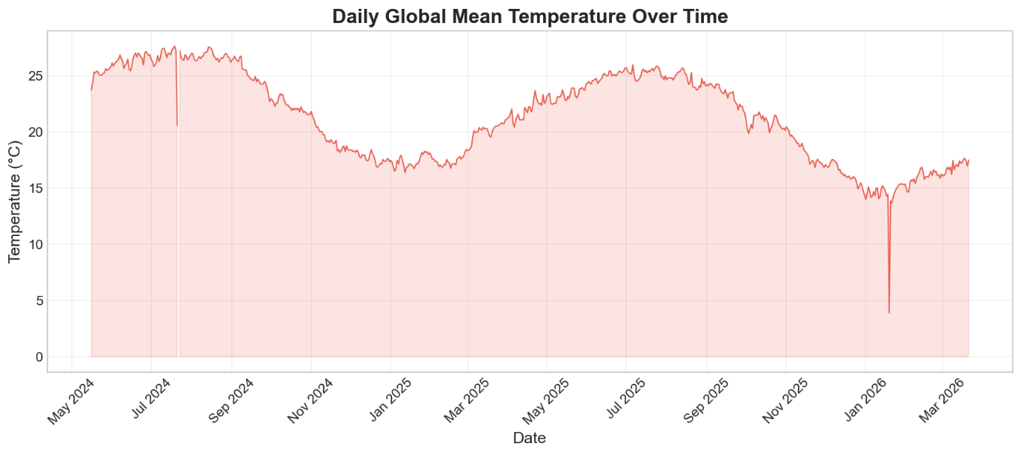
- Precipitation Distribution — Right-skewed histogram (most days have <1mm precipitation)
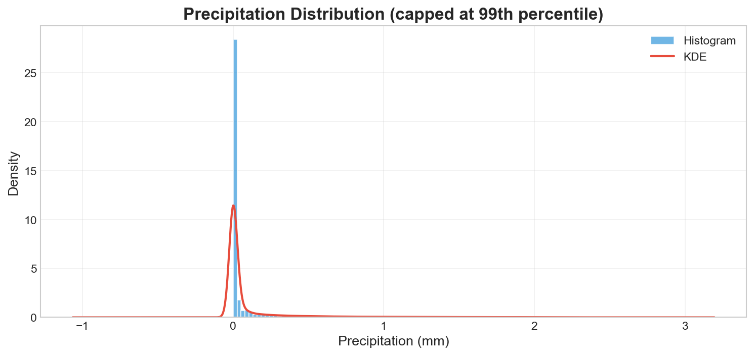
- Correlation Heatmap — Strong correlations between temperature pairs (Celsius/Fahrenheit/feels-like), wind speed pairs (mph/kph)
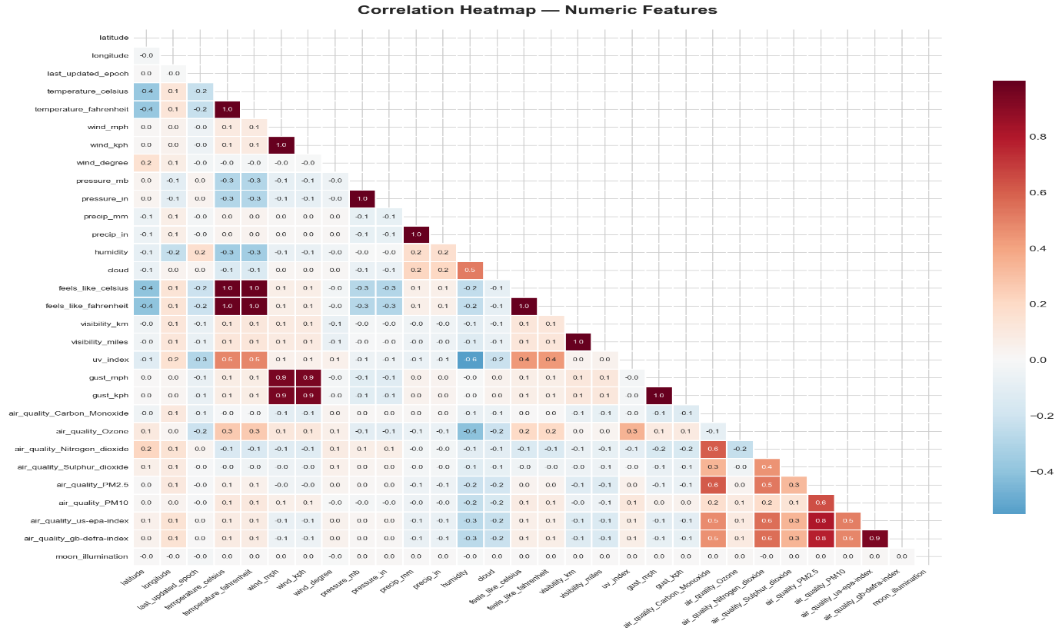
- Top 20 Countries by Avg Temperature — Hottest countries: Djibouti, Sudan, Niger, Chad
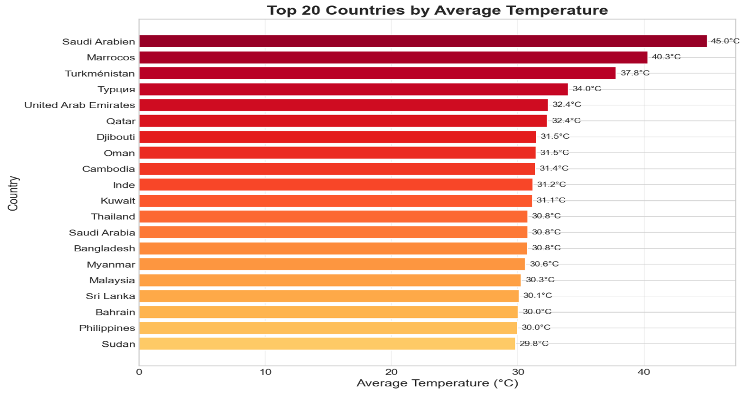
- Temperature by Continent — Africa has highest median temperature; Europe shows widest spread

- Wind Speed vs Temperature — Weak negative relationship; high-precipitation events cluster at moderate temperatures
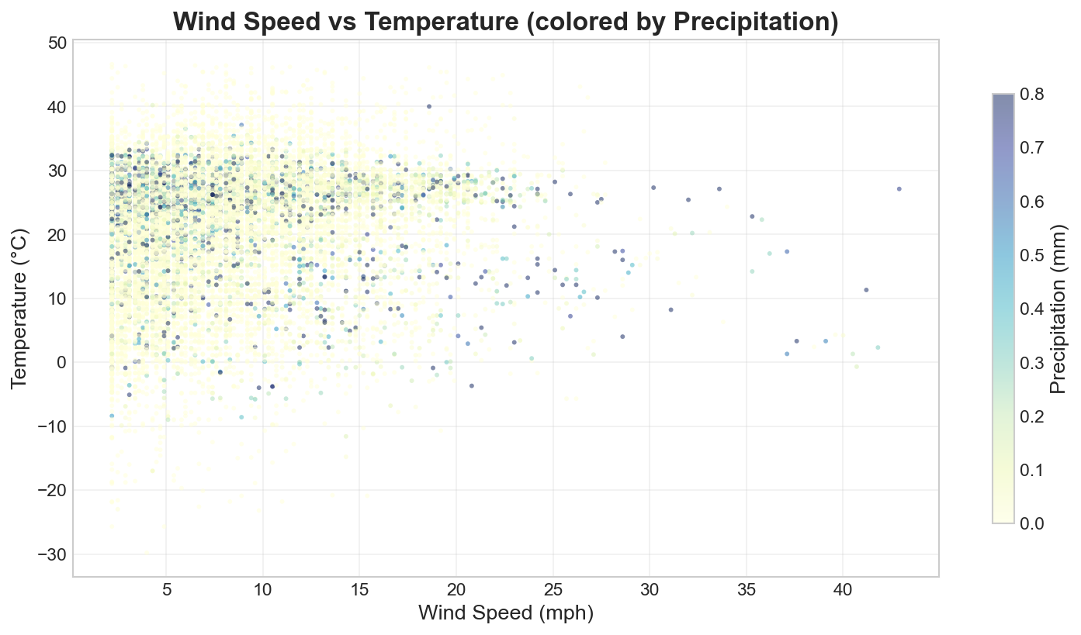

5. Anomaly Detection
- Algorithm: Isolation Forest (contamination=0.05, n_estimators=100)
- Features Used: temperature_celsius, precip_mm, wind_mph, humidity, pressure_mb
- Results: 6,540 anomalies detected (5.00%)
- Top Anomalies: Extreme heat events in Kuwait (49.2°C) and Baghdad, Iraq (49.1°C)
The anomalies primarily capture extreme temperature/humidity combinations and unusual precipitation events.
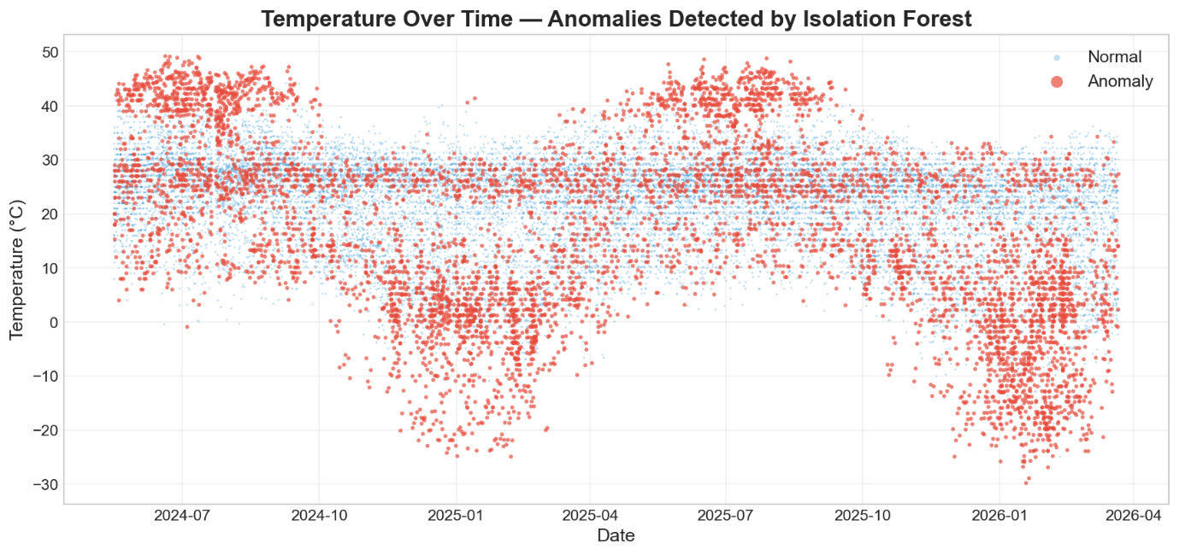

6. Forecasting Models
Setup
- Target: Daily global mean temperature (aggregated across all countries)
- Split: 80/20 chronological (539 train days / 135 test days)
- Split Date: November 7, 2025
Model Results
Model | MAE (°C) | RMSE (°C) | MAPE (%)
ARIMA (2,1,2) | 3.549 | 3.911 | 24.81
Facebook Prophet | 1.006 | 1.580 | 8.17
XGBoost (Lag Features) | 1.233 | 1.850 | 9.94
Ensemble (Simple Avg) | 1.867 | 2.323 | 13.96
Analysis
- Prophet performed best across all metrics, capturing yearly and weekly seasonality effectively
- XGBoost was competitive, leveraging lag features (1, 3, 7, 14, 30 days) and rolling statistics
- ARIMA struggled with the seasonal pattern, producing a near-flat forecast
- Ensemble was dragged down by ARIMA's poor performance; a weighted ensemble excluding ARIMA would likely outperform individual models
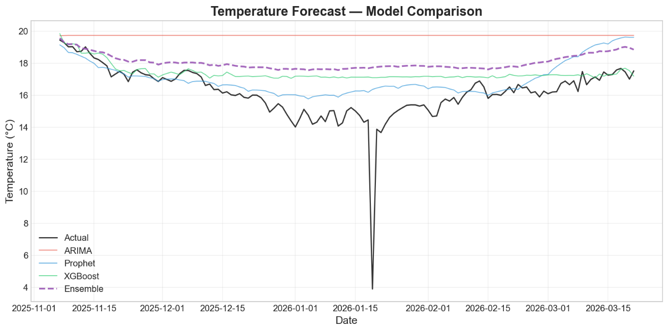

7. Unique Analyses
A. Feature Importance (XGBoost)
After excluding temperature-derived features (feels_like_celsius, feels_like_fahrenheit, temperature_fahrenheit), the most important predictors of temperature are:
- Humidity — Strong inverse relationship with temperature
- Wind Speed (mph) — Correlates with weather systems and fronts
- UV Index — Direct proxy for solar radiation
- Pressure (inches) — Barometric pressure indicates weather patterns
- Air Quality Indices — Industrial activity correlates with warmer urban areas
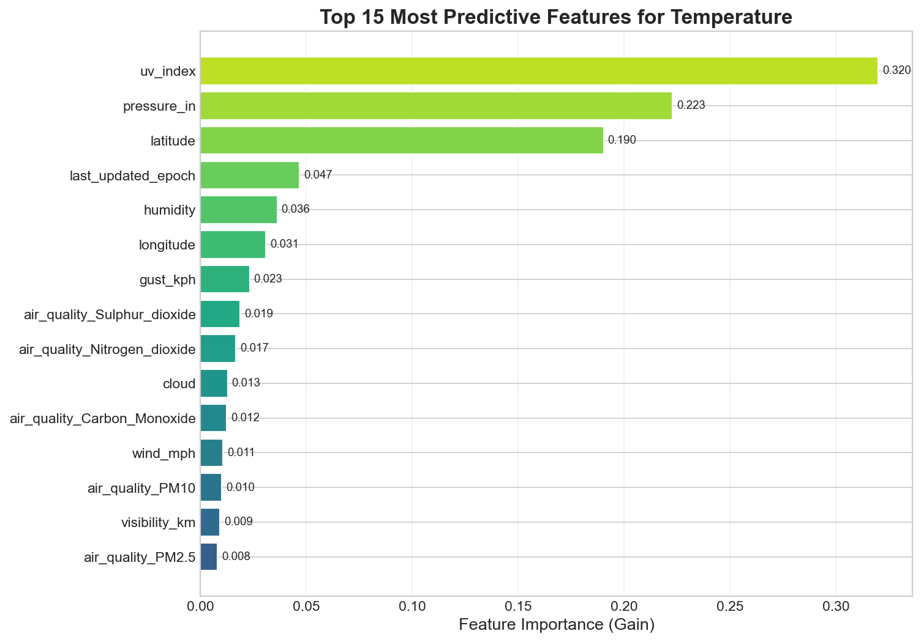
B. Spatial / Geographical Analysis
An interactive Plotly choropleth world map was created showing mean temperature by country. Key observations:
- Equatorial countries (Djibouti, Sudan, Niger) have the highest mean temperatures (>30°C)
- Northern European and North Asian countries have the lowest
- The map provides an intuitive geographical view of global temperature distribution

8. Conclusions & Recommendations
- Prophet is the recommended model for temperature forecasting on this dataset due to its strong seasonal modeling
- A weighted ensemble (excluding or down-weighting ARIMA) could further improve results
- Additional features like historical climate indices (ENSO, NAO) could enhance forecasting accuracy
- Country-specific models might outperform the global mean approach for localized forecasting

9. Repository Structure
PMA/
├── data/ # Raw and cleaned datasets
├── notebooks/
│ ├── 01_data_cleaning.ipynb # Data preprocessing
│ ├── 02_eda.ipynb # 6 EDA visualizations
│ ├── 03_anomaly_detection.ipynb # Isolation Forest
│ ├── 04_forecasting.ipynb # ARIMA, Prophet, XGBoost, Ensemble
│ └── 05_unique_analyses.ipynb # Feature importance + choropleth
├── src/utils.py # Shared utilities
├── outputs/
│ ├── figures/ # 11 plots (PNG) + 1 interactive map (HTML)
│ ├── models/ # Saved model files (.pkl)
│ └── model_comparison.csv # Metrics comparison table
├── report/ # This report
├── requirements.txt # Python dependencies
└── README.md # Project overview

