Employee Sentiment Analysis
A Comprehensive Analysis of Employee Engagement Through Email Sentiment

Dataset: Enron Employee Emails (2010-2011)
2,191 messages from 10 employees

Table of Contents
- 1. Introduction & Methodology
- 2. Task 1: Sentiment Labeling
- 3. Task 2: Exploratory Data Analysis (EDA)
- 4. Task 3: Employee Score Calculation
- 5. Task 4: Employee Ranking
- 6. Task 5: Flight Risk Identification
- 7. Task 6: Predictive Modeling
- 8. Conclusions & Recommendations

1. Introduction & Methodology
This report presents a comprehensive analysis of employee sentiment based on email communication data. The dataset comprises 2,191 email messages from 10 employees, spanning January 2010 to December 2011. The analysis aims to evaluate employee engagement by performing sentiment labeling, exploratory data analysis, score calculation, ranking, flight risk identification, and predictive modeling.

Methodology
Sentiment Labeling: We used TextBlob, a Python NLP library, to compute the polarity of each email body. Messages with polarity > 0.05 are labeled Positive, < -0.05 as Negative, and between as Neutral. This approach is reproducible, efficient, and does not require external API access.
The dataset contains 4 columns: Subject, body, date, and from (sender email). No missing values were found in the dataset.

2. Task 1: Sentiment Labeling
Each message was labeled using TextBlob polarity analysis. The resulting distribution is:
Sentiment | Count | Percentage
Positive | 1,144 | 52.21%
Neutral | 817 | 37.29%
Negative | 230 | 10.50%

The majority of messages (52.21%) carry positive sentiment, indicating a generally constructive communication culture. Only 10.50% of messages are negative.
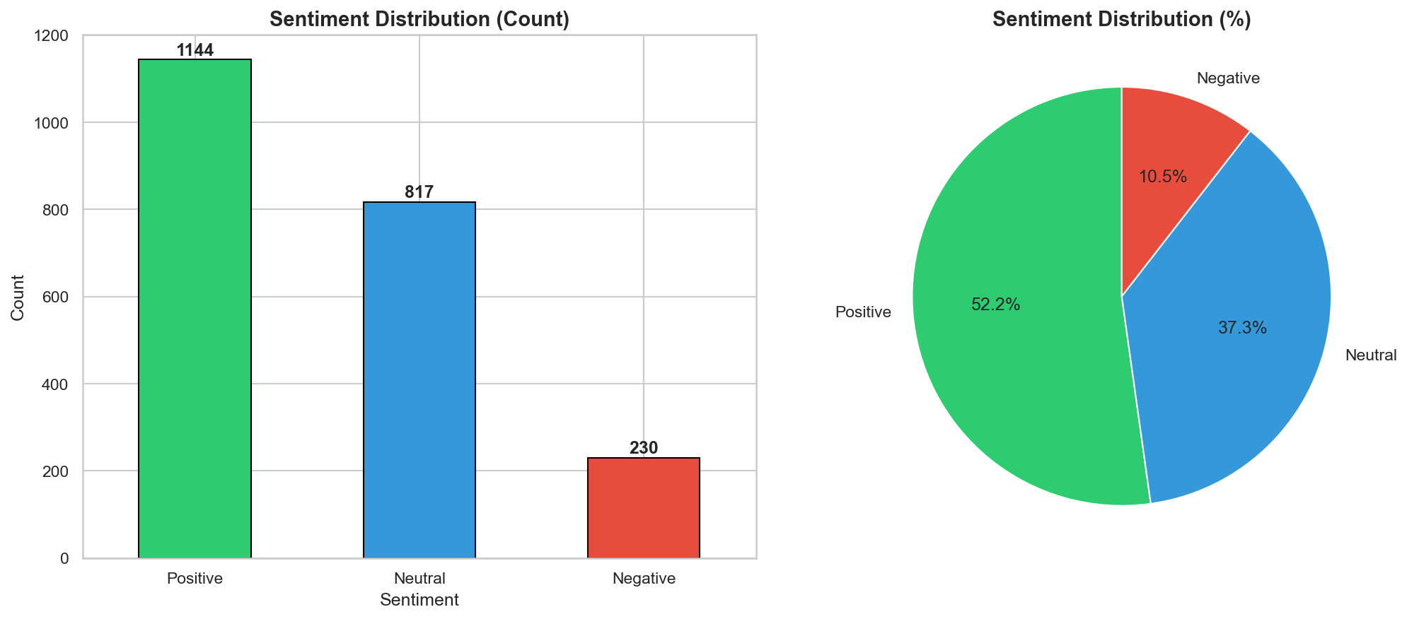

3. Task 2: Exploratory Data Analysis

3.1 Sentiment Trends Over Time
Monthly sentiment trends reveal fluctuations in communication patterns across the two-year period. Positive messages consistently outnumber negative ones, though seasonal variations are visible.
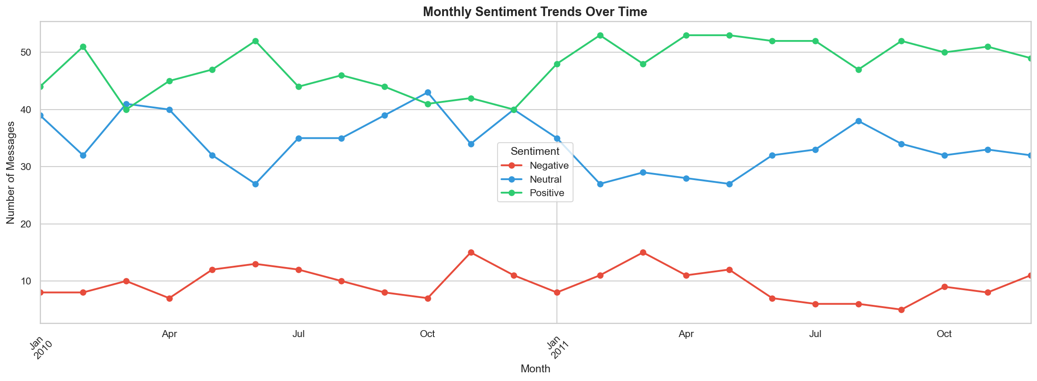

3.2 Employee Sentiment Breakdown
Each employee shows a distinct sentiment profile. Some employees are consistently positive communicators, while others show higher proportions of negative messages.
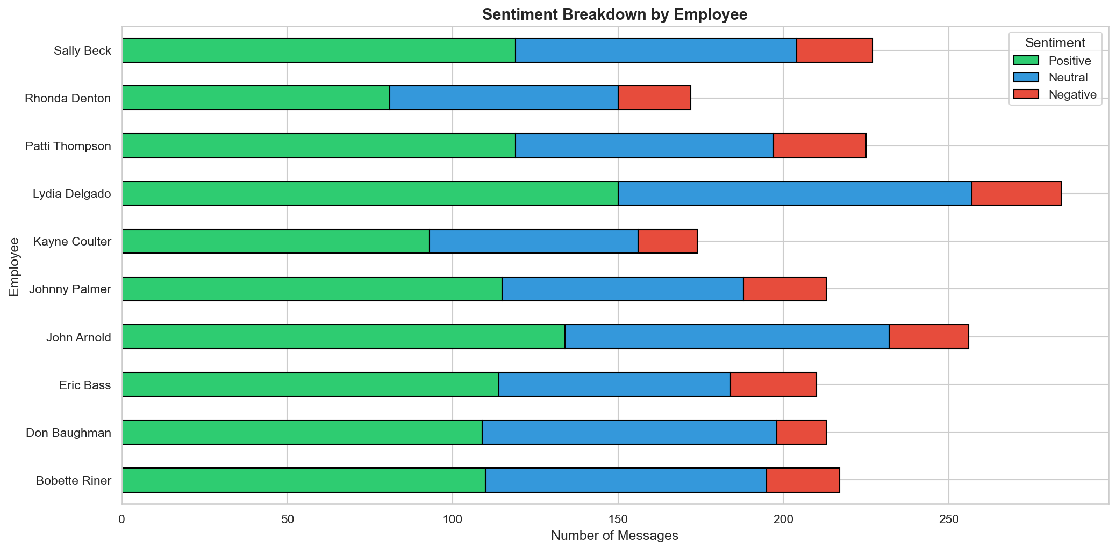

3.3 Message Frequency Heatmap
The heatmap shows message volume distribution across employees and months, highlighting periods of high and low activity.
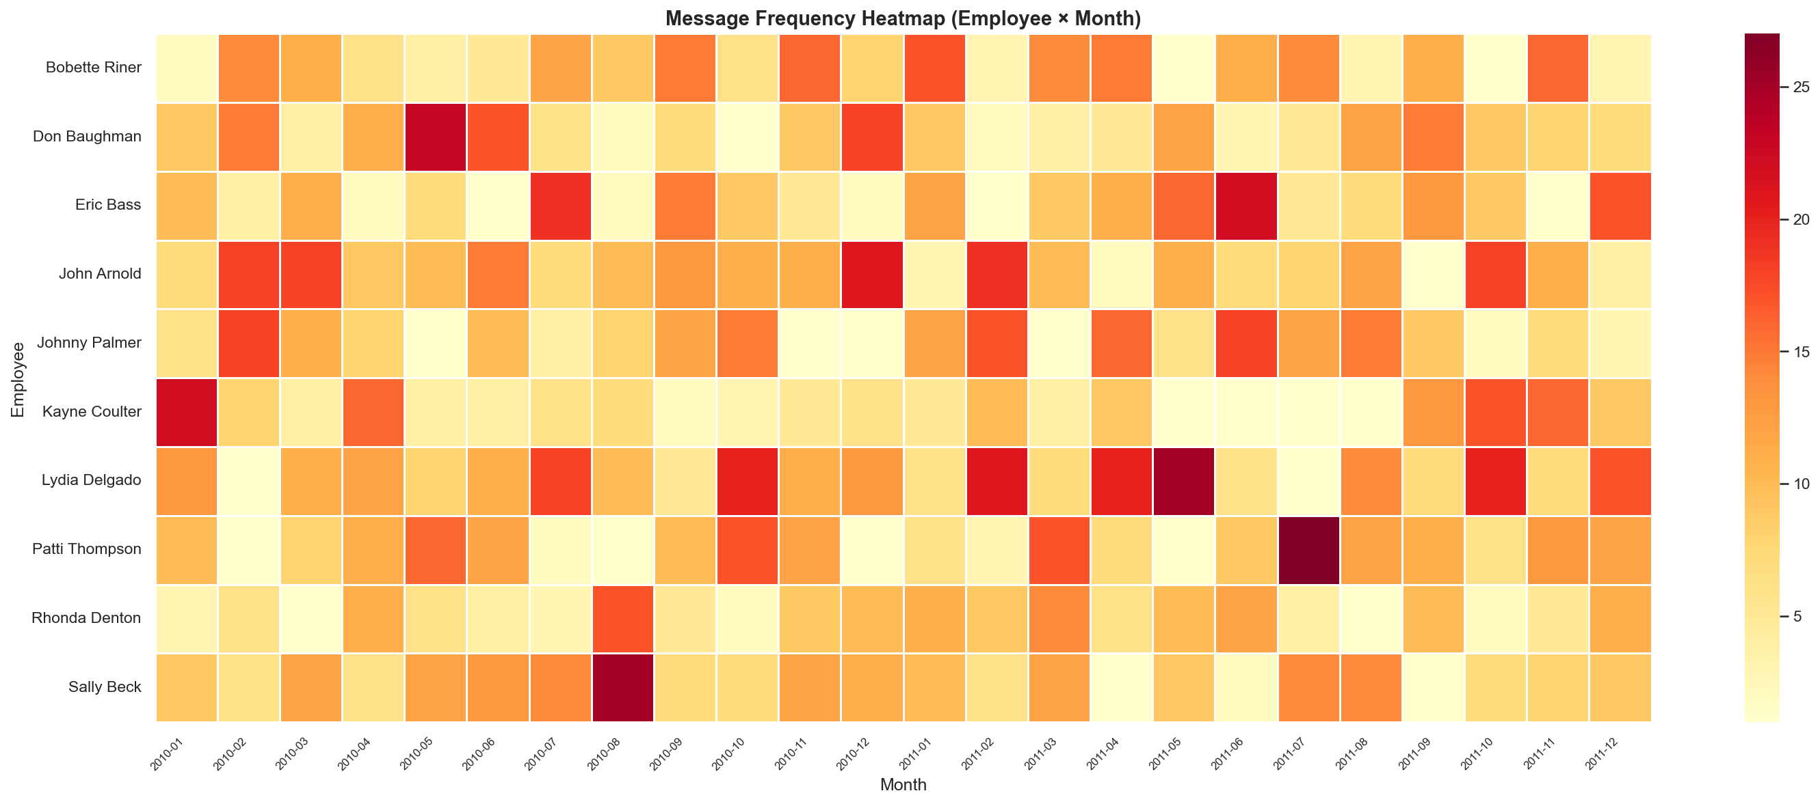

3.4 Message Length Analysis
Analysis of message length and word count by sentiment category reveals patterns in how employees communicate differently based on sentiment.
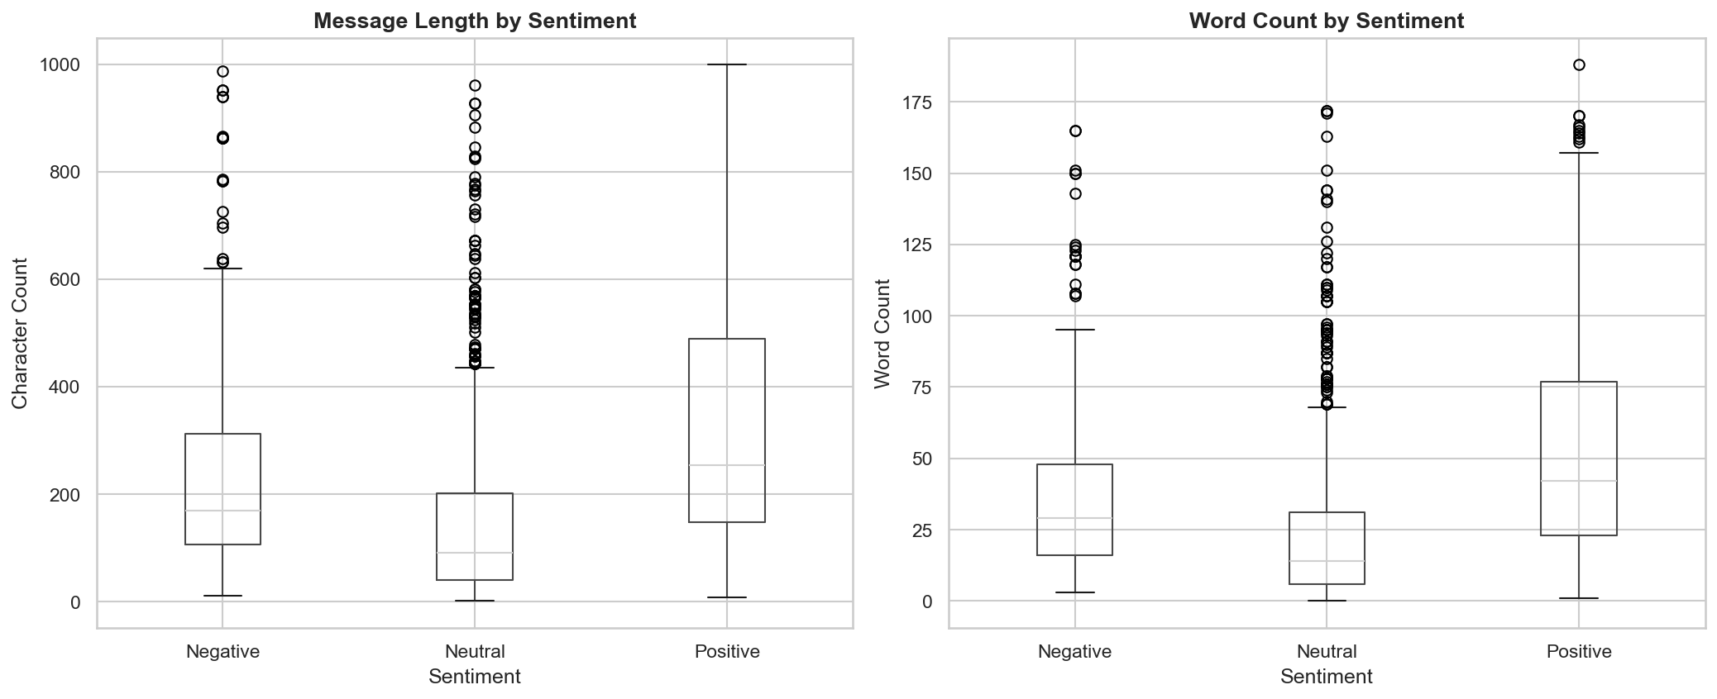

3.5 Polarity Distribution
The histogram of polarity scores shows the distribution of sentiment intensity across all messages.
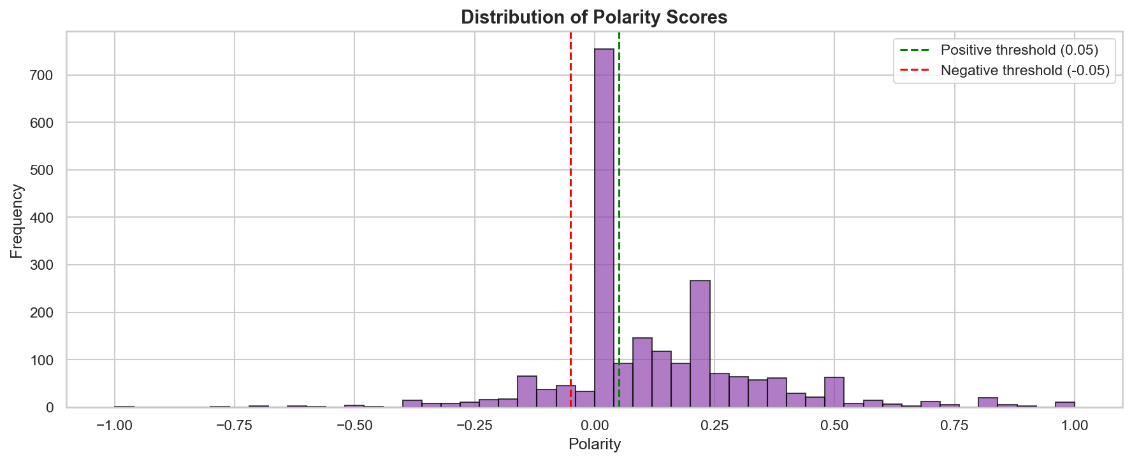

4. Task 3: Employee Score Calculation
Monthly sentiment scores were calculated by assigning +1 for positive messages, -1 for negative messages, and 0 for neutral messages. Scores reset at the beginning of each new month.
The scoring formula is straightforward: Score = Count(Positive) - Count(Negative). This provides a clear metric for comparing employee engagement levels across months.
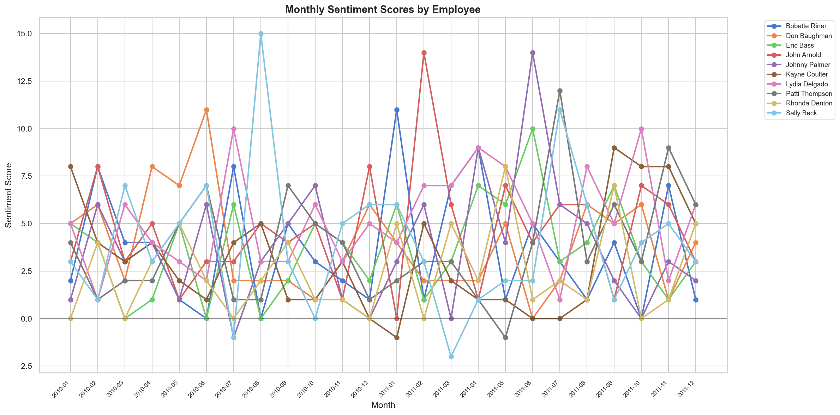

5. Task 4: Employee Ranking
Employees were ranked by their total sentiment scores across all months. Rankings are sorted by score (descending) and then alphabetically.

Top 3 Most Positive Employees (Overall)
Rank | Employee | Total Score
1 | Lydia Delgado | 123
2 | John Arnold | 110
3 | Sally Beck | 96

Top 3 Most Negative Employees (Overall)
Rank | Employee | Total Score
1 | Rhonda Denton | 59
2 | Kayne Coulter | 75
3 | Bobette Riner | 88

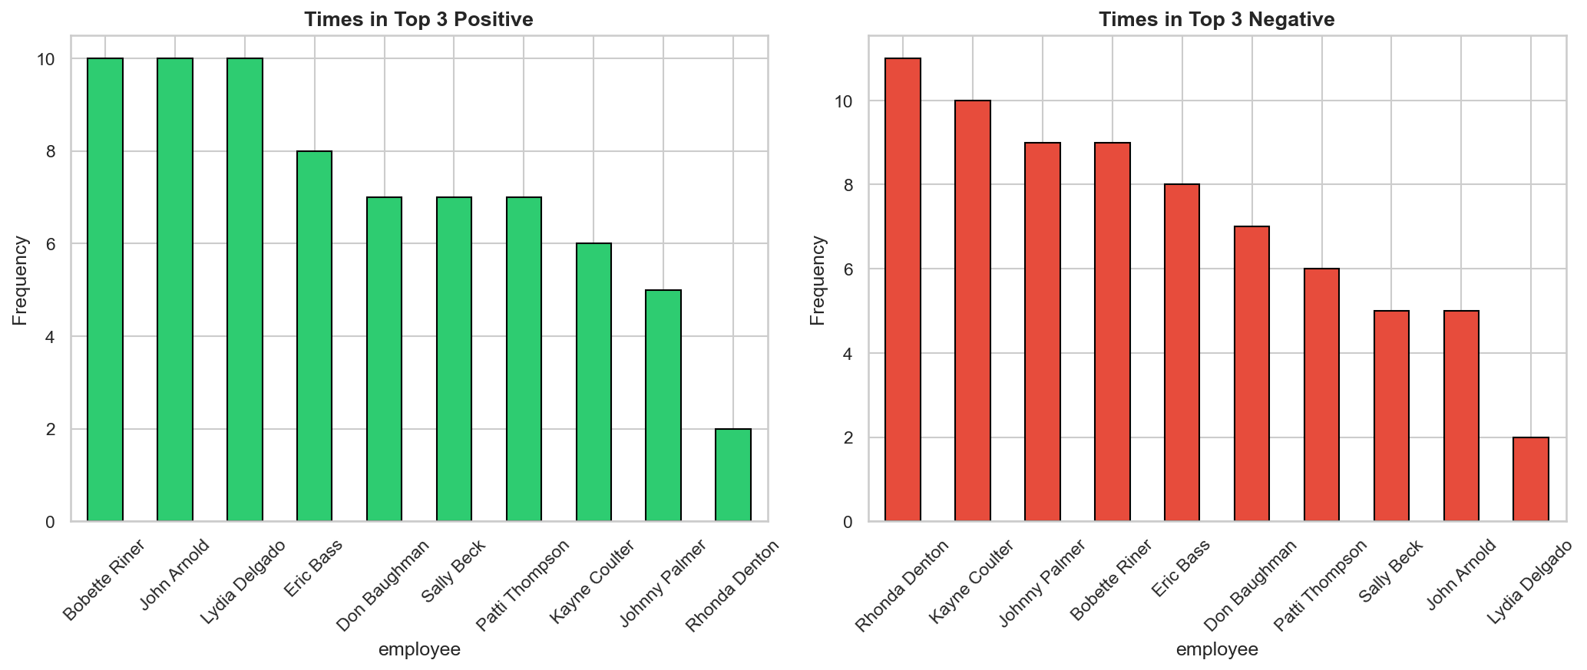
Monthly rankings were also generated for each individual month, showing which employees consistently appeared in the top positive or negative lists.

6. Task 5: Flight Risk Identification
Flight risk identification uses a rolling 30-day window approach. Any employee who sent 4 or more negative emails within any 30-day period is flagged as a flight risk, regardless of the calendar month.

Flagged Employees
Employee | Status
Lydia Delgado | At Risk
Johnny Palmer | At Risk
John Arnold | At Risk
Eric Bass | At Risk
Patti Thompson | At Risk
Sally Beck | At Risk
Bobette Riner | At Risk
Rhonda Denton | At Risk

A significant number of employees (8 out of 10) were flagged as flight risks at some point during the analysis period. This suggests periodic bursts of negative sentiment that warrant investigation into underlying causes such as workload, organizational changes, or personal factors.
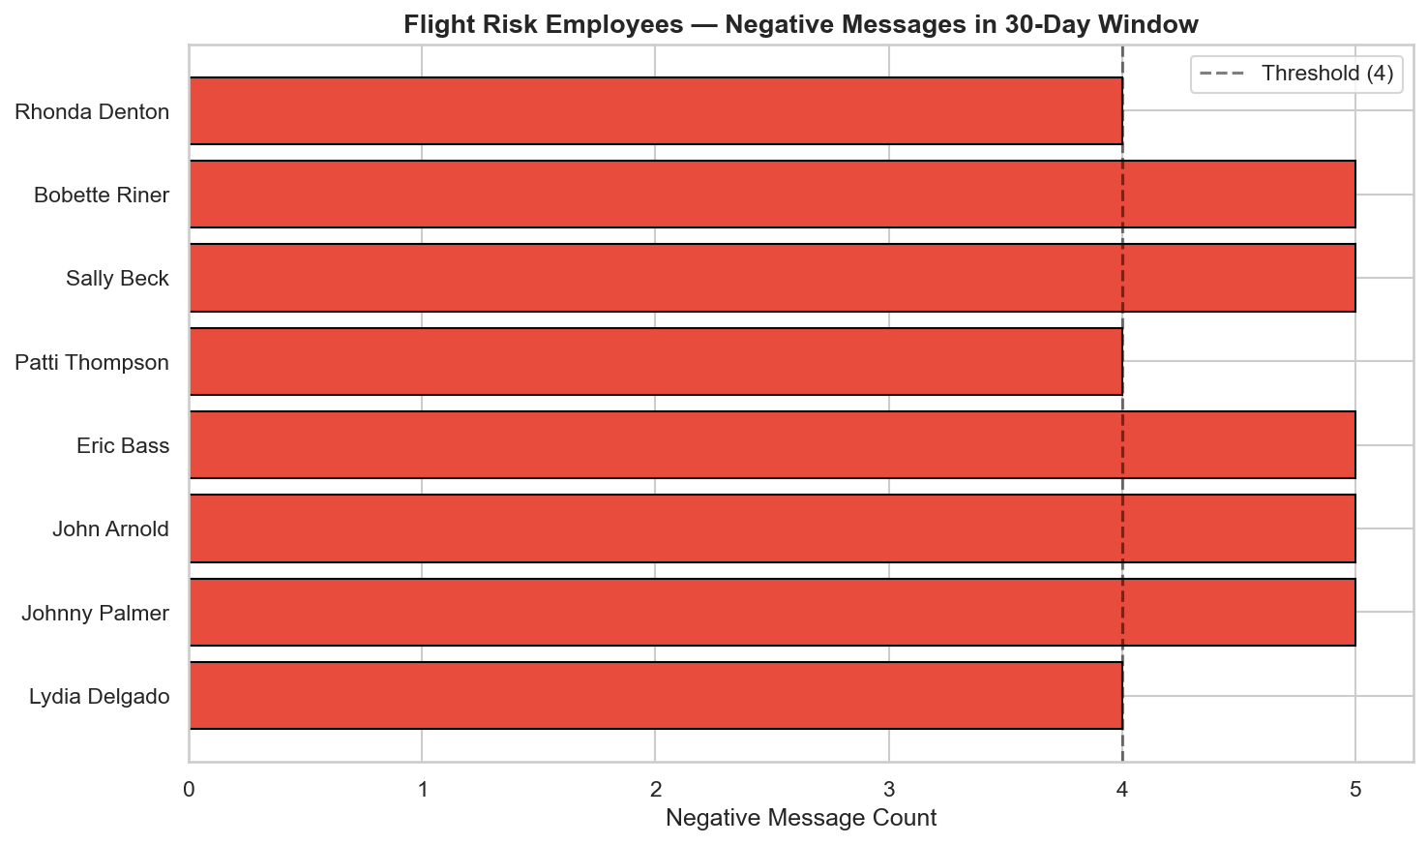

7. Task 6: Predictive Modeling
A linear regression model was developed to predict monthly sentiment scores using engineered features.

Features Used
- total_messages: Total messages sent in the month
- avg_msg_length: Average message length (characters)
- avg_word_count: Average word count per message
- positive_ratio: Proportion of positive messages
- negative_ratio: Proportion of negative messages

Model Performance
Metric | Value
R² Score | 0.7606
RMSE | 1.4466
MAE | 1.0300

Feature Coefficients
Feature | Coefficient
total_messages | +0.4176
avg_msg_length | +0.0126
avg_word_count | -0.0638
positive_ratio | +3.9097
negative_ratio | -6.4986
Intercept | -2.1305

The model achieves an R² of 0.7606, explaining approximately 76% of the variance in sentiment scores. The negative_ratio feature has the strongest negative impact (-6.50), while positive_ratio has the strongest positive impact (+3.91). This confirms that the ratio of negative messages is the most significant predictor of low sentiment scores.
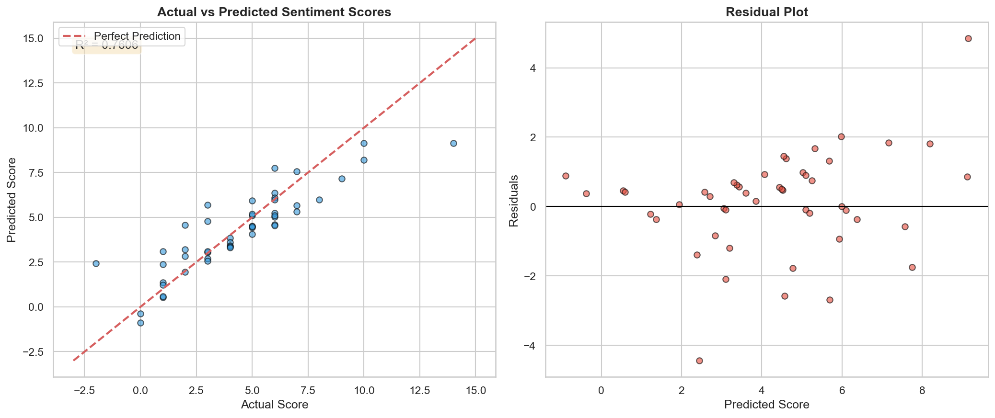

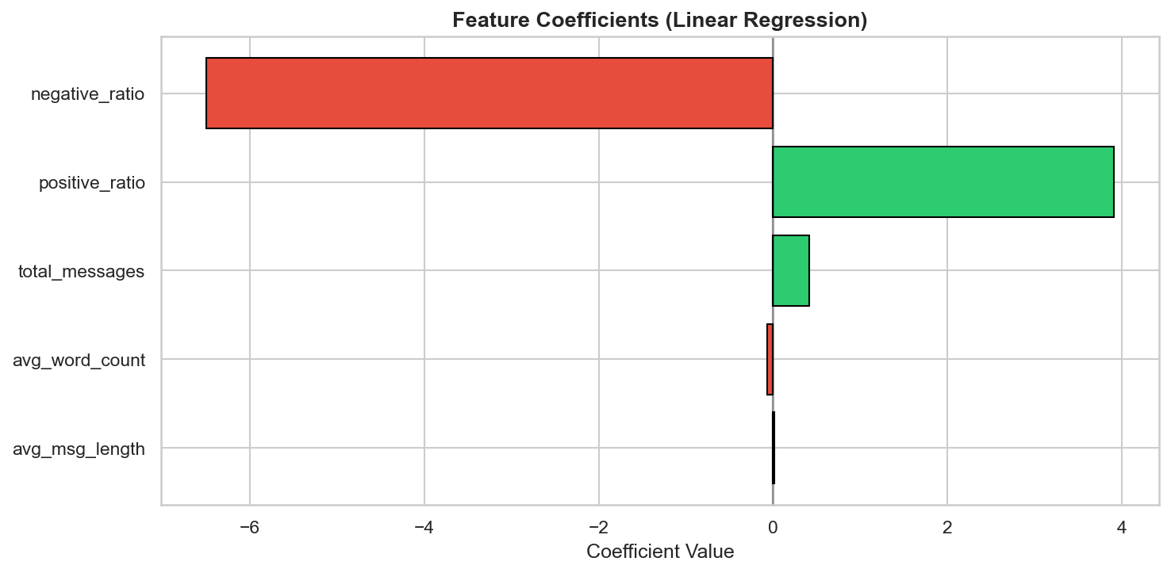

8. Conclusions & Recommendations

Key Findings
- The dataset shows a predominantly positive communication culture (52.21% positive messages).
- Lydia Delgado, John Arnold, and Sally Beck consistently demonstrate the most positive sentiment.
- Rhonda Denton and Kayne Coulter show the lowest overall sentiment scores.
- 8 out of 10 employees were flagged as flight risks at some point, indicating periodic negative bursts.
- The linear regression model (R² = 0.76) successfully identifies key drivers of sentiment scores.
- Negative message ratio is the strongest predictor of low sentiment scores.

Recommendations
- Implement regular sentiment monitoring to track employee engagement trends in real-time.
- Investigate root causes for employees with consistently low sentiment scores.
- Develop targeted interventions for employees flagged as flight risks.
- Use the predictive model to establish early warning systems for declining engagement.
- Consider qualitative follow-ups (surveys, 1-on-1s) with flight risk employees.
- Extend the analysis to include additional features such as email response times and thread depth.

