📋 E1JUXFR - Multi-System Environment Configuration Manager

## 🎯 1. Business Context

### 📊 Executive Summary

E1JUXFR operates as the foundational configuration orchestrator for enterprise multi-system environments. This critical component manages environment settings and parallel processing capabilities across three major business platforms, ensuring coordinated operations and optimal performance for all dependent business processes.

### 🎯 Business Purpose

Provides centralized configuration management services that enable consistent environment setup across E1, JW, and M3 systems, supporting enterprise-wide business operations through reliable multi-system coordination and performance optimization.

### Functional Area

IT Infrastructure & System Integration- Core configuration management services supporting all major enterprise business applications and enabling coordinated multi-system operations.

### 🎯 Strategic Business Impact

* Enterprise System Coordination:Ensures consistent configuration across all major business platforms
* Business Process Reliability:Provides stable foundation for multi-system business workflows
* Performance Optimization:Enables parallel processing for improved business process execution
* Operational Efficiency:Centralizes configuration management reducing system administration overhead
* Risk Management:Prevents configuration conflicts that could disrupt business operations

### 🎯 Key Business Functions

1. Execute User Function:Main orchestration and coordination of all configuration activities
2. Retrieve E1 Live Value:Obtain E1 system environment configuration settings
3. Set E1 Parallel Flag:Configure E1 parallel processing capabilities
4. Retrieve JW Live Value:Obtain JW system environment configuration settings
5. Set JW Parallel Flag:Configure JW parallel processing capabilities
6. Retrieve M3 Live Value:Obtain M3 system environment configuration settings
7. Set M3 Parallel Flag:Configure M3 parallel processing capabilities

### 🎯 Business User Community

* System Administrators:IT operations teams managing enterprise environments
* Business System Users:End users across E1, JW, and M3 platforms
* Integration Teams:Technical teams coordinating multi-system processes
* Business Operations:All business units dependent on enterprise system availability

## 📥 2. Inputs

### 🎯 Primary Business Inputs

### 🏢 Company Context

PAR.OMS_Company_Number:Critical business identifier that determines company-specific configuration settings for all environment retrievals and system setup operations.

### 🔧 Configuration Keys

System Identifiers:Predefined configuration keys ('E1LIVE', 'JWLIVE', 'M3LIVE') used to retrieve environment-specific settings for each enterprise system.

### 🔗 Configuration Service Dependencies

* Configuration Repository Access:Connection to centralized configuration service via 'Rtv OMS Co Val Alpha XF' program
* Company Validation:Valid OMS Company Number must exist in business system for configuration retrieval
* Environment Data:System-specific configuration values must be maintained in central repository

### Optional Configuration Parameters

* Environment Overrides:Alternative configuration values for special business scenarios
* Processing Mode Controls:Optional parameters for specific parallel processing requirements
* System Status Indicators:Operational status flags that may influence configuration decisions

## 🏗️ 3. Structure Overview

### 🎯 Complete Business Functions Catalog

|  |  |  |  |
| --- | --- | --- | --- |
| **Function** | **Purpose** | **Inputs** | **Output Parameters** |
| Execute User Function | Main orchestration function coordinating all environment configuration activities | OMS Company Number, System Configuration Keys | Complete environment parameters for all systems |
| Retrieve E1 Live Value | Obtains live environment configuration for E1 (Enterprise One) system | Company Number, E1LIVE configuration key | E1 environment status and configuration value |
| Set E1 Parallel Flag | Configures parallel processing capability for E1 system | E1 Live configuration value | E1 Parallel processing flag (P/N) |
| Retrieve JW Live Value | Obtains live environment configuration for JW (JD Edwards World) system | Company Number, JWLIVE configuration key | JW environment status and configuration value |
| Set JW Parallel Flag | Configures parallel processing capability for JW system | JW Live configuration value | JW Parallel processing flag (P/N) |
| Retrieve M3 Live Value | Obtains live environment configuration for M3 (Movex/M3 Business Engine) system | Company Number, M3LIVE configuration key | M3 environment status and configuration value |
| Set M3 Parallel Flag | Configures parallel processing capability for M3 system | M3 Live configuration value | M3 Parallel processing flag (P/N) |

### Architectural Organization

### 🎯 Configuration Layer

Functions 2, 4, 6:Environment retrieval functions that interface with centralized configuration services for each system

### ⚙️ ⚙️ Processing Layer

Functions 3, 5, 7:Business logic functions that implement parallel processing rules for each system

### 🎬 Orchestration Layer

Function 1:Main coordination function managing overall configuration workflow

### 🔗 Integration Architecture

* Configuration Service Interface:Standardized calls to 'Rtv OMS Co Val Alpha XF' for all environment retrievals
* Multi-System Coordination:Sequential processing ensuring proper dependency management
* Business Rule Implementation:Consistent parallel processing logic across all systems
* Parameter Management:Centralized handling of input/output parameters for business process integration

## 🔄 4. Logic Summary

### 🎯 Primary Business Workflow

1. Initialize Configuration Process:Begin coordinated environment setup for all enterprise systems
2. E1 System Configuration:Retrieve E1 environment settings and configure parallel processing capabilities
3. JW System Configuration:Retrieve JW environment settings and configure parallel processing capabilities
4. M3 System Configuration:Retrieve M3 environment settings and configure parallel processing capabilities
5. Finalize Configuration:Complete all environment settings for business operation readiness

### 🎯 Critical Business Rules

### 🔄 🔄 Parallel Processing Logic

Core Rule:If system environment configuration equals 'P', enable parallel processing. All other values default to standard sequential processing ('N').

### ✓ 🏢 Company Context Validation

Security Rule:Valid OMS Company Number required for all configuration access and environment setup operations.

### ⚙️ ⚙️ Sequential Processing

Dependency Rule:Systems must be configured in order (E1, JW, M3) to ensure proper dependency management.

### Exception Handling Framework

* Configuration Service Failures:Implement retry logic and escalation for service unavailability
* Invalid Company Access:Handle unauthorized or invalid company number scenarios
* Missing Configuration Data:Apply default settings when environment values unavailable
* System Integration Issues:Manage communication failures with configuration services

### ⚡ Performance Optimization Strategy

* Efficient Configuration Retrieval:Minimize calls to configuration services
* Parallel Processing Enablement:Optimize system performance through intelligent flag setting
* Resource Management:Efficient memory and processing resource utilization
* Scalability Considerations:Design supports multiple concurrent configuration requests

## 🔄 5. Logic Explanation and State Flow

### 🎯 Comprehensive Business Process Flow

E1JUXFR implements a systematic multi-system configuration orchestration process. The workflow begins with the main execution function establishing company context and then systematically processes each enterprise system through a standardized pattern of configuration retrieval and parallel processing optimization.

For each system (E1, JW, M3), the process follows an identical pattern: first calling the centralized configuration service to retrieve the live environment setting, then applying business logic to determine optimal parallel processing configuration. This ensures consistent treatment across all systems while maintaining system-specific flexibility.

### 🎯 Business Process State Diagram

**📊 Figure 1: Process Flow Diagram**

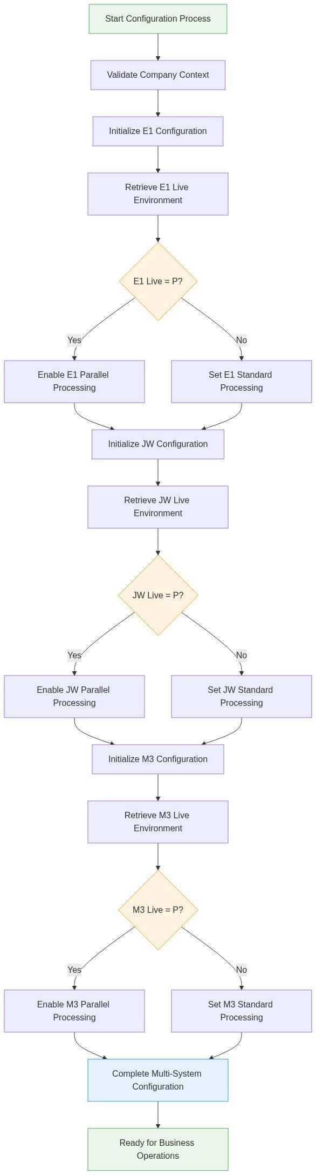

*Diagram 1*

### Function Call Tree and Architecture

E1JUXFR implements a systematic multi-system configuration orchestration with clear functional hierarchy. The following call tree shows the relationship between functions and their execution flow:

**📊 Figure 2: Process Flow Diagram**

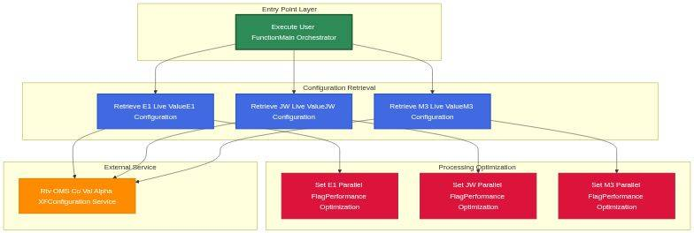

*Diagram 2*

#### 📊 Call Tree Analysis

### 🎯 Function Hierarchy

Single Entry Point:Execute User Function coordinates all activities.Parallel Branches:Three identical patterns for E1, JW, M3 systems.External Dependency:All configuration retrieval depends on central service.

### 🔄 Critical Call Paths

Configuration Path:Main calls Retrieve then Set Pattern for each system.Service Integration:All retrievals call external configuration service.Sequential Processing:Systems processed in E1 then JW then M3 order.

### ⚡ ⚡ Performance Considerations

Bottleneck Risk:Configuration service availability critical.Optimization Opportunity:Parallel processing flags enable performance gains.Scalability:Pattern supports additional systems easily.

### Critical Decision Points

### ⚙️ 🎯 Parallel Processing Decisions

Each system evaluation determines processing mode based on retrieved configuration. 'P' value enables parallel processing for performance optimization, all other values ensure stable sequential processing.

### ✓ 🔄 Configuration Validation

All configuration retrievals must complete successfully before business operations can proceed, ensuring system integrity and reliability.

### 🏢 Company Authorization

Valid company context required throughout process, ensuring secure access to appropriate configuration settings.

### 🔗 Integration Workflows

The component coordinates with centralized configuration management through standardized service calls. Each configuration retrieval follows the same pattern: company number validation, system key specification, and environment value retrieval. This consistency ensures reliable integration across all enterprise systems.

### 🎯 Business Process Dependencies

* Configuration Service Availability:Central configuration system must be operational
* Company Master Data:Valid company information required for authorization
* Environment Data Integrity:System-specific configuration values must be current
* Network Connectivity:Reliable communication with configuration services

## 💾 6. Data Interaction

### Configuration Repository Operations

|  |  |  |  |
| --- | --- | --- | --- |
| **System** | **Operation** | **Data Elements** | **Business Purpose** |
| E1 Enterprise | Configuration Read | Company Number, E1LIVE key, Environment Value | Determine E1 system operational mode and processing capabilities |
| JW World | Configuration Read | Company Number, JWLIVE key, Environment Value | Determine JW system operational mode and processing capabilities |
| M3 Business Engine | Configuration Read | Company Number, M3LIVE key, Environment Value | Determine M3 system operational mode and processing capabilities |
| Configuration Service | Parameter Exchange | Request/Response parameters, Status indicators | Coordinate configuration data retrieval and validation |

### 🎯 Business Data Validation Framework

### ✓ ✅ Input Validation

Company number format verification and authorization checking before any configuration access attempts.

### 🔍 Configuration Data Quality

Retrieved environment values validated for format, range, and business rule compliance.

### ⚙️ Output Parameter Integrity

All output parameters verified for completeness and consistency before business process handoff.

### 🔄 Information Processing Logic

* Configuration Retrieval:Extract company-specific environment settings using standardized service interface
* Business Rule Application:Apply parallel processing logic based on retrieved configuration values
* Parameter Generation:Create output parameters for downstream business process consumption
* Data Consistency Verification:Ensure all configuration data maintains business rule compliance

### Database Access Patterns

* Configuration Repository:Read-only access to centralized configuration data
* Company Master:Reference access for company validation and authorization
* System Parameters:Output parameter creation for business process integration
* Audit Logging:Configuration access and change tracking for compliance

### Data Quality Assurance

* Configuration Completeness:Verify all required configuration values retrieved successfully
* Business Rule Compliance:Ensure configuration changes align with business policies
* System Compatibility:Validate configuration settings compatible with current system versions
* Change Management:Maintain configuration change history for audit and rollback capability

## 🔗 7. Dependencies & Modernization

### 🎯 Critical Business Dependencies

#### 🔗 🔴 High-Priority Dependencies

* Configuration Service:'Rtv OMS Co Val Alpha XF' program must be operational
* Company Master Data:Valid OMS Company Number essential for all operations
* Environment Repository:Configuration database must contain current system settings

#### 🔗 🟡 Medium-Priority Dependencies

* Network Infrastructure:Reliable connectivity to configuration services
* Database Availability:Configuration repository must be accessible
* System Resources:Adequate processing capacity for configuration operations

### Downstream System Impact

* E1 Enterprise System:All E1 business processes depend on proper environment configuration
* JW World Applications:JD Edwards World operations require configuration for proper function
* M3 Business Engine:Movex/M3 processes need environment settings for optimal performance
* Integration Middleware:Multi-system coordination depends on consistent configuration
* Business Applications:All enterprise applications require proper multi-system setup

### 🚀 Modernization Strategy

### ☁️ Cloud-Native Configuration

Enhancement:Migrate to cloud-based configuration management with API-driven services, environment-specific configurations, and automated scaling capabilities.

### 🔄 Microservices Architecture

Transformation:Decompose into individual configuration microservices for each system with independent scaling and deployment capabilities.

### 🚀 Real-Time Configuration

Innovation:Implement real-time configuration updates with event-driven architecture and automatic system synchronization.

### 📊 Advanced Analytics

Intelligence:Add configuration analytics, performance monitoring, and predictive optimization for system performance.

### 🎯 Business Risk Mitigation

* Configuration Service Backup:Implement redundant configuration services for business continuity
* Default Value Management:Maintain safe default configurations for system stability
* Recovery Automation:Automated recovery procedures for configuration service restoration
* Monitoring and Alerting:Proactive monitoring of configuration health and availability

### ⚡ Performance Optimization Opportunities

* Configuration Caching:Implement intelligent caching for improved response times
* Parallel Processing Enhancement:Advanced parallel processing algorithms for better performance
* Resource Optimization:Efficient resource utilization and auto-scaling capabilities
* Predictive Configuration:Machine learning for optimal configuration predictions

## 🎯 8. Detailed Business Functions Analysis

### 🔍 Function Coverage Overview

E1JUXFR contains7 business functionsorganized into three logical categories. All functions are critical for multi-system environment configuration. This analysis provides comprehensive 4-part analysis for all 7 functions individually.

### Complete Function Catalog Summary

|  |  |  |  |  |  |
| --- | --- | --- | --- | --- | --- |
| **Function ID** | **Function Name** | **Category** | **Business Priority** | **System Impact** | **Call Pattern** |
| 1 | Execute User Function | Orchestration | Critical | Enterprise-wide coordination | Entry Point - Calls All |
| 2 | Retrieve E1 Live Value | Configuration | Critical | E1 system operations | External Service Call |
| 3 | Set E1 Parallel Flag | Performance | High | E1 processing optimization | Business Logic Only |
| 4 | Retrieve JW Live Value | Configuration | Critical | JW system operations | External Service Call |
| 5 | Set JW Parallel Flag | Performance | High | JW processing optimization | Business Logic Only |
| 6 | Retrieve M3 Live Value | Configuration | Critical | M3 system operations | External Service Call |
| 7 | Set M3 Parallel Flag | Performance | High | M3 processing optimization | Business Logic Only |

### ⚙️ Individual Function Analysis - All 7 Functions

Since E1JUXFR contains 7 functions (under the 10-function threshold), all are analyzed in detail below using the comprehensive 4-part analysis framework:

### Function 1: Execute User Function - Configuration Orchestrator

#### 🎯 1. Parameters and Business Data Elements

* Input Parameters:PAR.OMS_Company_Number (company context identifier)
* Output Parameters:Complete environment configuration set (E1_Live, E1_Parallel, JW_Live, JW_Parallel, M3_Live, M3_Parallel)
* Working Variables:LCL.E1_Live, LCL.JW_Live, LCL.M3_Live (local configuration values)
* Business Context:Company-specific multi-system environment coordination

#### 🎯 2. Business Logic Summary

* Primary Workflow:Orchestrates complete multi-system configuration process
* Coordination Logic:Manages sequential configuration of E1, JW, and M3 systems
* Integration Management:Ensures proper handoff between configuration and processing functions
* Exception Handling:Manages configuration failures and system unavailability scenarios

#### 🔄 3. Detailed Logic Explanation and State Flow Diagram

Comprehensive Business Process:This function serves as the central command center for all environment configuration activities, orchestrating six specialized functions in a carefully sequenced workflow.

**📊 Figure 3: Process Flow Diagram**

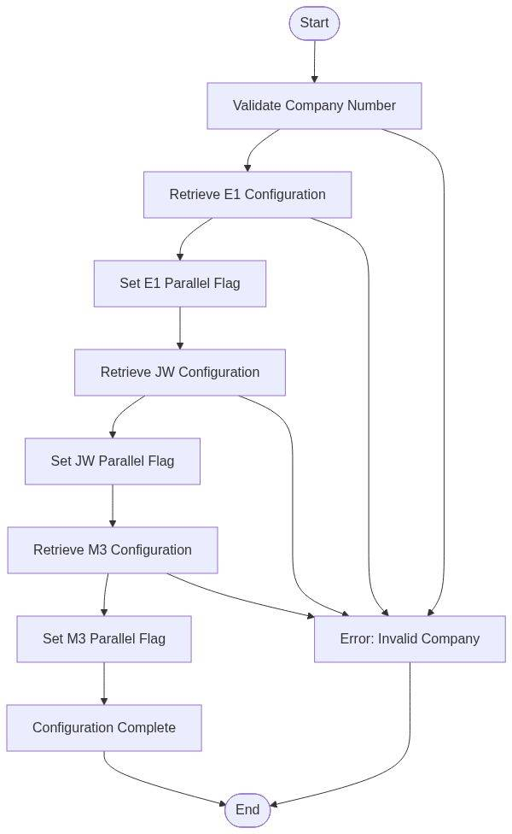

*Diagram 3*

Sequential Orchestration Pattern:The function validates company context, then systematically processes each enterprise system (E1 then JW then M3) through configuration retrieval and parallel processing optimization, ensuring complete multi-system environment setup before returning comprehensive configuration parameters to the calling business process.

#### 🎯 4. Data Interaction and Business Information Management

* Configuration Coordination:Manages all configuration service interactions for multi-system setup
* Parameter Management:Handles input validation and comprehensive output parameter generation
* Business Data Flow:Ensures proper data flow between configuration and business layers across all systems
* Audit and Compliance:Maintains configuration activity logging for business compliance and system monitoring

### 💎 Function 2: Retrieve E1 Live Value - E1 Configuration Service

#### 🎯 1. Parameters and Business Data Elements

* Input Parameters:PAR.OMS_Company_Number (company identifier), Configuration Key: 'E1LIVE'
* Output Parameters:LCL.E1_Live (E1 environment configuration value)
* Service Interface:'Rtv OMS Co Val Alpha XF' (configuration retrieval service)
* Business Context:E1 Enterprise system environment determination

#### 🎯 2. Business Logic Summary

* Configuration Retrieval:Calls centralized configuration service to obtain E1 environment settings
* Company Validation:Ensures valid company number before configuration access
* Service Integration:Standardized interface to configuration management system
* Error Handling:Manages service unavailability and invalid configuration scenarios

#### 🔄 3. Detailed Logic Explanation and State Flow Diagram

E1 Configuration Process:This function interfaces with the centralized configuration management system to retrieve E1-specific environment settings using a secure service call pattern.

**📊 Figure 4: Process Flow Diagram**

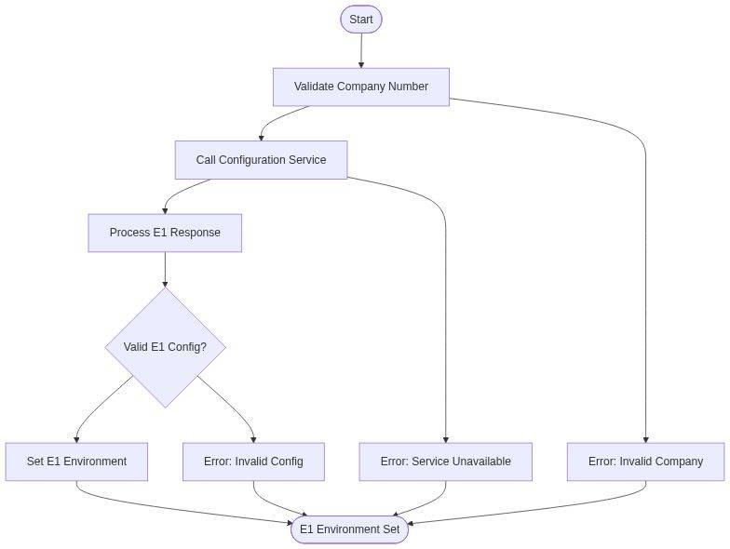

*Diagram 4*

Secure Configuration Retrieval:The function validates the company number, constructs the service call with 'E1LIVE' key, processes the returned configuration value, and determines whether E1 operates in production, test, or development mode, directly impacting business process execution and system performance.

#### 🎯 4. Data Interaction and Business Information Management

* Configuration Service Access:Secure access to centralized configuration repository using company-specific credentials
* E1 Environment Data:Retrieves critical E1 system environment configuration affecting all dependent business processes
* Business Data Validation:Validates retrieved configuration values against business rules and system requirements
* Integration Logging:Maintains service call logs for audit trail and troubleshooting purposes

### ⚡ Function 3: Set E1 Parallel Flag - E1 Performance Optimizer

#### 🎯 1. Parameters and Business Data Elements

* Input Parameters:LCL.E1_Live (E1 environment configuration value)
* Output Parameters:PAR.E1_Parallel (E1 parallel processing flag: 'P'/'N')
* Business Rule:If E1_Live = 'P' then E1_Parallel = 'P', else E1_Parallel = 'N'
* Business Context:E1 system performance optimization configuration

#### 🎯 2. Business Logic Summary

* Performance Decision:Determines E1 parallel processing capability based on environment setting
* Business Rule Application:Applies standardized parallel processing logic for E1 system
* System Optimization:Enables performance enhancement when appropriate environment conditions exist
* Default Safety:Defaults to sequential processing for system stability unless parallel explicitly configured

#### 🔄 3. Detailed Logic Explanation and State Flow Diagram

E1 Performance Configuration:This function implements a simple but critical business rule to determine E1 system performance optimization based on environment configuration.

**📊 Figure 5: Process Flow Diagram**

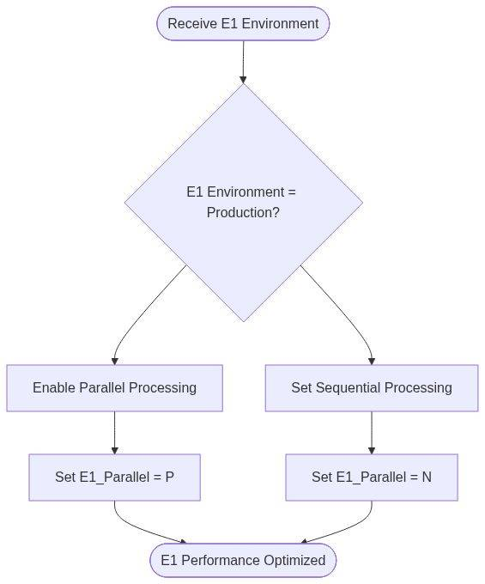

*Diagram 5*

Performance Optimization Logic:When E1 environment is configured for production parallel processing ('P'), the function enables parallel processing capabilities to improve business performance. For all other configurations, it ensures safe sequential processing ('N') to maintain system stability, directly impacting E1 business process execution speed and resource utilization.

#### 🎯 4. Data Interaction and Business Information Management

* Performance Parameter Generation:Creates E1 parallel processing configuration for downstream business processes
* Business Rule Enforcement:Ensures consistent application of parallel processing policies across E1 operations
* System Configuration Output:Provides performance optimization settings for E1 system integration
* Performance Monitoring Data:Generates configuration data for performance analysis and optimization tracking

### 💎 Function 4: Retrieve JW Live Value - JW Configuration Service

#### 🎯 1. Parameters and Business Data Elements

* Input Parameters:PAR.OMS_Company_Number (company identifier), Configuration Key: 'JWLIVE'
* Output Parameters:LCL.JW_Live (JW environment configuration value)
* Service Interface:'Rtv OMS Co Val Alpha XF' (configuration retrieval service)
* Business Context:JD Edwards World system environment determination

#### 🎯 2. Business Logic Summary

* Configuration Retrieval:Calls centralized configuration service to obtain JW environment settings
* Company Validation:Ensures valid company number before JW configuration access
* Service Integration:Standardized interface to configuration management system for JW-specific settings
* Error Handling:Manages service unavailability and invalid JW configuration scenarios

#### 🔄 3. Detailed Logic Explanation and State Flow Diagram

JW Configuration Process:This function interfaces with the centralized configuration management system to retrieve JD Edwards World-specific environment settings using the same secure pattern as E1 configuration.

**📊 Figure 6: Process Flow Diagram**

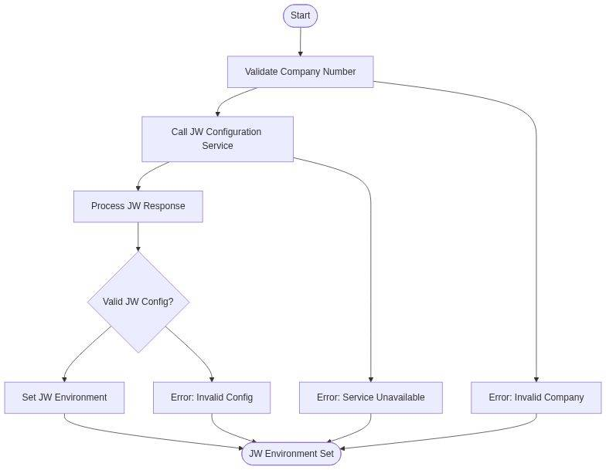

*Diagram 6*

JW-Specific Configuration Retrieval:The function validates company context, constructs the service call with 'JWLIVE' key, and processes the returned configuration value to determine whether JW operates in production, test, or development mode, directly impacting manufacturing, financial, and distribution business processes that depend on JD Edwards World functionality.

#### 🎯 4. Data Interaction and Business Information Management

* Configuration Service Access:Secure access to centralized configuration repository for JW-specific environment data
* JW Environment Data:Retrieves critical JW system environment configuration affecting manufacturing and financial processes
* Business Data Validation:Validates retrieved JW configuration values against business rules and system requirements
* Integration Logging:Maintains JW service call logs for audit trail and system troubleshooting

### ⚡ Function 5: Set JW Parallel Flag - JW Performance Optimizer

#### 🎯 1. Parameters and Business Data Elements

* Input Parameters:LCL.JW_Live (JW environment configuration value)
* Output Parameters:PAR.JW_Parallel (JW parallel processing flag: 'P'/'N')
* Business Rule:If JW_Live = 'P' then JW_Parallel = 'P', else JW_Parallel = 'N'
* Business Context:JD Edwards World system performance optimization configuration

#### 🎯 2. Business Logic Summary

* Performance Decision:Determines JW parallel processing capability based on environment setting
* Business Rule Application:Applies standardized parallel processing logic for JW system
* System Optimization:Enables performance enhancement when appropriate JW environment conditions exist
* Default Safety:Defaults to sequential processing for JW system stability unless parallel explicitly configured

#### 🔄 3. Detailed Logic Explanation and State Flow Diagram

JW Performance Configuration:This function applies business rules to determine optimal processing mode for JD Edwards World operations based on environment configuration.

**📊 Figure 7: Process Flow Diagram**

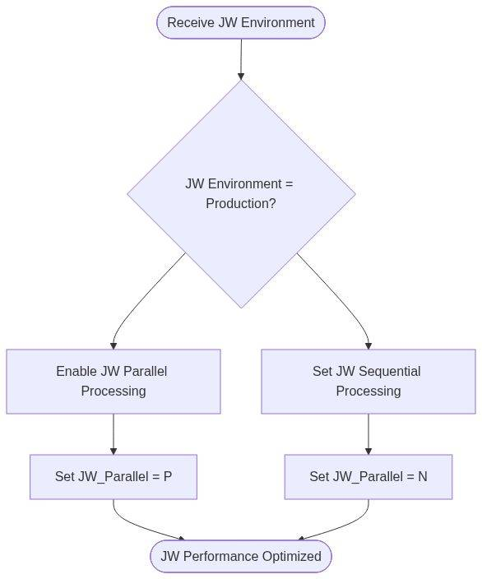

*Diagram 7*

JW-Specific Performance Optimization:When JW environment is configured for production parallel processing ('P'), the function enables parallel processing capabilities to improve manufacturing, financial, and distribution business performance. For other configurations, it ensures safe sequential processing ('N') to maintain JW system stability and data integrity, particularly critical for batch processing and financial reporting operations.

#### 🎯 4. Data Interaction and Business Information Management

* Performance Parameter Generation:Creates JW parallel processing configuration for downstream manufacturing and financial processes
* Business Rule Enforcement:Ensures consistent application of parallel processing policies across JW operations
* System Configuration Output:Provides performance optimization settings for JW system integration and batch processing
* Performance Monitoring Data:Generates JW-specific configuration data for performance analysis and optimization tracking

### 💎 Function 6: Retrieve M3 Live Value - M3 Configuration Service

#### 🎯 1. Parameters and Business Data Elements

* Input Parameters:PAR.OMS_Company_Number (company identifier), Configuration Key: 'M3LIVE'
* Output Parameters:LCL.M3_Live (M3 environment configuration value)
* Service Interface:'Rtv OMS Co Val Alpha XF' (configuration retrieval service)
* Business Context:Movex/M3 Business Engine system environment determination

#### 🎯 2. Business Logic Summary

* Configuration Retrieval:Calls centralized configuration service to obtain M3 environment settings
* Company Validation:Ensures valid company number before M3 configuration access
* Service Integration:Standardized interface to configuration management system for M3-specific settings
* Error Handling:Manages service unavailability and invalid M3 configuration scenarios

#### 🔄 3. Detailed Logic Explanation and State Flow Diagram

M3 Configuration Process:This function interfaces with the centralized configuration management system to retrieve Movex/M3 Business Engine-specific environment settings using the standardized configuration service pattern.

**📊 Figure 8: Process Flow Diagram**

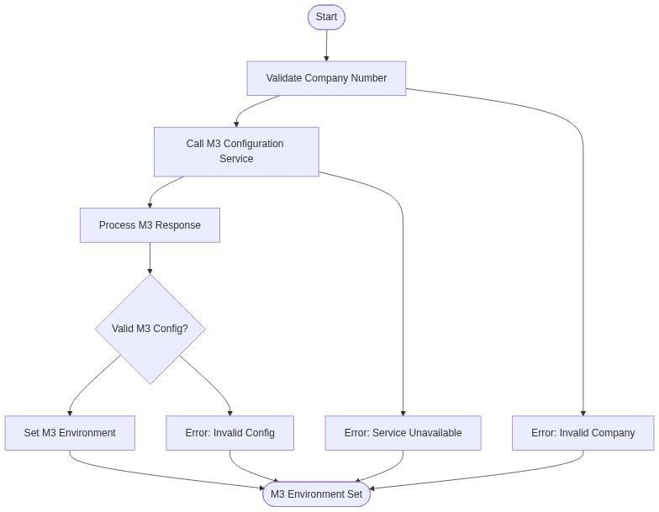

*Diagram 8*

M3-Specific Configuration Management:The function validates company context, constructs the service call with 'M3LIVE' key, and processes the returned configuration value to determine whether M3 operates in production, test, or development mode, directly impacting supply chain management, enterprise resource planning, and business intelligence processes that depend on M3 Business Engine functionality.

#### 🎯 4. Data Interaction and Business Information Management

* Configuration Service Access:Secure access to centralized configuration repository for M3-specific environment data
* M3 Environment Data:Retrieves critical M3 system environment configuration affecting supply chain and ERP processes
* Business Data Validation:Validates retrieved M3 configuration values against business rules and system requirements
* Integration Logging:Maintains M3 service call logs for audit trail and system troubleshooting

### ⚡ Function 7: Set M3 Parallel Flag - M3 Performance Optimizer

#### 🎯 1. Parameters and Business Data Elements

* Input Parameters:LCL.M3_Live (M3 environment configuration value)
* Output Parameters:PAR.M3_Parallel (M3 parallel processing flag: 'P'/'N')
* Business Rule:If M3_Live = 'P' then M3_Parallel = 'P', else M3_Parallel = 'N'
* Business Context:Movex/M3 Business Engine system performance optimization configuration

#### 🎯 2. Business Logic Summary

* Performance Decision:Determines M3 parallel processing capability based on environment setting
* Business Rule Application:Applies standardized parallel processing logic for M3 system
* System Optimization:Enables performance enhancement when appropriate M3 environment conditions exist
* Default Safety:Defaults to sequential processing for M3 system stability unless parallel explicitly configured

#### 🔄 3. Detailed Logic Explanation and State Flow Diagram

M3 Performance Configuration:This function applies business rules to determine optimal processing mode for Movex/M3 Business Engine operations based on environment configuration.

**📊 Figure 9: Process Flow Diagram**

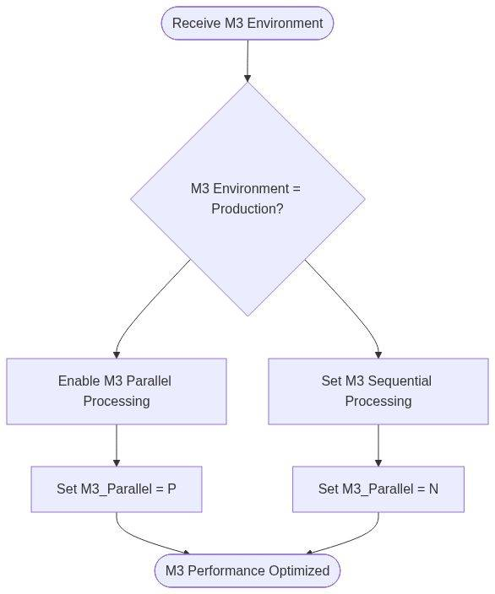

*Diagram 9*

M3-Specific Performance Optimization:When M3 environment is configured for production parallel processing ('P'), the function enables parallel processing capabilities to improve supply chain management, ERP, and business intelligence performance. For other configurations, it ensures safe sequential processing ('N') to maintain M3 system stability and data consistency, particularly critical for batch processing, supply chain optimization, and enterprise reporting operations.

#### 🎯 4. Data Interaction and Business Information Management

* Performance Parameter Generation:Creates M3 parallel processing configuration for downstream supply chain and ERP processes
* Business Rule Enforcement:Ensures consistent application of parallel processing policies across M3 operations
* System Configuration Output:Provides performance optimization settings for M3 system integration and batch processing
* Performance Monitoring Data:Generates M3-specific configuration data for performance analysis and supply chain optimization tracking

### 📊 Cross-Function Integration Analysis

### 🔄 Configuration Pattern Consistency

Standardized Approach:Functions 2,4,6 follow identical configuration retrieval patterns. Functions 3,5,7 implement consistent parallel processing logic. All functions maintain uniform error handling and business rule application.

### ⚡ ⚡ Performance Optimization Strategy

System-Specific Optimization:Each system (E1, JW, M3) receives tailored performance configuration. Parallel processing enablement based on environment readiness. Consistent safety defaults across all systems.

### 🔗 🏢 Enterprise Integration Architecture

Multi-System Coordination:All functions contribute to comprehensive enterprise configuration. Sequential processing ensures proper dependency management. Centralized configuration service provides consistency.

### 🚀 Modernization Recommendations

### 🔄 API-Driven Configuration

Transform configuration retrieval functions (2,4,6) into RESTful APIs with JSON-based configuration management and real-time updates

### ☁️ Cloud-Native Services

Migrate all functions to cloud-native microservices with independent scaling, containerization, and high availability

### ⚙️ 🚀 Advanced Parallel Processing

Enhance parallel processing logic (functions 3,5,7) with modern concurrency frameworks and distributed processing capabilities

### 📊 Intelligent Analytics

Add configuration analytics, performance monitoring, and predictive optimization for all 7 functions with ML-driven recommendations