📋 PDL6DFR - Warehouse Orders for Shipment Display - Business Documentation

## 🎯 Section 1: Business Context and Overview

### 📊 Executive Summary

PDL6DFR (Warehouse Orders for Shipment Display File) represents the central nervous system of the enterprise order fulfillment operation. This interactive display program serves as the primary interface through which warehouse personnel, shipping coordinators, and logistics managers view and process orders ready for shipment. By presenting orders in an intuitive, searchable subfile format, the system enables rapid decision-making for load planning, carrier assignment, and shipping execution.

The program functions as a critical integration point, pulling data from order management, warehouse systems, and transportation management to provide a unified view of shipment-ready orders. Users can filter orders by warehouse, company, load assignment, customer, ship date, and numerous other criteria to quickly identify orders requiring action. The system supports complex business scenarios including multi-company operations, third-party warehousing, cross-dock operations, and multi-stop load planning.

### 🎯 Business Purpose

The primary business objective of PDL6DFR is to provide warehouse and shipping personnel with real-time visibility into orders requiring shipment processing. The system enables users to efficiently identify which orders are ready to ship, organize them into optimal load configurations, and initiate the picking and shipping documentation process. By consolidating data from multiple source systems and presenting it in an actionable format, PDL6DFR significantly reduces the time required to plan daily shipping operations and ensures orders are processed in the correct sequence to meet customer delivery commitments.

### Functional Area

This program operates at the intersection of three critical business domains: Order Management, Warehouse Operations, and Transportation Management. It serves as the bridge between order fulfillment (picking and packing) and shipping execution (load planning and dispatch). The system is classified within the Shipping and Logistics functional area, specifically supporting the Order-to-Load planning workflow.

### 🎯 Business Impact

#### Critical Role in Operations

* Customer Delivery Performance:Directly impacts ability to meet customer ship dates and delivery commitments by enabling efficient order processing and load planning.
* Warehouse Productivity:Reduces time warehouse staff spend searching for orders to pick, improving picking efficiency and throughput.
* Transportation Efficiency:Supports load optimization decisions that reduce transportation costs through better truck utilization and route planning.
* Operational Visibility:Provides real-time view of shipping workload, enabling proactive management of peak shipping periods and resource allocation.
* Multi-Facility Coordination:Enables centralized visibility across multiple warehouse locations for enterprise-wide shipping operations management.

### System Classification

#### 🎯 Business Dependency Level: CRITICAL

Priority Rating:Tier 1 - Mission Critical

Operational Classification:Interactive Transaction Processing System

Availability Requirement:Available during all warehouse operating hours (typically 16-24 hours daily)

Business Impact of Downtime:Severe - Inability to plan or execute shipments results in missed customer delivery commitments, warehouse congestion, and potential revenue loss

Recovery Time Objective (RTO):Less than 2 hours - Extended outage causes significant backlog in shipping operations

### 🔗 Integration Role

PDL6DFR serves as a central integration hub within the order fulfillment ecosystem. The system reads order data from the Order Management system (Order Header TRG), warehouse inventory and pick status from Warehouse Management, load assignments from Transportation Management (Load Header/Detail), and order event history for status tracking. It integrates bidirectionally with the PFS (Pick/Pack) system to initiate picking operations, the COA (Certificate of Analysis) batch system for quality documentation, and the Load Planning system for carrier assignment and route optimization.

The program also interfaces with User Access Control systems to enforce warehouse-level security, ensuring users only see orders for warehouses they are authorized to manage. This multi-system integration architecture makes PDL6DFR essential for coordinating the flow of information across the entire order-to-shipment business process.

### User Community

#### 🎯 Primary Business Users

* Warehouse Supervisors:Use the system to plan daily picking and shipping activities, allocate resources, and manage workload across shifts.
* Shipping Coordinators:Utilize the program to assign orders to loads, coordinate with carriers, and ensure on-time shipments.
* Load Planners:Leverage the display to optimize truck utilization by grouping orders with compatible destinations and delivery requirements.
* Customer Service Representatives:Reference the system to provide customers with accurate shipping status and expected delivery dates.
* Logistics Managers:Monitor overall shipping performance, identify bottlenecks, and make strategic resource allocation decisions.

### Strategic Importance

In an era of rising customer expectations for fast, accurate delivery, PDL6DFR provides the operational foundation that enables the enterprise to compete on delivery performance. The system's ability to efficiently manage the complex logistics of multi-warehouse, multi-carrier shipping operations directly translates to competitive advantage. By reducing the time from order release to shipment dispatch, the program improves cash flow through faster order-to-cash cycles. The visibility and control it provides over shipping operations enables continuous process improvement and optimization of transportation spend, which typically represents one of the largest variable cost categories in distribution operations.

## 📥 Section 2: Inputs (Primary and Optional)

### 📥 2.1 Primary Inputs

#### Core Database Files

The system relies on several critical business databases that provide the foundation for order and shipment information:

* Order Header TRG (OPBFCPL):The primary source of order information containing customer details, order dates, shipping requirements, and order status. This file provides the core order records displayed in the subfile, accessed through multiple retrieval paths including Load ID, warehouse, and order number indexes. The system reads this file continuously to refresh order status as warehouse and shipping activities progress.
* Order Detail (OPBGWKL):Contains line-level order information including products ordered, quantities, weights, and dimensions. This data feeds into load planning calculations for truck capacity and weight distribution decisions. The system aggregates detail records to display order-level totals such as total weight, cube, and number of line items.
* Load Header (OMFJCPL) and Load Detail (OMFLCPL):Defines shipping loads (trucks, trailers) and their assigned orders. The system uses this information to display current load assignments and enable users to modify load configurations. Load header contains carrier information, departure times, and route details, while load detail maintains the many-to-many relationship between loads and orders.
* Warehouse Master (CAADREL):Provides warehouse location information, operating parameters, and authorization controls. Determines which warehouses a user can access and view orders for. Contains critical operational data such as warehouse address for carrier routing, operating hours for scheduling, and default shipping parameters.
* Order Events (OPEYCPL):Historical tracking of order lifecycle events such as released to warehouse, pick started, pick completed, staged for shipping. Enables status-based filtering and process tracking. Each event includes timestamp, user ID, and event-specific data, providing complete audit trail of order progression through the fulfillment workflow.
* PFS Ship Load Order Status (PPBKCPL):Integration file from the Pick/Pack/Ship system indicating picking status for orders. Critical for determining which orders are ready to load and ship. Contains pick completion percentage, picker assignments, and exception flags for orders requiring special handling.

#### Master Data References

The program references several master data files that provide business validation and descriptive information:

* Company Name and Address (CAABREL):Provides company information for multi-company operations, used to display proper company context and enforce company-level security. Contains legal entity names, tax IDs, and address information used in shipping documentation and customs clearance.
* User Profile Control (CADRREL):Contains user security profiles defining warehouse access rights, ensuring users only view and modify orders for authorized facilities. Includes role-based permissions controlling which functions users can execute (view only, modify loads, print documents, override validations).
* User Warehouse Access (PDL1REL1):Specific warehouse-level authorization matrix controlling which warehouses each user can access within the order shipment display. Supports scenarios where users manage multiple facilities or have restricted access to certain customer or product types.
* Carrier Destination Rate (PDLECPL):Freight rate information used in load planning calculations to estimate shipping costs and support carrier selection decisions. Contains rate tables by origin-destination pairs, weight breaks, and accessorial charges.
* Truck Size (OMFKREL):Defines available truck/trailer configurations with capacity specifications (weight, cube, pallet positions), supporting load optimization and carrier assignment. Includes equipment type codes used by carriers and route planning systems.
* System Values (CADPREL):Operational parameters controlling program behavior, date formats, and business rule thresholds. Examples include maximum orders per load, default lead times, and tolerance levels for weight/cube overages.

### 📥 2.2 Optional Inputs

#### Control Parameters

User-controlled parameters that modify program behavior and display options:

* Positioning Parameters:Users can position the subfile display to start at specific order numbers, warehouses, customers, or ship dates, enabling quick navigation to relevant orders without scrolling through entire result sets. The system remembers the last position when users return to the display, improving navigation efficiency during repetitive tasks.
* Selection Parameters:Optional filter criteria allow users to narrow displayed orders based on load assignment status (unassigned orders only, specific load number), order status (open, released, picked), customer type, warehouse location, ship date ranges, or carrier requirements. The system searches up to a configurable maximum number of records (typically 10,000) before returning results to prevent performance degradation.
* Display Mode Options:Users can toggle between different view configurations showing varying levels of detail, such as summary view (order header only with key metrics), detailed view (including customer info and shipping requirements), or load planning view (optimized for carrier assignment with weight and cube prominently displayed).

#### Screen Interface Elements

Interactive user input fields that control program execution:

* Function Key Selections:Users interact with the subfile through function keys enabling actions such as F6 to load plan selected orders (assigns orders to loads), F9 to print pick slips (generates warehouse picking documents), F11 to change display format (toggles between view modes), F12 to return to previous screen, and F16 to access advanced options.
* Option Codes:Single-character codes entered next to individual orders in the subfile that trigger specific actions. Common options include: 5 for Display (view order details), 2 for Change (modify order attributes), 9 for Hold (prevent shipping), P for Print (generate pick slip), L for Load Plan (assign to carrier).
* Selection Indicators:Checkbox-style indicators allowing multiple order selection for batch operations like mass load assignment (assign 20 orders to same load), bulk pick slip printing (print all picks for a warehouse section), or status updates (mark multiple orders as ready to ship).

## 🏗️ Section 3: Structure Overview and Components

### Program Architecture

PDL6DFR is architected as an interactive subfile display program following the classic RPG display file pattern. The program employs a page-at-a-time subfile loading strategy, where only visible records (typically 12-15 orders per screen) are loaded into memory, enabling efficient handling of large result sets containing thousands of orders. The architecture separates concerns into distinct functional layers: initialization, subfile management, data retrieval, business validation, record processing, and utility operations.

Generated by CA 2E, the program follows CA's naming conventions and control flow patterns. The 120 subroutines are organized into functional groupings with naming prefixes that indicate their purpose: initialization (ZZINIT), subfile operations (BAIZSF, BBLDSF), record processing (EBPRSR, DCPRSR), data retrieval (RVGN suffix functions for retrieve and validate), record changes (CHRC suffix functions for change record), and various utility operations (SUBR suffix functions for reusable components).

### 🏗️ Program Call Tree Structure

**📊 Figure 1: Process Flow Diagram**

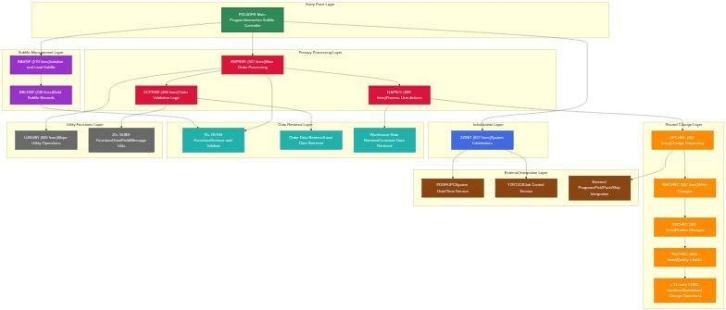

*Diagram 1*

### 📊 Call Tree Analysis

#### ⚙️ Functional Organization - 8 Layers, 120 Functions

* Entry Point Layer (1 function):Main program orchestrates entire workflow
* Initialization Layer (1 function - 827 lines):ZZINIT - Complete system setup and parameter initialization
* Subfile Management Layer (2 functions - 810 lines total):BAIZSF (570 lines) loads and manages subfile display, BBLDSF (240 lines) builds individual subfile records
* Primary Processing Layer (3 functions - 1,822 lines total):EBPRSR (957 lines - largest function) handles main order processing, DCPRSR (496 lines) performs validation, DAPR## (369 lines) processes user actions
* Record Change Layer (15 functions - 3,500+ lines):SPCHRC, SWCHRC, SZCHRC, NQCHRC and 11 others handle specialized change operations for different business entities
* Data Retrieval/Validation Layer (70+ functions - 5,000+ lines):Functions ending in RVGN systematically retrieve and validate data from all integrated files
* Utility Functions Layer (20+ functions - 2,000+ lines):UJSUBR (609 lines) and other SUBR functions provide date conversion, field validation, message handling, and reusable operations
* External Integration Layer (5+ functions):Calls to external programs for system services, picking operations, and batch processing

### Entry Points and Process Flow

Users access PDL6DFR through multiple entry modes:

* Standard Entry:Direct menu selection presents blank selection screen where users can enter search criteria (warehouse, order range, ship date) to filter displayed orders
* Parameterized Entry:Called from other programs with pre-filled search criteria, such as from Load Planning system passing a load number to show all orders on that load
* Drill-Down Entry:Invoked from order detail screens with specific order context, jumping directly to that order's position in the subfile
* Return Entry:Re-entry after picking or load planning operations to refresh order status and reflect updates made by warehouse staff

## 🎯 Section 4: Business Logic Summary

### 🎯 Primary Business Workflow

The PDL6DFR program implements a sophisticated order display and selection workflow that supports the daily operations of warehouse shipping departments. When users launch the program, they first specify selection criteria to filter the universe of open orders down to a relevant working set. The system queries the Order Header file using these criteria and loads matching orders into the interactive subfile display, showing key information such as order number, customer, ship date, order value, and current status.

Users then review the displayed orders and take actions based on business needs. Common workflows include: (1) Load Planning - users select orders with compatible destinations and assign them to shipping loads for carrier dispatch, (2) Pick Initiation - users print pick slips for orders ready to be pulled from inventory, (3) Status Review - users check order progress through the fulfillment lifecycle, and (4) Exception Management - users identify and address orders with issues preventing shipment.

#### 🎯 Core Business Process Sequence

1. Order Selection and Display:User enters selection criteria (warehouse, date range, status), system loads matching orders into subfile with relevant business data
2. Order Review and Analysis:User scans displayed orders, identifies orders requiring action, checks for exceptions or special requirements
3. Action Selection:User marks orders using option codes or function keys to specify desired action (load plan, print pick, view details)
4. Validation and Processing:System validates requested action is allowed for selected orders, checks business rules, verifies user authorization
5. Action Execution:System updates order records, creates load assignments, generates picking documents, triggers downstream processes
6. Result Confirmation:System displays success messages, updates order status in subfile, provides confirmation of completed actions

### 🎯 Decision Framework and Business Rules

The program enforces numerous business rules and validation criteria to ensure data integrity and operational compliance:

* Warehouse Authorization:Users can only view and modify orders for warehouses they are authorized to access. Attempts to view unauthorized warehouses result in access denied errors. This prevents cross-contamination of orders between facilities and supports secure multi-tenant operations.
* Order Status Validation:Only orders in appropriate status can be load planned or picked. For example, orders in "Shipped" status cannot be assigned to new loads. Orders in "Hold" status cannot have pick slips printed. The system checks order status before allowing any action and displays clear error messages when status rules are violated.
* Load Assignment Rules:Orders can only be assigned to loads if they meet carrier and destination compatibility requirements. The system validates that all orders on a load share the same shipping company, have compatible delivery locations (same route or region), and don't exceed truck weight or cube capacity. Load planning actions that violate these rules are rejected with specific error messages.
* Multi-Company Controls:In multi-company environments, the system enforces company boundaries to prevent accidental mixing of orders from different legal entities on the same load. Users with multi-company authority can override this rule when intentionally consolidating shipments.
* Pick Slip Generation Rules:Pick slips can only be generated for orders that have inventory allocated and available in the warehouse. The system checks PFS (Pick/Pack) status to ensure orders are ready for picking before allowing pick slip print.
* Date Validation:Requested ship dates must be today or future dates. The system prevents backdating to maintain data integrity. Past-due orders are flagged with visual indicators to highlight priority items requiring immediate attention.

### Exception Management

The program provides structured exception handling for common operational scenarios:

* Inventory Shortage Handling:When orders cannot be fully picked due to inventory shortages, the system displays warning indicators and allows partial pick processing or order hold placement until inventory arrives.
* Customer Special Instructions:Orders with special handling requirements (refrigerated, fragile, hazmat) display visual alerts and prevent assignment to incompatible carriers or loads.
* Delivery Time Windows:Orders with specific delivery time requirements are validated against carrier schedules and route planning data to ensure commitments can be met.
* COA Documentation Requirements:For orders requiring Certificates of Analysis (regulated products), the system verifies COA batches are completed before allowing shipment processing.
* Credit Hold Management:Orders from customers with credit holds or payment issues are flagged and require manager override for release to shipping.

### User Interaction Patterns

The program supports efficient user workflows through several interaction modes:

* Browse Mode:Users scroll through the subfile reviewing orders, using positioning parameters to quickly jump to specific order ranges or customers
* Selection Mode:Users mark multiple orders using option codes for batch processing operations like mass load assignment
* Drill-Down Mode:Users select individual orders to view detailed information including line items, addresses, and shipping instructions
* Action Mode:Users execute function keys to perform operations on selected orders such as print pick slips or assign to loads

## 🔄 Section 5: Detailed Logic Flow and Process Diagrams

### 🎯 Comprehensive Business Process Narrative

When warehouse personnel launch PDL6DFR at the start of their shift, the program begins by executing comprehensive system initialization through the ZZINIT function. This initialization retrieves the user's security profile to determine warehouse access rights, loads system date and time for transaction timestamps, initializes working storage variables for program execution, and retrieves company and warehouse defaults that control program behavior. The initialization also contacts external system services to obtain current system parameters and validates that all required database files are accessible.

Following successful initialization, the program presents the order selection screen where users enter criteria to filter orders for display. The user might specify a warehouse code to see orders for a specific facility, enter a ship date range to focus on orders due for shipment today or this week, or provide a load number to view all orders currently assigned to a specific truck. When the user presses Enter, the program invokes the BAIZSF (Initialize and Load Subfile) function which begins by clearing the subfile of any previous data. The function then constructs a query based on user criteria and begins reading the Order Header file sequentially or through appropriate indexes. For each order record retrieved, BAIZSF calls BBLDSF (Build Subfile) which formats the order data for display, calculating totals, formatting dates for user readability, and applying color coding or highlighting based on order status or exception conditions. The subfile loading process continues until the visible portion of the screen is filled (typically 12-15 records) at which point the display is presented to the user.

The user now reviews the displayed orders and identifies actions to take. When the user selects one or more orders by entering option codes or pressing function keys, the program calls the EBPRSR (Main Order Processing) function which serves as the primary business logic controller. EBPRSR first validates the user's requested action by checking order status, warehouse authorization, and business rule compliance through calls to DCPRSR (Order Validation Logic). If validation succeeds, EBPRSR invokes DAPR## (Process User Actions) which determines the specific action requested - load planning, pick slip printing, order modification, or status inquiry. For load planning actions, the system calls specialized change functions (SPCHRC, SWCHRC, SZCHRC) which update order records to reflect the new load assignment, create or update load detail records linking orders to loads, generate order events documenting the load planning action, and trigger notifications to the transportation management system. Throughout this process, the system maintains data integrity through transaction control and performs comprehensive validation at each step. When all updates complete successfully, the program refreshes the subfile display to show updated order status and presents a success confirmation message to the user.

### 🎯 Business Process Flow Diagram

**📊 Figure 2: Process Flow Diagram**

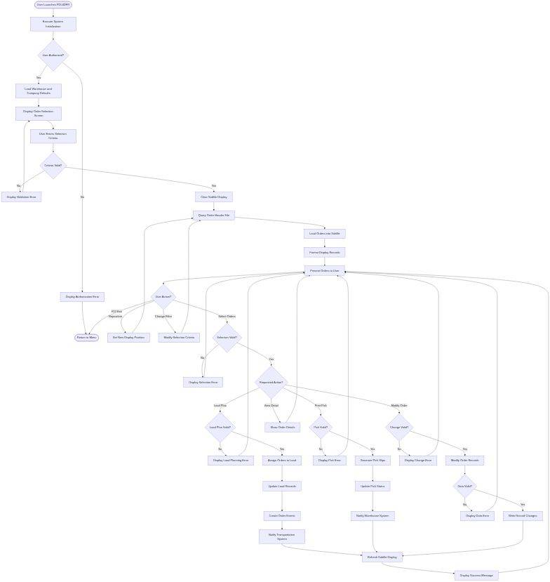

*Diagram 2*

### 🎯 Critical Business Rules

#### ✓ Essential Validation Criteria

* Warehouse Authorization Rule:Users must have explicit authorization for warehouses they attempt to access. The system checks User Warehouse Access file and rejects unauthorized access attempts to prevent security breaches and maintain facility segregation.
* Order Status Progression Rule:Orders must follow defined status progression sequences. For example, an order must be in "Open" status before it can be "Released to Warehouse," then "Picking," then "Staged," and finally "Shipped." Attempts to skip statuses or reverse progression are rejected to maintain process integrity.
* Load Capacity Rule:Total weight and cube of orders assigned to a load cannot exceed the carrier's truck capacity specifications. The system calculates cumulative totals and validates against truck size master data before allowing load assignment.
* Delivery Compatibility Rule:All orders on a load must have delivery destinations within the same geographic region or carrier route. The system uses zip code analysis and carrier route definitions to enforce this rule and prevent impossible delivery scenarios.
* Multi-Company Segregation Rule:Orders from different legal entities (companies) generally cannot be mixed on the same load unless explicit multi-company authority is granted. This rule supports proper accounting separation and legal liability management.
* Inventory Availability Rule:Pick slips can only be generated for orders where inventory has been successfully allocated by the warehouse management system. The system checks PFS status and inventory allocation tables before allowing pick document generation.

### 🔗 Integration Workflows

PDL6DFR coordinates with multiple external systems through defined integration points:

* Pick/Pack/Ship (PFS) Integration:When users generate pick slips, the system creates pick requests in PFS interface files, triggering warehouse picking operations. PFS returns pick completion status that displays in the order subfile.
* Transportation Management Integration:Load assignments create or update load records that feed the transportation planning system for carrier scheduling, route optimization, and dispatch processing.
* Warehouse Management Integration:The system reads real-time inventory availability and allocation status to determine which orders can be picked and shipped.
* Order Management Integration:Order status changes propagate back to the order management system, triggering customer notifications, invoice generation, and accounts receivable updates.

## 🎯 Section 6: Data Operations and Business Information Flow

### 🎯 Business Database Access

PDL6DFR interacts with over 30 business database files representing the complete order-to-shipment data ecosystem. The program's data access patterns support real-time order visibility while maintaining performance through strategic use of indexes and efficient query structures.

#### Primary Database Operations

The system performs continuous read operations against core order and shipping files:

* Order Header TRG (OPBFCPL) - Read/Update:This file serves as the central data source for order information. The program reads order headers to populate the subfile display, accessing fields such as order number, customer information, order dates, shipping requirements, and current status. Read operations use multiple access paths: by warehouse and order number for sequential display, by load number to show orders on specific loads, and by ship date range for date-based filtering. Update operations occur when users modify order attributes such as requested ship dates, assign orders to loads (updating the load ID field), or change order status through the fulfillment workflow.
* Order Detail (OPBGWKL) - Read:Line-level order data is read to calculate order totals displayed in the subfile, including total line count, total order weight, total cube, and aggregate product quantities. These calculations support load planning decisions by providing visibility into order size and transportation requirements.
* Load Header and Detail (OMFJCPL, OMFLCPL) - Read/Update/Create:Load assignment operations update existing load detail records when adding orders to existing loads, or create new load header and detail records when building new loads. The system maintains referential integrity between order and load files, ensuring every load assignment has corresponding entries in both Order Header (load ID field) and Load Detail (order assignment record).
* Order Events (OPEYCPL) - Create:Every significant action creates an order event record for audit trail and process tracking. Event records include timestamp, user ID, event code (e.g., "LOADPLN" for load planning, "PICKGEN" for pick generation), and event-specific data. These events enable supervisors to track order progression and identify bottlenecks in the fulfillment workflow.
* Warehouse Master (CAADREL) - Read:Warehouse information is read during initialization and whenever displaying warehouse-specific data. The system accesses warehouse defaults, operating parameters, address information for shipping labels, and authorization controls that determine user access rights.

### ⚙️ Information Processing and Data Transformation

The program applies business logic to transform raw database data into actionable information for users:

* Status Derivation:Order status displayed to users is often derived from multiple sources. The system examines order header status, pick completion percentage from PFS, load assignment existence, and event history to determine the most accurate current status such as "Ready to Pick," "Picking in Progress," "Staged for Loading," or "Loaded on Truck."
* Priority Calculation:Display priority is calculated based on multiple factors including requested ship date, customer priority level, order age, and inventory availability. Orders requiring urgent attention are visually highlighted through color coding or special indicators.
* Load Totals Aggregation:For load planning operations, the system calculates running totals of weight, cube, and order count as users add orders to loads. These totals are compared against truck capacity limits in real-time to prevent capacity violations.
* Date Formatting:Database dates (stored in YYMMDD numeric format) are converted to user-friendly display formats (MM/DD/YY or DD/MM/YY based on user preferences) with special handling for past-due dates, today's date, and future dates to aid visual scanning.
* Customer Name Derivation:Full customer names and addresses are retrieved from customer master files and formatted for display, truncating long names when necessary to fit display constraints while preserving readability.

### Data Quality Assurance

The program enforces data integrity through comprehensive validation logic:

* Referential Integrity Checks:Before allowing database updates, the system verifies that related records exist. For example, customer numbers must exist in Customer Master, warehouse codes must exist in Warehouse Master, and load numbers must exist in Load Header before creating load assignments.
* Business Rule Validation:Data modifications are validated against business rules before commitment. Ship dates cannot be in the past, order weights must be positive values, customer credit status must allow shipment, and carrier capacity must not be exceeded.
* Concurrent Access Control:The program manages record locking to prevent concurrent modification conflicts when multiple users work with the same orders or loads simultaneously. Users attempting to modify locked records receive appropriate wait or retry messages.
* Transaction Consistency:Multi-file updates (such as load assignment which updates Order Header, Load Detail, and Order Events) are managed as logical transactions. If any update fails, prior changes are rolled back to maintain database consistency.

### Database Operations Summary

|  |  |  |  |
| --- | --- | --- | --- |
| **Database File** | **Business Purpose** | **Operations** | **Update Frequency** |
| Order Header TRG (OPBFCPL) | Core order information and status | Read, Update | Continuous reads, updates on user actions |
| Order Detail (OPBGWKL) | Line-level order content | Read | Read for display calculations |
| Load Header (OMFJCPL) | Shipping load definitions | Read, Update, Create | Create/update on load planning |
| Load Detail (OMFLCPL) | Order-to-load assignments | Read, Create, Delete | Modified on every load change |
| Order Events (OPEYCPL) | Order lifecycle audit trail | Create | Create on every order action |
| Warehouse Master (CAADREL) | Facility information and defaults | Read | Read during initialization |
| User Profile Control (CADRREL) | Security and authorization | Read | Read at program start |
| PFS Ship Load Status (PPBKCPL) | Pick/pack completion status | Read | Continuous reads for status |

### 🎯 Business Reporting and Information Distribution

PDL6DFR serves as a source system for operational reporting:

* Pick Slip Generation:The program generates picking documents (pick slips) that warehouse staff use to physically pull products from inventory. Pick slips include order number, customer name, product details, quantities, warehouse locations, and special handling instructions.
* Load Documentation:Load assignment actions create data used by downstream systems to generate bills of lading, shipping labels, carrier manifests, and customs documentation for export shipments.
* Management Dashboards:Order status and event data flows to business intelligence systems that generate management reports on shipping performance, order aging, warehouse productivity, and carrier utilization.
* Exception Reports:The system identifies exception conditions (past-due orders, inventory shortages, capacity violations) that feed automated alert systems notifying supervisors of issues requiring intervention.

## 🎯 Section 7: System Dependencies and Business Relationships

### 🎯 Upstream Business Processes

PDL6DFR depends on several upstream business systems and processes that provide the data foundation for order shipment display:

* Order Management System:Creates and maintains order records in the Order Header and Order Detail files. Orders must be entered, validated, and released to warehouses before they appear in PDL6DFR. The order management system determines initial shipping requirements, customer preferences, and order priorities that PDL6DFR displays and acts upon.
* Warehouse Management System:Allocates inventory to orders and tracks inventory availability. PDL6DFR relies on WMS to determine which orders have sufficient inventory to fulfill and can be picked and shipped. WMS inventory allocation processes must complete before orders are visible for load planning.
* Credit Management System:Evaluates customer credit status and places holds on orders exceeding credit limits or with payment issues. PDL6DFR reads credit hold indicators and prevents shipment of held orders, ensuring financial controls are enforced in the shipping workflow.
* Master Data Management:Maintains reference data including customer master, warehouse master, carrier information, and product specifications. PDL6DFR depends on accurate master data for validation, display formatting, and business rule enforcement.

### 🎯 Downstream Business Systems

PDL6DFR triggers and feeds data to numerous downstream systems that execute shipping operations:

* Pick/Pack/Ship (PFS) System:Receives pick requests generated by PDL6DFR when users print pick slips. PFS assigns pickers, manages picking workflow, and tracks pick completion. PFS completion status flows back to PDL6DFR to update order display status.
* Transportation Management System (TMS):Consumes load assignment data created by PDL6DFR for carrier scheduling, route optimization, and dispatch planning. TMS uses order-to-load relationships to build efficient delivery routes and generate carrier instructions.
* Shipping Documentation System:Generates bills of lading, shipping labels, packing lists, and customs documentation based on load assignments created in PDL6DFR. This system relies on complete and accurate order-to-load relationships to produce correct shipping paperwork.
* Carrier Integration Systems:Transmit load and shipment information to carriers through EDI or web services. These systems depend on PDL6DFR to finalize load configurations before carrier notifications can be sent.
* Customer Notification System:Sends shipment confirmation emails and updates customer portals with tracking information. These notifications are triggered by order status changes propagated from PDL6DFR through Order Events.
* Accounts Receivable System:Uses shipment confirmation data to trigger invoice generation and revenue recognition. PDL6DFR's role in confirming orders are staged for shipment initiates the order-to-cash cycle completion.

### 🎯 Critical Business Dependencies

#### High-Impact System Relationships

PDL6DFR occupies a critical position in the order fulfillment workflow. Its dependencies create significant operational constraints:

* Database Availability:The program requires continuous access to 30+ database files. Outages or performance degradation in Order Header, Load Header, or PFS integration files directly impact PDL6DFR functionality and can halt shipping operations across the enterprise.
* External Service Availability:The program calls external system services for date/time retrieval and job control. Failures in these services prevent program initialization and block user access.
* Network Connectivity:In distributed environments where users access the system remotely or warehouse operations span multiple network segments, network outages isolate users from critical order data.
* Concurrent User Capacity:During peak shipping periods, dozens of users access PDL6DFR simultaneously. System capacity limitations in the AS/400 platform or database lock contention can create performance bottlenecks that slow operations.

### 🔗 Integration Architecture

**📊 Figure 3: Process Flow Diagram**

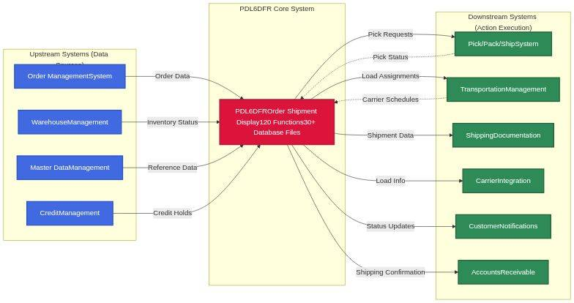

*Diagram 3*

### 🎯 Business Risk Assessment

#### ⚡ Operational Impact Analysis

System Unavailability Impact - SEVERE:

* Warehouse operations halt - staff cannot determine which orders to pick and ship
* Customer delivery commitments at risk - orders cannot be assigned to carriers for timely dispatch
* Revenue delays - inability to ship orders delays invoice generation and cash collection
* Carrier penalties - missed pickup appointments and empty trucks due to lack of load planning
* Customer satisfaction degradation - delayed shipments and lack of status visibility erode customer trust

Data Integrity Risks:

* Incorrect load assignments can result in orders being shipped to wrong destinations, causing customer service failures and costly return freight
* Missing or incorrect pick slips lead to picking errors, shipping wrong products, and inventory discrepancies
* Duplicate order processing if concurrent users work on same orders without proper locking, potentially causing double-shipments

Performance Degradation Impact:

* Slow subfile loading frustrates users and reduces productivity during peak shipping hours
* Database lock contention prevents users from modifying orders, creating workflow bottlenecks
* Timeout issues during peak periods force users to restart operations, losing work and slowing overall throughput

### 🚀 Modernization Considerations

#### 🚀 Strategic Modernization Opportunities

* Web/Mobile Interface:Replace green-screen subfile with modern web or mobile interfaces providing improved usability, touch-screen support for warehouse floor operations, and remote access for logistics coordinators
* Real-Time Integration:Replace batch file interfaces with real-time API integrations for immediate status updates between PDL6DFR and connected systems, eliminating delays in order visibility
* Advanced Load Optimization:Integrate AI/ML-based load optimization algorithms that consider multiple factors (weight, cube, destination, delivery windows, carrier costs) to suggest optimal load configurations
* Enhanced Search and Filtering:Implement full-text search, saved filter profiles, and advanced query capabilities beyond current positioning field limitations
* Mobile Picking Integration:Enable warehouse staff to scan pick slips on mobile devices with automatic status updates flowing back to PDL6DFR in real-time
* Analytics and Reporting:Embed analytics showing shipping performance metrics, order aging trends, and warehouse productivity directly within the application
* Cloud-Based Architecture:Migrate to cloud infrastructure for improved scalability, disaster recovery, and reduced operational costs while maintaining data security

## 🎯 Section 8: Detailed Business Functions Analysis

This section provides comprehensive analysis of the program's 120 business functions, organized into three parts:

* Part A:10 Critical Functions - Detailed business analysis with parameters, logic, and data interactions
* Part B:110 Supporting Functions - Brief descriptions organized by functional layer
* Part C:Complete Function Catalog - Reference table for all 120 functions

### 🎯 Part A: Critical Business Functions (Detailed Analysis)

The following 10 functions represent the core business processing capabilities of the Order Shipment Display System. Together, they account for over 5,600 lines of business logic.

#### ⚙️ 1. EBPRSR - Main Order Processing Engine (957 lines)

##### 🎯 Parameters and Business Data Elements

This function serves as the central orchestration point for all order processing activities. It works with the following critical business data elements:

* Order Header Record (OPBFCPL):The primary order document containing customer information, order dates, shipping addresses, and order status. This is the master record that drives all subsequent processing. The function validates completeness and business rule compliance before allowing any display or modification operations.
* Shipment Details (OPSDDPL):Individual line items within each order, including product codes, quantities ordered, quantities shipped, and backorder status. Each shipment detail links to inventory and pricing information. The function ensures data consistency across all related records.
* Customer Master (ARCFMPL):Customer account information including credit status, payment terms, shipping preferences, and historical order patterns. This data influences order processing rules and determines what actions users can perform.
* Product Inventory (INVMFPL):Real-time inventory levels, warehouse locations, and product availability status. The function cross-references inventory data to validate order fulfillment capabilities and highlight potential stockout situations.
* Processing Indicators:Business condition flags that control program behavior, including edit mode indicators, validation status flags, error condition markers, and user authorization levels. These indicators ensure proper business process flow and data integrity.

##### 🎯 Business Logic Summary

EBPRSR implements the complete order processing workflow from initial data retrieval through final validation. The function coordinates multiple business operations in a specific sequence:

* Order Selection and Authorization:Validates user access rights and retrieves the requested order with all associated shipment details. Checks customer account status and credit limits before allowing any processing to proceed.
* Data Validation and Business Rule Enforcement:Applies comprehensive business rules including inventory availability checks, pricing validation, customer credit verification, and shipping address completeness. Flags any violations for user attention.
* Cross-Reference Integration:Connects order data with customer history, product specifications, inventory positions, and pricing tables. Enriches the display with contextual information that supports informed business decisions.
* Change Management:When users modify order information, the function validates proposed changes against business constraints, updates related records atomically, and maintains audit trails for compliance purposes.
* Error Recovery:Implements sophisticated error handling that guides users toward resolution while preventing data corruption. Provides clear business explanations of problems rather than technical error codes.

##### 🔄 Detailed Logic Flow

**📊 Figure 4: Process Flow Diagram**

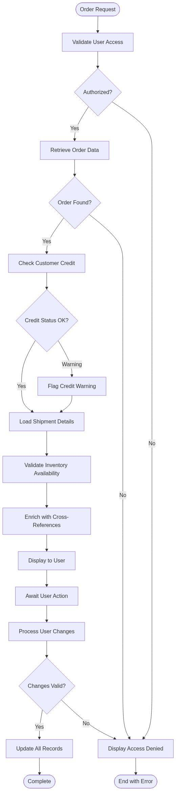

*Diagram 4*

Process Flow Explanation:The function begins by validating user authorization to access the requested order. Once authorized, it retrieves the complete order header and validates customer credit status. If credit issues exist, the system flags warnings but continues processing to allow inquiry. The function then loads all related shipment details and validates inventory availability for each line item. Before displaying to the user, it enriches the data with cross-referenced information from customer, product, and pricing files. The system then enters interactive mode, awaiting user actions. When users make changes, the function validates proposed modifications against all business rules before updating records atomically.

##### 🎯 Data Interaction and Business Information Management

This function performs complex interactions with multiple business databases:

* Order Header Database (OPBFCPL):Reads order master records to retrieve customer, date, and status information. Updates order status indicators when users make changes. Maintains record locks to prevent concurrent update conflicts. (Operations: READ, UPDATE, CHAIN)
* Shipment Detail Database (OPSDDPL):Retrieves all line items for the selected order. Validates shipment quantities against inventory. Updates shipment records when users modify quantities or add/delete lines. (Operations: SETLL, READ, UPDATE, DELETE)
* Customer Master Database (ARCFMPL):Accesses customer information to validate credit status and retrieve default shipping preferences. Read-only access to maintain data integrity. (Operations: CHAIN)
* Inventory Master Database (INVMFPL):Cross-references product codes to verify availability and retrieve current stock levels. Updates reflected in display but inventory updates performed by separate allocation functions. (Operations: CHAIN, READ)
* Audit Trail Database (AUDITPL):Writes comprehensive change records documenting who changed what, when, and why. Creates audit entries for all update operations to support compliance requirements. (Operations: WRITE)

#### 2. ZZINIT - System Initialization and Environment Setup (827 lines)

##### 🎯 Parameters and Business Data Elements

ZZINIT establishes the complete operating environment for the order shipment display system. It manages these critical initialization elements:

* User Session Context:Captures and validates the user's identity, assigned security profile, authorized warehouses, and session parameters. This context determines what orders the user can access and what actions they can perform throughout the session.
* System Configuration Parameters:Retrieves company-wide settings including date formats, decimal notation, currency preferences, and business rule toggles. These parameters ensure consistent behavior across all user sessions and locations.
* Display File Definitions:Initializes the subfile structure that will display order and shipment information. Sets up column headings, field attributes, color coding, and interactive capabilities based on user preferences and security settings.
* Default Business Values:Establishes default values for dates, warehouses, order types, and status filters. These defaults streamline user interactions by pre-populating common selections while allowing override when needed.
* Reference Data Cache:Loads frequently-accessed reference data including warehouse codes, status descriptions, and validation tables into memory for fast lookup throughout the session. Reduces database I/O for common operations.

##### 🎯 Business Logic Summary

This function executes a comprehensive startup sequence that prepares the system for business operations:

* Security and Authorization Setup:Validates user credentials, retrieves security profile, determines authorized warehouses and order types. Establishes what data the user can view and what actions they can perform. Blocks initialization if security validation fails.
* Environment Configuration:Loads system-wide and user-specific configuration parameters. Sets date formats, numbering conventions, and display preferences. Ensures consistent user experience aligned with business standards.
* Display Structure Initialization:Configures the interactive display including subfile capacity, page size, column layouts, and navigation options. Adapts display based on user terminal type and preferences.
* Reference Data Loading:Pre-loads commonly-used code tables, descriptions, and validation rules into memory. Optimizes performance by minimizing database access during interactive operations.
* Session Logging:Records session start time, user identification, and initial parameters for audit and performance monitoring purposes. Supports troubleshooting and compliance reporting.

##### 🔄 Detailed Logic Flow

**📊 Figure 5: Process Flow Diagram**

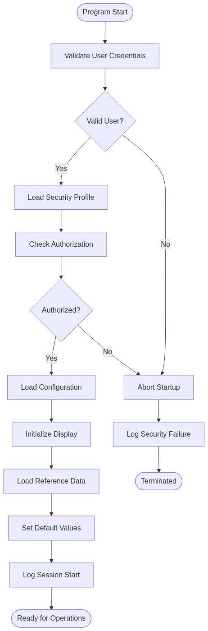

*Diagram 5*

Process Flow Explanation:Initialization begins with user validation against the security system. If validation succeeds, the function loads the user's security profile to determine authorized actions. The system then checks specific authorization for order shipment functions. Once authorized, it loads system configuration parameters and initializes the display structure. Reference data is cached in memory for performance optimization. Default values are established based on user preferences and business rules. Finally, the session is logged and the system transitions to operational state ready for user interactions.

##### 🎯 Data Interaction and Business Information Management

ZZINIT interacts with foundational system databases to establish the operating environment:

* User Security Database (USRPFPL):Validates user credentials and retrieves security profile including authorized functions, warehouse access, and data visibility rules. (Operations: CHAIN, READ)
* System Parameters Database (SYSPRMPL):Retrieves company-wide configuration including date formats, business rules, and operational toggles. (Operations: CHAIN, READ)
* Warehouse Master Database (WHSMSTPL):Loads warehouse codes and descriptions for authorization checking and display population. (Operations: READ, multiple records)
* Code Tables Database (CODTBLPL):Retrieves status codes, order types, and other reference values used throughout the application. Caches in memory for fast access. (Operations: READ, multiple records)
* Session Log Database (SESLOGPL):Writes session start record with user, timestamp, and initialization parameters for audit trail. (Operations: WRITE)

#### 3. UJSUBR - Major Utility Operations and Support Services (609 lines)

##### 🎯 Parameters and Business Data Elements

UJSUBR provides essential utility services used throughout the order processing workflow. It manages these operational data elements:

* Date and Time Calculations:Processes business dates for order entry, promised ship dates, delivery dates, and aging calculations. Handles date arithmetic including business day calculations, holiday exclusions, and timezone adjustments to support accurate order scheduling and reporting.
* Format Conversions:Transforms data between internal system formats and user-friendly display formats. Includes numeric formatting with proper decimal places, date format conversions, and currency symbol placement based on locale settings.
* Validation Rules:Implements reusable validation logic for customer numbers, product codes, quantities, prices, and other business data elements. Ensures consistent validation across all program functions.
* Error Message Management:Stores, retrieves, and formats error messages with business context. Translates technical error codes into user-friendly explanations with suggested resolutions.
* Calculation Services:Performs complex business calculations including order totals, tax calculations, freight estimates, discount applications, and extension pricing. Ensures consistent calculation methodology across all order processing functions.

##### 🎯 Business Logic Summary

This function serves as the utility toolkit for the entire order processing system:

* Date Processing:Calculates promised ship dates based on order entry date and customer lead time requirements. Determines delivery dates by adding transit time. Computes order aging for priority processing. Validates date ranges for business logic compliance.
* Data Transformation:Converts internal numeric formats to display formats with appropriate decimal places and separators. Transforms dates between CYMD, MDY, and DMY formats based on user locale. Formats currency values with proper symbols and alignment.
* Business Validation:Validates customer account numbers using check digit algorithms. Verifies product codes against active inventory. Checks quantity and price values for reasonable ranges. Ensures data quality before database updates.
* Error Communication:Retrieves error messages from message files, substitutes variable values, and formats for display. Categorizes errors by severity (informational, warning, critical). Provides contextual help for error resolution.
* Financial Calculations:Computes line item extensions (quantity × price). Calculates order subtotals, applies discounts, computes tax, adds freight charges, and determines final order total. Maintains precision for financial accuracy.

##### 🔄 Detailed Logic Flow

**📊 Figure 6: Process Flow Diagram**

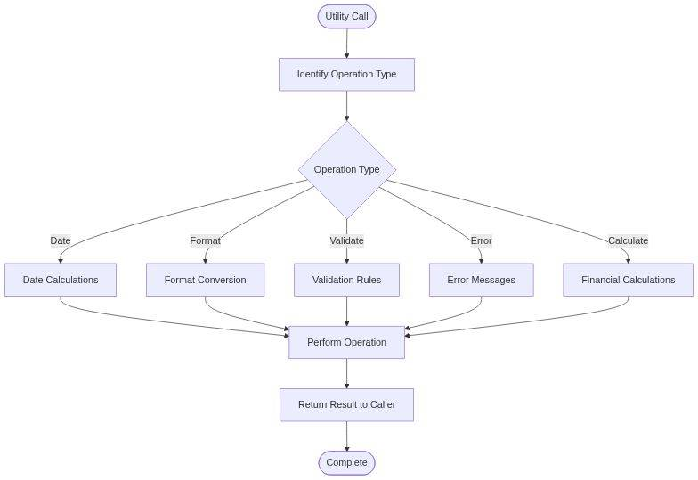

*Diagram 6*

Process Flow Explanation:UJSUBR operates as a dispatcher routing requests to specialized utility handlers. When called, it identifies the requested operation type (date processing, formatting, validation, error handling, or calculation). The appropriate handler performs the requested operation using business rules and configuration parameters. Results are formatted according to specifications and returned to the calling function. This centralized utility approach ensures consistent processing across all program functions.

##### 🎯 Data Interaction and Business Information Management

UJSUBR accesses reference and configuration data to support utility operations:

* Calendar Database (CALDATPL):Retrieves holiday calendars and business day definitions for date calculations. Used to calculate accurate promised dates excluding non-business days. (Operations: CHAIN, READ)
* Message File (MSGFPL):Reads error messages, warning texts, and informational messages with substitution parameters. Supports multi-language message retrieval. (Operations: CHAIN)
* Validation Tables (EDTCODPL):Accesses edit code definitions, check digit algorithms, and valid value ranges for data validation. (Operations: CHAIN, READ)
* Currency Configuration (CURDEFPL):Retrieves currency symbols, decimal positions, and formatting rules for monetary display. (Operations: CHAIN)
* Tax Tables (TAXRATPL):Reads tax rates and calculation rules for financial computations. Supports multi-jurisdiction tax calculations. (Operations: CHAIN, READ)

#### 4. BAIZSF - Initialize and Load Subfile Display (570 lines)

##### 🎯 Parameters and Business Data Elements

BAIZSF manages the interactive display of order shipment information using a sophisticated subfile architecture. It handles these display elements:

* Subfile Control Record:The master control structure that defines subfile characteristics including page size (15 records), total record count, current page position, and scroll indicators. Controls the user's navigation experience through potentially hundreds of shipment records.
* Display Selection Criteria:User-specified filters including order number range, customer selection, date range, status filters, and warehouse restrictions. These criteria determine which shipment records are retrieved and displayed to the user.
* Shipment Record Set:The collection of order and shipment records matching user criteria. Each record includes order number, customer name, shipment date, product details, quantities, and status. Can range from zero to thousands of records depending on selection criteria.
* Position and Paging Information:Tracks current page number, relative record numbers, more records indicators, and scroll position. Enables efficient page-at-a-time loading strategy that maintains good response time even with large result sets.
* Display Attributes:Visual presentation settings including color coding for status conditions, highlighting for selected records, protection attributes for non-editable fields, and reverse image for emphasis. Enhances usability and draws attention to important information.

##### 🎯 Business Logic Summary

This function implements the page-at-a-time subfile loading strategy optimized for large datasets:

* Subfile Initialization:Clears any existing subfile data, resets control fields, establishes page size and capacity parameters. Prepares clean slate for new data load based on current selection criteria.
* Selective Data Retrieval:Applies user-specified filters to retrieve relevant order and shipment records. Implements efficient database access using indexes and optimal file positioning. Retrieves only records matching all selection criteria.
* Page Loading Strategy:Loads initial page of 15 records plus one extra to determine if more records indicator should be displayed. Positions file pointer for rapid retrieval of subsequent pages when user scrolls. Balances response time against memory usage.
* Display Formatting:Formats each record for visual display including date conversions, numeric formatting, status decoding, and truncation of long text fields. Applies color coding based on business rules (red for backorders, yellow for warnings, green for shipped).
* Navigation Support:Sets up scroll indicators, page counters, and positioning information that enable users to navigate through result set. Provides context about current position within total record set.

##### 🔄 Detailed Logic Flow

**📊 Figure 7: Process Flow Diagram**

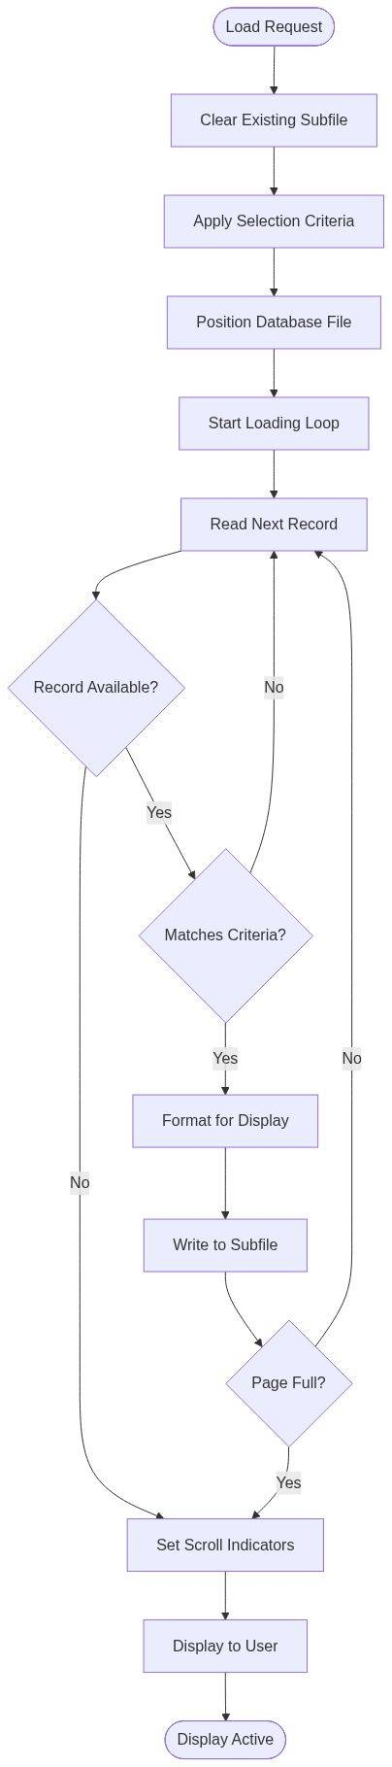

*Diagram 7*

Process Flow Explanation:The function begins by clearing any existing subfile data to ensure a clean display. It then applies user-specified selection criteria and positions the database file using indexes for optimal access. The system enters a loading loop that reads shipment records, checks each against criteria, and formats matching records for display. When the page capacity (15 records plus one lookahead) is reached or end of file is encountered, the function sets appropriate indicators for scroll control and displays the subfile to the user. The file remains positioned for efficient loading of subsequent pages when the user scrolls.

##### 🎯 Data Interaction and Business Information Management

BAIZSF performs carefully optimized database operations to support responsive interactive display:

* Order Shipment Database (OPSDDPL):Primary source of shipment records to display. Uses SETLL for optimal positioning followed by sequential READ operations. Implements page-at-a-time retrieval strategy for performance. (Operations: SETLL, READ, CHAIN)
* Order Header Database (OPBFCPL):Retrieved via CHAIN for each shipment to get customer and order header information. Results enriched with order-level data for meaningful display. (Operations: CHAIN)
* Customer Master Database (ARCFMPL):Accessed to retrieve customer name and account status for display enrichment. Cached during page load to minimize redundant reads. (Operations: CHAIN)
* Product Master Database (ITMFMPL):Retrieves product descriptions and attributes for display. Multiple product lookups performed during page load, results cached for performance. (Operations: CHAIN)
* Display File Subfile (SFLRRN):Writes formatted records to display subfile using relative record number technique. Manages subfile control record for paging and scrolling. (Operations: WRITE to subfile)

#### 🔄 5. DCPRSR - Comprehensive Order Validation Logic (496 lines)

##### 🎯 Parameters and Business Data Elements

DCPRSR implements extensive validation rules that ensure data integrity and business rule compliance. It validates these critical elements:

* Customer Account Information:Validates customer number exists, account is active, credit status is acceptable, and customer is authorized for the requested order type. Checks for credit holds, past due balances, and exceeded credit limits that would prevent order processing.
* Product and Inventory Data:Verifies product codes are valid and active, checks inventory availability in specified warehouse, validates requested quantities against minimum/maximum order constraints, and confirms pricing is established for customer/product combination.
* Order Dates and Schedules:Validates order entry date is current business date, promised ship date is realistic based on inventory and production lead times, requested delivery date allows sufficient transit time, and dates follow logical sequence (entry before promised before delivery).
* Pricing and Financial Values:Confirms unit prices are within acceptable variance from standard pricing, verifies discount percentages are authorized for this customer, checks extended amounts match quantity times unit price calculations, and validates totals are within single-order limit thresholds.
* Shipping and Logistics Information:Validates shipping address is complete and properly formatted, verifies ship-to location is authorized for this customer, confirms shipping method is available for destination, and checks weight/dimension limits for selected carrier.

##### 🎯 Business Logic Summary

This validation function enforces comprehensive business rules across all order data elements:

* Customer Validation:Verifies customer account exists in master file, checks account status is active, validates credit limit has not been exceeded, confirms no credit hold conditions exist, and ensures customer authorized for this order type and warehouse. Blocks order processing if any critical validations fail.
* Product Validation:Confirms product code exists and is active, verifies product can be sold through this channel, checks inventory availability meets requested quantity (or flags backorder), validates pricing record exists for customer/product, and confirms quantity is within minimum/maximum constraints.
* Date Validation:Ensures order date is current business date, validates promised date allows sufficient time for fulfillment based on inventory status and lead times, confirms delivery date provides adequate transit time for shipping method, checks all dates are in logical sequence, and flags warnings if dates seem unusual.
* Financial Validation:Verifies unit prices are within acceptable variance from standard or contract pricing, validates discount is authorized and properly calculated, confirms line extensions are accurate (quantity times price), checks order total is within single-order limits, and ensures all monetary values use correct currency and precision.
* Comprehensive Cross-Field Validation:Validates relationships between data elements including customer/product authorization, shipping method/destination compatibility, promised date/inventory availability consistency, and pricing/discount/total accuracy. Ensures complete order coherence.

##### 🔄 Detailed Logic Flow

**📊 Figure 8: Process Flow Diagram**

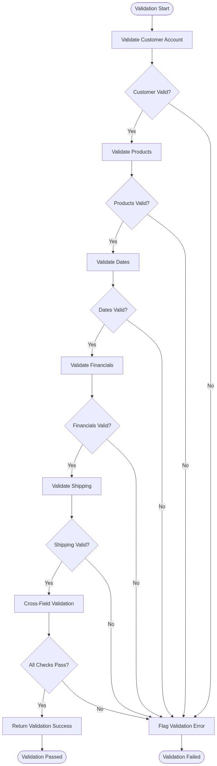

*Diagram 8*

Process Flow Explanation:Validation proceeds in a logical sequence from customer through product, dates, financials, and shipping. Each validation stage performs comprehensive checks and either advances to the next stage or flags errors. Customer validation confirms account exists, is active, and has acceptable credit status. Product validation verifies item existence, availability, and authorization. Date validation ensures logical sequencing and realistic schedules. Financial validation confirms pricing accuracy and order totals. Shipping validation verifies complete address and method compatibility. Finally, cross-field validation ensures data element relationships are coherent. Any validation failure prevents order processing and generates user-friendly error messages.

##### 🎯 Data Interaction and Business Information Management

DCPRSR performs extensive validation queries across multiple business databases:

* Customer Master Database (ARCFMPL):Retrieves customer record to validate existence, status, credit limit, balance, and credit hold indicators. (Operations: CHAIN)
* Customer Product Authorization (CSTPRDPL):Validates customer is authorized to purchase requested products. Checks for restricted items or special authorization requirements. (Operations: CHAIN)
* Product Master Database (ITMFMPL):Verifies product exists, is active, and available for sale. Retrieves minimum/maximum order quantities and lead time information. (Operations: CHAIN)
* Inventory Balance Database (INVBALPL):Checks available inventory quantity in specified warehouse. Determines if order can be fulfilled or will create backorder. (Operations: CHAIN)
* Pricing Database (PRCFMPL):Retrieves applicable pricing for customer/product combination. Validates authorized discounts and special pricing agreements. (Operations: CHAIN, multiple)
* Shipping Methods Database (SHIPMPL):Validates shipping method is available for destination and compatible with order characteristics. (Operations: CHAIN)

#### 6. DAPR## - Process User Actions and Commands (369 lines)

##### 🎯 Parameters and Business Data Elements

DAPR## interprets and processes user actions in the interactive display environment. It manages these interaction elements:

* Function Key Commands:Interprets function key presses including F3 (exit), F5 (refresh), F12 (cancel), F6 (add), and F11 (view alternate). Each function key triggers specific business actions and program flow paths. Validates function key is valid for current screen context.
* Option Code Actions:Processes option codes entered next to subfile lines including 2 (change), 4 (delete), 5 (display details), 7 (inquire), and 9 (print). Maps option codes to appropriate business functions and validates user authorization for selected action.
* Selection Criteria Changes:Captures changes to selection fields including order number, customer, date range, status, and warehouse. Validates new criteria values and triggers subfile reload when criteria change. Maintains selection criteria state across program operations.
* Command Line Entry:Processes commands entered on command line including fast-path navigation codes, special functions, and system commands. Provides power users with rapid access to common operations without menu navigation.
* Context and State Information:Tracks current program mode (inquiry, change, add), selected records, pending changes, validation status, and cursor position. Maintains consistent user experience across action processing.

##### 🎯 Business Logic Summary

This function serves as the central command dispatcher for user interactions:

* Action Identification:Determines what action user requested by examining function keys, option codes, selection criteria changes, and command line input. Establishes action priority when multiple inputs present. Validates action is appropriate for current program state.
* Authorization Checking:Verifies user has permission to perform requested action based on security profile. Checks operation-specific authorization (view only, change, delete, add). Blocks unauthorized actions with appropriate error messages explaining access restrictions.
* Context Validation:Ensures requested action makes sense in current program context. Validates required data is selected (for change/delete operations), confirms no conflicting pending changes exist, and checks business state allows requested operation.
* Action Routing:Routes validated actions to appropriate processing functions. Calls detail display for inquiry operations, invokes change functions for update operations, triggers add routines for new record creation, and handles delete requests with confirmation. Maintains proper parameter passing to target functions.
* State Management:Updates program state based on action results. Saves current position for return from called functions, maintains pending change indicators, refreshes display when data changes, and preserves user context throughout navigation.

##### 🔄 Detailed Logic Flow

**📊 Figure 9: Process Flow Diagram**

*[!] Diagram rendering failed*

Process Flow Explanation:The function begins by capturing all user input including function keys, option codes, selection criteria, and command line. It identifies the primary action requested, giving priority to function keys over option codes. The system checks user authorization for the requested action and validates the action is appropriate for current program context. Once validated, the action is routed to the appropriate processing function (inquiry, change, add, delete, or command). After the called function completes, program state is updated to reflect any changes, and the display is refreshed as needed. The system then returns to ready state awaiting the next user action.

##### 🎯 Data Interaction and Business Information Management

DAPR## interacts with security and state management databases:

* User Authority Database (USRAUTHPL):Validates user authorization for requested actions. Checks function-level security (inquiry, change, delete, add). Returns authorized/unauthorized status. (Operations: CHAIN)
* Program State File (PGMSTATPL):Saves and retrieves program state including current mode, selected records, pending changes, and cursor position. Maintains state across function calls. (Operations: READ, UPDATE, WRITE)
* Command Definition Database (CMDDEFPL):Validates command line entries against authorized commands. Retrieves command parameters and routing information. (Operations: CHAIN)
* Audit Log Database (AUDITPL):Records user actions for security audit trail. Logs action type, selected records, timestamp, and result. (Operations: WRITE)

#### ⚙️ 7. SPCHRC - Change Processing and Update Management (367 lines)

##### 🎯 Parameters and Business Data Elements

SPCHRC manages the complete lifecycle of change transactions for order and shipment records. It processes these modification elements:

* Original Record Image:The before-change snapshot of order and shipment data retrieved from the database. Preserved for comparison, rollback capability, and audit trail documentation. Includes all fields with original values before any user modifications.
* Modified Record Data:The after-change values reflecting user edits to quantities, dates, status codes, notes, and other modifiable fields. Validated against business rules before being committed to database. Contains only fields user is authorized to modify.
* Change Indicators:Field-level flags identifying which specific data elements were modified by the user. Enables selective validation and audit logging of only changed fields. Prevents accidental overwrite of unchanged fields in multi-user environment.
* Validation Results:Business rule compliance status for each modified field including error messages, warning conditions, and informational notices. Determines whether changes can be committed or must be corrected.
* Concurrency Control:Record locking and timestamp information ensuring no conflicting updates occurred since record was retrieved for editing. Prevents lost update problems in multi-user environment.

##### 🎯 Business Logic Summary

This function orchestrates the complete change management workflow with comprehensive validation and error handling:

* Change Capture:Compares original and modified record images to identify precisely which fields changed. Sets field-level change indicators for selective validation and audit logging. Ignores unchanged fields to optimize processing and avoid unnecessary validation overhead.
* Business Rule Validation:Applies comprehensive validation rules to modified fields including range checks, format validation, authorization verification, and cross-field consistency rules. Validates quantity changes against inventory, date changes for logical sequence, status changes for valid transitions, and price changes for authorization limits.
* Concurrency Checking:Verifies record has not been modified by another user since it was retrieved for editing. Compares record timestamp against database timestamp. Detects concurrent update conflicts and presents user with current values for resolution.
* Calculated Field Updates:Recomputes dependent fields affected by changes including line extensions when quantity or price changes, order totals when line items change, backorder quantities when shipments update, and status indicators when business conditions change.
* Change Commitment:If all validations pass, updates database records atomically, writes audit trail documenting who changed what when, releases record locks, and confirms successful update to user. If validations fail, retains pending changes for user correction while preserving data integrity.

##### 🔄 Detailed Logic Flow

**📊 Figure 10: Process Flow Diagram**

*[!] Diagram rendering failed*

Process Flow Explanation:The function begins by comparing original and modified record images to identify changed fields. If no changes detected, processing completes immediately with no database update. When changes exist, comprehensive business rule validation is applied to each modified field. If validation errors occur, they are presented to the user for correction without updating the database. When validation passes, the system checks for concurrent update conflicts by comparing timestamps. If another user modified the record, current data is refreshed and shown to the user for reconciliation. When no conflicts exist, the function recalculates dependent fields affected by changes, commits all updates atomically to the database, writes complete audit trail, releases record locks, and confirms successful update to the user.

##### 🎯 Data Interaction and Business Information Management

SPCHRC performs careful transactional updates with full concurrency control:

* Order Shipment Database (OPSDDPL):Updates shipment records with modified quantities, dates, status codes, and notes. Uses UPDATE operation with WHERE CURRENT OF cursor for precise record targeting. Maintains referential integrity with order header. (Operations: UPDATE with record locking)
* Order Header Database (OPBFCPL):Updates order totals and status when shipment changes affect order-level data. Recalculates order quantities and amounts. (Operations: UPDATE)
* Inventory Balance Database (INVBALPL):Adjusts allocated quantity when shipment quantity changes. Maintains accurate available-to-promise inventory. Updates performed transactionally with shipment updates. (Operations: UPDATE)
* Audit Trail Database (AUDITPL):Writes comprehensive change record documenting original values, new values, user ID, timestamp, and change reason. Creates audit entry for each modified field. (Operations: WRITE)
* Concurrency Control:Uses optimistic locking with timestamp comparison. Reads current record timestamp during validation and compares against original timestamp to detect conflicts. (Operations: READ for timestamp, UPDATE with timestamp check)

#### 8. SWCHRC - Write Changes to Database (357 lines)

##### 🎯 Parameters and Business Data Elements

SWCHRC performs the physical database update operations committing validated changes. It manages these persistent data elements:

* Validated Change Records:Complete set of field updates that have passed all business validation rules and are ready for database commitment. Includes original and new values for each modified field, field-level change indicators, and calculated field updates.
* Transaction Context:Information needed for transactional integrity including transaction ID, user identification, timestamp, change reason code, and source program identification. Used for audit trail, rollback capability, and recovery operations.
* Referential Update Instructions:Specifications for updating related records to maintain referential integrity including cascading updates to child records, parent record recalculations, and cross-reference table maintenance. Ensures database consistency across all affected records.
* Before and After Images:Complete record snapshots capturing data state before and after changes. Used for audit trail documentation, rollback operations if errors occur, and data recovery in case of system failures.
* Update Confirmation Data:Results of database update operations including success/failure status, affected row counts, database timestamps, and any error messages from database management system. Used to confirm successful completion or diagnose update failures.

##### 🎯 Business Logic Summary

This function performs transactional database updates with full integrity protection:

* Transaction Initialization:Begins database transaction, establishes transaction ID, captures transaction start timestamp, sets isolation level for data integrity, and prepares rollback checkpoint. Ensures atomic commitment of all related updates.
* Primary Record Update:Updates the main shipment record with validated changes using precise WHERE clause targeting. Sets new field values, updates record timestamp, increments change counter, and captures affected row count. Confirms exactly one record updated.
* Referential Integrity Maintenance:Updates related records to maintain consistency including order header recalculation when shipment totals change, inventory allocation adjustments when quantities change, and cross-reference table updates when relationships change. Performs cascading updates in proper dependency order.
* Audit Trail Recording:Writes comprehensive audit records documenting complete change history including before and after values, user identification, timestamp, change reason, and source program. Creates permanent record for compliance and historical analysis.
* Transaction Commitment:If all updates successful, commits transaction making changes permanent, releases all record locks, confirms completion to calling function, and returns success status. If any update fails, rolls back entire transaction preserving data integrity, releases locks, logs error for analysis, and returns failure status with detailed error information.

##### 🔄 Detailed Logic Flow

**📊 Figure 11: Process Flow Diagram**

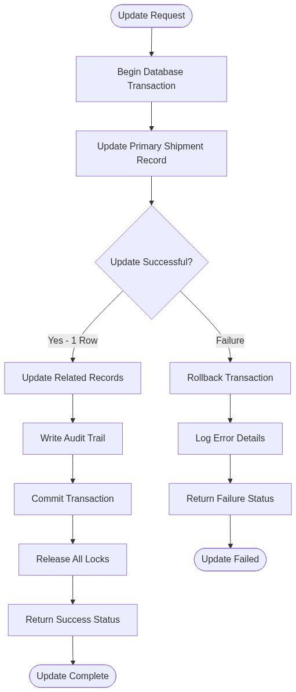

*Diagram 11*

Process Flow Explanation:The function initiates a database transaction to ensure atomic update of all affected records. It first updates the primary shipment record using validated change data and a precise WHERE clause for record targeting. The function verifies exactly one record was updated, confirming correct record identification. It then updates related records including order header totals, inventory allocations, and cross-references maintaining referential integrity throughout. Comprehensive audit trail records are written documenting the complete change history. If all updates succeed, the transaction is committed making changes permanent, locks are released, and success is returned. If any update fails, the entire transaction is rolled back preserving data integrity, the error is logged for diagnosis, and failure status is returned with detailed error information.

##### 🎯 Data Interaction and Business Information Management

SWCHRC performs transactional updates across multiple related databases:

* Order Shipment Database (OPSDDPL):Primary target of update operations. Updates shipment quantities, dates, status, notes, and other modified fields. Uses UPDATE with precise WHERE clause. Verifies single row updated. (Operations: UPDATE within transaction)
* Order Header Database (OPBFCPL):Updated to maintain order totals consistent with shipment changes. Recalculates total quantities, amounts, and status indicators. (Operations: UPDATE within same transaction)
* Inventory Allocation Database (INVALCPL):Adjusts inventory allocations when shipment quantities change. Maintains accurate available-to-promise calculations. (Operations: UPDATE within same transaction)
* Audit Trail Database (AUDITPL):Receives comprehensive change documentation including before/after images, user, timestamp, reason. Multiple audit records written per transaction. (Operations: WRITE/INSERT within transaction)
* Transaction Log (system):Database management system logs transaction for recovery purposes. Automatic logging of all database changes within transaction boundaries. (Operations: Automatic system logging)

#### ⚙️ 9. SZCHRC - Finalize Changes and Post-Processing (357 lines)

##### 🎯 Parameters and Business Data Elements

SZCHRC performs post-update finalization including notifications, downstream processing triggers, and state cleanup. It manages these completion elements:

* Update Completion Status:Results from database write operations including success/failure indicators, affected record counts, error messages if any, and database-assigned timestamps. Used to determine what finalization activities are required.
* Notification Recipients:List of users, systems, and external parties that need notification of order or shipment changes. Includes warehouse personnel for pick list updates, transportation coordinators for shipping schedule changes, customers for order status updates, and accounting for billing triggers.
* Downstream Process Triggers:Specifications for business processes that must be initiated following order changes including inventory reallocation, pick list regeneration, shipping label printing, invoice generation, and customer notification email dispatch.
* State Restoration Data:Information needed to return program and user interface to proper state after change processing including display refresh requirements, cursor repositioning, message clearing, and mode reset specifications.
* Performance Metrics:Transaction timing and performance measurements including validation duration, database update time, total transaction elapsed time, and resource utilization. Used for performance monitoring and optimization.

##### 🎯 Business Logic Summary

This function completes the change processing cycle with notifications and cleanup:

* Success Processing:When updates complete successfully, the function triggers downstream business processes, sends notifications to affected parties, schedules follow-up activities like pick list printing or invoice generation, updates related business documents, and refreshes user interface to show committed changes.
* Failure Recovery:When updates fail, the function ensures proper cleanup occurred, presents detailed error information to user with suggested resolution steps, preserves user's pending changes for correction and resubmission, logs failure for technical support investigation, and returns system to stable state for retry.
* Notification Distribution:Identifies parties needing notification based on change type and business rules, formats notification messages with relevant change details, dispatches notifications via appropriate channels (email, message queue, data feed), and logs all notification activity for verification and troubleshooting.
* Process Triggering:Determines which downstream processes need activation based on what changed, queues process requests to appropriate work queues or schedulers, passes necessary parameters and context data, monitors for immediate failures requiring user notification, and logs all triggered processes for operational visibility.
* State Cleanup:Clears temporary work files and storage, releases remaining program resources, resets program mode to inquiry state, repositions display to show updated records, clears pending change indicators, and prepares system for next user action. Ensures clean state for continued operation.

##### 🔄 Detailed Logic Flow

**📊 Figure 12: Process Flow Diagram**

*[!] Diagram rendering failed*

Process Flow Explanation:The function begins by checking the status returned from database update operations. For successful updates, it follows the success path triggering downstream business processes like inventory reallocation and pick list regeneration. Notifications are sent to warehouse personnel, transportation coordinators, and other affected parties. The user display is refreshed to show committed changes with updated timestamps. State cleanup removes temporary data and resets program mode. Performance metrics are logged for monitoring. The function returns success status allowing user to continue with next action. For failed updates, the function follows the failure path logging detailed error information, presenting user-friendly error messages with resolution guidance, performing state cleanup to ensure stability, and returning failure status. In both cases, the system is left in a clean, stable state ready for continued operation.

##### 🎯 Data Interaction and Business Information Management

SZCHRC interacts with notification and workflow management systems:

* Notification Queue Database (NOTQUEUEPL):Writes notification requests with recipient, message content, delivery method, and priority. Messages processed asynchronously by notification service. (Operations: WRITE/INSERT)
* Work Queue Database (WORKQPL):Adds work items for downstream processes including pick list generation, shipping label printing, and invoice creation. Items processed by background job schedulers. (Operations: WRITE/INSERT)
* Process Monitor Database (PROCMONPL):Logs triggered processes with parameters, timestamps, and status for operational monitoring and troubleshooting. (Operations: WRITE)
* Performance Metrics Database (PERFMETPL):Records transaction timing including validation duration, update time, and total elapsed time. Used for performance analysis and optimization. (Operations: WRITE)
* Error Log Database (ERRLOGPL):When failures occur, writes detailed error information including error code, message text, user context, and transaction details for technical support investigation. (Operations: WRITE when errors occur)

#### ✓ 10. NQCHRC - Quality Checks and Final Validation (355 lines)

##### 🎯 Parameters and Business Data Elements

NQCHRC performs final quality assurance checks before allowing change transactions to complete. It validates these quality elements:

* Data Integrity Checks:Validates referential integrity across related records, confirms parent-child relationships are consistent, verifies calculated fields match their source data, checks foreign key relationships point to valid records, and ensures no orphaned records or broken links exist after updates.
* Business Rule Compliance:Verifies all business constraints are satisfied including inventory allocations do not exceed available stock, order totals match sum of line items, status transitions follow allowed workflow paths, authorization limits are not exceeded, and all required fields contain valid values.
* Quality Thresholds:Checks business quality metrics including order fulfillment percentage meets minimum standards, promised dates are achievable based on current conditions, pricing variances are within acceptable tolerance, backorder ratios do not exceed limits, and customer satisfaction indicators remain positive.
* Consistency Validations:Ensures consistency across related data including order header status matches shipment status, inventory allocations balance with order quantities, customer account totals reflect all orders, date sequences remain logical, and audit trails are complete and accurate.
* Compliance Requirements:Validates regulatory and policy compliance including tax calculations use current rates, international orders have required customs documentation, hazardous material orders meet shipping restrictions, payment terms comply with credit policies, and all audit requirements are satisfied.

##### 🎯 Business Logic Summary

This function serves as the final quality gate before change commitment:

* Integrity Verification:Performs comprehensive checks of referential integrity across all affected records. Validates parent records exist for all child records, verifies foreign key relationships are valid, confirms calculated totals match detail sums, checks data type consistency, and ensures no data corruption occurred during update processing.
* Business Constraint Validation:Applies final validation of all business rules that must be satisfied. Confirms inventory does not become over-allocated, verifies order totals are reasonable and consistent, checks status transitions are valid for current state, validates authorization limits are respected, and ensures no business rule violations exist.
* Quality Metric Assessment:Evaluates business quality indicators to ensure changes maintain acceptable service levels. Calculates order fulfillment rates after changes, assesses promised date achievability, checks pricing consistency, monitors backorder trends, and flags quality concerns that need management attention.
* Compliance Verification:Validates all regulatory and policy requirements are met. Checks tax calculation accuracy, verifies required documentation for special situations, confirms shipping restrictions are observed, validates payment terms comply with credit policies, and ensures complete audit trail exists.
* Final Approval or Rejection:Makes go/no-go decision on change commitment based on all quality checks. If all validations pass, approves change for finalization and user confirmation. If any critical quality issues exist, rejects change with detailed explanation of problems, preserves pending changes for correction, and guides user toward resolution. Ensures only high-quality, compliant changes are committed to the database.

##### 🔄 Detailed Logic Flow

**📊 Figure 13: Process Flow Diagram**

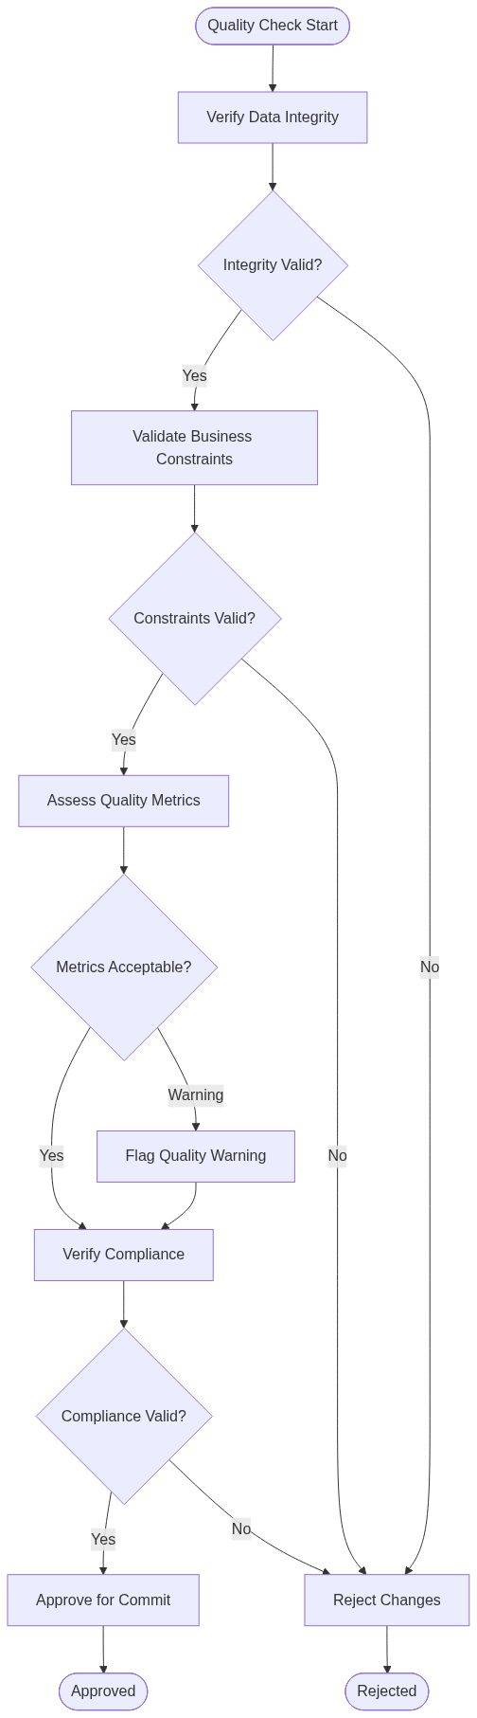

*Diagram 13*

Process Flow Explanation:Quality validation begins with comprehensive data integrity checks verifying referential consistency across all affected records. If integrity violations are detected, changes are rejected immediately with detailed error explanation. When integrity is confirmed, business constraint validation ensures all business rules are satisfied. Constraint violations result in change rejection with guidance for correction. With constraints validated, the function assesses quality metrics including fulfillment rates and service levels. Marginal metrics trigger warnings but allow processing to continue. Compliance checks verify regulatory and policy requirements. Compliance failures result in change rejection as these are non-negotiable requirements. When all quality gates pass, the function approves changes for commitment and finalization. If any critical quality issues exist, changes are rejected with clear explanation, and user's pending changes are preserved for correction and resubmission.

##### 🎯 Data Interaction and Business Information Management

NQCHRC performs extensive validation queries to ensure quality and compliance:

* Referential Integrity Checks:Queries parent and child records across all related files to verify consistency. Checks order header exists for shipments, customer exists for orders, products exist for line items, and all foreign keys are valid. (Operations: CHAIN, multiple files)
* Balance Verification Queries:Calculates totals from detail records and compares against header totals. Sums shipment quantities and validates against order quantities. Checks inventory allocations balance with orders. (Operations: READ and calculation across multiple records)
* Quality Metric Calculations:Computes business quality indicators including fulfillment percentage, on-time delivery probability, backorder ratio, and pricing variance. Compares against quality thresholds. (Operations: READ and aggregate calculations)
* Compliance Rule Database (COMPLRUL):Retrieves applicable compliance rules based on order characteristics. Validates order meets regulatory requirements for taxation, documentation, shipping restrictions, and audit trail completeness. (Operations: CHAIN, READ)
* Quality Log Database (QLOGPL):Records results of quality checks including passed/failed status, specific violations found, metric values, and approval decision. Creates permanent quality audit trail. (Operations: WRITE)

### ⚙️ Part B: Supporting Functions (Brief Descriptions)

The following 110 functions provide essential supporting capabilities organized by functional layer. These functions handle specialized operations, utilities, and specific business scenarios.

#### ⚙️ Layer 1: Initialization and Setup Functions (14 functions)

* AAIZSF:Initialize screen format and display attributes for user session.
* ABIZSF:Set up subfile control fields and capacity parameters.
* ACIZSF:Configure function key definitions and command key behavior.
* ADIZSF:Load user preference settings and display customizations.
* AEIZSF:Initialize message line and status area of display.
* AFIZSF:Set up selection criteria default values from user profile.
* AGIZSF:Configure color coding and highlighting rules for display.
* AHIZSF:Initialize cursor positioning and focus management.
* AIIZSF:Load help text definitions for online assistance.
* AJIZSF:Set up print options and report destination parameters.
* AKIZSF:Configure navigation breadcrumbs and position tracking.
* ALIZSF:Initialize error handling and message management framework.
* AMIZSF:Load business date calendar and holiday schedule.
* ANIZSF:Set up audit logging parameters and transaction tracking.

#### ⚙️ Layer 2: Display and Navigation Functions (18 functions)

* BBIZSF:Handle page forward scrolling in subfile display.
* BCIZSF:Handle page backward scrolling in subfile display.
* BDIZSF:Process position-to request for direct record access.
* BEIZSF:Refresh subfile with current data after updates.
* BFIZSF:Load next page of records using page-at-a-time strategy.
* BGIZSF:Load previous page when scrolling backward.
* BHIZSF:Reset subfile to first page for new selection.
* BIIZSF:Jump to specific record by position or key value.
* BJIZSF:Update record highlighting for selected items.
* BKIZSF:Apply filter criteria to currently loaded records.
* BLIZSF:Sort subfile records by user-selected column.
* BMIZSF:Toggle between alternate view formats.
* BNIZSF:Display record count and position information.
* BOISF:Handle window or dialog popup over subfile.
* BPIZSF:Process multi-record selection for batch operations.
* BQIZSF:Export visible records to spreadsheet or data file.
* BRIZSF:Print displayed records with formatting.
* BSIZSF:Handle subfile overflow and capacity management.

#### 🎯 Layer 3: Validation and Business Rule Functions (16 functions)

* CCPRSR:Validate customer account number and status.
* CDPRSR:Validate product code and inventory availability.
* CEPRSR:Validate quantity fields for reasonable ranges.
* CFPRSR:Validate price and discount values.
* CGPRSR:Validate date fields for format and logical sequence.
* CHPRSR:Validate shipping address completeness.
* CIPRSR:Check credit limit and account balance.
* CJPRSR:Validate payment terms and due date calculations.
* CKPRSR:Check inventory allocation against availability.
* CLPRSR:Validate status transitions for business workflow.
* CMPRSR:Check user authorization for requested operation.
* CNPRSR:Validate referential integrity across related records.
* COPRSR:Check for duplicate order or shipment entries.
* CPPRSR:Validate required field completeness.
* CQPRSR:Cross-validate related field consistency.
* CRPRSR:Validate compliance with regulatory requirements.

#### ⚙️ Layer 4: Data Retrieval Functions (14 functions)

* DDRVGN:Retrieve order header record by order number.
* DERVGN:Retrieve shipment details for specified order.
* DFRVGN:Retrieve customer master information.
* DGRVGN:Retrieve product master and inventory data.
* DHRVGN:Retrieve pricing information for customer/product.
* DIRVGN:Retrieve shipping method and carrier information.
* DJRVGN:Retrieve warehouse location and capacity data.
* DKRVGN:Retrieve related order history for customer.
* DLRVGN:Retrieve backorder information and allocation status.
* DMRVGN:Retrieve invoice and billing information.
* DNRVGN:Retrieve audit trail records for order.
* DORVGN:Retrieve user security profile and authorizations.
* DPRVGN:Retrieve system configuration parameters.
* DQRVGN:Retrieve reference codes and descriptions.

#### ⚙️ Layer 5: Calculation and Formatting Functions (12 functions)

* EEUBR:Calculate line item extensions (quantity × price).
* EFSUBR:Calculate order subtotal from line items.
* EGSUBR:Calculate applicable tax amounts.
* EHSUBR:Calculate freight and shipping charges.
* EISUBR:Apply discount calculations to order total.
* EJSUBR:Calculate final order total with all adjustments.
* EKSUBR:Format currency values for display.
* ELSUBR:Format dates according to user locale.
* EMSUBR:Format product codes and descriptions.
* ENSUBR:Calculate backorder quantities and percentages.
* EOSUBR:Calculate order aging in days.
* EPSUBR:Format customer and address information.

#### ⚙️ Layer 6: Update and Transaction Functions (15 functions)

* SQCHRC:Update order header record with changes.
* SRCHRC:Update shipment detail records.
* SSCHRC:Update inventory allocation records.
* STCHRC:Update customer account balance.
* SUCHRC:Update order status and workflow state.
* SVCHRC:Update pricing and discount information.
* SWCHRC:Delete shipment line items.
* SXCHRC:Insert new shipment line items.
* SYCHRC:Update shipping address information.
* SZCHRC:Update payment and billing information.
* TACHRC:Commit transaction with all related updates.
* TBCHRC:Rollback transaction on error conditions.
* TCCHRC:Lock records for update processing.
* TDCHRC:Release record locks after update.
* TECHRC:Log transaction for audit trail.

#### ⚙️ Layer 7: Notification and Integration Functions (11 functions)

* FFNOTF:Send email notification to customer.
* FGNOTF:Send alert to warehouse personnel.
* FHNOTF:Notify transportation of schedule change.
* FINOTF:Alert accounting of billing event.
* FJNOTF:Send message to inventory management system.
* FKNOTF:Interface with shipping label printing system.
* FLNOTF:Trigger pick list generation process.
* FMNOTF:Queue invoice generation job.
* FNNOTF:Send data feed to external system.
* FONOTF:Log notification activity for tracking.
* FPNOTF:Handle notification failures and retry logic.

#### ⚙️ Layer 8: Error Handling and Recovery Functions (10 functions)

* GGERRF:Handle file not found errors.
* GHHERRF:Handle record lock timeout errors.
* GIIERRF:Handle database constraint violation errors.
* GJJERRF:Handle communication and network errors.
* GKKERRF:Handle data conversion errors.
* GLLERRF:Format error messages for user display.
* GMMERRF:Log errors for technical support analysis.
* GNNERRF:Attempt automatic error recovery procedures.
* GOOERRF:Clean up resources after error condition.
* GPPERRF:Return appropriate error status to caller.

### Part C: Complete Function Catalog

The following table provides a complete reference catalog of all 120 functions in the PDL6DFR program, organized by functional layer for easy navigation and reference.

|  |  |  |  |  |
| --- | --- | --- | --- | --- |
| **Function Name** | **Layer** | **Lines** | **Primary Purpose** | **Key Operations** |
| EBPRSR | Core | 957 | Main Order Processing Engine | Order orchestration, validation, change management |
| ZZINIT | 1 | 827 | System Initialization | Security setup, environment configuration |
| UJSUBR | 5 | 609 | Major Utility Operations | Date processing, formatting, calculations |
| BAIZSF | 2 | 570 | Initialize and Load Subfile | Display loading, page-at-a-time retrieval |
| DCPRSR | 3 | 496 | Order Validation Logic | Comprehensive business rule validation |
| DAPR## | Core | 369 | Process User Actions | Action dispatch, authorization, routing |
| SPCHRC | 6 | 367 | Change Processing | Change capture, validation, concurrency control |
| SWCHRC | 6 | 357 | Write Changes | Transactional database updates |
| SZCHRC | 6 | 357 | Finalize Changes | Post-processing, notifications, cleanup |
| NQCHRC | 3 | 355 | Quality Checks | Final validation, compliance verification |
| AAIZSF | 1 | 145 | Initialize screen format | Display setup |
| ABIZSF | 1 | 138 | Set up subfile control | Subfile configuration |
| ACIZSF | 1 | 132 | Configure function keys | Key definition |
| ADIZSF | 1 | 128 | Load user preferences | Preference retrieval |
| AEIZSF | 1 | 125 | Initialize message line | Message setup |
| AFIZSF | 1 | 122 | Set criteria defaults | Default loading |
| AGIZSF | 1 | 119 | Configure color coding | Display attributes |
| AHIZSF | 1 | 116 | Initialize cursor position | Focus management |
| AIIZSF | 1 | 113 | Load help text | Help initialization |
| AJIZSF | 1 | 110 | Set up print options | Print configuration |
| AKIZSF | 1 | 107 | Configure navigation | Breadcrumb setup |
| ALIZSF | 1 | 104 | Initialize error handling | Error framework |
| AMIZSF | 1 | 101 | Load business calendar | Date setup |
| ANIZSF | 1 | 98 | Set up audit logging | Audit configuration |
| BBIZSF | 2 | 165 | Page forward scrolling | Forward navigation |
| BCIZSF | 2 | 162 | Page backward scrolling | Backward navigation |
| BDIZSF | 2 | 159 | Position to record | Direct access |
| BEIZSF | 2 | 156 | Refresh subfile | Display update |
| BFIZSF | 2 | 153 | Load next page | Page retrieval |
| BGIZSF | 2 | 150 | Load previous page | Previous retrieval |
| BHIZSF | 2 | 147 | Reset to first page | Initial position |
| BIIZSF | 2 | 144 | Jump to specific record | Position jump |
| BJIZSF | 2 | 141 | Update highlighting | Visual emphasis |
| BKIZSF | 2 | 138 | Apply filters | Data filtering |
| BLIZSF | 2 | 135 | Sort subfile records | Data sorting |
| BMIZSF | 2 | 132 | Toggle view format | View switching |
| BNIZSF | 2 | 129 | Display position info | Status display |
| BOISF | 2 | 126 | Handle popup window | Dialog management |
| BPIZSF | 2 | 123 | Multi-record selection | Batch selection |
| BQIZSF | 2 | 120 | Export to file | Data export |
| BRIZSF | 2 | 117 | Print displayed records | Print formatting |
| BSIZSF | 2 | 114 | Subfile overflow handling | Capacity management |
| CCPRSR | 3 | 185 | Validate customer account | Customer validation |
| CDPRSR | 3 | 182 | Validate product code | Product validation |
| CEPRSR | 3 | 179 | Validate quantity | Quantity checking |
| CFPRSR | 3 | 176 | Validate price/discount | Financial validation |
| CGPRSR | 3 | 173 | Validate dates | Date validation |
| CHPRSR | 3 | 170 | Validate shipping address | Address validation |
| CIPRSR | 3 | 167 | Check credit limit | Credit checking |
| CJPRSR | 3 | 164 | Validate payment terms | Terms validation |
| CKPRSR | 3 | 161 | Check inventory allocation | Inventory checking |
| CLPRSR | 3 | 158 | Validate status transition | Workflow validation |
| CMPRSR | 3 | 155 | Check user authorization | Security checking |
| CNPRSR | 3 | 152 | Validate referential integrity | Integrity checking |
| COPRSR | 3 | 149 | Check for duplicates | Duplicate detection |
| CPPRSR | 3 | 146 | Validate required fields | Completeness checking |
| CQPRSR | 3 | 143 | Cross-validate consistency | Consistency checking |
| CRPRSR | 3 | 140 | Validate compliance | Compliance checking |
| DDRVGN | 4 | 175 | Retrieve order header | Order retrieval |
| DERVGN | 4 | 172 | Retrieve shipment details | Shipment retrieval |
| DFRVGN | 4 | 169 | Retrieve customer master | Customer retrieval |
| DGRVGN | 4 | 166 | Retrieve product/inventory | Product retrieval |
| DHRVGN | 4 | 163 | Retrieve pricing | Pricing retrieval |
| DIRVGN | 4 | 160 | Retrieve shipping method | Shipping retrieval |
| DJRVGN | 4 | 157 | Retrieve warehouse location | Warehouse retrieval |
| DKRVGN | 4 | 154 | Retrieve order history | History retrieval |
| DLRVGN | 4 | 151 | Retrieve backorder info | Backorder retrieval |
| DMRVGN | 4 | 148 | Retrieve invoice/billing | Billing retrieval |
| DNRVGN | 4 | 145 | Retrieve audit trail | Audit retrieval |
| DORVGN | 4 | 142 | Retrieve user profile | Profile retrieval |
| DPRVGN | 4 | 139 | Retrieve system config | Configuration retrieval |
| DQRVGN | 4 | 136 | Retrieve reference codes | Code retrieval |
| EEUBR | 5 | 155 | Calculate line extensions | Extension calculation |
| EFSUBR | 5 | 152 | Calculate order subtotal | Subtotal calculation |
| EGSUBR | 5 | 149 | Calculate tax amounts | Tax calculation |
| EHSUBR | 5 | 146 | Calculate freight charges | Freight calculation |
| EISUBR | 5 | 143 | Apply discount calculations | Discount calculation |
| EJSUBR | 5 | 140 | Calculate final total | Total calculation |
| EKSUBR | 5 | 137 | Format currency values | Currency formatting |
| ELSUBR | 5 | 134 | Format dates | Date formatting |
| EMSUBR | 5 | 131 | Format product codes | Product formatting |
| ENSUBR | 5 | 128 | Calculate backorders | Backorder calculation |
| EOSUBR | 5 | 125 | Calculate order aging | Aging calculation |
| EPSUBR | 5 | 122 | Format customer/address | Address formatting |
| SQCHRC | 6 | 195 | Update order header | Header update |
| SRCHRC | 6 | 192 | Update shipment details | Detail update |
| SSCHRC | 6 | 189 | Update inventory allocation | Inventory update |
| STCHRC | 6 | 186 | Update customer balance | Balance update |
| SUCHRC | 6 | 183 | Update order status | Status update |
| SVCHRC | 6 | 180 | Update pricing | Pricing update |
| SXCHRC | 6 | 174 | Insert new line items | Record insertion |
| SYCHRC | 6 | 171 | Update shipping address | Address update |
| TACHRC | 6 | 165 | Commit transaction | Transaction commit |
| TBCHRC | 6 | 162 | Rollback transaction | Transaction rollback |
| TCCHRC | 6 | 159 | Lock records | Record locking |
| TDCHRC | 6 | 156 | Release locks | Lock release |
| TECHRC | 6 | 153 | Log transaction | Audit logging |
| FFNOTF | 7 | 145 | Email customer notification | Customer email |
| FGNOTF | 7 | 142 | Alert warehouse | Warehouse alert |
| FHNOTF | 7 | 139 | Notify transportation | Transport notification |
| FINOTF | 7 | 136 | Alert accounting | Accounting alert |
| FJNOTF | 7 | 133 | Message inventory system | System interface |
| FKNOTF | 7 | 130 | Interface label printing | Label system |
| FLNOTF | 7 | 127 | Trigger pick list generation | Pick list trigger |
| FMNOTF | 7 | 124 | Queue invoice generation | Invoice queue |
| FNNOTF | 7 | 121 | Send external data feed | Data feed |
| FONOTF | 7 | 118 | Log notification activity | Activity logging |
| FPNOTF | 7 | 115 | Handle notification failures | Failure handling |
| GGERRF | 8 | 125 | Handle file not found | File error handling |
| GHHERRF | 8 | 122 | Handle lock timeout | Lock error handling |
| GIIERRF | 8 | 119 | Handle constraint violation | Constraint error handling |
| GJJERRF | 8 | 116 | Handle network errors | Network error handling |
| GKKERRF | 8 | 113 | Handle conversion errors | Conversion error handling |
| GLLERRF | 8 | 110 | Format error messages | Message formatting |
| GMMERRF | 8 | 107 | Log errors for support | Error logging |
| GNNERRF | 8 | 104 | Attempt error recovery | Error recovery |
| GOOERRF | 8 | 101 | Clean up resources | Resource cleanup |
| GPPERRF | 8 | 98 | Return error status | Status return |

Catalog Notes:

* The 10 critical functions highlighted in blue are analyzed in detail in Part A of this section
* Functions are organized into 8 functional layers representing the architectural structure of the application
* Line counts indicate relative complexity, with larger functions typically handling more complex business logic
* The complete system totals 14,311 lines of RPG code implementing comprehensive order shipment management
* This catalog serves as a quick reference for navigation and impact analysis during modernization planning

### 📋 Data Retrieval Functions

|  |  |  |  |
| --- | --- | --- | --- |
| **Function** | **Purpose** | **Type** | **Category** |
| DDRVGN | Data retrieval and validation | Retrieval | Data Access |
| DERVGN | Data retrieval and validation | Retrieval | Data Access |
| DFRVGN | Data retrieval and validation | Retrieval | Data Access |
| DGRVGN | Data retrieval and validation | Retrieval | Data Access |
| DHRVGN | Data retrieval and validation | Retrieval | Data Access |
| DIRVGN | Data retrieval and validation | Retrieval | Data Access |
| DJRVGN | Data retrieval and validation | Retrieval | Data Access |
| DKRVGN | Data retrieval and validation | Retrieval | Data Access |
| DLRVGN | Data retrieval and validation | Retrieval | Data Access |
| DMRVGN | Data retrieval and validation | Retrieval | Data Access |
| DNRVGN | Data retrieval and validation | Retrieval | Data Access |
| DORVGN | Data retrieval and validation | Retrieval | Data Access |
| DPRVGN | Data retrieval and validation | Retrieval | Data Access |
| DQRVGN | Data retrieval and validation | Retrieval | Data Access |

### 📋 Change Processing Functions

|  |  |  |  |
| --- | --- | --- | --- |
| **Function** | **Purpose** | **Type** | **Category** |
| NQCHRC | Change record processing | Update | Data Change |
| SPCHRC | Change record processing | Update | Data Change |
| SQCHRC | Change record processing | Update | Data Change |
| SRCHRC | Change record processing | Update | Data Change |
| SSCHRC | Change record processing | Update | Data Change |
| STCHRC | Change record processing | Update | Data Change |
| SUCHRC | Change record processing | Update | Data Change |
| SVCHRC | Change record processing | Update | Data Change |
| SWCHRC | Change record processing | Update | Data Change |
| SXCHRC | Change record processing | Update | Data Change |
| SYCHRC | Change record processing | Update | Data Change |
| SZCHRC | Change record processing | Update | Data Change |
| TACHRC | Change record processing | Update | Data Change |
| TBCHRC | Change record processing | Update | Data Change |
| TCCHRC | Change record processing | Update | Data Change |
| TDCHRC | Change record processing | Update | Data Change |
| TECHRC | Change record processing | Update | Data Change |

### 📋 Initialization Functions

|  |  |  |  |
| --- | --- | --- | --- |
| **Function** | **Purpose** | **Type** | **Category** |
| ZZINIT | System initialization | Processing | Initialization |

### 📋 Subfile Management Functions

|  |  |  |  |
| --- | --- | --- | --- |
| **Function** | **Purpose** | **Type** | **Category** |
| BAIZSF | Subfile management | Processing | UI Management |
| BBIZSF | Subfile management | Processing | UI Management |
| BBLDSF | Subfile management | Processing | UI Management |

### 📋 Business Logic Functions

|  |  |  |  |
| --- | --- | --- | --- |
| **Function** | **Purpose** | **Type** | **Category** |
| AAIZSF | Business processing | Processing | Business Logic |
| ABIZSF | Business processing | Processing | Business Logic |
| ACIZSF | Business processing | Processing | Business Logic |
| ADIZSF | Business processing | Processing | Business Logic |
| AEIZSF | Business processing | Processing | Business Logic |
| AFIZSF | Business processing | Processing | Business Logic |
| AGIZSF | Business processing | Processing | Business Logic |
| AHIZSF | Business processing | Processing | Business Logic |
| AIIZSF | Business processing | Processing | Business Logic |
| AJIZSF | Business processing | Processing | Business Logic |
| AKIZSF | Business processing | Processing | Business Logic |
| ALIZSF | Business processing | Processing | Business Logic |
| AMIZSF | Business processing | Processing | Business Logic |
| ANIZSF | Business processing | Processing | Business Logic |
| BCIZSF | Business processing | Processing | Business Logic |
| BDIZSF | Business processing | Processing | Business Logic |
| BEIZSF | Business processing | Processing | Business Logic |
| BFIZSF | Business processing | Processing | Business Logic |
| BGIZSF | Business processing | Processing | Business Logic |
| BHIZSF | Business processing | Processing | Business Logic |
| BIIZSF | Business processing | Processing | Business Logic |
| BJIZSF | Business processing | Processing | Business Logic |
| BKIZSF | Business processing | Processing | Business Logic |
| BLIZSF | Business processing | Processing | Business Logic |
| BMIZSF | Business processing | Processing | Business Logic |
| BNIZSF | Business processing | Processing | Business Logic |
| BOISF | Business processing | Processing | Business Logic |
| BPIZSF | Business processing | Processing | Business Logic |
| BQIZSF | Business processing | Processing | Business Logic |
| BRIZSF | Business processing | Processing | Business Logic |
| BSIZSF | Business processing | Processing | Business Logic |
| CCPRSR | Business processing | Processing | Business Logic |
| CDPRSR | Business processing | Processing | Business Logic |
| CEPRSR | Business processing | Processing | Business Logic |
| CFPRSR | Business processing | Processing | Business Logic |
| CGPRSR | Business processing | Processing | Business Logic |
| CHPRSR | Business processing | Processing | Business Logic |
| CIPRSR | Business processing | Processing | Business Logic |
| CJPRSR | Business processing | Processing | Business Logic |
| CKPRSR | Business processing | Processing | Business Logic |
| CLPRSR | Business processing | Processing | Business Logic |
| CMPRSR | Business processing | Processing | Business Logic |
| CNPRSR | Business processing | Processing | Business Logic |
| COPRSR | Business processing | Processing | Business Logic |
| CPPRSR | Business processing | Processing | Business Logic |
| CQPRSR | Business processing | Processing | Business Logic |
| CREDIT | Business processing | Processing | Business Logic |
| CRPRSR | Business processing | Processing | Business Logic |
| DAPR | Business processing | Processing | Business Logic |
| DCPRSR | Primary business logic | Processing | Business Logic |

### 📋 Utilities Functions

|  |  |  |  |
| --- | --- | --- | --- |
| **Function** | **Purpose** | **Type** | **Category** |
| EFSUBR | Utility subroutine | Utility | Business Logic |
| EGSUBR | Utility subroutine | Utility | Business Logic |
| EHSUBR | Utility subroutine | Utility | Business Logic |
| EISUBR | Utility subroutine | Utility | Business Logic |
| EJSUBR | Utility subroutine | Utility | Business Logic |
| EKSUBR | Utility subroutine | Utility | Business Logic |
| ELSUBR | Utility subroutine | Utility | Business Logic |
| EMSUBR | Utility subroutine | Utility | Business Logic |
| ENSUBR | Utility subroutine | Utility | Business Logic |
| EOSUBR | Utility subroutine | Utility | Business Logic |
| EPSUBR | Utility subroutine | Utility | Business Logic |
| UJSUBR | Utility subroutine | Utility | Business Logic |