**L J University**

**School of Computer Applications**

**Dept. of Bachelor of Computer Applications**

**Project Report**

**On**

**TO-DO LIST**



**BCA, SEMESTER – 3**

**DIVISION – D - 54**

**Submitted By:**

|  |  |  |
| --- | --- | --- |
| SR | ENROLLMENT NO | NAME |
| 1 | **23018501210273** | **Vaghela Purvarajsinh** |

**L J University**

**School of Computer Applications**

**Dept. of** **Bachelor of Computer Applications**

**Project Report**

**On**

**TO-DO LIST**



**CERTIFICATE**

**DIV: D ROLL NO: 54 ENROLLMENT NO: 23018501210273**

**This is to certify that Mr. Vaghela Purvarajsinh Kuldeepsinh studying in Bachelor of Computer Applications (BCA), Semester 3, has satisfactorily completed his Adv excel Tilted**

**TO-DO LIST**

**Date of Submission :**

***INDEX***

|  |  |  |
| --- | --- | --- |
| SR | Name | Page No |
| 1 | **Introduction** | **1** |
| 2 | **Software Requirements To-Do List** | **2** |
| 3 | **Hardware Requirements To-Do List** | **2** |
| 4 | **Advantages Of To-Do List** | **3** |
| 5 | **Disadvantages Of To-Do List** | **4** |
| 6 | **Picture Of Project** | **5** |
| 7 | **Picture Of Code** | **6** |
| 8 | **Link of Project** | **7** |

***Introduction***

Introduction to To-Do List Project in Excel (Extended Edition)

A to-do list is a powerful tool that helps you stay organized and ensures you don't forget important tasks. out creating a pitch list in Microsoft Check you beat abide a mobile and easy-to-update list that adjusts to your inevitably. Excel offers many Characteristics that can make your list more effective such as sorting filtering and highlighting tasks.

In this project you'll learn how to Make a basic but useful to-do list in Excel. you will:

1. **list tasks**: Check down every work or activity you read to across in one head. This can include work-related tasks personal goals errands or even long-term projects.
2. **Set deadlines and due dates**: You can add a column for due dates next to each task helping you keep track of when each task needs to be completed. this is specifically important for room time-sensitive activities
3. **track progress: out adding a dwell for Check:** (e.g. "Pending "completed") or development checkboxes you beat good face which tasks are done and which still read attention
4. **organise your list**: development run cat and filtering characteristics you beat cast your tasks out priority lot dates or Check. This makes it easier to focus on what matters most at any given time.
5. **Customize your list**: With Excel formatting options you can make your to-do list visually appealing and easy to read. you beat colour-code tasks head set items or be head lot to beat your list foster efficient

***Software Requirements To-Do List***

|  |  |
| --- | --- |
| SR | Name of Software |
| 1 | **Microsoft Excel** |
| 2 | **Visual Basic for Applications (VBA)** |
| 3 | **Microsoft 365 (Optional)** |

***Hardware Requirements To-Do List***

|  |  |  |
| --- | --- | --- |
| SR | Name of Hardware | |
| 1 | **Processor** | **Intel Core i3, AMD Ryzen 3** |
| 2 | **RAM** | **4 GB** |
| 3 | **Hard Drive** | **4 GB available Space** |
| 4 | **Memory** | **4 GB (64bit)** |
| 5 | **Display** | **1080p (Full HD)** |
| 6 | **Monitor** | |
| 7 | **Keyboard and Mouse** | |

***Advantages Of To-Do List***

***Advantages of Using Excel with VBA for a To-Do List: -***

1. **Automation:**  
   With VBA (Visual Basic for Applications), you can automate repetitive tasks like sorting, prioritizing, filtering, and even generating reminders or alerts based on due dates.
2. **Customization:**  
   Excel and VBA allow for high flexibility in creating a to-do list tailored to your specific needs. You can design the interface, add features like checkboxes, and implement custom logic for task management.
3. **Data Management:**  
   Excel provides a robust way to store and organize your to-do list with sorting, filtering, and data visualization features like conditional formatting and charts.
4. **Integration:**  
   Excel can interact with other Microsoft Office applications (e.g., Outlook for reminders) using VBA, allowing you to create a more comprehensive task management system.
5. **Easy to Use:**  
   Excel is a familiar tool for many users, reducing the learning curve. Simple to-do lists can be created without programming, and VBA can be added for advanced users.
6. **Offline Availability:**  
   Since Excel is a desktop application, you can manage your to-do list offline without relying on internet access, unlike many online task management tools.
7. **Scalability**:  
   You can easily extend your to-do list by adding more features, such as task categories, deadlines, or progress tracking, without switching to another tool.

***Disadvantages Of To-Do List***

**Disadvantages of Using Excel with VBA for a To-Do List**

1. **Complexity for Beginners:**  
   Using VBA requires programming knowledge, which can be intimidating for beginners. Simple tasks might turn into complicated projects if you're unfamiliar with the language.
2. **Limited Collaboration:**  
   While Excel supports sharing files, it’s not designed for real-time collaboration like online task management tools (e.g., Trello, Asana, or Microsoft Planner). Multiple users can face issues with version control.
3. **Performance Issues:**  
   Large or complex VBA-driven to-do lists may suffer from performance problems, especially with extensive data, multiple formulas, or heavy automation.
4. **Maintenance:**  
   VBA scripts can break or become obsolete as Excel versions update. You’ll need to regularly maintain and update your code, especially if used by non-technical users.
5. **Lack of Integration with Modern Tools:**Although Excel can interact with Microsoft Office apps, it lacks the seamless integration with modern third-party task management tools and services (e.g., Slack, Google Calendar, or GitHub).
6. **Manual Setup for Reminders and Notifications:**  
   While reminders can be built using VBA, it takes extra effort to set them up compared to built-in task management tools that have these features by default.
7. **Security Risks:**  
   Macros in VBA can pose security risks if not handled properly, and organizations may disable macros by default due to potential threats.

***Picture Of Project***

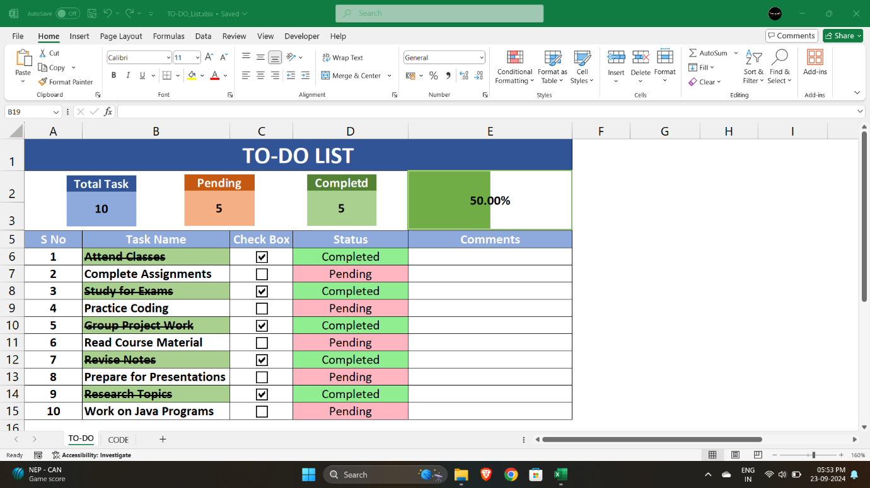

***Picture Of Code***

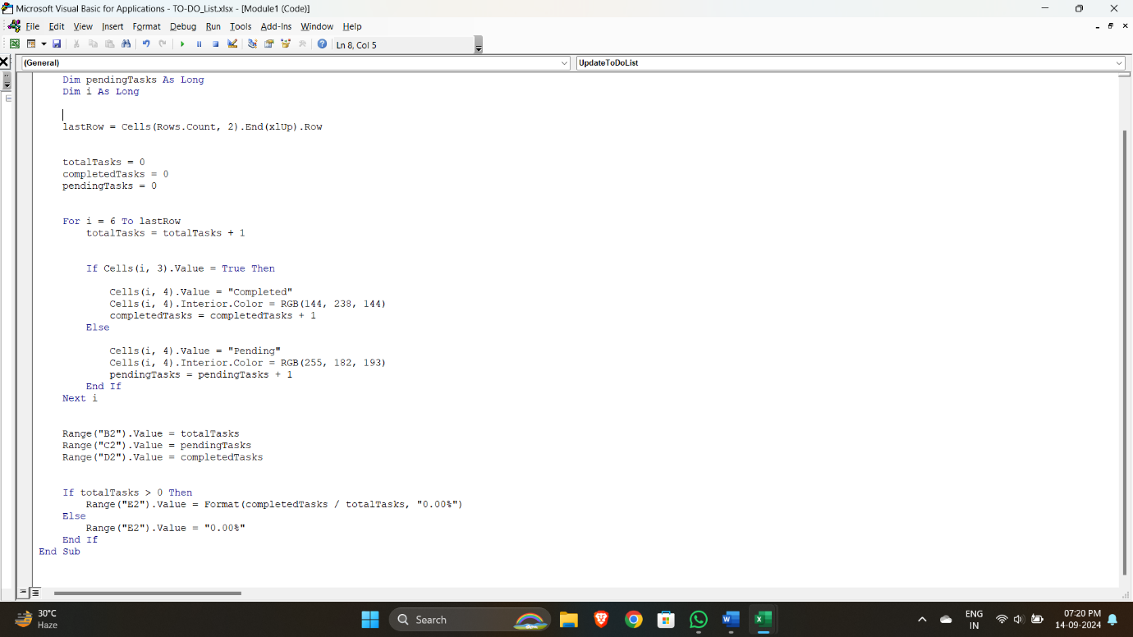

***Link of Project***

**Click Here to Download Project File (Excel): -**

***[TO-DO_List.xlsx](https://1drv.ms/x/c/b6da04b23e00f57b/EQeSmyk_VFpKgVf2xguK0A0B_02Lz1hnhX9e1mDN4CKSlA?e=RourO2)***