CLOUD ARCHITECTURE DESIGN
Course Code BCSE355L

Arcade Hub
Serverless Gaming Platform on AWS
  - Project Report

Project by
Purvi Malhotra
Registration Number 24BCI0040

Submitted to
Professor Saranya P

24 October 2026

2 Project overview
I developed Arcade Hub as a collection of mini games that can be played in a web browser. For this course project, I connected the React application to AWS so that players can sign in, save scores and earn achievements. My aim was to understand how different cloud services work together in a complete application without managing a server.

Objectives and scope
I wanted the website to load through HTTPS and keep player accounts and scores in the cloud. I also included friends, experience points (XP) and an all time leaderboard. I used Asia Pacific Sydney, ap-southeast-2, as the selected AWS Region for the regional resources. CloudFront delivers the website from its global network.
The application has nine playable games: Minesweeper, Pac-Man, Flappy Bird, Snake, Brick Breaker, Pong, Tic-Tac-Toe, Tetris and Shooter. Three other game cards are marked Coming soon. The games run in the browser, while AWS handles login and saved player information.

AWS services and their purpose
Service | Role in the project
Amazon S3 and CloudFront | Store the private production build and deliver it over HTTPS with caching and SPA route fallback.
Amazon Cognito Lite | Manage signup, email verification and password based sign in; issue authentication tokens.
Amazon API Gateway | Expose an HTTP API with JWT authorization, CORS and request throttling.
AWS Lambda | Run API logic and a separate asynchronous achievement worker.
Amazon DynamoDB and Streams | Store player records and publish score changes for achievement processing.
AWS IAM | Give the API and achievement worker separate, limited runtime permissions.
Amazon CloudWatch | Keep three day logs and alarms for API 5xx and worker function errors.
AWS CloudFormation | Create and update the infrastructure from version controlled definitions.

Cost conscious deployment
I kept the project on the AWS Free plan using its available credits. Before deployment, the script checks for an active plan, US$10 credit and one day remaining. Small database capacity, API throttling and short log retention limit usage but are not billing caps. Hosting depends on the free period and credits; I did not upgrade to a paid plan.

3 Methodology and working model

Architecture
I divided the architecture into website hosting and player services. S3 and CloudFront deliver the frontend. Cognito, API Gateway, Lambda and DynamoDB handle the player features. Scores are saved during the API request, while achievements are processed separately after a score changes.
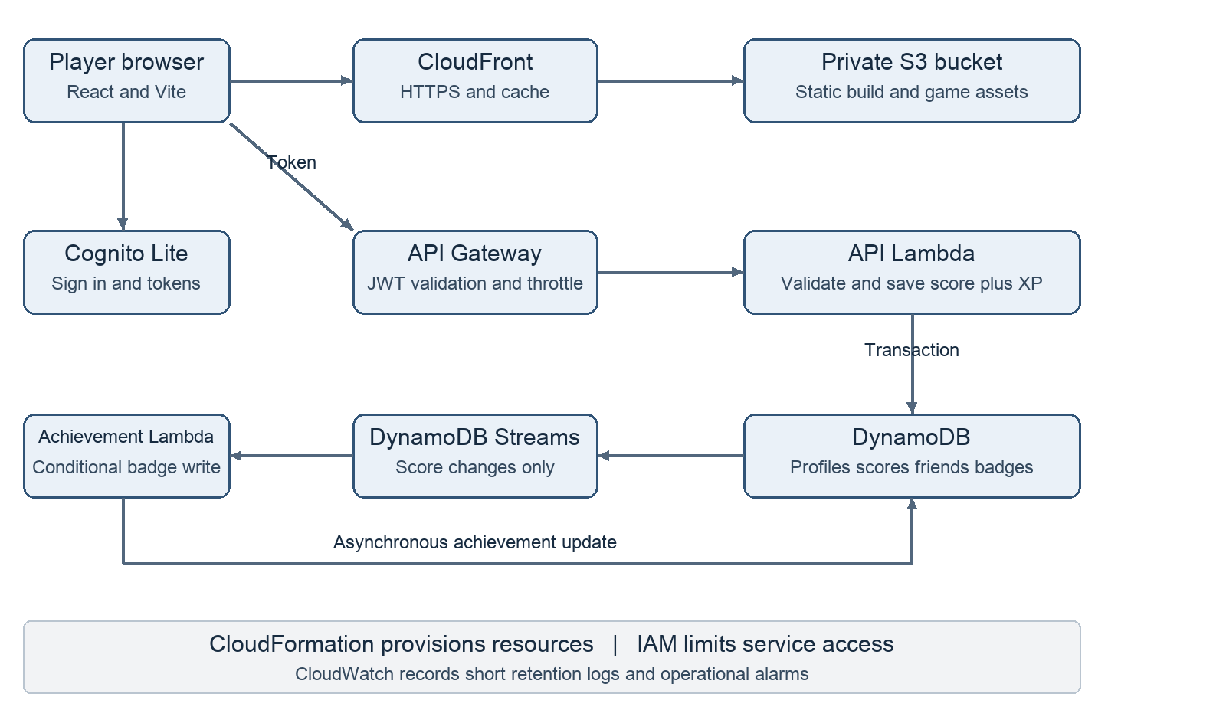
Implemented AWS architecture and request flow

Working sequence
1. The player opens the CloudFront URL. CloudFront retrieves the React build from the private S3 origin and caches static assets.
2. Cognito registers or authenticates the player. The browser sends the access token with protected API requests.
3. API Gateway validates the token. The API Lambda derives the player identity from the verified token and validates the submitted game, score and request identifier.
4. A DynamoDB transaction updates the cumulative game score, XP and submission receipt together. Repeating the same request identifier does not award points twice during the receipt retention period.
5. DynamoDB Streams forwards score changes to the achievement Lambda. Conditional writes award first score and 100 point game badges safely when events repeat.
6. The frontend retrieves profiles, friends, badges and the top 50 players by all time XP. Index updates and achievements may appear after a short delay.

3 AWS setup and deployment procedure

Setting up access and checking the plan
I first signed in to my AWS project and used the selected Region ap-southeast-2. I set up the AWS CLI with the profile name arcade-hub and used browser based login to obtain a temporary session. This allowed the deployment scripts to use AWS without putting permanent access keys in the code. I checked the Free plan status before creating the application resources.

Preparing and reviewing the infrastructure
I ran the local tests, lint check and production build before deployment. The aws:prepare command generated the CloudFormation template and prepared a change set. A change set lists the resources AWS will create or update, which makes the deployment easier to review. The template was checked with cfn-lint, selected AWS Guard rules and AWS change set validation.

Creating the backend and service permissions
CloudFormation created the Cognito user pool, API Gateway HTTP API, Lambda functions, DynamoDB table and indexes. Cognito manages player passwords and tokens. API Gateway passes valid requests to the API Lambda, which reads or updates DynamoDB. I used separate IAM runtime roles for the API and achievement worker. The API role can work with the application table and indexes; the worker can read score stream events and insert badges. This follows least privilege because each function receives the permissions it needs.

Connecting hosting and publishing the website
The stack also created a private S3 bucket and a CloudFront distribution. After the first deployment finished, the CloudFront hostname became available. A second change set added this exact website origin to the API CORS configuration, allowing the frontend to call the API. I then ran aws:publish. It read the stack outputs, built the frontend with the public Cognito and API settings, uploaded the static files to S3 and invalidated the CloudFront cache so visitors could receive the new version.

Enabling achievements and monitoring
I enabled DynamoDB Streams for score changes and connected the stream to the achievement Lambda. This function awards badges separately from the score request. Conditional writes stop repeated events from creating duplicate badges. CloudWatch stores function logs for three days and includes alarms for API server errors and unhandled achievement function errors.

Checking the deployed application
I checked that the CloudFront website and direct page routes loaded, while direct S3 access was denied. The live checks covered login, profile creation, score persistence, duplicate request handling, friend access, badges and the leaderboard. A 100 point submission produced 20 XP, and repeating its request ID did not add XP again. The test accounts did not send signup emails, so actual email delivery remains a separate check.
The main commands used were npm run aws:status, npm run aws:prepare, npm run aws:deploy and npm run aws:publish. I kept the project on the Free plan throughout deployment.

3 Data design and testing

Data design
Record | DynamoDB sort key | Purpose
Profile | PROFILE | Username and XP for a player
Score | SCORE#game | Cumulative points for one game
Friend | FRIEND#player | One way friend relationship
Badge | BADGE#id | Earned achievement
Receipt | REQUEST#UUID | Replay protection with seven day TTL
I used one DynamoDB table and grouped each player's records under USER#subject. Different sort keys identify the profile, scores, friends and badges. The Directory index helps search usernames, and the Leaderboard index sorts players by XP. I set the table to 5 read and 5 write capacity units, with 1 read and 1 write unit for each index, and left autoscaling disabled.

Security and reliability
I kept the S3 bucket private and allowed CloudFront to read it using origin access control. The website uses HTTPS, and I did not place AWS access keys or a Cognito client secret in the frontend. API Gateway checks the login token before protected requests reach Lambda. A player can view their own details or those of a player they have added as a friend. Search and leaderboard results do not show email addresses.
I added score checks for valid games and positive whole numbers up to 100000. A database transaction saves the score, XP and request receipt together. This avoids saving only part of an update. The receipt prevents the same request from adding points twice while it is retained. Scores still come from the browser, so this is not a complete anti-cheat system. The achievement worker retries failures, but a persistent failure may need manual repair because no dead letter destination is configured.

Validation results
Check | Observed result
Local quality checks | 12 tests passed; lint and production build passed.
Infrastructure validation | cfn-lint reported no errors or warnings; five selected AWS Guard rules passed; AWS change set validation passed.
Authentication and access | Anonymous protected request returned 401; nonfriend profile access returned 403; friend access returned 200.
Scores and events | 100 points produced 20 XP; replay did not add XP; two achievement badges were observed.
Hosting | CloudFront and direct SPA route returned 200; direct S3 access returned 403.

4 Project screenshots and AWS overview
The console style illustration below summarises the AWS services and IAM roles used in my design. The application screenshots show the dashboard and login interface.
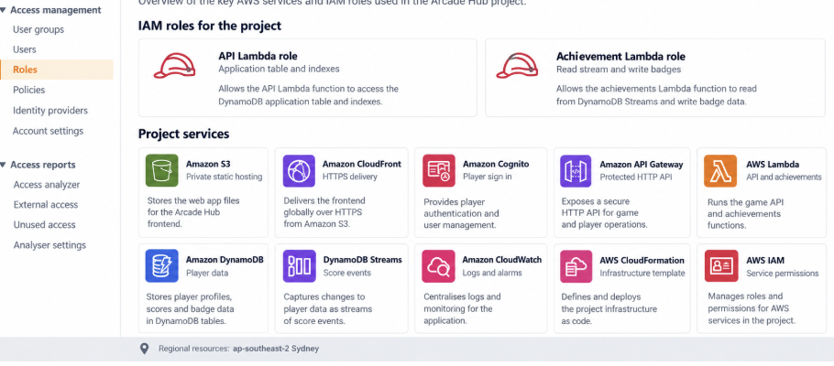
AWS service overview illustration
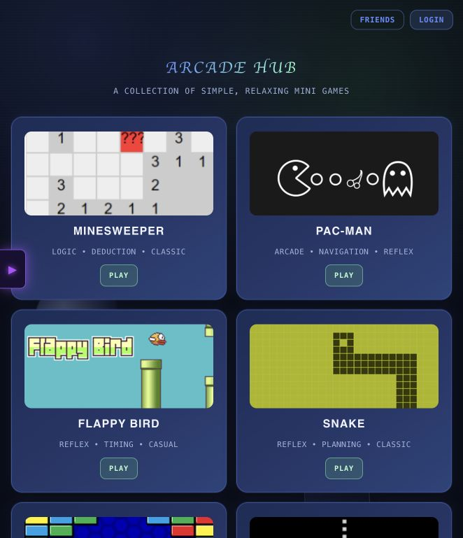  Arcade Hub dashboard | 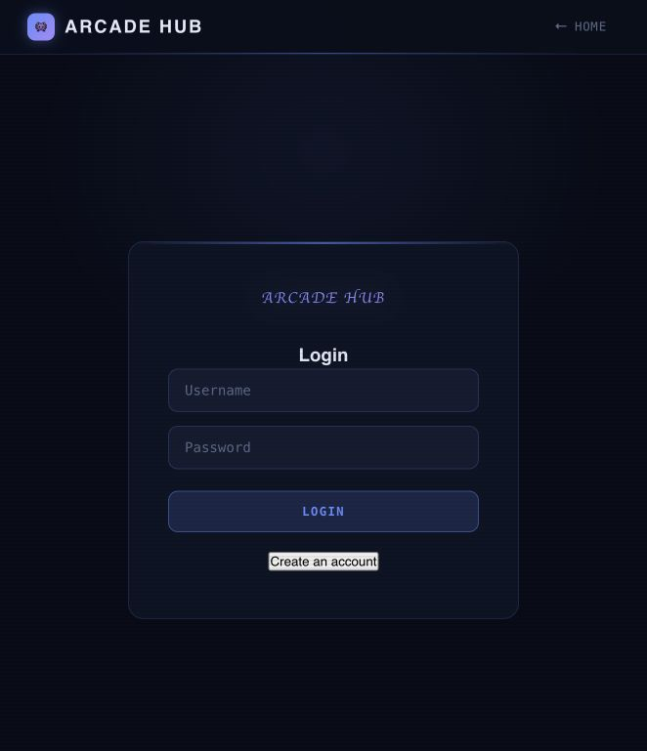  Player login

4 Gameplay and leaderboard
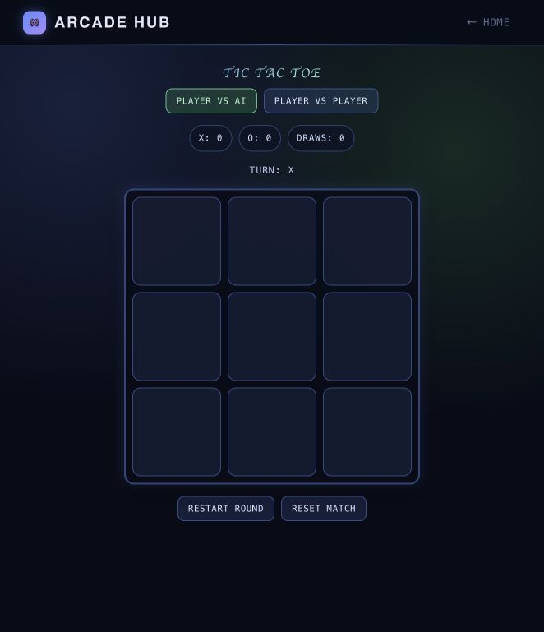  Tic Tac Toe game | 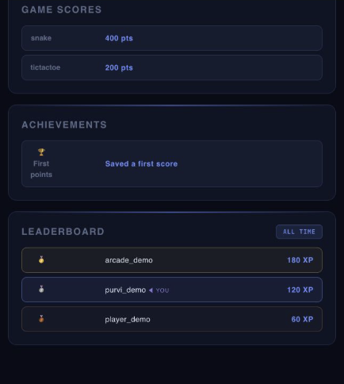  Local leaderboard preview with sample data

How the player features connect to AWS
The games run in the browser. When a signed in player earns points, the frontend sends the score to the protected API. Lambda validates the request and saves the cumulative score and XP in DynamoDB. The achievement worker responds to score changes and can add a badge.
I captured the leaderboard locally after stopping the AWS deployment. The visible usernames, scores and XP are sample records for the interface demonstration and are not live cloud data.
The leaderboard ranks up to 50 players by all time XP using a DynamoDB index. It shows usernames and XP without exposing email addresses. Because the index is eventually consistent, a score update may take a short time to appear in the ranking.

Project demonstration
For my demonstration, I can sign in, play a scoring game and open the profile to show the saved points, XP and badges. A second account can add the player as a friend to demonstrate access to that profile. The validation table records the backend checks completed during deployment.

5 Project links
GitHub repository https://github.com/PurviMalhotra/Cloud-Project
Original AWS deployment link https://d1q26zxj8f4vri.cloudfront.net
Project information | Details
Name | Purvi Malhotra
Registration number | 24BCI0040
Course | Cloud Architecture Design
Course code | BCSE355L
Professor | Saranya P
Project | Arcade Hub Serverless Gaming Platform on AWS
Selected Region | Asia Pacific Sydney ap-southeast-2

Implementation reference
My project files include the React games, AWS integration, Lambda code, infrastructure scripts and tests. I also included architecture and deployment notes so I can explain the setup and repeat the deployment. Workflow files are prepared for automated checks and optional publishing from GitHub.
The AWS version was deployed from my local project and was later stopped. I used a separate local preview to capture the leaderboard with sample data. The current source code is stored in my private Cloud-Project repository. GitHub Actions is disabled, and the optional publishing workflow is not connected.

Learning outcomes
Through this project, I learned how a frontend connects to managed cloud services. I worked with authentication tokens, IAM roles, API requests, DynamoDB records and stream events. I also learned why infrastructure templates, monitoring and cost checks are useful even for a small project.

Future improvements
In the future, I would like to add more games, improve score verification and store failed achievement events for later processing. If the website grows, I would also review the database and leaderboard design. I would check the cost of these changes before adding them.

Conclusion
Arcade Hub helped me apply cloud architecture concepts to a working gaming website. The final project brings together hosting, authentication, APIs, storage and event processing. It gives me a practical example to explain how AWS services communicate and why each service is used.

