1.Write a program to demonstrate how a JMeter script is recorded.

Recording Script using JMeter – record the script using Blazemeter plugin, and then upload the script on JMeter.

2. Write a program to demonstrate how load (threads) is added in JMeter.

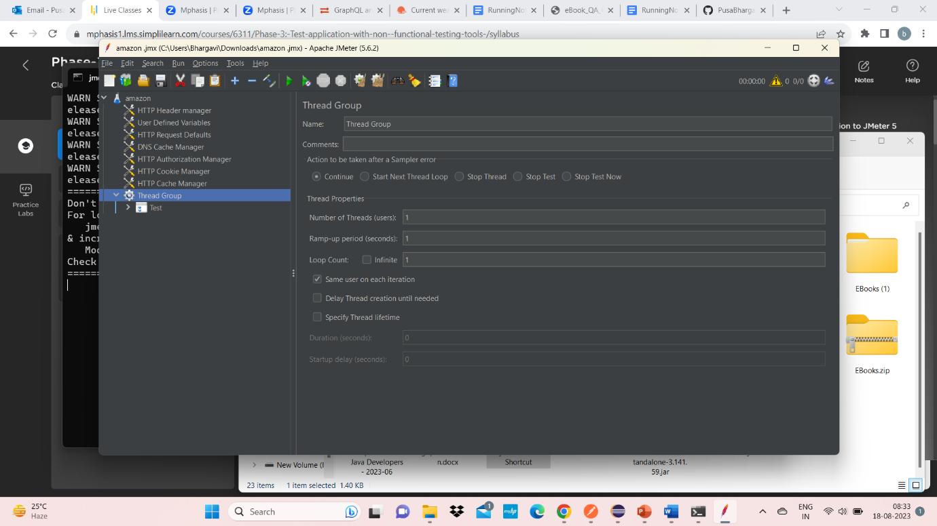

3. Write a program to demonstrate how load is increased in JMeter.

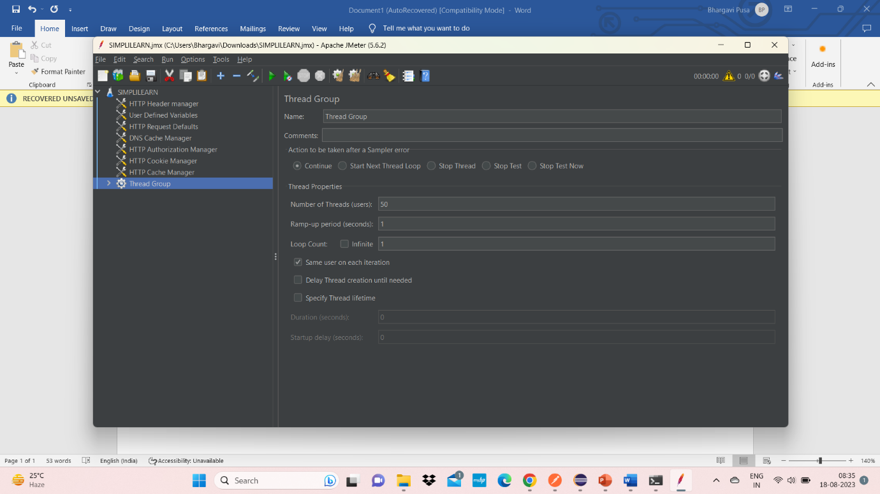

4. Write a program to demonstrate the use of thread group plugin in JMeter.

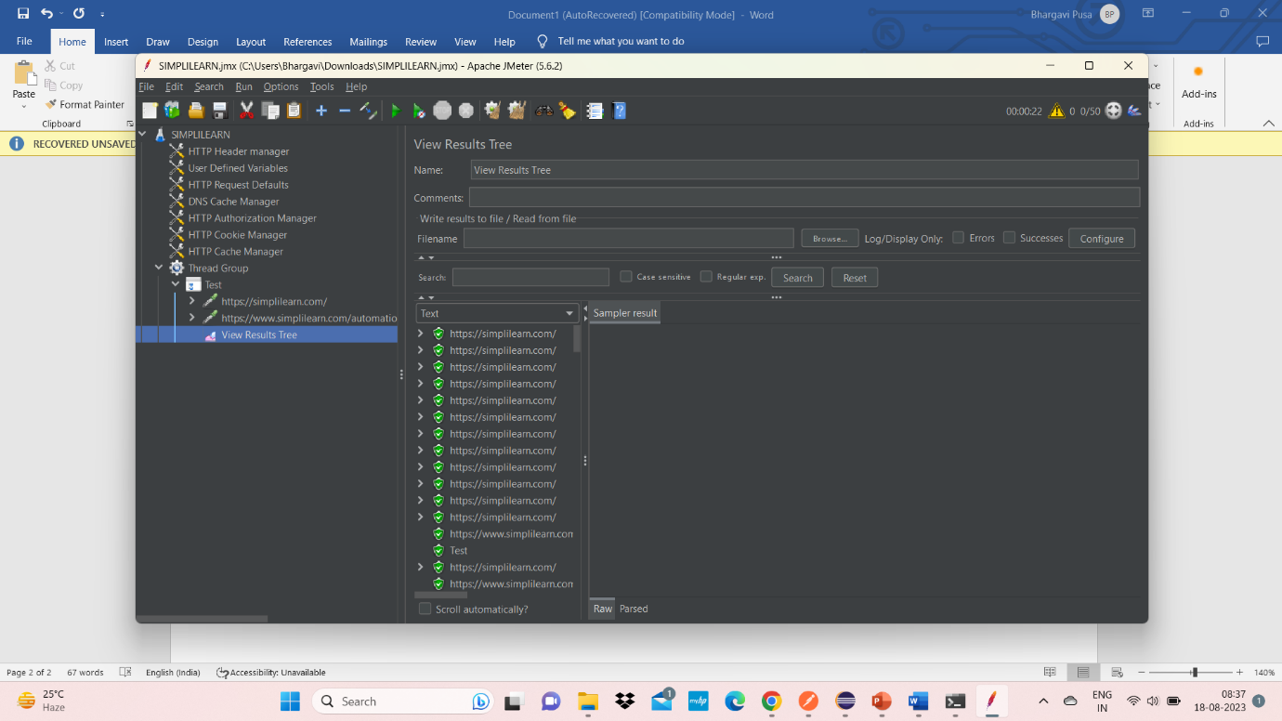

Write a program to demonstrate how a SMTP sampler script is run in JMeter.

* Add javamail.jar file to your JMeter’s ‘ext’ folder (C:\Users\dsbha\Downloads\apache-jmeter-5.6.2\apache-jmeter-5.6.2\lib\ext) and then restart JMeter.
* Right Click Test Plan > Add > Threads (Users) > Thread Group

Right Click Thread Group > Add > Sampler > SMTP Sampler

Write a program to demonstrate how a JDBC sampler script is run in JMeter.

1. Set up the Database
2. Download jdbc connector jar file and unzip it. Browse this jar file through the UI of JMeter by clicking on ‘Browse’ button on the ‘Test Plan’ panel.
3. Right Click Test Plan > Add > Threads (Users) > Thread Group
4. Right Click Thread Group > Add > Config Element > JDBC Connection Configuration and do the following settings –

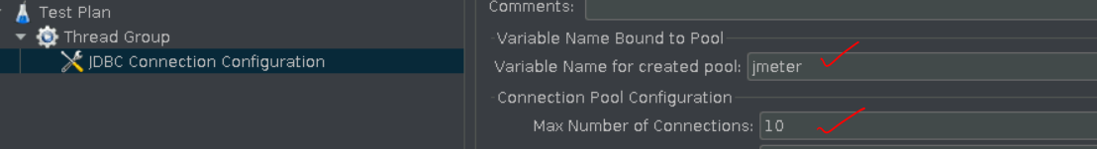

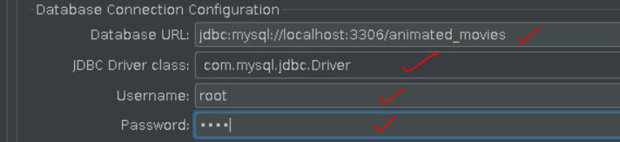

1. Right Click Thread Group > Add > Sampler > JDBC Request and write as shown below –

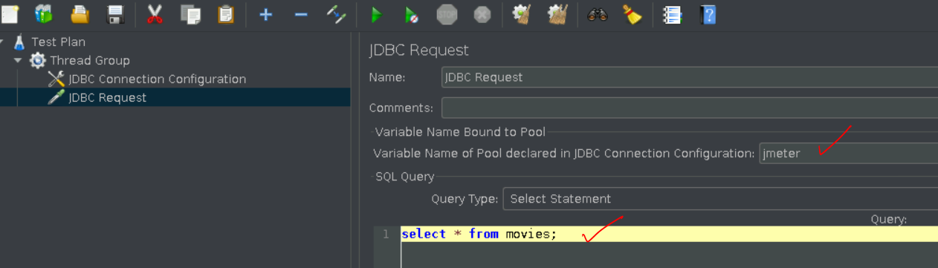

1. Right Click Thread Group > Add > Listener > View Results Tree.

Write a program to demonstrate how Selenium WebDriver is integrated using JMeter script.

* Add Plugins Manager to JMeter
* Install Selenium/WebDriver Support plugin.
* Right Click Test Plan > Add > Threads (Users) > Thread Group
* Right Click Thread Group > Add > Config Element > jp@gc – Chrome Driver Config
* Right Click Thread Group > Add > Sampler > jp@gc – Web Driver Sampler
* Right Click Thread Group > Add > Listener > View Results Tree
* Go to <https://www.selenium.dev/downloads/> > Scroll down to Browsers > Expands it > Click on Documentation corresponding to Chrome > Click on Downloads on next page under ‘Latest ChromeDriver Binaries’ section > Click on below link –



* Click on chromedriver_win32.zip on next page.
* Unzip the file.
* Go inside the unzipped folder > copy path of ‘chromedriver.exe’ file.
* Paste the path as shown below –

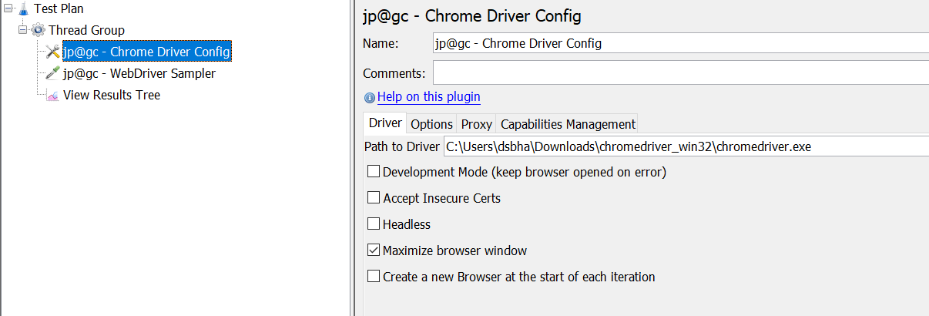

* In jp@gc – WebDriver –Sampler change the language to javascript from the drop-down and then run the default script –

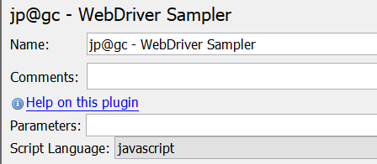

Write a program to demonstrate HTML assertions in JMeter.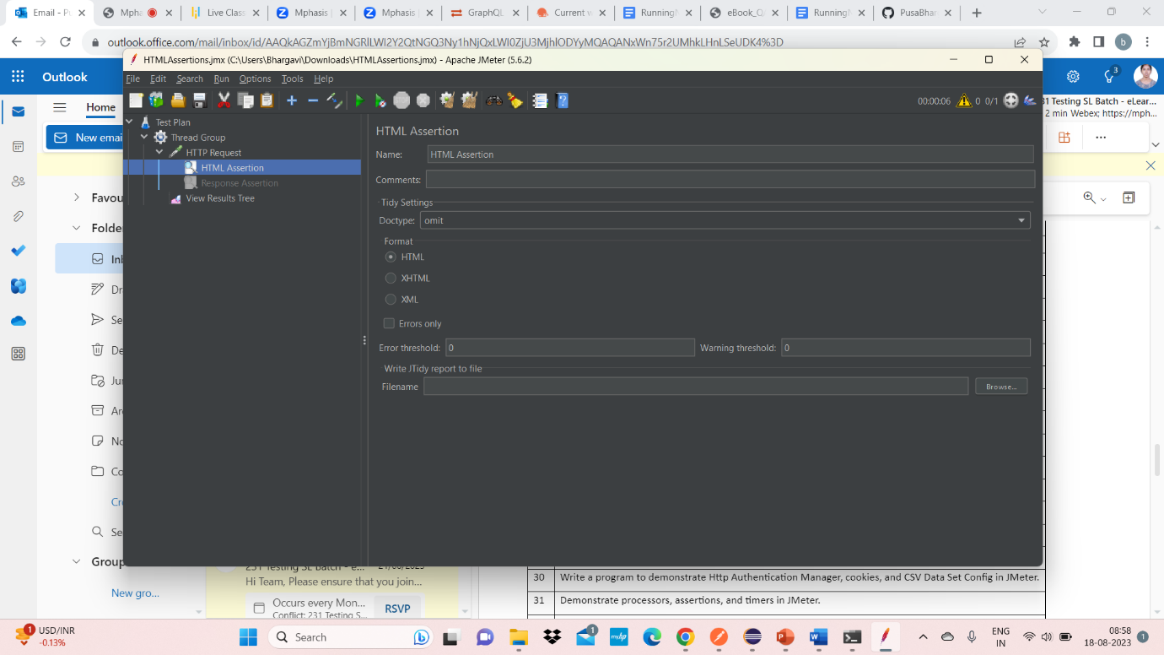

Write a program to demonstrate response assertions in Jmeter

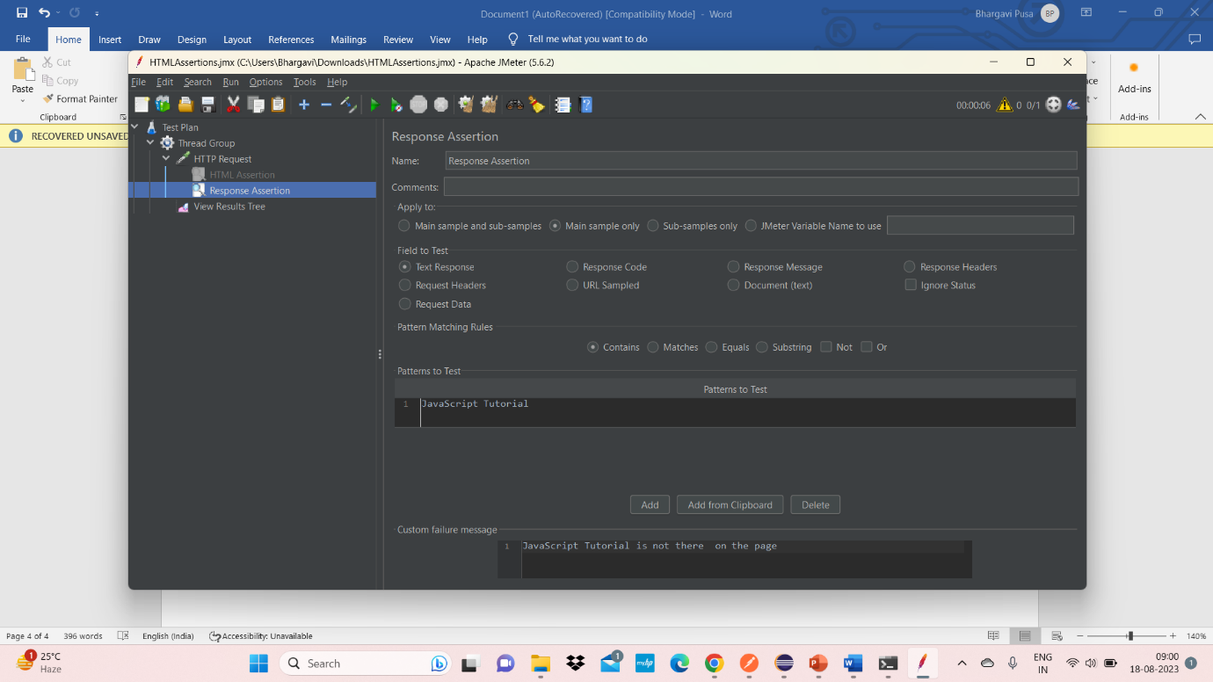

Write a program to demonstrate XML and XML schema assertions in JMeter.

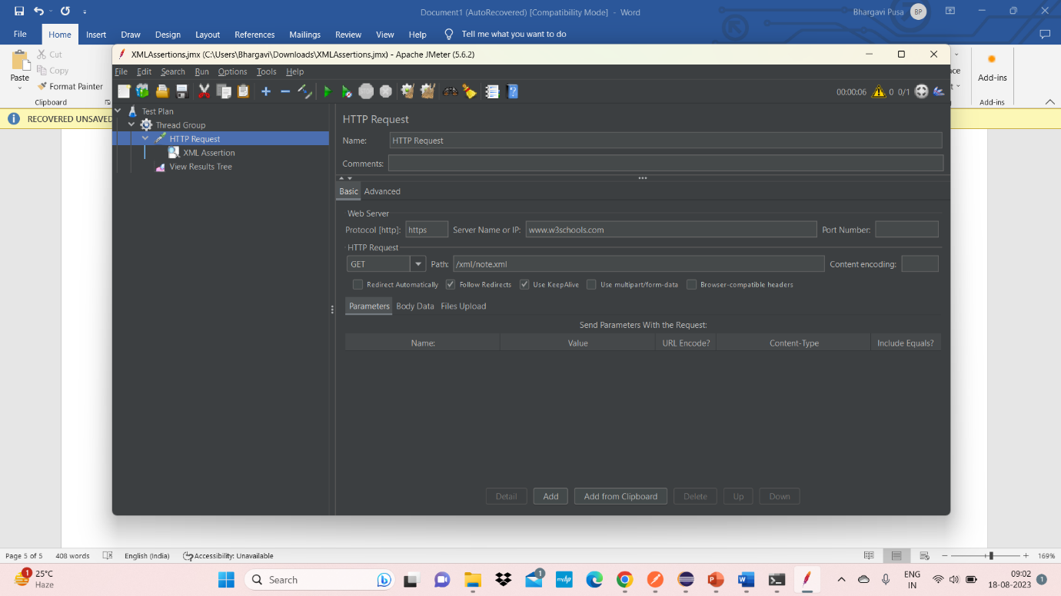

Write a program to demonstrate random timers (Constant, Gaussian, and Poisson timers) in JMeter.

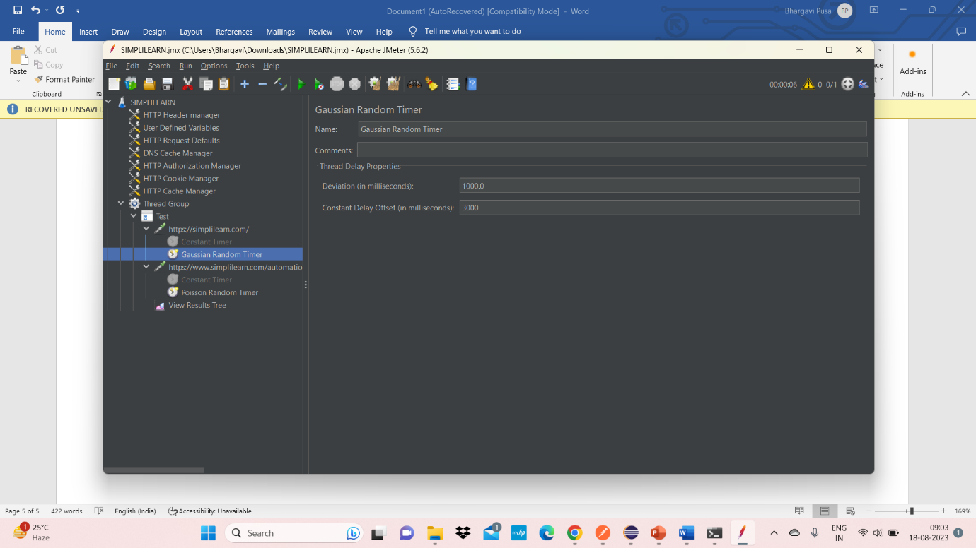

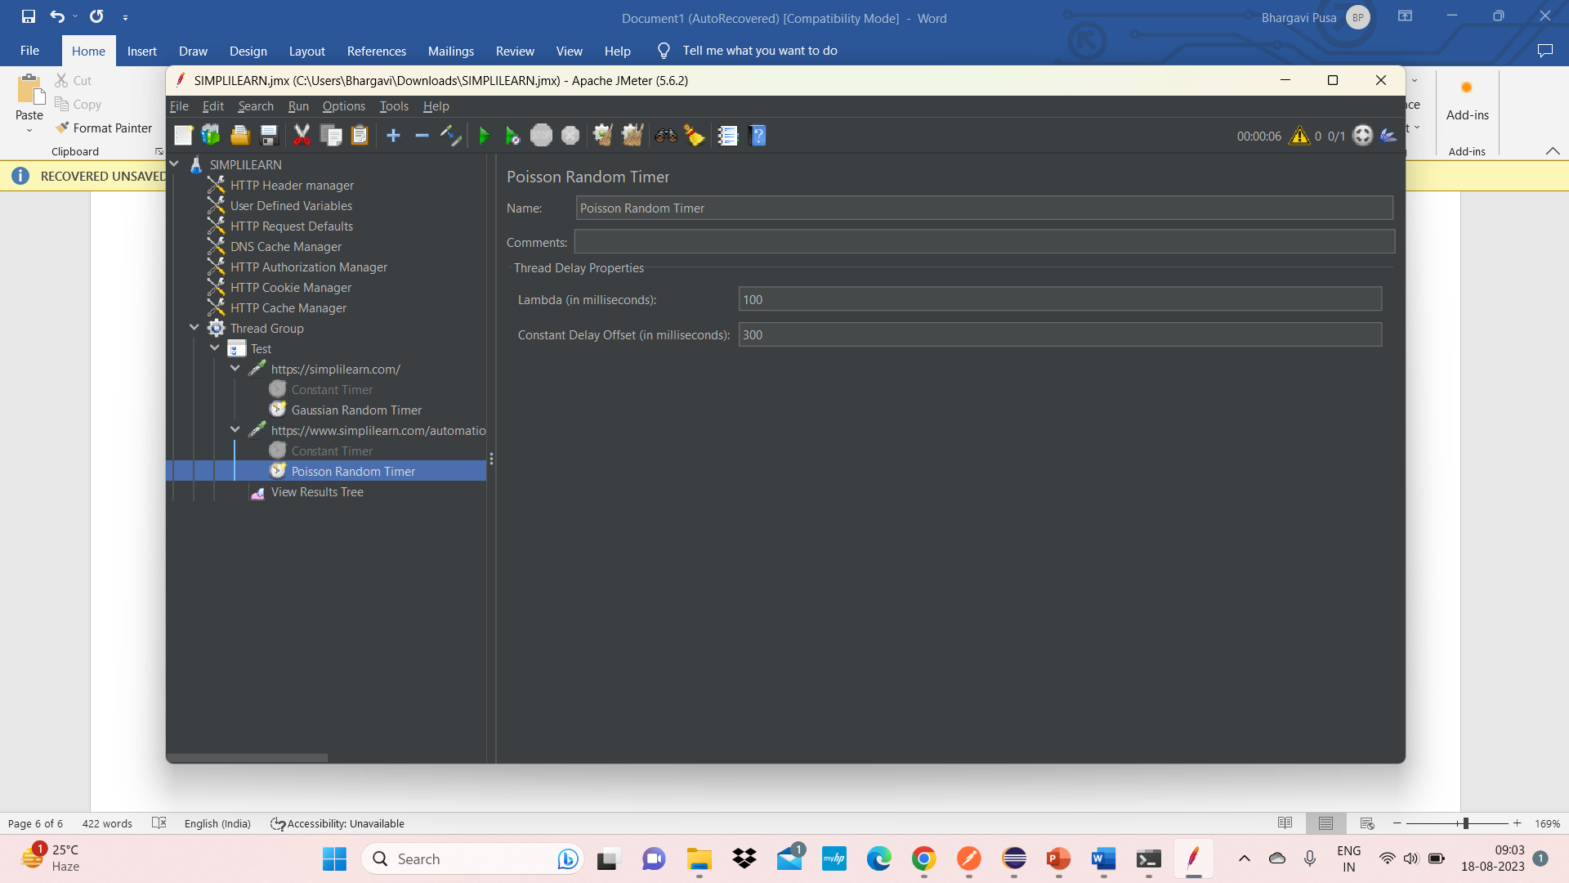

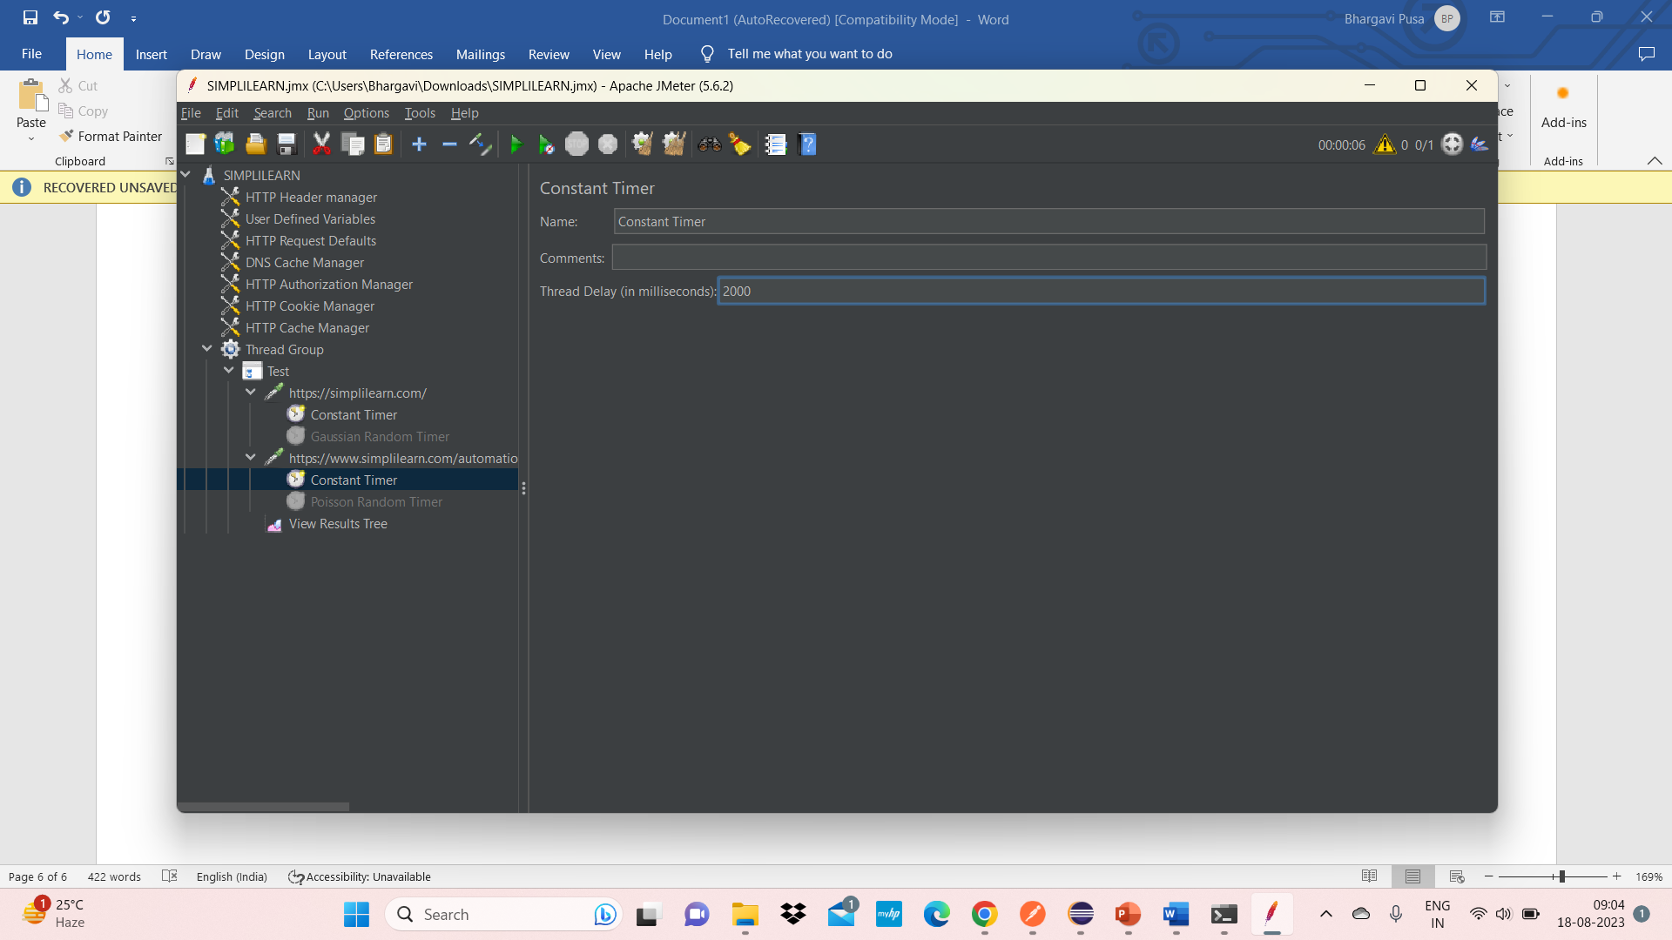

Write a program to demonstrate implementation of JMeter controllers using Selenium.

