SIMATS ENGINEERING
ASSESSMENT TOOL
COURSE NAME: Theory of Computation COURSE CODE: CSA13
COURSE OUTCOME COVERED
CO1: Analyze fundamental mathematical concepts of automata theory for formal languages and decision problems.(BL:3)
Assessment Tool Weightage: 40%
QUESTIONS: 5 Total Marks:25 Duration : 1 Hour
Analytical Problem
Code of Conduct:
I _Pusalapati Chandu_(192372119)_ (Name / Reg No) certify that this submission is my original work and that I have adhered to the guidelines specified for this assessment.
I understand that any violation of academic integrity rules will result in disciplinary action.
Signature of the student: 

SIMATS ENGINEERING
ASSESSMENT TOOL
1.Consider the NFA given below which accepts some language L over the alphabet ��={a,b}. Construct a DFA that represents the same language L
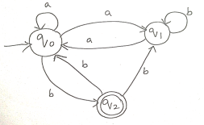
2.Let L be the language of words of length atleast 2 whose last two letters are difference from each other. For example abaab is in L but not bb, Construct an NFA for L, Then draw the equivalent DFA
3. Design a Nondeterministic Finite Automata (NFA) that takes a binary string as input and accepts the string only if the last two digits are the same (either 00 or 11). Write the formal definition of the NFA. Also show that the string 01011 is accepted by the NFA
4. Consider the NFA given below which accepts the language representing the set of all strings having 001 as a substring over the alphabet ��={0,1}. Construct a DFA that represents the same language.
5. A NFA with ε-transitions is given below. Find ε-closure for each state and Design an equivalent DFA which accepts the same language. Draw its transition table and mark the initial and final states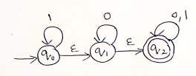

Question 1 — NFA to DFA Conversion
Given NFA over Σ = {a, b}, states {q0, q1, q2}, start state q0, final state q2:
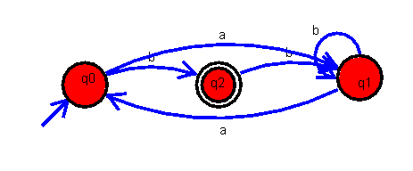
Step 1: Formal transition table of the NFA
State | a | b
→ q0 | q1 | q2
q1 | q0 | q1
* q2 | — | q1
(→ denotes start state, * denotes final state)
Step 2: Observation
Every state already has at most one transition per input symbol, so the automaton is deterministic except that q2 has no transition defined on 'a'. This missing transition is what makes it technically an NFA (a partial function). To build a complete DFA we simply add one extra 'trap' (dead) state to absorb the missing transition.
Step 3: Equivalent DFA
State | a | b
→ q0 | q1 | q2
q1 | q0 | q1
* q2 | Trap | q1
Trap | Trap | Trap
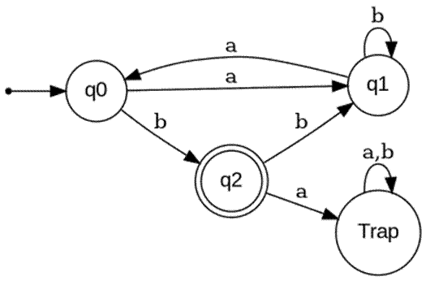
Final DFA = ({q0, q1, q2, Trap}, {a,b}, δ, q0, {q2}) — this accepts exactly the same language L as the original NFA.

Question 2 — Last Two Letters Are Different
L = { w ∈ {a,b}* : |w| ≥ 2 and the last two symbols of w are different } (i.e. w ends in 'ab' or 'ba').
Step 1: NFA construction
Idea: stay in q0 reading any prefix; nondeterministically 'guess' that the current symbol is the second-last symbol of the string, and check the following symbol differs from it.
State | a | b
→ q0 | {q0, q1} | {q0, q2}
q1 | — | {qf}
q2 | {qf} | —
* qf | — | —
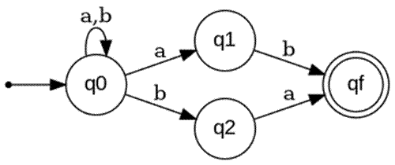
Step 2: Subset construction (NFA → DFA)
Let S={q0}, A={q0,q1}, B={q0,q2}, C={q0,q2,qf}, D={q0,q1,qf}.
DFA State | a | b
→ S = {q0} | A | B
A = {q0,q1} | A | C
B = {q0,q2} | D | B
* C = {q0,q2,qf} | D | B
* D = {q0,q1,qf} | A | C
Final states are C and D (they contain qf). The resulting DFA has 5 states and is already reachable/minimal for this construction.
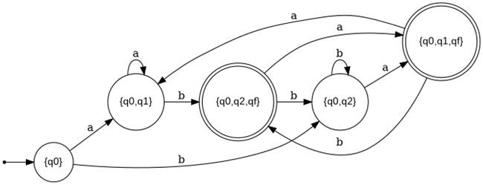
Verification
Check 'abaab' (should be accepted, ends in 'ab'): S -a-> A -b-> C -a-> D -a-> A -b-> C. Ends in C (final) ✓ accepted.
Check 'bb' (should be rejected): S -b-> B -b-> B. Ends in B (not final) ✓ correctly rejected.

Question 3 — Last Two Digits Are the Same (00 or 11)
Formal definition of the NFA
N = (Q, Σ, δ, q0, F) where:
Q = {q0, q1, q2, qf}
Σ = {0, 1}
start state = q0
F = {qf}
Transition function δ:
State | 0 | 1
→ q0 | {q0, q1} | {q0, q2}
q1 | {qf} | —
q2 | — | {qf}
* qf | — | —
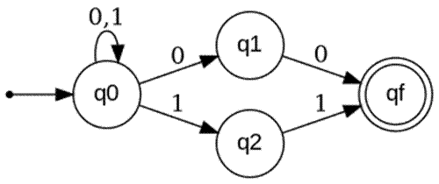
Idea: q0 loops on any input while nondeterministically guessing that the current symbol starts the last two digits; q1 confirms the pair '00', q2 confirms the pair '11'.
Showing the string 01011 is accepted
The string ends in '11', so we choose the path that guesses the pair at positions 4–5:
q0 --0--> q0 --1--> q0 --0--> q0 --1--> q2 --1--> qf
Symbol by symbol:

Step | Symbol read | State reached
1 | 0 | q0
2 | 1 | q0
3 | 0 | q0
4 | 1 | q2 (guess: last pair begins here)
5 | 1 | qf (accepting)
Since the automaton ends in qf ∈ F after reading all 5 symbols, the string 01011 is accepted by the NFA. ✓

Question 4 — Strings Containing '001' as a Substring
Note: no diagram was supplied for this question in the assessment sheet, so the standard NFA for 'contains 001 as a substring' is constructed below and then converted to its DFA.
Step 1: NFA construction
Idea: q0 loops on any symbol until the machine nondeterministically guesses it has found the start of '001'; q1 confirms the first '0', q2 confirms '00', and q3 confirms '001' and stays accepting forever after.
State | 0 | 1
→ q0 | {q0, q1} | {q0}
q1 | {q2} | —
q2 | {q2} | {q3}
* q3 | {q3} | {q3}
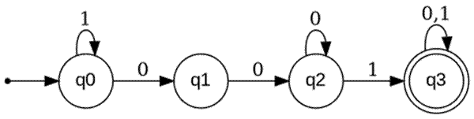

Step 2: Subset construction

Let S={q0}, A={q0,q1}, B={q0,q1,q2}, and once q3 is reached the set always stays a superset containing q3. All such 'contains q3' sets behave identically (once you've seen 001 you can never un-see it), so after merging equivalent accepting sets we get a single accepting state F:
DFA State | Meaning | 0 | 1
→ S | no progress yet | A | S
A | seen '0' | B | S
B | seen '00' | B | F
* F | seen '001' (absorbing) | F | F
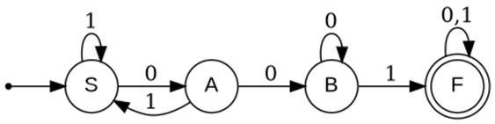

This 4-state DFA is the minimal DFA equivalent to the given NFA and accepts exactly the strings over {0,1} that contain '001' as a substring.
Verification
Check '1100101' (contains 001 ✓): S-1->S-1->S-0->A-0->B-1->F-0->F-1->F. Ends in F ✓ accepted.
Check '1010' (no 001): S-1->S-0->A-1->S-0->A. Ends in A (not accepting) ✓ correctly rejected.

Question 5 — ε-NFA to DFA (ε-closure method)
Given ε-NFA over Σ = {0,1}, states {q0, q1, q2}, start q0, final q2:
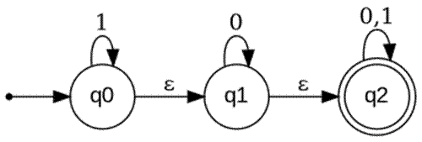
State | 0 | 1 | ε
→ q0 | — | {q0} | {q1}
q1 | {q1} | — | {q2}
* q2 | {q2} | {q2} | —
Step 1: ε-closure of each state
State | ε-closure
q0 | {q0, q1, q2}
q1 | {q1, q2}
q2 | {q2}
Step 2: Subset construction using ε-closures
Start state of DFA = ε-closure(q0) = {q0, q1, q2} → call it A. Since A contains q2, A is a final state (accepts the empty string too).
A = {q0,q1,q2}: on 0 → move(A,0)={q1,q2}, ε-closure = {q1,q2} = B. on 1 → move(A,1)={q0,q2}, ε-closure = {q0,q1,q2} = A.
B = {q1,q2}: on 0 → move(B,0)={q1,q2}, ε-closure = {q1,q2} = B. on 1 → move(B,1)={q2}, ε-closure = {q2} = C.
C = {q2}: on 0 → {q2} = C. on 1 → {q2} = C.
Step 3: DFA transition table
DFA State | NFA states | 0 | 1 | Final?
→ A | {q0,q1,q2} | B | A | Yes
B | {q1,q2} | B | C | Yes
C | {q2} | C | C | Yes
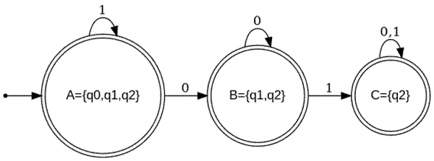
Conclusion
Every reachable DFA state contains q2, so every state is a final state. This means the DFA (and hence the original ε-NFA) accepts every string over {0,1}, including the empty string — i.e. L = Σ*.

