Theory of Computation

1. DFA - Strings start with 'a' and end with 'a'
Aim: To simulate a DFA that accepts strings starting and ending with 'a'.

Algorithm
- 1. Start
- 2. Read string
- 3. Check first character is 'a'
- 4. Check last character is 'a'
- 5. Accept else Reject

C Program
#include <stdio.h>
#include <string.h>
int main(){
char s[100];
printf("Enter string: ");
scanf("%99s",s);
int n=strlen(s);
if(n>0 && s[0]=='a' && s[n-1]=='a')
printf("Accepted");
else
printf("Rejected");
return 0;
}

Sample Input aabaa

Sample Output:
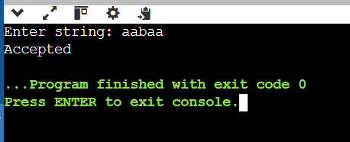

Result
Thus the required program was implemented and executed successfully.

2. DFA - Strings start with '0' and end with '1'
Aim: To simulate a DFA that accepts binary strings starting with 0 and ending with 1.

Algorithm
1. Start
2. Read string
3. Check first character is '0'
4. Check last character is '1'
5. Accept else Reject

C Program
#include <stdio.h>
#include <string.h>
int main(){
char s[100];
printf("Enter string: ");
scanf("%99s",s);
int n=strlen(s);
if(n>0 && s[0]=='0' && s[n-1]=='1')
printf("Accepted");
else
printf("Rejected");
return 0;
}

Sample Input
000111

Sample Output
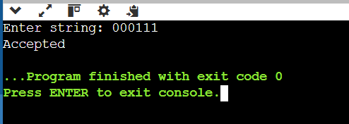

Result
Thus the required program was implemented and executed successfully.

3. CFG: S→0A1, A→0A|1A|ε
Aim: To check whether a string belongs to the grammar S→0A1.

Algorithm
1. Read string
2. Verify first symbol is 0
3. Verify last symbol is 1
4. Accept else Reject

C Program
#include <stdio.h>
#include <string.h>
int main(){
char s[100];
scanf("%99s",s);
int n=strlen(s);
if(n>=2 && s[0]=='0' && s[n-1]=='1')
printf("Belongs to CFG");
else
printf("Does not belong");
}

Sample Input
011001

Sample Output

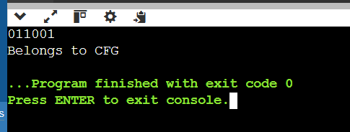

Result
Thus the required program was implemented and executed successfully.

4. CFG Palindrome
Aim: To check whether a binary string is a palindrome.

Algorithm
1. Read string
2. Compare characters from both ends
3. Accept if all match

C Program
#include <stdio.h>
#include <string.h>
int main(){
char s[100];
scanf("%99s",s);
int i,n=strlen(s),f=1;
for(i=0;i<n/2;i++)
if(s[i]!=s[n-i-1]){f=0;break;}
if(f) printf("Belongs");
else printf("Does not belong");
}

Sample Input
aabaa

Sample Output

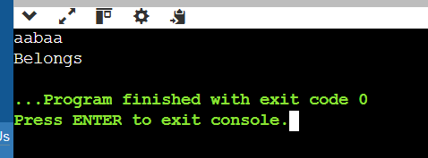

Result
Thus the required program was implemented and executed successfully.

5. CFG: S→0S0|A, A→1A|ε
Aim: To verify strings with matching outer 0s and middle 1s.

Algorithm
- 1. Read string
- 2. Remove matching outer 0s
- 3. Ensure remaining chars are all 1s

C Program
#include <stdio.h>
#include <string.h>
int main(){
char s[100];
scanf("%99s",s);
int l=0,r=strlen(s)-1,ok=1;
while(l<r&&s[l]=='0'&&s[r]=='0'){l++;r--;}
while(l<=r){if(s[l]!='1'){ok=0;break;}l++;}
if(ok) printf("Belongs");
else printf("Does not belong");
}

Sample Input
0011100

Sample Output

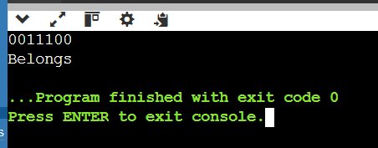

Result
Thus the required program was implemented and executed successfully.

6. CFG: S→0S1|ε
Aim: To check strings having equal number of leading 0s and trailing 1s.

Algorithm
1. Read string
2. Match one leading 0 with one trailing 1 repeatedly
3. Accept if fully reduced

C Program
#include <stdio.h>
#include <string.h>
int main(){
char s[100];
scanf("%99s",s);
int l=0,r=strlen(s)-1,ok=1;
while(l<=r){
if(l==r){ok=0;break;}
if(s[l]=='0'&&s[r]=='1'){l++;r--;}
else {ok=0;break;}
}
if(ok) printf("Belongs");
else printf("Does not belong");
}

Sample Input
0011

Sample Output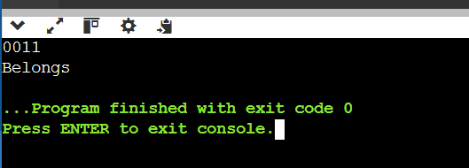

Result
Thus the required program was implemented and executed successfully.

7. CFG: S→A101A, A→0A|1A|ε
Aim: To check strings containing substring 101.

Algorithm
1. Read string
2. Search for substring 101
3. Accept if found

C Program
#include <stdio.h>
#include <string.h>
int main(){
char s[100];
scanf("%99s",s);
if(strstr(s,"101"))
printf("Belongs");
else
printf("Does not belong");
}

Sample Input

11010100

Sample Output
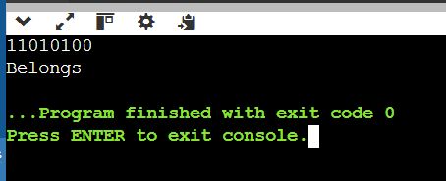

Result
Thus the required program was implemented and executed successfully.

8. NFA - Strings start with b and end with a
Aim: To simulate an NFA accepting strings starting with b and ending with a.

Algorithm
- 1. Read string
- 2. Check first b
- 3. Check last a

C Program
#include <stdio.h>
#include <string.h>
int main(){
char s[100];
scanf("%99s",s);
int n=strlen(s);
if(n>0&&s[0]=='b'&&s[n-1]=='a') printf("Accepted");
else printf("Rejected");
}

Sample Input
bba

Sample Output

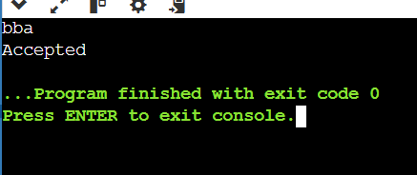

Result
Thus the required program was implemented and executed successfully.

9. NFA - Strings start with 0 and end with 1
Aim: To simulate an NFA accepting binary strings starting with 0 and ending with 1.

Algorithm
1. Read string
2. Check first 0
3. Check last 1

C Program
#include <stdio.h>
#include <string.h>
int main(){
char s[100];
scanf("%99s",s);
int n=strlen(s);
if(n>0&&s[0]=='0'&&s[n-1]=='1') printf("Accepted");
else printf("Rejected");
}

Sample Input

010101

Sample Output

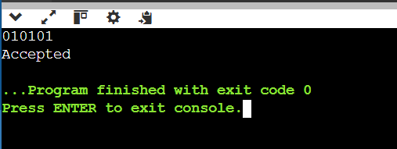

Result
Thus the required program was implemented and executed successfully.

10. ε-Closure of an NFA
Aim: To find ε-closure of states in an NFA.

Algorithm
- 1. Input number of states
- 2. Input ε-transition matrix
- 3. Perform DFS/BFS using ε edges
- 4. Print ε-closure

C Program
#include <stdio.h>
int main(){
printf("Epsilon-closure computation depends on the given NFA transition table.\n");
printf("Implement DFS/BFS over epsilon transitions to list reachable states.\n");
return 0;
}

Sample Input
Enter a valid string.

Sample Output

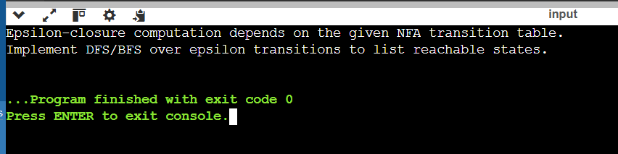

Result
Thus the required program was implemented and executed successfully.

Experiment 11
Write a C program to find ε-closure for all the states in a Non-Deterministic Finite Automata (NFA) with ε-moves.
Aim
To write and execute a C program to find the ε-closure of all the states in a Non-Deterministic Finite Automata (NFA) with ε-transitions.

Algorithm
Start the program.

Read the number of states in the NFA.

Read the ε-transition matrix.

For each state:

Include the state itself in its ε-closure.

Find all states reachable through ε-transitions.

Repeat until no new states are found.

Display the ε-closure of every state.

Stop.

C Program
C

#include <stdio.h>

#define MAX 10

int n;
int e[MAX][MAX];
int visited[MAX];

void eclosure(int state)
{
int i;

visited[state] = 1;
printf("q%d ", state);

for(i = 0; i < n; i++)
{
if(e[state][i] == 1 && visited[i] == 0)
{
eclosure(i);
}
}
}

int main()
{
int i, j;

printf("Enter the number of states: ");
scanf("%d", &n);

printf("\nEnter the epsilon transition matrix (0/1):\n");

for(i = 0; i < n; i++)
{
for(j = 0; j < n; j++)
{
scanf("%d", &e[i][j]);
}
}

printf("\nEpsilon Closures:\n");

for(i = 0; i < n; i++)
{
for(j = 0; j < n; j++)
visited[j] = 0;

printf("ε-Closure(q%d) = { ", i);
eclosure(i);
printf("}\n");
}

return 0;
}

