**Assignment 6:**

Pusalapati Chandu

192372119

1. **Calculating the Final Grade:**

public class StudentGrade {

public static void main(String[] args) {

String studentName = "Alice";

int assignmentScore = 85;

int midtermScore = 78;

int finalExamScore = 92;

String finalGrade;

double finalScore = (assignmentScore * 0.3) + (midtermScore * 0.3) + (finalExamScore * 0.4);

if (finalScore >= 90)

{

finalGrade = "A";

}

else if (finalScore >= 80)

{

finalGrade = "B";

}

else if (finalScore >= 70)

{

finalGrade = "C";

}

else if (finalScore >= 60)

{

finalGrade = "D";

}

else

{

finalGrade = "F";

}

System.out.println(studentName + "'s final grade is " + finalGrade + ".");

}

}

**Output:**

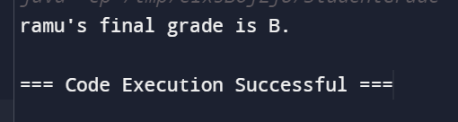

1. **Calculating the Mileage of a Car:**

public class CarMileage

{

public static void main(String[] args)

{

String carModel = "Toyota Camry";

double distanceTraveled = 300;

double fuelConsumed = 15;

double mileage;

mileage = distanceTraveled / fuelConsumed;

System.out.println("The mileage of " + carModel + " is " + mileage + " miles per gallon.");

}

}

**Output:**

1. **Calculating the Fine for Overdue Books:**

public class LibraryFine {

public static void main(String[] args) {

String bookTitle = "Harry Potter";

int daysOverdue = 5;

double finePerDay = 0.50;

double totalFine;

totalFine = daysOverdue * finePerDay;

System.out.println("The fine for " + bookTitle + " is $" + totalFine + ".");

}

}

**Output:**

