Business/Organization Overview:

1. Nature and Scope:
- The business focuses on providing fitness services, including personalized training, workout plans, nutrition guidance, and various activities.
- It encompasses a wide range of fitness-related activities to cater to diverse user needs.

2. Purpose of Database:
- The database is developed to efficiently manage and organize user-related information, fitness plans, schedules, payments, and preferences.
- It aims to enhance day-to-day operations by providing a centralized and structured data storage system.

3. Anticipated Functionalities and Features:
- Efficient tracking of user progress and fitness goals.
- Seamless integration with membership plans, workout plans, and nutrition plans.
- Simplified scheduling for users and trainers.
- Facilitation of payments and tracking of referrals.
- Effective management of fitness events and user preferences.
- Data-driven decision-making for improving overall business efficiency.

---

**User:**
- **Attributes:**
1. User ID (Primary Key)
2. User Progress
3. Fitness Goal
4. Trail Period

- **Relationships:**
- Membership Plan (Foreign Key referencing Membership Plan table)
- Schedule (Foreign Key referencing Schedule table)
- User Progress (Foreign Key referencing User Progress table)

---

**Trainer:**
- **Attributes:**
1. Trainer ID (Primary Key)
2. Personal Trainer
3. Pre-recorded Videos
4. Group Sessions

- **Relationships:**
- Membership Plan (Foreign Key referencing Membership Plan table)

---

**Workout Plan:**
- **Attributes:**
1. Plan ID (Primary Key)
2. Plan Type (e.g., Beginner, Intermediate, Advanced)

---

**Nutrition Plan:**
- **Attributes:**
1. Plan ID (Primary Key)
2. Linked Membership Plan (Foreign Key referencing Membership Plan table)

---

**Membership Plan:**
- **Attributes:**
1. Plan ID (Primary Key)
2. Trail Period
3. Silver
4. Gold
5. Diamond

- **Relationships:**
- Workout Plan (Foreign Key referencing Workout Plan table)
- Nutrition Plan (Foreign Key referencing Nutrition Plan table)
- Trainer (Foreign Key referencing Trainer table)

---

**Type of Activities:**
- **Attributes:**
1. Activity ID (Primary Key)
2. Activity Type (e.g., Yoga, Zumba)

---

**Schedule:**
- **Attributes:**
1. Schedule ID (Primary Key)
2. Start Date
3. End Date

- **Relationships:**
- User (Foreign Key referencing User table)
- Trainer (Foreign Key referencing Trainer table)

---

**Fitness Events:**
- **Attributes:**
1. Event ID (Primary Key)
2. Event Name
3. Date
4. Location

---

**User Progress:**
- **Attributes:**
1. Progress ID (Primary Key)
2. User ID (Foreign Key referencing User table)
3. Membership Plan (Foreign Key referencing Membership Plan table)

---

**Payments:**
- **Attributes:**
1. Payment ID (Primary Key)
2. User ID (Foreign Key referencing User table)
3. Membership Plan (Foreign Key referencing Membership Plan table)
4. Referrals
5. Method of Payment

---

**Fitness Goal:**
- **Attributes:**
1. Goal ID (Primary Key)
2. Goal Type (e.g., Weight Loss, Muscle Gain)

---

**User Preference:**
- **Attributes:**
1. Preference ID (Primary Key)
2. User ID (Foreign Key referencing User table)
3. Preferred Activities (Foreign Key referencing Type of Activities table)

This structured database schema aims to support the business by effectively managing and organizing data, ultimately improving operational efficiency and decision-making processes.

TRIAL 1

### Entities:

1. **User:**
- UserID (Primary Key)
- Username
- Email
- Password
- FirstName
- LastName
- Birthdate

2. **FitnessPlan:**
- PlanID (Primary Key)
- PlanName
- Description
- Duration
- DifficultyLevel

3. **Exercise:**
- ExerciseID (Primary Key)
- ExerciseName
- Description
- DifficultyLevel

4. **WorkoutSession:**
- SessionID (Primary Key)
- Date
- Duration
- CaloriesBurned

### Specialization Rules:

- **PremiumUser (Subtype of User):**
- PremiumUserID (Primary Key, Foreign Key referencing User.UserID)
- SubscriptionDate
- SubscriptionStatus

- **FreeUser (Subtype of User):**
- FreeUserID (Primary Key, Foreign Key referencing User.UserID)
- RegistrationDate

### Disjoint and Overlap Rules:

- **User Type (Disjoint):**
- PremiumUser XOR FreeUser (A user can either be a premium user or a free user, but not both)

### Supertype/Subtype Hierarchy:

- **User Type (Supertype):**
- UserID (Primary Key)
- Username
- Email
- Password
- FirstName
- LastName
- Birthdate

### Entity Clustering:

- **UserAccount (Clustered Entity):**
- UserID (Primary Key)
- Username
- Email
- Password

### Associative Entity:

- **UserFitnessRecord:**
- RecordID (Primary Key)
- UserID (Foreign Key referencing User.UserID)
- ExerciseID (Foreign Key referencing Exercise.ExerciseID)
- SessionID (Foreign Key referencing WorkoutSession.SessionID)
- CompletionStatus
- Rating

### Relationships:

- **UserPlans (Many-to-Many between User and FitnessPlan):**
- UserID (Foreign Key referencing User.UserID)
- PlanID (Foreign Key referencing FitnessPlan.PlanID)
- StartDate
- CompletionStatus

- **PlanExercises (Many-to-Many between FitnessPlan and Exercise):**
- PlanID (Foreign Key referencing FitnessPlan.PlanID)
- ExerciseID (Foreign Key referencing Exercise.ExerciseID)
- Sets
- Repetitions

- **UserSessions (Many-to-Many between User and WorkoutSession):**
- UserID (Foreign Key referencing User.UserID)
- SessionID (Foreign Key referencing WorkoutSession.SessionID)

### Cardinality and Degree:

- User to UserPlans: 1 to Many (A user can have multiple fitness plans)
- FitnessPlan to PlanExercises: Many to Many (A fitness plan can have multiple exercises, and an exercise can be part of multiple plans)
- User to UserSessions: Many to Many (A user can have multiple workout sessions, and a session can have multiple users)
- UserFitnessRecord: Many to Many (A user can have multiple fitness records, and a record can include multiple exercises and sessions)

This ER diagram represents a comprehensive structure for an online fitness platform with various entities, relationships, and rules to capture the complexity of user interactions, fitness plans, exercises, and workout sessions.

// Use DBML to define your database structure
// Docs: https://dbml.dbdiagram.io/docs

Table User {
UserID int [pk]
Username varchar
Email varchar
Password varchar
FirstName varchar
LastName varchar
Birthdate date
}

Table PremiumUser {
PremiumUserID int [pk]
SubscriptionDate date
SubscriptionStatus varchar
}

Table FreeUser {
FreeUserID int [pk]
RegistrationDate date
}

Table UserAccount {
UserID int [pk]
Username varchar
Email varchar
Password varchar
}

Table FitnessPlan {
PlanID int [pk]
PlanName varchar
Description text
Duration int
DifficultyLevel varchar
}

Table Exercise {
ExerciseID int [pk]
ExerciseName varchar
Description text
DifficultyLevel varchar
}

Table WorkoutSession {
SessionID int [pk]
Date date
Duration int
CaloriesBurned int
}

Table UserPlans {
UserID int [ref: > User.UserID]
PlanID int [ref: > FitnessPlan.PlanID]
StartDate date
CompletionStatus varchar
}

Table PlanExercises {
PlanID int [ref: > FitnessPlan.PlanID]
ExerciseID int [ref: > Exercise.ExerciseID]
Sets int
Repetitions int
}

Table UserSessions {
UserID int [ref: > User.UserID]
SessionID int [ref: > WorkoutSession.SessionID]
}

Table UserFitnessRecord {
RecordID int [pk]
UserID int [ref: > User.UserID]
ExerciseID int [ref: > Exercise.ExerciseID]
SessionID int [ref: > WorkoutSession.SessionID]
CompletionStatus varchar
Rating int
}

TRIAL 2

Entities:

User:

UserID (PK)
Username
Email
Password
FirstName
LastName
Gender
DateOfBirth
Trainer:

TrainerID (PK)
UserID (FK)
Specialization
Customer:

CustomerID (PK)
UserID (FK)
FitnessLevel
SubscriptionStatus
Exercise:

ExerciseID (PK)
ExerciseName
Description
DifficultyLevel
WorkoutPlan:

PlanID (PK)
PlanName
Description
ExerciseInPlan:

PlanID (FK)
ExerciseID (FK)
Sets
Repetitions
Session:

SessionID (PK)
TrainerID (FK)
CustomerID (FK)
Date
Duration
Feedback:

FeedbackID (PK)
SessionID (FK)
Rating
Comment
Payment:

PaymentID (PK)
CustomerID (FK)
Amount
PaymentDate
Equipment:

EquipmentID (PK)
EquipmentName
Description
UserEquipment:

UserID (FK)
EquipmentID (FK)
PurchaseDate
BlogPost:

PostID (PK)
UserID (FK)
Title
Content
PostDate
Relationships:

Trainer-Customer (1:1):

TrainerID (Trainer) - TrainerID (User)
CustomerID (Customer) - CustomerID (User)
User-Trainer (1:1):

UserID (User) - TrainerID (Trainer)
User-Customer (1:1):

UserID (User) - CustomerID (Customer)
Trainer-Session (1:N):

TrainerID (Trainer) - TrainerID (Session)
Customer-Session (1:N):

CustomerID (Customer) - CustomerID (Session)
Exercise-ExerciseInPlan (M:N):

ExerciseID (Exercise) - ExerciseID (ExerciseInPlan)
PlanID (WorkoutPlan) - PlanID (ExerciseInPlan)
Session-Feedback (1:N):

SessionID (Session) - SessionID (Feedback)
Customer-Payment (1:N):

CustomerID (Customer) - CustomerID (Payment)
User-UserEquipment (M:N):

UserID (User) - UserID (UserEquipment)
EquipmentID (Equipment) - EquipmentID (UserEquipment)
User-BlogPost (1:N):

UserID (User) - UserID (BlogPost)
Specialization Rules:

User:

Disjoint: Yes (Trainer and Customer are exclusive)
Overlap: No (A user cannot be both a Trainer and a Customer)
Exercise:

Disjoint: No (An exercise can be part of multiple workout plans)
Overlap: Yes (An exercise can exist independently)
Supertype/Subtype Hierarchy:

User (Supertype):

Trainer (Subtype)
Customer (Subtype)
Exercise (Supertype):

ExerciseInPlan (Subtype)
Associative Entity:

ExerciseInPlan:
Resolves the M:N relationship between Exercise and WorkoutPlan.
Entity Clustering:

User and Trainer:

Grouped together as they share common attributes.
User and Customer:

Grouped together as they share common attributes.

Table User {
UserID Int [PK]
Username String
Email String
Password String
FirstName String
LastName String
Gender String
DateOfBirth Date
}

Table Trainer {
TrainerID Int [PK]
Specialization String
UserID Int [Ref: > User.UserID]
}

Table Customer {
CustomerID Int [PK]
FitnessLevel String
SubscriptionStatus String
UserID Int [Ref: > User.UserID]
}

Table Exercise {
ExerciseID Int [PK]
ExerciseName String
Description Text
DifficultyLevel String
}

Table WorkoutPlan {
PlanID Int [PK]
PlanName String
Description Text
}

Table ExerciseInPlan {
PlanID Int [Ref: > WorkoutPlan.PlanID]
ExerciseID Int [Ref: > Exercise.ExerciseID]
Sets Int
Repetitions Int
}

Table Session {
SessionID Int [PK]
Date Date
Duration Int
TrainerID Int [Ref: > Trainer.TrainerID]
CustomerID Int [Ref: > Customer.CustomerID]
}

Table Feedback {
FeedbackID Int [PK]
Rating Int
Comment Text
SessionID Int [Ref: > Session.SessionID]
}

Table Payment {
PaymentID Int [PK]
Amount Decimal
PaymentDate Date
CustomerID Int [Ref: > Customer.CustomerID]
}

Table Equipment {
EquipmentID Int [PK]
EquipmentName String
Description Text
}

Table UserEquipment {
UserID Int [Ref: > User.UserID]
EquipmentID Int [Ref: > Equipment.EquipmentID]
PurchaseDate Date
}

Table BlogPost {
PostID Int [PK]
Title String
Content Text
PostDate Date
UserID Int [Ref: > User.UserID]
}

References
https://www.researchgate.net/publication/320284487_Usability_Testing_of_Fitness_Mobile_Application_Methodology_and_Quantitative_Results

https://everfit.io/?utm_campaign=J2F%20%7C%20PT%20Keywords%20%7C%20V1%20%7C%202022_05_27&utm_source=adwords&utm_term=fitness%20software&utm_medium=ppc&hsa_acc=9263320399&hsa_cam=17337457198&hsa_grp=140128963827&hsa_ad=600535526550&hsa_src=g&hsa_tgt=kwd-15365810&hsa_kw=fitness%20software&hsa_mt=b&hsa_net=adwords&hsa_ver=3&gad_source=1&gclid=CjwKCAiAxaCvBhBaEiwAvsLmWODWV1ijDjJsQOKvbXSxWuOzPC9481I7PXQLiO0zhnNlzITnyBDWORoCoTEQAvD_BwE

https://vertabelo.com/blog/health-is-wealth-a-data-model-to-keep-track-of-your-most-precious-possession/

https://www.dittofi.com/learn/how-to-design-a-data-model-for-a-workout-tracking-app

https://mlsdev.com/blog/create-a-fitness-app

https://topflightapps.com/ideas/how-to-build-a-fitness-app/

https://softwareengineering.stackexchange.com/questions/226189/designing-a-fitness-weight-lifiting-routine-database

https://ddi-dev.com/blog/case/how-weve-created-a-fitness-app/

https://1000projects.org/gym-fitness-management-system-python-project-using-django-html5-css-js-mysql.html

https://www.academia.edu/38709662/Gym_club_management_System_for_Bahir_Dar_Gym
https://chloeting.com/program/2024/weight-loss-challenge

For diagrams
https://dbdiagram.io/d

https://mermaid.live/view#pako:eNqVlN9ugyAUxl_FcN2-gHdLui1L9sesXZYs3jA5VlIFc8AmxvbdB1Zri7Y4Lwh6fh_nO3CkIYlkQEICuOJ0i7SIRWCeLwUYHA7LpWzaeYRyi6BUEAYxaYMvq5iM2SeuhcGeJc196AYpzyNALtltVLboGxS_gCrjZZRT4aPXSQasysHH-eo6jdamGFxPWOmJQeloviXuZKXvCE7jJXc7XTtxpe-VRq65FB7xKxc7YBeRwIau13Jk3W65RTg2pkXXtmbL-g26t1mbuoSP9CHRfG8ygOqLvjr9LlyP1GfqosenesDl5jjr_oHHPQitfAmGtjy3okcxxU6c9N0jjmhdzHHncv_N8wkpINJcjYu1ERAJzCvXpUen3_ZWi6Hp7yFglyELUgAWlDNz0TV22ZjoDAqIiZUxSGmVa0seDUorLde1SEiYGuOwIFXJqIbuejx_Lan4kbJ_P_4BiHu2wg

https://lucid.app/documents#/documents?folder_id=recent

https://app.hubql.com/?file=fil_b00654308ac842ae85040c152efe72fe

Entities:

User:

UserID (PK)
Username
Email
Password
FirstName
LastName
Gender
DateOfBirth
Trainer:

TrainerID (PK)
UserID (FK)
Specialization
Customer:

CustomerID (PK)
UserID (FK)
FitnessLevel
SubscriptionStatus
Exercise:

ExerciseID (PK)
ExerciseName
Description
DifficultyLevel
WorkoutPlan:

PlanID (PK)
PlanName
Description
ExerciseInPlan:

PlanID (FK)
ExerciseID (FK)
Sets
Repetitions
Session:

SessionID (PK)
TrainerID (FK)
CustomerID (FK)
Date
Duration
Feedback:

FeedbackID (PK)
SessionID (FK)
Rating
Comment
Payment:

PaymentID (PK)
CustomerID (FK)
Amount
PaymentDate
Equipment:

EquipmentID (PK)
EquipmentName
Description
UserEquipment:

UserID (FK)
EquipmentID (FK)
PurchaseDate
BlogPost:

PostID (PK)
UserID (FK)
Title
Content
PostDate
Relationships:

Trainer-Customer (1:1):

TrainerID (Trainer) - TrainerID (User)
CustomerID (Customer) - CustomerID (User)
User-Trainer (1:1):

UserID (User) - TrainerID (Trainer)
User-Customer (1:1):

UserID (User) - CustomerID (Customer)
Trainer-Session (1:N):

TrainerID (Trainer) - TrainerID (Session)
Customer-Session (1:N):

CustomerID (Customer) - CustomerID (Session)
Exercise-ExerciseInPlan (M:N):

ExerciseID (Exercise) - ExerciseID (ExerciseInPlan)
PlanID (WorkoutPlan) - PlanID (ExerciseInPlan)
Session-Feedback (1:N):

SessionID (Session) - SessionID (Feedback)
Customer-Payment (1:N):

CustomerID (Customer) - CustomerID (Payment)
User-UserEquipment (M:N):

UserID (User) - UserID (UserEquipment)
EquipmentID (Equipment) - EquipmentID (UserEquipment)
User-BlogPost (1:N):

UserID (User) - UserID (BlogPost)
Specialization Rules:

User:

Disjoint: Yes (Trainer and Customer are exclusive)
Overlap: No (A user cannot be both a Trainer and a Customer)
Exercise:

Disjoint: No (An exercise can be part of multiple workout plans)
Overlap: Yes (An exercise can exist independently)
Supertype/Subtype Hierarchy:

User (Supertype):

Trainer (Subtype)
Customer (Subtype)
Exercise (Supertype):

ExerciseInPlan (Subtype)
Associative Entity:

ExerciseInPlan:
Resolves the M:N relationship between Exercise and WorkoutPlan.
Entity Clustering:

User and Trainer:

Grouped together as they share common attributes.
User and Customer:

Grouped together as they share common attributes.

FINALLL
Explanation:

User_Trainer and User_Customer: Represent the M:N relationship between User and Trainer/Customer.
Customer_Payment: Represents the M:N relationship between Customer and Payment.
WorkoutPlan_ExercisePlan: Represents the M:N relationship between WorkoutPlan and ExercisePlan.
Membership_User: Represents the M:N relationship between Membership and User.
Session_Feedback: Represents the M:N relationship between Session and Feedback.
WorkoutPlan_NutritionPlan: Represents the M:N relationship between WorkoutPlan and NutritionPlan.
Specialization Rules:

User:

Disjoint: Yes (Trainer and Customer are exclusive)
Overlap: No (A user cannot be both a Trainer and a Customer)
Session:

Disjoint: Yes (Online and Personal sessions are exclusive)
Overlap: No (A session cannot be both online and personal)
Membership:

Disjoint: Yes (Gold, Silver, and Diamond are exclusive)
Overlap: No (A membership cannot be both Gold and Silver, for example)
Supertype/Subtype Hierarchy:

User (Supertype):

Trainer (Subtype)
Customer (Subtype)
Session (Supertype):

Online (Subtype)
Personal (Subtype)
Membership (Supertype):

Gold (Subtype)
Silver (Subtype)
Diamond (Subtype)
Associative Entity:

User_Trainer, User_Customer, Customer_Payment, WorkoutPlan_ExercisePlan, Membership_User, Session_Feedback, WorkoutPlan_NutritionPlan: These tables represent associative entities resolving M:N relationships.
Entity Clustering:

User and Trainer
User and Customer

[User]
- UserID (PK)
- Username
- Email
- Password
- FirstName
- LastName
- Gender
- DateOfBirth

[Login]
- LoginID (PK)
- UserID (FK)
- LoginTime
- LogoutTime

[Trainer]
- TrainerID (PK)
- UserID (FK)
- Specialization

[Customer]
- CustomerID (PK)
- UserID (FK)
- FitnessLevel
- SubscriptionStatus

[WorkoutPlan]
- PlanID (PK)
- PlanName
- Description

[ExercisePlan]
- PlanID (PK)
- ExerciseID (PK)
- Sets
- Repetitions

[Exercise]
- ExerciseID (PK)
- ExerciseName
- Description
- DifficultyLevel

[Session]
- SessionID (PK)
- TrainerID (FK)
- CustomerID (FK)
- Date
- Duration

[Feedback]
- FeedbackID (PK)
- SessionID (FK)
- Rating
- Comment

[Membership]
- MembershipID (PK)
- MembershipType

[Gold]
- MembershipID (PK) (FK)
- AdditionalGoldFeature

[Silver]
- MembershipID (PK) (FK)
- AdditionalSilverFeature

[Diamond]
- MembershipID (PK) (FK)
- AdditionalDiamondFeature

[Online]
- SessionID (PK) (FK)
- OnlineDetails

[Personal]
- SessionID (PK) (FK)
- PersonalDetails

[NutritionPlan]
- PlanID (PK) (FK)
- PlanDetails

[User_Trainer]
- UserID (PK) (FK)
- TrainerID (PK) (FK)

[User_Customer]
- UserID (PK) (FK)
- CustomerID (PK) (FK)

[Customer_Payment]
- CustomerID (PK) (FK)
- PaymentID (PK) (FK)

[WorkoutPlan_ExercisePlan]
- PlanID (PK) (FK)
- ExerciseID (PK) (FK)

[Membership_User]
- MembershipID (PK) (FK)
- UserID (PK) (FK)

[Session_Feedback]
- SessionID (PK) (FK)
- FeedbackID (PK) (FK)

[WorkoutPlan_NutritionPlan]
- PlanID (PK) (FK)
- NutritionPlanID (PK) (FK)

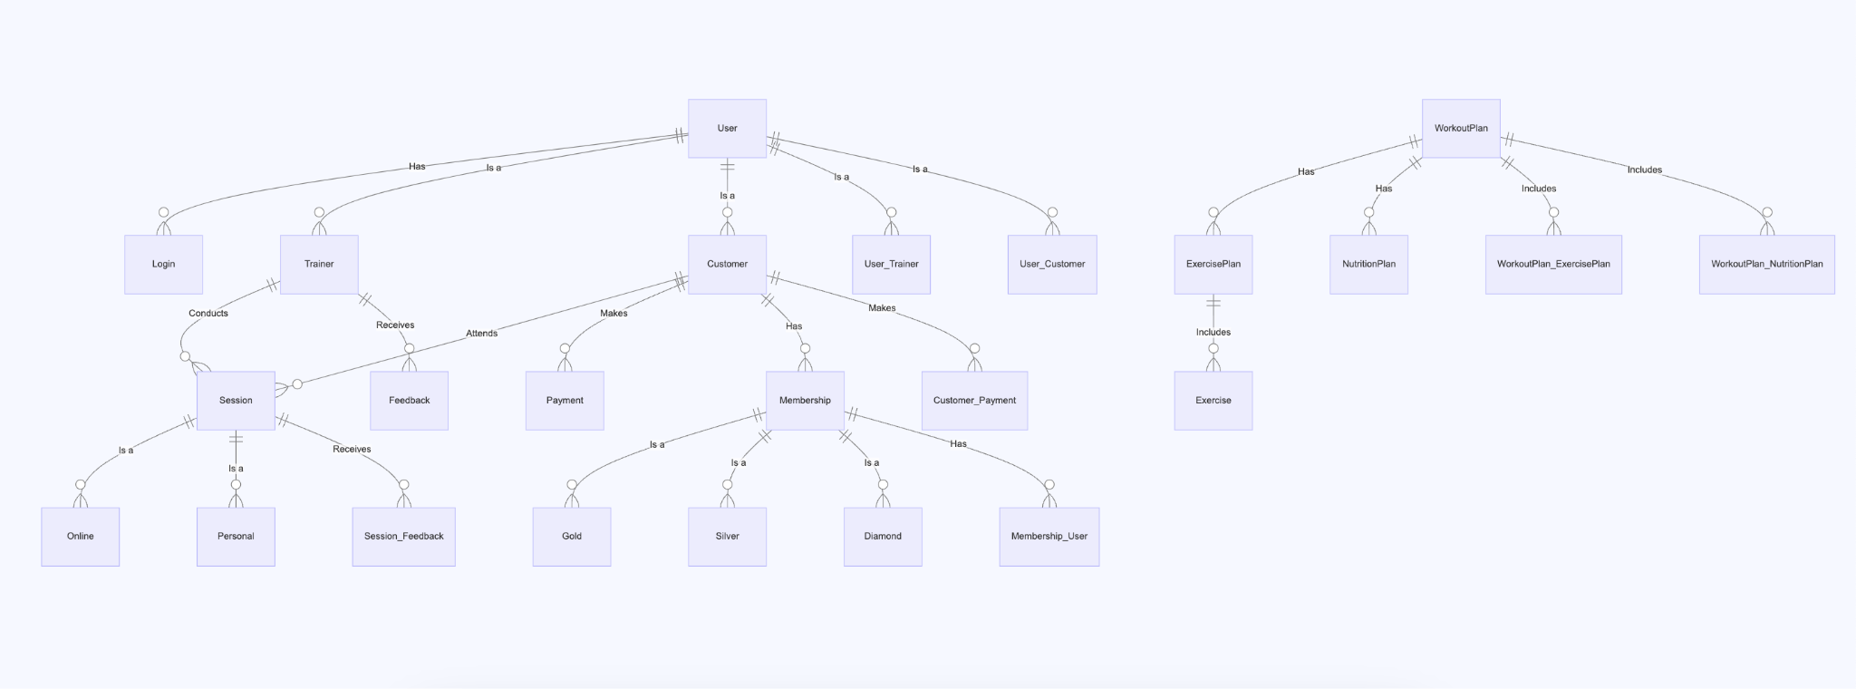

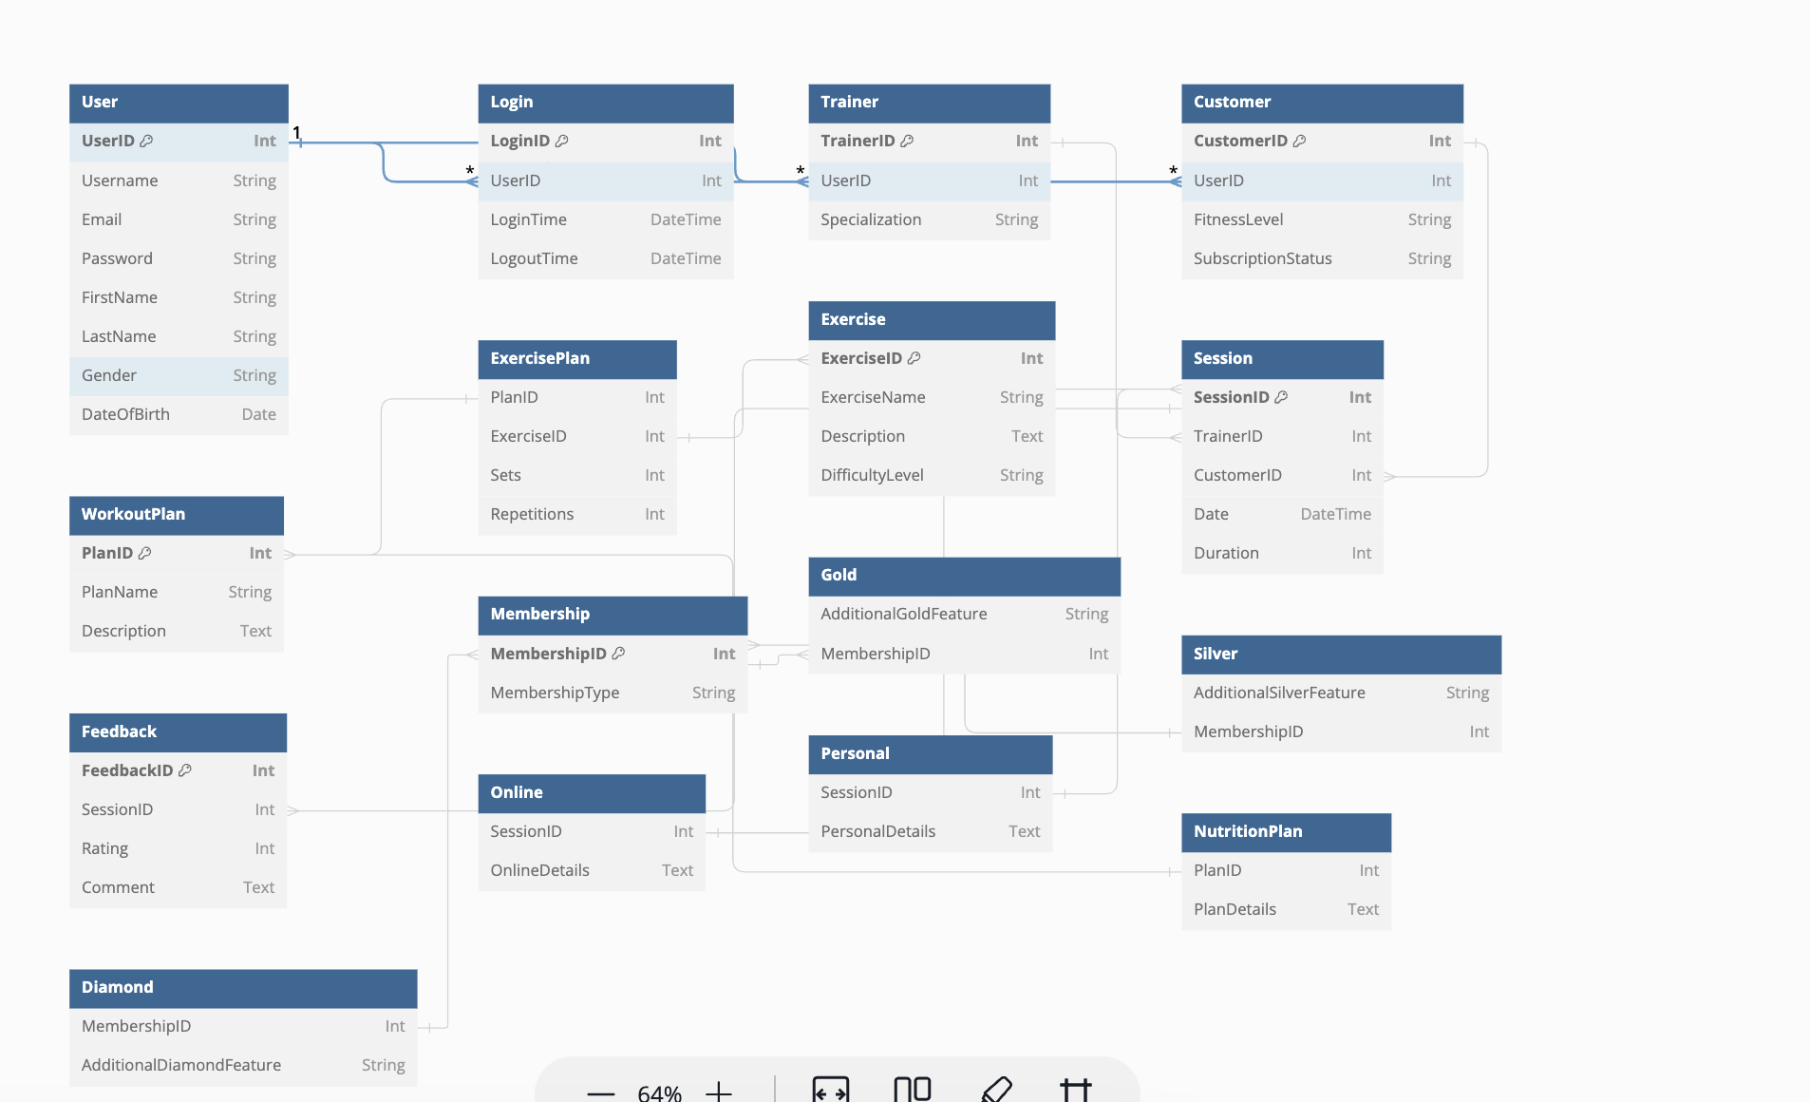

Pending things to do

- Feedback - associative entity
- we need to name relationships
- Payment is sep table so if customer leaves, we can still see how much they paid, if anything is pending…etc
- Feedback is sep bec if a customer leaves we can still see their feedbacks

