

International School

Capstone Project 1
CMU-SE 450

Architecture Design
Version 1.1
Date: September 30, 2026

AI-Powered Learning Support System for Students
Submitted by C1SE.64
Hao, Nguyen Du Nhat
Tuan, Nguyen Dac Quoc
Lanh, Mai Thi
Tien, Nguyen Cong
Phi, Nguyen Dinh

Approved by
MSc Duc, Nguyen Manh

Proposal Review Panel Representative:

Name Signature Date

Capstone Project 1- Mentor:

Name Signature Date
PROJECT INFORMATION

Project acronym | EduSense
Project Title | EduSense: AI-Powered Learning Support System for Students
Start Date | August 24, 2026 | End Date | September 30, 2026
Lead Institution | International School, Duy Tan University
Project Mentor | MSc Duc, Nguyen Manh  Email: ducnm@duytan.edu.vn  Tel: 0905159359
Scrum master / Project Leader & contact details | Hao, Nguyen Du Nhat  Email: haonguyen30102005@gmail.com  Tel: 0936212369
Partner Organization | Duy Tan University
Project Web URL
Team members | Name | Email |  | Tel
29219023675 | Hao, Nguyen Du Nhat | haonguyen30102005@gmail.com |  | 0359791713
29219048338 | Tuan, Nguyen Dac Quoc | tuanff125325@gmail.com |  | 0343030053
29201160157 | Lanh, Mai Thi | mailanh1562005@gmail.com |  | 0385438258
29219037446 | Tien, Nguyen Cong | tien120405@gmail.com |  | 0379444801
29211355447 | Phi, Nguyen Dinh | phinguyen18112005@gmail.com |  | 0359575089

DOCUMENT APPROVALS
The following signatures are required for approval of this document.
Hao, Nguyen Du Nhat  Student ID: 29219023675  Scrum Master | Signature | Date
Tuan, Nguyen Dac Quoc Student ID: 29219048338  Team Member | Signature | Date
Lanh, Mai Thi  Student ID: 29201160157  Team Member | Signature | Date
Tien, Nguyen Cong  Student ID: 29219037446  Team Member | Signature | Date
Phi, Nguyen Dinh  Student ID: 29211355447  Team Member | Signature | Date

REVISION HISTORY

Version | Date | Comments | Author
1.0 | September 19, 2026 | Initial release | C1SE.64 Team
1.1 | September 30, 2026 | Update | Quoc Tuan

Menu
1. INTRODUCTION 1
1.1. Background and Problem Statement 1
1.2. Reference Documents 1
1.3. Purpose of the Document 1
1.4. Scope 2
2. ARCHITECTURALLY SIGNIFICANT REQUIREMENTS (ASRs) 2
2.1. Business Goals and Constraints 2
2.2. Quality Attribute Scenarios Table 5
3. ARCHITECTURAL DESIGN DECISIONS 7
3.1. Design Iterations 7
3.2. Applied Tactics 8
3.3. Responsibilities of Elements 10
3.4. Interfaces Between Elements 10
4. SYSTEM ARCHITECTURE USING THE C4 MODEL. 11
4.1. Level 1 - System Context Diagram 11
4.2. Level 2 - Container Diagram 16
4.2.1. Component and Connector View (C&C view). 16
4.2.2. Module View 19
4.3. Level 3 - Component Diagram: 21
4.3.1. AI Service 22
4.3.2. API Backend 25
4.3.3. Background Worker 31
4.4. Level 4 - Code (Organizational Principles) 34
4.4.1. API Backend (FastAPI) 34
4.4.2. AI Service (Python) 35
4.4.3. Background Worker (Celery) 35
4.4.4. Two Key Processing Flows 36
4.5. Deployment View. 39
5. MAIN FLOW: DOCUMENT BASED Q&A (RAG). 41
6. TRACEABILITY TABLE: QUALITY ATTRIBUTE → TACTIC → DECISION → C4 43
7. TECHNOLOGIES APPLIED PER CONTAINER 45
8. ARCHITECTURAL RISKS AND MITIGATION 48
9. CONCLUSION 54

Figure Table
Figure 1. C4 Level 1 - System Context Diagram 15
Figure 2. C4 Level 2 - Container Diagram 18
Figure 3. C4 Level 2 - Module View of the System 21
Figure 4. C4 Level 3 - Component Diagram (C&C View) of the AI Service 23
Figure 5. C4 Level 3 - Module View of the AI Service 25
Figure 6. C4 Level 3 - Component Diagram (C&C View) of the API Backend 28
Figure 7. C4 Level 3 - Module View of the API Backend 30
Figure 8. C4 Level 3 - Component Diagram (C&C View) of the Background Worker 32
Figure 9. C4 Level 3 - Module View of the Background Worker 34
Figure 10. C4 Level 4 - Class Diagram — Document Processing Task 37
Figure 11. C4 Level 4 - Class Diagram — Generation Module 38
Figure 12. Deployment View 39
Figure 13. Document-Based Q&A (RAG) Processing Flow 43

Table of tables
Table 1. Reference Documents 1
Table 2. Quality Attribute Scenario QAS-01 - Performance 5
Table 3. Quality Attribute Scenario QAS-02 - Reliability 5
Table 4. Quality Attribute Scenario QAS-03 - Security 6
Table 5. Quality Attribute Scenario QAS-04 - Cost Control 6
Table 6. Quality Attribute Scenario QAS-05 - AI/RAG Quality 7
Table 7. Three Design Iterations under Attribute-Driven Design (ADD). 8
Table 8. Applied Tactics for Iteration 1 8
Table 9. Applied Tactics for Iteration 2 9
Table 10. Applied Tactics for Iteration 3 9
Table 11. Traceability Table: Quality Attribute → Tactic → Design Decision → C4 43
Table 12. Supplementary Tactics (No Dedicated QAS Scenario) 44
Table 13. Technologies Applied per Container 46
Table 14. Architectural Risks and Mitigation 48

1. INTRODUCTION

1.1. Background and Problem Statement
EduSense is being built to address the fragmentation in how university students in Vietnam manage their studies. Students currently have to use many different tools to manage courses, assignments, exam schedules, notes, and documents. Meanwhile, popular AI chatbots such as ChatGPT, StudyX, or Notion AI are not directly connected to students' personal study materials, so their answers may not closely match what the student is actually studying.
Architecturally, EduSense must handle two groups of functionality with different characteristics at the same time:
- Study management: courses, assignments, exam schedules, and documents.
- AI/RAG: document search, information retrieval, and answer generation using Google Gemini.
Study management functions must be fast and stable, whereas AI/RAG functions have higher latency, variable cost, and depend on external services. The system therefore needs an architecture that is designed methodically rather than a simple CRUD architecture.

1.2. Reference Documents
Table 1. Reference Documents
# | Document | File Name
1 | Project Proposal | C1SE_64-Proposal-ver1.2.docx
2 | Product Backlog | C1SE_64-ProductBacklog-v1.1.docx
3 | User Stories | C1SE_64-UserStories-v1.1.docx

1.3. Purpose of the Document
This document aims to:
- Present how the EduSense architecture is designed based on the functional and non-functional requirements identified in the Project Proposal.
- Use Attribute-Driven Design (ADD) to select solutions suited to key requirements such as performance, scalability, reliability, security, and cost.
- Use the C4 Model to describe the architecture at four levels: System Context, Container, Component, and Code.
- Build a traceability table linking quality requirements, architectural decisions, and system components.
- Provide a foundation for the development team to implement the correct system structure and to extend it easily in later phases.

1.4. Scope
This document covers the architecture of the entire EduSense system, including:
- Phase 1 – MVP: account management, courses, assignments, exam schedules, document upload, and a basic AI/RAG chatbot, basic AI usage quota.
- Phase 2 – Expansion: document summarization, question bank generation, AI-assisted study planning, reminders, and AI cost control, Pro subscription plan, payment via SePay, automatic downgrade on expiry.
- Overall architecture design at the System Context and Container levels.
- More detailed design at the Component level for the AI Service, API Backend, and Background Worker, and organizational principles at the Code level.
- Focus on key non-functional requirements: Performance, Reliability, Security, Scalability, Cost Control, and AI/RAG Quality.

2. ARCHITECTURALLY SIGNIFICANT REQUIREMENTS (ASRs)

2.1. Business Goals and Constraints
Business Goals
- Provide an integrated study-support platform for Vietnamese university students that combines study management (courses, assignments, exam schedules) with an AI assistant "grounded" in the student's own study documents (RAG), rather than a general-purpose chatbot detached from personal data.
- Operate with AI costs that are predictable and controllable: because the system depends on an LLM provider billed per token (Google Gemini), AI costs must grow in a controlled way with the number of users and must not become unbounded.
- Ensure that the study-management experience (logging in, viewing documents, managing assignments/exam schedules) is always stable and responsive, even when AI tasks (summarization, question generation, RAG) are running heavily in the background.
- Support partial scaling: the AI/document-processing components have load characteristics very different from the business CRUD components, so they must be able to scale independently as the number of users and the volume of documents grow.
- Protect students' personal study data (documents, progress, account information) and comply with basic privacy principles (deleting data on request, limiting the data sent out to third-party AI providers).
Architectural Constraints
- The technology stack is predetermined: Vue.js frontend, Python/FastAPI backend, PostgreSQL with pgvector for both business data and vector embeddings, MinIO for file storage, Celery + Redis for background task queues, JWT + RBAC for authentication, and containerization with Docker/Docker Compose.
- The AI provider is fixed as Google Gemini (LLM: Gemini 3.5 Flash; Embedding: Gemini Embedding). The architecture must isolate this dependency behind an interface layer so that another provider can be substituted later with minimal impact on the rest of the system.
- The system must operate stably under the initial target load at a medium scale (about 50–100 concurrent users in load testing). A large-scale distributed architecture is not required from the outset, but the design must not block future scalability.
- Development time and resources are limited (a small team working sprint by sprint), so the architecture must be simple to deploy and operate in the early phase, favoring a service-based architecture with a shared database (three main services plus a shared library) over a full microservices architecture from the start.
- The initial deployment environment is containerized on a simple cloud/on-prem platform (no assumption that Kubernetes or complex distributed infrastructure is available).

2.2. Quality Attribute Scenarios Table
Table 2. Quality Attribute Scenario QAS-01 - Performance
Element | Content
Quality Attribute | Performance
Source | Student
Stimulus | Accessing documents, managing assignments/exam schedules
Artifact | API Backend (FastAPI)
Environment | Normal runtime
Response | Handles and responds directly, unaffected by AI tasks running in the background
Response Measure | P95 ≤ 3 s and error rate < 1% at 50 concurrent users; AI chat/RAG P95 ≤ 15 s for successful requests, measured until the full answer is returned; long tasks (summarization, question generation) run asynchronously.

Table 3. Quality Attribute Scenario QAS-02 - Reliability
Element | Content
Quality Attribute | Reliability
Source | Google Gemini API
Stimulus | Slow response or temporary interruption
Artifact | AI Service / LLM & Embedding Adapter
Environment | Degraded (external provider)
Response | Limited retries, timeout, display of a fallback message
Response Measure | Study-management (non-AI) functions availability ≥ 99% even when Gemini is down; AI functions show a fallback message when Gemini is unavailable; error rate < 1%; Gemini timeout 10 s, max 1 retry (worst case about 20 s); circuit breaker opens after 5 failures and retries after 30 s; fallback message within 30 s.
Table 4. Quality Attribute Scenario QAS-03 - Security
Element | Content
Quality Attribute | Security
Source | Any user (including attack behavior)
Stimulus | Missing/invalid token, incorrect access rights
Artifact | API Backend (Auth Module)
Environment | Normal runtime
Response | Access denied, no data exposed, security event logged
Response Measure | 100% of APIs reject invalid tokens (401) and wrong roles (403); passwords hashed with bcrypt; access token 15 min, refresh token 7 days; 0 high-severity OWASP ZAP findings.
Table 5. Quality Attribute Scenario QAS-04 - Cost Control
Element | Content
Quality Attribute | Cost Control
Source | Student
Stimulus | Sending many AI requests in succession
Artifact | Quota Manager
Environment | Normal runtime
Response | Check quota before calling AI; reject/warn when exceeded
Response Measure | 100% of Gemini calls (from the AI Service and the Background Worker) are recorded (tokens, cost); 100% of AI requests (including summarization) sent after a student's quota is used up are rejected before any call to Gemini; default quota is 10 AI requests/day (Free) and 150 AI requests/day (Pro); a warning is shown at 80% of quota; if Redis is unreachable, requests are rejected.

Table 6. Quality Attribute Scenario QAS-05 - AI/RAG Quality
Element | Content
Quality Attribute | AI/RAG Quality (project-specific attribute, related to Functional suitability / accuracy)
Source | Student
Stimulus | Asks a question related to uploaded documents
Artifact | AI/RAG Service
Environment | Normal runtime
Response | Retrieves the most relevant content chunks and generates an answer with source citations
Response Measure | Top-K = 5; on a 30-question golden set (≥ 10 unanswerable): citations ≥ 90%, accuracy ≥ 80%, faithfulness ≥ 85%; ≥ 90% of unanswerable queries return "no information found".

3. ARCHITECTURAL DESIGN DECISIONS

3.1. Design Iterations
The architecture was built through three successive iterations, each driven by a specific group of quality attributes (Section 2.2), instead of designing the entire system in a single step.
Table 7. Three Design Iterations under Attribute-Driven Design (ADD).
Iteration | Design Goal | Driving Quality Attribute (Driver)
Iteration 1 | Split the whole system into containers, separating study-management logic from AI workloads. Concept: layered architecture with services separated by workload. | Performance (QAS-01)
Iteration 2 | Design asynchronous processing and recovery from external-service failures across the API Backend, AI Service, and Background Worker. Concept: task queue. | Reliability (QAS-02)
Iteration 3 | Break the AI Service into internal components for security, cost control, and RAG quality. Concept: AI integration interface layer (AI Service Facade). | Security, Cost Control, AI/RAG Quality (QAS-03, QAS-04, QAS-05)
The AI Service is refined most deeply because it concentrates most of the system's risks: high latency, dependence on a third-party provider, usage-dependent cost, and a quality requirement (QAS-05) that no other container has.

3.2. Applied Tactics
Iteration 1:
Table 8. Applied Tactics for Iteration 1
Driver | Applied Tactic | Rationale
QAS-01 | Separate the AI Service into a process independent of the API Backend | Prevent high-latency AI workloads from affecting the response time of ordinary business operations
NFR05 | Allow resources to be scaled independently per container | Increase the number of AI Service processes or workers when needed, without affecting the Web Client and API Backend

Iteration 2:
Table 9. Applied Tactics for Iteration 2
Driver | Applied Tactic | Rationale
QAS-02 | Parallel processing with workers (Celery) | Ensure that time-consuming tasks - text extraction, embedding generation, summarization, question generation - do not slow down the responses to primary requests
QAS-02 | Bounded retries, timeouts, and a circuit breaker upon persistent failures when calling the Gemini API | Isolate faults from the external AI provider and prevent errors from propagating across the whole system
NFR10 | Periodic data backup and restore | Ensure recoverability when a failure occurs at the storage layer

Iteration 3:
Table 10. Applied Tactics for Iteration 3
Driver | Applied Tactic | Rationale
QAS-03 | Authenticate, authorize, and validate input data before processing | Every request is checked for JWT/RBAC at the API Backend, requests into the AI Service are checked by an internal service token, and uploaded files are validated before processing
QAS-04 | Rate limiting and usage quota tracking via Redis | Prevent AI costs from spiraling out of control as usage traffic increases
QAS-05 | Separate the retrieval step from the generation step in the RAG pipeline | Ensure answers are always checked for grounding before being returned, limiting erroneous inference
NFR06 | Abstract the AI provider behind a common interface layer | Allow the LLM provider or vector database to be replaced without affecting other business modules

3.3. Responsibilities of Elements
Responsibilities are allocated as follows (detailed as diagrams in Section 4):
- Web Client: handles the user interface; does not process business logic.
- API Backend: authentication, authorization, study-management business logic (courses, assignments, exam schedules, documents), and orchestration of requests to the AI Service and Background Worker.
- AI Service: processes AI requests (chat, RAG Q&A, summarization, question generation, study planning), performs semantic retrieval, builds prompts, calls the LLM Provider, and enforces usage quota control.
- Background Worker & Scheduler: asynchronous tasks such as text extraction, embedding generation, long-document summarization, and sending reminder emails.
- Data Layer: PostgreSQL stores business data, pgvector stores embeddings, MinIO stores original documents, and Redis serves caching, usage quotas, and the task queue.
- Notification Module: reads and displays notifications and marks them as read.
- Subscription Module: manages plan purchases, verifies SePay webhooks, and coordinates with the Scheduler/Background Worker to downgrade an expired subscription to Free.
- Email Sender Task (Background Worker): generates and sends notifications/emails, avoiding duplicates through the Idempotency Guard.

3.4. Interfaces Between Elements
- Web Client ↔ API Backend: REST API over HTTPS, authenticated with JWT (access token plus refresh token).
- API Backend ↔ AI Service: internal interface, authenticated by an internal service token and carrying user_id, plan, and the scope of documents the user may access.
- AI Service / Background Worker ↔ LLM/Embedding Provider: through the shared adapter interface; no other module may call the provider's SDK directly.
- API Backend / AI Service ↔ Background Worker: indirectly via the task queue (Celery with Redis as broker); no direct synchronous calls.
- All components ↔ Data Layer: through the data access layer (repository); the presentation layer may not access the database directly.
- Long AI tasks (summarization, question-bank generation, study planning): the API Backend returns a job_id immediately; the Web Client polls the job status until the result or error is available. The job status and result are stored in PostgreSQL.

4. SYSTEM ARCHITECTURE USING THE C4 MODEL.

4.1. Level 1 - System Context Diagram
- The AI-Powered Learning Support System will be designed using a layered, modular architecture. The web client, core business API, AI processing functions, data services, and background workers are separated by clear interfaces. This approach is selected because the system combines conventional learning-management operations with long-running and cost-sensitive AI workloads.
- The architecture can initially be deployed as a modular backend with independent worker processes. The AI service and background-processing components can later be separated and scaled independently without requiring the entire application to be redesigned. The main architectural considerations are:
- Separation of concerns: The Vue.js frontend handles presentation and user interaction; the FastAPI backend enforces business rules and security; the AI service handles RAG; and the data layer manages structured data and vectors.
- Independent scalability: AI chat, document indexing, summarization, and question generation can consume substantially more resources than account or task management. AI workers and document-processing workers can therefore be scaled separately according to workload.
- Asynchronous processing: Time-consuming operations such as text extraction, chunking, embedding generation, long-document summarization, question-bank generation, and scheduled email delivery are executed through Celery or RQ workers so that web requests remain responsive.
- Reliability and fault isolation: A temporary failure of the LLM provider or email service must not prevent students from viewing courses, deadlines, documents, and progress. Failed background jobs are recorded and retried using controlled retry and timeout policies.
- Security and privacy: The API gateway layer validates JWT access tokens, applies role-based authorization, validates uploaded files, isolates user-owned learning data, and limits the context sent to external AI providers.
- Cost control: Per-user quotas, request rate limits, token-usage logging, context-length limits, and cache reuse are applied to prevent uncontrolled AI API expenditure.
- Maintainability and extensibility: Well-defined modules and REST interfaces allow the team to test and deploy features independently and to replace an LLM, embedding model, vector database, storage provider, or email provider with limited impact on other modules.
  - The core logical components include:
- Web client (Vue.js): Provides responsive interfaces for account management, subjects, assignments, examinations, documents, AI chat, study plans, progress dashboards, and system administration.
- API and application service (FastAPI): Acts as the single entry point for clients, exposes REST APIs, validates requests, applies authentication and authorization, and coordinates learning-management and AI workflows.
- Authentication and user module: Manages registration, login, password security, access and refresh tokens, user profiles, roles, permissions, and account status.
- Learning management module: Manages courses, assignments, examinations, deadlines, study tasks, study plans, and progress records.
- Document management module: Validates uploaded files, stores metadata, controls access to source documents, and coordinates extraction and indexing jobs.
- AI and RAG service: Performs semantic retrieval, constructs grounded prompts, calls the LLM API, returns source citations, summarizes documents, generates review content and question banks, and assists with study-plan creation.
- Background worker and scheduler: Processes document ingestion and AI generation jobs asynchronously and scans upcoming deadlines to schedule reminder emails.
- Notification module: Creates reminder messages, submits them to the configured email provider, records delivery results, and prevents duplicate scheduled notifications.
- Quota, cache, and usage module: Uses Redis and persistent usage records to enforce rate limits, cache reusable results, track tokens and requests, and support cost monitoring.
- Data layer: Uses PostgreSQL for relational data, pgvector for embeddings, and MinIO for storing original files.
- Administration and monitoring module: Provides user and role management, quota configuration, service status, processing-job monitoring, usage statistics, and audit information.

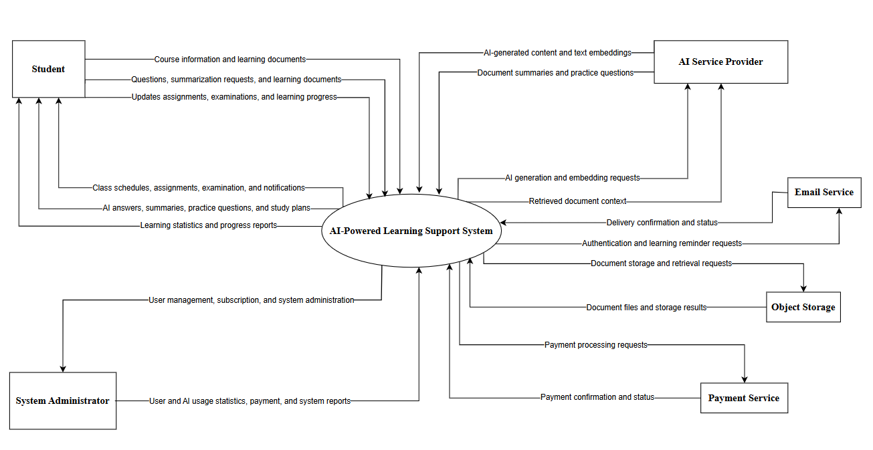
Figure 1. C4 Level 1 - System Context Diagram

4.2. Level 2 - Container Diagram

4.2.1. Component and Connector View (C&C view).
Description of Main Containers
Web Client (Vue.js)
- Sits at the outermost layer, facing only the browser
- It does not talk to any other container except the API Backend
- Every action the Student or Administrator takes leaves this container as a REST/HTTPS request straight to the API Backend, and nowhere else
API Backend (FastAPI)
- Sits directly behind the Web Client as the one and only gateway into the backend
- Every request from the Web Client passes through here first for JWT/RBAC authentication before being handled as study-management business logic (courses, assignments, exam schedules, documents, subscriptions) or forwarded onward
- AI requests go straight to the AI Service
- Background jobs go down into the task queue
- Payment requests go out to SePay
- No other container is reachable directly from the Web Client
AI Service (Python)
- Sits one level in from the Web Client, beside the API Backend
- Is reachable only through an internal call from the API Backend - never directly from the Web Client
- AI Service and Background Worker are the only two containers that talk to Google Gemini API
- Both through the same LLM & Embedding Adapter class, through the adapter layer
- For chatbot, RAG Q&A, summarization, question generation, and study planning
- Then returns its result back up to the API Backend
Background Worker (Celery Worker)
- Sits on the asynchronous side of the system, below Redis
- Is never called directly by anything - it only picks up tasks that the API Backend or Scheduler have already placed into the queue
- From there it runs text extraction & chunking, embedding generation, long-document summarization
- Sends verification/reminder emails straight to the external Email Service
- Downgrades an expired subscription to the Free plan when the Scheduler's task tells it to
- Calls Gemini via the shared adapter for embedding generation and summarization
Scheduler (Celery Beat)
- Sits on the same asynchronous side as the Background Worker, but is triggered by nothing except its own timer
- It runs two scanners side by side, the Deadline Scanner (upcoming assignment/exam deadlines) and the Subscription Expiry Scanner (expired subscriptions)
- It never touches the Background Worker directly
- Both scanners push their tasks down into Redis, and the Background Worker is the only one that picks them up from there
- It also re-queues tasks stuck in processing beyond a time threshold (R-01)
Message Broker & Cache (Redis)
- Sits between the two task producers (API Backend and Scheduler) and their one consumer (Background Worker), holding tasks until the Worker is free
- It also sits beside the API Backend and AI Service as their shared cache and AI-quota counter store
Relational Database (PostgreSQL + pgvector)
- Sits at the bottom of the stack as the one shared data store that every processing container - API Backend, AI Service, Background Worker, and Scheduler - reads from and writes to directly
- Holds structured business data (accounts, courses, assignments, exam schedules, progress, learning content, subscriptions, payment transactions) plus vector embeddings for RAG
Object Storage (MinIO)
- Sits alongside PostgreSQL at the data tier, but reachable by only two containers
- The API Backend writes the original document files (PDF, DOCX, images) here when a student uploads
- The Background Worker later reads them back out for processing
SePay (Payment Gateway)
- Sits entirely outside the Docker Host as the only external system reachable exclusively through the API Backend
- No other container ever calls it, and it never calls anything but the API Backend back
- It creates a payment request and returns a QR code over HTTPS/REST
- Then later calls back through a webhook, also over HTTPS, to confirm the payment succeeded

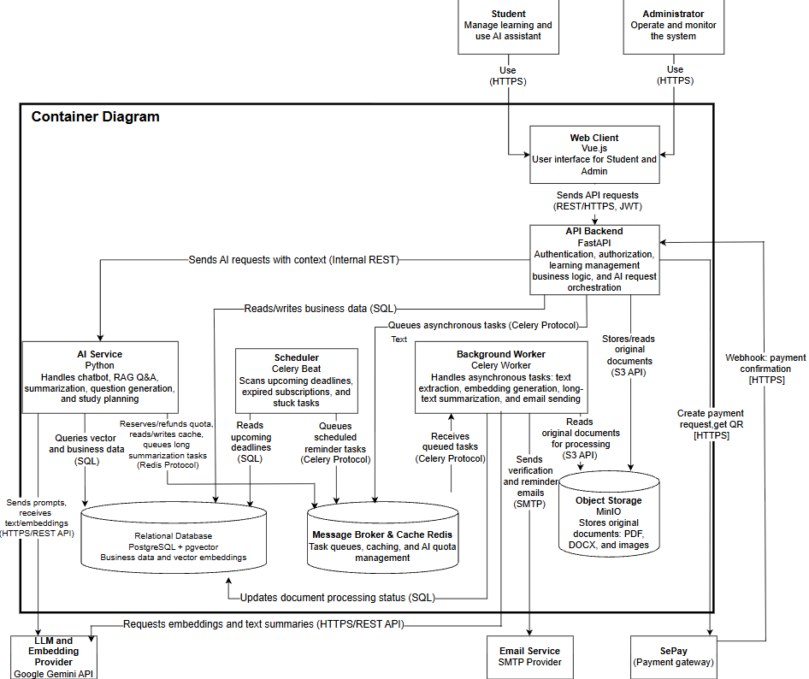
Figure 2. C4 Level 2 - Container Diagram

4.2.2. Module View
Prose
This Module View illustrates the static decomposition of the system into major modules and their responsibilities at the container level. The architecture separates API Backend, AI Service, and Background Worker into independent codebases, each organized internally by concern (see Sections 4.3–4.5), while sharing a single Core module for cross-cutting types and a single Providers module for all outbound calls to Google Gemini (Core and Providers are versioned shared packages: Core is used by all three services, Providers by AI Service and Background Worker) — improving modifiability, maintainability, and testability across the whole system.
API Backend Module:
Routers
- Receive and validate incoming HTTP requests
- Route requests to the appropriate Service, never to a Repository directly
Services
- Implement business logic for Auth, Schedule, Document, Progress, Notification, Admin, Subscription, and Chat
- Coordinate operations across multiple entities before persisting data
Repositories
- Implement data access logic against PostgreSQL
- Provide CRUD operations shared across all business modules
Clients
- Encapsulate communication with AI Service, Object Storage, the task queue, and SePay
- Isolate external protocol details from business logic
AI Service Module:
API
- Authenticate the internal request from API Backend
- Classify the request by AI task type and route it internally
Quota
- Check and update the AI usage quota before processing continues
- Apply a different limit depending on the student's current plan
Retrieval
- Convert the question into an embedding and search pgvector for relevant chunks
- Restrict results to documents the user is permitted to access
Generation
- Build the prompt from the question, retrieved context, and conversation history
- Verify the answer is grounded before returning it
Background Worker Module:
Task Dispatcher
- Receive tasks from Redis and read the task type
- Route each task to its corresponding handler
Idempotency Guard
- Check whether a task has already been processed
- Skip tasks already marked done before any handler runs
Tasks
- Handle document processing, summarization, email sending, and subscription downgrade
- Write their results back to PostgreSQL, Object Storage, or the Email Service
Scheduler (Celery Beat) Module:
Deadline Scanner
- Periodically scan for upcoming assignment/exam deadlines
- Enqueue reminder tasks for the Background Worker
Subscription Expiry Scanner
- Periodically scan for subscriptions past their expiry date
- Enqueue a downgrade task for the Background Worker
Stuck-Task Requeue Scanner
- Periodically scan for tasks stuck in processing beyond a threshold
- Re-enqueue them for the Background Worker
Web Client (Vue.js) Module:
Student Pages
- Provide authentication, schedule, document, and progress screens
- Send all requests to API Backend only, via REST/HTTPS
AI Assistant & Subscription Pages
- Provide chat, study-planning, and plan-purchase screens
- Display the SePay QR code and subscription status returned by API Backend
Admin Dashboard
- Provide account, quota, and monitoring screens for the Administrator
- Send all requests to API Backend only, via REST/HTTPS
Providers (shared) Module:
LLM & Embedding Adapter
- Serve as the only component in the entire system permitted to call Gemini
- Apply retry, timeout, and circuit breaker; shared by AI Service and Background Worker
Core (general-purpose) Module:
Schemas / DTO
- Define request/response data structures
- Prevent internal data models from being exposed directly
Config
- Manage configuration values shared across modules
- Centralize settings to avoid duplication between containers
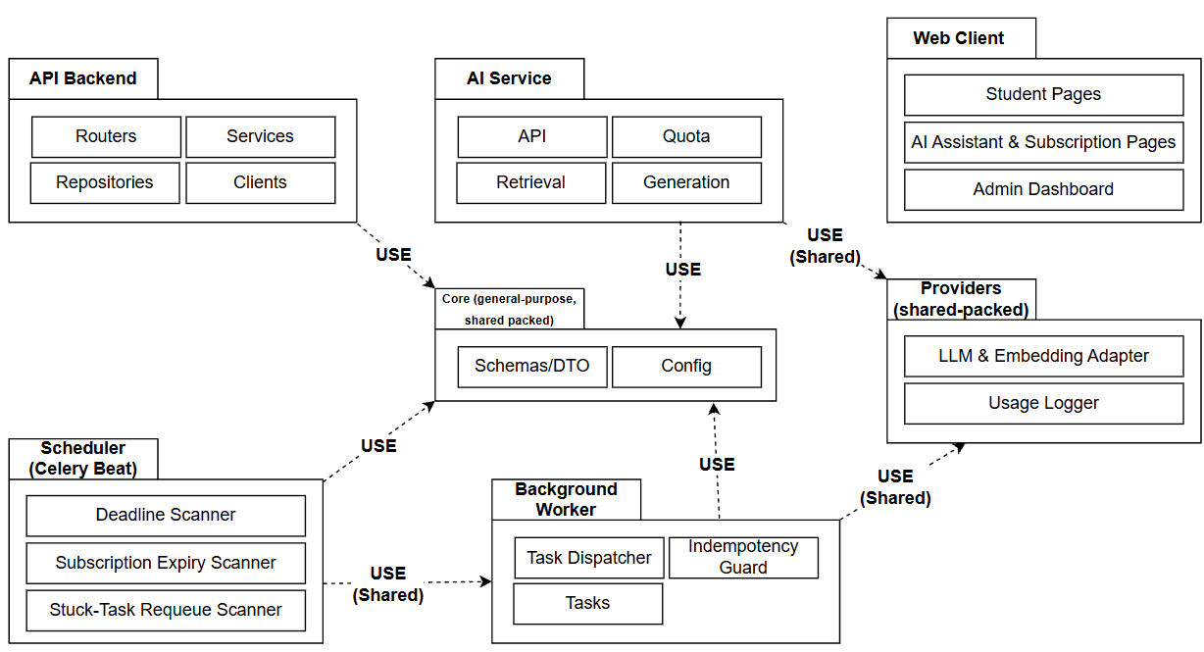
Figure 3. C4 Level 2 - Module View of the System

4.3. Level 3 - Component Diagram:

4.3.1. AI Service

4.3.1.1. Component and Connector View (C&C view)
Description of Main Components:
Internal API Layer
- The entry point of the AI Service
- Receives requests from the API Backend together with an internal service token, user_id, plan, and document_scope
- Verifies the service token
- Enforces the document access scope (tactic Authenticate/Authorize actors - QAS-03)
Quota Manager
- Rejects requests when the quota is exceeded
- When usage reaches 80% of the quota, it returns a quota_warning flag in its response instead of writing to the notifications table itself
- It reserves quota before the Gemini call and refunds it if the call fails
- It applies different quotas per plan (Free/Pro), receiving the plan parameter from the API Backend in each request
Request Router
- Routes the request to the appropriate processing module depending on the task type - chat/RAG, summarization, question generation, or study planning
Retrieval Module
- Receives the question, converts it into an embedding
- Queries the top-K most relevant document chunks from pgvector, only within the scope of documents the user is permitted to access (tactic: separate retrieval from generation - QAS-05)
Prompt Builder
- Builds the complete prompt from the original question, the retrieved context, and the conversation history (if any)
- Before inserting the retrieved context into the prompt, the Prompt Builder sanitizes the content of the document chunks and applies input/output filtering to reduce the risk of prompt injection from uploaded documents (R-08)
- Document content is placed in a separate data block with an instruction not to follow any command found inside it
- The AI is given no tool or action permissions
Generation Module
- Sends the prompt to the LLM Adapter, receives the generated text
- Performs a grounding check before returning it
- If no relevant content is found, it answers "no information found" instead of inferring (QAS-05)
LLM & Embedding Adapter
- The only abstraction layer permitted to call the Gemini API
- Isolates all SDK/provider details from the other business components (tactic Abstract common services -NFR06)
- Applies retry/timeout/circuit breaker when calling external services (QAS-02)
Usage Logger
- Records the tokens/cost of every Gemini call in the database, for statistics
- It is called by the shared LLM & Embedding Adapter, so calls made by the Background Worker are recorded as well

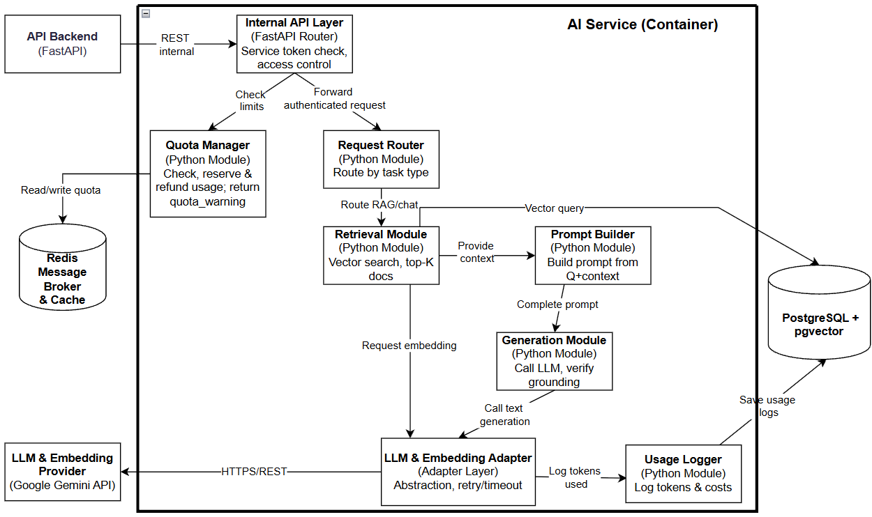
Figure 4. C4 Level 3 - Component Diagram (C&C View) of the AI Service

4.3.1.2. Module View
Prose
This Module View illustrates the static decomposition of the AI Service into major modules and their responsibilities. The architecture separates request handling, quota control, retrieval, and generation into independent modules, with a single Providers module isolating all communication with the external Gemini API — improving modifiability and testability of each concern.
API Module:
Internal API Layer
- Receive the internal request from API Backend
- Verify the internal service token and enforce the document access scope
Request Router
- Classify the request by AI task type (chat/RAG, summarization, question generation, study planning)
- Route it to the appropriate processing module
Quota Module:
Quota Manager
- Check and update the AI usage quota before allowing further processing
- Reject the request, or warn when usage approaches the limit
Retrieval Module:
Retrieval Module
- Convert the question into an embedding and query pgvector for the top-K relevant chunks
- Restrict the search to documents the user is permitted to access
Generation Module:
Prompt Builder
- Build the complete prompt from the question, retrieved context, and conversation history
- Sanitize document content to reduce the risk of prompt injection
Generation Module
- Send the prompt to the LLM Adapter and receive the generated text
- Perform a grounding check before returning the answer
Provider Module:
LLM & Embedding Adapter
- Serve as the only component in AI Service permitted to call Gemini directly
- Apply retry, timeout, and circuit breaker when calling the external provider
Core (general-purpose) Module:
Schemas / DTO
- Define the data structures used between internal modules
- Keep each module's output in a consistent shape
Config
- Manage configuration shared across all AI Service modules

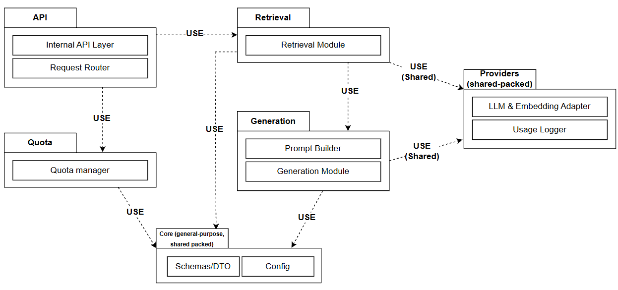
Figure 5. C4 Level 3 - Module View of the AI Service

4.3.2. API Backend

4.3.2.1. Component and Connector View (C&C view)
Description of Main Components:
Auth Module
- Handles registration, login, password recovery via emailed verification code, profile updates, JWT creation/decoding, and RBAC checks (student/admin)
- Blocks requests before they reach the business modules
Schedule Management Module
- Consolidates all business logic related to study schedules - CRUD for Course, Assignment, Exam, and Class Schedule (FR02, FR14)
- Because all four share the same pattern (belong to one user, filtered by user_id, related to courses)
- It also stores study plans suggested by the AI Service and lets students edit, accept, or dismiss them (FR08)
Document Module
- Business logic for uploading/managing document metadata (FR03), including search and filtering (FR13)
- Stores files via the Object Storage Client
- Triggers asynchronous processing through the Task Queue Client
- It also stores AI-generated questions in the student's personal question bank (FR07) and serves them for revision and practice tests, reading through the Repository Layer without calling the AI Service
Progress Module
- Aggregates study progress (FR15) from the Assignment/Exam data already available in Schedule Management and from question-practice results in the question bank
- Does not call AI, only performs calculations
- When study progress is detected to be behind the plan, writes a record to the notifications table (via the Repository Layer) for the Notification Module to display
AI Request Client
- The layer that calls the AI Service (internal REST), isolating communication details - business modules must not call the AI Service directly
Notification Module
- Manages notifications displayed to users (FR12)
- Reads the notification list and marks notifications as read
- Notification data is written to the notifications table from multiple sources depending on the event type:
- (1) Background Worker – upcoming deadlines/exams and email delivery results; (2) Progress Module – study plan falling behind; (3) API Backend – when the AI Service response carries the quota_warning flag, the API Backend creates the notification (AI quota about to be reached)
- The Notification Module is only responsible for reading/displaying notifications to the Student and does not generate notifications itself
Administration and Monitoring Module
- Manages user accounts and roles, Configures AI quotas and subscription settings; Views service status; Monitors processing tasks and retries failed ones; Provides usage statistics and subscription/payment reports (FR16)
Object Storage Client
- The layer that calls MinIO (S3 API) to store/read original documents
Task Queue Client
- The layer that pushes asynchronous tasks into Redis/Celery (e.g., triggering document indexing after upload)
Repository Layer
- The shared data access layer for all business modules, operating on PostgreSQL
- This is the only layer permitted to touch the database
- Every business module (Auth, Schedule Management, Document, Progress) must go through the Repository Layer and must not write queries directly
- This layering principle is presented in more detail in Section 4.4 (source code organization)
Subscription Module
- Handles plan purchases and plan status viewing, Receives and verifies the SePay webhook, Updates subscriptions/payment_transactions upon successful payment
Payment Client
- Calls the SePay API to create a payment request and retrieve the QR code
SePay
- Handles payment via QR code / bank transfer; calls the confirmation webhook back to the API Backend

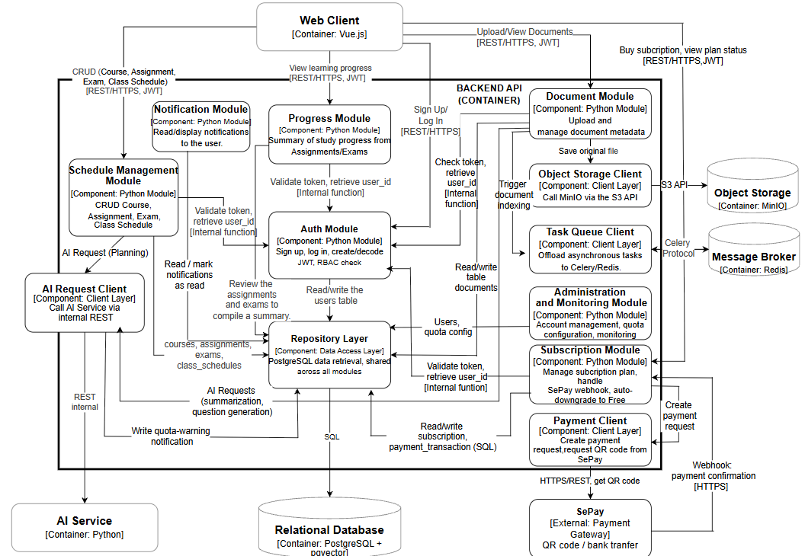

Figure 6. C4 Level 3 - Component Diagram (C&C View) of the API Backend

4.3.2.2. Module View
Prose
This Module View illustrates the static decomposition of the API Backend into major modules and their responsibilities. The architecture follows a layered structure — Routers, Services, Repositories, and Clients — separating request handling, business logic, data access, and external communication to improve modifiability, maintainability, and testability.
Routers Module:
Auth / Schedule / Document / Progress / Notification / Admin / Subscription / AI-Chat Routes
- Receive and validate incoming HTTP requests for each business area
- Route requests to the matching Service, never to a Repository directly
Services Module:
Auth Service
- Handle registration, login, and JWT creation/decoding
- Enforce RBAC checks before a request reaches other modules
Schedule / Document / Progress / Notification / Admin Service
- Implement the core business logic for each business area
- Coordinate with Repositories and Clients as needed
Subscription Service
- Manage plan purchases and plan status, and verify SePay webhooks
- Update subscription and payment records on successful payment
Chat Service
- Forward AI requests (chat, RAG, summarization, content generation, and study planning) to AI Service.
- Return the AI Service's response to the Web Client
Repositories Module:
User / Schedule / Document / Notification / Subscription Repository
- Implement data access logic against PostgreSQL for each business area
- Provide CRUD operations shared across all Services
Clients Module:
AI Client
- Call AI Service via internal REST
- Isolate the communication details from business logic
Storage Client
- Call MinIO via the S3 API to store and read original documents
Queue Client
- Push asynchronous tasks into Redis/Celery
Payment Client
- Call the SePay API to create a payment request and retrieve the QR code
Core (general-purpose) Module:
Schemas / DTO
- Define the data structures for the API's input and output
Config
- Manage configuration shared across the whole API Backend
Security (JWT / RBAC)
- Provide the authentication and authorization components shared across modules

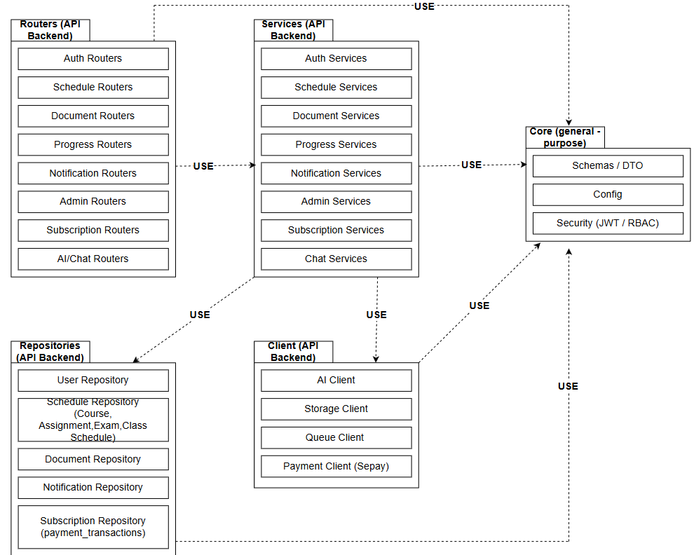
Figure 7. C4 Level 3 - Module View of the API Backend

4.3.3. Background Worker

4.3.3.1. Component and Connector View (C&C view)
Description of Main Components:
Task Dispatcher
- Receives tasks from the Message Broker (Redis)
- Reads the task type (document_index, summarize_long, send_email, downgrade_subscription)
- Routes it to the corresponding task handler
Idempotency Guard
- Tracks each task identifier (idempotency_key) with three states: in_progress, done, failed
- A task is skipped only when its state is done, and the state becomes done only after the handler finishes successfully, so a Celery retry after a failure can run again
- A task stuck in in_progress beyond a time threshold may be run again
- For subscription downgrade, the state is kept in PostgreSQL, not only in Redis
- This step runs before every task handler
Document Processing Task
- Reads the original file from Object Storage
- Extracts the text
- Splits it into chunks
- Computes a fixed identifier for each chunk (document_id + sequence number)
- Performs an UPSERT into the Vector Database
- The document status is updated to " embedded" only after all chunks have been written
Summarization Task
- Handles long-document summarization (a time-consuming task, not suitable for synchronous processing in the AI Service)
- Short documents are summarized synchronously by the AI Service
- Documents above a set threshold are sent to this task through the queue, after the AI Service has checked the student's quota
Email Sender Task
- Sends account verification, password recovery, and reminder emails via SMTP
- Before sending, it checks through the Idempotency Guard to avoid sending duplicate notifications for the same event
- After sending, it records the result (success/failure) in the notifications table so that the Notification Module (API Backend) can display it back to the user
Subscription Downgrade Task
- Triggered by the Scheduler's Subscription Expiry Scanner
- Checks through the Idempotency Guard to avoid downgrading the same subscription twice
- Then updates the subscription's plan to Free in PostgreSQL
Provider Adapter
- Reuses the same class as the LLM & Embedding Adapter already defined in the AI Service Component Diagram (4.3.1)
- The Background Worker does not write its own Gemini-calling logic, which avoids code duplication and ensures retry/timeout are applied consistently
- Because Usage Logger is called from this adapter, the Worker's embedding and summarization calls are also recorded
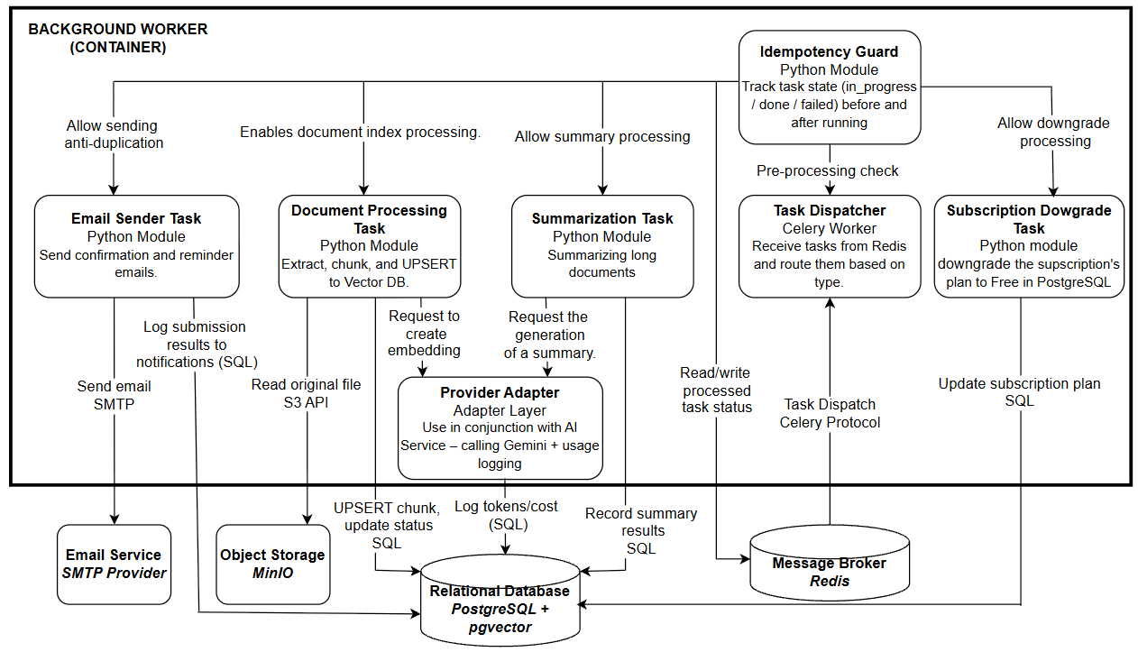
Figure 8. C4 Level 3 - Component Diagram (C&C View) of the Background Worker

4.3.3.2. Module View
Prose
This Module View illustrates the static decomposition of the Background Worker into major modules and their responsibilities. The architecture separates task dispatching, duplicate-processing prevention, and task execution into independent modules, while sharing the same Providers module as AI Service — ensuring exactly one place in the system calls Gemini.
dispatcher Module:
Task Dispatcher
- Receive tasks from the Message Broker and read the task type
- Route each task to its corresponding handler
idempotency Module:
Idempotency Guard
- Check whether the task identifier has already been processed
- Skip tasks already marked done before any handler runs
tasks Module:
Document Processing Task
- Extract text from the original file, chunk it, and UPSERT embeddings into pgvector
- Update the document status to embedded only after all chunks are written
Summarization Task
- Summarize long documents as an asynchronous job
Email Sender Task
- Send verification and reminder emails via SMTP
- Record the delivery result in the notifications table
Subscription Downgrade Task
- Downgrade an expired subscription to the Free plan when triggered by the Scheduler
- Update the subscription record in PostgreSQL
providers (shared) Module:
Provider Adapter
- Reuse the same class as the LLM & Embedding Adapter in AI Service
- Avoid writing separate Gemini-calling logic in the Background Worker
Core (general-purpose) Module:
Schemas / DTO
- Define the data structures used between internal modules
Config
- Manage configuration shared across all Background Worker modules

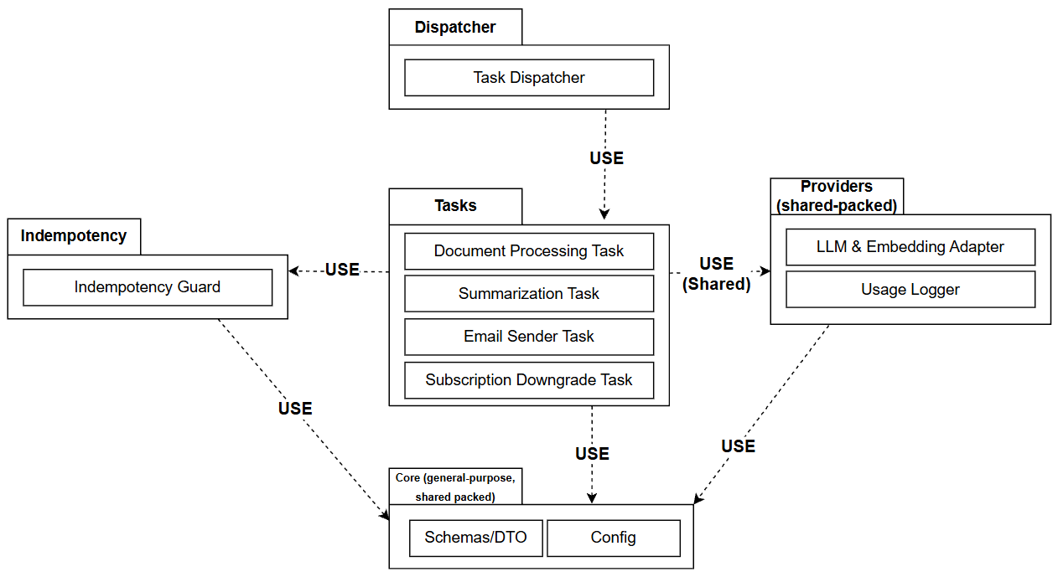
Figure 9. C4 Level 3 - Module View of the Background Worker

4.4. Level 4 - Code (Organizational Principles)
Purpose:
Ensure that the source code structure accurately reflects the 3 Component diagrams already drawn (4.3.1, 4.3.2, 4.3.3) - each part of the code corresponds to one element in the diagrams, avoiding the situation where the code and the documentation drift out of sync over time.

4.4.1. API Backend (FastAPI)
The API Backend is divided into the following parts:
- Routers: Receive requests and validate input data, organized into 8 business groups (Auth, Schedules, Documents, Progress, Notifications, Admin, Subscriptions, AI/Chat).
- Services: Handle the main business logic, including subscription lifecycle management and SePay webhook verification.
- Repositories: Operate directly on the data in PostgreSQL, including the subscriptions and payment_transactions tables.
- Schemas: Define the data structures for the API's input and output.
- Core: Configuration, authentication, and components shared across the whole system.
- Clients: Responsible for communication with the AI Service, Object Storage, the Celery queue, and the SePay payment gateway.
Routers may only call Services and must not call Repositories directly. This ensures that all business rules are fully checked before data is written to the database.
Clients separate "external communication" from business logic. If the way of connecting to the AI Service, the queue, or the payment gateway needs to change later, only this part needs to be modified without affecting other parts.
.

4.4.2. AI Service (Python)
The AI Service is divided into the following parts:
- API: Internal authentication and classification of requests by AI task type.
- Quota: Checks and updates the AI usage quota before allowing further processing, applying a different limit depending on the student's current subscription plan (Free or Pro), which is passed in from the API Backend with each request.
- Retrieval: Finds the document chunks related to the question.
- Generation: Builds the content sent to the AI and checks whether the answer is properly grounded.
- Providers: Communicates with Google Gemini to create embeddings and generate answers.
- Core: Configuration and shared components.
Retrieval and Generation are two separate parts that only exchange results with each other and do not interfere with each other's internal processing. This makes it possible to change how documents are found or how answers are generated without affecting the rest.
Providers is the only place permitted to call Gemini directly. If a different AI provider is needed later, only this part needs to change, with no need to touch Retrieval or Generation.

4.4.3. Background Worker (Celery)
The Background Worker is divided into the following parts:
- Dispatcher: Receives tasks from Redis and classifies them for routing to the right handler.
- Idempotency: Checks whether a task has already been processed.
- Tasks: Handle specific jobs - document processing (extraction, embedding creation), long-document summarization, sending email, and downgrading an expired subscription to the Free plan when notified by the Scheduler.
- Providers: Shared with the AI Service for calling Gemini.
- Core: Configuration and shared components.
Every task in Tasks must pass through Idempotency before it actually runs. This way, a task already marked done is skipped, while a failed task can be retried without creating duplicate data.
Providers here is not written separately but shared with the AI Service - so the whole system has exactly one place that calls Gemini, avoiding duplicated code in two different places.

4.4.4. Two Key Processing Flows

4.4.4.1. Document Processing Task
Purpose: This class diagram describes in detail how DocumentProcessingTask implements the idempotent/UPSERT mechanism argued in R-01 (Section 8) - the location with the highest architectural risk in the entire system.
Description of Classes and Roles:
- TaskDispatcher: Receives tasks from the queue and calls IdempotencyGuard to check before handing over to DocumentProcessingTask - ensuring that no task runs without first passing the duplicate check.
- IdempotencyGuard: Stores the state of each task identifier (in_progress / done / failed) and answers whether execution may continue; the state is set to done only after the task completes.
- DocumentProcessingTask: The main orchestrating class - reads the file, extracts the text, splits it into chunks, then hands each chunk to ChunkIdGenerator and EmbeddingProvider for processing.
- ChunkIdGenerator: Generates a fixed identifier for each chunk, computed from documentId + sequence number - this is the core of the R-01 solution: even if DocumentProcessingTask is invoked multiple times (due to network errors or Celery retries), this identifier is always identical for the same chunk, so VectorRepository.upsertChunk() only overwrites and does not create duplicate data.
- Chunk: A temporary data object holding the text content of the chunk and the corresponding embedding before it is saved.
- EmbeddingProvider: Calls Gemini to create an embedding for each chunk - part of the Provider Adapter described in the Component Diagram (4.3.3).
- VectorRepository: Performs an UPSERT of each chunk into the Vector Database, and only updates the document status to " embedded" after all chunks have been written - following the order committed in R-01, which avoids the situation where the system reports " embedded" while the vector data is incomplete.

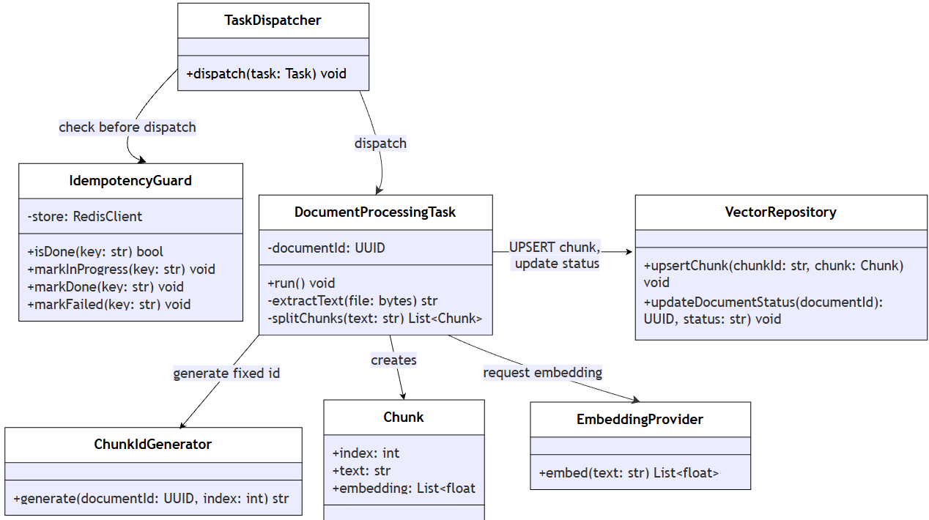
Figure 10. C4 Level 4 - Class Diagram — Document Processing Task

4.4.4.2. Generation Module
Purpose: This class diagram describes in detail how GenerationModule implements the grounding check mechanism argued in QAS-05 (Section 2.2) - ensuring that the AI does not make inferences on its own when the documents contain no relevant information.
Description of Classes and Roles:
- RequestRouter: Receives requests that have passed the quota check (Quota Manager) and routes them to RetrievalModule to start the RAG pipeline.
- RetrievalModule: Queries the Vector Database and returns the list of the most relevant Chunks (top-K) within the scope of documents/users the requester is permitted to access.
- PromptBuilder: Combines the original question and the retrieved Chunks into a complete prompt, ready to be sent to the model.
- GenerationModule: The central class - calls LLMProvider to generate a raw answer, then must pass it through GroundingChecker before returning the result; the LLM's answer must never be returned directly to the outside.
- GroundingChecker: Compares the answer with the content of the retrieved Chunks - if there is insufficient grounding, returns the status "no relevant information found" rather than letting an answer (possibly an incorrect inference) slip through.
- AnswerResult: The final result object, carrying the status (answered / no grounding found), the answer content, and the list of cited sources - matching the response structure defined in the internal API Design section.
- LLMProvider: Part of the Provider Adapter shared with EmbeddingProvider (4.3.3) - the same abstraction layer that calls Gemini, applying retry/timeout consistently for both embedding generation and text generation.

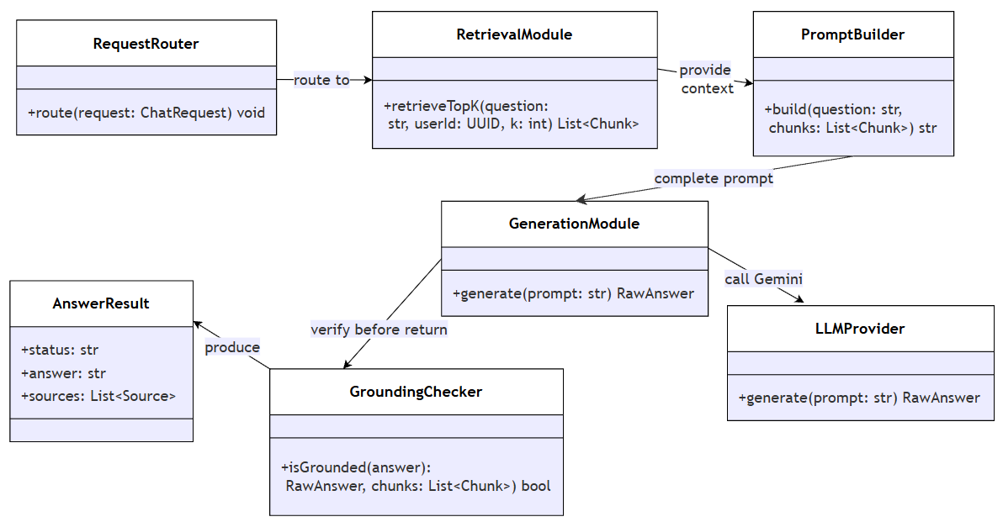

Figure 11. C4 Level 4 - Class Diagram — Generation Module

4.5. Deployment View.

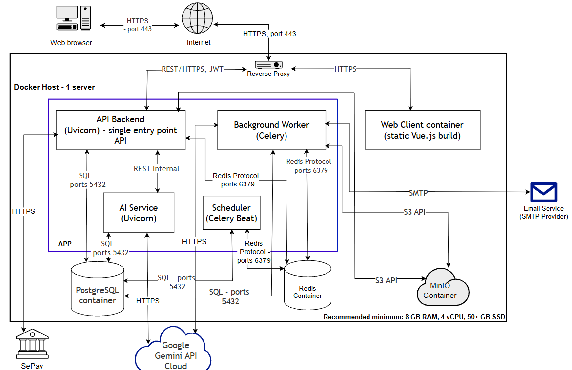

Figure 12. Deployment View
User machine / Network
Web Browser
- Send HTTP requests to the system and render responses for the user
- Communicate with the system exclusively over HTTPS
Internet
- Serve as the public network between the user's browser and the Docker Host
- Carry all inbound and outbound traffic over HTTPS
Docker Host - 1 server
- Recommended minimum host: 8 GB RAM, 4 vCPU, 50+ GB SSD
Reverse Proxy container (Nginx/Traefik)
- Terminate TLS so that all traffic from the Internet is served over HTTPS
- Route /api requests to the API Backend and static content to the Web Client container
Web Client container
- Serve the static Vue.js build to the browser
- Receive requests from the Internet through the Reverse Proxy, independent of the API Backend
- Recommended configuration: 0.5 vCPU, 256 MB RAM, 200 MB storage
API Backend (Uvicorn) - single entry point API
- Act as the sole entry point for all API requests from the Web Client
- Authenticate requests and orchestrate calls to AI Service, database, cache, and storage
- Recommended configuration: 1 vCPU, 1 GB RAM
AI Service (Uvicorn)
- Process AI-related requests forwarded internally from the API Backend
- Call the Gemini API and read/write vector data in PostgreSQL
- Recommended configuration: 1 vCPU, 1 GB RAM
Background Worker (Celery)
- Execute asynchronous tasks: document indexing, summarization, and email sending
- Read from Object Storage and write results back to PostgreSQL
- Recommended configuration: 1 vCPU, 1–2 GB RAM
Scheduler (Celery Beat)
- Periodically scan the database for upcoming deadlines and for expired subscriptions
- Enqueue reminder tasks and, when a subscription has expired, a downgrade task into Redis for the Background Worker to process
- Recommended configuration: 0.25 vCPU, 256 MB RAM.
Data repositories residing on the Docker Host
PostgreSQL container
- Store business data and vector embeddings
- Serve SQL connections from API Backend, AI Service, Background Worker, and Scheduler
- Recommended configuration: 1 vCPU, 2 GB RAM, 20 GB SSD (growable)
Redis Container
- Serve as the message broker and cache
- Queue asynchronous tasks and store AI usage quota counters
- Recommended configuration: 0.5 vCPU, 512 MB RAM
MinIO Container
- Store original uploaded documents (PDF, DOCX, images)
- Serve S3 API requests from API Backend and Background Worker
- Recommended configuration: 0.5 vCPU, 512 MB RAM, 20–50 GB storage (growable)
External services
Google Gemini API (Cloud)
- Provide text generation and embedding creation
- Receive requests exclusively from AI Service and Background Worker over HTTPS
Email Service (SMTP Provider)
- Deliver verification and reminder emails
- Receive requests exclusively from Background Worker over SMTP
Payment Service (SePay - Payment Gateway)
- Process Pro subscription payments via QR code / bank transfer
- Receive payment initiation requests from the API Backend and send real-time payment-confirmation webhooks back to the API Backend, both over HTTPS

5. MAIN FLOW: DOCUMENT BASED Q&A (RAG).
Flow description (grouped by container, without going into each internal component):
- The student sends a question from the Web Client → API Backend (with JWT).
- The API Backend authenticates the request, determines the scope of documents the student may access, and forwards the request to the AI Service.
- The AI Service checks and reserves the AI usage quota (Quota Manager): the counter in Redis is increased atomically before the call, and refunded if the call fails.
  - Quota exceeded → return an error immediately and stop the flow (saves LLM call costs).
  - Quota available → continue.
- The AI Service retrieves the relevant context: creates an embedding for the question and finds the top-K matching document chunks in PostgreSQL/pgvector.
- The AI Service builds the prompt and calls the Gemini API to generate the answer.
- The AI Service performs the grounding check (comparing the answer against the retrieved context).
  - Grounded → answer with source citations.
  - No relevant content found → answer "no relevant information found".
- Log token/cost usage to PostgreSQL (for reporting); the Redis counter is the source of truth for the daily quota, and a failed request is refunded.
- Return the result to the Web Client.
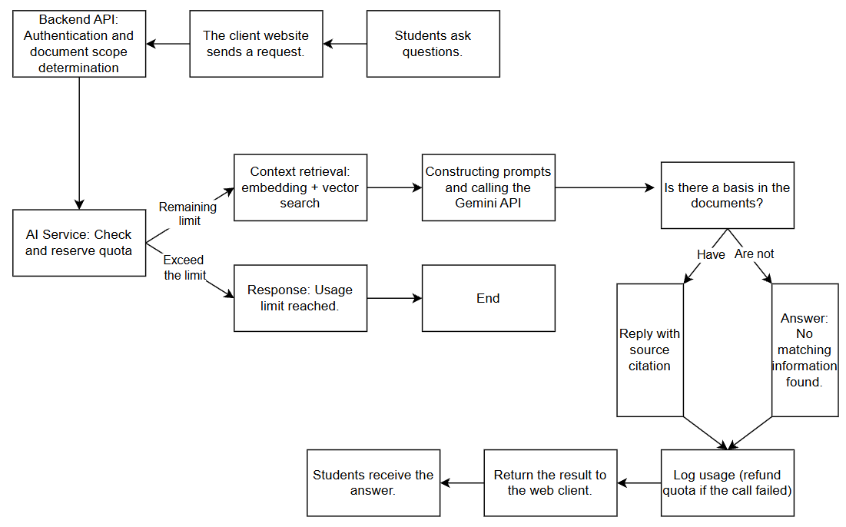
Figure 13. Document-Based Q&A (RAG) Processing Flow

6. TRACEABILITY TABLE: QUALITY ATTRIBUTE → TACTIC → DECISION → C4
Purpose:
The traceability table links the parts of the document, from quality requirements (QAS) to tactics, design decisions, and the corresponding C4 elements. Through it, the team can verify that every key requirement has been considered and addressed at the architecture level. If a QAS does not appear in the table, it should be reviewed to ensure the requirement has not been overlooked.
Table 11. Traceability Table: Quality Attribute → Tactic → Design Decision → C4
QAS | Quality Attribute | Applied Tactic | Design Decision | Location in C4
QAS-01 | Performance | Separate processes by workload | Separate the AI Service into a container independent of the API Backend | Container: AI Service, API Backend (4.2)
QAS-02 | Reliability | Retry, Timeout, Circuit breaker | Adapter that controls failures when calling the Gemini API | Component: LLM & Embedding Adapter (4.3)
QAS-03 | Security | Authenticate/Authorize actors | JWT/RBAC checks at the API Backend; internal service-token check at the AI Service entry point | Container: API Backend; Component: Auth Module (4.3.2), Internal API Layer (4.3.1)
QAS-04 | Cost Control | Manage resources (quota limiting) | Check the quota in Redis before entering the RAG pipeline or queueing summarization; log every Gemini call in the shared adapter | Component: Quota Manager, Usage Logger (4.3)
QAS-05 | AI/RAG Quality | Separate retrieval from generation (RAG-specific tactic) | Separate Retrieval Module, grounding check | Component: Retrieval Module (4.3)
Table 12. Supplementary Tactics (No Dedicated QAS Scenario)
NFR | Design | Applied Tactic | Location in C4
NFR05 - Scalability | Increase instances independently | Increase resources per container | Container: AI Service, Background Worker (4.2)
NFR10 - Disaster Recovery | Periodic backup & restore (RPO 24 h, RTO 4 h; daily backup stored outside the Docker Host) | Recovery (backup and restore) | Container: Relational Database, Object Storage (4.2)
NFR04 - Security | Uploaded file validation (file type, size, and page limits set by the Administrator; malware check) | Validate input | Container: API Backend (upload logic, 4.2)
NFR04 - Security | Login attempt limiting; secrets (Gemini and SePay keys) kept in environment configuration, not in code; restricted CORS | Resist attacks; Limit access | Container: API Backend (Auth Module, Core, 4.2)
NFR06 - Maintainability | LLM Adapter - provider abstraction | Abstract common services | Component: LLM & Embedding Adapter (4.3)
NFR03 - Reliability | Idempotency Guard - prevents duplicate sending | Idempotent processing | Component: Email Sender Task, Idempotency Guard (4.3.3); description: 3.3
NFR07 - Cost Control | Admin module - quota management, monitoring | Administration interface | Component: Administration and Monitoring Module (4.3.2)
NFR02 - Usability | Handled at UI level; verified by usability testing | None (non-architectural) | Container: Web Client (4.2)
NFR08 - Observability | Correlation ID propagated across containers; structured logs; health-check endpoint on each service; error tracking with Sentry | Maintain audit trail | Container: API Backend, AI Service, Background Worker (Core, 4.4)
NFR09 - Legal Compliance & Data Privacy | Per-user retrieval scope; cascade deletion of user data; user consent before documents are sent to Gemini, and the data-processing terms of the Gemini API plan in use are checked | Limit exposure; remove data on request | Component: Retrieval Module (4.3.1), Auth Module (4.3.2); Container: Relational Database, Object Storage (4.2)
- In addition to the 5 main quality attribute scenarios, the following design decisions are applied as good engineering practice (best practice) to ensure the basic correctness of the system, tied to the corresponding NFRs rather than having a separate QAS scenario

7. TECHNOLOGIES APPLIED PER CONTAINER

Table 13. Technologies Applied per Container
Layer / Container | Proposed Technology | Selection Notes
Frontend (Web App) | Vue.js, HTML, CSS, JavaScript | Lightweight, suitable for SPAs, popular ecosystem
Backend API | Python, FastAPI, REST API | Good performance, async support, auto-generated OpenAPI documentation
AI Service | Python, LLM API (Gemini 3.5 Flash) + embedding model | Separated to scale independently; easy to switch LLM provider
Relational Database | PostgreSQL + pgvector | Suited to structured data; pgvector enables semantic search within the same database system, with no need to operate a separate database
Object Storage | MinIO | Stores the original files; PostgreSQL only stores metadata, reducing load on object storage
Task Queue & Scheduler | Celery + Redis | Asynchronous processing and reminder email scheduling
Cache | Redis | Reduces load on the AI API and database for frequently used queries
Authentication | JWT (access + refresh token), RBAC | Widely adopted standard, supports role-based authorization
Email | SMTP | Flexible between self-hosting and managed services
Containerization | Docker, Docker Compose (extendable to Kubernetes when needed) | Consistent deployment across dev/prod environments
Version Control & CI/CD | Git/GitHub, GitHub Actions | Basic automation of testing and deployment
Payment Gateway | SePay API | QR code payment gateway.
Observability | Sentry | Error tracking and abnormal-latency alerting

8. ARCHITECTURAL RISKS AND MITIGATION
Table 14. Architectural Risks and Mitigation
# | Risk | Cause | Impact | Mitigation
R-01 | Embeddings may be incomplete while a document is still being processed | Chunking and embedding consist of multiple consecutive writes (not a single transaction), so the document status may be updated before all embeddings are written | The status shows "embedded" but the embeddings are not fully stored, so RAG misses part of the content | (1) Idempotent writes: chunk_id is a deterministic hash of document_id + chunk index, written with UPSERT, so retries create no duplicates. (2) Processing status extended to 4 values: pending, processing, embedded, failed. (3) Two new columns: total_chunks (set after chunking) and chunks_processed (incremented by an atomic UPDATE after each successful UPSERT); the status becomes embedded only when chunks_processed reaches total_chunks. (4) Task claiming uses an atomic UPDATE ... WHERE status = 'pending', so only one worker takes a pending document; a worker whose UPDATE changes 0 rows skips it. (5) Tasks stuck in processing beyond a time threshold are re-queued by a periodic Celery Beat job.
R-02 | Complete dependence on a single AI provider (Google Gemini) | The technology constraint is fixed (Section 2.1) | A provider outage or a change in policy/pricing affects all AI features | All calls go through the LLM & Embedding Adapter; a new provider only needs a new adapter, with no change to business logic
R-03 | AI costs exceed expectations as users or usage grow rapidly | Costs are billed per token and are hard to predict early on | Exceeding the operating budget | The Quota Manager enforces quotas in real time (QAS-04, NFR07); the Usage Logger tracks costs so quotas can be adjusted promptly
R-04 | Boundaries between services and shared packages may be violated, making them hard to maintain or split later | Developers may bypass interfaces or call modules directly | Lower maintainability and future scalability | Automated CI checks on key boundaries (providers/, clients/) and periodic architecture reviews
R-05 | RAG answer quality depends on document extraction and chunking | Documents come in varied formats (PDF, DOCX), so processing is not uniform | Poor extraction or chunking makes answers inaccurate | Grounding check before returning results; chunking strategy improved progressively from real data
R-06 | Students' study data may be accessed across accounts if the Retrieval Module handles permissions incorrectly | Document-scope logic may be scattered or inconsistent | Serious security and privacy violations | Centralize access control in the Retrieval Module and add tests for cross-account access cases
R-07 | Redis serves as cache, message broker, and quota store, creating a shared dependency | Functions are consolidated to simplify initial operations | A Redis failure may affect caching, the task queue, and quota control together | Phase 1 uses a single Redis instance. Phase 2 plans to split it: one instance for the cache (durability not required) and one for the broker and quota counters (AOF persistence). In all phases the Quota Manager is fail-closed: if Redis is unreachable, quota is treated as exhausted and the request is rejected
R-08 | Prompt injection via uploaded documents | Retrieved chunks are inserted into the LLM prompt, and documents may contain malicious instructions | The LLM is manipulated into misleading or unintended answers, affecting security and RAG quality | Sanitize retrieved chunks before inserting them into the prompt; apply input/output filtering; conduct periodic security testing; place document content in a separate data block with an instruction not to follow commands inside it; give the AI no tool or action permissions; include injection test cases in the golden set
R-09 | SePay webhook is called in duplicate or spoofed | An attacker calls the endpoint with a forged sepay_transaction_id, or SePay retries after a timeout | A subscription is activated without payment, or the same payment is processed twice | Verify the webhook signature and check whether the sepay_transaction_id was already processed, enforced by a UNIQUE constraint in the DB. The Background Worker's Idempotency Guard is not reused because this is a synchronous flow inside the API Backend

9. CONCLUSION
This document has presented the process of designing the EduSense system architecture based on Attribute-Driven Design (ADD) combined with the C4 Model. The process was carried out from identifying the architectural requirements and selecting decisions based on quality attributes, to modeling the architecture and tracing the design decisions.
The core points of the architecture include:
- Workload separation: the API Backend handles the main business logic, while the AI Service and Background Worker handle AI tasks, maintaining performance for ordinary functions.
- Monetization: a Pro subscription flow via SePay (QR code) is isolated in its own Subscription Module and Payment Client, keeping payment logic out of the AI Service and Background Worker entirely.
- A controlled RAG pipeline: quota is checked before processing, Retrieval and Generation are separated, a grounding check is performed, and an Adapter isolates the AI provider, which helps control costs, improve reliability, and make technology changes easier.
- Unified data storage: PostgreSQL with pgvector handles both business data and vector embeddings in a single database system, reducing the number of infrastructure components to operate; in exchange, the system needs to monitor query performance as the data volume grows.
- Cost and operability: prioritize open-source technologies that can be self-operated and fit the project's resources.
Architectural limitations: The current architecture targets an initial scale of about 50–100 concurrent users and is not yet optimized for large-scale distributed systems. PostgreSQL's scalability when the vector volume grows large needs to be monitored so that the architecture can be adjusted as the system grows.
Implementation direction: The document is the technical basis for system development. Implementation can proceed in phases, starting from the core components and gradually adding asynchronous processing mechanisms, cost control, and extended AI features, while ensuring adherence to the defined responsibility boundaries and architectural decisions.

