package com.company;  
  
public class Employee {  
 public String name;  
 public int age;  
 public String city;  
  
 public void display() {  
 System.*out*.println(name);  
 System.*out*.println(age);  
 System.*out*.println(city);  
 }  
  
}

package com.company;  
  
  
//import java.util.Scanner;  
public class Main {  
  
 public static void main(String[] args) {  
  
 Employee e1=new Employee();  
 e1.name="Pushpa";  
 e1.age= 18;  
 e1.city="Jalandhar";  
 e1.display();  
 }  
}

Output of Day2:

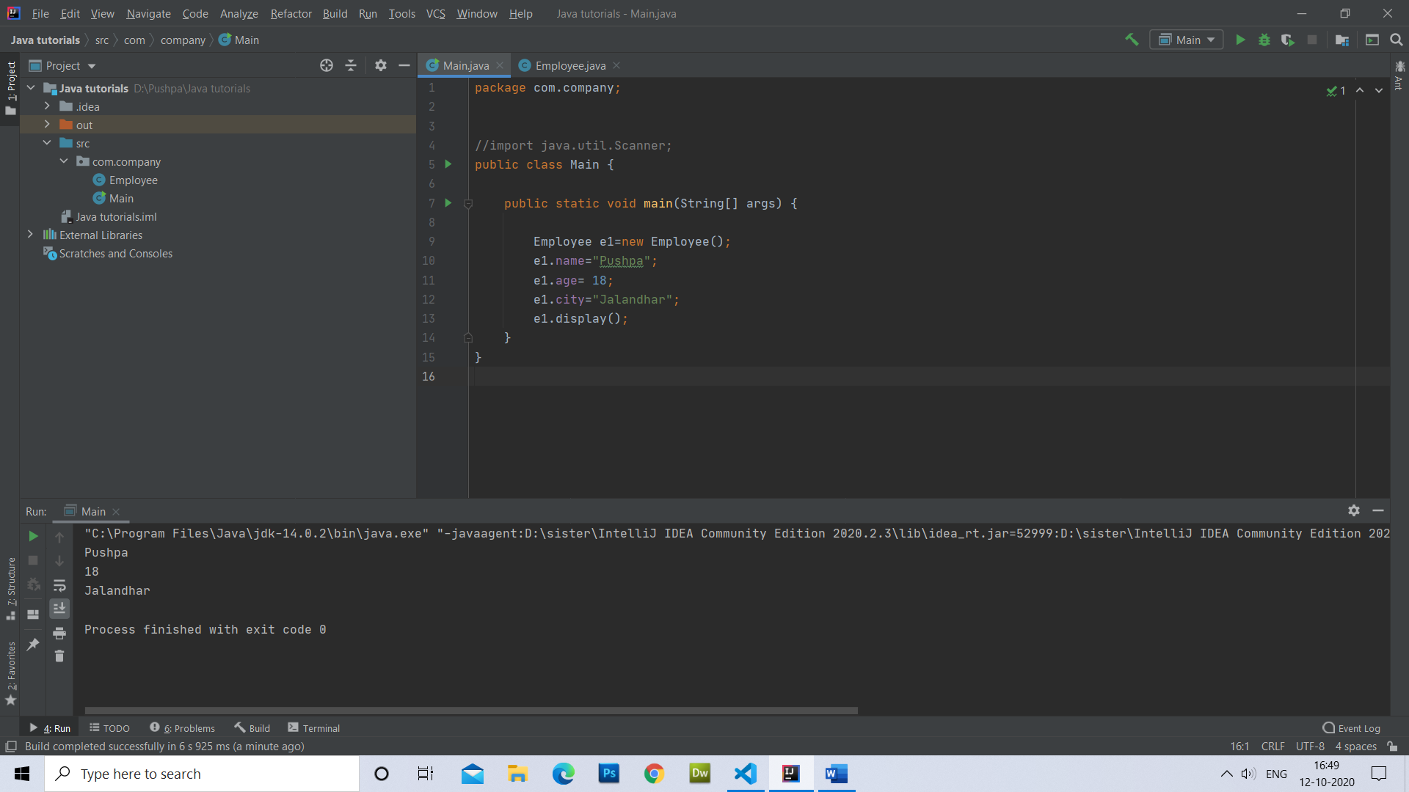

Day 3. Question1. Student Grade

package com.company;  
  
//Java Program to print grade of a student  
import java.util.Scanner;  
  
public class StudentGrade {  
 public static void main(String[] args) {  
 Scanner sc= new Scanner(System.*in*);  
 sc = new Scanner(System.*in*);  
  
 int english, chemistry, computers, physics, maths;  
 System.*out*.print(" Please Enter the Five Subjects Marks : ");  
 english = sc.nextInt();  
 chemistry = sc.nextInt();  
 computers = sc.nextInt();  
 physics = sc.nextInt();  
 maths = sc.nextInt();  
  
 float total, Percentage;  
 total = english+ chemistry+ computers +physics+ maths;  
 Percentage = (total / 500) * 100;  
 System.*out*.println(" Total Marks = " + total);  
 System.*out*.println(" Marks Percentage = " + Percentage);  
  
 if(Percentage >= 90) {  
 System.*out*.println("\n Grade A");  
 }  
 else if(Percentage >= 80) {  
 System.*out*.println("\n Grade B");  
 }  
 else if(Percentage >= 70) {  
 System.*out*.println("\n Grade C");  
 }  
 else if(Percentage >= 60) {  
 System.*out*.println("\n Grade D");  
 } else if(Percentage >= 40) {  
 System.*out*.println("\n Grade E");  
 }  
 else {  
 System.*out*.println("\n Fail");  
 }  
 }  
  
}

output:

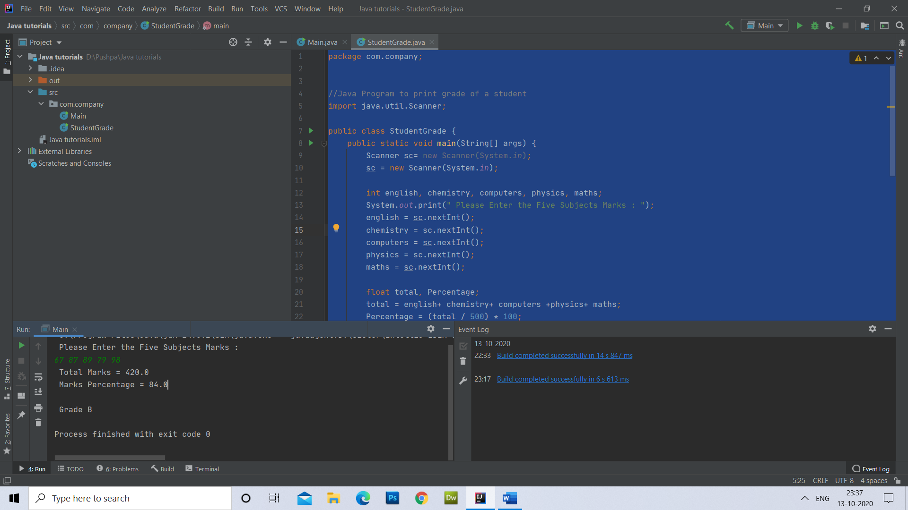

Day-3 question 2. Print Employee’s name, age , salary, income tax.

package com.company;  
  
//Java Program to print grade of a student  
import java.util.Scanner;  
  
public class Main {  
 public static void main(String[] args) {  
 Scanner sc = new Scanner(System.*in*);  
 sc = new Scanner(System.*in*);  
 String name;  
 int dob, mob, yob, monthly_salary, tax;  
 System.*out*.println("Enter your name: ");  
 name = sc.nextLine();  
 System.*out*.println("Enter Your Day of birth");  
 dob = sc.nextInt();  
 System.*out*.println("Enter Your Month of birth in number from 1 to 12");  
 mob = sc.nextInt();  
 System.*out*.println("Enter Your Year of birth in number");  
 yob = sc.nextInt();  
 System.*out*.println("Enter Your Monthly Salary");  
 monthly_salary = sc.nextInt();  
  
 int age = 2020 - yob;  
 int annual_salary = (monthly_salary * 12);  
  
 if (annual_salary >= 500000) {  
 tax = (annual_salary * 20) / 100;  
 System.*out*.println("Hello, " + name + " , Your age is " + age + ", annual salary is " + annual_salary + ", and Tax amount is " + tax);  
 }  
 else if (annual_salary >= 400000) {  
 tax = (annual_salary * 15) / 100;  
 System.*out*.println("Hello, " + name + " , Your age is " + age + ", annual salary is " + annual_salary + ", and Tax amount is " + tax);  
 }  
 else if (annual_salary >= 300000) {  
 tax = (annual_salary * 10) / 100;  
 System.*out*.println("Hello, " + name + " , Your age is " + age + ", annual salary is " + annual_salary + ", and Tax amount is " + tax);  
 } else if (annual_salary >= 200000) {  
 tax = (annual_salary * 5) / 100;  
 System.*out*.println("Hello, " + name + " , Your age is " + age + ", annual salary is " + annual_salary + ", and Tax is " + tax);  
 }  
 else {  
 tax= (annual_salary * 15) / 100;  
 System.*out*.println("Hello, " +name+ " , Your age is " + age + ", annual salary is " +annual_salary+ ", and Tax is not need to pay");  
  
 }  
 }  
}

Output:

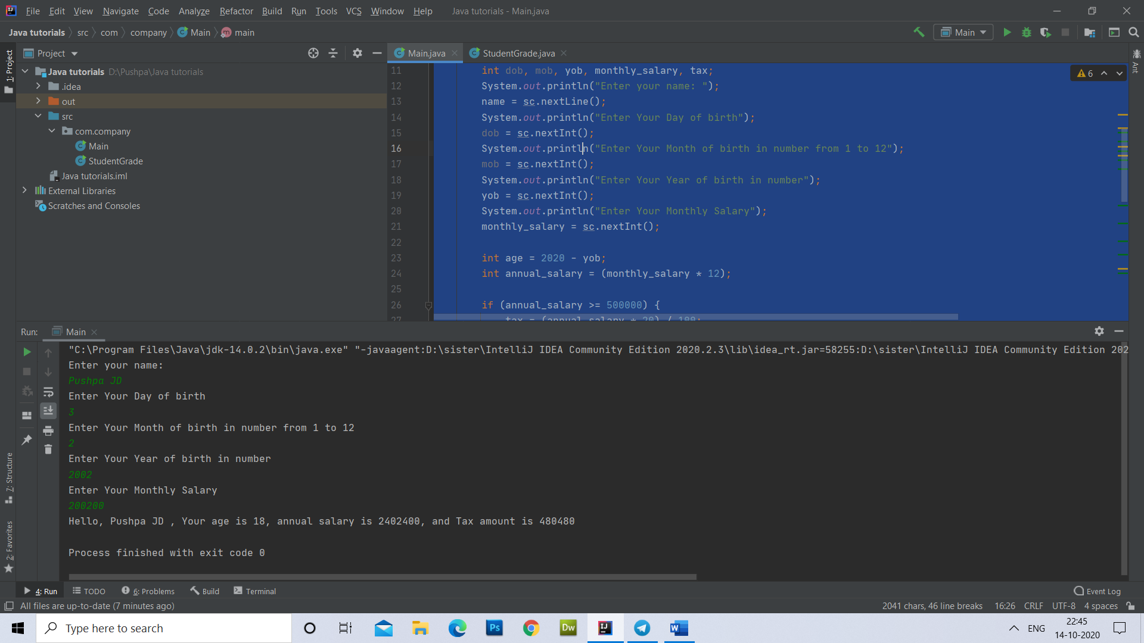

Day 4 Question 1. Take 5 avengers name, age, powers, weapon & planet.

package com.company;  
  
import java.util.Scanner;  
  
public class Avenger {  
 Scanner sc= new Scanner(System.*in*);  
 //sc = new Scanner(System.in);  
 public String name;  
 public int age;  
 public String power;  
 public String weapon;  
 public String planet;  
  
 public void getDetails() {  
 System.*out*.println("Enter the name");  
 name = sc.nextLine();  
 System.*out*.println("Enter the age of Avenger");  
 //age = sc.nextInt();  
  
 age=Integer.*parseInt*(sc.nextLine());  
  
 System.*out*.println("Enter the power of that avenger");  
 power = sc.nextLine();  
  
 System.*out*.println("Enter the weapon that avenger use");  
 weapon = sc.nextLine();  
  
 System.*out*.println("Enter the planet where that avenger live");  
 planet = sc.nextLine();  
 }  
  
 public void displayDetails() {  
 System.*out*.println("The name of the Avenger is "+name+" and the age is "+age+ " and power is " +power+ "and powerful weapon is "+weapon+ "and lives in " +planet);  
  
 }  
  
}

Main:

package com.company;  
  
public class Main {  
 public static void main(String[] args) {  
  
 Avenger[] avengers=new Avenger[5];  
 //creating objects  
 for(int i=0;i<5;i++)  
 {  
 avengers[i]=new Avenger();  
 }  
  
 //get details  
 for(int i=0;i<5;i++)  
 {  
 avengers[i].getDetails();  
 }  
 //print details  
 for(int i=0;i<5;i++)  
 {  
 avengers[i].displayDetails();  
 }  
  
 }  
}

Output:

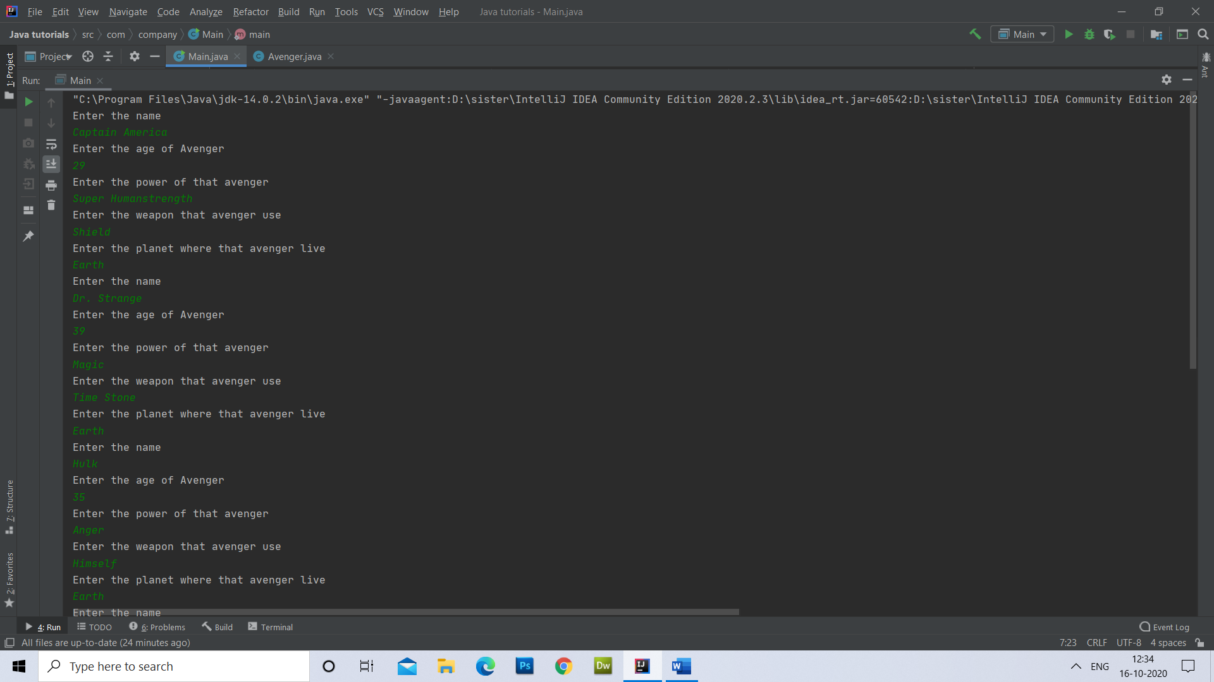

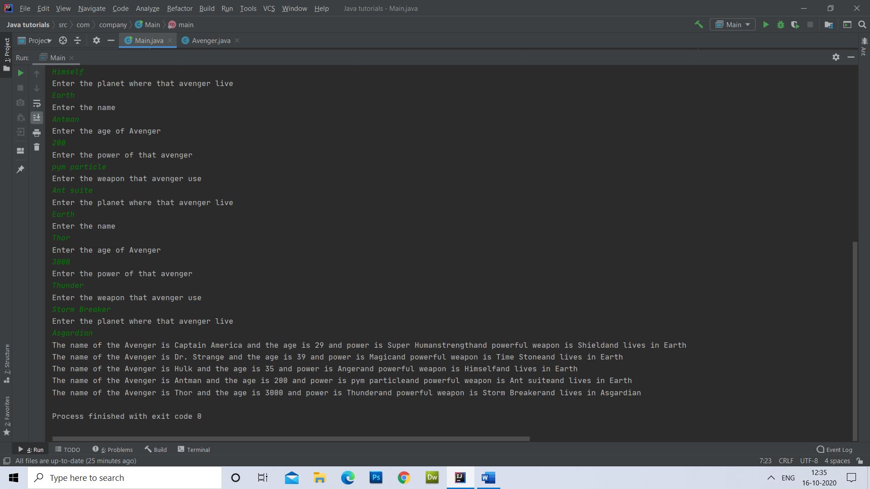

Question2. Take 5 values and print odd numbers.

package com.company;  
import java.util.Scanner;  
public class Main {  
 public static void main(String[] args) {  
 Scanner sc= new Scanner(System.*in*);  
 int[] array=new int[5];  
  
 array[0]=8;  
 array[1]=7;  
 array[2]=13;  
 array[3]=12;  
 array[4]=19;  
  
 System.*out*.println("Odd values are:");  
 for(int i=0;i<5;i++){  
 if(array[i]%2!=0)  
 {  
 System.*out*.println(array[i]);  
 }  
 }  
   
 }  
}

Output:

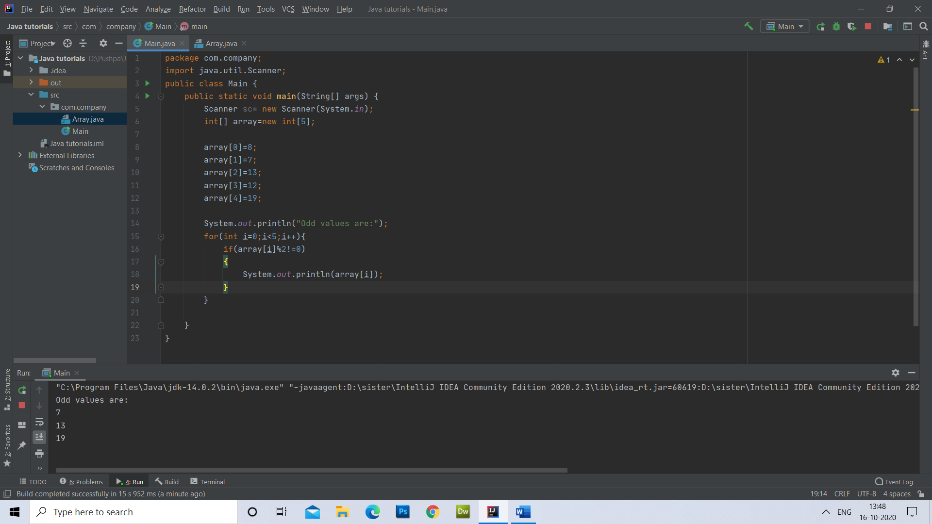

Question3. Take 5 numbers from user and print the sum.

package com.company;  
import java.util.Scanner;  
public class Main {  
 public static void main(String[] args) {  
 Scanner sc= new Scanner(System.*in*);  
 int sum=0;  
 int[] array=new int[5] ;  
  
 for(int i=0;i<5;i++)  
 {  
 System.*out*.println("Enter the number " +i+ " index: ");  
 array[i]=sc.nextInt();  
  
 }  
  
 for(int i=0;i<5;i++)  
 {  
 sum=sum + array[i];  
 }  
  
 System.*out*.println("Sum of the array values is " +sum);  
 }  
}

Output:

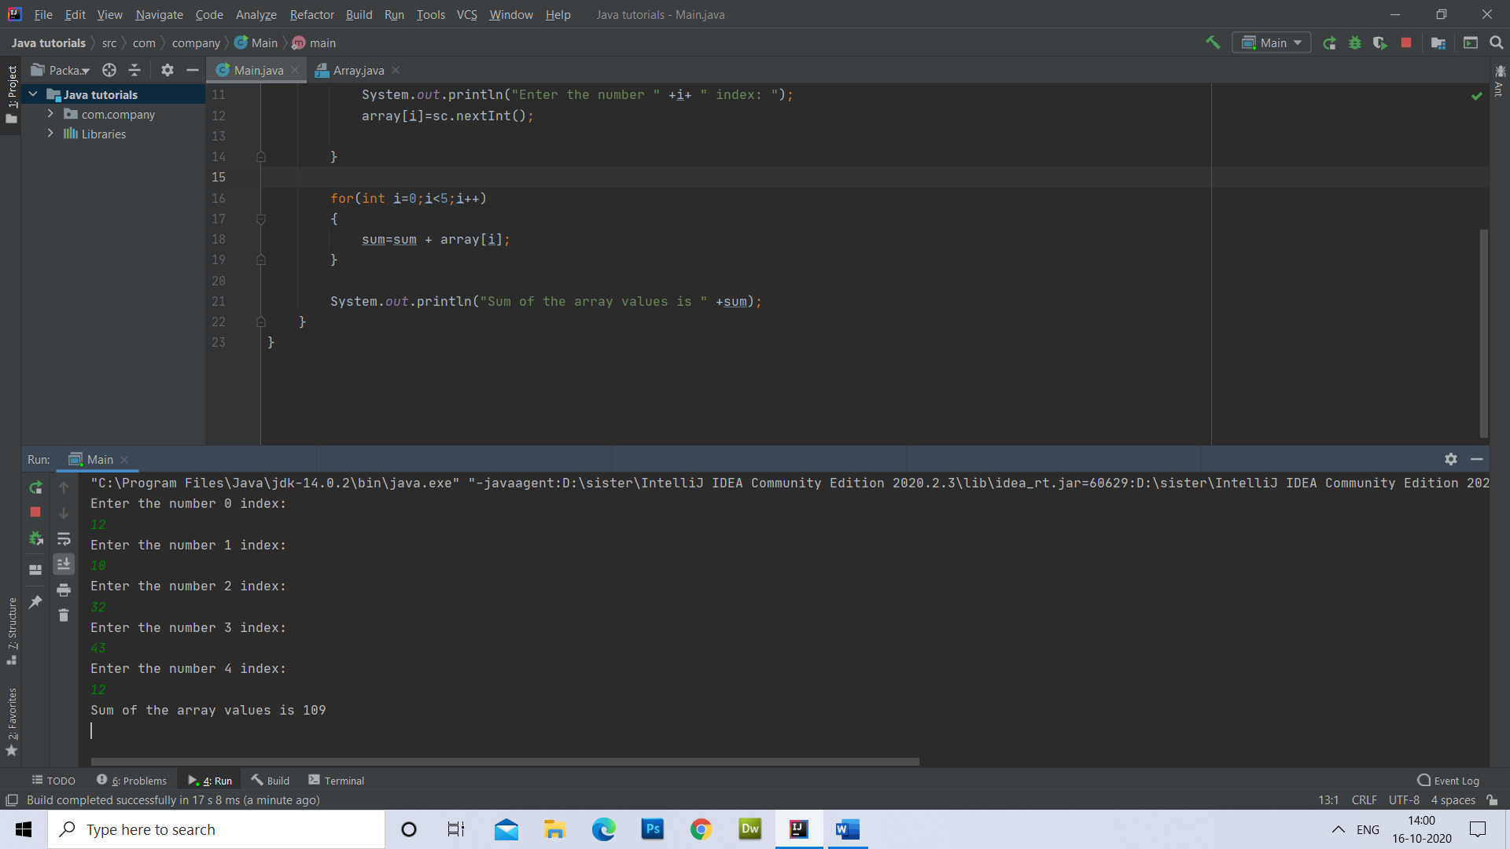

Day 5. Question1. Quiz Application

package com.quizapplication;  
import java.util.Scanner;  
public class Question {  
 Scanner sc=new Scanner(System.*in*);  
 String question,option1,option2,option3,option4;  
 int correctAnswer,userAnswer;  
 public boolean askQuestion()  
 {  
 System.*out*.println(question);  
 System.*out*.println("1. "+option1);  
 System.*out*.println("2. "+option2);  
 System.*out*.println("3. "+option3);  
 System.*out*.println("4. "+option4);  
 System.*out*.println("please choose an option");  
 userAnswer=sc.nextInt();  
 if(userAnswer==correctAnswer){  
 return true;  
 }  
 return false;  
 }  
}

Player

package com.quizapplication;  
import java.util.Scanner;  
public class Player {  
 Scanner sc=new Scanner(System.*in*);  
 String name;  
 int Score=0;  
  
 public void getDetails() {  
 System.*out*.println("Enter player name");  
 name=sc.next();  
 }  
}

Game

package com.quizapplication;  
  
public class Game {  
  
 Question[] questions=new Question[5];  
 Player player=new Player();  
 public void initGame()  
 {  
 //creating three objects  
 for(int i=0; i<3; i++) {  
 questions[i]=new Question();  
 }  
 //applying values to the variables of the object  
 questions[0].question="Who is the Strongest Avenger?";  
 questions[0].option1="Ironman";  
 questions[0].option2="Thor";  
 questions[0].option3="Hulk";  
 questions[0].option4="Dr. Strange";  
 questions[0].correctAnswer=2;  
  
 questions[1].question="What is the closest planet to sun?";  
 questions[1].option1="Earth";  
 questions[1].option2="Venus";  
 questions[1].option3="Mercury";  
 questions[1].option4="Jupiter";  
 questions[1].correctAnswer=1;  
  
 questions[2].question="What is the capital of Australia?";  
 questions[2].option1="Sydney";  
 questions[2].option2="Melbourne";  
 questions[2].option3="Perth";  
 questions[2].option4="Canberra";  
 questions[2].correctAnswer=4;  
 }  
 public void play()  
 {  
 player.getDetails();  
 for(int i=0;i<3;i++)  
 {  
 boolean status=questions[i].askQuestion();  
 if(status==true)  
 {  
 System.*out*.println("Jhakkas! khele ho bhai.");  
 player.Score++;  
 }  
 else{  
 System.*out*.println("Marr gya biddu!");  
  
 }  
 }  
 System.*out*.println(player.name +" your score is: "+ player.Score);  
 }  
}

Main

package com.quizapplication;  
  
public class Main {  
  
 public static void main(String[] args) {  
 // quizapplication  
 Game game= new Game();  
 game.initGame();  
 game.play();  
 }  
}

Output:

