December 2015

Swype it 2.0.0 beta test plan

Hi! Welcome to the Swype It 2.0 beta test group! Wahoo, your are awesome and I love you, any way, follow this list!

# using testflgiht

Ok. So we are using TestFlight to distribute the app! It’s a service from Apple and you will get an email that looks like:

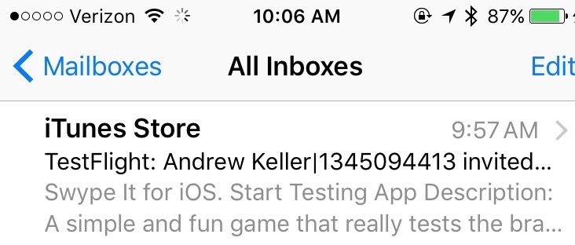

I have definitely heard of it going to SPAM folders so check there and if it’s still not there let me know! I’ll resend it on my end.

## Follow the instructions in that email

### Download the test flight app

### Tap redeem

### Copy and paste that code in if necessary

## Now from here on out you will get a notification when I send out a new build!

## Wahoo you should now be good to go, life is good!!! RIGHT??!

# sending feedback

## I made it super easy for YOU to send ME feedback! (Yay! I know awesome right?!?!)

## All you need to do to send me feedback is SWIPE WITH TWO FINGERS TO THE LEFT!!!! That’s it, like does it get better than that? No. It doesn’t.

## So If you’re playing and all the sudden the game locks up or something, swipe with two fingers to the left and draw a picture or tell me about the steps you did to make that happen!

# Playing your first game

## Now the fun part!! Yay games! I love games, sorry got excited there, I’m back.

## Tap the start screen to play a game,

## You will be guided through a tutorial to introduce the new power ups.

# Go crazy!! if you need more coin$, follow thE$E $TEP$!

## Go to the iPhone settings app

## Tap Settings, next tap iTunes & App Store then tap the top row button that looks like ‘Apple ID: [joe@dirt.com](mailto:joe@dirt.com)’ but instead of [joe@dirt.com](mailto:joe@dirt.com) it is your real life apple id, then tap ‘Sign Out’.

## Yay great now you are ready to use a test account (so you are not actually spending real money!)

## Now sign in with one of the following accounts

|  |  |
| --- | --- |
| Username | Password |
| [swype002@test.com](mailto:swype002@test.com) | aj8Lassie |
| [swype003@test.com](mailto:swype003@test.com) | aj8Lassie |
| [swype004@test.com](mailto:swype004@test.com) | aj8Lassie |

## Signed in with this ‘Sandbox’ account you may now go to the app and visit the store and TREAT YO SELF to a big ol’ chest of coins!!

## IMPORANT NOTE: DO NOT TRY TO USE THIS APPLE ID WITH A REAL APP!!! IT LOCKS THE TEST ACCOUNT FOR EVERYONE ELSE ☹ SIGN OUT using the same steps when you are done testing for the day (or done buying more coins or going ad free)

### That’s why we cant use the swype001 account hahaha I tried already ☺

# Play around with the app at will!

## Test power ups, switch the game version, sign in with a test account and go ad free, do what ever you like, have fun though, that’s important too I guess ☺