Ageing or Attack? Cause-Aware Learning for Safe Self‑Calibration Under Disguised Sensor Poisoning
Pushkal Gupta¹, Shridhar M², Vanka Kaushik³, Syamasudha Veeragandham⁴
^{1,2,3,4}School of Computer Science and Engineering, Vellore Institute of Technology, Vellore, Tamil Nadu, India – 632014
Email: ¹pushkal.gupta2023@vitstudent.ac.in, ²shridhar.m2023@vitstudent.ac.in, ³vanka.kaushik2023@vitstudent.ac.in, ⁴syamasudha.v@vit.ac.in
⁴Corresponding author

Abstract
Many IoT pipelines now recalibrate, update their baselines and retrain using the data they accept. An injection that imitates normal transducer ageing is therefore learned as the new normal, and it later masks real faults. We cast the task of telling drift from poisoning as cause-aware learning under adversarial distribution shift. Our attacker hierarchy matches benign ageing in size and rate, and we prove that an on-path attacker cannot be told apart from drift, yet a bounded correction anchored in physics still limits the damage it can do. PIRCAD compares each channel with a physics-based expectation that leaves that channel out, assigns one of four causes (normal, drift, poisoning, process event) using features of the residual's character and of where constraint violations localise, and uses that cause to decide what each adaptive element may learn. Across 180 held-out simulated episodes, PIRCAD reaches macro-F1 0.943 (random forest) and 0.962 (gradient boosting); a supervised 1D-CNN (0.938) and a generic-feature forest (0.974) are as accurate in distribution. Without retraining, under eleven simulated distribution shifts, PIRCAD's worst case is 0.712 against 0.477 and 0.288. In an attack-then-fault experiment, a downstream safety alarm fired in 100 % of 120 episodes, while tuned Kalman, Page-Hinkley and EWMA self-calibration never raised it. On real Intel Berkeley Lab data with mote-disjoint splits, the data-driven learners lead on labels and the CNN also withstands a sensor-noise shift; we report this and every other limitation, including three defects that the stronger evaluation exposed in our earlier pipeline.
Keywords: Sensor drift; Data poisoning; Self-calibration; Root-cause classification; Physics-informed machine learning; Adversarial robustness; Internet of Things; Fog computing

1. Introduction
Networked sensing underpins industrial monitoring, building automation and environmental observation, and every analytic, control decision and safety interlock computed downstream inherits the trustworthiness of the stream it is given [1,2]. In practice these streams come from many low-cost transducers left to run unattended, and their readings can become wrong for two quite different reasons. The first is ageing. Over time a transducer picks up a slow, smooth offset, yet it keeps measuring the process, so the right action is to recalibrate it, not to throw it away [3,4]. The second is attack. False-data injection produces values that each look reasonable on their own [2,5], and acoustic or thermal tampering at the sensor itself happens before any encryption on the link can help [6–8].
Ageing and attack need opposite responses, but an attacker can make one look like the other. An offset that rises by a few hundredths of a degree each minute is what an old thermistor does, and it is also what a careful attacker would inject. The problem is sharpened by the fact that IoT pipelines now adapt. They recalibrate on the data they have accepted [3], update their baselines and thresholds [9], and absorb concept drift so that it stops raising alarms [10,11]. An adaptive element that treats every slow, persistent deviation as benign drift will absorb an injection shaped like drift into its own reference, and the damage outlasts the attack: once the reference has moved, genuine faults are under-reported. This has been shown against drift-adaptive detectors in industrial control [12,13] and, physically, by acoustically poisoning the training data of an on-device anomaly detector until the machine fault it existed to detect became invisible [7].
The dominant machine-learning formulation does not pose the question that would prevent this. Time-series anomaly detectors emit a score or a flag [14–16]; drift detectors emit a change point [11]. Neither carries a vocabulary of causes, so a system built on them has nothing on which to condition its response, and it does the same thing whatever the reason for the deviation. Recent work has begun to separate faults from attacks [5,17–19] and adversarial from real concept drift [20], but only between hypotheses that differ in their signature at the plant, not against an injection deliberately matched to benign ageing; and none of it closes the loop from the verdict to which adaptive elements may learn from the data.
This paper treats the problem as one of cause-aware learning under adversarial distribution shift. We ask a fog-layer learner to decide, for every deviation, whether it is benign transducer drift, data poisoning, or a genuine excursion of the monitored process; and to let that verdict gate every element that adapts. The approach, PIRCAD (physics-anchored root-cause attribution with adaptation governance), rests on one structural idea: each channel is judged against an expectation that it cannot influence. For each channel we build that expectation from the other instruments and the process physics only (a leave-one-channel-out, or dedicated-observer, estimator). A slow bias on the channel then shows up in the residual at its full size. Size and rate cannot tell ageing from attack, but the character of the residual can: a drifting transducer still sees the real process, while a substituted stream does not.
The contributions are:
- A formulation and threat model for drift-versus-poisoning attribution in which the adversary matches benign ageing in magnitude and rate, organised as a hierarchy of attacker knowledge. We state the limit of the problem explicitly: an on-path attacker that adds a ramp to the genuine signal is observationally equivalent to drift on the attacked channel (Proposition 1), and we show that a physics-anchored, bounded correction nevertheless bounds the damage such an attacker can do (Proposition 2).
- A physics-anchored root-cause learner: leave-one-out residuals, a compact set of residual-character features, and a localisation of physical-constraint violations whose hypothesis signatures come from perturbing the model rather than from labelled faults. The learner is back-end agnostic; we report five.
- Adaptation governance: a per-channel state machine that withholds suspect data from every adaptive element, with a cause-dependent response — bounded recalibration for drift, quarantine for poisoning, forward-and-alarm for process events — and a rule that no irreversible action (quarantine) is taken on an uncertain verdict, so that one misclassification cannot lock a serviceable sensor out of correction.
- A statistically powered evaluation against supervised deep and feature-based learners, unsupervised detectors and tuned self-calibrating estimators: 30 held-out seeds with paired tests, an attacker-capability sweep, eleven distribution-shift conditions without retraining, an end-to-end safety experiment, and a real-data study on the Intel Berkeley Research Lab deployment with sensor-disjoint train and test splits [21].
- Reproducibility: all code, the attack generators and the scripts that produce every number and figure are released; Section 7.2 also documents three defects that the stronger evaluation exposed in our own earlier pipeline, and their fixes.
Section 2 reviews related work. Section 3 formalises the problem and the threat model. The method is given in Section 4 and the experimental design in Section 5, and Section 6 presents the results. Section 7 discusses limitations and threats to validity, and Section 8 concludes.

2. Related work
Anomaly and change detection. Fog-, edge- and on-device anomaly detection place lightweight learners next to the sensors [15,16], and deep time-series anomaly detection has been surveyed comprehensively [14]; work on the decision stage makes thresholds adaptive and uncertainty-aware [9]. Isolation-based scoring [22] and sequential change detection [23] remain the low-cost workhorses. These methods improve the score, not its semantics: the output is a single anomaly label, so there is nothing on which to condition a cause-specific response.
Drift compensation and adaptation. Field recalibration of low-cost sensor networks [3] and learned drift compensation [4] treat slow, persistent, one-directional bias as something to absorb — correctly, when the cause really is ageing — and drift-aware IoT detectors adapt to configuration changes to suppress false positives [10]; concept-drift adaptation more broadly is surveyed in [11]. None of this literature carries an adversarial hypothesis, so absorbing an injection shaped like ageing lies outside its threat model.
Attacks on sensing and on adaptive learners. Stealthy false-data injection against state estimation [24] and replay attacks [25] define the classical adversary; surveys review detectors [2], and random-matrix methods separate injection from replay [5]. Learned detectors are themselves attackable: detectors that predict each sensor from the others can be evaded [26], and gradient-crafted injections are misclassified as legitimate faults [27]. Most directly relevant to this paper, detectors retrained online to follow drift can be poisoned by fake sensor signals so that later attacks go undetected [12,13]; drift detectors can be evaded by adversarially constructed drift [28]; on-device learners have been poisoned physically [7]; and thermal attacks have exploited the temperature-dependent internal calibration of low-cost pollution sensors [8]. Outside IoT, a physical attack on autonomous vehicles first triggers camera–LiDAR online recalibration and then steers the estimate [29] — the same exploit of a self-calibrating element. Poisoning defences for federated learners [30] protect a training corpus, not the calibration offsets and normalisation statistics of a fog pipeline.
Physics-informed and model-based detection. Model-based diagnosis generates residuals against a process model and exploits analytical redundancy [31]; observer-based residuals remain effective for data-efficient diagnosis [32]. Physics-informed learning brings known laws into anomaly detection [33,34], invariant rules among process variables detect attacks in industrial control [35], and digital twins act as observers [36,37]. The nearest edge system, PhySec-Edge, combines process-model residuals, Kalman estimation and cross-sensor checks with learned detectors [38]; it detects attack classes, but benign ageing is not among its hypotheses and the residual is not used to select a response.
Distinguishing faults, attacks and drift. The closest work in objective separates which kind of anomaly occurred: attacks from faults in interconnected cyber-physical systems [17], replay attacks from sensor faults [18], malicious anomalies from sensor faults and genuine events with an ensemble pipeline [19], and adversarial from real concept drift in generic data streams [20]. Table 1 positions these against PIRCAD. Three properties are, to our knowledge, not combined elsewhere: an injection matched to benign ageing in both magnitude and rate as the decisive hypothesis; attribution grounded in physical constraints whose signatures need no labelled faults; and the verdict gating every adaptive element, evaluated by its end effect on a downstream safety function rather than by label accuracy alone.
Table 1. Positioning against the closest prior work. ✓ = addressed; ~ = partially; – = not addressed.
Work | Ageing-matched attack as hypothesis | Drift / attack / process event | Physics-grounded attribution | Cause-dependent response | Gates adaptation | Real data
Drift compensation [3,4] | – | drift only | – | recalibrates | – | ✓
Drift-aware IoT AD [10] | – | – | – | adapts | – | ✓
Poisoning of online ICS detectors [12,13] | ~ (attack study) | – | – | – | – | ✓
Adversarial vs real drift [20] | ~ | drift vs adversarial | – | – | ~ | ✓
Fault vs attack [17,18] | – | fault vs attack | ✓ (observers) | – | – | –
Malicious vs fault vs event [19] | – | ✓ | – | – | – | ✓
PhySec-Edge [38] | – | attack classes | ✓ | – | – | ~
PIRCAD (this work) | ✓ (hierarchy A0–A5) | ✓ | ✓ | ✓ | ✓ (all elements) | ✓ (semi-synthetic)

3. Problem formulation and threat model

3.1 Setting
A fog node receives synchronous samples y(k) = [y₁(k), …, y_{C}(k)] from C transducers observing a common physical process with state x(k) and known inputs u(k) (actuator commands, or exogenous measurements such as neighbouring sensors). In nominal operation y_{i}(k) = h_{i}(x(k)) + e_{i}(k), with e_{i} the transducer noise. The node forwards samples to a cloud tier and maintains a set 𝒜 of adaptive elements: calibration offsets c_{i}, residual normalisation statistics, the state of its process model, and any learned model that is retrained on accepted data. Each sample of each channel carries a latent cause z_{i}(k) ∈ {NORMAL, DRIFT, POISON, PROCESS}:
- DRIFT — the transducer degrades: y_{i}(k) = h_{i}(x(k)) + e_{i}(k) + b_{i}(k), with b_{i} smooth and |ḃ_{i}| ≤ ρ_{i}, the manufacturer's ageing envelope. The sensor still observes the real process.
- POISON — the reported value is replaced or modified by an adversary (Section 3.2).
- PROCESS — the plant itself departs from nominal (e.g. an actuator fails); the instruments remain healthy and mutually consistent.
The learning task is to infer ẑ_{i}(k) causally and to choose an action a_{i}(k) = π(ẑ_{i}(k)) and an adaptation mask g_{i}(k) ∈ {0, 1} that decides whether sample k of channel i may update any element of 𝒜. The objective is not label accuracy alone but its consequences: drifting sensors should stay in service with their bias removed, poisoned samples should neither be forwarded nor reach 𝒜, and process events should be forwarded and alarmed without ever being calibrated away.

3.2 Threat model: an attacker-capability hierarchy
The adversary controls the reported stream of one channel (or, at level A5, several) and wants its injection absorbed as drift. Throughout, the injected deviation is rate-matched to benign drift — the same ramp rate, within the ageing envelope — so any detector reasoning about magnitude, persistence or growth rate is at chance by construction. The levels differ in what the attacker knows about the live process:
- A0 (stale surrogate). The attacker replaces the reading with a delayed copy of the process (an exponential moving average, factor 0.02), adds the ramp, and adds white noise with the same variance as the transducer.
- A1 (noise-matched). As A0, but the noise reproduces the transducer's coloured (AR(1)) spectrum.
- A2 (higher fidelity). The surrogate tracks the live process with smoothing factor 0.05–0.30.
- A3 (exact state). The attacker has the true process state in real time (factor 1.0); only the transducer's own noise is unknown to it.
- A4 (on-path). Sitting on the link, the attacker leaves the genuine reading in place and simply adds the ramp to it.
- A5 (coordinated). The attacker controls T, P and RH and derives all three from a single forged temperature, so the physical relations between the instruments still hold.
We also test two attack families that are not rate-matched: isolated spike substitutions, and replay of an earlier genuine window. On the defender's side we assume a clean commissioning window and a reasonably accurate process model; at levels A0–A4 we assume the attacker cannot touch the inputs u(k).

3.3 Limits of separability
Proposition 1 (observational equivalence). Let an A4 attacker add the ramp b(k) = ρ(k − k₀) with |ρ| inside the ageing envelope. The sequence the attacked channel reports then has exactly the same distribution as that channel would have under benign drift with b_{i} = b. Proof. Both equal h_{i}(x(k)) + e_{i}(k) + ρ(k − k₀) with the same noise realisation; no function of {y_{i}(k)} can separate them, and the other channels are untouched in both cases. ∎
Proposition 1 fixes the frontier of the problem: no detector — physics-based or learned — can label A4 correctly from the data alone. What a system can control is the consequence of mislabelling it.
Proposition 2 (bounded harm of anchored correction). Let the calibration offset c_{i} be driven only by residuals against an expectation ŷ_{i}(k | y_{−i}(k), u(k)) that excludes channel i, with per-sample rate limit δ and total cap c_{max}. Suppose an A4 ramp b(k) is labelled as drift. Then the corrected value that is forwarded obeys |y_{i} − c_{i} − h_{i}(x)| ≤ |ε_{ref}| + |e_{i}| + max(0, |b| − c_{max}) + L, with ε_{ref} the error of the reference and L ≤ max(0, |ḃ| − δ)·t the lag of the tracker. Proof. The expectation does not use channel i, so the residual is an estimate of b + ε_{ref}, and the corrector subtracts it within its rate and cap limits. ∎
This is why the response matters as much as the classifier. An attack that can only be labelled drift is still corrected against the physics, instead of being folded into a baseline built from the channel itself. A corrector that follows the channel's own history (a rolling mean, an EWMA reference, or recalibration triggered by Page-Hinkley) does the opposite: it follows b, and the whole bias reaches the forwarded value. Both claims are tested in Sections 6.2 and 6.4.

4. Method
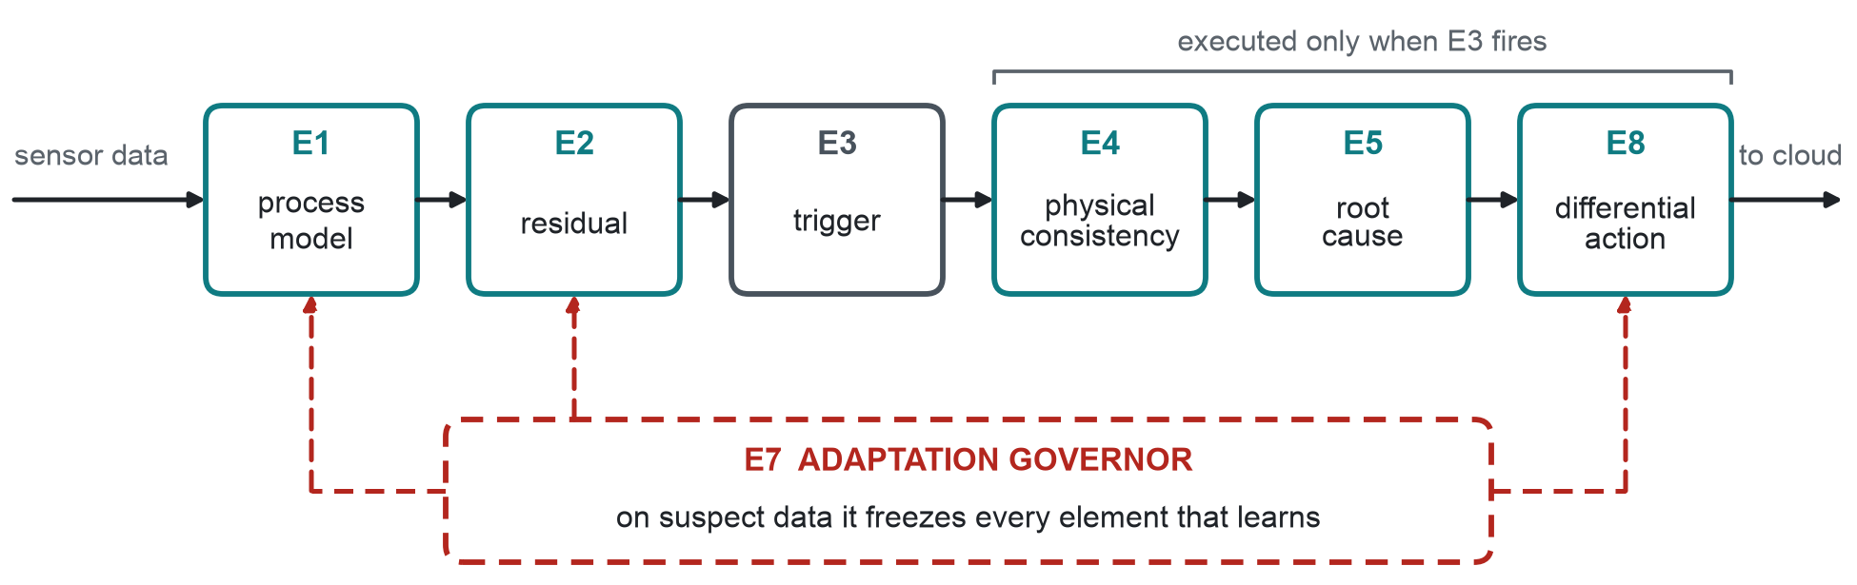
Fig. 1. Structure of PIRCAD on the fog node. Stages E4, E5 and E8 are costly and run only after the lightweight trigger E3 fires. The adaptation governor E7 decides what each learning element may use: the process-model state, the residual statistics and the calibration offsets.

4.1 Leave-one-out physics residuals (E1–E2)
For each channel i the expected value is produced by a dedicated observer whose state excludes that channel:
r_{i}(k) = y_{i}(k) − c_{i}(k) − ŷ_{i}(k | y_{−i}(k), u(k)) (1)
A single closed-loop estimator that also uses channel i tracks a slow bias on that channel, so its innovation stays at the noise floor; excluding the channel makes the bias appear in r_{i} at full amplitude (with a retrained classifier the practical effect is small; Section 6.6). Each observer is re-anchored only on channels the governor currently trusts, with weights that are slewed rather than switched (a step change in an anchor's weight would itself appear as a jump in other channels' residuals). Residual location and scale are learned on a clean commissioning window and then frozen: an adaptive scale is precisely the handle a slow injection would use to normalise itself away.
In the simulated testbed (Section 5.1) the process is a heated, sealed vessel with a bang-bang controller, and the observers combine Newtonian heating, the isochoric ideal-gas law P ∝ T and conservation of absolute humidity through the Magnus relation [39]:
e_{s}(T) = 610.94 · exp(17.625 T / (T + 243.04)), RH = 100 e / e_{s}(T) (2)
In the real-data embodiment (Section 5.2) there is no actuator; the expectation of a mote's temperature fuses the Magnus inversion of its own humidity at the neighbours' vapour pressure with the neighbours' mean temperature (inverse-variance weights fixed during commissioning), and the expectation of its humidity follows from its temperature and the neighbours' vapour pressure.

4.2 Residual-character features (E2)
A rate-matched injection and benign drift have, by construction, the same residual magnitude and slope. The features therefore describe how the residual evolves (Table 2). Their physical rationale is that a drifting transducer still observes the real process: its innovation statistics and its response to the modelled micro-dynamics are preserved, whereas a substituted stream carries the attacker's noise and does not follow the plant. The most legible example is excitation coherence,
κ_{i}(k) = − corr_{W}( Δr_{i}, Δŷ_{i} ) (3)
the negated correlation, over a window W, between residual increments and model-predicted increments: near zero for a sensor that tracks the real dynamics, positive for a stream whose increments do not. Forging it requires the attacker to reproduce the plant's micro-dynamics in real time — which is exactly the knowledge axis of the hierarchy in Section 3.2.
Table 2. Feature vector of the root-cause learner (22 features).
Group | Features | What separates the causes
Size | z_now, z_abs_max, r_mean_norm, r_std_norm, slope_norm, persistence, exceed_frac | Trigger context only; uninformative between rate-matched causes by design
Ageing envelope & onset | slope_ratio (vs. ρ_{i}), monotone_frac, corner, jump_max | Ageing is smooth, one-directional and inside ρ_{i}; an injection has an onset
Noise signature | acf_shift, var_ratio, flatness, hf_ratio, kurt_incr | Changes in the innovation statistics relative to commissioning
Dynamics | dyn_coherence (κ) | Does the stream still follow the modelled micro-dynamics?
Localisation (E4) | loc_score, loc_margin, loc_magnitude, loc_is_self, loc_is_process | Which hypothesis best explains the constraint-violation direction

4.3 Physics-signature localisation (E4)
A vector g(k) of physical-constraint violations is evaluated on the reported measurements and normalised by commissioning statistics (vessel: gas law, humidity conservation, open-loop dynamics, energy balance, regulation; indoor: Magnus consistency, spatial temperature, spatial humidity). For each hypothesis h — a unit bias on each channel, or an unmodelled process input — a signature s_{h} is obtained by perturbing the model at the commissioning operating point, so no labelled fault data are needed. Localisation reports the hypothesis that best explains the direction of the windowed mean violation ḡ, its share of the violation energy and its margin over the runner-up:
h* = argmax_{h} ( s_{h}ᵀ ḡ / ‖ḡ‖ )² (4)
Localisation does not decide between drift and poisoning. It asks a different question: did an instrument go wrong, or did the plant itself change? Getting this right is what stops a real process event from being calibrated out. Indoors, for instance, a local heat source shifts temperature and humidity together while vapour pressure stays fixed, so the Magnus relation still holds; a biased transducer breaks it.

4.4 Root-cause learner (E5)
A four-class classifier takes the feature vector as input. To build its training set we run the full pipeline with the classifier switched off, which guarantees that the features seen in training match those seen at inference. Channels other than the target are labelled NORMAL, so the learner learns to ignore triggers caused by a neighbour's fault. The hybrid version adds a small physical override. When localisation points confidently at the process, the verdict is PROCESS, since a mistake there affects safety; when the violations point clearly at the channel itself, a PROCESS verdict is rejected. Any classifier can be used. We test a random forest [40] (the default), gradient boosting, logistic regression, a multilayer perceptron and a rule set that needs no training. A fog node classifies samples one at a time, so we store the forest as flat arrays and walk all trees in one vectorised pass. The output matches the library implementation exactly (the test suite checks this) and is about 200× faster per sample.

4.5 Adaptation governance and differential response (E7–E8)
Every channel is in one of five states: TRUSTED, WATCH, DRIFTING, QUARANTINED or RECOVERING. As soon as its trigger fires, a channel drops out of TRUSTED, even before a cause has been assigned. From that point it carries less weight in the process model and no longer updates the residual statistics. What happens next depends on the cause:
- DRIFT → bounded, rate-limited, audited recalibration c_{i} ← clip(c_{i} + clip(γ b̂_{i}, ±δ), ±c_{max}), with b̂_{i} the robust residual bias; data keep flowing. The channel stays in the drift state while the correction is active: a residual kept at zero by the correction shows that the correction is working, not that the sensor has healed.
- POISON → quarantine. The node forwards nothing, freezes all adaptive elements and raises a security alert, and the channel must wait out a minimum hold before it can recover.
- PROCESS → the data are forwarded with an alarm, and no calibration is allowed.
Quarantine policy. A drift verdict cannot release a quarantined channel; if it could, an attacker would only need to push one verdict towards drift to get recalibrated. The node also follows the governor's current state, not the most recent verdict, so a quarantined channel forwards nothing even when it is labelled drift. Quarantine is latched by default, meaning the channel comes back only after the freeze hold has passed and a clean run has been seen. We also evaluate an availability-oriented alternative, re-attribution, in which a quarantined channel moves to DRIFTING after the hold plus a sustained run of 200 consecutive drift verdicts; Section 6.4 shows why latching is the safer default.
Uncertain verdicts. A verdict below the confidence threshold (0.62) is escalated to a heavier back-end when one is configured. Without one, an uncertain POISON verdict holds that sample — it is neither forwarded nor admitted to any adaptive element — but it is recorded by the governor as UNKNOWN and cannot latch a quarantine; only a confident POISON verdict does. Uncertain DRIFT and PROCESS verdicts act locally, since their actions are bounded and reversible. This realises the rule that no irreversible action is taken on an ambiguous sample.

4.6 Cost
Per sample and channel, the nominal path is one model evaluation, a subtraction and a CUSUM update; features, localisation and classification run only on engaged channels, at a configurable re-evaluation interval (a fresh trigger always forces re-evaluation). Section 6.7 reports measured latency.

5. Experimental design

5.1 Simulated benchmark
The testbed is a heated vessel (thermal capacitance 5 kJ/K, loss 20 W/K, 400 W heater, bang-bang control at 30 °C with 0.3 °C hysteresis, sinusoidal ambient with a random-walk component) instrumented with internal temperature T_{in}, pressure P, humidity RH and ambient temperature T_{amb}, each with coloured AR(1) noise and quantisation. The fog node's model is deliberately mismatched (thermal capacitance +3 %, loss −2.5 %, heater +1 %, reference pressure +0.08 %, vapour pressure +1.5 %). Six scenarios are generated: clean, benign drift, rate-matched poisoning (A0), spike poisoning, replay poisoning and a process event (heater contactor welded on or failed open). Onset and rate are drawn per episode (onset in the second quarter of the episode; rate 0.8–2.5 × 10⁻³ units per sample), and the event polarity — drift or ramp direction, heater on or off — is balanced. Episodes are 4000 samples, of which the first 600 are a scored-out warm-up.
Splits. Models are trained on 6 seeds × 6 scenarios × 2 polarities (72 episodes, 509 513 labelled channel-samples) and evaluated on 30 disjoint seeds × 6 scenarios (180 episodes). Every reported number comes from the held-out bank.

5.2 Real data: Intel Berkeley Research Lab
The Intel Berkeley Research Lab deployment [21] recorded temperature, humidity, light and battery voltage from 54 Mica2Dot motes in an office between February and April 2004. We bin the ≈31 s epochs into 2-minute samples, interpolate gaps of up to 30 minutes, and use days 0–10, before battery failures make readings meaningless; 51 motes have ≤2 % missing data after interpolation. The clean signal — with its real micro-climate, occupancy and packet loss — is therefore real. Ground truth for drift and poisoning can only exist if events are injected, so they are injected into the real temperature streams (semi-synthetic evaluation): drift and A0 poisoning at 0.6–2.0 × 10⁻³ °C per sample, spikes, a replay of the previous day, and a genuine-process surrogate — a local heat source or draught that changes temperature by 1.5–4 °C and humidity exactly as psychrometrics requires at constant vapour pressure. Each mote uses its four nearest neighbours as physical references. Motes are split at random into disjoint train and test halves; every model is fitted on train motes only. Clean test episodes measure false alarms on unmodified real data.

5.3 Comparison systems
All learned baselines are trained on the same episodes with the same four labels and see at least the information PIRCAD sees — every raw channel plus the actuator command or neighbour aggregates — but no physics (Table 3). Self-calibrating baselines were tuned to minimise their own correction error on benign drift (training seeds only), so that none can appear safe merely by not adapting.
Table 3. Comparison systems.
System | Type | Input | Output
Multi-scale 1D-CNN | Supervised deep learner; dilated convolutions over the last 128 samples and an 8× pooled 1024-sample context | All raw channels + command, standardised on commissioning | 4 causes
Generic-feature RF | Random forest over multi-scale window statistics incl. rolling cross-channel correlations | As above | 4 causes
Gen-1 FHAD | Rolling-mean detrending + CUSUM + windowed classifier (authors' earlier pipeline) | Target channel | 4 causes
Isolation Forest [22], PCA-SPE, autoencoder | Unsupervised detectors on generic features / raw windows, 1 % clean FPR | All channels | anomaly flag
Kalman χ² [41] | Single closed-loop observer over all channels, windowed NIS test | All channels + command | anomaly flag
EWMA self-recalibration | EWMA reference; z-test-triggered absorption | Target channel | corrected value
Kalman bias estimator | Augmented state [T, b], same process model as PIRCAD | Target + command + ambient | corrected value
Page-Hinkley recalibration [23] | Detect persistent shift → recalibrate → restart | Target channel | corrected value

5.4 Metrics and statistics
Root-cause accuracy and macro-F1 over the classes present in an episode are computed per sample after warm-up. Two directional errors are reported separately because they have opposite consequences: the false-drift rate (poisoned samples labelled drift — the attack is recalibrated into the reference) and the false-poison rate (drifting samples labelled poisoned — a serviceable sensor is discarded); the process-masking rate is the fraction of genuine process-event samples labelled as an instrument fault. Effect-level metrics measure what the system does: poisoning containment (poisoned samples not forwarded), retraining protection (1 − poisoned samples admitted to any adaptive element / poisoned samples) and forwarded error (mean absolute error between the forwarded, corrected value of the target channel and its true physical value over the event window, with withheld samples contributing zero). All metrics are computed per episode; we report means with 95 % bootstrap confidence intervals (4000 resamples) and compare systems with paired two-sided Wilcoxon signed-rank tests [42] matched by episode, with Holm correction [43] and rank-biserial effect sizes.

6. Results

6.1 In-distribution benchmark
Table 4. Root-cause attribution on 180 held-out simulated episodes (30 seeds × 6 scenarios). Mean [95 % bootstrap CI]; p: paired Wilcoxon test of per-episode macro-F1 against PIRCAD (random forest), Holm-corrected. ↓ lower is better.
System | Macro-F1 | Accuracy | False-drift ↓ | False-poison ↓ | Process masked ↓ | False alarm ↓ | p
PIRCAD (random forest) | 0.943 [0.932, 0.954] | 0.941 [0.929, 0.953] | 0.002 | 0.001 | 0.017 | 0.030 | ref.
PIRCAD (gradient boosting) | 0.962 [0.950, 0.972] | 0.946 [0.933, 0.958] | 0.001 | 0.072 | 0.022 | 0.031 | <10⁻⁴
PIRCAD (MLP) | 0.863 [0.836, 0.889] | 0.859 [0.827, 0.890] | 0.001 | 0.393 | 0.010 | 0.112 | <10⁻⁴
PIRCAD (logistic regression) | 0.673 [0.636, 0.711] | 0.655 [0.612, 0.699] | 0.033 | 0.758 | 0.021 | 0.368 | <10⁻⁴
PIRCAD (rules, no training) | 0.643 [0.602, 0.683] | 0.597 [0.556, 0.637] | 0.080 | 0.625 | 0.433 | 0.211 | <10⁻⁴
Multi-scale 1D-CNN | 0.938 [0.922, 0.954] | 0.989 [0.988, 0.991] | 0.005 | 0.001 | 0.001 | 0.004 | 0.274
Generic-feature RF | 0.974 [0.964, 0.982] | 0.988 [0.986, 0.990] | 0.000 | 0.001 | 0.000 | 0.001 | <10⁻⁴
Gen-1 FHAD | 0.454 [0.402, 0.504] | 0.514 [0.462, 0.564] | 0.000 | 0.000 | 0.000 | 0.000 | <10⁻⁴

Table 4 addresses the first question: is a physics-anchored learner more accurate than a strong data-driven one when train and test come from the same distribution? It is not. PIRCAD reaches macro-F1 0.943 with a random forest and 0.962 with gradient boosting; the multi-scale 1D-CNN reaches 0.938 (not significantly different from PIRCAD-rf, p = 0.27) and the generic-feature forest 0.974, significantly higher. Both learned baselines see every raw channel and the actuator command, so in distribution they can learn the coupling the physics encodes. The authors' earlier pipeline (Gen-1), against which our prototype was originally compared, reaches 0.454: a comparison against it alone would overstate the contribution.
Three properties of PIRCAD's errors matter more than its mean. The two operationally dangerous confusions are near zero: poisoning read as drift (0.002) and drift read as poisoning (0.001). Its residual error is concentrated in benign drift, where the verdict is withheld until the ramp rises out of the noise (mean detection delay 69 samples), and in a false-alarm rate of 0.030 on clean data. And the back-end matters less than its calibration: gradient boosting and the random forest are within 0.02 of each other, the MLP reaches 0.86 because it issues confident poisoning verdicts early in benign drift, which the latched quarantine then holds (false-poison rate 0.39), and the linear model and the training-free rule set are far behind — the feature space is informative but not linearly separable.
Table 5. Detection only (anomalous vs. not), all scenarios pooled. Unsupervised detectors are thresholded at 1 % false alarms on clean training data.
System | Detection F1 | Recall | False alarm
PIRCAD (random forest) | 0.818 | – | 0.030
Multi-scale 1D-CNN | 0.862 | – | 0.004
Isolation Forest | 0.444 | 0.616 | 0.090
PCA-SPE | 0.738 | 0.994 | 0.504
Autoencoder | 0.760 | 0.935 | 0.138
Kalman χ² | 0.749 | 0.896 | 0.024

Table 5 places the unsupervised detectors. They flag most deviations but cannot name them, and none has a response that differs by cause; the Kalman χ² bad-data detector recalls 0.95 of rate-matched poisoning but would answer drift and poisoning identically. PIRCAD's own detection F1 is lower than the learned baselines' because it deliberately withholds a cause until the evidence supports one.
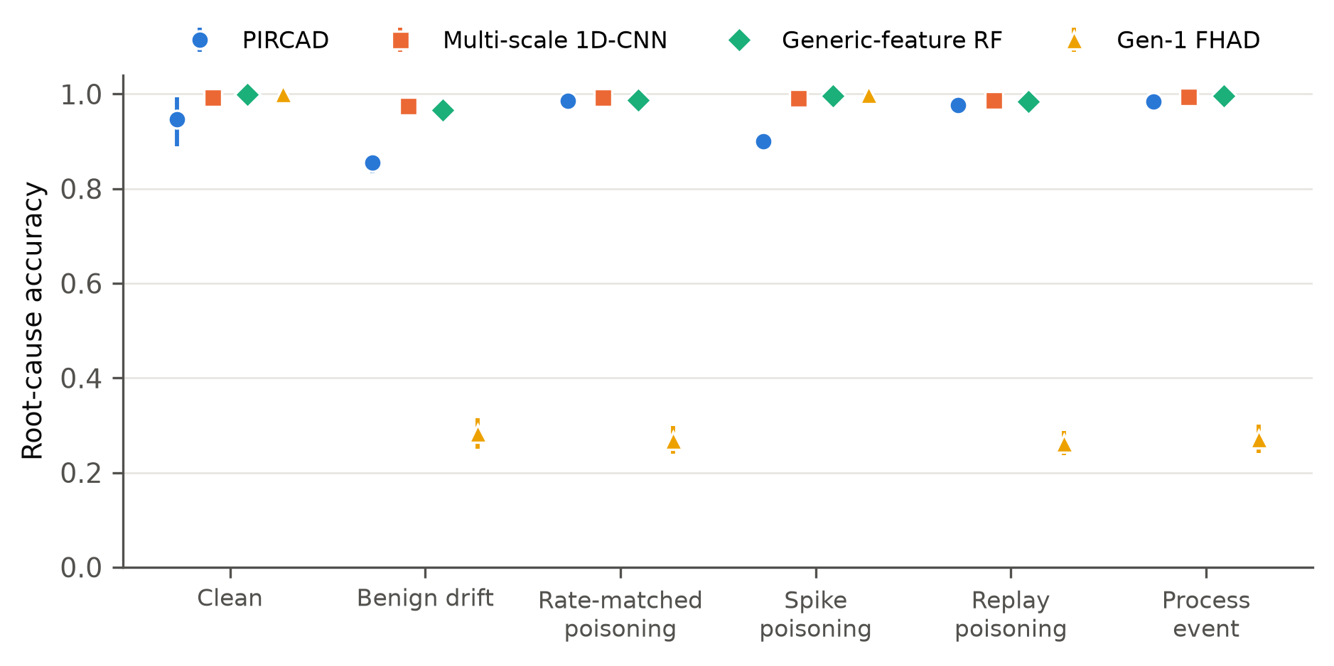
Fig. 2. Per-scenario root-cause accuracy on the held-out bank (mean, 95 % CI). PIRCAD's shortfall is concentrated in benign drift (detection delay) and spike poisoning; the learned baselines are uniformly strong in distribution, and Gen-1 can only name what a threshold on a rolling mean can see.

6.2 How much does the attacker need to know?
Table 6. Attacker-capability sweep (20 seeds per condition; models trained on A0 only). Recall is drift recall for the reference row and poisoning recall otherwise. Useful-data rate: fraction of event-window samples forwarded within 0.5 °C of the true value. Forwarded error: PIRCAD's mean absolute error over forwarded samples (°C).
Condition | Recall PIRCAD | Recall CNN | Recall RF | False-drift PIRCAD | Useful PIRCAD | Useful CNN | Useful RF | Fwd. error PIRCAD
Benign drift (reference) | 0.808 | 0.967 | 0.954 | – | 0.99 | 0.03 | 0.04 | 0.17
A0 stale surrogate | 0.989 | 0.992 | 0.982 | 0.000 | 0.01 | 0.01 | 0.02 | 0.10
A1 noise-matched | 0.985 | 0.991 | 0.979 | 0.001 | 0.01 | 0.01 | 0.02 | 0.12
A2 fidelity 0.05 | 0.984 | 0.990 | 0.979 | 0.001 | 0.02 | 0.01 | 0.02 | 0.12
A2 fidelity 0.10 | 0.982 | 0.988 | 0.977 | 0.001 | 0.02 | 0.01 | 0.02 | 0.13
A2 fidelity 0.30 | 0.946 | 0.547 | 0.673 | 0.020 | 0.05 | 0.02 | 0.03 | 0.11
A3 exact state | 0.357 | 0.000 | 0.755 | 0.532 | 0.61 | 0.03 | 0.04 | 0.18
A3 exact state + matched noise | 0.003 | 0.002 | 0.002 | 0.833 | 0.99 | 0.03 | 0.04 | 0.18
A4 on-path (MITM) | 0.002 | 0.001 | 0.003 | 0.831 | 0.99 | 0.03 | 0.04 | 0.17
A5 coordinated, stale | 0.148 | 0.088 | 0.060 | 0.000 | 0.03 | 0.01 | 0.05 | 2.50
A5 coordinated, exact | 0.000 | 0.002 | 0.000 | 0.010 | 0.13 | 0.04 | 0.05 | 2.19

Table 6 sweeps the threat hierarchy of Section 3.2 without retraining any model. When the attacker sees the live process only through a delayed surrogate (A0–A2, fidelity up to 0.10), every learned system catches at least 0.98 of the poisoning, and copying the sensor's noise spectrum gains the attacker nothing. Differences between the systems appear only once the surrogate becomes more accurate. At fidelity 0.30 PIRCAD retains recall 0.95 against 0.67 (generic forest) and 0.55 (CNN), with the lowest false-drift rate; with the exact process state but white noise (A3) the generic forest is best (0.76 against 0.36 for PIRCAD) and the CNN collapses to zero. No method dominates: each has a different breaking point along the knowledge axis.
Once the attacker also matches the transducer's noise (A3) or adds the ramp to the genuine reading (A4), every system's poisoning recall falls to ≤ 0.003 — Proposition 1 observed: the attacked channel is statistically benign drift, and calling it drift is the only consistent verdict. What differs is the consequence. A label-only system can withhold what it flags but cannot correct it, because it has no estimate of the bias, so it delivers almost none of the affected channel: its useful-data rate on these attacks — and on genuine drift — is 0.03–0.04. PIRCAD calls the A4 ramp drift, as it must, but corrects it against the physics: 99 % of the attacked channel is delivered within 0.5 °C of the truth, with a mean forwarded error of 0.17 °C, while the injected bias itself grows to several degrees. This is Proposition 2 observed: a mislabelled equivalent attack is neutralised in effect, which no amount of classification accuracy can achieve.
The coordinated attacker (A5) marks the limit of the method. By forging every physically coupled instrument from one fake temperature, it keeps the instrument-side constraints satisfied; PIRCAD's localisation then attributes the deviation to the process, and the node forwards it with a process alarm (forwarded error 2.5 °C). The alarm is raised, but the forged values are delivered. Stopping A5 needs at least one instrument outside the attacker's control, such as an independent reference, a measurement on the actuator side, or a channel with cryptographic attestation. A single fog node cannot provide that on its own.
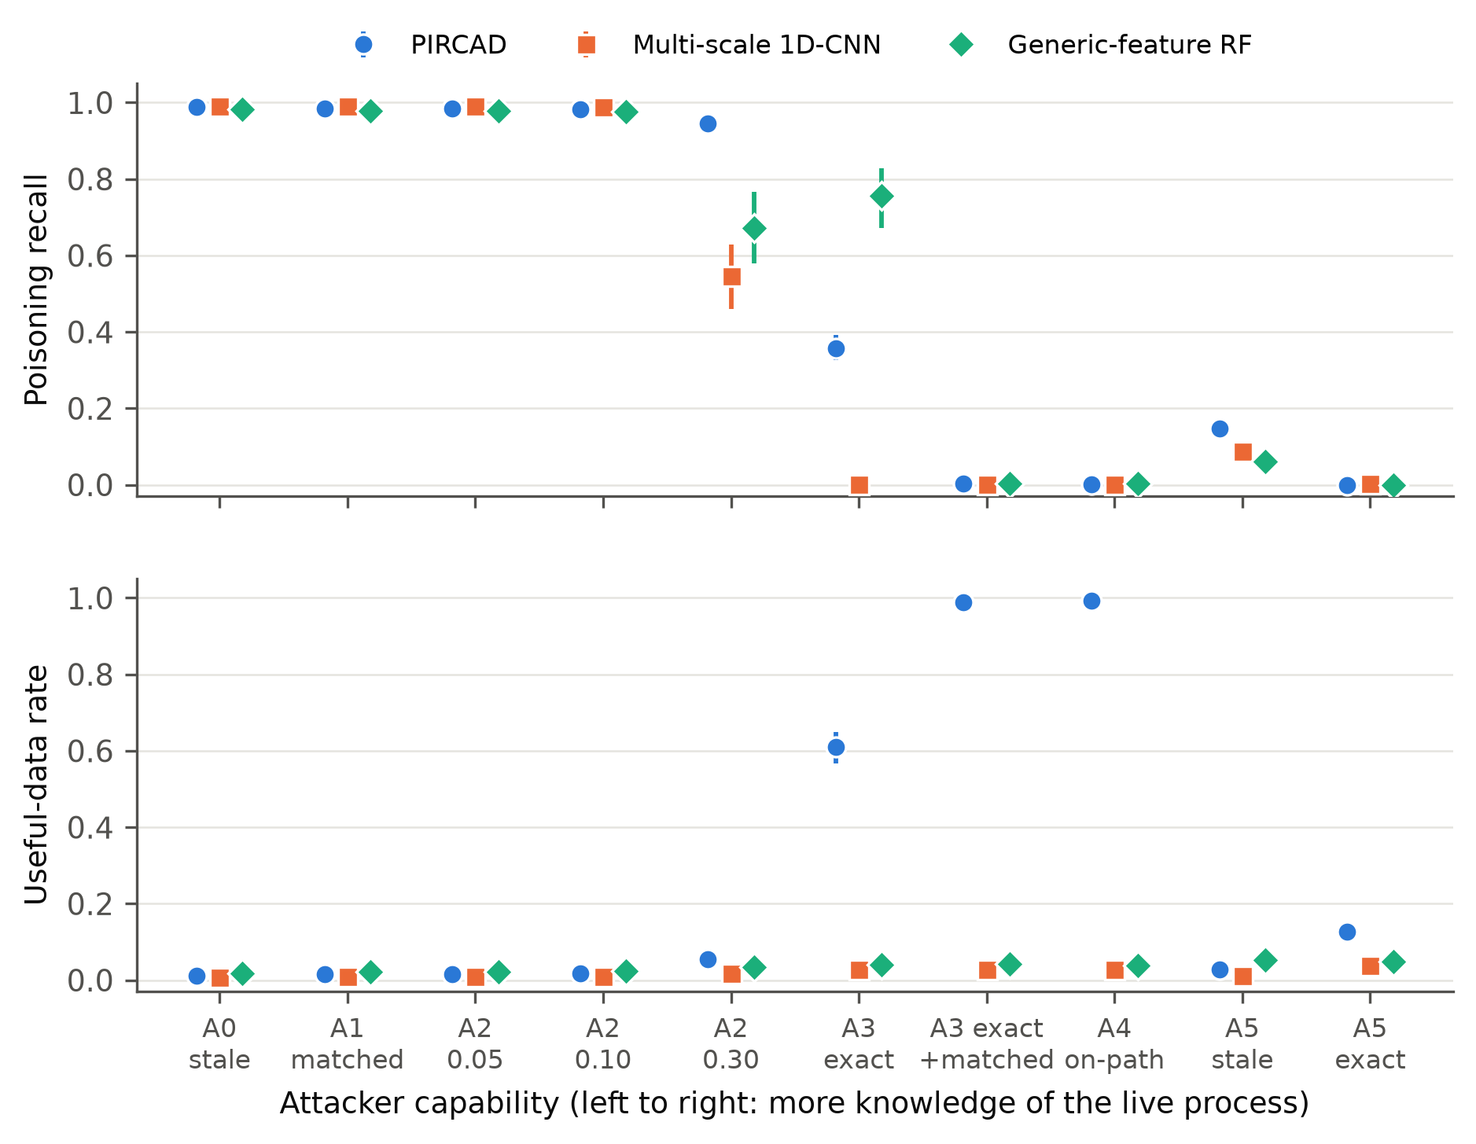
Fig. 3. Attacker-capability sweep. (a) Poisoning recall; (b) useful-data rate on the attacked channel. Left to right the attacker knows more about the live process. Where no system can label the attack (A3 with matched noise, A4), PIRCAD still delivers the channel corrected to the physical truth; label-only systems can only withhold it.

6.3 Robustness to distribution shift
Table 7. Macro-F1 under distribution shift, no retraining (10 seeds × 6 scenarios per condition). The process-model mismatch rows apply to PIRCAD only, since the learned baselines have no model to degrade. The last two columns are PIRCAD's false-drift and false-alarm rates.
Condition | PIRCAD | 1D-CNN | Generic RF | False-drift PIRCAD | False alarm PIRCAD
Nominal | 0.939 | 0.937 | 0.974 | 0.005 | 0.030
Process-model mismatch ×3 | 0.865 | n/a | n/a | 0.014 | 0.148
Process-model mismatch ×6 | 0.785 | n/a | n/a | 0.012 | 0.297
Plant dynamics −15 % | 0.935 | 0.932 | 0.978 | 0.003 | 0.040
Plant dynamics +20 % | 0.933 | 0.873 | 0.966 | 0.000 | 0.015
Sensor noise ×2 | 0.843 | 0.763 | 0.299 | 0.294 | 0.007
Sensor noise ×3 | 0.712 | 0.527 | 0.288 | 0.228 | 0.002
Ambient swing ×2.5 | 0.953 | 0.912 | 0.968 | 0.001 | 0.019
Set-point 35 °C | 0.936 | 0.477 | 0.942 | 0.001 | 0.036
Rates 0.3–0.8 ×10⁻³ | 0.928 | 0.932 | 0.966 | 0.005 | 0.030
Rates 2.5–2.9 ×10⁻³ | 0.947 | 0.938 | 0.976 | 0.005 | 0.030

Table 7 trains every system once, on the nominal plant, and evaluates it on plants and sensors it has never seen. The data-driven learners are excellent until a shift touches what they learned, and then they fail abruptly. The generic-feature forest is unaffected by changed plant dynamics, ambient swing or set-point, but when the transducers become twice as noisy its macro-F1 falls to 0.299 with a false-alarm rate of 0.88: its features are scaled to the commissioning noise level, so the whole clean stream now looks anomalous. The CNN degrades under noise (0.527 at ×3) and collapses when the plant is merely regulated at a different set-point (0.477, false alarms 0.82) — a shift that changes nothing about the causes, only the operating point the network memorised.
PIRCAD degrades but does not collapse: its worst condition is sensor noise ×3 at macro-F1 0.712, against 0.477 (set-point 35 °C) for the CNN and 0.288 (sensor noise ×3) for the generic forest, and its mean over all conditions is 0.889 against 0.810 and 0.817. Most of these shifts leave the residual untouched, because a new set-point, ambient or plant dynamics changes the expectation and the measurement together. Only shifts that change the residual itself cause harm, and two of them expose genuine weaknesses. With the strongest noise shift the false-drift rate climbs to 0.23: the noise-signature features, which distinguish a substituted stream from a drifting one, were calibrated on the commissioning noise level. And with a poor process model (mismatch ×6) the false-alarm rate reaches 0.30. In short, PIRCAD is only as robust as its process model is accurate; that is the cost of checking a channel against physics instead of against its own history.
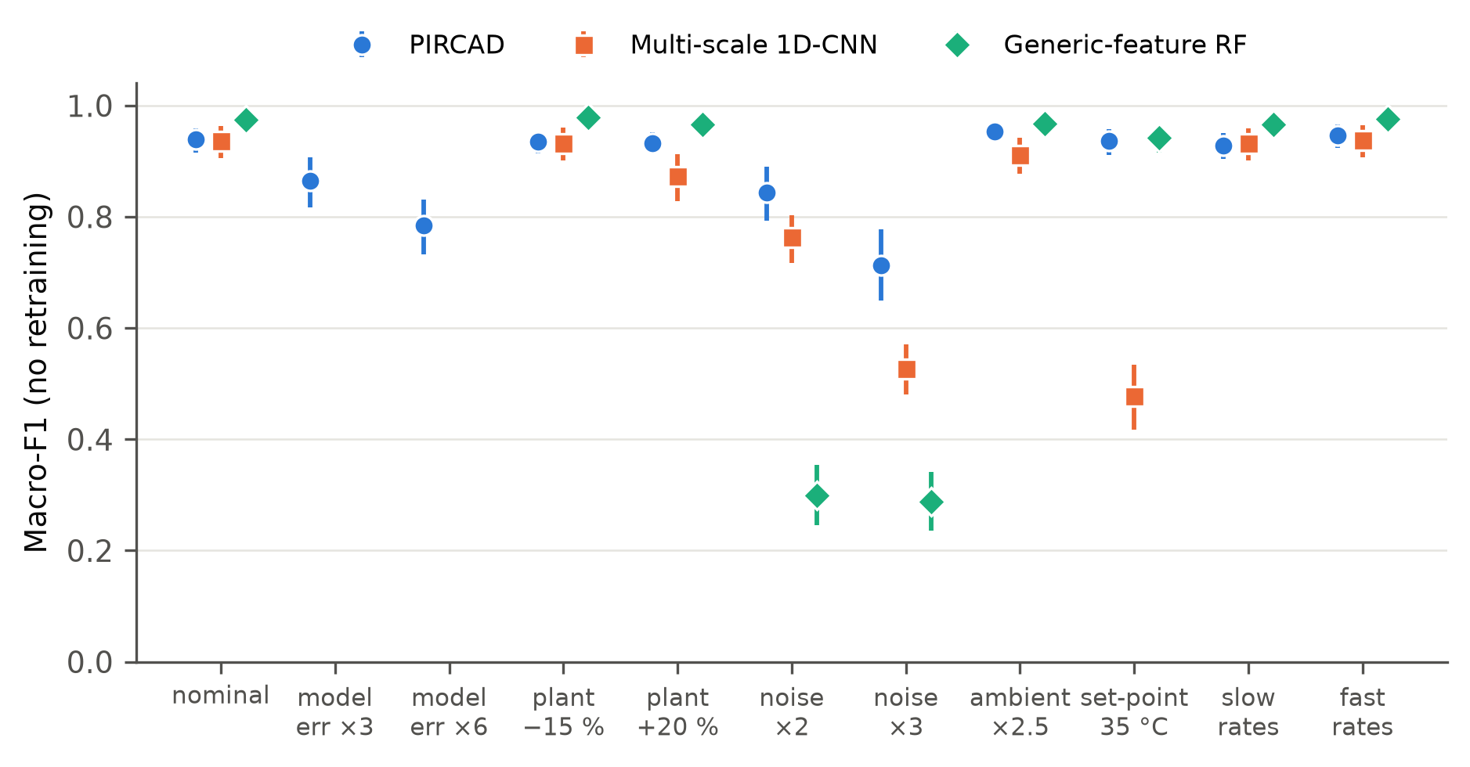
Fig. 4. Macro-F1 under distribution shift, with no retraining (mean, 95 % CI). Both data-driven learners break down under at least one condition, while PIRCAD's lowest score stays well above theirs. The model-mismatch conditions only apply to PIRCAD.

6.4 Does the safety function survive the attack?
Correct labels are only a means to an end. What really counts is whether, after an attack, the adaptive parts of the system are still sound enough to report the next real fault. In each of 120 episodes (20 seeds × 3 attack rates × 2 attackers: A0, and a fidelity-0.30 noise-matched A2), a rate-matched injection biases the internal temperature downwards for 4500 samples; the attacker then withdraws and the heater contactor welds shut, a genuine over-temperature fault. In the cloud, an alarm fires when the value forwarded by the fog layer passes 34 °C. Each self-calibrating baseline was tuned on benign drift (training seeds) to do its own job well, and a benign-drift arm (60 episodes, no attack) measures that job.
Table 8. Attack-then-fault (120 episodes) and benign drift (60 episodes). Spurious trip: the forwarded value crossed 34 °C before the fault existed. Premature trip: the forwarded value crossed during the fault, at least 5 samples ahead of the plant (a real excursion read too high, which errs on the safe side). Error at crossing: forwarded temperature minus true temperature at the moment the plant actually reached 34 °C, mean [95 % CI]. Last column: mean error of the corrected, forwarded value under benign drift.
System | Alarm fired | Spurious trip | Premature trip | Error at crossing (°C) | Poison forwarded | Drift correction error (°C)
PIRCAD | 1.00 | 0.01 | 0.17 | +0.18 [+0.09, +0.30] | 0.021 | 0.41
PIRCAD auto re-attribution | 1.00 | 0.27 | 0.19 | +1.46 [+1.08, +1.88] | 0.135 | 0.43
PIRCAD non-differential | 1.00 | 0.72 | 0.13 | +2.94 [+2.54, +3.34] | 1.000 | 0.44
EWMA recalibration | 0.00 | 0.33 | 0.00 | -6.43 [-6.49, -6.38] | 1.000 | 2.60
Kalman bias estimator | 0.00 | 0.67 | 0.00 | -4.72 [-4.75, -4.68] | 1.000 | 0.14
Page-Hinkley recalibration | 0.00 | 0.67 | 0.00 | -3.69 [-3.71, -3.67] | 1.000 | 0.10

Table 8 shows the consequence of absorbing an injection. None of the three self-calibrating baselines ever raises the alarm: each adopts part of the attacker's bias as its correction, and when the real fault arrives it under-reports by 3.7–6.4 °C. The tuned Kalman bias estimator is instructive: it uses the same process model as PIRCAD and is the best drift corrector in the table (0.14 °C), yet it fails the safety test, because a model-based bias estimator with no cause vocabulary must treat a slow injection exactly as it treats ageing. PIRCAD raises the alarm in 100 % of episodes, with an error of +0.18 °C at the crossing, a spurious-trip rate of 0.008, and 2.1 % of poisoned samples forwarded.
The two PIRCAD variants isolate where this comes from. With the response made non-differential — the same detector and classifier, but every detected deviation answered with recalibration — the alarm still fires, but 100 % of the poisoning is forwarded and the forwarded value over-reads by +2.94 °C at the crossing, with spurious trips in 72 % of episodes: detection without a cause-dependent response does not protect the safety function. With auto re-attribution instead of the latched quarantine, spurious trips rise to 0.27 and the crossing error to +1.46 °C, because the noise-matched attacker occasionally sustains enough drift verdicts to be re-attributed and partly corrected-in, while benign drift is corrected no better (0.43 against 0.41 °C). This is why latching is the default.
PIRCAD pays for this protection in drift-correction accuracy: its correction error during benign drift (0.41 °C) is larger than that of the tuned Kalman and Page-Hinkley correctors (0.14 and 0.10 °C), because its correction is rate-limited and is only engaged after the drift verdict. Where no attacker is expected, those correctors are the better choice; where one is, they should not run without a guard.
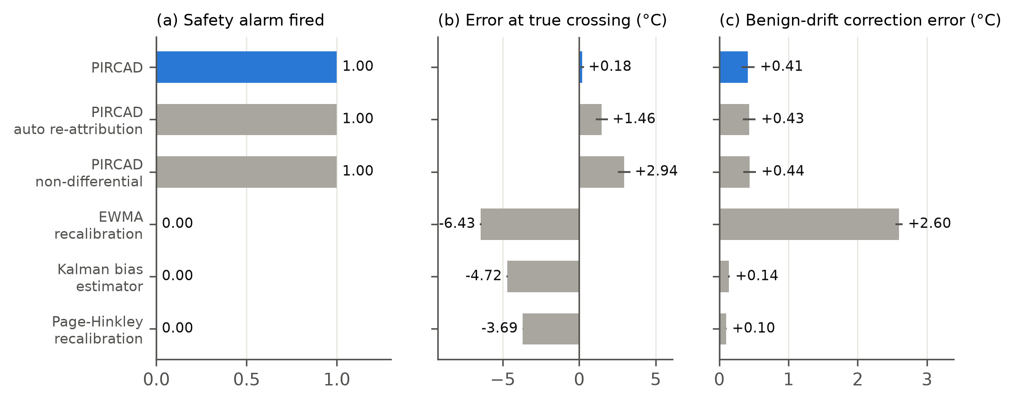
Fig. 5. Effect of poisoning the adaptation on the safety alarm. (a) Share of episodes in which the cloud-side 34 °C alarm fired for the genuine fault; (b) forwarded minus true temperature at the true crossing (negative = under-report, the dangerous direction); (c) correction error during benign drift. Means with 95 % CIs.

6.5 Real sensor data: Intel Berkeley Research Lab
Table 9. Intel Lab results: 312 test episodes (26 held-out motes, 6 scenarios, 2 replicates each), with all models trained on a separate set of 25 motes. Mean [95 % CI]; p: paired Wilcoxon on macro-F1 vs. PIRCAD (random forest), Holm-corrected. Harm: mean forwarded error on the injected channel (°C).
System | Macro-F1 | Drift recall | Poison recall | Process recall | False-drift ↓ | False alarm ↓ | Harm ↓ | p
PIRCAD (random forest) | 0.712 [0.688, 0.735] | 0.372 | 0.709 | 0.501 | 0.002 | 0.161 | 0.23 | ref.
PIRCAD (gradient boosting) | 0.664 [0.638, 0.688] | 0.128 | 0.759 | 0.559 | 0.001 | 0.222 | 0.35 | <10⁻⁴
PIRCAD (rules, no training) | 0.649 [0.620, 0.677] | 0.017 | 0.843 | 0.303 | 0.001 | 0.177 | 0.07 | <10⁻⁴
Multi-scale 1D-CNN | 0.854 [0.834, 0.874] | 0.859 | 0.669 | 0.958 | 0.008 | 0.079 | 0.03 | <10⁻⁴
Generic-feature RF | 0.845 [0.828, 0.862] | 0.838 | 0.714 | 0.946 | 0.004 | 0.095 | 0.04 | <10⁻⁴
Gen-1 FHAD | 0.355 [0.324, 0.387] | 0.016 | 0.051 | 0.072 | 0.006 | 0.154 | 1.96 | <10⁻⁴

Table 9 is the least favourable result for PIRCAD in this paper, and we report it as such. On real streams with mote-disjoint splits, PIRCAD reaches macro-F1 0.712; the CNN and the generic forest reach 0.854 and 0.845, significantly higher. PIRCAD detects poisoning about as well as they do (recall 0.71 against 0.67 and 0.71) and never confuses it with drift (0.002), but it recognises real benign drift far less often (0.37) and raises more false alarms on clean real data (0.16). The reason is the expectation model. In the vessel the physics is exact up to a few per cent; in an office the leave-one-out expectation of a mote's temperature combines a psychrometric relation that assumes spatially uniform vapour pressure with a spatial relation that ignores sunlight, vents and occupants, and its residual carries real micro-climate that the commissioning statistics cannot anticipate. The character features that separate a drifting transducer from a substituted stream are then measured on a noisier residual. The data-driven learners, trained and tested on the same building and the same injection generator, do not pay that price.
Table 10. Intel Lab under a transducer-noise shift (every mote given extra white noise; no retraining). Macro-F1 and false-alarm rate on held-out motes.
Condition | Macro-F1 PIRCAD | Macro-F1 Multi-scale 1D-CNN | Macro-F1 Generic-feature RF | False alarm PIRCAD | False alarm Multi-scale 1D-CNN | False alarm Generic-feature RF
No added noise | 0.712 | 0.854 | 0.845 | 0.16 | 0.08 | 0.10
Noise +0.10 °C / +0.3 %RH | 0.680 | 0.854 | 0.690 | 0.14 | 0.08 | 0.15
Noise +0.20 °C / +0.6 %RH | 0.661 | 0.854 | 0.672 | 0.15 | 0.08 | 0.05

Table 10 repeats the decisive shift of Section 6.3 on the real deployment: the trained models are applied to test motes whose transducers have become noisier. At the strongest level macro-F1 falls by 0.051 for PIRCAD, 0.001 for the CNN and 0.173 for the generic-feature forest. The generic forest degrades to PIRCAD's level, as in simulation, but the CNN is essentially unaffected: on real data, whose own variability is large relative to the added noise, its standardised multi-scale input absorbs the shift. The robustness advantage PIRCAD showed in simulation therefore does not transfer to this real deployment under this shift, and we do not claim it does.
Two simulated findings do carry over, in weakened form. The on-path ramp (A4) again cannot be labelled — the learned baselines call it drift (poisoning recall 0.02 and 0.00); PIRCAD flags 0.35 of it, largely because its noisier real-data residual triggers poisoning verdicts on drift-like ramps too, so this is not evidence of separability. And only the system that corrects against an independent reference delivers a usable channel: PIRCAD forwards 34 % of the attacked channel and 35 % of a genuinely drifting one within 0.5 °C of the truth, against 5–7 % for the label-only learners — a sixfold difference, but far from the 99 % achieved in simulation, because the real-data correction is only as accurate as the real-data expectation.
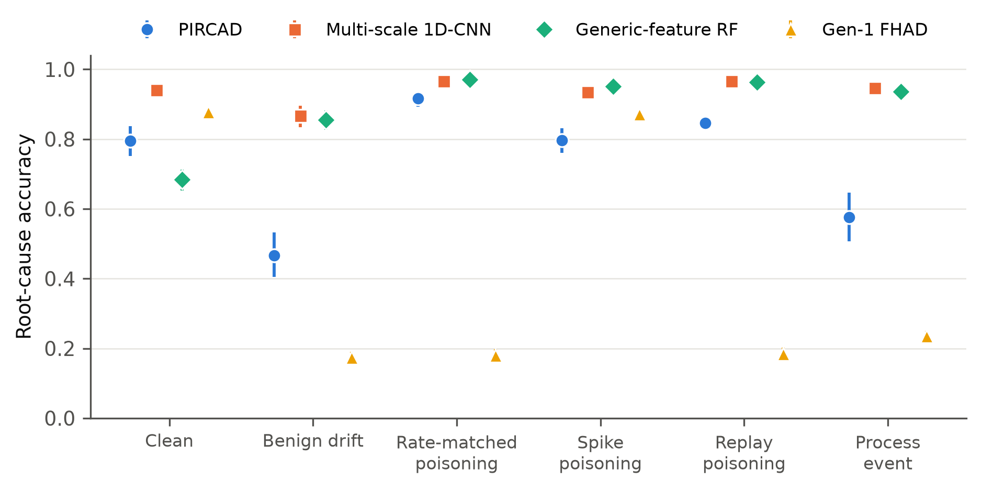
Fig. 6. Per-scenario root-cause accuracy on held-out Intel Lab motes (mean, 95 % CI). PIRCAD comes closest to the learned baselines on rate-matched poisoning and trails them elsewhere, most of all on real benign drift and local heat events.

6.6 Ablation and combined features
Table 11. Ablation on the 180-episode bank, one element removed per row; rows that change the features are retrained on a corpus collected under the same change. p: paired Wilcoxon on macro-F1 vs. the full system, Holm-corrected.
Configuration | Macro-F1 | False-drift ↓ | Containment ↑ | Process masked ↓ | Retraining protection ↑ | Harm ↓ | p
Full system | 0.943 [0.932, 0.954] | 0.002 | 0.973 | 0.017 | 0.998 | 0.05 | ref.
− physics residual (rolling mean) | 0.642 [0.597, 0.686] | 0.019 | 0.512 | 0.352 | 0.551 | 0.41 | <10⁻⁴
− dedicated observers | 0.930 [0.912, 0.947] | 0.000 | 0.979 | 0.024 | 0.997 | 0.04 | 0.538
− cross-sensor consistency | 0.937 [0.924, 0.949] | 0.002 | 0.975 | 0.001 | 0.998 | 0.05 | 0.678
− excitation coherence | 0.942 [0.931, 0.953] | 0.001 | 0.971 | 0.018 | 0.998 | 0.05 | 0.538
− noise-signature features | 0.956 [0.945, 0.966] | 0.009 | 0.955 | 0.045 | 0.998 | 0.05 | 5.5×10⁻⁴
− all character features | 0.868 [0.841, 0.895] | 0.008 | 0.935 | 0.130 | 0.998 | 0.02 | <10⁻⁴
− adaptation governor | 0.947 [0.937, 0.957] | 0.000 | 0.972 | 0.022 | 0.000 | 0.05 | 0.678
− differential response | 0.908 [0.893, 0.923] | 0.022 | 0.000 | 0.315 | 0.998 | 0.17 | <10⁻⁴

Table 11 removes one element at a time. The physics residual carries the result: replacing it by the channel's own rolling mean lowers macro-F1 from 0.943 to 0.642, cuts poisoning containment to 0.51, and lets 35 % of genuine process events be mislabelled as instrument faults. Removing the whole group of residual-character features costs 0.075 (p < 10⁻⁴), whereas any single member is redundant with the others: excitation coherence alone changes nothing measurable (0.942, p = 0.54), and removing the noise-signature group even raises macro-F1 to 0.956 while raising the false-drift rate to 0.009 — a trade of label accuracy for the dangerous error.
Two results contradict hypotheses that motivated our initial design. Replacing the dedicated observers by one shared closed-loop estimator does not significantly change macro-F1 (0.930, p = 0.54) once the classifier is retrained on the changed features: the bias is attenuated in a shared estimator's residual, but the trigger and the remaining features still see it. Dropping the cross-sensor localisation also leaves macro-F1 where it was (0.937, p = 0.68), because in this plant the character of the residual is enough to spot the process event. Neither element, then, is needed for in-distribution classification, and we do not claim otherwise. We keep the leave-one-out design because Proposition 2 depends on an expectation that leaves the channel out. Here a shared estimator happens to rely mostly on the other instruments, which is why the gap is small; that will not hold for every plant.
The two governance elements change what the system does, not the labels it assigns, so judging them by label accuracy alone would make them look useless. Remove the adaptation governor and macro-F1 stays the same, but retraining protection drops from 0.998 to 0.000, meaning every poisoned sample reaches an adaptive element. Remove the differential response and containment drops from 0.973 to 0.000 and process masking rises from 0.017 to 0.315.
Table 12. Macro-F1 with physics features only, generic features only, and the two combined in a single learner. The combined learner uses PIRCAD's governance and response unchanged.
Condition | PIRCAD (physics) | Generic-feature RF | PIRCAD (physics + generic) | False alarm, combined
Nominal (180-episode bank) | 0.943 | 0.974 | 0.976 | 0.001
Plant dynamics +20 % | 0.933 | 0.966 | 0.947 | 0.001
Sensor noise ×2 | 0.843 | 0.299 | 0.624 | 0.001
Sensor noise ×3 | 0.712 | 0.288 | 0.525 | 0.001

Table 12 tests whether the two kinds of feature complement each other. On the nominal bank the combined learner scores 0.976, closing the gap to the generic forest; but with the strongest noise shift it falls to 0.525, so it inherits the fragility of the generic features. Mixing data-driven features into a physics-anchored learner thus buys in-distribution accuracy at the price of robustness, the same trade-off seen in the main comparison, rather than giving a gain for free.
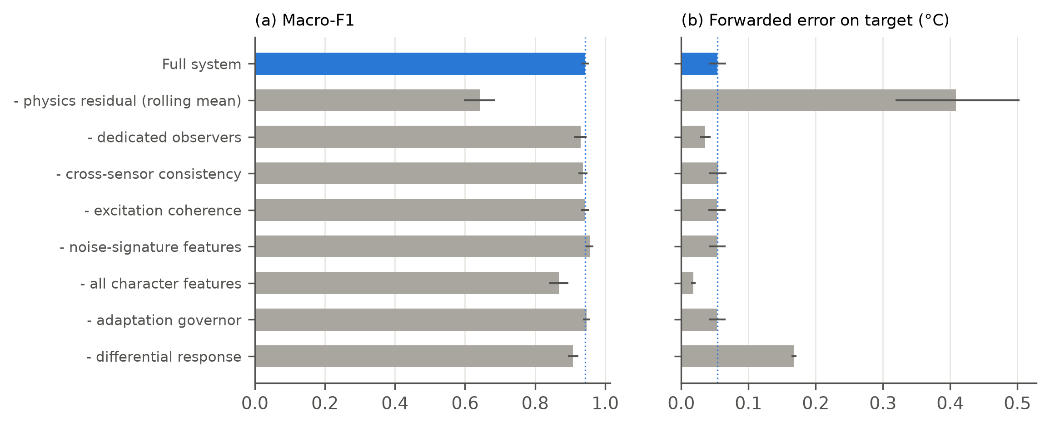
Fig. 7. Results of removing one element at a time (mean, 95 % CI): (a) macro-F1 and (b) forwarded error on the target channel. The dotted line shows the complete system.

6.7 Computational cost
Over the 180 held-out episodes, PIRCAD processes a four-channel frame in a median of 0.42 ms (95th percentile 0.68 ms) in single-threaded Python on an Apple-silicon laptop, and the expensive stages run on 31 % of channel-samples. The single-sample forest evaluation of Section 4.4 is what makes this feasible: the library implementation spends about 16 ms per single-sample call on per-tree task dispatch, which made a straightforward implementation 30× slower with identical outputs. The two-channel edge kernel runs in closed form on an ESP32-class microcontroller (Section 6.8).

6.8 Constrained edge deployment
The same architecture was reduced to closed form for an ESP32 DevKit with a single DHT22, whose temperature and humidity transducers supply the cross-channel redundancy through the Magnus relation; the decision kernel (about 4 µs per sample, compiled C++) runs in the Wokwi simulator and is unchanged from our earlier prototype. With no learned model on the node, it recalls 88.1 % and 87.5 % of linear and exponential drift, 100 % of step and spike injections and 93.1 % of a drift-shaped ramp above the ageing envelope, and admits under 1 °C of a 6 °C step or a stealth ramp into its reference, against 5.8–6.8 °C for a rolling-mean baseline. A ramp matched to the benign drift rate is not separable with two channels at one node — the regression suite asserts that it fails — which is the single-node instance of Proposition 1. The node has not yet been run on physical silicon.

7. Discussion

7.1 What the evidence supports
The results support a narrower and, we think, more useful claim than the one we started with. PIRCAD is not a more accurate classifier than a strong data-driven learner trained on the same distribution: in simulation the CNN and the generic forest match or beat it, and on real data they beat it clearly. Its advantages lie elsewhere:
- Bounded worst case under shift — in simulation. In simulation, each data-driven learner failed badly under some shift (lowest macro-F1 0.29 and 0.48), whereas PIRCAD never fell below 0.71 as long as its process model was reasonably good. On the real deployment, however, the noise shift we could apply did not affect the CNN, so this advantage still has to be shown on real data.
- The ability to act on a verdict. To correct a drifting sensor, you need an estimate of its bias taken against a reference the sensor cannot affect. A label-only system can only withhold what it flags; on benign drift PIRCAD delivered 99 % of the channel within tolerance against 4 % for the learned baselines in simulation, and 35 % against 7 % on real data.
- Harm bounded where labels are impossible. For attacks that are observationally equivalent to drift (Proposition 1), no system labels them, but physics-anchored correction neutralises them in effect (Proposition 2, Table 6).
- A safety function that survives poisoning. Against tuned self-calibrating estimators that never raised the alarm, PIRCAD raised it in 100 % of attack-then-fault episodes.
A practitioner should therefore read the comparison as complementary rather than competitive. Where the deployment is stable and labelled data are plentiful, a data-driven learner is the better classifier; it is the governance — what may learn from the data, and how a verdict is acted on — that needs an independent reference. The combined-feature experiment (Section 6.6) shows the classifier back-end can be swapped without touching the governance, which is where we expect the most productive follow-up work.

7.2 Three defects exposed by the stronger evaluation
Our earlier prototype of this system was evaluated on four seeds against its own predecessor. Re-evaluating it at the scale reported here exposed three defects, each invisible to the original benchmark:
- A polarity shortcut. Every drift and attack ramp in the original training bank rose, and every process event heated. The classifier learned the sign: a falling drift was called normal, then a process event, and was never corrected. A first fix that drew the polarity at random happened, with six training seeds, to make every training drift fall — and the model learned that rising drift is normal. Training on both polarities of every episode removed the shortcut.
- Quarantine lock-in. One transient poisoning verdict at the onset of genuine drift latched quarantine for the rest of the run, while the response still followed the latest (drift) verdict, so uncorrected data were forwarded from a channel the governor believed quarantined. Containment now follows the governor's standing state.
- Irreversible action on uncertain verdicts. With no escalation back-end the fallback forced an uncertain verdict to full confidence, so a 0.3-confidence poisoning guess latched quarantine. On real data this turned a classifier that mostly called drift correctly into one that reported poisoning for most of each drift episode. Now, a poisoning verdict with low confidence only holds back that sample and does not trigger a latched quarantine.
All three made the system look better or worse than it was in ways that a label-accuracy table on a small, one-sided bank cannot reveal. We report them because they are the most transferable lesson of this work for anyone evaluating an adaptive anomaly pipeline: balance the polarity of every event class, evaluate on effect as well as labels, and test the governance logic with episodes long enough for its state machine to matter.

7.3 Limitations and threats to validity
- Simulation. The decisive comparisons use a simulated plant whose physics is known up to a few per cent. The real-data study shows that a weaker expectation model costs PIRCAD accuracy; the method's benefits are only as good as its reference.
- Semi-synthetic real data. The Intel streams are real, but drift, poisoning and the local heat events are injected, by the same generator family used for training; the data-driven baselines benefit from that match. No public dataset provides labelled real ageing alongside real attacks.
- Attackers. The hierarchy covers knowledge of the process and the noise, on-path manipulation and coordinated forgery, but not an attacker who adapts to the classifier's gradients or controls the actuator commands.
- Coordinated forgery (A5). Forging every coupled instrument consistently defeats the constraint attribution; the node raises a process alarm but forwards the forged values.
- Sensitivity. PIRCAD's false-drift rate rises under strong transducer-noise shift, and its false-alarm rate under a poor process model.
- Baselines. The learned baselines were not tuned beyond sensible defaults; the self-calibrating baselines were tuned on benign drift only. A stronger attack-aware baseline (e.g. robust drift detection [20]) was not re-implemented.
- Hardware. The edge node has been run in simulation only; energy and memory on physical silicon are not reported.

8. Conclusion
Self-calibrating IoT pipelines can be poisoned by injections shaped like benign transducer ageing, and the harm outlasts the attack. We framed the defence as cause-aware learning whose verdicts govern every adaptive element, stated the limit of what any detector can separate, and showed that judging each channel against a physics expectation it cannot influence bounds the harm even beyond that limit. A statistically powered evaluation against deep and feature-based learners, unsupervised detectors and tuned self-calibrating estimators, including a real-data study, supports a precise conclusion: physics anchoring does not buy in-distribution accuracy, and on real data a well-trained CNN remains the better classifier; what it buys is the ability to correct rather than discard, harm that stays bounded where labels are impossible, a downstream safety function that survives poisoning, and — in simulation — a bounded worst case under shift. The most promising direction is to combine the governance studied here with learned expectation models whose reference remains independent of the channel being judged, so that the robustness of the physics can be carried to deployments where exact physics is not available.

CRediT authorship contribution statement
Pushkal Gupta: Conceptualization (lead), Methodology (lead), Software (lead), Formal analysis (lead), Investigation (lead), Data curation (lead), Validation (lead), Visualization (lead), Writing – original draft (lead), Writing – review & editing (lead), Project administration (lead). Shridhar M: Software (supporting), Validation (supporting), Investigation (supporting), Writing – review & editing (supporting). Vanka Kaushik: Software (supporting), Validation (supporting), Data curation (supporting), Writing – review & editing (supporting). Syamasudha Veeragandham: Supervision (lead), Resources (lead), Conceptualization (supporting), Writing – review & editing (supporting).
P. Gupta conceived the drift-versus-poisoning attribution problem and the physics-anchored formulation, designed the threat model and the two propositions, implemented the fog pipeline, the attack and scenario generators, all comparison systems and the edge kernel, designed and ran every experiment, carried out the statistical analysis and the Intel Lab study, identified and fixed the three defects reported in Section 7.2, produced all figures and wrote the manuscript.

Declaration of competing interest
The authors declare that they have no known competing financial interests or personal relationships that could have appeared to influence the work reported in this paper.

Funding
This research did not receive any specific grant from funding agencies in the public, commercial, or not-for-profit sectors.

Data availability
The Intel Berkeley Research Lab data are publicly available [21]. All code — the fog pipeline, the scenario and attack generators, every comparison system, the experiment scripts that produce each table and figure, and the regression tests — is available at https://github.com/Pushkal-Gupta/Sensor-Drift-and-Data-Poisoning-in-IoT-Sensor-Networks.

Declaration of generative AI and AI-assisted technologies in the manuscript preparation process
During the preparation of this work the authors used Claude (Anthropic) to assist with software development, the execution of the experiments, and drafting and editing of the manuscript. After using this tool, the authors reviewed and edited the content as needed and take full responsibility for the content of the published article.

References
[1] N. Mishra, S.H. Islam, S. Zeadally, A survey on security and cryptographic perspective of Industrial-Internet-of-Things, Internet Things 25 (2024) 101037. https://doi.org/10.1016/j.iot.2023.101037
[2] W. Xing, J. Shen, Security control of cyber–physical systems under cyber attacks: a survey, Sensors 24 (2024) 3815. https://doi.org/10.3390/s24123815
[3] R. Ahmad, Enhanced drift self-calibration of low-cost sensor networks based on cluster and advanced statistical tools, Measurement 236 (2024) 115158. https://doi.org/10.1016/j.measurement.2024.115158
[4] M. Schaller, M. Kruse, A. Ortega, M. Lindauer, B. Rosenhahn, AutoML for multi-class anomaly compensation of sensor drift, Measurement 250 (2025) 117097. https://doi.org/10.1016/j.measurement.2025.117097
[5] Y. Shen, Z. Qin, Detection, differentiation and localization of replay attack and false data injection attack based on random matrix, Sci. Rep. 14 (2024) 2758. https://doi.org/10.1038/s41598-024-52954-z
[6] C. Sahu, S. Poddar, Acoustic attack mitigation approach for MEMS inertial sensors using change point detection on MhIMU framework, IEEE Trans. Aerosp. Electron. Syst. 61 (2025) 743–752. https://doi.org/10.1109/TAES.2024.3447626
[7] T. Ino, K. Yoshida, H. Matsutani, T. Fujino, Data poisoning attack against neural network-based on-device learning anomaly detector by physical attacks on sensors, Sensors 24 (2024) 6416. https://doi.org/10.3390/s24196416
[8] N. Morand, A. Boubrima, W. Bechkit, Z. Shaikhanov, HeatPulse: thermal attacks on air pollution sensors, in: SPICES Workshop, co-located with EWSN 2024, Abu Dhabi, 2024. https://ewsn.org/file-repository/ewsn2024/SPICES_2024_CamReady_9.pdf
[9] J. Lee, J. Lee, S.B. Kim, Uncertainty-informed dynamic threshold for time series anomaly detection, Expert Syst. Appl. 278 (2025) 127379. https://doi.org/10.1016/j.eswa.2025.127379
[10] L. Xu, Z. Han, D. Zhao, X. Li, F. Yu, C. Chen, Addressing concept drift in IoT anomaly detection: drift detection, interpretation, and adaptation, IEEE Trans. Sustain. Comput. 9 (2024) 913–924. https://doi.org/10.1109/TSUSC.2024.3386667
[11] J. Gama, I. Žliobaitė, A. Bifet, M. Pechenizkiy, A. Bouchachia, A survey on concept drift adaptation, ACM Comput. Surv. 46 (2014) 1–37. https://doi.org/10.1145/2523813
[12] M. Kravchik, B. Biggio, A. Shabtai, Poisoning attacks on cyber attack detectors for industrial control systems, in: Proc. 36th Annu. ACM Symp. Appl. Comput. (SAC '21), ACM, 2021, pp. 116–125. https://doi.org/10.1145/3412841.3441892
[13] M. Kravchik, L. Demetrio, B. Biggio, A. Shabtai, Practical evaluation of poisoning attacks on online anomaly detectors in industrial control systems, Comput. Secur. 122 (2022) 102901. https://doi.org/10.1016/j.cose.2022.102901
[14] Z. Zamanzadeh Darban, G.I. Webb, S. Pan, C. Aggarwal, M. Salehi, Deep learning for time series anomaly detection: a survey, ACM Comput. Surv. 57 (2025) 1–42. https://doi.org/10.1145/3691338
[15] Y.S. Yap, M.R. Ahmad, Modified overcomplete autoencoder for anomaly detection based on TinyML, IEEE Sens. Lett. 8 (2024) 1–4. https://doi.org/10.1109/LSENS.2024.3463977
[16] M.J.C.S. Reis, Lightweight signal processing and edge AI for real-time anomaly detection in IoT sensor networks, Sensors 25 (2025) 6629. https://doi.org/10.3390/s25216629
[17] C. Liu, Y. Shi, S. Zhou, L. Xu, Y. Li, Distinguishable attack and fault detection in interconnected cyber–physical systems, Control Eng. Pract. 156 (2025) 106216. https://doi.org/10.1016/j.conengprac.2024.106216
[18] Y. Hu, X. Dai, D. Cui, Q. Liu, Anomaly identification for cyber-physical systems subject to replay attacks and sensor faults, IEEE Trans. Circuits Syst. II Express Briefs 71 (2024) 5044–5048. https://doi.org/10.1109/TCSII.2024.3349777
[19] R.M. Shukla, S. Sengupta, A novel machine learning pipeline to detect malicious anomalies for the Internet of Things, Internet Things 20 (2022) 100603. https://doi.org/10.1016/j.iot.2022.100603
[20] Ł. Korycki, B. Krawczyk, Adversarial concept drift detection under poisoning attacks for robust data stream mining, Mach. Learn. 112 (2023) 4013–4048. https://doi.org/10.1007/s10994-022-06177-w
[21] P. Bodik, W. Hong, C. Guestrin, S. Madden, M. Paskin, R. Thibaux, Intel Lab Data, Intel Berkeley Research Lab, 2004. http://db.csail.mit.edu/labdata/labdata.html (accessed 12 October 2026)
[22] F.T. Liu, K.M. Ting, Z.-H. Zhou, Isolation forest, in: Proc. 8th IEEE Int. Conf. Data Min. (ICDM 2008), IEEE, 2008, pp. 413–422. https://doi.org/10.1109/ICDM.2008.17
[23] E.S. Page, Continuous inspection schemes, Biometrika 41 (1954) 100–115. https://doi.org/10.1093/biomet/41.1-2.100
[24] Y. Liu, P. Ning, M.K. Reiter, False data injection attacks against state estimation in electric power grids, in: Proc. 16th ACM Conf. Comput. Commun. Secur. (CCS '09), ACM, 2009, pp. 21–32. https://doi.org/10.1145/1653662.1653666
[25] Y. Mo, B. Sinopoli, Secure control against replay attacks, in: Proc. 47th Annu. Allerton Conf. Commun. Control Comput., IEEE, 2009, pp. 911–918. https://doi.org/10.1109/ALLERTON.2009.5394956
[26] A. Ghafouri, Y. Vorobeychik, X. Koutsoukos, Adversarial regression for detecting attacks in cyber-physical systems, in: Proc. 27th Int. Joint Conf. Artif. Intell. (IJCAI-18), 2018, pp. 3769–3775. https://doi.org/10.24963/ijcai.2018/524
[27] A.M. Saber, A. Maheshwari, A. Youssef, D. Kundur, Adversarial attacks on deep learning-based false data injection detection in differential relays, IEEE Trans. Smart Grid 16 (2025) 4155–4166. https://doi.org/10.1109/TSG.2025.3579316
[28] F. Hinder, V. Vaquet, B. Hammer, Adversarial attacks for drift detection, in: Proc. Eur. Symp. Artif. Neural Netw. Comput. Intell. Mach. Learn. (ESANN 2025), Bruges, 2025, pp. 555–560. https://doi.org/10.48550/arXiv.2411.16591
[29] L. Liu, Q. Zhang, K.G. Shin, Adversarial calibration attack on autonomous vehicles, arXiv preprint arXiv:2608.28778, 2026. https://doi.org/10.48550/arXiv.2608.28778
[30] H. Yang, D. Gu, J. He, A robust and efficient federated learning algorithm against adaptive model poisoning attacks, IEEE Internet Things J. 11 (2024) 16289–16302. https://doi.org/10.1109/JIOT.2024.3351371
[31] R. Isermann, Model-based fault-detection and diagnosis – status and applications, Annu. Rev. Control 29 (2005) 71–85. https://doi.org/10.1016/j.arcontrol.2004.12.002
[32] S. Ullah, M.F. Siddique, J.-M. Kim, Multi-sensor observer-based residual learning with auto-permutation feature importance for fault diagnosis of multistage centrifugal pumps under variable pressures, Sci. Rep. 15 (2025) 45735. https://doi.org/10.1038/s41598-025-32726-z
[33] Y. Wu, B. Sicard, S.A. Gadsden, Physics-informed machine learning: a comprehensive review on applications in anomaly detection and condition monitoring, Expert Syst. Appl. 255 (2024) 124678. https://doi.org/10.1016/j.eswa.2024.124678
[34] M.J. Zideh, P. Chatterjee, A.K. Srivastava, Physics-informed machine learning for data anomaly detection, classification, localization, and mitigation: a review, challenges, and path forward, IEEE Access 12 (2024) 4597–4617. https://doi.org/10.1109/ACCESS.2023.3347989
[35] Q. Zhu, Y. Ding, J. Jiang, S.-H. Yang, Anomaly detection using invariant rules in industrial control systems, Control Eng. Pract. 154 (2025) 106164. https://doi.org/10.1016/j.conengprac.2024.106164
[36] A. Sayghe, Digital twin-driven intrusion detection for industrial SCADA: a cyber-physical case study, Sensors 25 (2025) 4963. https://doi.org/10.3390/s25164963
[37] C.S. Kallesøe, R. Wisniewski, Cyber-attack and fault detection using a digital twin of the controller software, IFAC-PapersOnLine 58 (2024) 97–102. https://doi.org/10.1016/j.ifacol.2024.07.200
[38] D. Radovanovic, N. Savanovic, P. Kresoja, J. Janackovic, T. Petrovic, PhySec-Edge: a hybrid physics-informed and edge AI framework for anomaly detection in industrial IoT sensor networks, J. Sens. Actuator Netw. 15 (2026) 58. https://doi.org/10.3390/jsan15040058
[39] O.A. Alduchov, R.E. Eskridge, Improved Magnus form approximation of saturation vapor pressure, J. Appl. Meteorol. 35 (1996) 601–609. https://doi.org/10.1175/1520-0450(1996)035<0601:IMFAOS>2.0.CO;2
[40] L. Breiman, Random forests, Mach. Learn. 45 (2001) 5–32. https://doi.org/10.1023/A:1010933404324
[41] R.E. Kalman, A new approach to linear filtering and prediction problems, J. Basic Eng. 82 (1960) 35–45. https://doi.org/10.1115/1.3662552
[42] F. Wilcoxon, Individual comparisons by ranking methods, Biom. Bull. 1 (1945) 80–83. https://doi.org/10.2307/3001968
[43] S. Holm, A simple sequentially rejective multiple test procedure, Scand. J. Stat. 6 (1979) 65–70. https://www.jstor.org/stable/4615733

