Fragmentation, not heterogeneity, drives the accuracy cost of federated household load forecasting
Pushkal Gupta¹, Vanka Kaushik¹, Kalaavathi B^{1,*}
¹ School of Computer Science and Engineering, Vellore Institute of Technology, Vellore 632014, Tamil Nadu, India
* Corresponding author: Kalaavathi B, kalaavathi.b@vit.ac.in
E-mail addresses: pushkal.gupta2023@vitstudent.ac.in (P. Gupta), vanka.kaushik2023@vitstudent.ac.in (V. Kaushik)
ORCID: 0009-0004-7032-6847 (Pushkal Gupta), 0009-0003-0735-264X (Vanka Kaushik), 0000-0003-4027-3137 (Kalaavathi B)
Abstract
Federated learning (FL) is widely proposed for household load forecasting because smart-meter readings never leave the home. Its accuracy loss is usually blamed on differences between households, and its bandwidth advantage over collecting the data is usually assumed rather than measured. This study separated these effects under controlled conditions. One hundred standard-tariff London households from the Low Carbon London trial, one chronological test period, one long short-term memory (LSTM) forecaster and one training budget were held fixed, and a single factor was changed at a time: the number of clients the homes were split over, the heterogeneity between clients (dialled over real load-profile clusters and measured directly), client participation, the aggregation rule and the precision of the transmitted updates. Every byte exchanged was counted, and households were compared pairwise. Federated training on a single client matched centralised accuracy (mean absolute error 0.0809 against 0.0812 kWh). The gap grew with fragmentation, from 1.8 % with five clients to 10.0 % with one client per home. Heterogeneity at a fixed number of clients changed final error by at most 0.0012 kWh but raised the traffic needed to approach centralised accuracy by about 85 %, and federated training moved more bytes than uploading the raw readings. Plain federated averaging left 65 % of households worse off than local models; one epoch of local fine-tuning reduced this to 50 %. Operators and aggregators should therefore federate a few aggregated clients, fine-tune locally and treat federation as a governance choice rather than a bandwidth saving.
Keywords: federated learning; load forecasting; smart meters; non-IID data; communication efficiency; personalisation; Low Carbon London

1. Introduction
Short-term forecasts of the load of a single household feed demand response, home energy management, local flexibility markets and the operation of low-voltage networks that now host heat pumps, electric vehicles and rooftop photovoltaics. Deep recurrent models, and the long short-term memory (LSTM) network [1] in particular, forecast individual homes better than per-home statistical models when they are trained on many households at once [2], [3]. Pooling the readings in one place is, however, exactly what smart-meter regulation and customer consent increasingly discourage, because half-hourly consumption reveals occupancy, daily routines and appliance use.
Federated learning (FL) [4], [5] offers a way around this. Each meter, home gateway or community energy hub trains on its own data, and only model weights travel to an aggregator. A sizeable literature now applies FL to residential load forecasting [6]–[12]. Two premises run through it. The first is that household data are strongly non-identically distributed (non-IID), so that plain federated averaging (FedAvg) suffers and needs remedies such as the proximal term of FedProx [13], clustering [8], [14] or personalisation [9], [10]. The second is that FL is the communication-light option compared with uploading the data [15], [16].
Neither premise has been tested under controlled conditions. Published studies differ in dataset, cohort, horizon, model, number of rounds and evaluation protocol, and almost none holds the households and the test set fixed while varying only how the data are split across clients. The field therefore cannot say how much of the accuracy lost by FL is caused by heterogeneity, how much by splitting the data at all, and how much by the federated training protocol itself. Bandwidth claims rest on analytic estimates or on argument rather than on bytes counted during training [15], [17], and the effect of federation on individual households is rarely reported.
This paper measures where the accuracy and communication costs of federated household load forecasting come from, using a one-factor-at-a-time experiment on 100 homes of the Low Carbon London (LCL) trial [18].
The principal contributions of this work are as follows:
- A controlled decomposition of the gap between federated and centralised training into the costs of the round protocol, of fragmentation, of heterogeneity and of partial participation. It shows that the gap is a fragmentation cost: absent on a single client and growing with the number of clients to 10.0 % when every home is a client.
- A measured, label-free heterogeneity index and two communication-priced metrics, R@$ε$ and B@$ε$, computed from an exact byte ledger. They show that heterogeneity mainly costs traffic rather than accuracy, and that federated training of a small LSTM moves more bytes than the raw readings it keeps local.
- A household-level equity analysis with paired signed-rank tests, which identifies who loses from federation and shows that one epoch of local fine-tuning, at no communication cost, removes most of that harm at community scale.
- A heterogeneity-adaptive proximal rule (HA-FedProx) that schedules the FedProx coefficient from the disagreement of the client updates, and the negative result that this signal is dominated by convergence rather than by heterogeneity, a caution for any regulariser adapted to update statistics.
- An open pipeline that regenerates every table and figure of this paper from the public LCL release.
The remainder of this paper is organised as follows. Section 2 reviews related work. Section 3 describes the methodology. Section 4 presents the experimental results. Section 5 discusses the findings and limitations, and Section 6 concludes.

2. Literature Review

2.1 Deep learning for household load forecasting
Household load is volatile and driven by occupant behaviour. Kong et al. [2] showed that LSTMs outperform shallow and statistical baselines for individual residential customers, and Shi et al. [3] showed that pooling the data of neighbouring households reduces over-fitting, which is the effect that motivates collaborative training in the first place. Later work added embeddings, bidirectional recurrences and multi-task sharing [19], [20], as well as clustering of consumption profiles [21]. All of these gains assume that the data are pooled on one server.

2.2 Federated household load forecasting
Federated forecasting of residential load has grown quickly [6]–[12], [14], [22]–[42], yet the studies disagree on whether federation pays off at all. The closest to the present work is that of Briggs et al. [43], who trained a two-layer LSTM with FedAvg on 100 LCL households. Plain FL was 7.6 % worse in mean RMSE than localised learning; clustering reduced the shortfall to 4.7 %, and local fine-tuning made the federated models better than local ones. Gholizadeh and Musilek [8] likewise found local learning best on average for individual Canadian homes, whereas Fekri et al. [7] found FedAvg comparable to, or better than, per-meter models on 19 Ontario homes. Personalised and clustered variants [9], [10], [12], [14], [35], [38] are almost always motivated by heterogeneity among households. Privacy is the other usual motivation, but keeping data local is not by itself a guarantee: model updates can leak training data through gradient inversion [44], [45].

2.3 Communication cost of federation
Communication efficiency was a founding motivation of FL [4], [46]. In load forecasting the evidence points both ways. Taïk and Cherkaoui [15] estimated analytically that FL saves 90–97 % of the network load of uploading data, and Savi and Olivadese [16] reported up to 50 times less exchanged data at sub-hourly resolution. Briggs et al. [17], by contrast, argued without measurement that exchanging weight vectors costs more bandwidth than sending half-hourly readings over constrained smart-meter links. Most federated forecasting studies count rounds rather than bytes [7], or report the payload per round without comparing it with the data [47].

2.4 Non-IID data and adaptive proximal regularisation
Statistical heterogeneity slows and biases FedAvg [5], [48], [49]. The remedies proposed include proximal regularisation (FedProx [13]), control variates (SCAFFOLD [50]), dynamic regularisation (FedDyn [51]), normalised averaging (FedNova [52]), adaptive server optimisers [53], personalisation [54], [55] and fairness-aware objectives [56]. Heterogeneity is usually induced with a Dirichlet split over class labels [57], which has no direct analogue for regression on smart-meter data. Choosing the proximal coefficient also remains ad hoc. The FedProx paper adapts it from the training loss [13], HAPI-FedProx from a local-versus-global performance index [58], and Yu et al. [59] characterise the optimal strength as a function of heterogeneity in theory. FedAdp [60] uses the geometry of client updates to set aggregation weights, and gradient diversity [61] uses a closely related ratio to explain limits on mini-batch speed-up.

2.5 Research gap
Table 1 summarises the studies closest to this one. None varies heterogeneity while holding the households and the test set fixed, so the share of the federated gap caused by heterogeneity, as opposed to fragmentation or the training protocol, has not been measured. Bandwidth has been estimated analytically or argued about, but not counted during training against the volume of the raw data. Adaptive proximal coefficients have not been examined on energy data. The present study addresses these three gaps on the same public dataset as the closest prior work.
Table 1. Comparison of related work and the gap addressed by this study.
Study | Approach | Dataset / setting | Limitation
Briggs et al. (2022) [43] | Two-layer LSTM; FedAvg, client clustering, local fine-tuning | LCL, 100 households, 30-min | Heterogeneity not controlled; bytes not measured
Fekri et al. (2022) [7] | LSTM; FedSGD and FedAvg | London Hydro (Ontario), 19 homes, hourly | Communication counted in rounds, not bytes
Gholizadeh and Musilek (2022) [8] | LSTM; FedAvg with hyperparameter-based client clustering | EPCOR (Edmonton), 75 locations, non-public | Local learning best on average; cause of the gap not isolated
Taïk and Cherkaoui (2020) [15] | LSTM; FedAvg with local personalisation | Pecan Street, 200 houses, hourly | Bandwidth saving estimated analytically, not measured
Briggs et al. (2020) [17] | Position paper | Smart-meter networks | Bandwidth cost argued without measurement
Li et al. (2020) [13] | FedProx; loss-driven adaptive μ | Image and text benchmarks | Not evaluated on load data
Mhou et al. (2025) [58] | Performance-index-adaptive proximal term | CIFAR-10 | Not evaluated on load data
This work | Controlled decomposition; byte ledger with R@ε, B@ε; HA-FedProx; household equity | LCL, 100 households, 30-min, K from 1 to 100 | –

3. Methodology

3.1 Problem formulation
Let $x_{i,t}$ denote the energy (kWh) consumed by household $i$ in half-hour $t$. Each household's series was standardised with a mean and standard deviation estimated on its own training period only. The forecaster receives the last $L=48$ standardised readings (24 h) and predicts the next half-hour:
${\hat{x}}_{i,t+1}=f_{w}\left(x_{i,t−L+1} , … , x_{i,t}\right)$ (1)
where $f_{w}$ is a single-layer LSTM with 64 hidden units followed by a linear output layer, and $w$ collects its $P=17,217$ parameters (68.9 kB in 32-bit floating point). The same architecture was used by every arm. Training minimised the mean squared error with Adam (learning rate ${10}^{−3}$, batch size 256), and errors were reported in kWh after inverting each household's scaling. The model was kept small and fixed on purpose: the object of study is the training regime, not the architecture.
In the federated arms, $K$ clients each hold the windows of one or more households. In round $t$ the server samples a set $S_{t}$ of clients and sends them the global weights $w_{t}$; each client trains for $E$ local epochs and returns $w_{k}$, and the server forms
$w_{t+1}=\sum_{k∈S_{t}^{′}}{p_{k}}w_{k},p_{k}=\frac{n_{k}}{\sum_{j∈S_{t}^{′}}{n_{j}}}$ (2)
where $n_{k}$ is the number of training windows of client $k$ and $S_{t}^{′}⊆S_{t}$ the clients that returned [4].

3.2 Data
The public release of the Low Carbon London smart-meter trial run by UK Power Networks [18] contains half-hourly consumption of 5,567 London households between November 2011 and February 2014. All 168 files of the partitioned release (93.1 million readings in the study year) were streamed, and 5,528 household identifiers were observed. The study period was calendar year 2013. Only standard-tariff households were kept, because the time-of-use group received dynamic price signals in 2013 that would confound the comparison. Unparseable, negative or implausible readings (above 10 kWh per half-hour) were set to missing, duplicate time stamps were averaged, and each series was re-indexed to a full 30-minute grid. Gaps of up to 2 h were linearly interpolated and longer gaps were left missing; any window touching a missing value was dropped. Households with at least 95 % coverage in 2013 were eligible (4,034 homes). From these a cohort of 100 homes was drawn, stratified into quintiles of training-period mean load (20 per quintile) with a fixed selection seed. The cohort's mean training-period load was 0.206 kWh per half-hour (range 0.008–0.972), and its mean coverage was 99.9 %.
The split was chronological and identical for every household: training January–August 2013, validation September–October and test November–December. A window belongs to the split of its target time stamp, so its inputs may reach back into the previous split; those readings are known at forecast time. This gave 1,160,952 training and 292,052 test windows. Scalers, load-profile clusters and the heterogeneity index were computed from training data only, and every decision (early stopping, best federated round, hyper-parameters) used validation error only. The test error never drove a decision. The data are public and anonymised, and no ethics approval was required for their secondary use.

3.3 Proposed approach
Fig. 1 gives an overview of the study. All arms shared the cohort, the split, the model and the training budget; they differed only in how the data were combined.
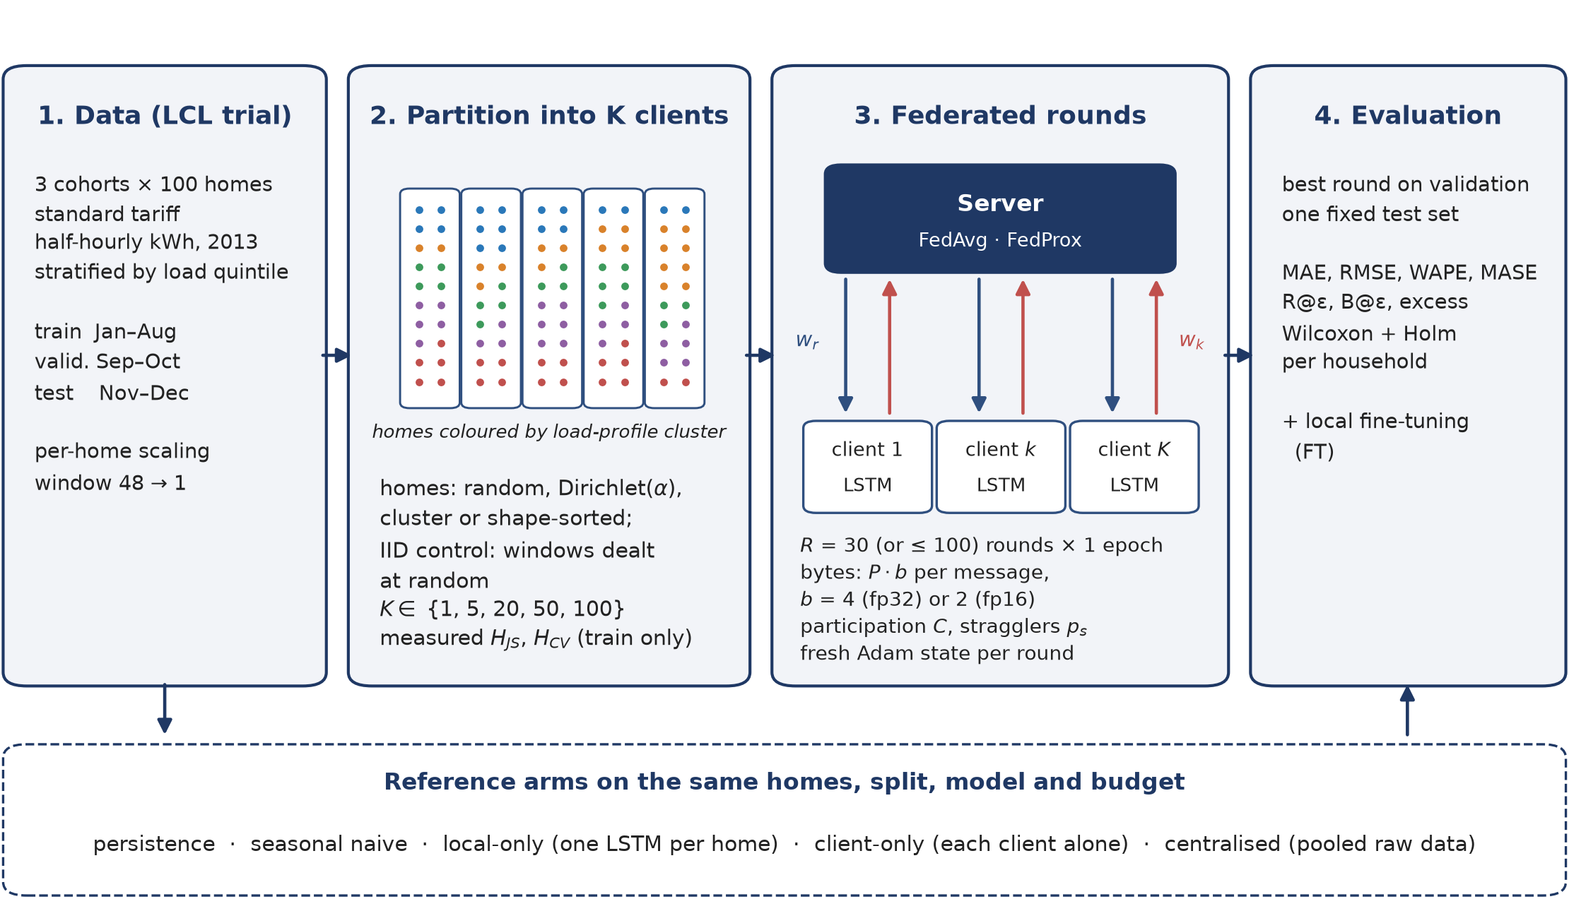
Figure 1. Study workflow. The same 100 households, chronological split and LSTM were used by every arm. In the federated arms the homes were partitioned into $K$ clients by random, Dirichlet($α$) or cluster grouping over load-profile clusters, trained for $T=30$ rounds of one local epoch, and evaluated once on the fixed test set at the round chosen on validation error. $w_{t}$: global weights sent to the clients; $w_{k}$: weights returned by client $k$; $P·b$: bytes per message; $ρ_{t}$: update disagreement; R@$ε$, B@$ε$: rounds and bytes to come within $ε$ of centralised validation error; FT: local fine-tuning.
Arms. Two naive references were used: persistence (${\hat{x}}_{t+1}=x_{t}$) and seasonal naive (${\hat{x}}_{t+1}=x_{t−47}$). In the local-only arm, every household trained its own model on its own windows, with early stopping on its own validation error, so no data or weights left the home. The centralised arm trained one model on the pooled windows of all households with early stopping on pooled validation error; it is the accuracy reference and requires the raw readings to leave the home. FedAvg followed Eq. (2). In FedProx each client minimised $F_{k}(w)+\frac{μ}{2}‖w−w_{t}‖^{2}$, and stragglers' partial updates were kept rather than dropped [13]. HA-FedProx is FedProx with a coefficient $μ_{t}$ set by the server in every round, as described below. Finally, after federated training each household fine-tuned the final global model for one epoch on its own training windows (FT). This costs no communication and was evaluated for every federated run. Clients were stateless: a fresh optimiser was created at every local update, as is standard for cross-device FL.
Clients and controlled partitions. Two client models were considered. In household mode each home is a client ($K=100$), which reflects meter-level or home-gateway deployment and has natural, uncontrolled heterogeneity. In community mode the same homes are grouped into $K$ clients, which reflects a building gateway, a community energy hub or an aggregator. To dial heterogeneity with real rather than invented labels, every household was described by its normalised 24-bin mean daily load shape and its log mean load, both from the training period. These features were standardised and clustered with $k$-means ($k=5$, 10 restarts) into load-profile groups such as evening-peaking or flat, low or high consumption. Households were then assigned to clients in one of three ways: random, where homes are shuffled into equal groups; Dirichlet($α$) [57], where each client draws mixture proportions $π_{k}\sim Dir(α1)$ over the profile clusters and fills its slots by sampling clusters from $π_{k}$; and cluster, where homes are sorted by cluster and mean load and chunked, the most separated case. Because the homes, and hence the test windows, are identical under every strategy, error differences between partitions are caused by the partition alone.
Measured heterogeneity index. Nominal labels such as $α=0.3$ do not say how different the resulting clients are, so heterogeneity was measured directly on training data. For client $k$, let $q_{k}$ be the distribution of its total training consumption over the 168 hours of the week and $m_{k}$ its mean load. With $JS$ the Jensen–Shannon divergence in base 2 [62],
$H_{JS}={\left({K \atop 2}\right)}^{−1}\sum_{k<l}{JS}\left(q_{k} ‖ q_{l}\right),H_{CV}=\frac{sd(m_{k})}{mean(m_{k})}$ (3)
$H=H_{JS}+\frac{H_{CV}}{1+H_{CV}}$ (4)
$H_{JS}∈[0,1]$ measures differences in when clients consume, and the bounded transform of $H_{CV}$ measures differences in how much they consume. $H=0$ for a single client or for identical clients. The index uses no labels and no test data.
HA-FedProx. The proximal coefficient of FedProx trades client drift against local progress and is usually fixed by tuning, although the appropriate strength should depend on how much the client updates disagree. After aggregating round $t$, the server holds the updates $Δ_{k}=w_{k}−w_{t}$ and their weighted mean $\overline{Δ}=\sum_{k}{p_{k}}Δ_{k}$. It computes the update-disagreement ratio
$ρ_{t}=\frac{\sum_{k}{p_{k}}‖Δ_{k}−\overline{Δ}‖^{2}}{\sum_{k}{p_{k}}‖Δ_{k}‖^{2}}∈[0,1]$ (5)
which is 0 when all clients move identically and approaches 1 when their updates cancel. Because $\sum_{k}{p_{k}}‖Δ_{k}‖^{2}=‖\overline{Δ}‖^{2}+\sum_{k}{p_{k}}‖Δ_{k}−\overline{Δ}‖^{2}$, it equals $1−1/B_{t}^{2}$ with $B_{t}^{2}=\sum_{k}{p_{k}}‖Δ_{k}‖^{2}/‖\overline{Δ}‖^{2}$, an update-space analogue of the $B$-local dissimilarity in the convergence analysis of FedProx [13] and of gradient diversity [61]. The next round uses
$μ_{t+1}=clip\left(μ_{0}ρ_{t} , μ_{min} , μ_{max}\right)$ (6)
with $μ_{min}={10}^{−4}$, $μ_{max}=1$ and $μ_{0}$ tuned on validation data in the same way as FedProx's fixed $μ$. The rule needs no extra client computation or messages and reduces to FedAvg for $μ_{0}=0$.
Participation, stragglers and communication accounting. In each round a fraction $C$ of clients was sampled. Each sampled client became a straggler with probability $p_{s}$ and completed only a uniform random fraction $u\sim U(0.1,1)$ of its local work. Following Li et al. [13], FedAvg dropped stragglers (they download but never upload), while FedProx and HA-FedProx aggregated their partial updates. A model message carries $P·b$ bytes, with $b=4$ for 32-bit and $b=2$ for 16-bit updates, so round $t$ costs $Pb(|S_{t}|+|S_{t}^{′}|)$. Protocol framing was excluded; the Flower backend measured it at about 1 % of the payload. For the centralised arm the volume of the raw training readings was reported, at 4 bytes per value plus an 8-byte time stamp. With $v_{t}$ the validation MAE of the global model after round $t$ and $v^{⋆}$ the centralised validation MAE,
$R@ε=min\{t:v_{t}≤(1+ε)v^{⋆}\},B@ε=\sum_{s≤R@ε}{Pb}\left(|S_{s}|+|S_{s}^{′}|\right)$ (7)
with $ε=10\%$. These metrics convert “how close to centralised” into “at what network price”.

3.4 Experimental setup
Table 2 lists the experiments. Unless stated otherwise, community mode used $K=20$ clients of five homes each, every client participated in every round, and training ran for $T=30$ rounds of $E=1$ local epoch. This equals the number of passes over the data allowed to the centralised arm (30 epochs, early stopping with patience 4), so federated and centralised training had the same computational budget. FedProx's $μ$ and HA-FedProx's $μ_{0}$ were tuned on validation data over the grids $\left\{{10}^{−3} , {10}^{−2} , {10}^{−1}\right\}$ and $\left\{{10}^{−2} , {10}^{−1} , 1\right\}$, under the cluster partition and with the first seed. This selected $μ=0.001$ and $μ_{0}=0.01$, which were then used in every other experiment. Each experiment was repeated with three seeds (42, 43 and 44), which changed model initialisation, client sampling, stragglers and the random and Dirichlet groupings, but not the cohort, the profile clusters or the split. In total 90 runs were completed: 6 tuning runs and 28 configurations with three seeds each.
Table 2. Experimental matrix. All rows use the same 100 households, split, model and budget.
ID | Arm(s) | Factor varied
E0 | Persistence, seasonal naive | Reference
E1 | Local-only | No collaboration
E2 | Centralised | Pooled raw data
E3 | FedAvg | Random grouping, K=20
E4, E5 | FedAvg, FedProx | Dirichlet α=0.3
E6, E7 | FedAvg, FedProx | Cluster grouping (strong non-IID)
E8, E9, E11 | FedAvg, FedProx, HA-FedProx | α=0.3, C=0.5, 20 % stragglers
E10 | FedAvg, FedProx, HA-FedProx | α∈{∞,1,0.3,0.1,0} sweep
E12 | FedAvg | α=0.3, 16-bit updates
E13 | FedAvg, FedProx, HA-FedProx | One household per client (K=100)
E14 | FedAvg | Random grouping, K∈{1,5,50}

The pipeline was written in Python 3.14.7 with PyTorch 2.14.1, NumPy 2.5.3, pandas 3.0.6, scikit-learn 1.9.1, SciPy 1.18.1 and Matplotlib 3.11.2. The federated loop is a deterministic in-process simulator whose clients implement the Flower NumPyClient interface. An optional backend runs the same clients through the FedAvg and FedProx strategies of Flower 1.39.0 [63]; on a test configuration it reproduced the simulator's per-round validation error and final test error exactly. Experiments ran on a single Apple M5 Max workstation (Metal backend), eight runs in parallel.
Accuracy was measured by the mean absolute error (MAE), the root mean squared error (RMSE), the weighted absolute percentage error (WAPE $=100∑|x−\hat{x}|/∑|x|$), and the mean absolute percentage error restricted to half-hours with $x≥0.05$ kWh (MAPE*), because unrestricted MAPE is unbounded at the near-zero night-time loads common in households. Pooled metrics were micro-averaged over every test half-hour of every household. Per-household errors were averaged over seeds and compared with two-sided Wilcoxon signed-rank tests [64] over the 100 households, with Holm correction [65] across the family of comparisons. Because $p$-values over 100 paired households can be small for negligible effects, each test is reported with its median paired difference and the share of households for which one arm was better. Results are means over three seeds with standard deviations.

4. Results

4.1 Accuracy of the arms
Table 3 compares all arms on the 292,052 test half-hours. Every LSTM beat both naive references. Persistence (0.0890 kWh) was a much stronger baseline than seasonal naive (0.1332 kWh) at a 30-minute horizon. The centralised LSTM was the most accurate arm (MAE 0.0812 kWh) and was better than local-only training (0.0839 kWh) for 72 % of households (Holm-adjusted $p$ 0.0002).
Table 3. Test error of all arms (kWh per half-hour; mean $±$ s.d. over three seeds). MAPE* is computed over half-hours with load of at least 0.05 kWh. Traffic is the cumulative upload plus download over all rounds; for the centralised arm it is the raw training-data volume.
Method | MAE | RMSE | MAPE* | WAPE | Best rd. | Traffic (MB)
Persistence (naive) | 0.0890 | 0.1987 | 41.1 | 37.6 | n/a | 0.0
Seasonal naive (t-−48) | 0.1332 | 0.2773 | 63.6 | 56.3 | n/a | 0.0
Local-only | 0.0839 ± 0.0003 | 0.1777 ± 0.0006 | 37.2 ± 0.3 | 35.5 | n/a | 0.0
Centralised | 0.0812 ± 0.0004 | 0.1721 ± 0.0013 | 36.5 ± 0.8 | 34.3 | n/a | 14.0
FedAvg, random | 0.0854 ± 0.0008 | 0.1758 ± 0.0006 | 39.0 ± 0.6 | 36.1 | 22.0 / 30 | 82.6
FedAvg, α=0.3 | 0.0860 ± 0.0003 | 0.1757 ± 0.0005 | 39.7 ± 0.2 | 36.4 | 24.0 / 30 | 82.6
FedProx, α=0.3 | 0.0857 ± 0.0002 | 0.1759 ± 0.0009 | 39.3 ± 0.4 | 36.3 | 22.8 / 30 | 82.6
HA-FedProx, α=0.3 | 0.0863 ± 0.0003 | 0.1765 ± 0.0005 | 39.6 ± 0.1 | 36.5 | 20.7 / 30 | 82.6
FedAvg, cluster | 0.0857 ± 0.0003 | 0.1759 ± 0.0004 | 39.2 ± 0.2 | 36.2 | 21.4 / 30 | 82.6
FedProx, cluster | 0.0858 ± 0.0002 | 0.1759 ± 0.0006 | 39.3 ± 0.2 | 36.3 | 23.3 / 30 | 82.6
HA-FedProx, cluster | 0.0862 ± 0.0004 | 0.1768 ± 0.0008 | 39.4 ± 0.4 | 36.5 | 18.0 / 30 | 82.6
FedAvg, α=0.3, partial | 0.0850 ± 0.0005 | 0.1759 ± 0.0008 | 38.7 ± 0.5 | 36.0 | 22.4 / 30 | 37.2
FedProx, α=0.3, partial | 0.0857 ± 0.0003 | 0.1764 ± 0.0012 | 39.1 ± 0.3 | 36.2 | 20.7 / 30 | 41.3
HA-FedProx, α=0.3, partial | 0.0857 ± 0.0003 | 0.1769 ± 0.0011 | 39.1 ± 0.2 | 36.2 | 23.0 / 30 | 41.3
FedAvg, α=0.3, fp16 | 0.0857 ± 0.0004 | 0.1755 ± 0.0007 | 39.5 ± 0.2 | 36.3 | 25.2 / 30 | 41.3
FedAvg, K=100 | 0.0893 ± 0.0009 | 0.1810 ± 0.0009 | 40.9 ± 1.1 | 37.8 | 29.2 / 30 | 413.2
FedProx, K=100 | 0.0893 ± 0.0013 | 0.1817 ± 0.0011 | 40.7 ± 1.6 | 37.8 | 30.0 / 30 | 413.2
HA-FedProx, K=100 | 0.0901 ± 0.0005 | 0.1823 ± 0.0009 | 41.2 ± 0.8 | 38.1 | 29.3 / 30 | 413.2
FedAvg, K=1, random | 0.0809 ± 0.0004 | 0.1709 ± 0.0005 | 36.8 ± 0.3 | 34.2 | 18.6 / 30 | 4.1
FedAvg, K=5, random | 0.0826 ± 0.0005 | 0.1721 ± 0.0005 | 38.0 ± 0.3 | 35.0 | 21.8 / 30 | 20.7
FedAvg, K=50, random | 0.0870 ± 0.0005 | 0.1780 ± 0.0005 | 39.8 ± 0.5 | 36.8 | 26.6 / 30 | 206.6

FedAvg with random grouping reached 0.0854 kWh, 5.2 % above centralised, and was worse than centralised for every household. Under moderate heterogeneity ($α=0.3$) FedAvg reached 0.0860 kWh and was worse than local-only training on pooled MAE; per household it beat local-only for only 35 % of homes ($p_{Holm}$ 0.0029). On RMSE the ordering reversed: FedAvg (0.1757 kWh) beat local-only (0.1777 kWh). Fig. 2 shows the first three test days of the household whose mean load is closest to the cohort median. All learned models tracked the daily pattern and lagged sharp, short spikes by one step, and the differences between arms were small relative to the volatility of the series.
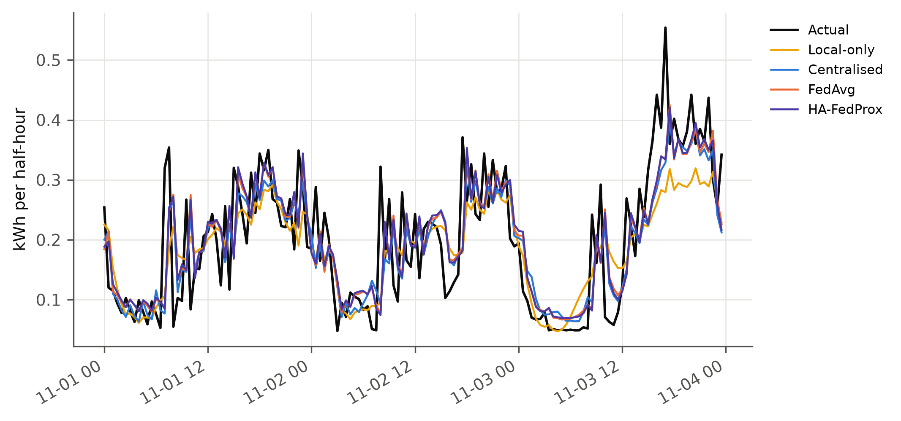
Figure 2. Actual and predicted load (kWh per half-hour) for the household closest to the cohort's median load, chosen without reference to any error, over the first three test days.

4.2 Where the federated gap comes from
Table 4 walks from centralised training to the hardest federated setting, adding one factor at a time, and Table 5 and Fig. 3 give the fragmentation sweep. Running the federated protocol with a single client that held all 100 homes ($K=1$) reproduced centralised accuracy: 0.0809 kWh against 0.0812 kWh, with no significant per-household difference (49 % of homes better, $p_{Holm}$ 0.6645). The gap appeared as soon as the same data were split and grew steadily with the number of clients, from 1.8 % at $K=5$ through 5.2 % at $K=20$ and 7.2 % at $K=50$ to 10.0 % when every household was its own client. At $K=20$, FedAvg with random grouping was worse than the single-client run for 98 % of households.
Table 4. Decomposition of the federated–centralised gap (FedAvg, test MAE in kWh). Each row adds one factor to the row above; rows without a $Δ$ are alternatives to the row above, not additions.
Setting | Test MAE | Δ vs previous | Gap to central (%)
Centralised (pooled raw data) | 0.0812 ± 0.0004 | – | +0.0
+ round protocol, 1 client (K=1) | 0.0809 ± 0.0004 | −0.0003 | −0.4
+ split over 20 clients, random grouping | 0.0854 ± 0.0008 | +0.0045 | +5.2
+ label-skewed grouping (α=0.3) | 0.0860 ± 0.0003 | +0.0006 | +5.9
+ 50% participation, 20% stragglers | 0.0850 ± 0.0005 | −0.0009 | +4.7
cluster grouping instead (strong non-IID) | 0.0857 ± 0.0003 | – | +5.5
1 home = 1 client (K=100) | 0.0893 ± 0.0009 | – | +10.0

Table 5. Fragmentation sweep: the same 100 households split over $K$ clients with random grouping ($K=100$ is household mode). FT: one epoch of local fine-tuning of the final global model.
K | homes/client | H_{JS} | Test MAE | FT MAE | ρ̄ | Gap to central (%)
1 | 100 | 0.0000 | 0.0809 ± 0.0004 | 0.0811 | 0.000 | −0.4
5 | 20 | 0.0026 | 0.0826 ± 0.0005 | 0.0818 | 0.756 | +1.8
20 | 5 | 0.0106 | 0.0854 ± 0.0008 | 0.0833 | 0.858 | +5.2
50 | 2 | 0.0263 | 0.0870 ± 0.0005 | 0.0841 | 0.883 | +7.2
100 | 1 | 0.0497 | 0.0893 ± 0.0009 | 0.0849 | 0.888 | +10.0

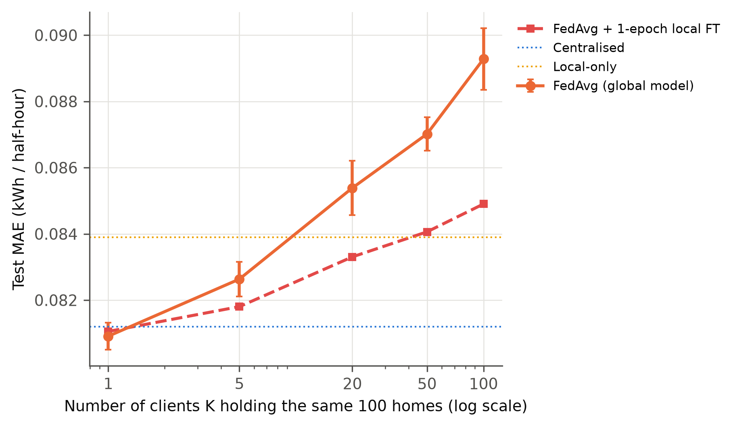
Figure 3. Test MAE (kWh) when the same 100 households are split over $K$ clients with random grouping ($K=100$ is one household per client; mean over three seeds). The dashed line adds one epoch of local fine-tuning to the final global model.
Splitting homes over more clients also raises the measured heterogeneity between clients, so the two effects were separated statistically. A regression of per-run FedAvg test MAE on $logK$ and $H_{JS}$ over all full-participation runs ($n=40$, $R^{2}=0.90$) attributed the error to fragmentation: each unit of $logK$ added $1.53×{10}^{−3}$ kWh ($p$ $<{10}^{−4}$), while the heterogeneity term was not significant ($p$ 0.0349). Within $K=20$, where heterogeneity was dialled independently of $K$, error and $H_{JS}$ were unrelated (Spearman +0.18, $p$ 0.3812, $n=25$). Fifty clients of two randomly grouped homes ($H=0.353$) were also worse than twenty clients grouped by load profile ($H=0.381$): 0.0870 against 0.0857 kWh.

4.3 Heterogeneity changes the price of accuracy, not accuracy
Table 6 and Fig. 4 report the heterogeneity sweep. The load-shape divergence between clients, $H_{JS}$, increased monotonically from random grouping to the cluster partition, by a factor of about two. The composite index $H$ did not, because random grouping produced a larger spread of client mean load than the Dirichlet groupings, and the cluster partition, which sorts homes by load level, produced the largest spread. Across this range the final FedAvg error moved by at most 0.0012 kWh (from 0.0851 to 0.0860 kWh), comparable to the seed-to-seed standard deviation, and did not trend with $H_{JS}$. Per household, FedAvg under the cluster partition was better than under random grouping for 44 % of homes, and the difference was not significant after correction ($p_{Holm}$ 0.0744). The traffic needed to come within 10 % of centralised validation MAE, however, grew from 31.4 MB (11.4 rounds) with random grouping to 39.1 MB at $α=0.3$ and 34.2 MB under the cluster partition, an increase of about 85 %.
Table 6. Heterogeneity sweep ($K=20$): measured indices, mean update disagreement $\overline{ρ}$, test MAE (kWh) and gap to centralised for each grouping and algorithm.
Partition | Method | H | H_{JS} | ρ̄ | Test MAE | Gap to central (%)
α=0.1 | FedAvg | 0.241 | 0.0189 | 0.874 | 0.0856 ± 0.0004 | +5.4
α=0.1 | FedProx | 0.242 | 0.0181 | 0.863 | 0.0856 ± 0.0006 | +5.4
α=0.1 | HA-FedProx | 0.242 | 0.0181 | 0.844 | 0.0859 ± 0.0003 | +5.7
α=0.3 | HA-FedProx | 0.243 | 0.0153 | 0.844 | 0.0863 ± 0.0003 | +6.3
α=0.3 | FedAvg | 0.246 | 0.0152 | 0.871 | 0.0860 ± 0.0003 | +5.9
α=0.3 | FedProx | 0.246 | 0.0152 | 0.859 | 0.0857 ± 0.0002 | +5.6
random | FedAvg | 0.253 | 0.0106 | 0.858 | 0.0854 ± 0.0008 | +5.2
random | FedProx | 0.255 | 0.0105 | 0.845 | 0.0855 ± 0.0003 | +5.3
random | HA-FedProx | 0.255 | 0.0105 | 0.822 | 0.0859 ± 0.0009 | +5.8
α=1.0 | FedAvg | 0.262 | 0.0125 | 0.868 | 0.0851 ± 0.0007 | +4.8
α=1.0 | FedProx | 0.270 | 0.0124 | 0.856 | 0.0857 ± 0.0001 | +5.6
α=1.0 | HA-FedProx | 0.270 | 0.0124 | 0.841 | 0.0857 ± 0.0008 | +5.6
cluster | FedProx | 0.381 | 0.0202 | 0.866 | 0.0858 ± 0.0002 | +5.6
cluster | FedAvg | 0.381 | 0.0202 | 0.876 | 0.0857 ± 0.0003 | +5.5
cluster | HA-FedProx | 0.381 | 0.0202 | 0.849 | 0.0862 ± 0.0004 | +6.2

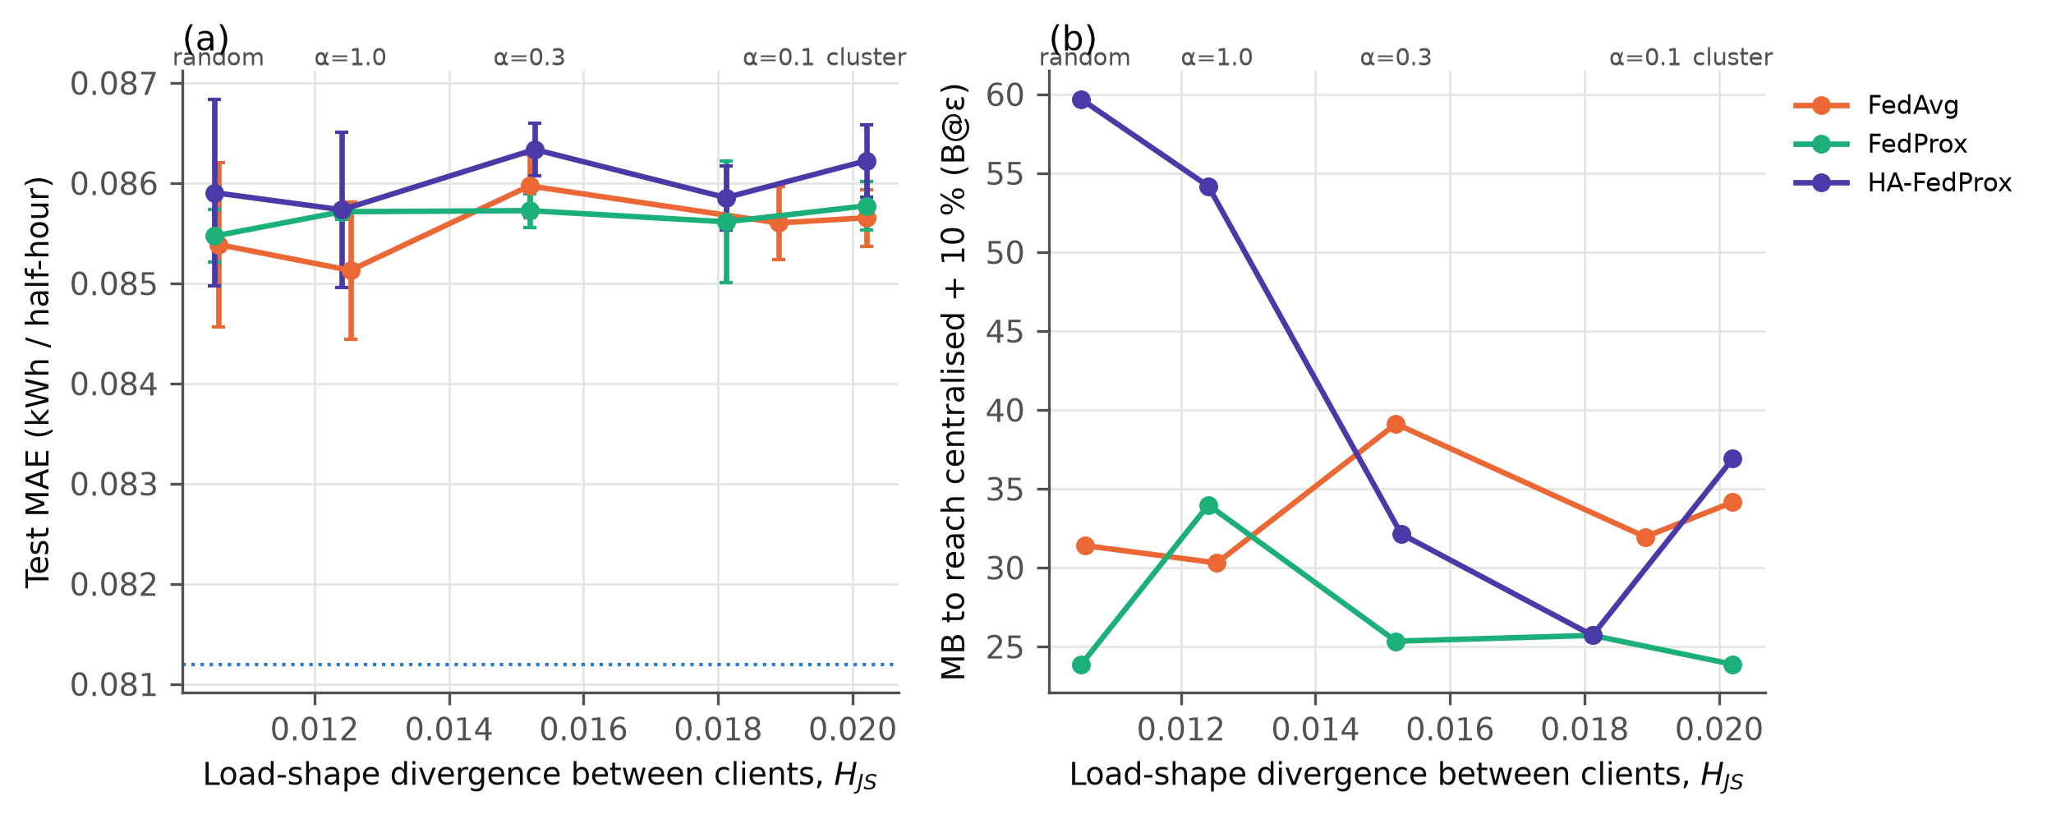
Figure 4. Heterogeneity sweep (community mode, $K=20$). (a) Final test MAE (kWh) against the measured load-shape divergence between clients, $H_{JS}$; the dotted line is centralised training. (b) Megabytes exchanged before the validation MAE first came within 10 % of centralised (B@$ε$). Points are means over three seeds, and labels give the grouping strategy.

4.4 Proximal regularisation and HA-FedProx
Validation-based tuning selected the smallest proximal coefficient in the grid for both methods ($μ=0.001$, $μ_{0}=0.01$); larger values consistently increased validation error. With the tuned coefficient FedProx and FedAvg were practically indistinguishable (Table 7). Under $α=0.3$ FedProx was better for 79 % of households, but the median paired difference was −0.0002 kWh, about 0.1 % of the error. Under the cluster partition and under partial participation FedProx was slightly worse.
Table 7. Paired Wilcoxon signed-rank tests over the 100 households (per-household test MAE averaged over seeds). “A better” is the share of households for which A had the lower MAE; $p_{Holm}$ is Holm-adjusted across all rows.
A | B | median ΔMAE (A−B) | A better (%) | p | p_{Holm}
FedAvg, α=0.3 | Local-only | +0.0012 | 35 | 0.0003 | 0.0029
FedAvg, α=0.3 | Centralised | +0.0025 | 1 | <10⁻⁴ | <10⁻⁴
FedAvg, random | Centralised | +0.0021 | 1 | <10⁻⁴ | <10⁻⁴
FedProx, α=0.3 | FedAvg, α=0.3 | −0.0002 | 79 | <10⁻⁴ | <10⁻⁴
FedProx, cluster | FedAvg, cluster | +0.0001 | 31 | 0.0004 | 0.0034
FedProx, α=0.3, partial | FedAvg, α=0.3, partial | +0.0003 | 19 | <10⁻⁴ | <10⁻⁴
HA-FedProx, α=0.3 | FedAvg, α=0.3 | +0.0001 | 42 | 0.0674 | 0.2021
HA-FedProx, α=0.3 | FedProx, α=0.3 | +0.0002 | 26 | <10⁻⁴ | <10⁻⁴
HA-FedProx, cluster | FedAvg, cluster | +0.0003 | 27 | <10⁻⁴ | <10⁻⁴
HA-FedProx, cluster | FedProx, cluster | +0.0001 | 42 | 0.0210 | 0.1263
HA-FedProx, α=0.3, partial | FedAvg, α=0.3, partial | +0.0004 | 22 | <10⁻⁴ | <10⁻⁴
HA-FedProx, α=0.3, partial | FedProx, α=0.3, partial | +0.0002 | 35 | 0.0469 | 0.1875
FedAvg, cluster | FedAvg, random | +0.0001 | 44 | 0.0106 | 0.0744
FedAvg, K=100 | Local-only | +0.0026 | 18 | <10⁻⁴ | <10⁻⁴
FedAvg, K=100 | Centralised | +0.0041 | 1 | <10⁻⁴ | <10⁻⁴
HA-FedProx, K=100 | FedAvg, K=100 | +0.0004 | 13 | <10⁻⁴ | <10⁻⁴
FedAvg, α=0.3, fp16 | FedAvg, α=0.3 | −0.0001 | 92 | <10⁻⁴ | <10⁻⁴
Centralised | Local-only | −0.0015 | 72 | <10⁻⁴ | 0.0002
FedAvg, K=1, random | Centralised | +0.0000 | 49 | 0.3322 | 0.6645
FedAvg, random | FedAvg, K=1, random | +0.0022 | 2 | <10⁻⁴ | <10⁻⁴
FedAvg, α=0.3 + local FT | Local-only | −0.0000 | 50 | 0.5158 | 0.6645
FedAvg, α=0.3 + local FT | Centralised | +0.0014 | 27 | <10⁻⁴ | <10⁻⁴
FedAvg, K=100 + local FT | Local-only | +0.0004 | 41 | 0.0283 | 0.1413

HA-FedProx never improved on FedAvg. Under the cluster partition it was worse for 73 % of households (median +0.0003 kWh, $p_{Holm}$ $<{10}^{−4}$), and with random grouping it needed more traffic to reach the $ε$ band (59.7 MB against 31.4 MB for FedAvg). Fig. 5 shows the update-disagreement ratio. It started low (0.15 on average in round 1), rose quickly and settled near 0.96. Across the full-participation runs with $K=20$, mean $ρ$ increased with $H_{JS}$ (Spearman +0.51, $p$ 0.0044, $n=30$), and the round-1 value did so more strongly (Spearman +0.52). The spread of mean $ρ$ across groupings was only 0.017, however, whereas $ρ_{t}$ rose by 0.81 within a typical run, about 46 times more.
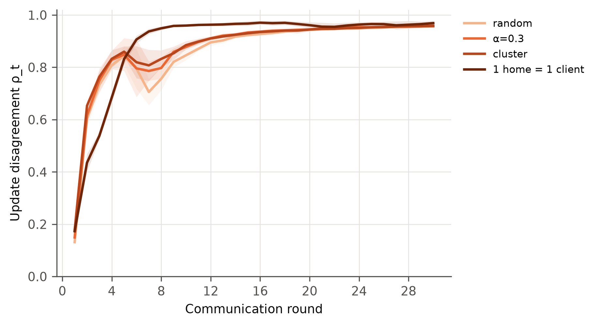
Figure 5. Update-disagreement ratio $ρ_{t}$ (Eq. (5)) per round for FedAvg under different groupings (mean $±$ s.d. over three seeds).

4.5 Communication
One model message was 68.9 kB. Thirty rounds of full participation with $K=20$ clients therefore moved 82.6 MB, about six times the 14.0 MB of raw training readings that centralised training would upload once. The traffic needed for near-centralised accuracy was much smaller and comparable to the data volume (Fig. 6). FedAvg with 50 % participation and 20 % stragglers reached the $ε$ band after 21.9 MB and ended at 0.0850 kWh, no worse than full participation, using 37.2 MB in total. Sending updates as 16-bit floats halved the traffic (41.3 MB in total, 16.3 MB to the $ε$ band) without harming accuracy: 0.0857 kWh against 0.0860 kWh at 32 bits, and marginally better for 92 % of households (median −0.0001 kWh).
Fragmentation dominated the bill. One client moved only 4.1 MB over 30 rounds, while household clients moved 413.2 MB, about 30 times the raw training data. Only two of the three household-mode FedAvg runs reached the $ε$ band within 30 rounds, after 30.0 rounds and 413.2 MB on average; none of the HA-FedProx household runs did. Validation error did not decrease monotonically with traffic: all federated variants passed through a transient rise in rounds 5–8 before converging, coinciding with the dip in $ρ_{t}$.
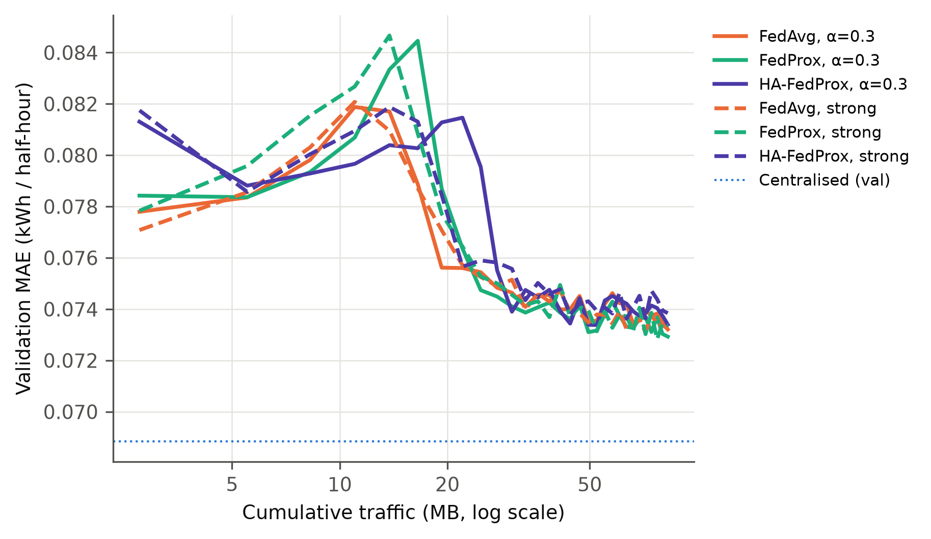
Figure 6. Validation MAE (kWh) of the global model against cumulative traffic (upload plus download, MB, log scale), mean over three seeds. The dotted line is the centralised validation MAE.

4.6 Who gains from federation?
Table 8 and Fig. 7 give the per-household view. Centralised training left 28 % of households worse off than training alone. FedAvg left 61 % (random grouping) to 65 % ($α=0.3$) worse off, and one epoch of local fine-tuning reduced this to 50–50 %. After fine-tuning, FedAvg was statistically indistinguishable from local training per household (50 % better, $p_{Holm}$ 0.6645), improved pooled MAE to 0.0833 kWh, and remained behind centralised training (27 % of households better). With household clients FedAvg was worse than local training for 82 % of households ($p_{Holm}$ $<{10}^{−4}$), and its 90th-percentile household error rose to 0.1501 kWh against 0.1434 kWh for local training. Fine-tuning reduced the share harmed to 59 % and the pooled MAE to 0.0849 kWh, still not better than local training (41 % of households better, $p_{Holm}$ 0.1413). By consumption quintile, the advantage of pooling raw data was concentrated in the highest-consuming homes, and in the top quintile the median household error of FedAvg was above that of local training.
Table 8. Equity of federation relative to local-only training. P90 MAE is the 90th percentile of household test MAE (kWh). FT: one epoch of local fine-tuning of the final global model.
Arm | Harmed vs local (%) | Median benefit (kWh) | P90 MAE | Harmed after FT (%)
Centralised | 28 | +0.0015 | 0.1362 | –
FedAvg, random | 61 | −0.0008 | 0.1436 | 50
FedAvg, α=0.3 | 65 | −0.0012 | 0.1442 | 50
FedAvg, cluster | 63 | −0.0008 | 0.1431 | 48
HA-FedProx, α=0.3 | 67 | −0.0013 | 0.1454 | 55
FedAvg, K=100 | 82 | −0.0026 | 0.1494 | 59
HA-FedProx, K=100 | 84 | −0.0030 | 0.1515 | 65

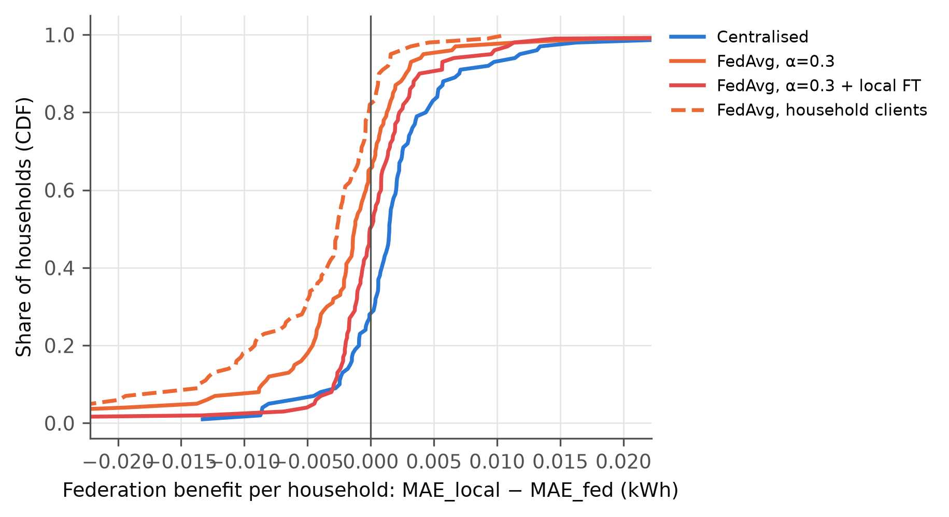
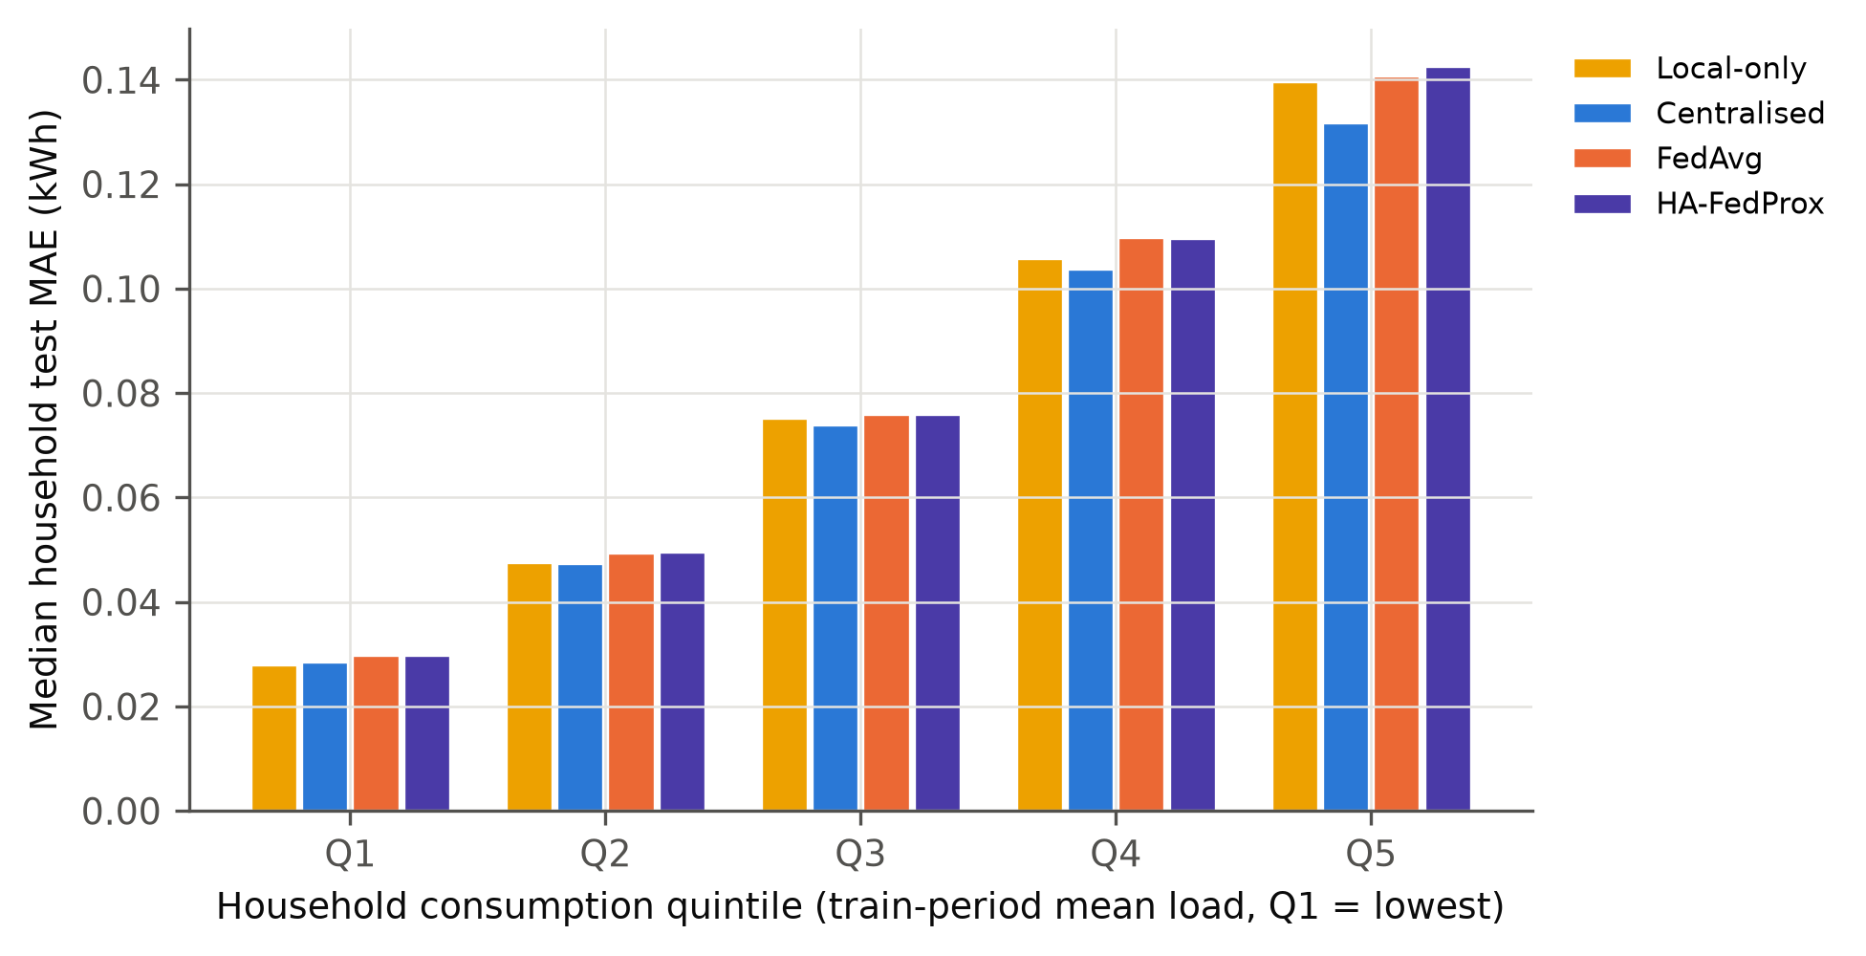
Figure 7. (a) Distribution over households of the benefit of each collaborative arm over local training (${MAE}_{local}−{MAE}_{arm}$, kWh; left of zero means worse off). (b) Median household test MAE (kWh) by quintile of training-period mean load.

5. Discussion
The central finding is that the accuracy cost of federation in this setting came from fragmentation rather than from heterogeneity. The federated protocol itself cost nothing: rounds, a fresh optimiser at every round and best-round selection reproduced centralised accuracy on a single client. The gap appeared only when the same data were split, and grew with the logarithm of the number of clients whether or not those clients differed. The likely mechanism is the averaging step. With one local epoch per round, each client takes about ${n_{k}}/{256}$ optimiser steps on its own data before its model is averaged with the others, so smaller clients take fewer and noisier steps, and the average of $K$ such models falls further from the model that one pass over the pooled data would produce. The total data and computation are the same for every $K$; what changes is how much of the learning is combined by averaging weights rather than by following gradients. Heterogeneity, by contrast, changed how fast the federation approached centralised accuracy, not where it ended, as long as the round budget was large enough and the best round was chosen on validation data. This also explains why drift-oriented remedies helped little: when fragmentation causes most of the gap, a proximal penalty has little drift to correct and mainly slows local progress. HA-FedProx failed for a related reason. Its disagreement ratio does rank partitions by heterogeneity, but within a run it is dominated by convergence: as the shared descent direction shrinks, any residual disagreement, stochastic-gradient noise included, pushes the ratio towards one, so a schedule proportional to $ρ_{t}$ raises the proximal pull late in training whatever the data. The small advantage of 16-bit updates may reflect rounding acting as a mild regulariser, although the present experiments cannot confirm this.
These results agree with Briggs et al. [43] that plain FedAvg can lose to local models on LCL, but here only on MAE: on RMSE the shared model was better, because it handles large deviations better while per-home models fit the typical half-hour more closely. Their finding that local fine-tuning turns the comparison around was reproduced at community scale, where fine-tuned FedAvg tied with local training, but not with one household per client. The tie of Fekri et al. [7] and the local advantage of Gholizadeh and Musilek [8] are both consistent with a fragmentation cost that depends on how many clients the data are spread over. On communication, the measured traffic supports the qualitative argument of Briggs et al. [17] rather than the analytic savings of Taïk and Cherkaoui [15] and Savi and Olivadese [16]. The difference is not a contradiction: the sign of the comparison depends on model size, sampling resolution and the number of rounds, and Taïk and Cherkaoui, for example, compared a 1.9 kb model with 16 Mb of data. The adaptive rule tested here, like HAPI-FedProx [58], which was slightly worse than FedAvg on IID data in its own evaluation, did not beat a well-tuned baseline.
For practice, the most consequential choice was the number of clients. Aggregating homes behind a building gateway, a community energy hub or a supplier-side aggregator and federating those ($K=5$ here) cost 1.8 % in MAE relative to centralised training with 20.7 MB of traffic, whereas meter-level federation lost 10.0 % and moved about 30 times the raw data. Eight months of half-hourly training readings from one household occupy about 140 kB, roughly twice a single message of this small LSTM, so at this scale federation is a governance choice based on data minimisation, consent and regulation, not a bandwidth saving. Distribution system operators, suppliers and aggregators adopting federated forecasts should fine-tune the global model locally, which costs no communication and cut the share of harmed homes from about two thirds to under one half; choose the round on validation error, because validation error rose transiently in every federated configuration; and evaluate errors per consumption tier, because the largest consumers, whose forecasts matter most for congestion management, gained most from pooling and were served worst by FedAvg.
The study has limitations. It covers one dataset, one city, one year and one horizon: a winter test period and 30-minute-ahead forecasts for 100 standard-tariff London homes. Its conclusions concern a small LSTM; larger models raise per-message traffic in proportion, which would strengthen the communication finding but might change the accuracy results. The network and the stragglers were simulated, and traffic counts payload bytes only. Keeping data local is not a formal privacy guarantee [44], [45], and neither differential privacy nor secure aggregation was applied; both would add accuracy or communication costs to those reported here. The learning rate, model size and input window were fixed in advance and shared by all arms, with only the proximal coefficients tuned; a per-arm search could move individual numbers, although the controlled design should make such shifts affect all arms alike. Finally, the simulator scored the global model centrally for efficiency, whereas a deployment would compute these scores on the clients.

6. Conclusion
This study held the households, test set, model and training budget fixed and changed one factor at a time to find where the costs of federated household load forecasting come from, using 100 Low Carbon London homes. The federated protocol on a single client matched centralised accuracy, and the error grew with the number of clients the same homes were spread over, to 10.0 % when every home was its own client. Regrouping homes from random to fully profile-clustered barely changed final accuracy but raised the traffic needed to approach centralised accuracy by about 85 %, and federated training moved more bytes than the readings it kept local. Local fine-tuning removed most of the harm to individual households at community scale; proximal regularisation, fixed or adaptive, brought no benefit. The work shows that the federated accuracy gap is a fragmentation cost, that heterogeneity is mainly a communication cost, and that the case for federation in residential forecasting rests on governance rather than bandwidth. Future work will test these conclusions on other datasets, climates, horizons and larger models, add differential privacy and secure aggregation, and design heterogeneity signals that do not depend on the stage of training.

Declarations
Acknowledgements. The authors thank UK Power Networks for making the Low Carbon London trial data publicly available.
Funding. This research received no specific grant from any funding agency in the public, commercial or not-for-profit sectors.
Conflict of interest. The authors declare no conflict of interest.
Data availability. The Low Carbon London smart-meter data are publicly available from the London Datastore (https://data.london.gov.uk/dataset/smartmeter-energy-consumption-data-in-london-households-vqm0d) and are not redistributed by the authors. All code, configuration files, per-run results and the scripts that generate every table and figure in this paper are available at [repository URL to be inserted; provided to reviewers as a supplementary archive].
Author contributions. Pushkal Gupta: conceptualisation, methodology, software, data curation, investigation, formal analysis, visualisation, writing – original draft. Vanka Kaushik: conceptualisation, investigation, validation, writing – review and editing. Kalaavathi B: supervision, methodology, writing – review and editing.
Declaration of generative AI use. During the preparation of this work the authors used Claude (Anthropic), an AI assistant, to help write and test the software pipeline and to draft and edit the text of the manuscript. After using this tool, the authors reviewed and edited the code, the results and the content as needed and take full responsibility for the content of the publication.

References
[1] Hochreiter, S., Schmidhuber, J. (1997). Long short-term memory. Neural Computation, 9(8): 1735-1780. https://doi.org/10.1162/neco.1997.9.8.1735
[2] Kong, W., Dong, Z.Y., Jia, Y., Hill, D.J., Xu, Y., Zhang, Y. (2019). Short-term residential load forecasting based on LSTM recurrent neural network. IEEE Transactions on Smart Grid, 10(1): 841-851. https://doi.org/10.1109/TSG.2017.2753802
[3] Shi, H., Xu, M., Li, R. (2018). Deep learning for household load forecasting—A novel pooling deep RNN. IEEE Transactions on Smart Grid, 9(5): 5271-5280. https://doi.org/10.1109/TSG.2017.2686012
[4] McMahan, B., Moore, E., Ramage, D., Hampson, S., Agüera y Arcas, B. (2017). Communication-efficient learning of deep networks from decentralized data. In Proceedings of the 20th International Conference on Artificial Intelligence and Statistics (AISTATS), vol. 54, pp. 1273-1282. https://proceedings.mlr.press/v54/mcmahan17a.html
[5] Kairouz, P., McMahan, H.B., et al. (2021). Advances and open problems in federated learning. Foundations and Trends in Machine Learning, 14(1–2): 1-210. https://doi.org/10.1561/2200000083
[6] Fernández, J.D., Menci, S.P., Lee, C.M., Rieger, A., Fridgen, G. (2022). Privacy-preserving federated learning for residential short-term load forecasting. Applied Energy, 326: 119915. https://doi.org/10.1016/j.apenergy.2022.119915
[7] Fekri, M.N., Grolinger, K., Mir, S. (2022). Distributed load forecasting using smart meter data: Federated learning with recurrent neural networks. International Journal of Electrical Power & Energy Systems, 137: 107669. https://doi.org/10.1016/j.ijepes.2021.107669
[8] Gholizadeh, N., Musilek, P. (2022). Federated learning with hyperparameter-based clustering for electrical load forecasting. Internet of Things, 17: 100470. https://doi.org/10.1016/j.iot.2021.100470
[9] Widmer, F., Nowak, S., Bowler, B., Huber, P., Papaemmanouil, A. (2023). Data-driven comparison of federated learning and model personalization for electric load forecasting. Energy and AI, 14: 100253. https://doi.org/10.1016/j.egyai.2023.100253
[10] Qu, X., Guan, C., Xie, G., Tian, Z., Sood, K., Sun, C., et al. (2023). Personalized federated learning for heterogeneous residential load forecasting. Big Data Mining and Analytics, 6(4): 421-432. https://doi.org/10.26599/BDMA.2022.9020043
[11] Liu, Y., Dong, Z., Liu, B., Xu, Y., Ding, Z. (2023). FedForecast: A federated learning framework for short-term probabilistic individual load forecasting in smart grid. International Journal of Electrical Power & Energy Systems, 152: 109172. https://doi.org/10.1016/j.ijepes.2023.109172
[12] Das, P., Pandey, S., Pandey, C., Kumar, D. (2026). Heterogeneity-aware personalised federated learning for household energy forecasting on multi-source real-world smart meter data. Scientific Reports, 16: 24957. https://doi.org/10.1038/s41598-026-53020-6
[13] Li, T., Sahu, A.K., Zaheer, M., Sanjabi, M., Talwalkar, A., Smith, V. (2020). Federated optimization in heterogeneous networks. In Proceedings of Machine Learning and Systems (MLSys), vol. 2, pp. 429-450. https://proceedings.mlsys.org/paper_files/paper/2020/hash/1f5fe83998a09396ebe6477d9475ba0c-Abstract.html
[14] Dogra, A., Anand, A., Bedi, J. (2023). Consumers profiling based federated learning approach for energy load forecasting. Sustainable Cities and Society, 98: 104815. https://doi.org/10.1016/j.scs.2023.104815
[15] Taïk, A., Cherkaoui, S. (2020). Electrical load forecasting using edge computing and federated learning. In ICC 2020 – 2020 IEEE International Conference on Communications (ICC), pp. 1-6. https://doi.org/10.1109/ICC40277.2020.9148937
[16] Savi, M., Olivadese, F. (2021). Short-term energy consumption forecasting at the edge: A federated learning approach. IEEE Access, 9: 95949-95969. https://doi.org/10.1109/ACCESS.2021.3094089
[17] Briggs, C., Fan, Z., Andras, P. (2020). Privacy preserving demand forecasting to encourage consumer acceptance of smart energy meters. In NeurIPS 2020 Workshop on Tackling Climate Change with Machine Learning. https://doi.org/10.48550/arXiv.2012.07449
[18] UK Power Networks (2015). SmartMeter energy consumption data in London households (Low Carbon London project). London Datastore. https://data.london.gov.uk/dataset/smartmeter-energy-consumption-data-in-london-households-vqm0d, accessed on 8 October 2026
[19] Aurangzeb, K., Haider, S.I., Alhussein, M. (2024). Individual household load forecasting using bi-directional LSTM network with time-based embedding. Energy Reports, 11: 3963-3975. https://doi.org/10.1016/j.egyr.2024.03.028
[20] Xiao, J.-W., Cao, M., Fang, H., Wang, J., Wang, Y.-W. (2023). Joint load prediction of multiple buildings using multi-task learning with selected-shared-private mechanism. Energy and Buildings, 293: 113178. https://doi.org/10.1016/j.enbuild.2023.113178
[21] Dab, K., Henao, N., Nagarsheth, S., Dubé, Y., Sansregret, S., Agbossou, K. (2023). Consensus-based time-series clustering approach to short-term load forecasting for residential electricity demand. Energy and Buildings, 299: 113550. https://doi.org/10.1016/j.enbuild.2023.113550
[22] Yang, Y., Wang, Z., Zhao, S., Wu, J. (2023). An integrated federated learning algorithm for short-term load forecasting. Electric Power Systems Research, 214: 108830. https://doi.org/10.1016/j.epsr.2022.108830
[23] Fekri, M.N., Grolinger, K., Mir, S. (2023). Asynchronous adaptive federated learning for distributed load forecasting with smart meter data. International Journal of Electrical Power & Energy Systems, 153: 109285. https://doi.org/10.1016/j.ijepes.2023.109285
[24] Wang, R., Yun, H., Rayhana, R., Bin, J., Zhang, C., Herrera, O.E., et al. (2023). An adaptive federated learning system for community building energy load forecasting and anomaly prediction. Energy and Buildings, 295: 113215. https://doi.org/10.1016/j.enbuild.2023.113215
[25] Khalil, M., Esseghir, M., Merghem Boulahia, L. (2023). Privacy-preserving federated learning: An application for big data load forecast in buildings. Computers & Security, 131: 103211. https://doi.org/10.1016/j.cose.2023.103211
[26] de Moraes Sarmento, E.M., Ribeiro, I.F., Marciano, P.R.N., Neris, Y.G., Rocha, H.R.d.O., Mota, V.F.S., et al. (2024). Forecasting energy power consumption using federated learning in edge computing devices. Internet of Things, 25: 101050. https://doi.org/10.1016/j.iot.2023.101050
[27] Abdulla, N., Demirci, M., Ozdemir, S. (2024). Smart meter-based energy consumption forecasting for smart cities using adaptive federated learning. Sustainable Energy, Grids and Networks, 38: 101342. https://doi.org/10.1016/j.segan.2024.101342
[28] Singh, G., Bedi, J. (2024). A federated and transfer learning based approach for households load forecasting. Knowledge-Based Systems, 299: 111967. https://doi.org/10.1016/j.knosys.2024.111967
[29] Manzoor, H.U., Jafri, A., Zoha, A. (2024). Adaptive single-layer aggregation framework for energy-efficient and privacy-preserving load forecasting in heterogeneous federated smart grids. Internet of Things, 28: 101376. https://doi.org/10.1016/j.iot.2024.101376
[30] Mao, Q., Wang, L., Long, Y., Han, L., Wang, Z., Chen, K. (2024). A blockchain-based framework for federated learning with privacy preservation in power load forecasting. Knowledge-Based Systems, 284: 111338. https://doi.org/10.1016/j.knosys.2023.111338
[31] Huang, Y., Song, Y., Jing, Z. (2024). Load forecasting using federated learning with considering electricity data privacy preservation of EASP. Ain Shams Engineering Journal, 15(6): 102724. https://doi.org/10.1016/j.asej.2024.102724
[32] Mostafanezhad, M., Mohammadi, M., Keihan Asl, D., Karimipour, H. (2025). Personalized poison attack tolerant federated learning for residential load forecasting. Sustainable Energy, Grids and Networks, 43: 101794. https://doi.org/10.1016/j.segan.2025.101794
[33] Kaur, I., Bedi, J., Aggarwal, A. (2025). Privacy preserving and computationally efficient federated learning approach for household load estimation. Sustainable Energy, Grids and Networks, 44: 102021. https://doi.org/10.1016/j.segan.2025.102021
[34] Shao, L., Pang, K., Feng, C., Yang, Y., Wen, F. (2026). Privacy-preserving residential short-term load forecasting with missing data tolerance. IEEE Transactions on Smart Grid, 17(2): 1664-1679. https://doi.org/10.1109/TSG.2025.3628876
[35] Wang, J., Xu, D., Xing, L., Chen, T., Liu, Y., Shahidehpour, M., et al. (2026). Personalized federated learning with mixture of experts and conformal prediction for household energy forecasting. Expert Systems with Applications, 300: 130417. https://doi.org/10.1016/j.eswa.2025.130417
[36] Tibermacine, A., Naidji, I., Tibermacine, I.E., Sahraoui, S., Zouai, M., Rabehi, A., et al. (2026). Privacy-preserving load forecasting in smart grids using federated learning: a comparative analysis of aggregation strategies. Frontiers in Energy Research, 14: 1854654. https://doi.org/10.3389/fenrg.2026.1854654
[37] He, Z., Zhang, H., Liu, Y. (2026). Privacy-preserving electricity load forecasting using hierarchical federated learning. Journal of Information and Intelligence, 4(4): 350-363. https://doi.org/10.1016/j.jiixd.2026.04.009
[38] Lu, N., Liu, S., Wen, Q., Chen, Q., Sun, L., Wang, Y. (2024). Federated domain separation for distributed forecasting of non-IID household loads. IEEE Transactions on Smart Grid, 15(4): 4271-4283. https://doi.org/10.1109/TSG.2024.3367766
[39] Husnoo, M.A., Anwar, A., Hosseinzadeh, N., Islam, S.N., Mahmood, A.N., Doss, R. (2024). A secure federated learning framework for residential short-term load forecasting. IEEE Transactions on Smart Grid, 15(2): 2044-2055. https://doi.org/10.1109/TSG.2023.3292382
[40] He, Y., Luo, F., Sun, M., Ranzi, G. (2023). Privacy-preserving and hierarchically federated framework for short-term residential load forecasting. IEEE Transactions on Smart Grid, 14(6): 4409-4423. https://doi.org/10.1109/TSG.2023.3268633
[41] Duttagupta, A., Zhao, J., Shreejith, S. (2023). Exploring lightweight federated learning for distributed load forecasting. In 2023 IEEE International Conference on Communications, Control, and Computing Technologies for Smart Grids (SmartGridComm), pp. 1-6. https://doi.org/10.1109/SmartGridComm57358.2023.10333889
[42] Rahman, R., Moriano, P., Khan, S.U., Nguyen, D.C. (2025). Electrical load forecasting over multihop smart metering networks with federated learning. IEEE Internet of Things Journal, 12(18): 38413-38426. https://doi.org/10.1109/JIOT.2025.3586115
[43] Briggs, C., Fan, Z., Andras, P. (2022). Federated learning for short-term residential load forecasting. IEEE Open Access Journal of Power and Energy, 9: 573-583. https://doi.org/10.1109/OAJPE.2022.3206220
[44] Zhu, L., Liu, Z., Han, S. (2019). Deep leakage from gradients. In Advances in Neural Information Processing Systems (NeurIPS), vol. 32. https://proceedings.neurips.cc/paper_files/paper/2019/hash/60a6c4002cc7b29142def8871531281a-Abstract.html
[45] Geiping, J., Bauermeister, H., Dröge, H., Moeller, M. (2020). Inverting gradients – How easy is it to break privacy in federated learning? In Advances in Neural Information Processing Systems (NeurIPS), vol. 33, pp. 16937-16947. https://proceedings.neurips.cc/paper_files/paper/2020/hash/c4ede56bbd98819ae6112b20ac6bf145-Abstract.html
[46] Konečný, J., McMahan, H.B., Yu, F.X., Richtárik, P., Suresh, A.T., Bacon, D. (2016). Federated learning: Strategies for improving communication efficiency. arXiv preprint arXiv:1610.05492. https://doi.org/10.48550/arXiv.1610.05492
[47] Bose, S., Kim, K. (2023). Federated short-term load forecasting with personalization layers for heterogeneous clients. arXiv preprint arXiv:2309.13194. https://doi.org/10.48550/arXiv.2309.13194
[48] Zhao, Y., Li, M., Lai, L., Suda, N., Civin, D., Chandra, V. (2018). Federated learning with non-IID data. arXiv preprint arXiv:1806.00582. https://doi.org/10.48550/arXiv.1806.00582
[49] Hsieh, K., Phanishayee, A., Mutlu, O., Gibbons, P. (2020). The non-IID data quagmire of decentralized machine learning. In Proceedings of the 37th International Conference on Machine Learning (ICML), vol. 119, pp. 4387-4398. https://proceedings.mlr.press/v119/hsieh20a.html
[50] Karimireddy, S.P., Kale, S., Mohri, M., Reddi, S., Stich, S., Suresh, A.T. (2020). SCAFFOLD: Stochastic controlled averaging for federated learning. In Proceedings of the 37th International Conference on Machine Learning (ICML), vol. 119, pp. 5132-5143. https://proceedings.mlr.press/v119/karimireddy20a.html
[51] Acar, D.A.E., Zhao, Y., Matas Navarro, R., Mattina, M., Whatmough, P.N., Saligrama, V. (2021). Federated learning based on dynamic regularization. In International Conference on Learning Representations (ICLR). https://arxiv.org/abs/2111.04263
[52] Wang, J., Liu, Q., Liang, H., Joshi, G., Poor, H.V. (2020). Tackling the objective inconsistency problem in heterogeneous federated optimization. In Advances in Neural Information Processing Systems (NeurIPS), vol. 33, pp. 7611-7623. https://proceedings.neurips.cc/paper_files/paper/2020/hash/564127c03caab942e503ee6f810f54fd-Abstract.html
[53] Reddi, S., Charles, Z., Zaheer, M., Garrett, Z., Rush, K., Konečný, J., et al. (2021). Adaptive federated optimization. In International Conference on Learning Representations (ICLR). https://arxiv.org/abs/2003.00295
[54] Fallah, A., Mokhtari, A., Ozdaglar, A. (2020). Personalized federated learning with theoretical guarantees: A model-agnostic meta-learning approach. In Advances in Neural Information Processing Systems (NeurIPS), vol. 33, pp. 3557-3568. https://proceedings.neurips.cc/paper_files/paper/2020/hash/24389bfe4fe2eba8bf9aa9203a44cdad-Abstract.html
[55] Li, T., Hu, S., Beirami, A., Smith, V. (2021). Ditto: Fair and robust federated learning through personalization. In Proceedings of the 38th International Conference on Machine Learning (ICML), vol. 139, pp. 6357-6368. https://proceedings.mlr.press/v139/li21h.html
[56] Li, T., Sanjabi, M., Beirami, A., Smith, V. (2020). Fair resource allocation in federated learning. In International Conference on Learning Representations (ICLR). https://arxiv.org/abs/1905.10497
[57] Hsu, T.-M.H., Qi, H., Brown, M. (2019). Measuring the effects of non-identical data distribution for federated visual classification. arXiv preprint arXiv:1909.06335. https://doi.org/10.48550/arXiv.1909.06335
[58] Mhou, K., Senekane, M. (2025). HAPI-FedProx: Heterogeneity-aware adaptive proximal optimization for federated learning. In Artificial Intelligence Research (SACAIR), pp. 272-286. https://doi.org/10.1007/978-3-032-11733-5_17
[59] Yu, X., He, Z., Sun, Y., Xue, L., Li, R. (2025). Understanding the statistical accuracy-communication trade-off in personalized federated learning with minimax guarantees. In Proceedings of the 42nd International Conference on Machine Learning (ICML), vol. 267, pp. 73009-73050. https://arxiv.org/abs/2410.08934
[60] Wu, H., Wang, P. (2021). Fast-convergent federated learning with adaptive weighting. IEEE Transactions on Cognitive Communications and Networking, 7(4): 1078-1088. https://doi.org/10.1109/TCCN.2021.3084406
[61] Yin, D., Pananjady, A., Lam, M., Papailiopoulos, D., Ramchandran, K., Bartlett, P. (2018). Gradient diversity: a key ingredient for scalable distributed learning. In Proceedings of the 21st International Conference on Artificial Intelligence and Statistics (AISTATS), vol. 84, pp. 1998-2007. https://proceedings.mlr.press/v84/yin18a.html
[62] Lin, J. (1991). Divergence measures based on the Shannon entropy. IEEE Transactions on Information Theory, 37(1): 145-151. https://doi.org/10.1109/18.61115
[63] Beutel, D.J., Topal, T., Mathur, A., Qiu, X., Fernandez-Marques, J., Gao, Y., et al. (2020). Flower: A friendly federated learning research framework. arXiv preprint arXiv:2007.14390. https://doi.org/10.48550/arXiv.2007.14390
[64] Wilcoxon, F. (1945). Individual comparisons by ranking methods. Biometrics Bulletin, 1(6): 80-83. https://doi.org/10.2307/3001968
[65] Holm, S. (1979). A simple sequentially rejective multiple test procedure. Scandinavian Journal of Statistics, 6(2): 65-70. https://www.jstor.org/stable/4615733

