Training budget and fragmentation, more than heterogeneity, drive the accuracy cost of federated household load forecasting
Pushkal Gupta¹, Vanka Kaushik¹, Kalaavathi B^{1,*}
¹ School of Computer Science and Engineering, Vellore Institute of Technology, Vellore 632014, Tamil Nadu, India
* Corresponding author: Kalaavathi B, kalaavathi.b@vit.ac.in
E-mail addresses: pushkal.gupta2023@vitstudent.ac.in (P. Gupta), vanka.kaushik2023@vitstudent.ac.in (V. Kaushik)
ORCID: 0009-0004-7032-6847 (P. Gupta), 0009-0003-0735-264X (V. Kaushik),
0000-0003-4027-3137 (Kalaavathi B)
Abstract
Federated learning (FL) is proposed for household load forecasting because meter readings stay at home. Its accuracy loss is usually blamed on differences between households, and its bandwidth advantage is assumed. This study separated heterogeneity, data fragmentation and training budget on 100 London households from the Low Carbon London trial with a fixed one-step long short-term memory forecaster. The homes were split over 1 to 100 clients, including a control that dealt training windows, not homes, to clients so that clients did not differ. After 30 rounds, the gap to centralised training grew from 1.8 % at five clients to 10.0 % with one home per client, and with 20 or more clients the control kept 71–96 % of the gap in three cohorts. Training to a plateau, at about 4,711 MB per run on average (6,887 MB for the run stopped at the round cap), shrank the gap to 1.8–5.4 % for homes and 1.3–3.5 % for the control: much of the cost was training budget, and part remained without heterogeneity. Over 100 rounds, server-side Adam narrowed the one-home-per-client gap from 7.3 to 5.3 %; kept client optimiser state and client SGD did not help. With 20 or more clients, federated training moved more bytes than the raw readings in every encoding tested. With one home per client, federated averaging with local fine-tuning (0.0849 kWh mean absolute error) still lost to local models (0.0839 kWh). For one-step forecasts, federation here is a governance choice, not a bandwidth saving.
Keywords: federated learning; load forecasting; smart meters; non-IID data; communication efficiency; personalisation; Low Carbon London

1. Introduction
Short-term forecasts of single-household load feed demand response, home energy management, local flexibility markets and low-voltage network operation. Long short-term memory (LSTM) networks [1] forecast individual homes better than per-home statistical models when they are trained on many households at once [2], [3], but pooling the readings is exactly what smart-meter regulation and customer consent discourage, because half-hourly consumption reveals occupancy and daily routines.
Federated learning (FL) [4], [5] lets each meter, gateway or community hub train locally and send only model weights to an aggregator. Its use for residential load forecasting is growing [6]–[12], built on two premises: that household data are so heterogeneous (non-IID) that plain federated averaging (FedAvg) needs remedies such as FedProx [13], clustering [8], [14] or personalisation [9], [10], and that FL is the communication-light option [15], [16].
Neither premise has been tested under controlled conditions: studies rarely hold the households and test set fixed while varying only how the data are split. Three causes of the accuracy lost by FL are therefore entangled: heterogeneity between clients, the fragmentation of the data into many small clients, and the optimisation budget, since smaller clients take fewer local steps per round. Bandwidth claims rest on analytic estimates [15], [17]. This paper separates these factors on 100 homes of the Low Carbon London (LCL) trial [18], with an independent and identically distributed (IID) control that fragments the data without making clients different, training to a plateau, three client and server optimisers, and two further cohorts.
The principal contributions of this work are as follows:
- A controlled decomposition of the federated–centralised gap with an IID control trained to a plateau, showing that most of the gap after a fixed budget is a cost of fragmenting the data and of the budget itself: with 20 or more clients, clients that did not differ kept 76–85 % of the 30-round gap (60 % at $K=5$), training to a plateau removed much but not all of it, and measured heterogeneity added a smaller share.
- A byte ledger of federated training against four encodings of the raw readings, showing that federation of a small LSTM with 20 or more clients moves more data than it keeps local, and that the traffic effect of heterogeneity is small and depends on the threshold used to measure it.
- A household-level analysis of who loses from federation, with a 1 % margin and a client-only baseline, showing that federation between community hubs improves on client-only training, if at all, only with local fine-tuning (consistently across seeds but not significantly after correction), which lowers the share of harmed homes from 56 to 40 % at $K=20$ and from 73 to 46 % at $K=100$ without removing it.
- Negative results for calendar inputs, for proximal regularisation, whose validation-tuned coefficient was zero, and for client-side optimiser changes, against a partial gain from a server-side adaptive optimiser.

2. Literature Review

2.1 Federated household load forecasting
Pooling neighbouring households reduces over-fitting in deep household forecasters [3]; whether federation preserves that benefit is disputed. On 100 LCL households, Briggs et al. [19] found plain FedAvg 7.6 % worse in RMSE than localised learning, with clustering reducing the shortfall to 4.7 % and local fine-tuning reversing it; in the same study their centralised model was 4.8 % worse than localised learning. Gholizadeh and Musilek [8] also found local learning best on average, whereas Fekri et al. [7] found FedAvg comparable to, or better than, per-meter models on 19 homes. Personalised and clustered variants [9], [10], [12], [14], [20] are almost always motivated by household heterogeneity, and recent work continues in that direction with shared encoders [21], meta-learning with control variates [22], adaptive or metaheuristic aggregation [23], [24], fairness between participants [25], personalised building models [26], [27] and secure or attack-tolerant training [28], [29]. A recent benchmark found that once every household fine-tunes the shared model, clustering and personalisation end within 2 % of each other, with clustering needing about a third of the rounds [30].

2.2 Communication cost of federation
Communication efficiency was a founding motivation of FL [4], [31], but for load forecasting the evidence points both ways. Taïk and Cherkaoui [15] estimated analytically that FL saves 90–97 % of the network load of uploading data, and Savi and Olivadese [16] reported up to 50 times less exchanged data, whereas Briggs et al. [17] argued without measurement that weight vectors cost more than half-hourly readings on smart-meter links. The advantage reported by Savi and Olivadese was tied to sampling finer than one hour, and both savings figures compare a model with the data volume rather than counting the bytes of a training run.

2.3 Non-IID data, local steps and proximal regularisation
Statistical heterogeneity slows and biases FedAvg [5], [32]. Remedies include proximal regularisation (FedProx [13]), control variates (SCAFFOLD [33]), adaptive server optimisers [34] and personalisation, and heterogeneity is usually induced with a Dirichlet split over class labels [35], which has no direct analogue for regression. A separate line of work on local stochastic gradient descent shows that, even with IID data, the error of averaged local updates depends on the number of local steps between averaging and on how many workers share the data [36]–[38]. Splitting a fixed data set over more clients changes exactly these quantities, so a growing federated gap need not indicate heterogeneity at all. The FedProx coefficient is usually tuned by hand, with adaptive variants based on the training loss [13] or a performance index [39].

2.4 Research gap
The closest studies used LCL [19], London Hydro [7], EPCOR [8] and Pecan Street [15] homes. None separates heterogeneity from fragmentation and budget while holding households and test set fixed, and none counts bytes during training against the raw-data volume.

3. Methodology

3.1 Problem formulation
Let $x_{i,t}$ be the energy (kWh) used by household $i$ in half-hour $t$, standardised with statistics from that household's training period. From the last $L=48$ readings the model predicts the next half-hour,
${\hat{x}}_{i,t+1}=f_{w}\left(x_{i,t−L+1} , … , x_{i,t}\right)$ (1)
where $f_{w}$ is a single-layer LSTM with 64 hidden units and a linear output ($P=17,217$ parameters, 68.9 kB in 32-bit floats), trained with mean squared error and Adam (learning rate ${10}^{−3}$, batch 256). In the federated arms, $K$ clients hold disjoint subsets of the training windows; in round $r$ the server sends the global weights $w_{r}$ to a set of clients, each trains for $E$ local epochs, and the returning set $S_{r}^{′}$ is averaged:
$w_{r+1}=\sum_{k∈S_{r}^{′}}{p_{k}}w_{k},p_{k}=\frac{n_{k}}{\sum_{j∈S_{r}^{′}}{n_{j}}}$ (2)
where $n_{k}$ is the number of training windows of client $k$ [4]. By default clients are stateless: each local update starts a fresh Adam optimiser from $w_{r}$. Three alternatives were tested: client Adam state kept across rounds, plain client stochastic gradient descent (SGD), and FedAdam [34], which applies Adam on the server to the averaged update $\sum_{k}{p_{k}}w_{k}−w_{r}$ ($β_{1}=0.9$, $β_{2}=0.99$, $τ={10}^{−3}$). The SGD and server step sizes were chosen on validation MAE (Supplementary Table S7).

3.2 Data
The public LCL release [18] contains half-hourly consumption of 5,567 London households. For calendar year 2013, standard-tariff households with at least 95 % coverage were eligible (4,034 homes); the time-of-use group was excluded because it received dynamic prices that year. The main cohort of 100 homes was drawn with a fixed seed, stratified by quintile of mean load; two further cohorts were drawn the same way with other seeds and share only three or four homes with it. Invalid or implausible readings (above 10 kWh per half-hour) were set to missing, gaps of up to 2 h were interpolated, and windows touching longer gaps were dropped. The split was chronological for every home: training January–August, validation September–October and test November–December 2013 (1,160,952 training and 292,052 test windows in the main cohort). Scalers, profile clusters and the heterogeneity index used training data only, and every model-selection decision used validation data only. The data are public and anonymised.

3.3 Arms and partitions
Fig. 1 summarises the study. Persistence (${\hat{x}}_{t+1}=x_{t}$) and seasonal naive (${\hat{x}}_{t+1}=x_{t−47}$) forecasts served as references. Local-only training fitted one model per household and centralised training one model to the pooled windows of all households; both ran for at most 30 epochs with early stopping on validation MAE (patience 4). A client-only arm let each federated client train alone on the homes it holds, with the same early stopping. FedAvg followed Eq. (2); FedProx added $\frac{μ}{2}‖w−w_{r}‖^{2}$ to each local loss [13]; and FT fine-tuned the final global model for one epoch on each household's own data, at no communication cost.
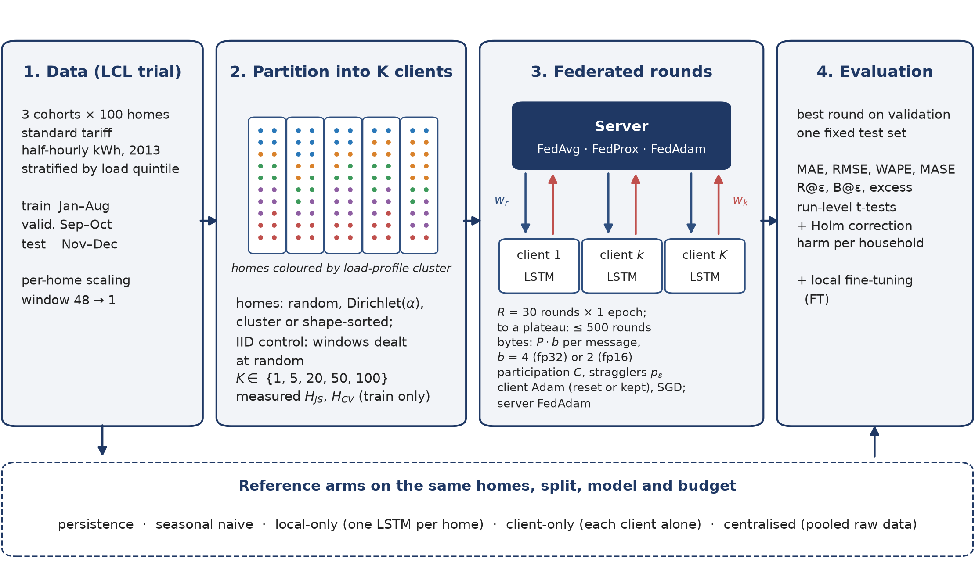
Figure 1. Study workflow. All arms used the same households, split and LSTM. Federated arms partitioned the training data into $K$ clients and were tested once at the round chosen on validation error. $w_{r}$, $w_{k}$: global and client weights; $P·b$: bytes per message; FT: local fine-tuning.
With one home per client, $K=100$. Otherwise the same homes were grouped into $K$ equal-sized clients of ${100}/K$ homes, as behind a building gateway or community energy hub. Each household was described by its normalised daily load shape and log mean load and clustered with $k$-means into $G=5$ profile clusters. Four groupings of homes were used, together with one control. Random grouping permuted the homes and cut the permutation into $K$ blocks. Dirichlet grouping drew for each client a mixture $π\sim Dir(α1_{G})$ and filled each of its slots with a random home from a cluster drawn from $π$, renormalised over clusters with homes left [35]. Cluster grouping sorted homes by cluster and mean load and cut the list into blocks. Shape grouping sorted homes by the first principal component of their hour-of-week profile and cut the list into blocks, the largest difference in load shape that equal-sized clients of these homes allow. Finally, the window control was not a grouping of homes: the pooled training windows of all homes were dealt at random into $K$ equal shards, so that every client saw the same mixture of homes. It fragments the data exactly as household grouping does while keeping clients statistically identical, so any gap it shows is due to fragmentation and budget, not heterogeneity. Validation and test errors were always computed per household on the same windows.
Measured heterogeneity. With $q_{k}$ the distribution of client $k$'s training consumption over the 168 hours of the week and JS the Jensen–Shannon divergence with base-2 logarithms [40], bounded in $\left[0 , 1\right]$,
$H_{JS}={\left({K \atop 2}\right)}^{−1}\sum_{k<l}{JS}\left(q_{k} ‖ q_{l}\right)$ (3)
$H_{JS}$ measures differences in when clients consume. Differences in how much they consume were measured separately by the coefficient of variation of client mean load, $H_{CV}$; the two were not combined, because a composite would be dominated by the level term (it made up 94 % of $H_{JS}+H_{CV}/(1+H_{CV})$; Supplementary Table S3).
Communication. A message carries $P·b$ bytes ($b=4$ for 32-bit, 2 for 16-bit updates), with one download per selected client and one upload per returning client; framing headers are excluded. With $v_{r}$ the validation MAE after round $r$ and $v^{⋆}$ that of centralised training, R@$ε$ is the first round after which $v_{r}≤(1+ε)v^{⋆}$ held for every remaining round of the run, so that a transient dip does not count, and B@$ε$ the bytes exchanged up to it, for $ε∈\{5,10,15,20\}\%$. Because any single threshold is arbitrary, the mean excess $\frac{1}{30}\sum_{r}{(}v_{r}/v^{⋆}−1)$ over the first 30 rounds was also reported. The raw-data volume was counted for four encodings: 2- and 4-byte readings, a 12-byte reading with a 4-byte timestamp offset and a 4-byte household index (the figure used for centralised traffic), and the public comma-separated file. Stragglers (probability 0.2) completed a random fraction of their local work; FedAvg dropped them, FedProx kept their partial updates [13].

3.4 Experimental setup
The default federated setting used $K=20$, full participation and $R=30$ rounds of $E=1$ epoch, the same number of passes over the data as the centralised budget. The experiments varied $K$ (1, 5, 20, 50, 100), the grouping (window, random, $α∈\{1,0.3,0.1\}$, cluster and shape), participation ($C=0.5$ with stragglers), the aggregation rule and 16-bit updates. The local budget per round shrinks with $K$: a client took 4,535 Adam steps per round at $K=1$, 227 at $K=20$ and 46 at $K=100$. FedAvg with homes and with the window control was therefore also trained to a plateau at $K=20$, 50 and 100: up to 500 rounds, stopped after 50 rounds without a new best validation MAE. The optimisers were compared at $K=20$ and 100 over 100 rounds, stopped after 25 rounds without improvement. Two further checks addressed the forecaster: sine and cosine encodings of time of day and day of week as extra inputs, and the mean absolute scaled error (MASE), scaled per household by the in-sample one-step naive MAE on its training data. Each configuration ran with three seeds; the arms in the main comparisons and the heterogeneity, participation and precision configurations ran with five. A seed fixed the model initialisation, the random grouping or Dirichlet draw, client sampling and stragglers, and the order of mini-batches; the cohort was fixed. The proximal coefficients were tuned on validation data over $μ∈\{0,{10}^{−4},{10}^{−3},{10}^{−2},{10}^{−1}\}$. The pipeline used Python 3.14.7, PyTorch 2.14.1 and an in-process simulator whose clients follow the Flower interface; Flower 1.39.0 [41] reproduced its results exactly.
Accuracy was measured by MAE, RMSE and weighted absolute percentage error (WAPE), micro-averaged over all test half-hours, and by MASE. Households scored by one trained model are not independent, so the training run was the unit of replication: arms were compared on the pooled test MAE of each run, paired by seed where both had the same seeds (paired $t$-test) and with Welch's test otherwise. With every household in every run this is equivalent to testing the arm in a linear mixed model with crossed random effects for household and run. One family of 31 comparisons (Supplementary Table S1) was corrected with Holm's method [42], and every $p$-value in the text is this corrected value unless marked otherwise; differences $Δ$ are given in ${10}^{−4}$ kWh with 95 % confidence intervals. The share of households that did better under an arm is descriptive only. A household was counted as harmed by an arm if its MAE was more than 1 % above its local-only MAE. Results with $p_{Holm}≥0.05$ are described as not significant, without implying equivalence.

4. Results

4.1 Main arms
Table 1 gives the test error of the main arms. Centralised training was the most accurate arm, better than persistence by 8.7 % in MAE, and better than local-only training in 5 of 5 paired seeds ($Δ=−27.0$, 95 % CI −33.8 to −20.2, $p_{Holm}$ $=0.011$) and for 72 % of households. Not every federated arm beat the naive references: with one home per client, FedAvg was slightly worse than persistence in MAE (0.0893 against 0.0890 kWh), although better in RMSE. As a sanity check of the federated implementation, running it on a single client holding all homes ($K=1$) reproduced centralised accuracy ($Δ=−2.9$, CI −8.5 to +2.8).
Table 1. Test error of the main arms (kWh per half-hour; MAE as mean $±$ s.d. over seeds). Gap: MAE relative to centralised training. Traffic: upload plus download over 30 rounds; for centralised training, the raw training data at 12 bytes per reading. FT: after one epoch of local fine-tuning on each home. Client-only: each client trains alone on its homes.
Arm | K | MAE | RMSE | WAPE (%) | Gap (%) | MAE, FT | Traffic (MB)
Persistence | – | 0.0890 | 0.1987 | 37.6 | – | – | 0
Seasonal naive | – | 0.1332 | 0.2773 | 56.3 | – | – | 0
Local-only | – | 0.0839 ± 0.0003 | 0.1777 | 35.5 | +3.3 | – | 0
Centralised | – | 0.0812 ± 0.0004 | 0.1721 | 34.3 | 0.0 | – | 14.0
FedAvg, sanity check | 1 | 0.0809 ± 0.0004 | 0.1709 | 34.2 | −0.4 | 0.0811 | 4.1
Client-only | 5 | 0.0842 ± 0.0011 | 0.1770 | 35.6 | +3.6 | 0.0838 | 0
Client-only | 20 | 0.0851 ± 0.0006 | 0.1798 | 36.0 | +4.8 | 0.0852 | 0
FedAvg, random | 5 | 0.0826 ± 0.0005 | 0.1721 | 35.0 | +1.8 | 0.0818 | 20.7
FedAvg, random | 20 | 0.0854 ± 0.0008 | 0.1758 | 36.1 | +5.2 | 0.0833 | 82.6
FedAvg, random | 50 | 0.0870 ± 0.0005 | 0.1780 | 36.8 | +7.2 | 0.0841 | 206.6
FedAvg, one home per client | 100 | 0.0893 ± 0.0009 | 0.1810 | 37.8 | +10.0 | 0.0849 | 413.2
FedAvg, α=0.3 | 20 | 0.0860 ± 0.0003 | 0.1757 | 36.4 | +5.9 | 0.0833 | 82.6
FedAvg, cluster | 20 | 0.0857 ± 0.0003 | 0.1759 | 36.2 | +5.5 | 0.0834 | 82.6
FedAvg, α=0.3, C=0.5, stragglers | 20 | 0.0850 ± 0.0005 | 0.1759 | 36.0 | +4.7 | 0.0833 | 37.2
FedAvg, α=0.3, 16-bit | 20 | 0.0857 ± 0.0004 | 0.1755 | 36.3 | +5.6 | 0.0833 | 41.3

4.2 Fragmentation and training budget
The gap to centralised training appeared as soon as the homes were split and grew with the number of clients (Table 2), from 1.8 % at $K=5$ to 5.2 % at $K=20$, 7.2 % at $K=50$ and 10.0 % with one home per client after 30 rounds; at run level the gaps at $K=20$ ($Δ=+41.9$, $p_{Holm}$ $=0.016$) and $K=100$ ($Δ=+80.9$, $p_{Holm}$ $=0.0013$) were significant. Under random grouping, however, splitting also makes clients more different: $H_{JS}$ rose from 0.0026 at $K=5$ to 0.0497 at $K=100$, because a smaller client averages over fewer homes. The window control removed this confound. With windows dealt at random, $H_{JS}$ stayed at or below 0.0094 (the sampling noise of finite shards) and client mean loads were equal, yet the gap remained 1.1, 4.4, 5.4 and 7.6 % at $K=5$, 20, 50 and 100, that is 76–85 % of the gap with homes at $K≥20$ and 60 % at $K=5$ (shares from unrounded gaps). At run level the windows were better than homes by $Δ=−6.1$ at $K=20$ and −18.9 at $K=100$, neither significant ($p_{Holm}$ $=1.000$ at $K=20$ and $p_{Holm}$ $=0.598$ at $K=100$).
A regression of run-level test MAE on $lnK$, $H_{JS}$ and an indicator for groupings of homes, over all FedAvg runs with random, Dirichlet, cluster, shape and window partitions ($n=70$), gave $1.43×{10}^{−3}$ kWh per unit of $lnK$ (95 % CI 1.25 to 1.62, $p$ $<{10}^{−4}$), $41.9×{10}^{−3}$ kWh per unit of $H_{JS}$ (CI 22.6 to 61.1, $p$ $<{10}^{−4}$) and $0.5×{10}^{−3}$ kWh for homes rather than windows (CI 0.0 to 0.9, $p$ $=0.037$; uncorrected). Among groupings of homes $lnK$ and $H_{JS}$ were correlated ($r=0.85$), so the pooled fit cannot fully separate them; within $K=20$ alone, the $H_{JS}$ term was $37.5×{10}^{−3}$ kWh (CI −9.5 to 84.5, $n=30$). Over the ranges tested, the three-term model gives 0.0043 kWh for going from five to 100 clients ($1.43×{10}^{−3}×ln20$), whereas the whole range of $H_{JS}$ obtained at $K=20$ (0.0019 to 0.0213) corresponds to 0.0008 kWh.
Table 2. Fragmentation with and without heterogeneity (FedAvg). Homes: homes grouped at random; windows: training windows dealt at random to equal shards (IID control). Gap: test MAE relative to centralised training after 30 rounds, and at the plateau (up to 500 rounds, stopped after 50 rounds without improvement). Share: part of the 30-round gap kept by the control, from unrounded gaps.
K | H_{JS}, homes | H_{JS}, windows | Gap, homes (%) | Gap, windows (%) | Share (%) | Plateau gap, homes (%) | Plateau gap, windows (%)
1 | 0.0000 | – | −0.4 | – | – | – | –
5 | 0.0026 | 0.0005 | +1.8 | +1.1 | 60 | – | –
20 | 0.0106 | 0.0019 | +5.2 | +4.4 | 85 | +1.8 | +1.3
50 | 0.0263 | 0.0048 | +7.2 | +5.4 | 76 | +4.4 | +1.9
100 | 0.0497 | 0.0094 | +10.0 | +7.6 | 77 | +5.4 | +3.5

Part of the fragmentation cost is a budget cost. With one local epoch per round, a client took 4,535 Adam steps per round at $K=1$ but only 46 at $K=100$, and the round selected on validation moved towards the end of the 30 rounds as $K$ grew (Supplementary Table S2 and Fig. S1). Trained to a plateau (Figs. 2 and 3), the gap fell to 1.8, 4.4 and 5.4 % with homes and to 1.3, 1.9 and 3.5 % with windows at $K=20$, 50 and 100. More rounds thus removed 39–66 % of the 30-round gap with homes, but the IID control did not close: identical clients still kept 42–74 % of the gap with homes. The best rounds per seed were 192, 98, 123 ($K=20$), 52, 113, 274 ($K=50$) and 477, 202, 224 ($K=100$) with homes, and 261, 75, 66 ($K=20$), 346, 247, 154 ($K=50$) and 295, 180, 53 ($K=100$) with windows (Supplementary Table S5). All runs but one stopped after 50 rounds without improvement; one $K=100$ run with homes was still improving at the 500-round cap, so that gap is an upper bound. At $K=20$ and 100 every plateau run, with homes or windows, remained less accurate than centralised training of the same seed, but with three seeds per arm the plateau differences between homes and windows ($Δ=−3.8$ to −15.2) were not significant after correction. Reaching the plateau was expensive: on average a $K=100$ run with homes moved 4,146 MB up to its best round and 4,711 MB in all, and the run stopped at the 500-round cap moved 6,887 MB, against 413.2 MB for 30 rounds; the runs of up to 100 rounds in Supplementary Table S2 moved 275, 521 and 1,377 MB at $K=20$, 50 and 100.
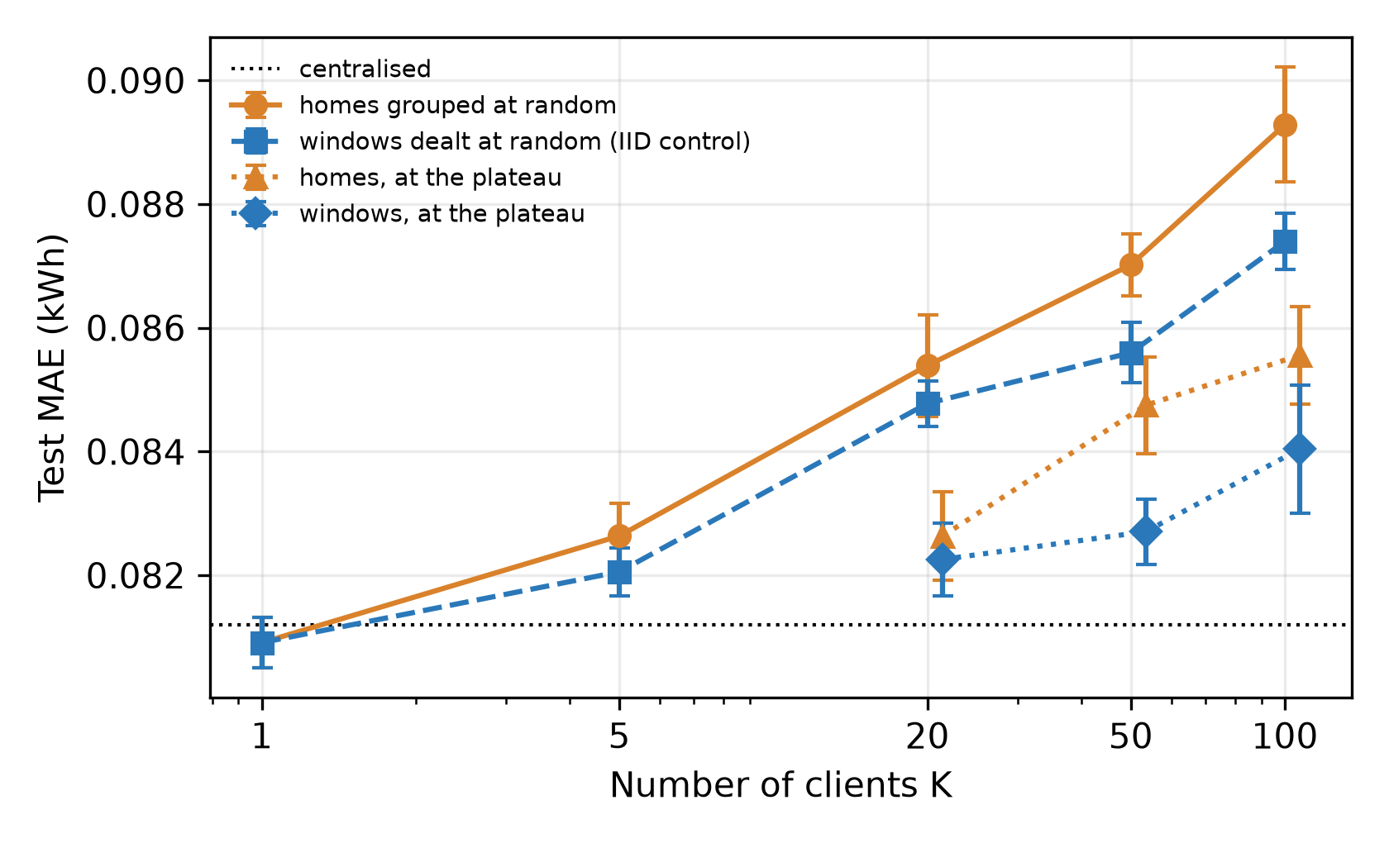
Figure 2. Test MAE (kWh) when the same 100 households are split over $K$ clients (mean $±$ s.d. over seeds). Circles: homes grouped at random and squares: training windows dealt at random (IID control), both after 30 rounds; filled triangles and diamonds: the same at the plateau. Dotted: centralised.
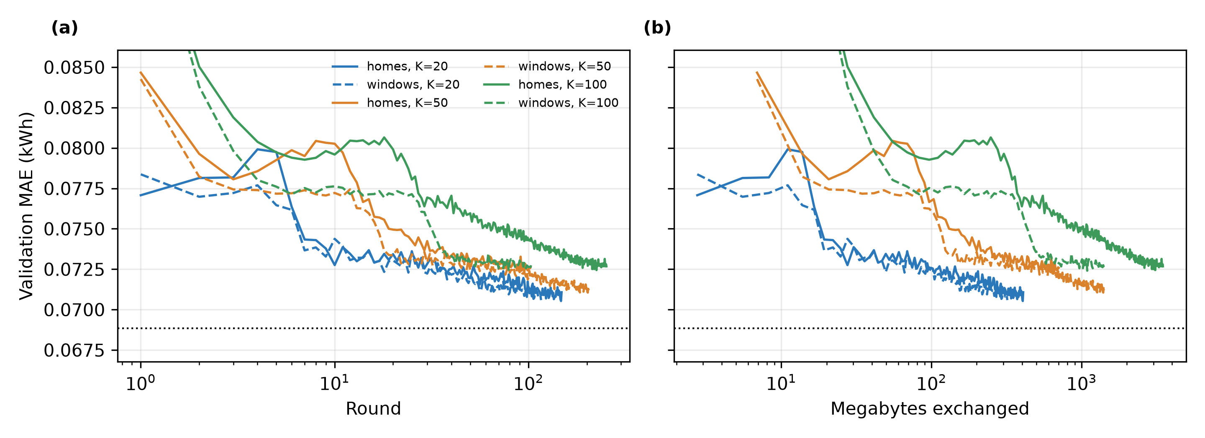
Figure 3. FedAvg trained to a plateau (mean over three seeds, plotted while every seed was running). (a) Validation MAE against rounds and (b) against megabytes exchanged. Solid: homes grouped at random; dashed: training windows dealt at random (IID control). Dotted: centralised.

4.3 Optimiser set-up
Restarting Adam in every round is a design choice, so the 100-round runs at $K=20$ and $K=100$ were repeated with three alternatives (Supplementary Table S6). Keeping the client Adam state gave a test MAE of 0.0838 against 0.0832 kWh at $K=20$ ($Δ=+6.0$, $p_{Holm}$ $=1.000$) and 0.0872 against 0.0871 kWh at $K=100$ ($Δ=+0.8$, $p_{Holm}$ $=1.000$). Client SGD with the step size chosen on validation (0.3) reached 0.0879 and 0.0897 kWh, and FedAdam with server step size 0.01 reached 0.0842 and 0.0855 kWh ($Δ=+10.0$ and −16.3 against Adam with restarts). Keeping the optimiser state therefore made no difference, and client SGD was worse at both sizes, significantly so at $K=20$ ($p_{Holm}$ $=0.034$). FedAdam did not help at $K=20$, but with one home per client it narrowed the gap from 7.3 to 5.3 % in 3 of 3 paired seeds, selecting its model by round 35 on average, about as close as plain FedAvg came after hundreds of rounds (5.4 % at the plateau); the difference was not significant with three seeds ($p_{Holm}$ $=1.000$). The step size 0.03, run because 0.01 lay at the edge of the grid and almost tied with it on validation, gave 4.2 % at $K=100$ and 2.1 % at $K=20$; it is reported but was not selected. A server-side adaptive optimiser thus recovers part of the budget cost of meter-level federation, but no optimiser closed the gap.

4.4 Heterogeneity at a fixed number of clients
At $K=20$, grouping the homes from random to cluster almost doubled $H_{JS}$ (Table 3), and cluster grouping also raised the spread of client mean load. Final test error hardly moved: across the groupings of homes it ranged from 0.0851 to 0.0860 kWh, the 95 % intervals overlapped, and the rank correlation between $H_{JS}$ and test MAE over runs was +0.14 ($p$ $=0.465$, uncorrected, $n=30$). Cluster grouping did not differ significantly from random grouping ($Δ=+2.7$, CI −4.3 to +9.6, $p_{Holm}$ $=1.000$). The window control was the most accurate grouping (0.0848 kWh). Sorting homes by load shape gave the largest divergence ($H_{JS}=0.0213$) and the same error (0.0857 kWh), so the absence of an effect is not an artefact of the cluster definition; it holds, however, only over the narrow range of heterogeneity that equal-sized clients of these homes allow.
Heterogeneity showed up early in training rather than at the end. After the first round, validation error rose for a few rounds before falling (Fig. 4a): the largest rise above its running minimum in the first ten rounds was 2.2 % for the window control and 4.8–7.9 % for groupings of homes. In the same rounds the client updates disagreed far more when clients held different homes (mean normalised disagreement over rounds 2–5 of 0.75–0.78, against 0.24 for the control; Supplementary Eq. S1): each client's first epochs pull the shared model towards its own profiles, and the average of these divergent models is temporarily worse. Restarting Adam each round did not cause the rise: with the optimiser state kept, it was 5.1 % at $K=20$, against 4.7 % with restarts over the same seeds.
The traffic needed to settle near centralised accuracy depended more on the threshold and the seed than on the grouping (Fig. 4b). Within 20 %, the control settled after the first round in every seed (2.8 MB), whereas seeds of the groupings of homes needed between 2.8 and 22.0 MB. Within 10 %, the control needed the least traffic on average (20.9 MB; 13.8–38.6 MB over seeds). Among groupings of homes the means ranged from 23.1 MB for shape-sorted grouping, the most divergent, to 34.2 MB for cluster grouping, with random grouping at 31.4 MB, and their seed ranges overlapped widely (random 16.5–77.1, cluster 16.5–46.8 MB), so traffic did not follow $H_{JS}$. Within 5 %, 3 of 5 control runs settled within 30 rounds, against 1 run at $α=0.3$, 1 at $α=0.1$ and none with the other groupings of homes, all of them near the end of the 30 rounds. The threshold-free excess error over the first 30 rounds was 7.1 % for the control and 8.3–9.4 % for the groupings of homes, not ordered by $H_{JS}$: heterogeneity slowed FedAvg slightly, without a dose–response over this range. These results concern FedAvg; the proximal variants converged differently (Supplementary Section S3).
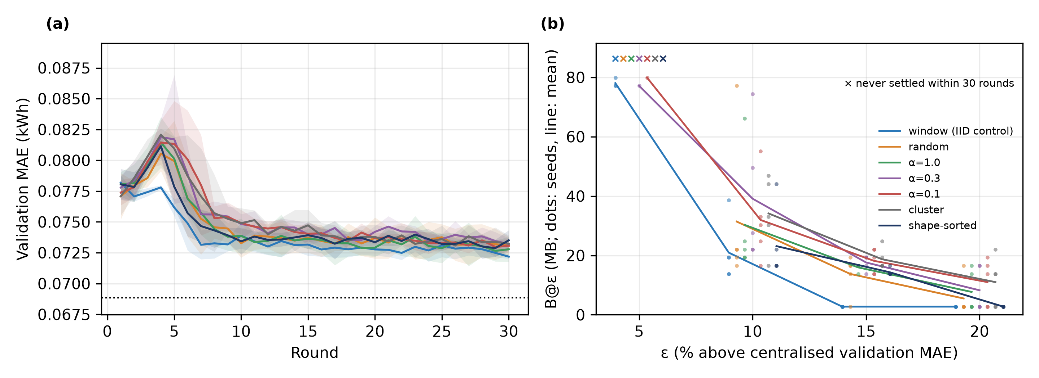
Figure 4. Groupings of the same homes into $K=20$ clients (FedAvg). (a) Validation MAE per round (mean $±$ s.d. over seeds; dotted: centralised). (b) Megabytes exchanged up to the round after which validation MAE stayed within $ε$ of centralised for the rest of the 30 rounds, for four thresholds; dots are seeds, crosses mark seeds that never settled (a run that qualifies only in its last round counts as not settled).
Table 3. Groupings of the same homes into $K=20$ clients (FedAvg, 30 rounds). $H_{JS}$: load-shape divergence (base 2); $H_{CV}$: variation of client mean load; test MAE with 95 % confidence interval over seeds; B@$ε$: megabytes exchanged up to the round after which validation MAE stayed within $ε$ of centralised, averaged over the seeds that settled (in brackets; qualifying only in the last round does not count); Excess: mean validation error above centralised over the first 30 rounds.
Grouping | Seeds | H_{JS} | H_{CV} | Test MAE (±95% CI) | B@5% | B@10% | B@20% | Excess (%)
window (IID control) | 5 | 0.0019 | 0.005 | 0.0848 ± 0.0005 | 78.1 (3/5) | 20.9 (5/5) | 2.8 (5/5) | 7.1
random | 5 | 0.0106 | 0.320 | 0.0854 ± 0.0010 | – (0/5) | 31.4 (5/5) | 5.5 (5/5) | 8.4
α=1.0 | 5 | 0.0125 | 0.333 | 0.0851 ± 0.0009 | – (0/5) | 30.3 (5/5) | 7.7 (5/5) | 8.3
α=0.3 | 5 | 0.0152 | 0.301 | 0.0860 ± 0.0004 | 77.1 (1/5) | 39.1 (5/5) | 8.3 (5/5) | 9.4
α=0.1 | 5 | 0.0189 | 0.286 | 0.0856 ± 0.0005 | 79.9 (1/5) | 32.0 (5/5) | 11.0 (5/5) | 9.2
cluster | 5 | 0.0202 | 0.564 | 0.0857 ± 0.0004 | – (0/5) | 34.2 (5/5) | 11.0 (5/5) | 9.3
shape-sorted | 5 | 0.0213 | 0.350 | 0.0857 ± 0.0003 | – (0/5) | 23.1 (5/5) | 2.8 (5/5) | 8.3

4.5 Forecaster strength, client-only training and other cohorts
Calendar inputs did not strengthen the forecaster (Supplementary Table S10): centralised MAE went from 0.0812 to 0.0815 kWh, and with one home per client FedAvg became worse (0.0919 kWh, a gap of 12.8 %). With MASE, centralised training (0.989) beat the in-sample naive scale while FedAvg with one home per client (1.109) did not; persistence scored 1.074 on the test period. The claims of this paper are therefore limited to one-step forecasts.
The client-only arm tests what federation adds once homes are pooled (Table 1). Each of five clients training alone on its 20 homes reached 0.0842 kWh, against 0.0826 kWh for FedAvg over the same five clients ($Δ=−15.2$, CI −33.0 to +2.6, $p_{Holm}$ $=1.000$); at $K=20$ the two were 0.0851 and 0.0854 kWh ($Δ=+3.1$, $p_{Holm}$ $=1.000$). To compare like with like, the client-only models were also fine-tuned for one epoch on each home. Fine-tuning helped them little (0.0838 and 0.0852 kWh), because they had already been trained on the same homes, whereas it helped FedAvg more: FedAvg with fine-tuning was better than client-only with fine-tuning by $Δ=−20.1$ at $K=5$ (CI −30.1 to −10.1, $p_{Holm}$ $=0.120$) and −18.8 at $K=20$ (CI −26.1 to −11.4, $p_{Holm}$ $=0.054$), in 5 of 5 and 5 of 5 paired seeds, although neither difference was significant after correction.
Table 4. Gap to centralised training (%) in three cohorts of 100 homes, FedAvg after 30 rounds, homes grouped at random and windows dealt at random (IID control). Each cohort is compared with its own centralised arm. Main cohort: all seeds of Table 2; second and third cohorts: two seeds.
Cohort | Centralised MAE (kWh) | Local-only gap (%) | K=5: homes / windows (%) | K=20: homes / windows (%) | K=100: homes / windows (%)
Main | 0.0812 | +3.3 | +1.8 / +1.1 | +5.2 / +4.4 | +10.0 / +7.6
Second | 0.0847 | +3.7 | +0.8 / −0.2 | +5.7 / +4.1 | +7.4 / +7.1
Third | 0.0876 | −1.2 | −1.2 / −1.5 | +0.9 / +0.7 | +3.8 / +3.7

The growth of the gap with $K$ and the share kept by the control were repeated in the two further cohorts (Table 4). With 20 or more clients the control kept 71–96 % of the gap with homes in every cohort. At $K=5$ the gaps were small (at most 1.8 %) and changed sign between cohorts, so a share is not meaningful there. The size of the gap varied: at $K=100$ it ranged from 3.8 to 10.0 % across cohorts and at $K=20$ from 0.9 to 5.7 %. The ranking of centralised and local training was not stable either: local-only training was between −1.2 and 3.7 % from centralised, and in one cohort it was the better of the two.

4.6 Proximal regularisation
Validation tuning over a grid that included $μ=0$ selected $μ=0$, that is plain FedAvg (validation MAE 0.07238 against 0.07259 kWh for the best positive coefficient, $μ=0.001$; Supplementary Table S4). FedProx with that coefficient was practically indistinguishable from FedAvg at $α=0.3$ ($Δ=−2.5$, CI −5.3 to +0.4, $p_{Holm}$ $=1.000$). An adaptive schedule driven by the disagreement between client updates did not improve on FedAvg either ($Δ=+5.7$ under cluster grouping, $p_{Holm}$ $=0.682$; Supplementary Section S3).

4.7 Communication
One message was 68.9 kB, so 30 rounds with $K=20$ moved 82.6 MB and household clients moved 413.2 MB (Table 1). The eight months of training readings of the cohort (1.17 million values) occupy 2.3 MB at 2 bytes per reading, 4.7 MB at 4 bytes, 14.0 MB at 12 bytes and 58.1 MB in the public comma-separated format (about 50 bytes per row). Thirty rounds at $K≥20$ with 32-bit updates and full participation thus moved more bytes than the readings in any of these encodings. Settings with less traffic, $K=5$ (20.7 MB), 16-bit updates (41.3 MB) and half participation with stragglers (37.2 MB), moved more than the binary encodings but less than the comma-separated file: 16-bit updates halved the traffic and half participation with stragglers lowered it further. Neither lost accuracy: against full participation with 32-bit updates, the pooled MAE changed by −0.3 % with 16-bit updates ($Δ=−2.4$, $p_{Holm}$ $=1.000$; 92 % of households did better) and by −1.1 % with half participation ($Δ=−9.3$, $p_{Holm}$ $=0.807$; 94 % of households did better). Both plausibly act as mild regularisers. Training to a plateau multiplies traffic by the number of rounds (see the plateau runs above), so at these settings the bandwidth comparison with the raw readings only becomes less favourable to federation with longer training.

4.8 Who gains from federation?
Table 5, Supplementary Table S9 and Supplementary Fig. S2 give the per-household view. With the 1 % margin, centralised training harmed 25 % of households and helped 64 %. FedAvg at $K=20$ harmed 51 % (random grouping) to 56 % ($α=0.3$) of households, and 73 % with one home per client. One epoch of fine-tuning reduced the share at $α=0.3$ to 40 %, after which FedAvg was not significantly different from local training ($Δ=−6.2$, $p_{Holm}$ $=0.103$). With one home per client fine-tuning reduced the share to 46 %, but FedAvg with fine-tuning (0.0849 kWh) remained less accurate than local models (0.0839 kWh; $Δ=+10.0$, CI +3.0 to +17.1, $p_{Holm}$ $=0.372$; not significant after correction). The benefit of pooling was largest for the highest-consuming fifth of homes: their median MAE was 0.1396 kWh with local models, 0.1319 kWh with centralised training and 0.1408 kWh with FedAvg at $α=0.3$ (Supplementary Table S8).
Table 5. Share of households (%) whose test MAE was worse than local-only training at all, worse by more than 1 %, and better by more than 1 %. FedAvg at $K=20$ unless stated; FT: after one epoch of local fine-tuning.
Arm | Worse than local (%) | Worse by >1% (%) | Better by >1% (%)
Centralised | 28 | 25 | 64
FedAvg, random | 61 | 51 | 32
FedAvg, α=0.3 | 65 | 56 | 29
FedAvg, α=0.3 + FT | 50 | 40 | 42
FedAvg, K=100 | 82 | 73 | 12
FedAvg, K=100 + FT | 59 | 46 | 29

5. Discussion
After a fixed budget, most of the accuracy cost of federation in this setting came from fragmentation and from the budget itself. Splitting the same data over more clients cost accuracy even when the clients were statistically identical, as described for local stochastic gradient descent: smaller shards give each client fewer steps between averages, and the average of many short local trajectories progresses less per round than one pass over the pooled data [36]–[38]. Training to a plateau recovered a large part of this cost, at a traffic of gigabytes per run, but not all of it, and the part that remained with identical clients was of the same order as the part attributable to heterogeneity. Heterogeneity mainly slowed early convergence, through disagreeing client updates, which may explain why drift remedies helped little here, whereas a server-side adaptive optimiser, which acts on the budget, narrowed the meter-level gap. The heterogeneity reachable with these homes was limited ($H_{JS}$ at most 0.0497), and populations with photovoltaics, electric vehicles, heat pumps or time-of-use tariffs, or clients of unequal size, may differ much more, so the relative weight of the costs should not be generalised beyond London households of this kind.
In practice, the number of clients and the budget were the most consequential choices. Federating five aggregated clients cost 1.8 % in MAE after 30 rounds; meter-level federation cost 10.0 % after 30 rounds and 5.4 % at the plateau, after about 4,711 MB of traffic per run on average (6,887 MB for the capped run). Since one household's eight months of training readings occupy about 47 kB even at 4 bytes per value, less than one 68.9 kB message, federation at this scale is a governance choice based on data minimisation and consent, not a bandwidth saving. Operators should federate few, aggregated clients held by a trusted hub such as a building gateway or energy community, budget rounds by local steps rather than epochs, fine-tune locally and check errors per consumption tier; a hub gains little from federating with other hubs unless the shared model is fine-tuned on its homes.
The results agree with Briggs et al. [19] that plain FedAvg can lose to local models on LCL, and that local fine-tuning recovers most of the loss. They differ on centralised training, which was the best arm here but 4.8 % worse than localised learning in their Table II. Their models were smaller (two layers of 20 units), used hourly sequences of 6 to 24 steps and were trained for up to 500 epochs, and their centralised error was averaged over sequences rather than per client. A budget that large is consistent with the present finding that much of the federated gap is a budget cost. The measured traffic supports the argument of Briggs et al. [17] rather than the analytic savings of Taïk and Cherkaoui [15], whose “1.9 kb” model (two LSTM layers of 200 units, about 1.9 MB in 32-bit floats) was probably a unit slip and would be of the same order as their 16 Mb of data.
The study covers one dataset and year, standard-tariff homes in equal-sized clients, one-step forecasts and a small LSTM, and its claims are limited to that horizon; day-ahead forecasting with rolling evaluation was not tested. The forecaster is close to persistence (MASE near one), as is typical for single homes at this resolution, so absolute gains are small. Three to five seeds per arm gave little power at run level, so several differences that were consistent in direction were not significant after correction. The network was simulated, traffic counts payload only, and data locality is not a formal privacy guarantee [43], [44]: neither differential privacy nor secure aggregation was applied.

6. Conclusion
Holding households, test set and model fixed on 100 Low Carbon London homes and two further cohorts, this study found that the error of federated household load forecasting grew with the number of clients the same homes were spread over, to 10.0 % after 30 rounds when every home was its own client, and that most of that growth remained when clients received random shares of the data and did not differ at all. Training to a plateau removed much of the gap at a large traffic cost, but not all of it, even for identical clients; heterogeneity added a smaller cost and slowed early convergence. A server-side adaptive optimiser recovered part of the budget cost with one home per client; keeping client optimiser state or using client SGD did not. With 20 or more clients, training moved more bytes than the readings it kept local, and local fine-tuning reduced, but did not remove, the share of harmed households. Calendar inputs and proximal regularisation brought no benefit. For one-step forecasts, the federated gap here is mainly a cost of budget and fragmentation, and the case for federation in residential forecasting rests on governance rather than bandwidth. Future work will test more heterogeneous populations and unequal clients, day-ahead horizons with rolling evaluation, larger models, and differential privacy and secure aggregation.

Declarations
Acknowledgements. The authors thank UK Power Networks for making the Low Carbon London trial data publicly available.
Funding. This research received no specific grant from any funding agency in the public, commercial or not-for-profit sectors.
Conflict of interest. The authors declare no conflict of interest.
Data availability. The Low Carbon London data are publicly available from the London Datastore (https://data.london.gov.uk/dataset/smartmeter-energy-consumption-data-in-london-households-vqm0d). All code, configuration files, per-run results and the scripts that generate every table and figure are available at https://github.com/Pushkal-Gupta/Short-Term-Household-Energy-Load-Forecasting.
Author contributions. Pushkal Gupta: conceptualisation, methodology, software, data curation, investigation, formal analysis, visualisation, writing – original draft. Vanka Kaushik: conceptualisation, investigation, validation, writing – review and editing. Kalaavathi B: supervision, methodology, writing – review and editing.
Declaration of generative AI and AI-assisted technologies in the writing process. During the preparation of this work the authors used Claude (Anthropic) to help write and test the simulation and analysis software (Section 3 and the code repository) and to draft and edit the text of all sections (Abstract and Sections 1–6) and of the supplementary material. The tool was not used to generate data or results: every number comes from the authors' experiment runs through scripts in the repository. After using this tool, the authors reviewed and edited the code, the results and the content as needed and take full responsibility for the content of the publication.

References
[1] Hochreiter, S., Schmidhuber, J. (1997). Long short-term memory. Neural Computation, 9(8): 1735-1780. https://doi.org/10.1162/neco.1997.9.8.1735
[2] Kong, W., Dong, Z.Y., Jia, Y., Hill, D.J., Xu, Y., Zhang, Y. (2019). Short-term residential load forecasting based on LSTM recurrent neural network. IEEE Transactions on Smart Grid, 10(1): 841-851. https://doi.org/10.1109/TSG.2017.2753802
[3] Shi, H., Xu, M., Li, R. (2018). Deep learning for household load forecasting—A novel pooling deep RNN. IEEE Transactions on Smart Grid, 9(5): 5271-5280. https://doi.org/10.1109/TSG.2017.2686012
[4] McMahan, B., Moore, E., Ramage, D., Hampson, S., Agüera y Arcas, B. (2017). Communication-efficient learning of deep networks from decentralized data. In Proceedings of the 20th International Conference on Artificial Intelligence and Statistics (AISTATS), vol. 54, pp. 1273-1282. https://proceedings.mlr.press/v54/mcmahan17a.html
[5] Kairouz, P., McMahan, H.B., et al. (2021). Advances and open problems in federated learning. Foundations and Trends in Machine Learning, 14(1–2): 1-210. https://doi.org/10.1561/2200000083
[6] Fernández, J.D., Menci, S.P., Lee, C.M., Rieger, A., Fridgen, G. (2022). Privacy-preserving federated learning for residential short-term load forecasting. Applied Energy, 326: 119915. https://doi.org/10.1016/j.apenergy.2022.119915
[7] Fekri, M.N., Grolinger, K., Mir, S. (2022). Distributed load forecasting using smart meter data: Federated learning with recurrent neural networks. International Journal of Electrical Power & Energy Systems, 137: 107669. https://doi.org/10.1016/j.ijepes.2021.107669
[8] Gholizadeh, N., Musilek, P. (2022). Federated learning with hyperparameter-based clustering for electrical load forecasting. Internet of Things, 17: 100470. https://doi.org/10.1016/j.iot.2021.100470
[9] Widmer, F., Nowak, S., Bowler, B., Huber, P., Papaemmanouil, A. (2023). Data-driven comparison of federated learning and model personalization for electric load forecasting. Energy and AI, 14: 100253. https://doi.org/10.1016/j.egyai.2023.100253
[10] Qu, X., Guan, C., Xie, G., Tian, Z., Sood, K., Sun, C., et al. (2023). Personalized federated learning for heterogeneous residential load forecasting. Big Data Mining and Analytics, 6(4): 421-432. https://doi.org/10.26599/BDMA.2022.9020043
[11] Liu, Y., Dong, Z., Liu, B., Xu, Y., Ding, Z. (2023). FedForecast: A federated learning framework for short-term probabilistic individual load forecasting in smart grid. International Journal of Electrical Power & Energy Systems, 152: 109172. https://doi.org/10.1016/j.ijepes.2023.109172
[12] Das, P., Pandey, S., Pandey, C., Kumar, D. (2026). Heterogeneity-aware personalised federated learning for household energy forecasting on multi-source real-world smart meter data. Scientific Reports, 16: 24957. https://doi.org/10.1038/s41598-026-53020-6
[13] Li, T., Sahu, A.K., Zaheer, M., Sanjabi, M., Talwalkar, A., Smith, V. (2020). Federated optimization in heterogeneous networks. In Proceedings of Machine Learning and Systems (MLSys), vol. 2, pp. 429-450. https://proceedings.mlsys.org/paper_files/paper/2020/hash/1f5fe83998a09396ebe6477d9475ba0c-Abstract.html
[14] Dogra, A., Anand, A., Bedi, J. (2023). Consumers profiling based federated learning approach for energy load forecasting. Sustainable Cities and Society, 98: 104815. https://doi.org/10.1016/j.scs.2023.104815
[15] Taïk, A., Cherkaoui, S. (2020). Electrical load forecasting using edge computing and federated learning. In ICC 2020 – 2020 IEEE International Conference on Communications (ICC), pp. 1-6. https://doi.org/10.1109/ICC40277.2020.9148937
[16] Savi, M., Olivadese, F. (2021). Short-term energy consumption forecasting at the edge: A federated learning approach. IEEE Access, 9: 95949-95969. https://doi.org/10.1109/ACCESS.2021.3094089
[17] Briggs, C., Fan, Z., Andras, P. (2020). Privacy preserving demand forecasting to encourage consumer acceptance of smart energy meters. In NeurIPS 2020 Workshop on Tackling Climate Change with Machine Learning. https://doi.org/10.48550/arXiv.2012.07449
[18] UK Power Networks (2015). SmartMeter energy consumption data in London households (Low Carbon London project). London Datastore. https://data.london.gov.uk/dataset/smartmeter-energy-consumption-data-in-london-households-vqm0d, accessed on 8 October 2026
[19] Briggs, C., Fan, Z., Andras, P. (2022). Federated learning for short-term residential load forecasting. IEEE Open Access Journal of Power and Energy, 9: 573-583. https://doi.org/10.1109/OAJPE.2022.3206220
[20] Lu, N., Liu, S., Wen, Q., Chen, Q., Sun, L., Wang, Y. (2024). Federated domain separation for distributed forecasting of non-IID household loads. IEEE Transactions on Smart Grid, 15(4): 4271-4283. https://doi.org/10.1109/TSG.2024.3367766
[21] Zhu, S., Shi, X., Zhao, H., Chen, Y., Zhang, H., Song, X., et al. (2025). Personalized federated learning for household electricity load prediction with imbalanced historical data. Applied Energy, 384: 125419. https://doi.org/10.1016/j.apenergy.2025.125419
[22] Feng, C., Shao, L., Wang, J., Zhang, Y., Wen, F. (2025). Short-term load forecasting of distribution transformer supply zones based on federated model-agnostic meta learning. IEEE Transactions on Power Systems, 40(1): 31-45. https://doi.org/10.1109/TPWRS.2024.3393017
[23] Abdulla, N., Demirci, M., Ozdemir, S. (2024). Smart meter-based energy consumption forecasting for smart cities using adaptive federated learning. Sustainable Energy, Grids and Networks, 38: 101342. https://doi.org/10.1016/j.segan.2024.101342
[24] Sarantinopoulos, E., Michalakopoulos, V., Sarmas, E., Marinakis, V., Toderean, L., Cioara, T. (2025). Meta-heuristic federated learning aggregation methods for load forecasting. Energy and AI, 22: 100594. https://doi.org/10.1016/j.egyai.2025.100594
[25] Wang, H., Xing, S., Si, C., Pan, Z., Zhao, J., Qiu, J., et al. (2025). Multi-gradient-descent federated learning with parity for cooperative short-term load forecasting. IEEE Transactions on Power Systems, 40(2): 1199-1213. https://doi.org/10.1109/TPWRS.2024.3420811
[26] Wang, R., Bai, L., Rayhana, R., Liu, Z. (2024). Personalized federated learning for buildings energy consumption forecasting. Energy and Buildings, 323: 114762. https://doi.org/10.1016/j.enbuild.2024.114762
[27] Dissem, M., Amayri, M. (2025). Toward efficient federated load forecasting: Personalization mechanisms and their impact. IEEE Internet of Things Journal, 12(17): 36045-36062. https://doi.org/10.1109/JIOT.2025.3580378
[28] Husnoo, M.A., Anwar, A., Hosseinzadeh, N., Islam, S.N., Mahmood, A.N., Doss, R. (2024). A secure federated learning framework for residential short-term load forecasting. IEEE Transactions on Smart Grid, 15(2): 2044-2055. https://doi.org/10.1109/TSG.2023.3292382
[29] Mostafanezhad, M., Mohammadi, M., Keihan Asl, D., Karimipour, H. (2025). Personalized poison attack tolerant federated learning for residential load forecasting. Sustainable Energy, Grids and Networks, 43: 101794. https://doi.org/10.1016/j.segan.2025.101794
[30] Zheng, R., Barja-Martinez, S., Aragüés-Peñalba, M., Sumper, A. (2026). Client clustering versus personalization in federated residential load forecasting: A personalization-fair benchmark of accuracy and communication overhead. Energy Reports, 16: 109681. https://doi.org/10.1016/j.egyr.2026.109681
[31] Konečný, J., McMahan, H.B., Yu, F.X., Richtárik, P., Suresh, A.T., Bacon, D. (2016). Federated learning: Strategies for improving communication efficiency. arXiv preprint arXiv:1610.05492. https://doi.org/10.48550/arXiv.1610.05492
[32] Zhao, Y., Li, M., Lai, L., Suda, N., Civin, D., Chandra, V. (2018). Federated learning with non-IID data. arXiv preprint arXiv:1806.00582. https://doi.org/10.48550/arXiv.1806.00582
[33] Karimireddy, S.P., Kale, S., Mohri, M., Reddi, S., Stich, S., Suresh, A.T. (2020). SCAFFOLD: Stochastic controlled averaging for federated learning. In Proceedings of the 37th International Conference on Machine Learning (ICML), vol. 119, pp. 5132-5143. https://proceedings.mlr.press/v119/karimireddy20a.html
[34] Reddi, S., Charles, Z., Zaheer, M., Garrett, Z., Rush, K., Konečný, J., et al. (2021). Adaptive federated optimization. In International Conference on Learning Representations (ICLR). https://arxiv.org/abs/2003.00295
[35] Hsu, T.-M.H., Qi, H., Brown, M. (2019). Measuring the effects of non-identical data distribution for federated visual classification. arXiv preprint arXiv:1909.06335. https://doi.org/10.48550/arXiv.1909.06335
[36] Stich, S.U. (2019). Local SGD converges fast and communicates little. In International Conference on Learning Representations (ICLR). https://arxiv.org/abs/1805.09767
[37] Woodworth, B., Patel, K.K., Stich, S., Dai, Z., Bullins, B., McMahan, B., et al. (2020). Is local SGD better than minibatch SGD? In Proceedings of the 37th International Conference on Machine Learning (ICML), vol. 119, pp. 10334-10343. https://proceedings.mlr.press/v119/woodworth20a.html
[38] Woodworth, B.E., Patel, K.K., Srebro, N. (2020). Minibatch vs local SGD for heterogeneous distributed learning. In Advances in Neural Information Processing Systems (NeurIPS), vol. 33. https://proceedings.neurips.cc/paper/2020/hash/45713f6ff2041d3fdfae927b82488db8-Abstract.html
[39] Mhou, K., Senekane, M. (2026). HAPI-FedProx: Heterogeneity-aware adaptive proximal optimization for federated learning. In Artificial Intelligence Research (SACAIR 2025), Communications in Computer and Information Science, vol. 2784, pp. 272-286. https://doi.org/10.1007/978-3-032-11733-5_17
[40] Lin, J. (1991). Divergence measures based on the Shannon entropy. IEEE Transactions on Information Theory, 37(1): 145-151. https://doi.org/10.1109/18.61115
[41] Beutel, D.J., Topal, T., Mathur, A., Qiu, X., Fernandez-Marques, J., Gao, Y., et al. (2020). Flower: A friendly federated learning research framework. arXiv preprint arXiv:2007.14390. https://doi.org/10.48550/arXiv.2007.14390
[42] Holm, S. (1979). A simple sequentially rejective multiple test procedure. Scandinavian Journal of Statistics, 6(2): 65-70. https://www.jstor.org/stable/4615733
[43] Zhu, L., Liu, Z., Han, S. (2019). Deep leakage from gradients. In Advances in Neural Information Processing Systems (NeurIPS), vol. 32. https://proceedings.neurips.cc/paper_files/paper/2019/hash/60a6c4002cc7b29142def8871531281a-Abstract.html
[44] Geiping, J., Bauermeister, H., Dröge, H., Moeller, M. (2020). Inverting gradients – How easy is it to break privacy in federated learning? In Advances in Neural Information Processing Systems (NeurIPS), vol. 33, pp. 16937-16947. https://proceedings.neurips.cc/paper_files/paper/2020/hash/c4ede56bbd98819ae6112b20ac6bf145-Abstract.html

