Supplementary material
Pushkal Gupta¹, Vanka Kaushik¹, Kalaavathi B^{1,*}
¹ School of Computer Science and Engineering, Vellore Institute of Technology, Vellore 632014, Tamil Nadu, India
* Corresponding author: Kalaavathi B, kalaavathi.b@vit.ac.in

S1. Run-level tests
Table S1 lists every comparison in the paper. Households scored by one trained model are not independent, so the unit of replication is the training run: each run contributes its pooled test MAE. Where both arms ran with the same seeds, the differences were paired by seed (paired $t$-test); otherwise Welch's $t$-test was used. With every household present in every run, this is equivalent to testing the arm in a linear mixed model with crossed random effects for household and run. The Holm correction was applied over all rows together, and it is the only correction used in the paper. $Δ$MAE is A minus B; negative values favour A. The share of households doing better under A is descriptive only.
Table S1. Run-level comparisons (${10}^{−4}$ kWh, 95 % confidence interval). Test: paired by seed ($n$ pairs) or Welch ($n_{A}+n_{B}$ runs).
A | B | Test (runs) | ΔMAE A−B (10⁻⁴ kWh) [95% CI] | Homes A better (%) | p_{Holm}
Centralised | Local-only | paired, n=5 | −27.0 [−33.8, −20.2] | 72 | 0.011
FedAvg, K=1 | Centralised | paired, n=5 | −2.9 [−8.5, +2.8] | 49 | 1.000
FedAvg, K=20 | Centralised | paired, n=5 | +41.9 [+30.2, +53.6] | 1 | 0.016
FedAvg, K=100 | Centralised | paired, n=5 | +80.9 [+69.2, +92.5] | 1 | 0.0013
Windows, K=20 | Homes, K=20 | paired, n=5 | −6.1 [−16.0, +3.7] | 71 | 1.000
Windows, K=100 | Homes, K=100 | paired, n=5 | −18.9 [−34.5, −3.2] | 65 | 0.598
FedAvg, cluster | FedAvg, random | paired, n=5 | +2.7 [−4.3, +9.6] | 44 | 1.000
FedAvg, shape | FedAvg, random | paired, n=5 | +2.7 [−6.5, +11.8] | 51 | 1.000
FedProx, α=0.3 | FedAvg, α=0.3 | paired, n=5 | −2.5 [−5.3, +0.4] | 79 | 1.000
HA-FedProx, cluster | FedAvg, cluster | paired, n=5 | +5.7 [+0.7, +10.7] | 27 | 0.682
FedAvg, α=0.3, 16-bit | FedAvg, α=0.3 | paired, n=5 | −2.4 [−5.4, +0.6] | 92 | 1.000
FedAvg, α=0.3, C=0.5 | FedAvg, α=0.3 | paired, n=5 | −9.3 [−18.2, −0.5] | 94 | 0.807
FedAvg, K=5 | Client-only, K=5 | paired, n=5 | −15.2 [−33.0, +2.6] | 63 | 1.000
FedAvg, K=20 | Client-only, K=20 | paired, n=5 | +3.1 [−5.0, +11.3] | 46 | 1.000
FedAvg + FT, K=5 | Client-only + FT, K=5 | paired, n=5 | −20.1 [−30.1, −10.1] | 91 | 0.120
FedAvg + FT, K=20 | Client-only + FT, K=20 | paired, n=5 | −18.8 [−26.1, −11.4] | 83 | 0.054
FedAvg + FT, α=0.3 | Local-only | paired, n=5 | −6.2 [−9.1, −3.3] | 50 | 0.103
FedAvg, K=100 | Local-only | paired, n=5 | +53.8 [+40.1, +67.5] | 18 | 0.012
FedAvg + FT, K=100 | Local-only | paired, n=5 | +10.0 [+3.0, +17.1] | 41 | 0.372
Windows, K=20, plateau | Homes, K=20, plateau | paired, n=3 | −3.8 [−17.4, +9.9] | 44 | 1.000
Windows, K=50, plateau | Homes, K=50, plateau | paired, n=3 | −20.4 [−49.7, +8.9] | 63 | 1.000
Windows, K=100, plateau | Homes, K=100, plateau | paired, n=3 | −15.2 [−38.8, +8.4] | 48 | 1.000
Windows, K=20, plateau | Centralised | paired, n=3 | +11.9 [−4.4, +28.1] | 9 | 1.000
Windows, K=100, plateau | Centralised | paired, n=3 | +29.7 [−0.0, +59.5] | 2 | 0.878
Homes, K=100, plateau | Centralised | paired, n=3 | +44.9 [+27.7, +62.1] | 6 | 0.180
Adam kept, K=20 | Adam reset, K=20 | paired, n=3 | +6.0 [−16.1, +28.1] | 18 | 1.000
Adam kept, K=100 | Adam reset, K=100 | paired, n=3 | +0.8 [−18.0, +19.6] | 35 | 1.000
SGD, K=20 | Adam reset, K=20 | paired, n=3 | +47.1 [+39.9, +54.3] | 10 | 0.034
SGD, K=100 | Adam reset, K=100 | paired, n=3 | +25.6 [+0.3, +50.9] | 19 | 0.878
FedAdam, K=20 | Adam reset, K=20 | paired, n=3 | +10.0 [−1.3, +21.3] | 48 | 0.995
FedAdam, K=100 | Adam reset, K=100 | paired, n=3 | −16.3 [−42.9, +10.2] | 65 | 1.000

S2. Training budget and round selection
Table S2 gives, for each number of clients, the local Adam steps per client and round, the round chosen on validation error and the test MAE, for the 30-round budget of the main text and for runs of up to 100 rounds that stopped after 25 rounds without a new best validation MAE; for the latter, the best and last round of each seed. Fig. S1 shows the validation curves. These 100-round runs are the reference for the optimiser comparison (Section S6); the plateau runs are in Section S5.
Table S2. Budget per number of clients $K$ (FedAvg, random grouping). Steps/round: Adam steps per client per round. Best rd.: round selected on validation MAE (mean over seeds). Best / run: best round and rounds run per seed. Gap: test MAE relative to centralised.
K | Steps/round | Best rd. (30) | MAE (30) | Gap (%) | Best / run per seed (100) | MAE (100) | Gap (%)
1 | 4,535 | 18.6 | 0.0809 | −0.4 | – | – | –
5 | 907 | 21.8 | 0.0826 | +1.8 | – | – | –
20 | 227 | 22.0 | 0.0854 | +5.2 | 91, 98, 100 / 100, 100, 100 | 0.0832 | +2.5
50 | 91 | 26.6 | 0.0870 | +7.2 | 52, 90, 25 / 77, 100, 50 | 0.0858 | +5.7
100 | 46 | 29.2 | 0.0893 | +10.0 | 99, 95, 92 / 100, 100, 100 | 0.0871 | +7.3

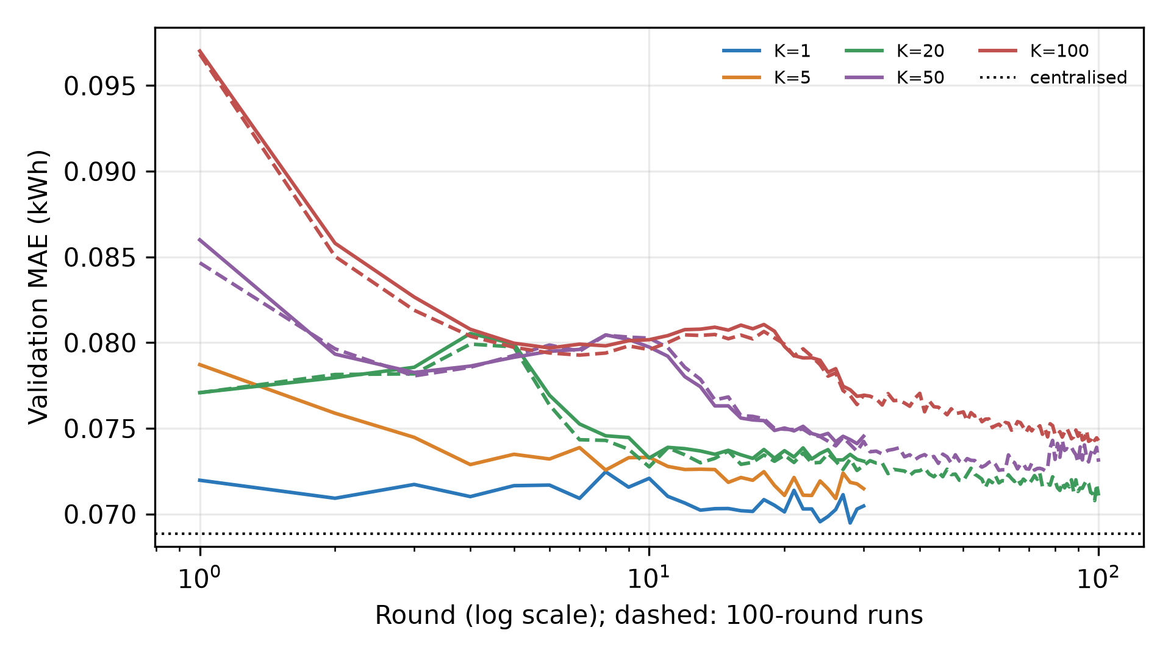
Figure S1. Validation MAE per round for each number of clients (mean over seeds). Solid: 30-round runs; dashed: runs of up to 100 rounds. Dotted: centralised.

S3. Heterogeneity-adaptive proximal coefficient
A rule was also tested that sets the proximal coefficient from the disagreement between client updates. After round $r$ the server holds the updates $Δ_{k}=w_{k}−w_{r}$ and their weighted mean $\overline{Δ}$, and computes
$ρ_{r}=\frac{\sum_{k}{p_{k}}‖Δ_{k}−\overline{Δ}‖^{2}}{\sum_{k}{p_{k}}‖Δ_{k}‖^{2}}∈[0,1],μ_{r+1}=clip\left(μ_{0}ρ_{r} , {10}^{−4} , 1\right)$ (S1)
The rule never improved on FedAvg. Under the cluster partition its run-level difference from FedAvg was $Δ=+5.7×{10}^{−4}$ kWh (95 % CI +0.7 to +10.7, $p_{Holm}$ $=0.682$), and 27 % of households did better under it. Its signal $ρ_{r}$ ranked partitions by heterogeneity (Spearman +0.51 with $H_{JS}$, $p$ = 0.0044, $n=30$ runs), but on average it rose from 0.15 in round 1 to 0.96 in the last round, a change about 46 times its spread across partitions. As the shared descent direction shrinks during training, any residual disagreement pushes $ρ_{r}$ towards one, so a coefficient proportional to it grows late in training whatever the data. Table S3 gives all three aggregation rules for each grouping.
Table S3. All aggregation rules for each grouping at $K=20$ (mean $±$ s.d. over three to five seeds). $H=H_{JS}+H_{CV}/(1+H_{CV})$, a composite shown for reference; $\overline{ρ}$: mean update disagreement.
Partition | Method | H | H_{JS} | ρ̄ | Test MAE | Gap to central (%)
α=0.1 | FedAvg | 0.241 | 0.0189 | 0.874 | 0.0856 ± 0.0004 | +5.4
α=0.1 | FedProx | 0.242 | 0.0181 | 0.863 | 0.0856 ± 0.0006 | +5.4
α=0.1 | HA-FedProx | 0.242 | 0.0181 | 0.844 | 0.0859 ± 0.0003 | +5.7
α=0.3 | HA-FedProx | 0.243 | 0.0153 | 0.844 | 0.0863 ± 0.0003 | +6.3
α=0.3 | FedAvg | 0.246 | 0.0152 | 0.871 | 0.0860 ± 0.0003 | +5.9
α=0.3 | FedProx | 0.246 | 0.0152 | 0.859 | 0.0857 ± 0.0002 | +5.6
random | FedAvg | 0.253 | 0.0106 | 0.858 | 0.0854 ± 0.0008 | +5.2
random | FedProx | 0.255 | 0.0105 | 0.845 | 0.0855 ± 0.0003 | +5.3
random | HA-FedProx | 0.255 | 0.0105 | 0.822 | 0.0859 ± 0.0009 | +5.8
α=1.0 | FedAvg | 0.262 | 0.0125 | 0.868 | 0.0851 ± 0.0007 | +4.8
α=1.0 | FedProx | 0.270 | 0.0124 | 0.856 | 0.0857 ± 0.0001 | +5.6
α=1.0 | HA-FedProx | 0.270 | 0.0124 | 0.841 | 0.0857 ± 0.0008 | +5.6
cluster | FedProx | 0.381 | 0.0202 | 0.866 | 0.0858 ± 0.0002 | +5.6
cluster | FedAvg | 0.381 | 0.0202 | 0.876 | 0.0857 ± 0.0003 | +5.5
cluster | HA-FedProx | 0.381 | 0.0202 | 0.849 | 0.0862 ± 0.0004 | +6.2

S4. Proximal coefficient grid
Table S4 gives the best validation MAE for each coefficient (cluster partition, seed 42). The row $μ=0$ is plain FedAvg.
Table S4. Best-round validation MAE (kWh) over the proximal coefficient grid.
μ (FedProx) or μ₀ (adaptive) | FedProx | Adaptive (HA-FedProx)
0 | 0.07238 | 0.07238
0.0001 | 0.07260 | 0.07260
0.001 | 0.07259 | 0.07268
0.01 | 0.07320 | 0.07332
0.1 | 0.07666 | 0.07682
1 | – | 0.07803

S5. Training to a plateau
FedAvg with homes grouped at random and with training windows dealt at random was trained for up to 500 rounds and stopped after 50 rounds without a new best validation MAE (three seeds). Table S5 gives, per seed, the round selected on validation and the number of rounds run, with the traffic up to the best round and in total. A run that reached 500 rounds was still improving, and its gap is an upper bound.
Table S5. FedAvg trained to a plateau. Clients: homes grouped at random, or training windows dealt at random (IID control). MB to best: traffic up to the selected round; MB total: traffic of the whole run (means over seeds).
K | Clients | Seeds | Best round (per seed) | Rounds run | Test MAE | Gap (%) | MB to best | MB total
20 | homes | 3 | 192, 98, 123 | 242, 148, 173 | 0.0826 ± 0.0007 | +1.8 | 379 | 517
20 | windows | 3 | 261, 75, 66 | 311, 125, 116 | 0.0823 ± 0.0006 | +1.3 | 369 | 507
50 | homes | 3 | 52, 113, 274 | 102, 163, 324 | 0.0847 ± 0.0008 | +4.4 | 1,008 | 1,352
50 | windows | 3 | 346, 247, 154 | 396, 297, 204 | 0.0827 ± 0.0005 | +1.9 | 1,715 | 2,059
100 | homes | 3 | 477, 202, 224 | 500, 252, 274 | 0.0856 ± 0.0008 | +5.4 | 4,146 | 4,711
100 | windows | 3 | 295, 180, 53 | 345, 230, 103 | 0.0840 ± 0.0010 | +3.5 | 2,424 | 3,113

S6. Optimiser set-up
At $K=20$ (random grouping) and $K=100$ (one home per client), FedAvg with Adam restarted every round was compared with client Adam whose state is kept across rounds, plain client SGD, and FedAdam, all for up to 100 rounds and stopped after 25 rounds without improvement (Table S6). Early rise: the largest rise of validation MAE above its running minimum in the first ten rounds. The SGD and server step sizes were chosen on validation MAE at $K=20$ (seed 42) over the grid of Table S7.
Table S6. Optimiser set-up (FedAvg, up to 100 rounds; mean over seeds). Gap: test MAE relative to centralised.
K | Optimiser | Seeds | Best round | Test MAE | Gap (%) | Early rise (%)
20 | Adam, reset each round | 3 | 96 | 0.0832 ± 0.0002 | +2.5 | 4.7
20 | Adam, state kept | 3 | 62 | 0.0838 ± 0.0007 | +3.2 | 5.1
20 | SGD | 3 | 7 | 0.0879 ± 0.0001 | +8.3 | 4.0
20 | FedAdam (server) | 3 | 23 | 0.0842 ± 0.0004 | +3.7 | 1.8
20 | FedAdam, step 0.03 (not selected) | 3 | 30 | 0.0829 ± 0.0002 | +2.1 | 27.1
100 | Adam, reset each round | 3 | 95 | 0.0871 ± 0.0004 | +7.3 | 1.0
100 | Adam, state kept | 3 | 71 | 0.0872 ± 0.0005 | +7.4 | 1.7
100 | SGD | 3 | 22 | 0.0897 ± 0.0007 | +10.4 | 2.3
100 | FedAdam (server) | 3 | 35 | 0.0855 ± 0.0007 | +5.3 | 24.7
100 | FedAdam, step 0.03 (not selected) | 3 | 30 | 0.0846 ± 0.0003 | +4.2 | 27.9

Table S7. Step-size grid (validation MAE, $K=20$ random grouping, seed 42, up to 100 rounds). Diverged: validation error not finite.
Optimiser | Step size | Best validation MAE (kWh)
FedAdam (server) | 0.001 | 0.07516
FedAdam (server) | 0.003 | 0.07193
FedAdam (server) | 0.01 | 0.06954
FedAdam (server) | 0.03 | 0.06963
Client SGD | 0.1 | 0.07630
Client SGD | 0.3 | 0.07551
Client SGD | 1 | diverged

S7. Error by consumption quintile
Households were divided into quintiles of mean training load (Q1 lowest). Table S8 gives the median household test MAE in each quintile, Fig. S2 the distribution of the benefit of each arm over local training, and Table S9 summary statistics of that benefit.
Table S8. Median household test MAE (kWh) by consumption quintile. FedAvg at $K=20$ unless stated.
Quintile | Local-only | Centralised | FedAvg, α=0.3 | FedAvg, α=0.3 + FT | FedAvg, K=100
Q1 | 0.0280 | 0.0285 | 0.0299 | 0.0297 | 0.0309
Q2 | 0.0476 | 0.0474 | 0.0494 | 0.0481 | 0.0513
Q3 | 0.0752 | 0.0741 | 0.0760 | 0.0782 | 0.0787
Q4 | 0.1058 | 0.1038 | 0.1099 | 0.1073 | 0.1118
Q5 | 0.1396 | 0.1319 | 0.1408 | 0.1393 | 0.1470

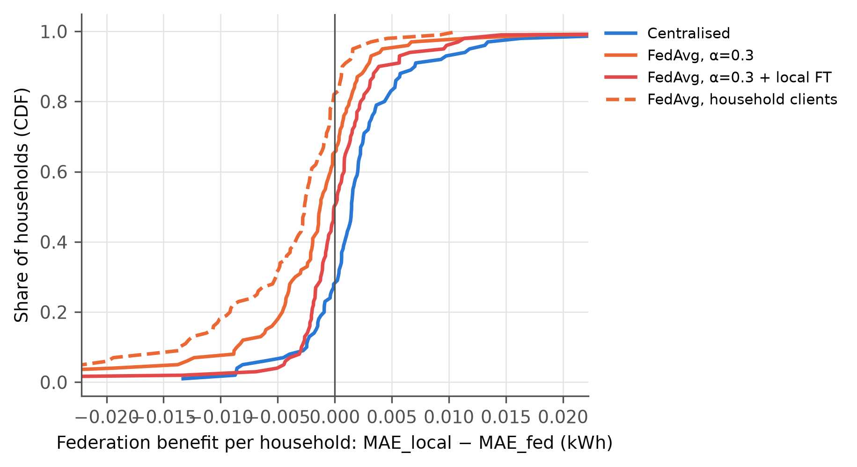
Figure S2. Distribution over households of the benefit of each collaborative arm over local training (${MAE}_{local}−{MAE}_{arm}$, kWh; left of zero means worse off).
Table S9. Equity relative to local-only training (seed-averaged household MAE): share harmed (any difference), median benefit, 90th-percentile household MAE and share harmed after fine-tuning (FT).
Arm | Harmed vs local (%) | Median benefit (kWh) | P90 MAE | Harmed after FT (%)
Centralised | 28 | +0.0015 | 0.1362 | –
FedAvg, random | 61 | −0.0008 | 0.1436 | 50
FedAvg, α=0.3 | 65 | −0.0012 | 0.1442 | 50
FedAvg, cluster | 63 | −0.0008 | 0.1431 | 48
HA-FedProx, α=0.3 | 67 | −0.0013 | 0.1454 | 55
FedAvg, K=100 | 82 | −0.0026 | 0.1494 | 59
HA-FedProx, K=100 | 84 | −0.0030 | 0.1515 | 65

S8. Calendar inputs and scaled error
Sine and cosine encodings of time of day and day of week were added as input channels to every arm in Table S10, with all other settings unchanged.
Table S10. Effect of calendar inputs, and MASE (scaled per household by the in-sample one-step naive MAE). Gain: MAE reduction relative to persistence; cal.: with calendar inputs. Gap: MAE relative to centralised training with the same inputs.
Arm | MAE | MASE | Gain (%) | MAE, cal. | MASE, cal. | Gain, cal. (%) | Gap, cal. (%)
Centralised | 0.0812 | 0.989 | +8.7 | 0.0815 | 0.996 | +8.4 | –
Local-only | 0.0839 | 1.006 | +5.7 | 0.0838 | 1.007 | +5.8 | –
FedAvg, K=20 | 0.0854 | 1.045 | +4.0 | 0.0863 | 1.057 | +3.1 | +5.8
FedAvg, K=100 | 0.0893 | 1.109 | −0.3 | 0.0919 | 1.158 | −3.3 | +12.8

