Supplementary material
Pushkal Gupta^{1,*}, Vanka Kaushik¹, Kalaavathi B¹
¹ School of Computer Science and Engineering, Vellore Institute of Technology, Vellore 632014, Tamil Nadu, India
* Corresponding author: pushkal.gupta2023@vitstudent.ac.in

S1. Paired household-level tests
Table S1 lists every paired comparison. Each household's test MAE was averaged over the seeds of an arm before testing, so each test has one pair per household (100 pairs). The Holm correction was applied over all rows of the table together. Median $Δ$MAE is the median over households of the difference A minus B; negative values favour A.
Table S1. Wilcoxon signed-rank tests over households (seed-averaged MAE). A better: share of households with lower MAE under A.
A | B | median ΔMAE (A−B) | A better (%) | p | p_{Holm}
FedAvg, α=0.3 | Local-only | +0.0012 | 34 | 0.0005 | 0.0047
FedAvg, α=0.3 | Centralised | +0.0025 | 0 | <10⁻⁴ | <10⁻⁴
FedAvg, random | Centralised | +0.0021 | 0 | <10⁻⁴ | <10⁻⁴
FedProx, α=0.3 | FedAvg, α=0.3 | −0.0001 | 69 | 0.0007 | 0.0061
FedProx, cluster | FedAvg, cluster | +0.0001 | 31 | 0.0004 | 0.0047
FedProx, α=0.3, partial | FedAvg, α=0.3, partial | +0.0003 | 19 | <10⁻⁴ | <10⁻⁴
HA-FedProx, α=0.3 | FedAvg, α=0.3 | +0.0001 | 42 | 0.0674 | 0.2021
HA-FedProx, α=0.3 | FedProx, α=0.3 | +0.0001 | 43 | 0.0031 | 0.0217
HA-FedProx, cluster | FedAvg, cluster | +0.0003 | 25 | <10⁻⁴ | <10⁻⁴
HA-FedProx, cluster | FedProx, cluster | +0.0001 | 39 | 0.0012 | 0.0093
HA-FedProx, α=0.3, partial | FedAvg, α=0.3, partial | +0.0004 | 22 | <10⁻⁴ | <10⁻⁴
HA-FedProx, α=0.3, partial | FedProx, α=0.3, partial | +0.0002 | 35 | 0.0469 | 0.1875
FedAvg, cluster | FedAvg, random | +0.0001 | 44 | 0.0106 | 0.0638
FedAvg, K=100 | Local-only | +0.0027 | 18 | <10⁻⁴ | <10⁻⁴
FedAvg, K=100 | Centralised | +0.0045 | 0 | <10⁻⁴ | <10⁻⁴
HA-FedProx, K=100 | FedAvg, K=100 | +0.0003 | 22 | <10⁻⁴ | <10⁻⁴
FedAvg, α=0.3, fp16 | FedAvg, α=0.3 | −0.0001 | 92 | <10⁻⁴ | <10⁻⁴
Centralised | Local-only | −0.0016 | 72 | <10⁻⁴ | <10⁻⁴
FedAvg, K=1, random | Centralised | −0.0000 | 52 | 0.1046 | 0.2092
FedAvg, random | FedAvg, K=1, random | +0.0023 | 1 | <10⁻⁴ | <10⁻⁴
FedAvg, α=0.3 + local FT | Local-only | −0.0001 | 51 | 0.4960 | 0.4960
FedAvg, α=0.3 + local FT | Centralised | +0.0013 | 26 | <10⁻⁴ | <10⁻⁴
FedAvg, K=100 + local FT | Local-only | +0.0006 | 39 | 0.0142 | 0.0711

S2. Training budget and round selection
Table S2 gives, for each number of clients, the local Adam steps per client and round, the round chosen on validation error and the test MAE, for the 30-round budget of the main text and for runs of up to 100 rounds that stopped after 25 rounds without a new best validation MAE. Fig. S1 shows the validation curves.
Table S2. Budget per number of clients $K$ (FedAvg, random grouping). Steps/round: Adam steps per client per round. Best rd.: round selected on validation MAE (mean over seeds). Gap: test MAE relative to centralised.
K | Steps/round | Best rd. (30) | MAE (30) | Gap (%) | Best / run (100) | MAE (100) | Gap (%)
1 | 4,534 | 16.3 | 0.0808 | −0.3 | – | – | –
5 | 907 | 23.0 | 0.0827 | +2.0 | – | – | –
20 | 227 | 22.0 | 0.0854 | +5.3 | 96 / 100 | 0.0832 | +2.7
50 | 91 | 26.7 | 0.0869 | +7.2 | 56 / 76 | 0.0858 | +5.9
100 | 46 | 29.0 | 0.0894 | +10.3 | 95 / 100 | 0.0871 | +7.4

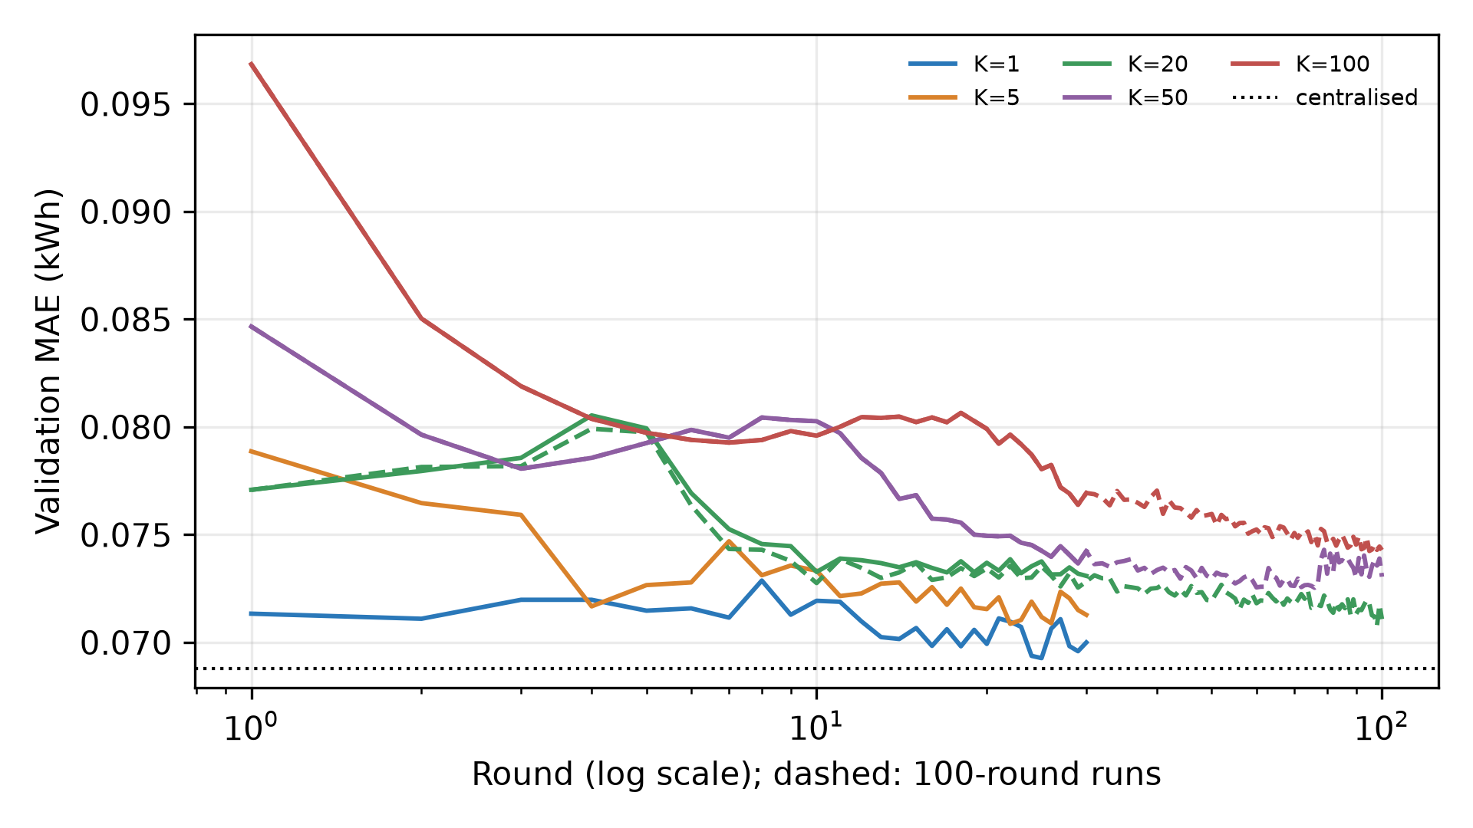
Figure S1. Validation MAE per round for each number of clients (mean over seeds). Solid: 30-round runs; dashed: runs of up to 100 rounds. Dotted: centralised.

S3. Heterogeneity-adaptive proximal coefficient
The original submission proposed a rule that sets the proximal coefficient from the disagreement between client updates. After round $r$ the server holds the updates $Δ_{k}=w_{k}−w_{r}$ and their weighted mean $\overline{Δ}$, and computes
$ρ_{r}=\frac{\sum_{k}{p_{k}}‖Δ_{k}−\overline{Δ}‖^{2}}{\sum_{k}{p_{k}}‖Δ_{k}‖^{2}}∈[0,1],μ_{r+1}=clip\left(μ_{0}ρ_{r} , {10}^{−4} , 1\right)$ (S1)
The rule never improved on FedAvg. Under the cluster partition it was worse for 75 % of households ($p_{Holm}$ $<{10}^{−4}$). Its signal $ρ_{r}$ ranked partitions by heterogeneity (Spearman +0.51 with $H_{JS}$, $p$ = 0.0044, $n=30$ runs), but on average it rose from 0.15 in round 1 to 0.96 in the last round, a change about 46 times its spread across partitions. As the shared descent direction shrinks during training, any residual disagreement pushes $ρ_{r}$ towards one, so a coefficient proportional to it grows late in training whatever the data. Table S3 gives all three aggregation rules for each grouping.
Table S3. All aggregation rules for each grouping at $K=20$ (three seeds). $H$: composite index of the original submission; $\overline{ρ}$: mean update disagreement.
Partition | Method | H | H_{JS} | ρ̄ | Test MAE | Gap to central (%)
α=0.1 | FedAvg | 0.241 | 0.0189 | 0.874 | 0.0856 ± 0.0004 | +5.6
α=0.1 | FedProx | 0.242 | 0.0181 | 0.863 | 0.0856 ± 0.0006 | +5.6
α=0.1 | HA-FedProx | 0.242 | 0.0181 | 0.844 | 0.0859 ± 0.0003 | +5.9
α=0.3 | FedProx | 0.243 | 0.0153 | 0.861 | 0.0858 ± 0.0001 | +5.9
α=0.3 | HA-FedProx | 0.243 | 0.0153 | 0.844 | 0.0863 ± 0.0003 | +6.5
α=0.3 | FedAvg | 0.246 | 0.0152 | 0.871 | 0.0860 ± 0.0003 | +6.0
random | FedAvg | 0.253 | 0.0106 | 0.858 | 0.0854 ± 0.0008 | +5.3
random | FedProx | 0.255 | 0.0105 | 0.845 | 0.0855 ± 0.0003 | +5.4
random | HA-FedProx | 0.255 | 0.0105 | 0.822 | 0.0859 ± 0.0009 | +6.0
α=1.0 | FedAvg | 0.262 | 0.0125 | 0.868 | 0.0851 ± 0.0007 | +5.0
α=1.0 | FedProx | 0.270 | 0.0124 | 0.856 | 0.0857 ± 0.0001 | +5.7
α=1.0 | HA-FedProx | 0.270 | 0.0124 | 0.841 | 0.0857 ± 0.0008 | +5.8
cluster | FedProx | 0.381 | 0.0202 | 0.866 | 0.0858 ± 0.0002 | +5.8
cluster | HA-FedProx | 0.381 | 0.0202 | 0.851 | 0.0865 ± 0.0002 | +6.7
cluster | FedAvg | 0.381 | 0.0202 | 0.876 | 0.0857 ± 0.0003 | +5.7

S4. Proximal coefficient grid
Table S4 gives the best validation MAE for each coefficient (cluster partition, seed 42). The row $μ=0$ is plain FedAvg.
Table S4. Best-round validation MAE (kWh) over the proximal coefficient grid.
μ (FedProx) or μ₀ (adaptive) | FedProx | Adaptive (HA-FedProx)
0 | 0.07238 | 0.07238
0.0001 | 0.07260 | 0.07260
0.001 | 0.07259 | 0.07268
0.01 | 0.07320 | 0.07332
0.1 | 0.07666 | 0.07682
1 | – | 0.07803

S5. Additional cohorts
Two further cohorts of 100 homes were drawn with the same eligibility rules and stratification but different selection seeds (43 and 44); they share three or four homes with the main cohort. Each arm ran with two seeds.
Table S5. Test MAE (kWh) of the main arms on three cohorts, and the FedAvg gap to centralised training at $K=1$, 5, 20 and 100.
Cohort | Centralised | Local-only | FedAvg, K=1 | FedAvg, K=5 | FedAvg, K=20 | FedAvg, K=100 | FedAvg gap, K=1/5/20/100 (%)
main (seed 42) | 0.0812 | 0.0838 | 0.0806 | 0.0828 | 0.0855 | 0.0898 | −0.7, +2.0, +5.4, +10.7
cohort 43 | 0.0847 | 0.0878 | 0.0832 | 0.0853 | 0.0895 | 0.0909 | −1.7, +0.8, +5.7, +7.4
cohort 44 | 0.0876 | 0.0866 | 0.0856 | 0.0866 | 0.0884 | 0.0910 | −2.3, −1.2, +0.9, +3.8

S6. Error by consumption quintile
Households were divided into quintiles of mean training load (Q1 lowest). Table S6 gives the median household test MAE in each quintile, Fig. S2 the distribution of the benefit of each arm over local training, and Table S7 summary statistics of that benefit.
Table S6. Median household test MAE (kWh) by consumption quintile. FedAvg at $K=20$ unless stated.
Quintile | Local-only | Centralised | FedAvg, α=0.3 | FedAvg, α=0.3 + FT | FedAvg, K=100
Q1 | 0.0279 | 0.0281 | 0.0299 | 0.0297 | 0.0304
Q2 | 0.0467 | 0.0470 | 0.0494 | 0.0481 | 0.0514
Q3 | 0.0755 | 0.0742 | 0.0760 | 0.0782 | 0.0790
Q4 | 0.1053 | 0.1031 | 0.1099 | 0.1073 | 0.1117
Q5 | 0.1393 | 0.1317 | 0.1408 | 0.1393 | 0.1487

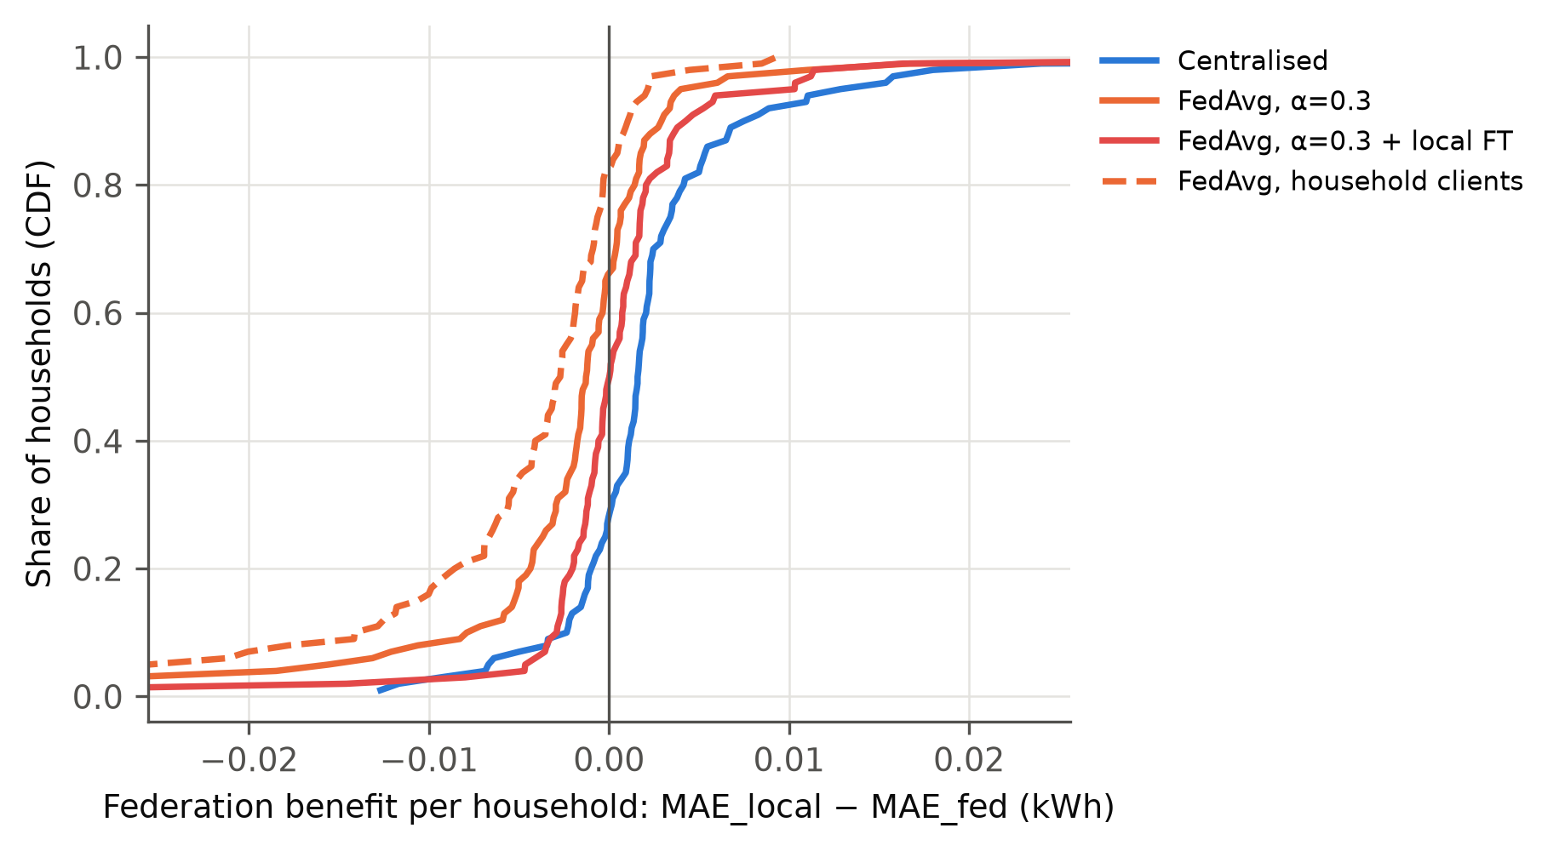
Figure S2. Distribution over households of the benefit of each collaborative arm over local training (${MAE}_{local}−{MAE}_{arm}$, kWh; left of zero means worse off).
Table S7. Equity relative to local-only training (seed-averaged household MAE): share harmed (any difference), median benefit, 90th-percentile household MAE and share harmed after fine-tuning (FT).
Arm | Harmed vs local (%) | Median benefit (kWh) | P90 MAE | Harmed after FT (%)
Centralised | 28 | +0.0016 | 0.1364 | –
FedAvg, random | 56 | −0.0007 | 0.1436 | 51
FedAvg, α=0.3 | 66 | −0.0012 | 0.1442 | 49
FedAvg, cluster | 60 | −0.0008 | 0.1431 | 46
HA-FedProx, α=0.3 | 66 | −0.0013 | 0.1454 | 55
FedAvg, K=100 | 82 | −0.0027 | 0.1514 | 61
HA-FedProx, K=100 | 85 | −0.0028 | 0.1515 | 67

S7. Calendar inputs and scaled error
Sine and cosine encodings of time of day and day of week were added as input channels to every arm in Table S8, with all other settings unchanged.
Table S8. Effect of calendar inputs, and MASE (scaled per household by the in-sample one-step naive MAE). Gain: MAE reduction relative to persistence; cal.: with calendar inputs. Gap: MAE relative to centralised training with the same inputs.
Arm | MAE | MASE | Gain (%) | MAE, cal. | MASE, cal. | Gain, cal. (%) | Gap, cal. (%)
Centralised | 0.0811 | 0.987 | +8.9 | 0.0815 | 0.996 | +8.4 | –
Local-only | 0.0840 | 1.006 | +5.6 | 0.0838 | 1.007 | +5.8 | –
FedAvg, K=20 | 0.0854 | 1.045 | +4.0 | 0.0863 | 1.057 | +3.1 | +5.8
FedAvg, K=100 | 0.0894 | 1.111 | −0.5 | 0.0919 | 1.158 | −3.3 | +12.8

