1,2,3)// AVL tree implementation in C++

#include <iostream>
using namespace std;

class Node {
public:
int key;
Node *left;
Node *right;
int height;

Node(int v)
{
key = v;
left = NULL;
right = NULL;
height = 1;
}
};

int max(int a, int b)
{
return (a > b) ? a : b;
}

int height(Node *N)
{
if (N == NULL)
return 0;
return N->height;
}

// Rotate right
Node *rightRotate(Node *y) {
Node *x = y->left;
Node *T2 = x->right;
x->right = y;
y->left = T2;
y->height = max(height(y->left),height(y->right)) + 1;
x->height = max(height(x->left),height(x->right)) + 1;
return x;
}

// Rotate left
Node *leftRotate(Node *x) {
Node *y = x->right;
Node *T2 = y->left;
y->left = x;
x->right = T2;
x->height = max(height(x->left), height(x->right)) + 1;
y->height = max(height(y->left), height(y->right)) + 1;
return y;
}

// Get the balance factor of each node
int getBalanceFactor(Node *N) {
if (N == NULL)
return 0;
return height(N->left) - height(N->right);
}

// Insert a node
Node *insertNode(Node *node, int key) {
// Find the correct position and insert the node
if (node == NULL)
return (new Node(key));
if (key < node->key)
node->left = insertNode(node->left, key);
else if (key > node->key)
node->right = insertNode(node->right, key);
else
return node;

// Update the balance factor of each node and balance the tree
node->height = 1 + max(height(node->left), height(node->right));

int balanceFactor = getBalanceFactor(node);

if (balanceFactor > 1) {
if (key < node->left->key) { // ll -> right rotation
return rightRotate(node);
} else if (key > node->left->key) { // lr rotation
node->left = leftRotate(node->left);
return rightRotate(node);
}
}

if (balanceFactor < -1) {
if (key > node->right->key) { // rr -> Left rotation
return leftRotate(node);
} else if (key < node->right->key) { // rl rotation
node->right = rightRotate(node->right);
return leftRotate(node);
}
}
return node;
}

// Node with minimum value
Node *nodeWithMimumValue(Node *node) {
Node *current = node;
while (current->left != NULL)
current = current->left;
return current;
}

// Delete a node
Node *deleteNode(Node *root, int key) {
// Find the node and delete it
if (root == NULL)
return root;
if (key < root->key)
root->left = deleteNode(root->left, key);
else if (key > root->key)
root->right = deleteNode(root->right, key);
else {
if ((root->left == NULL) ||
(root->right == NULL)) {
Node *temp = root->left ? root->left : root->right;
if (temp == NULL) {
temp = root;
root = NULL;
} else
*root = *temp;
free(temp);
} else {
Node *temp = nodeWithMimumValue(root->right);
root->key = temp->key;
root->right = deleteNode(root->right,temp->key);
}
}

if (root == NULL)
return root;

root->height = 1 + max(height(root->left),height(root->right));
int balanceFactor = getBalanceFactor(root);
if (balanceFactor > 1) {
if (getBalanceFactor(root->left) >= 0) {
return rightRotate(root);
} else {
root->left = leftRotate(root->left);
return rightRotate(root);
}
}
if (balanceFactor < -1) {
if (getBalanceFactor(root->right) <= 0) {
return leftRotate(root);
} else {
root->right = rightRotate(root->right);
return leftRotate(root);
}
}
return root;
}

void printInOrder(Node *root) {
if (root != NULL) {
printInOrder(root->left);
printf("%d ", root->key);
printInOrder(root->right);
}
}

int main() {
Node *root = NULL;
root = insertNode(root, 10);
root = insertNode(root, 20);
root = insertNode(root, 15);
root = insertNode(root, 87);
root = insertNode(root, 35);
root = insertNode(root, 40);
root = insertNode(root, 68);
root = insertNode(root, 90);
printInOrder(root);
}

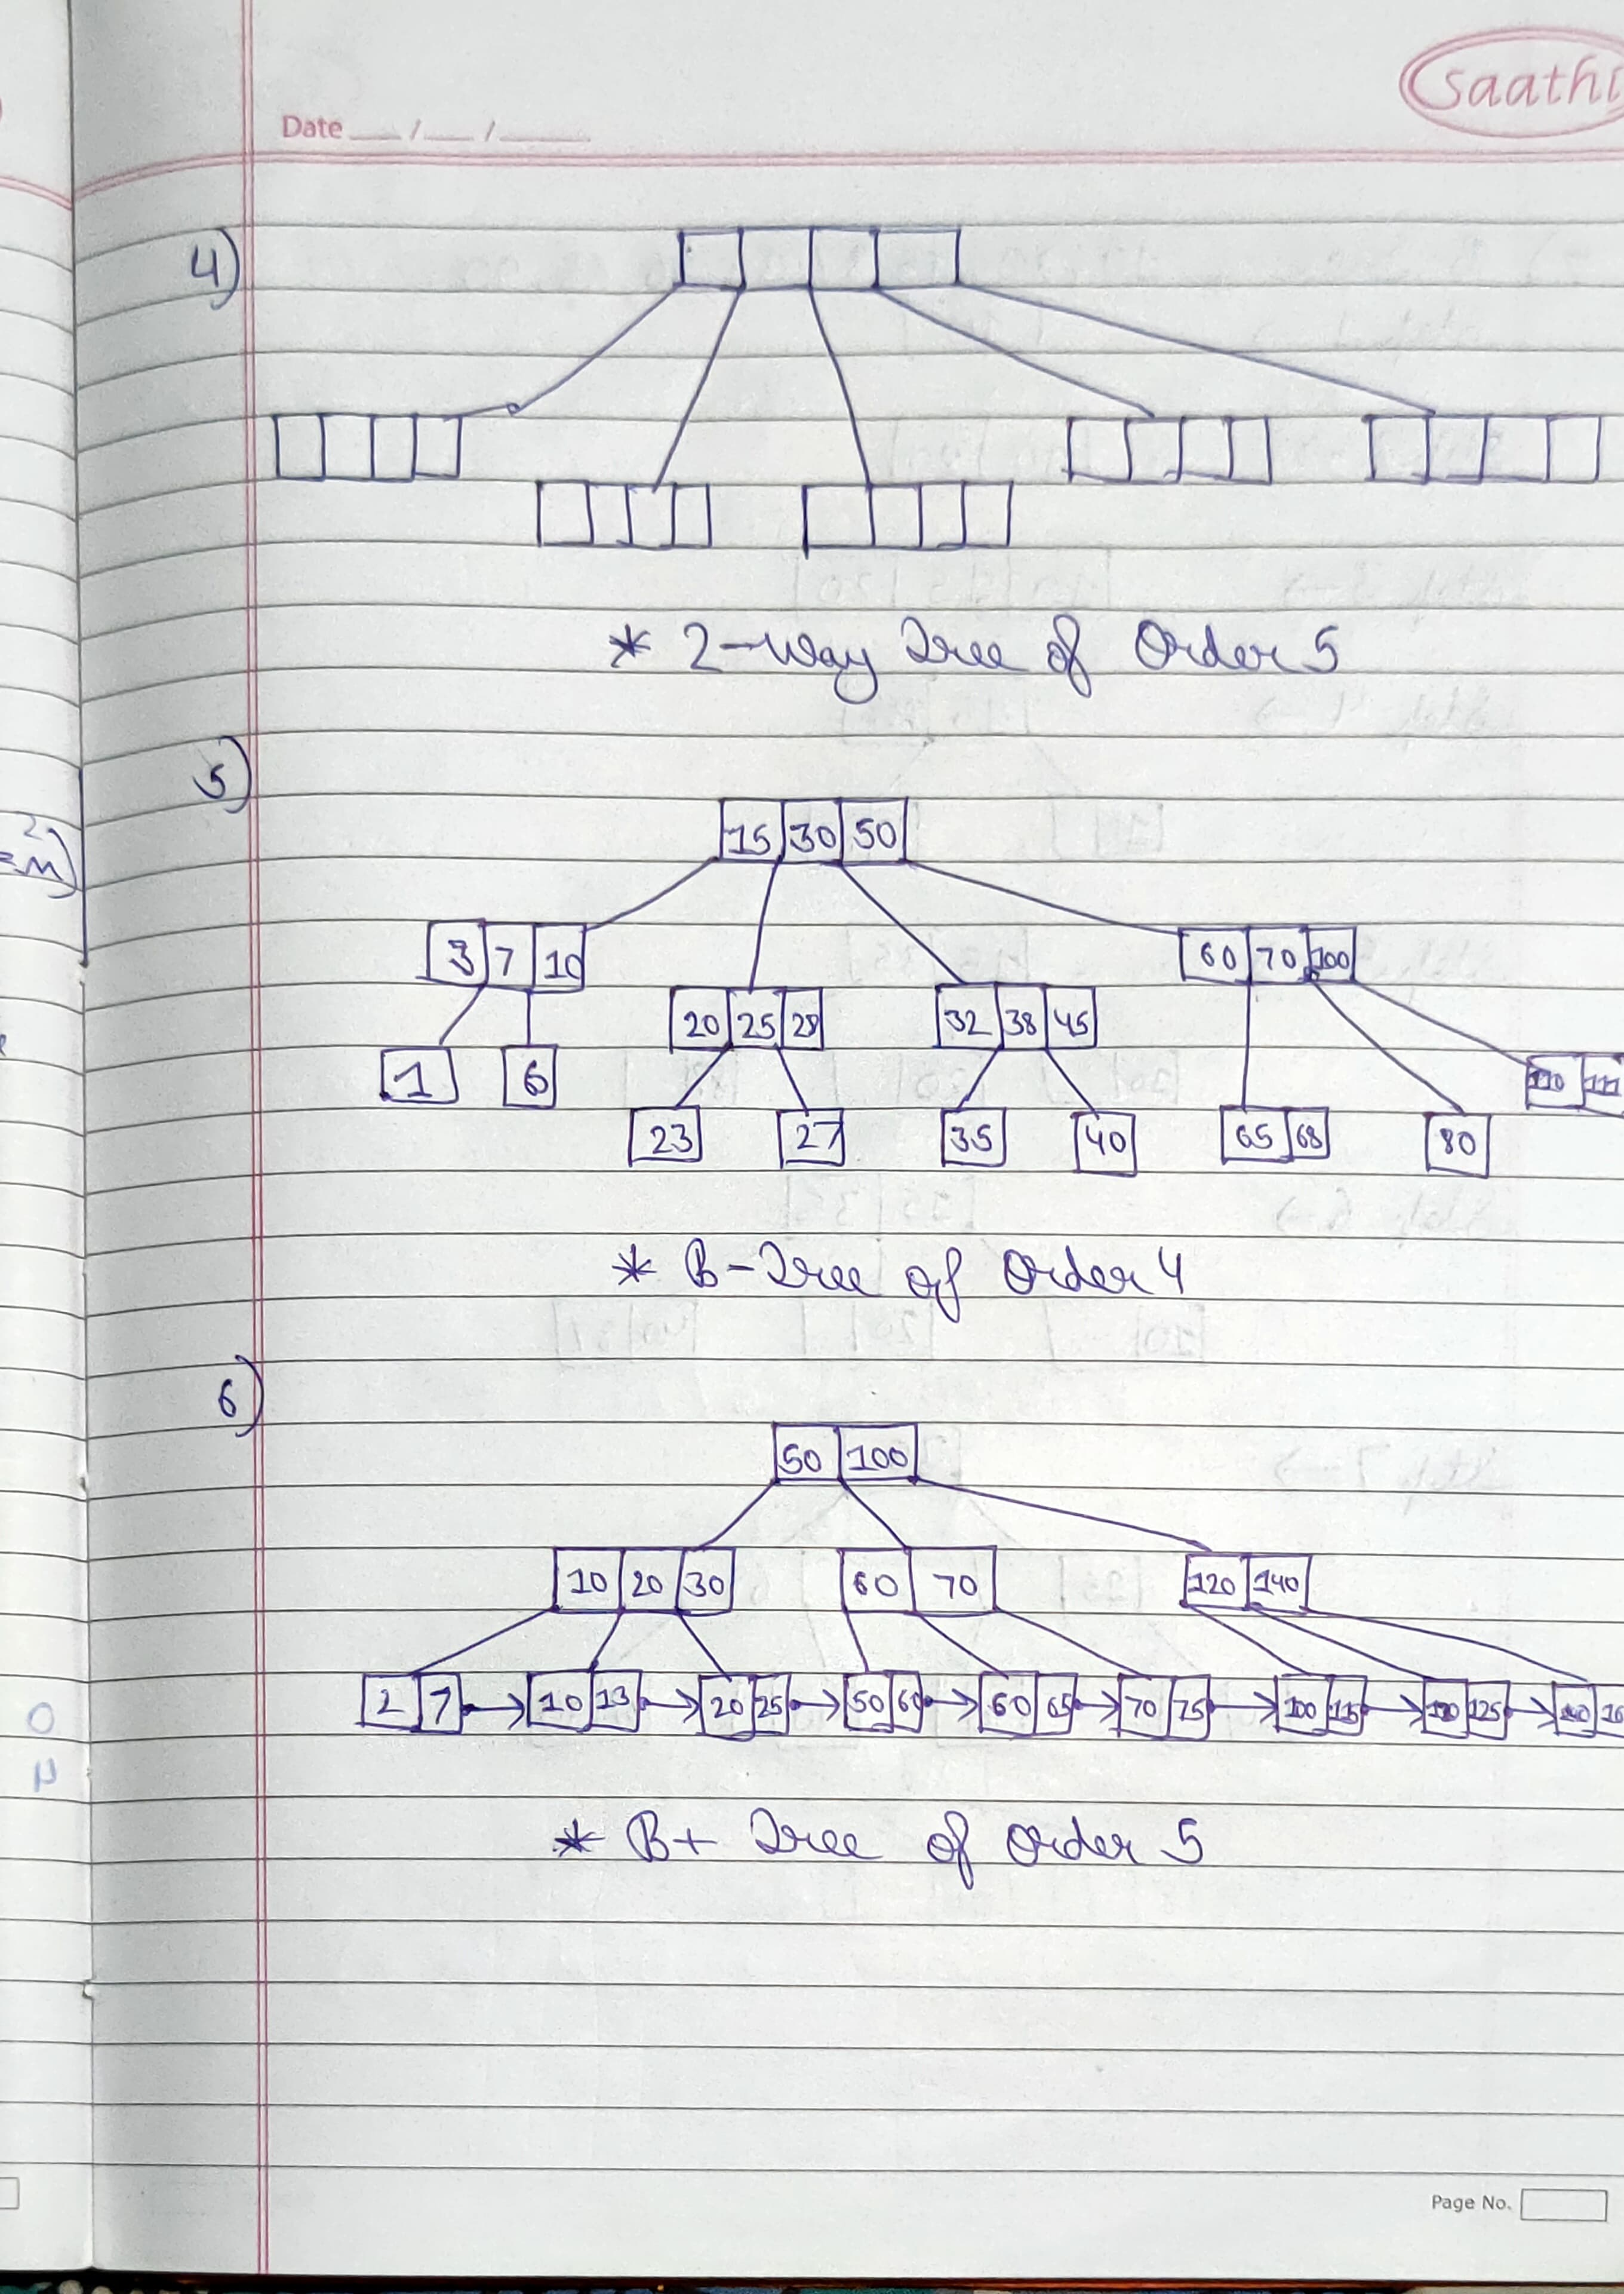
4,5,6)
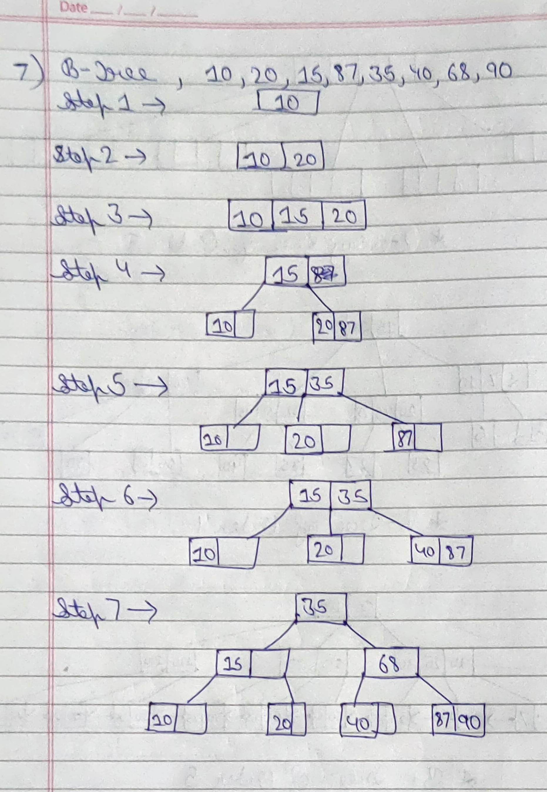
7)
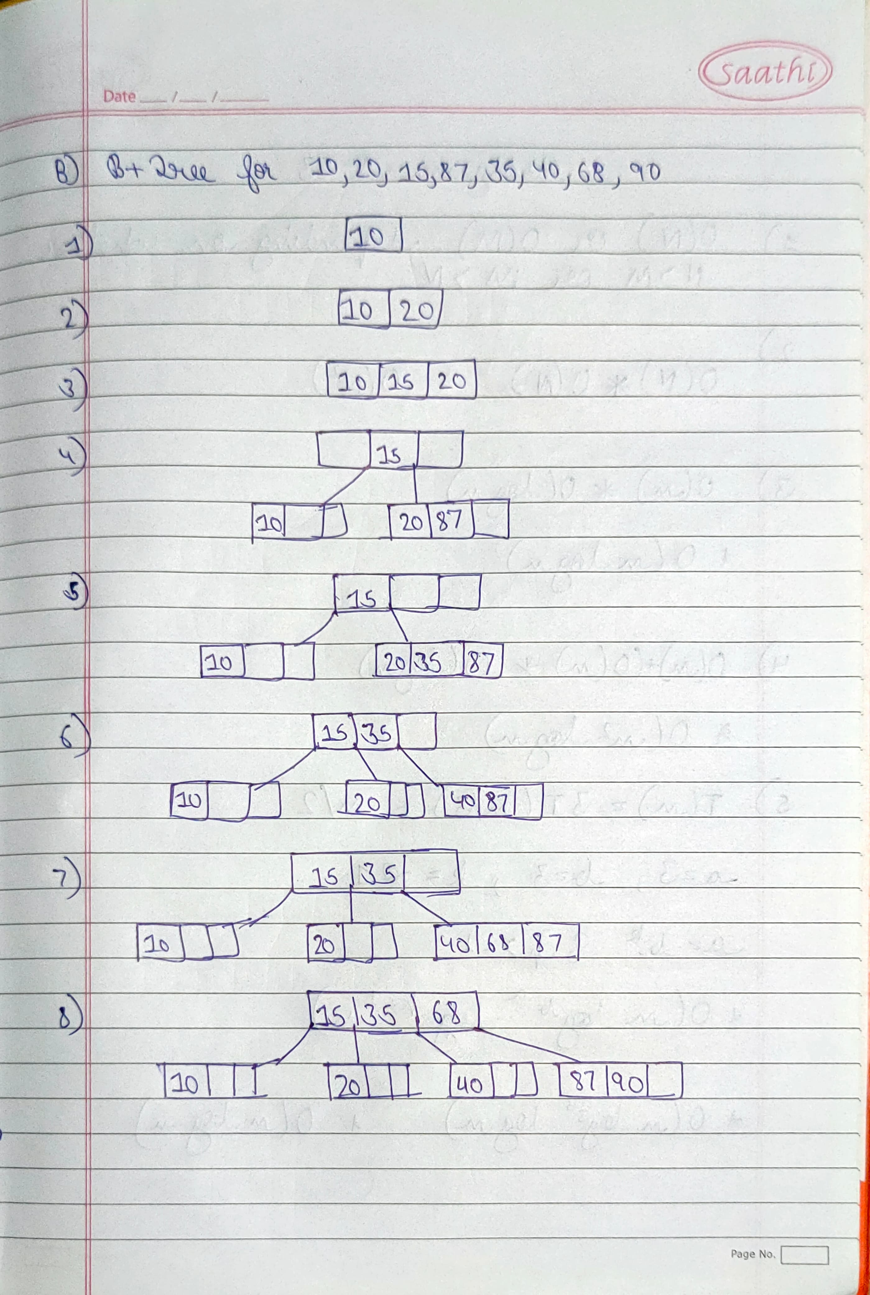
8)

