SECURITY CONTROL VALIDATION / EVIDENCE REPORT
AWS S3 Control Automation
Live detection, safe remediation and verified teardown
A controlled AWS lab demonstration using AWS Config, a custom Lambda rule, and AWS Systems Manager Automation. All evidence was collected on November 11, 2026 in us-east-1.
13  LOCAL TESTS PASSED | 5  AWS CONSOLE CAPTURES | 19  TERRAFORM RESOURCES REMOVED | 0  S3 BUCKETS REMAINING
VALIDATED WORKFLOW
RECORD | DETECT | DRY RUN | REMEDIATE | VERIFY
KEY FINDINGS
Detection | The custom AWS Config rule marked the disposable test bucket NON_COMPLIANT when RestrictPublicBuckets was false.
Dry run | The SSM Automation execution succeeded and returned WOULD_REMEDIATE; the bucket remained unchanged.
Actual remediation | After a human-approved test, the runbook returned REMEDIATED. A separate S3 check confirmed all four settings were true.
Independent verification | AWS Config subsequently displayed the same test bucket as COMPLIANT.
Teardown | SSM (3), Config rules/Lambda (6) and recorder module (10) were destroyed; final AWS CLI checks showed no Config recorders, delivery channels or S3 buckets.
SCOPE & EVIDENCE INTEGRITY
Single-bucket lab validation, not a production audit. Live remediation followed manual approval; no enforced approval workflow was tested. The AWS Console images preserve actual results while masking account identifiers. Companion CLI outputs support the dry-run, remediation and teardown findings.
EVIDENCE 01 / 05
S3-only configuration recording
AWS Config > Settings | Customer-managed recorder
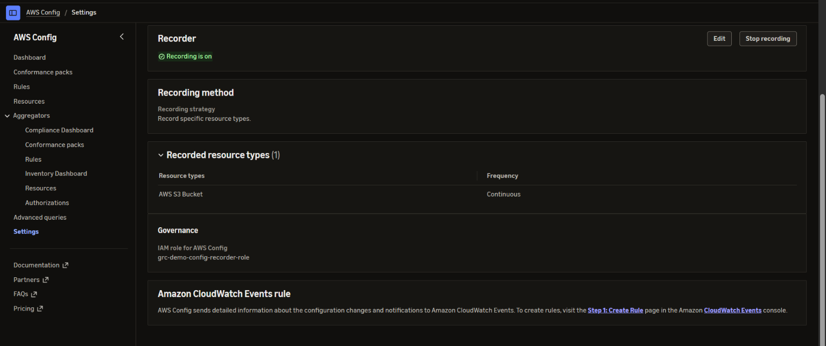
OBSERVED | Recording was ON, with continuous recording limited to AWS S3 Bucket resources.
WHY IT MATTERS | Shows that compliance checks were supported by a running, narrowly scoped configuration recorder.

Evidence note: The screenshot verifies the recorder state at capture time; it does not establish ongoing operation after teardown.
EVIDENCE 02 / 05
Managed and custom rules deployed
AWS Config > Rules | AWS-managed S3 check and custom Lambda rule
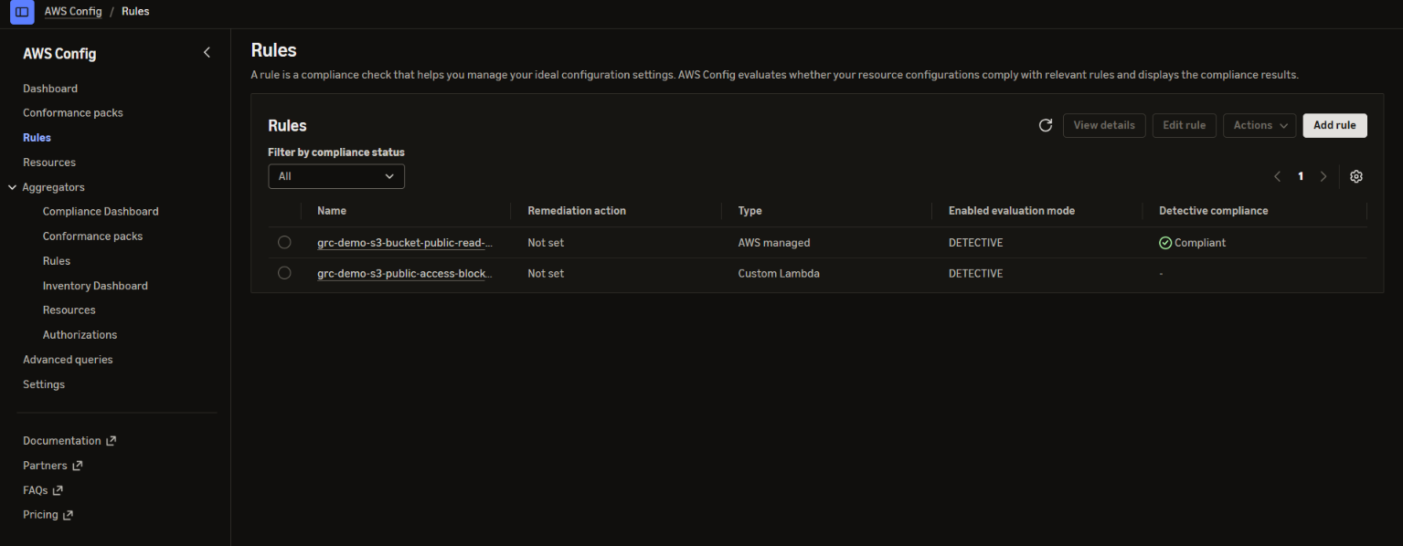
OBSERVED | Both rules appear in detective mode. At this point the managed rule showed Compliant; the custom rule had no displayed evaluation result.
WHY IT MATTERS | Demonstrates that the managed AWS Config check and project-specific Lambda evaluator were installed without implying that both had already evaluated the test bucket.

Evidence note: Actual custom-rule detection is documented separately in Evidence 03.
EVIDENCE 03 / 05
Misconfiguration detected
AWS Config > Custom rule details | Deliberately non-compliant disposable bucket
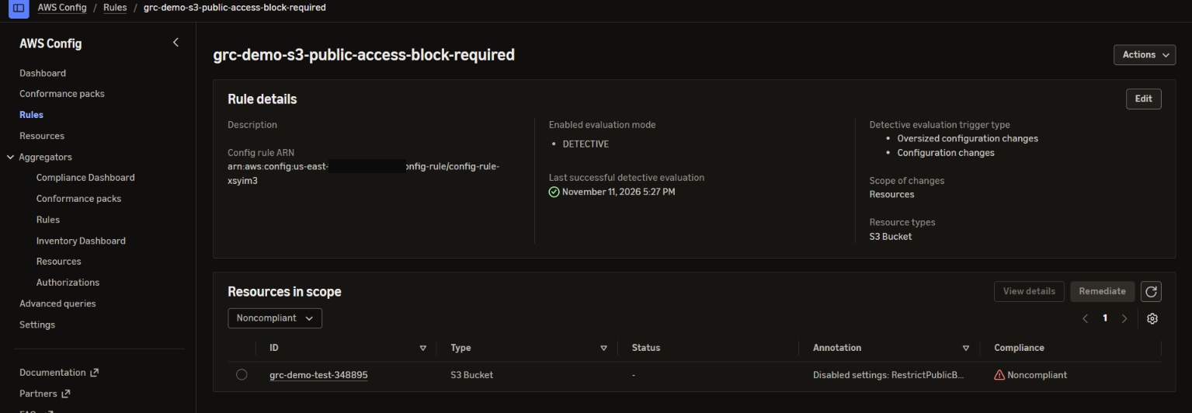
OBSERVED | The test bucket was listed as Noncompliant, with an annotation naming disabled RestrictPublicBuckets. The other three public-access-block settings remained true.
WHY IT MATTERS | Demonstrates real detection of a targeted configuration drift without publishing objects or deliberately granting public read access.

Evidence note: This proves the custom rule evaluated one lab condition; it is not evidence of complete S3 posture coverage.
EVIDENCE 04 / 05
SSM dry run executed successfully
AWS Systems Manager > Automation | Successful runbook execution
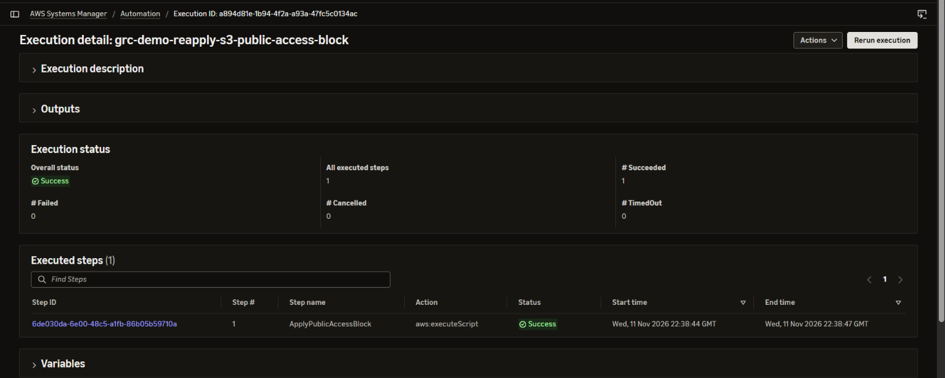
OBSERVED | The Console recorded one successful aws:executeScript step. The companion CLI result reported DryRun=true and WOULD_REMEDIATE; S3 verification showed RestrictPublicBuckets remained false.
WHY IT MATTERS | Shows a non-destructive verification checkpoint before an approved write action.

Evidence note: The Console screenshot alone shows success; the dry-run parameter and outcome were verified in the companion CLI output, not visibly in this capture.
EVIDENCE 05 / 05
Compliance restored after remediation
AWS Config > Custom rule details | The same disposable bucket after remediation
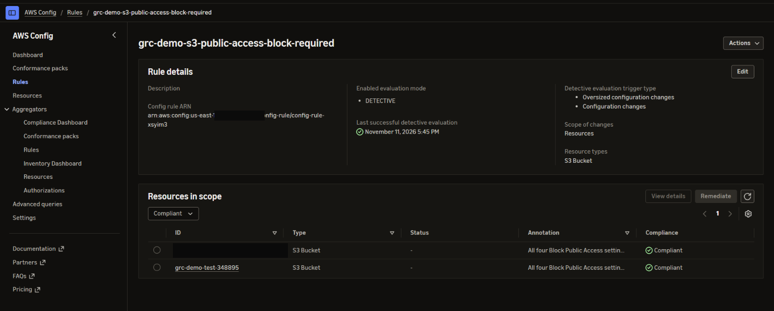
OBSERVED | SSM reported REMEDIATED. A read-back returned true for all four Block Public Access settings, and AWS Config then listed the test bucket as Compliant.
WHY IT MATTERS | Confirms a closed-loop result: a previously detected gap was corrected, then re-evaluated by the same custom Config rule.

Evidence note: The evidence bucket row and account-specific ARN text were redacted; the test bucket and compliance result are preserved.

