Project: Gender and Age detection

- Image Segmentation

- Image processing
- Feature extraction
- Classification

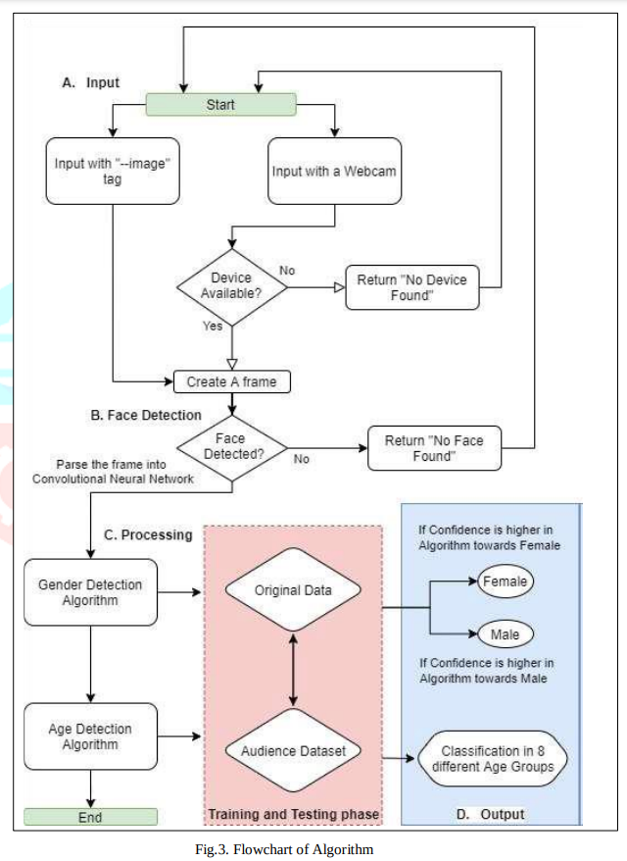
Use Cases
- Identify target audience in marketing organization
- Ensure Applicant’s validity in recruitment process
- Verification of the identity of those applying for government identification cards. •
- In the medical sector, a forensic department collects information about deceased people. •
- In the banking industry, age and gender detection can be used to extract information about an individual from photos. •
- The Criminal Investigation Department will compile information on the suspects based on their age and gender.

