Bank Loan Approval Prediction
Week 4 Major Project — Option 2
Machine Learning & AI | Full ML Pipeline + Documentation + Presentation

1. Project Objective
The objective is to build a practical classification model that predicts whether a bank loan application will be approved or rejected. The supplied Loan Prediction Dataset is used as the basis of the project.

2. Dataset
The dataset contains 614 applications and 13 columns. The prediction target is Loan_Status, where Y represents approval and N represents rejection.
Column | Role
Loan_ID | Identifier
Gender | Feature
Married | Feature
Dependents | Feature
Education | Feature
Self_Employed | Feature
ApplicantIncome | Feature
CoapplicantIncome | Feature
LoanAmount | Feature
Loan_Amount_Term | Feature
Credit_History | Feature
Property_Area | Feature
Loan_Status | Target

3. Data Cleaning and Preprocessing
Missing numerical values are replaced using the median. Missing categorical values are replaced using the most frequent category. Categorical features are one-hot encoded. Loan_ID is excluded because it is an identifier. The preprocessing steps are placed inside a scikit-learn pipeline to avoid applying test-set information during training.

4. Model
A Random Forest Classifier is used, matching the Week 4 Option 2 workflow. The model uses 300 trees, random_state=42, and balanced class weights.

5. Train/Test Split
The data is split into 80% training (491 rows) and 20% testing (123 rows). A stratified split preserves the target-class proportions.

6. Evaluation Results
Accuracy | 0.8130
Precision | 0.8370
Recall | 0.9059
Confusion matrix: [[23, 15], [8, 77]]
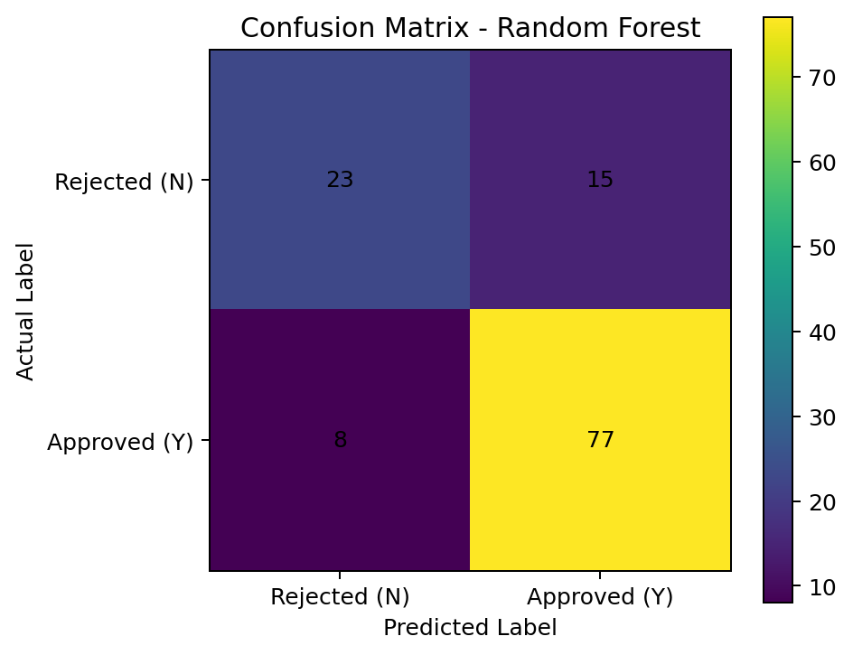

7. Data Distribution
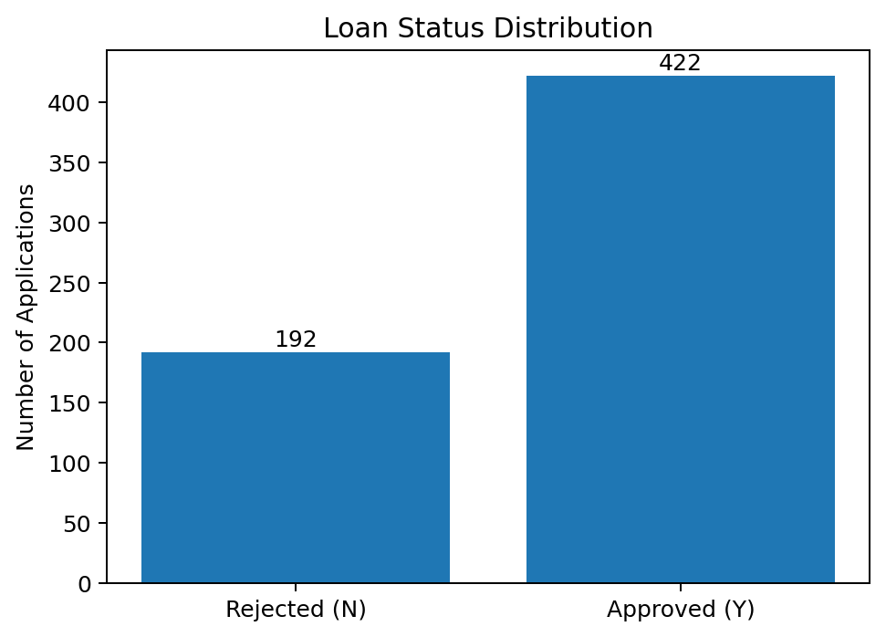

8. Feature Importance
The chart below shows the ten features with the highest Random Forest importance in this fitted model. Feature importance is model-specific and should not be interpreted as proof of causation.
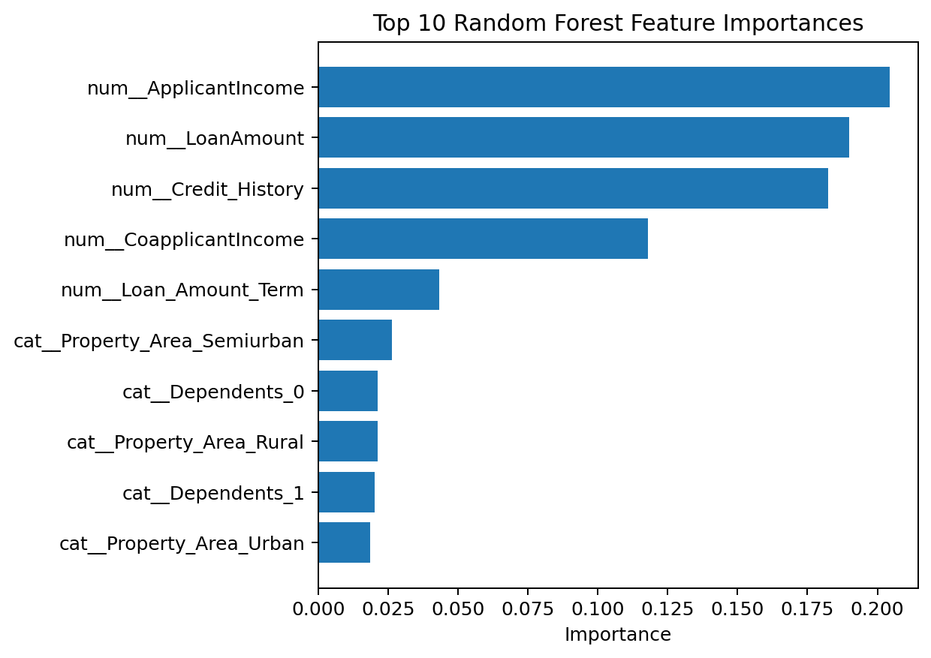

9. Conclusion
The project demonstrates a complete bank-loan classification workflow: data preparation, categorical encoding, model training, evaluation with a confusion matrix, and prediction. The supplied dataset can be processed reproducibly using the included Python script.

10. Submission Contents
- loan_prediction_dataset.csv
- bank_loan_approval.py
- bank_loan_approval_report.docx
- bank_loan_approval_presentation.pptx
- confusion_matrix.png
- loan_status_distribution.png
- feature_importance.png
- sample_predictions.csv
- results.txt
- requirements.txt
- README.md

