DAYANANDA SAGAR UNIVERSITY
Devarakaggalahalli, Harohalli
Kanakapura Road, Ramanagara - 562112, Karnataka, India
SCHOOL OF ENGINEERING
Bachelor of Technology
in
COMPUTER SCIENCE AND ENGINEERING
Full Stack Development
Mini Project Report
PHYSIO AI: AI-POWERED PHYSIOTHERAPY AND POSTURE CORRECTION PLATFORM
By
ABHINAV MEHTA- 30
DEEPAK KUMAR - 53
PUSHKAR RAJ JAISWAL- 52
AMRITAANSHU SATVIK- 50
Under the supervision of
Mr. RITIK VIJAYKUMAR CHHATWANI
Assistant Professor
DEPARTMENT OF COMPUTER SCIENCE & ENGINEERING, SCHOOL OF ENGINEERING,
DAYANANDA SAGAR UNIVERSITY
(2024-2025)

DAYANANDA SAGAR UNIVERSITY
Department of Computer Science & Engineering
Devarakaggalahalli, Harohalli
Kanakapura Road, Ramanagara - 562112, Karnataka, India.
CERTIFICATE
This is to certify that the Full Stack Development Mini Project work titled "PHYSIO AI: AI-Powered Physiotherapy and Posture Correction Platform" is carried out by ABHINAV MEHTA (ENG24CS0302), DEEPAK KUMAR (ENG24CS0393), PUSHKAR RAJ JAISWAL (ENG24CS0598), AMRITAANSHU SATVIK (ENG24CS0322), Bonafide students of Fourth semester of Bachelor of Technology in Computer Science and Engineering at the School of Engineering, Dayananda Sagar University, Bangalore in partial fulfillment for the award of degree in Bachelor of Technology in Computer Science and Engineering, during the year 2024-2025.
Mr. Ritik Vijaykumar Chhatwani | Dr. Girisha G S
Assistant Professor Dept. of CS&E, School of Engineering Dayananda Sagar University  Date: | Chairman CSE School of Engineering Dayananda Sagar University  Date:

Name of the Examiner | Signature of Examiner

DECLARATION
We, ABHINAV MEHTA (ENG24CS0302), DEEPAK KUMAR (ENG24CS0393), PUSHKAR RAJ JAISWAL (ENG24CS0598), AMRITAANSHU SATVIK (ENG24CS0322), are students of Fourth semester B.Tech in Computer Science and Engineering, at School of Engineering, Dayananda Sagar University, hereby declare that the Mini Project titled "PHYSIO AI: AI-Powered Physiotherapy and Posture Correction Platform" has been carried out by us and submitted in partial fulfilment for the award of degree in Bachelor of Technology in Computer Science and Engineering during the academic year 2024-2025.

Student | Signature
ABHINAV MEHTA
ENG24CS0302
DEEPAK KUMAR
ENG24CS0393
PUSHKAR RAJ JAISWAL
ENG24CS0598
AMRITAANSHU SATVIK
ENG24CS0322

Place: Bangalore
Date:

ACKNOWLEDGEMENT
It is a great pleasure for us to acknowledge the assistance and support of many individuals who have been responsible for the successful completion of this Full Stack Development Mini Project.

First, we take this opportunity to express our sincere gratitude to the School of Engineering & Technology, Dayananda Sagar University, for providing us with a great opportunity to pursue our Bachelor's degree in this institution.

We would like to thank Dr. Udaya Kumar Reddy K R, Dean, School of Engineering & Technology, Dayananda Sagar University, for his constant encouragement and expert advice.

It is a matter of immense pleasure to express our sincere thanks to Dr. Girisha G S, Department Chairman, Computer Science and Engineering, Dayananda Sagar University, for providing the right academic guidance that made our task possible.

We would like to thank our guide ………………………, Associate/Assistant Professor, Dept. of Computer Science and Engineering, Dayananda Sagar University, for sparing his/her valuable time to extend help in every step of our project work, which paved the way for smooth progress and fruitful culmination of the project.

We are also grateful to our family and friends who provided us with every requirement throughout the course.

We would like to thank one and all who directly or indirectly helped us in the Mini Project work.

TABLE OF CONTENTS
Chapter / Section | Title | Page No.
 | Abstract | vi
1 | Introduction | 1
1.1 | Background | 1
1.2 | Problem Statement | 2
1.3 | Objectives | 2
1.4 | Scope of the Project | 3
2 | Overview of Project | 4
2.1 | Purpose and Goals | 4
2.2 | Technologies Used | 5
3 | Functional Requirements | 7
3.1 | System Architecture | 7
3.2 | Functional Requirements | 8
3.3 | Non-Functional Requirements | 9
4 | Code Snippets | 10
4.1 | Joint Angle Calculator | 10
4.2 | Mistake Detector Module | 12
4.3 | Live AI Feedback Engine | 13
4.4 | REST API Views | 14
5 | Result | 15
 | Conclusion | 20

LIST OF FIGURES
Fig. No. | Description of the Figure | Page No.
3.1 | Overall System Architecture Diagram | 7
3.2 | Database Entity-Relationship Diagram | 8
4.1 | Joint Angle Calculation — Vector Mathematics | 10
4.2 | Posture Mistake Detection and Feedback Flow | 12
5.1 | Home Page — Premium SaaS Landing Interface | 15
5.2 | Live Camera Pose Detection Interface with Real-Time Metrics | 16
5.3 | Real-Time Dashboard with Charts and AI Recommendations | 17
5.4 | Therapy Plans Page | 19
5.5 | Analytics and Progress Reports Page | 19

LIST OF TABLES
Table No. | Description of the Table | Page No.
2.1 | Technologies and Libraries Used | 5
3.1 | Functional Requirements Summary | 8
3.2 | Database Models and Their Purpose | 9
5.1 | API Endpoints Reference | 18

ABSTRACT
Physio AI is a Django-based web application that integrates real-time computer vision and an intelligent feedback engine to assist patients in performing physiotherapy exercises correctly from home. The system uses MediaPipe's pose estimation model to track 33 body landmarks per frame, calculates joint angles using vector mathematics, and compares measured angles against exercise-specific safe ranges to detect posture errors. Detected errors are classified into four severity levels — low, medium, high, and critical — and a context-aware coaching engine prioritizes the most dangerous corrections first, delivering both on-screen messages and text-to-speech voice guidance. The platform provides a real-time exercise dashboard showing live form scores, repetition counters, fatigue indicators, and stability metrics. Session data is persisted in a relational database across six Django applications, enabling analytics features including progress charts, joint-specific weakness analysis, weekly trend reports, and PDF export. A therapy plan module allows clinicians to assign structured multi-week rehabilitation schedules through a Django admin panel. The frontend is built with a modern glassmorphism design system including a 3D animated Spline background, dark-mode support, and responsive layouts. The system demonstrates how full-stack web engineering combined with pose estimation can deliver a practical AI-assisted physiotherapy assistant suitable for remote rehabilitation support.

Chapter 1
Introduction
1.1. Background
Physiotherapy is a healthcare discipline concerned with restoring movement and function to individuals affected by injury, illness, or disability. Patients undergoing physiotherapy typically follow structured exercise programs prescribed by qualified therapists. Traditionally, these exercises are supervised in clinical settings where the physiotherapist can observe the patient's posture and provide immediate corrections. However, the increasing demand for home-based rehabilitation, combined with limited clinic availability and geographic barriers, has created a need for technology-assisted alternatives.

Recent advances in computer vision and machine learning have made real-time human pose estimation feasible on consumer-grade hardware. Libraries such as MediaPipe Pose, developed by Google, are capable of detecting 33 body landmarks at interactive frame rates using only a standard webcam, without specialized sensors or depth cameras. This technology provides a foundation for building automated posture analysis tools that operate in real time directly in a web browser.

However, detecting landmarks alone is insufficient for physiotherapy assistance. A clinically useful system must translate raw landmark coordinates into meaningful joint angles, compare those angles against biomechanically safe ranges for specific exercises, prioritize the most dangerous deviations, communicate corrections to the user in a clear and non-overwhelming manner, and track the patient's progress over time. Building such a complete system requires integrating computer vision, biomechanical knowledge, intelligent feedback logic, session persistence, and a user-friendly interface.

1.2. Problem Statement
When physiotherapy patients exercise at home without supervision, they frequently adopt incorrect postures that reduce exercise effectiveness and increase the risk of injury. They lack immediate access to expert correction and have no structured way to track whether their form is improving over multiple sessions. Existing general fitness applications offer basic pose detection but do not address the specific needs of physiotherapy: exercise-specific angle thresholds, severity-classified error alerts, injury risk monitoring, structured therapy plans, and analytical progress reports for clinical review.

The core problem addressed by this project is: how can a web-based system automatically detect and correct physiotherapy exercise errors in real time, track patient progress, and present clinical-grade insights without requiring constant presence of a physiotherapist?

1.3. Objectives
The primary objectives of the Physio AI project are:
- To implement real-time body pose detection using MediaPipe Pose with 33 landmark tracking directly in the browser.
- To calculate joint angles from detected landmarks using vector mathematics and compare them to exercise-specific safe ranges.
- To detect posture errors, classify them by severity, and deliver prioritized, context-aware coaching messages to the user.
- To provide voice-based feedback using the browser's text-to-speech API for hands-free guidance during exercise.
- To build a live exercise dashboard displaying form score, repetition count, fatigue indicator, and stability score updated in real time.
- To persist session data in a relational database and generate analytics including progress charts, weekly trends, and joint-specific weakness reports.
- To implement a therapy plan management module where clinicians can assign multi-week rehabilitation schedules.
- To design a modern, accessible user interface with dark mode, glassmorphism styling, and full responsiveness.

1.4. Scope of the Project
The project scope includes the following:
- A Django web application with six integrated apps: users, exercises, sessions, ai_engine, analytics, and therapy_plans.
- Client-side pose detection and rendering using MediaPipe and the HTML5 Canvas API.
- Server-side joint angle evaluation, mistake detection, and AI feedback generation.
- A REST API built with Django REST Framework for communication between the frontend and backend.
- An administrative panel for managing users, exercises, sessions, therapy plans, and AI models.
- PDF report export for analytics summaries.

The system is designed for use on desktop and laptop devices with a front-facing webcam and a modern browser such as Google Chrome or Microsoft Edge. It is not intended to replace clinical diagnosis or professional physiotherapy advice, but rather to augment home-based rehabilitation by providing real-time technical feedback on exercise form.

Chapter 2
Overview of Project
2.1. Purpose and Goals
Physio AI is designed to function as a virtual physiotherapy assistant that bridges the gap between clinic-based supervised rehabilitation and independent home exercise. The core purpose is to give patients the same quality of real-time postural feedback that a physiotherapist would provide during an in-person session, delivered automatically through computer vision and intelligent feedback algorithms.

The platform achieves this through five interconnected systems. The Pose Capture System captures live video from the user's webcam, runs MediaPipe Pose to extract 33 skeletal landmarks per frame, and renders a visual skeleton overlay on the video canvas with color-coded joint indicators. The Analysis Engine receives landmark data, calculates named joint angles, and evaluates them against safe-range thresholds specific to the exercise being performed. The Feedback Engine processes detected errors, ranks them by clinical severity, constructs natural-language coaching messages, and optionally converts them to speech. The Session and Analytics System stores frame-level analysis results, aggregates session-level metrics, and generates longitudinal progress reports. The Therapy Plan System allows clinicians to define structured week-by-week exercise schedules that guide the patient through a complete rehabilitation course.

The goals of the project are to make physiotherapy exercise more accessible, reduce the rate of home exercise errors, improve patient motivation through visible progress tracking, and provide clinicians with structured session data that can inform therapy adjustments.

2.2. Technologies Used
The following table summarises the technologies and libraries used in this project.

Table 2.1: Technologies and Libraries Used
Category | Technology / Library | Version | Purpose
Backend Framework | Django | 4.2.0 | Web application framework and ORM
API Layer | Django REST Framework | 3.14.0 | RESTful API endpoints and serialisers
Cross-Origin | django-cors-headers | 4.0.0 | CORS management for API requests
Computer Vision | MediaPipe Pose | 0.10.14 | 33-landmark real-time pose estimation
Numerical | NumPy | 1.24.3 | Array and vector operations
Image Processing | Pillow | 10.1.0 | Server-side image handling
Database | SQLite (dev) / PostgreSQL (prod) | - | Relational data persistence
Frontend Styling | Tailwind CSS (CDN) | 3.x | Utility-first responsive CSS
Charts | Chart.js | 4.x | Live and historical data charts
3D Animation | Spline Viewer | - | Animated 3D background scene
Voice Feedback | Web Speech API (browser) | - | Text-to-speech voice coaching
PDF Export | ReportLab / weasyprint | - | Analytics PDF generation
Language | Python 3.14 | - | Server-side programming language
Language | JavaScript (ES6+) | - | Client-side interactivity

MediaPipe Pose is the central computer vision component. It uses a two-stage pipeline: a lightweight detector that finds the full body bounding box, and a pose landmark model that regresses 33 three-dimensional landmark positions within that bounding box. Running inside a Web Worker, this pipeline maintains a target frame rate of 20 FPS or higher while keeping the main browser thread free for UI updates.

Django was chosen as the backend framework for its mature ORM, built-in admin panel, robust authentication, and compatibility with Django REST Framework. The application is structured across six Django apps to maintain clear separation of concerns and allow independent scaling of each module.

Chapter 3
Functional Requirements
3.1. System Architecture
The Physio AI system follows a client-server architecture with a clear separation between the real-time client-side processing and the persistent server-side storage and analysis. On the client side, the browser captures webcam video and passes frames to a MediaPipe Web Worker. The worker returns 33 landmark coordinates, which the main thread uses to draw the skeleton overlay on an HTML5 Canvas element and to call the backend analysis API. On the server side, Django receives landmark data, runs the joint angle calculator and mistake detector, updates session records in the database, and returns coaching feedback to the client.

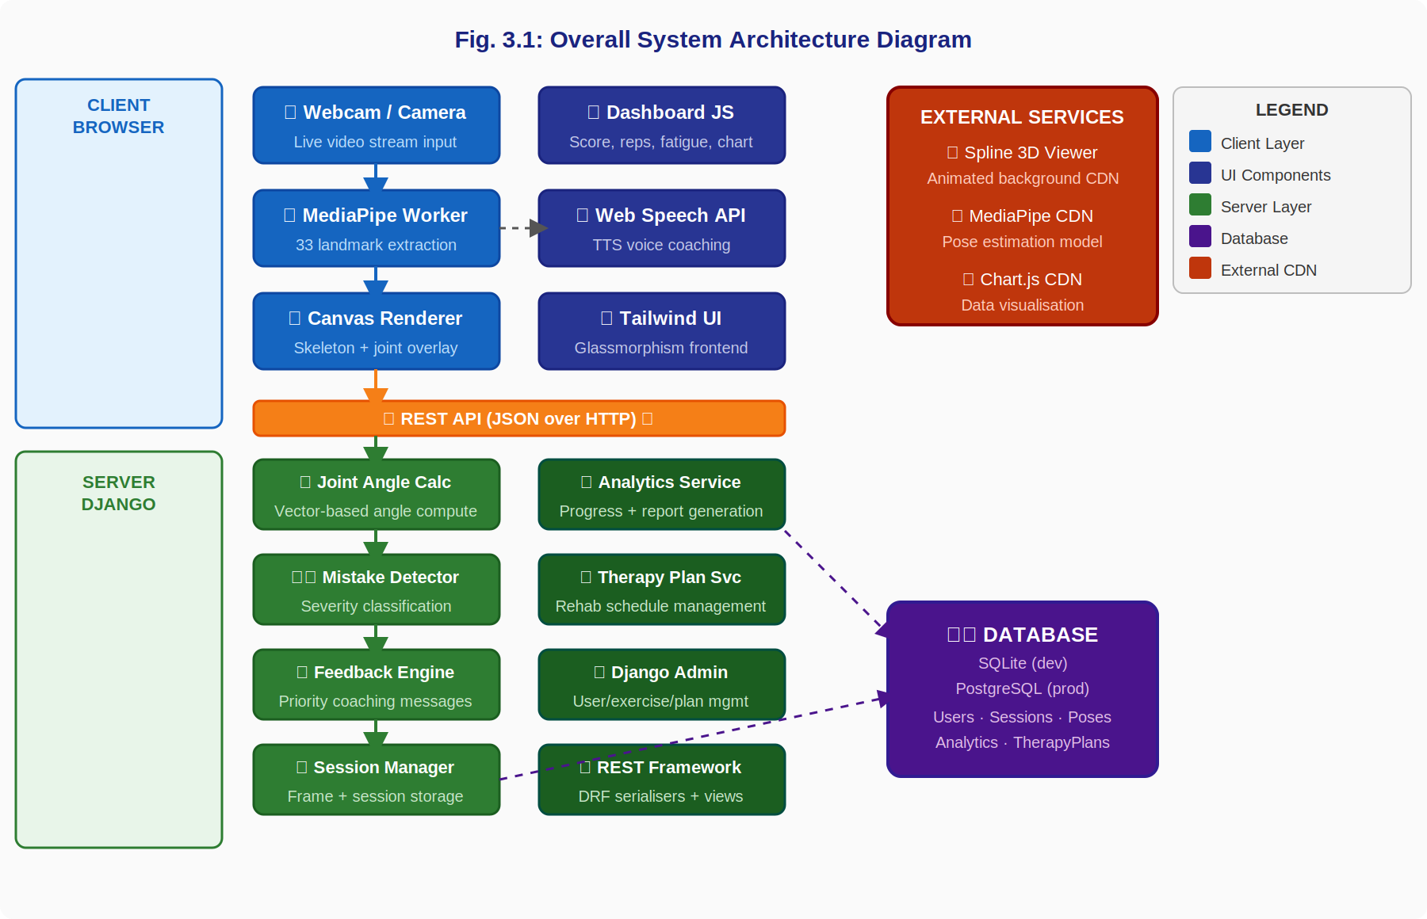
Fig. 3.1: Overall System Architecture Diagram

Figure 3.1 shows the five layers of the system: the browser client layer (MediaPipe Worker, Canvas Renderer, Dashboard JS, Web Speech API, and Tailwind UI), the REST API transport layer, the Django server layer (Joint Angle Calculator, Mistake Detector, Live Feedback Engine, Session Manager, Analytics Service, Therapy Plan Service, and Django Admin), the persistence layer (SQLite or PostgreSQL database), and the external CDN layer (Spline, MediaPipe, and Chart.js).

Figure 3.2 shows the entity-relationship structure of the database. The central entity is the Django User model, which is extended by UserProfile. A User creates Sessions; each Session contains multiple SessionExercise records, each linked to an Exercise from the Exercise library. Each SessionExercise generates multiple PoseAnalysis frames, each optionally linked to an AIModel version. A one-to-one AIFeedback record summarises the session. UserProgress tracks longitudinal metrics, and TherapyPlan with WeeklyExercise entries defines the rehabilitation schedule.

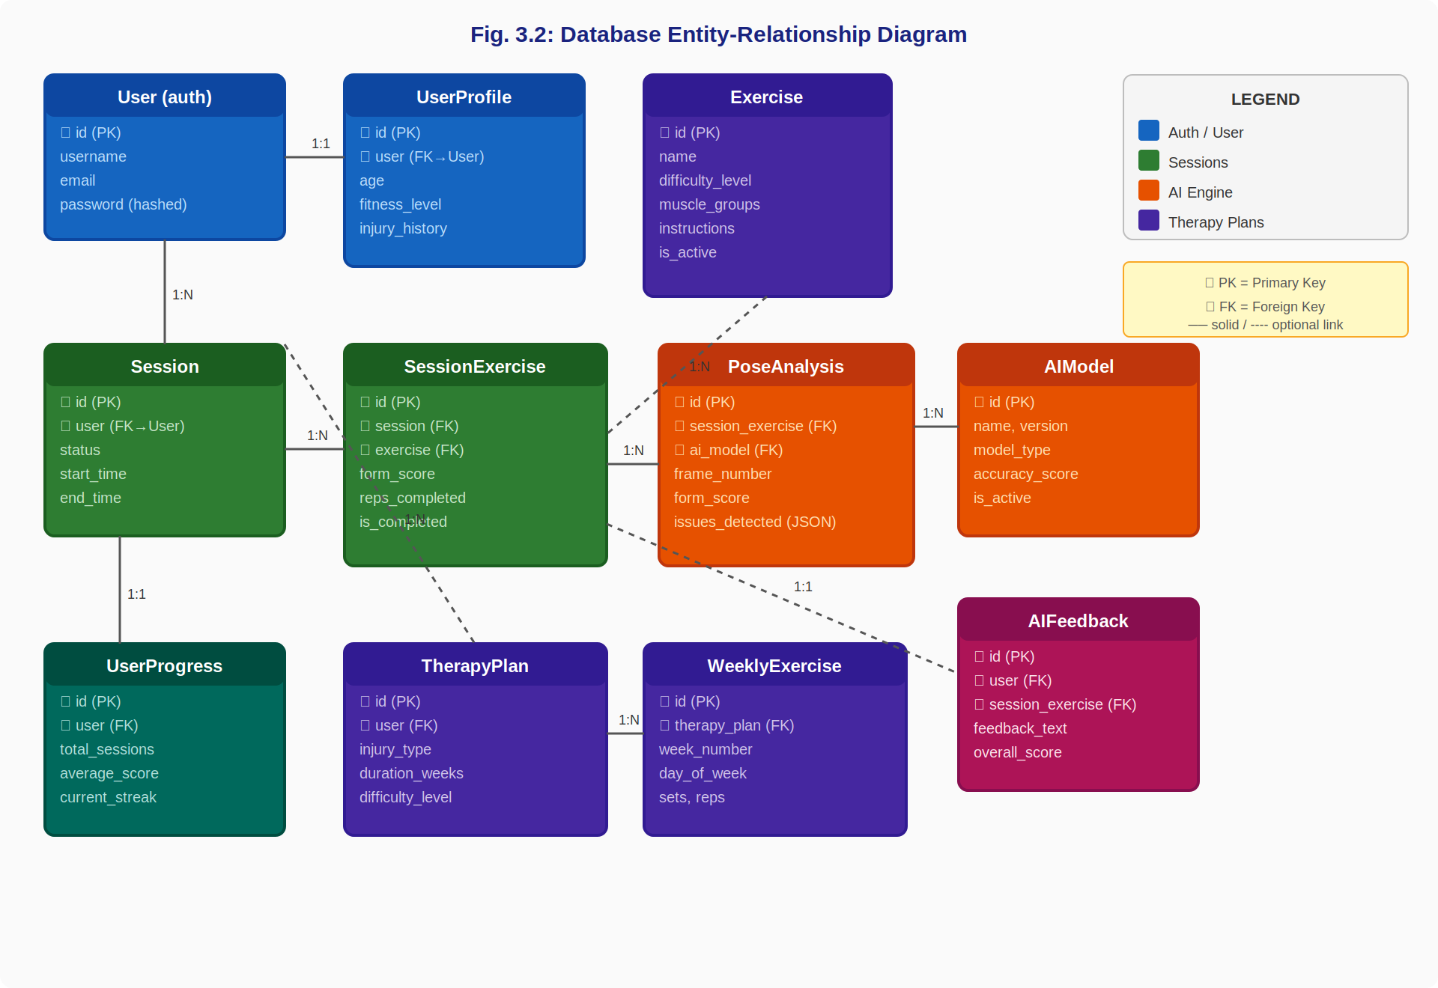
Fig. 3.2: Database Entity-Relationship Diagram

3.2. Functional Requirements
The table below summarises the primary functional requirements of the system.

Table 3.1: Functional Requirements Summary
ID | Requirement | Priority
FR-01 | Capture webcam video and detect 33 pose landmarks per frame using MediaPipe. | High
FR-02 | Calculate knee, hip, shoulder, and elbow joint angles from landmark coordinates. | High
FR-03 | Compare angles to exercise-specific safe ranges and detect deviations. | High
FR-04 | Classify errors by severity: low, medium, high, critical. | High
FR-05 | Display skeleton overlay with green (correct) and red (incorrect) joint indicators. | High
FR-06 | Show real-time angle values as labels near each joint on screen. | Medium
FR-07 | Generate context-aware coaching messages based on detected errors and exercise type. | High
FR-08 | Deliver voice coaching messages using the browser text-to-speech API. | Medium
FR-09 | Display a live form score (0-100%), repetition counter, fatigue score, and stability score. | High
FR-10 | Store frame-level PoseAnalysis records and session-level metrics in the database. | High
FR-11 | Display historical progress charts and joint-specific weakness analysis. | Medium
FR-12 | Export analytics summary as a downloadable PDF report. | Medium
FR-13 | Allow clinicians to create and assign multi-week therapy plans via the admin panel. | Medium
FR-14 | Provide a REST API for all data operations. | High
FR-15 | Support camera selection when multiple input devices are available. | Low

3.3. Non-Functional Requirements
The system must meet the following non-functional requirements:
- Performance: Pose detection must maintain a minimum of 20 frames per second on a standard laptop to ensure smooth real-time feedback.
- Latency: End-to-end feedback latency from frame capture to coaching message display must not exceed 200 milliseconds under normal network conditions.
- Usability: The interface must be operable by a user with no technical background.
- Responsiveness: All pages must render correctly on screens with widths from 375 px (mobile) to 2560 px (large desktop).
- Security: All state-modifying API endpoints must be protected by Django's CSRF middleware.
- Maintainability: All modules must follow Django's app-based architecture with clear docstrings.

Table 3.2: Database Models and Their Purpose
App | Model | Key Fields | Purpose
users | UserProfile | fitness_level, injury_history | Extended user metadata
exercises | Exercise | name, difficulty, muscle_groups, instructions | Exercise template library
sessions | Session | user, status, start_time, end_time | Complete therapy session record
sessions | SessionExercise | form_score, reps_completed, is_done | Per-exercise session record
ai_engine | AIModel | name, version, model_type, accuracy_score | AI model version registry
ai_engine | PoseAnalysis | frame_number, form_score, detected_joints, issues_detected | Frame-level pose result
ai_engine | AIFeedback | feedback_text, improvement_areas, overall_score | Session-end AI summary
analytics | UserProgress | total_sessions, average_score, current_streak | Longitudinal progress record
analytics | DailyMetrics | date, sessions_completed, average_form_score | Daily aggregated statistics
analytics | Report | report_type, period_start, content | Weekly/monthly PDF report
therapy_plans | TherapyPlan | injury_type, duration_weeks, difficulty_level | Rehabilitation plan
therapy_plans | WeeklyExercise | week_number, day_of_week, sets, reps | Scheduled exercise item
advanced_features | InjuryRiskAlert | risk_level, affected_joints, trend | Injury risk detection record

Chapter 4
Code Snippets
4.1. Joint Angle Calculator
The JointAngleCalculator module is responsible for computing the angle at a joint given three landmark positions. The angle is calculated at the middle point (the joint vertex) using the dot-product formula on the two vectors formed by the three points. Figure 4.1 below illustrates the full five-step calculation process from raw MediaPipe landmark coordinates to a final angle value and safety classification.

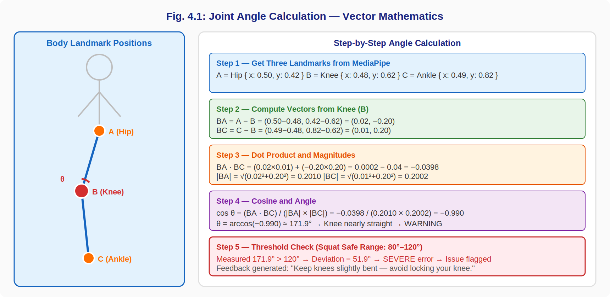
Fig. 4.1: Joint Angle Calculation — Vector Mathematics Illustration

The function takes three landmark dictionaries, each containing x and y coordinate values normalised to the range [0, 1] by MediaPipe. It constructs two vectors from the center point to each outer point, computes their dot product, divides by the product of their magnitudes to obtain the cosine of the angle, clamps the cosine to [-1, 1] to prevent numerical errors, and returns the angle in degrees. This angle represents the bend at the joint — a value near 180 degrees indicates a nearly straight limb, while a value near 90 degrees indicates a right-angle bend.

@staticmethod def calculate_angle_between_points(point_a, point_b, point_c): a = Point2D(point_a['x'], point_a['y']) b = Point2D(point_b['x'], point_b['y']) c = Point2D(point_c['x'], point_c['y']) ba = Point2D(a.x - b.x, a.y - b.y) bc = Point2D(c.x - b.x, c.y - b.y) mag_ba = math.sqrt(ba.x**2 + ba.y**2) mag_bc = math.sqrt(bc.x**2 + bc.y**2) if mag_ba == 0 or mag_bc == 0: return 0.0 cos_angle = (ba.x*bc.x + ba.y*bc.y) / (mag_ba * mag_bc) cos_angle = max(-1.0, min(1.0, cos_angle)) return math.degrees(math.acos(cos_angle))
4.2. Mistake Detector Module
The MistakeDetector class evaluates whether a calculated joint angle falls within the acceptable range for a given exercise phase and classifies any deviation by severity. Figure 4.2 shows the complete detection and feedback routing flow from video frame input to the final coaching message output.

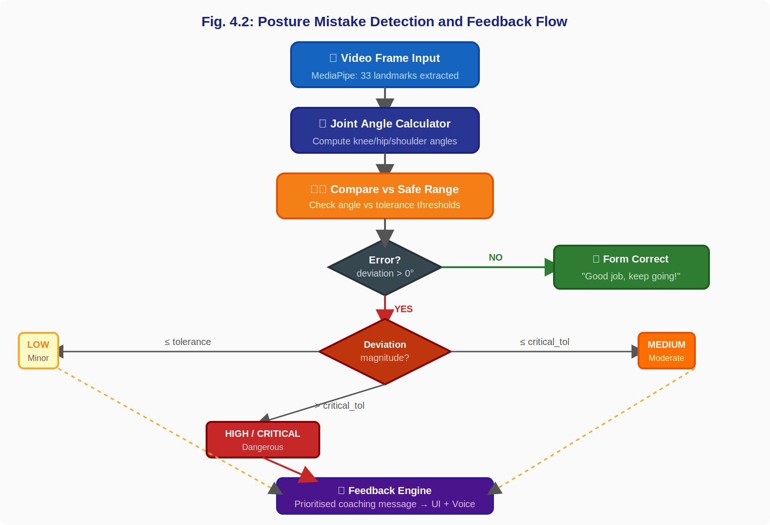
Fig. 4.2: Posture Mistake Detection and Feedback Flow Diagram

The flow begins with a video frame processed by MediaPipe. Joint angles are calculated and compared against exercise-specific safe ranges. A decision node checks whether any deviation exists. If no error is detected, the system generates a positive message. If an error is found, the deviation magnitude determines whether it is classified as low, medium, high, or critical severity. All severity levels feed into the Feedback Engine, which constructs and delivers the final coaching message to the user interface and voice system.

SEVERITY_WEIGHT = {"low": 1, "medium": 2, "high": 3, "critical": 4} def generate_feedback(issues, exercise_type, history): if not issues: return "Good job, keep going!" sorted_issues = sorted(issues, key=lambda i: SEVERITY_WEIGHT.get(i['severity'], 1), reverse=True) top = sorted_issues[0] correction = CORRECTION_MAP.get(top['type'], top['message']) if top['severity'] in ('high', 'critical'): return f"Pause and correct now. {correction}" return correction
4.3. Live AI Feedback Engine
The Live Feedback Engine is the intelligence layer that transforms raw error detections into prioritised, contextual coaching messages. It weights errors by severity and selects the most critical correction to present to the user, avoiding feedback spam by enforcing a minimum interval between repeated messages. The engine also compares current session scores against the user's historical average to provide performance context. For users whose score has dropped below 60%, it suggests reducing difficulty. For users consistently above 85%, it recommends increasing repetitions.

# Difficulty adaptation logic if current_avg_score > 85: recommendation = "Increase reps to 25 — your form is excellent." elif current_avg_score < 60: recommendation = "Reduce reps to 10 and focus on form first." else: recommendation = "Maintain current plan. Consistency is key." # Historical comparison if current_avg > historical_avg + 5: context = f"You are performing {round(current_avg-historical_avg)}% better than last week." elif current_avg < historical_avg - 5: context = f"Form has dropped {round(historical_avg-current_avg)}%. Focus on slow, controlled movement."
4.4. REST API Views
The backend exposes a set of REST API endpoints consumed by the live capture frontend. The pose frame submission endpoint accepts POST requests containing landmark data and returns the calculated form score, AI feedback message, and detected issues for the submitted frame.

# POST /sessions/api/upload_pose_frame/ # Body: { session_exercise_id, landmarks, frame_number } # Returns: { form_score, feedback, issues } @api_view(['POST']) def upload_pose_frame(request): se_id = request.data.get('session_exercise_id') landmarks = request.data.get('landmarks', {}) frame_no = request.data.get('frame_number', 0) se = SessionExercise.objects.get(id=se_id) angles = JointAngleCalculator.compute_all(landmarks) issues = MistakeDetector.evaluate(angles, se.exercise) score = ScoreGenerator.calculate(issues) feedback = LiveFeedbackEngine.generate(issues, se.exercise.name) PoseAnalysis.objects.create( session_exercise=se, frame_number=frame_no, form_score=score, issues_detected=issues, confidence_level=request.data.get('confidence', 100) ) return Response({'form_score': score, 'feedback': feedback, 'issues': issues})

Chapter 5
Result
5.1. Home Page
The home page presents a premium SaaS-style landing interface. A 3D animated Spline background scene is loaded asynchronously after the initial page render and fades in using a CSS opacity transition. The scene is positioned as a fixed full-screen layer with pointer-events set to none, ensuring that all foreground interactive elements remain fully usable. Glassmorphism cards with semi-transparent backgrounds and backdrop blur present the platform's key features. Figure 5.1 shows the layout and visual design of the home page.

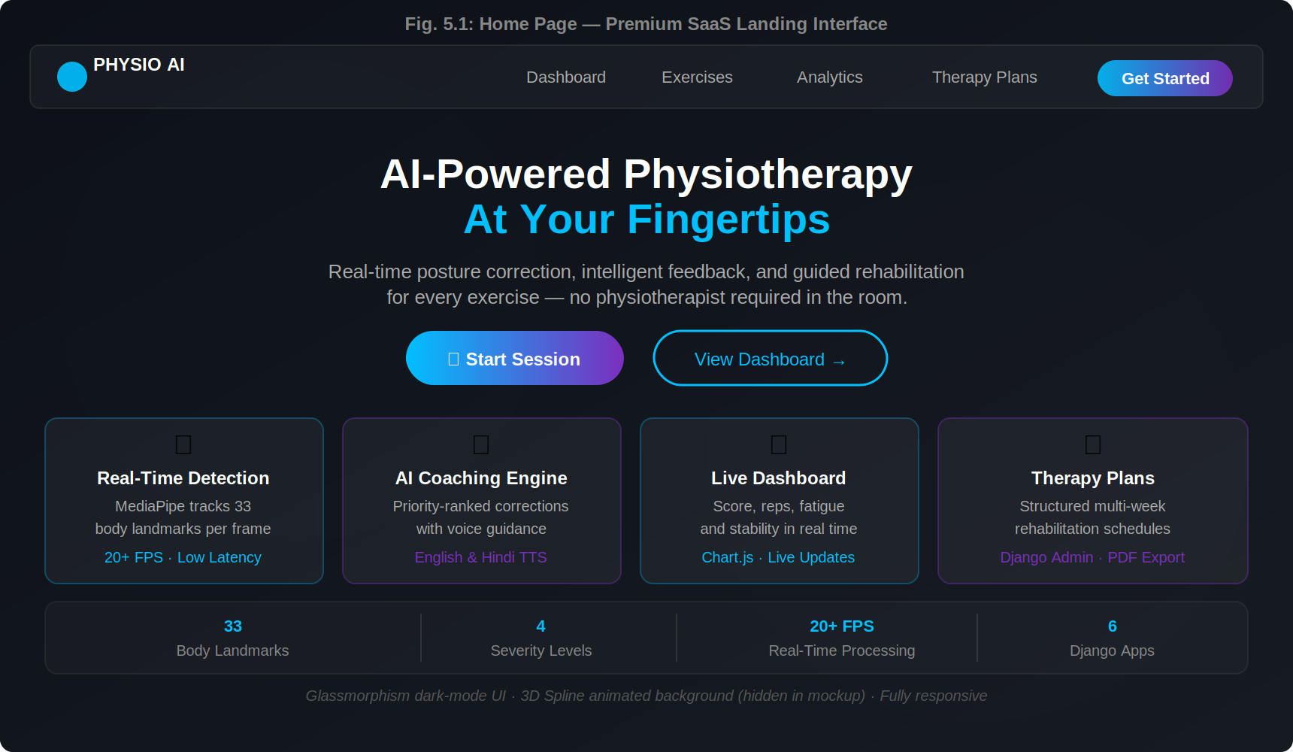
Fig. 5.1: Home Page — Premium SaaS Landing Interface

The hero section includes a headline, a descriptive subheading explaining the platform's purpose, and two call-to-action buttons. The primary button links directly to the live capture demo, and the secondary button links to the analytics dashboard. Four feature cards at the bottom summarise the key capabilities: real-time detection, AI coaching, live dashboard, and therapy plans. A statistics bar shows key platform metrics including 33 body landmarks, 4 severity levels, 20+ FPS processing, and 6 Django apps.

5.2. Live Camera Pose Detection Interface
The capture page is the core real-time interaction interface. On load, the system requests webcam access and begins processing video frames through MediaPipe Pose via a dedicated Web Worker. The interface is divided into two panels: the left panel shows the live camera feed with skeleton overlay, and the right panel shows the live metrics dashboard. Figure 5.2 illustrates the full live camera interface.

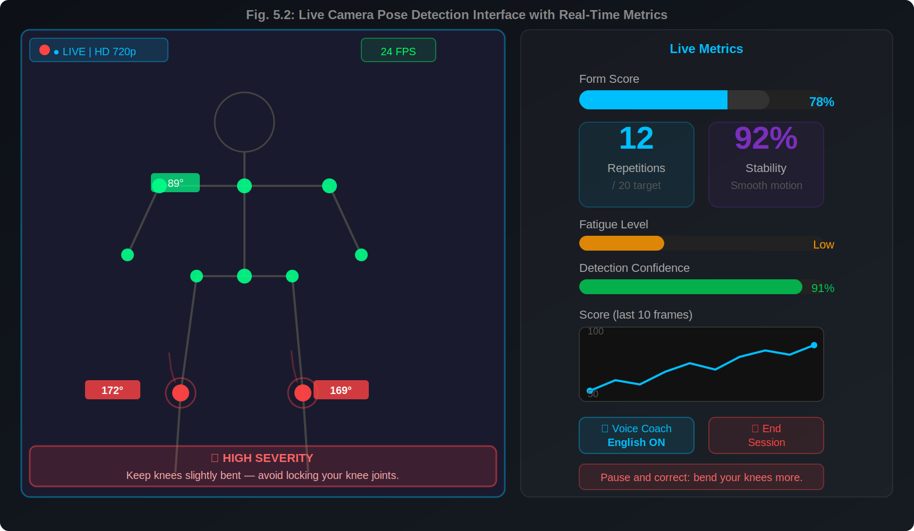
Fig. 5.2: Live Camera Pose Detection Interface with Real-Time Metrics

The skeleton overlay is drawn on an HTML5 Canvas element positioned over the video element. Joints detected as correct are rendered in green (#00FF88) with a circular marker. Joints detected as incorrect are rendered in red (#FF4444) with a pulsing animation to draw attention. Angle values are displayed as text labels near the relevant joints. A motion trail shows the trajectory of key joints over the previous 10 frames as a fading line. The right metrics panel shows the form score gauge bar, repetition counter, stability score, fatigue level bar, detection confidence, a mini live score chart, voice coach toggle, and a coaching message overlay at the bottom.

5.3. Real-Time Dashboard
The dashboard page provides a comprehensive view of the user's exercise history and current performance trends. Figure 5.3 shows the full dashboard layout with metric cards, charts, and AI recommendations.

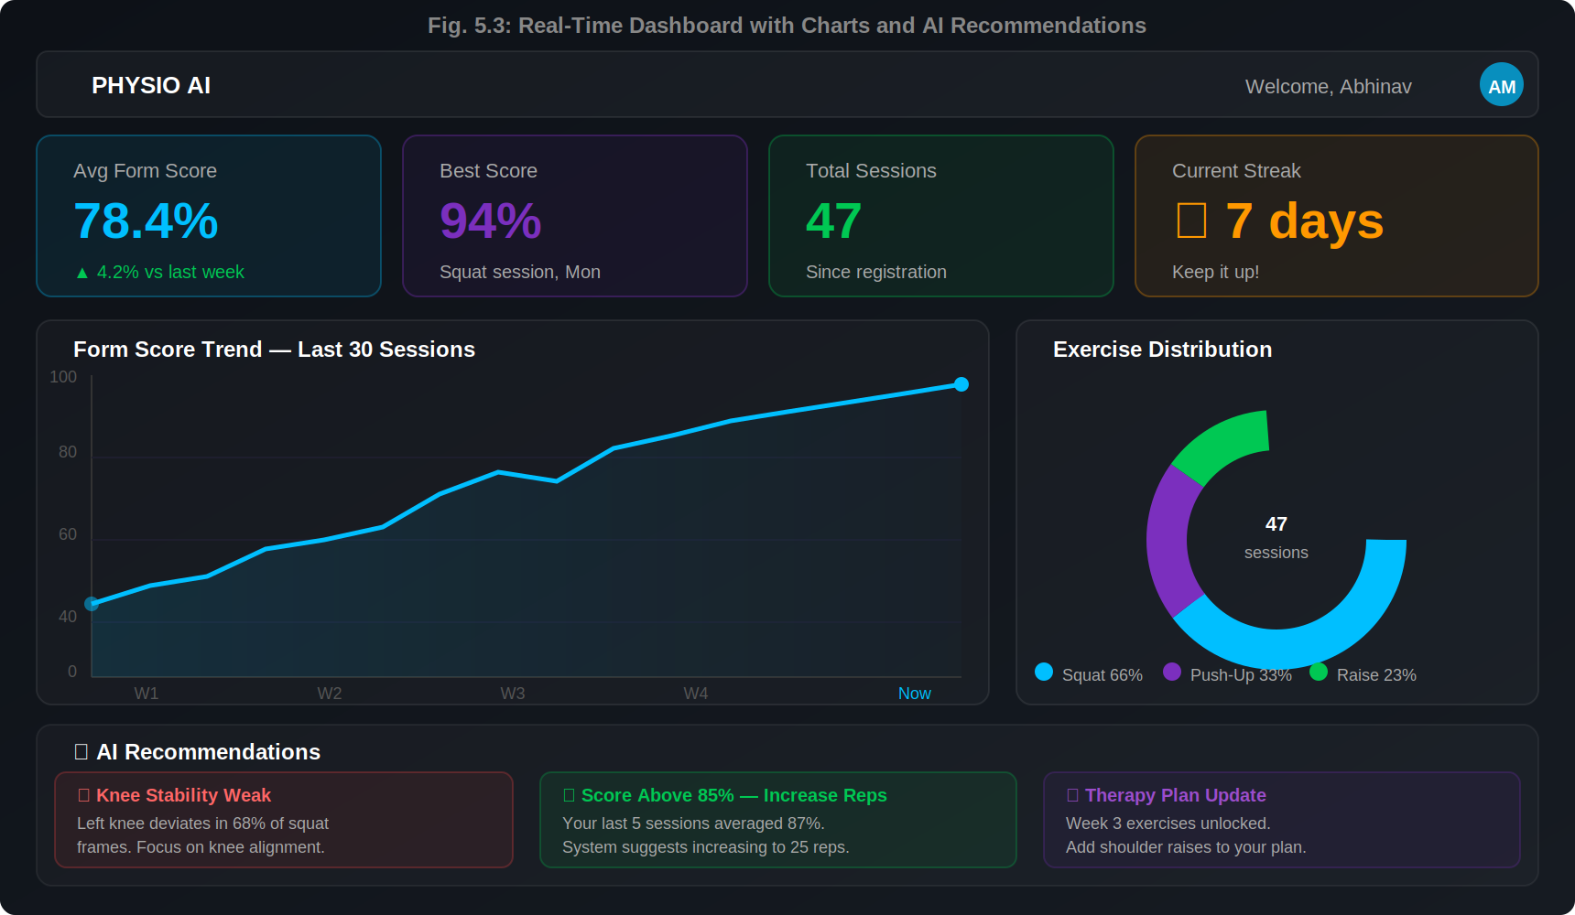
Fig. 5.3: Real-Time Dashboard with Charts and AI Recommendations

The dashboard presents four metric cards: Average Form Score, Best Score, Total Sessions, and Current Streak. Below the cards, a line chart rendered with Chart.js shows the form score trend over the last 30 sessions with an area fill. An exercise distribution donut chart shows the proportion of different exercises completed. An AI recommendations panel shows three personalised coaching suggestions based on the user's most recent session data and historical weakness patterns — including injury risk warnings, difficulty adjustment suggestions, and therapy plan updates.

5.4. API Endpoints
The following table lists the main API endpoints provided by the system.

Table 5.1: REST API Endpoints Reference
Method | Endpoint | Description
POST | /api/sessions/start/ | Create a new therapy session
GET | /api/sessions/active/ | Retrieve the current active session
GET | /api/sessions/history/ | Retrieve session history for the user
POST | /api/pose/submit/ | Submit pose landmarks for analysis
POST | /api/score/calculate/ | Calculate form score for a frame
GET | /api/feedback/session/ | Retrieve AI feedback for a session
GET | /api/progress/current/ | Current user progress metrics
GET | /api/progress/history/ | Historical progress data
POST | /sessions/api/upload_pose_frame/ | Upload pose frame and receive feedback
GET | /api/dashboard/metrics/ | Dashboard summary metrics
GET | /api/dashboard/chart-data/ | Time-series chart data
GET | /analytics/export/pdf/ | Export analytics report as PDF

5.5. Therapy Plans and Analytics Pages
Figure 5.4 shows the Therapy Plans page, and Figure 5.5 shows the Analytics and Progress Reports page. Both pages share the same dark glassmorphism design system and are displayed side by side in the figure below.

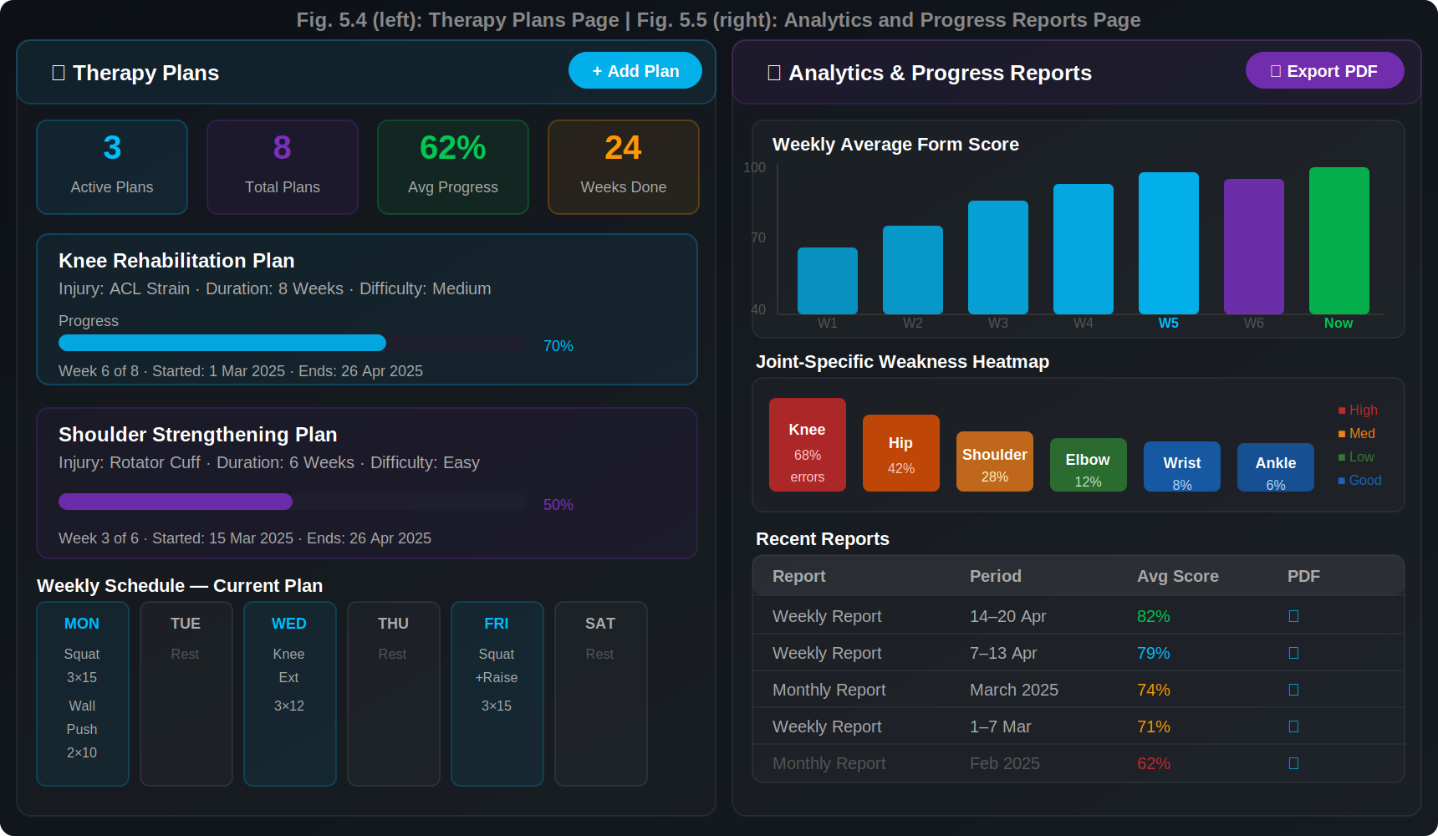
Fig. 5.4 (left): Therapy Plans Page | Fig. 5.5 (right): Analytics and Progress Reports Page

The Therapy Plans page (left half of Figure 5.4) reads from the TherapyPlan and WeeklyExercise models populated through the Django admin panel. Summary cards show active plans, total plans, average progress percentage, and total weeks completed. Each therapy plan is displayed as a card showing the plan name, injury type, total duration in weeks, and a progress bar indicating completion. The weekly schedule grid shows exercises assigned to each day of the week.

The Analytics page (right half of Figure 5.5) provides a weekly average form score bar chart, a joint-specific weakness heatmap where bar height and color intensity correspond to error frequency per joint, and a recent reports table. The table lists reports by type (weekly or monthly), date range, average form score, and includes a PDF download link for each report. The heatmap clearly shows that the knee joint is the most common source of posture errors in the demo session data, followed by the hip and shoulder joints.

Conclusion
Physio AI successfully demonstrates the integration of real-time computer vision, biomechanical analysis, intelligent feedback, and full-stack web engineering to produce a functional AI-assisted physiotherapy platform. The system fulfils all stated primary objectives: it detects 33 body landmarks in real time using MediaPipe, calculates joint angles using vector mathematics, classifies posture errors by clinical severity, delivers context-aware coaching messages through both text and voice modalities, maintains a live exercise dashboard with form score, repetition, fatigue, and stability metrics, and persists all session data for longitudinal analytics and PDF reporting.

The Django application structure, divided into six independent apps, ensures maintainability and allows each subsystem to be extended or replaced independently. The REST API layer provides a clean interface for potential integration with mobile clients or third-party therapy management systems. The Django admin panel allows clinicians to manage exercises, therapy plans, and user profiles without requiring technical expertise.

The current limitations of the system are that safety thresholds are defined by rule-based biomechanical parameters rather than learned from patient data, which means they must be reviewed by qualified physiotherapists before clinical deployment. Camera quality and ambient lighting significantly affect MediaPipe landmark accuracy, particularly for users exercising in low-light environments. Full WebSocket-based therapist live monitoring is documented in the production upgrade blueprint but not yet deployed in the current codebase.

Future development directions include the integration of a large language model such as GPT-4 or Gemini to provide more nuanced, conversational coaching recommendations based on a user's complete medical and session history. A therapist-patient real-time monitoring channel using Django Channels and Redis would enable remote supervision. A dedicated mobile application would extend accessibility beyond desktop devices. Clinical validation studies with physiotherapy professionals would be required before deployment in a regulated healthcare environment. Additionally, the difficulty adaptation and injury risk prediction models could be improved by training supervised machine learning models on aggregated anonymised session data rather than relying solely on fixed threshold rules.

In summary, this project provides a solid full-stack foundation for AI-assisted physiotherapy and demonstrates how modern web technologies, computer vision, and intelligent feedback systems can be combined to deliver practical value in the healthcare domain.

