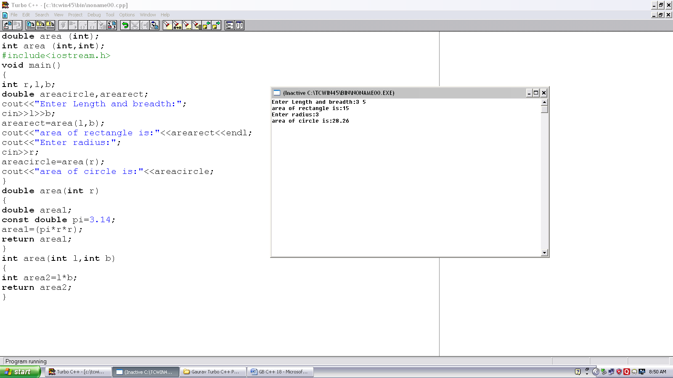
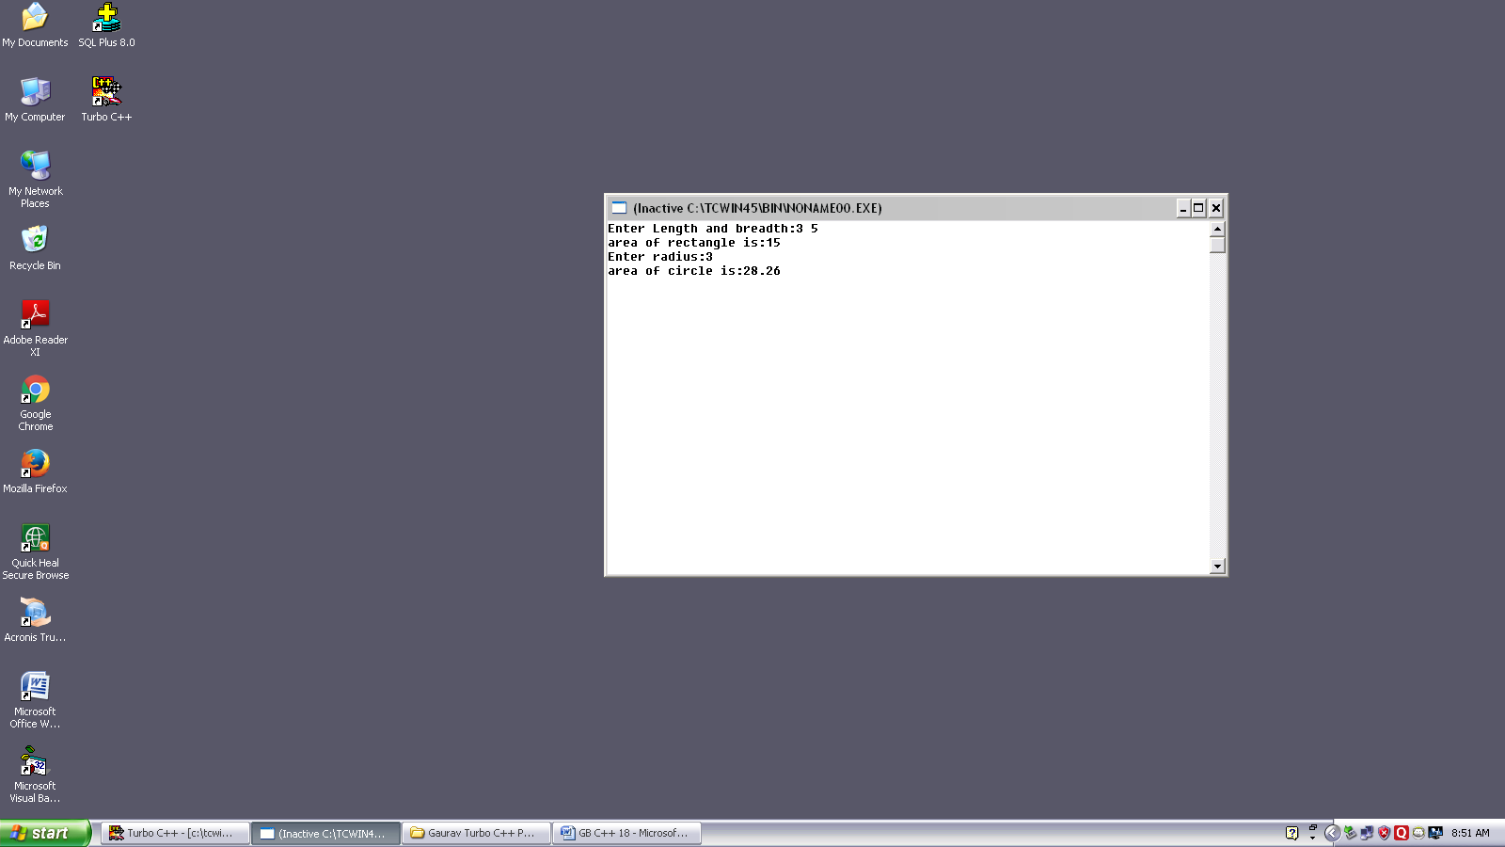
Program no. :-18
Made by :- YASH CHOUDHURY

/* Program calculates the area of circle and rectangle using overloaded function area.*/
double area (int);
int area (int,int);
#include<iostream.h>
void main()
{
int r,l,b;
double areacircle,arearect;
cout<<”Enter Length and breadth:”;
cin>>I>>b;
arearect=area(I,b);
cout<<”area of rectangle is:”<<arearect<<,endl;
cout<<”Enter radius:”;
cin>>r;
areacircle=area(r);
cout<<”area of circle is:”<<areacircle;
}
double area(int r)
{
double area1;
const double pi=3.14;
area1=(pi*r*r);
return area1;
}
int area(int I,int b)
{
int area2=I*b;
return area2;
}

