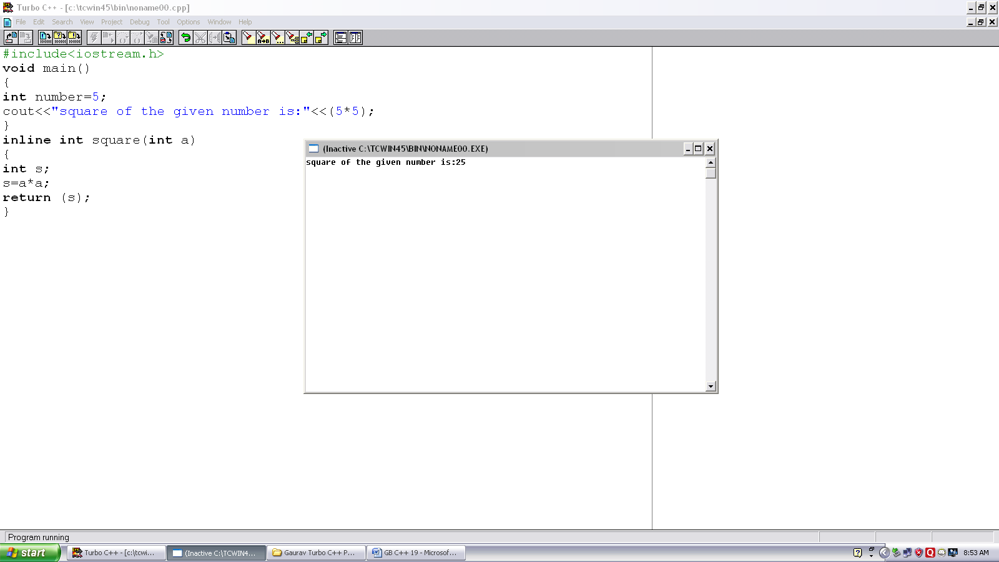
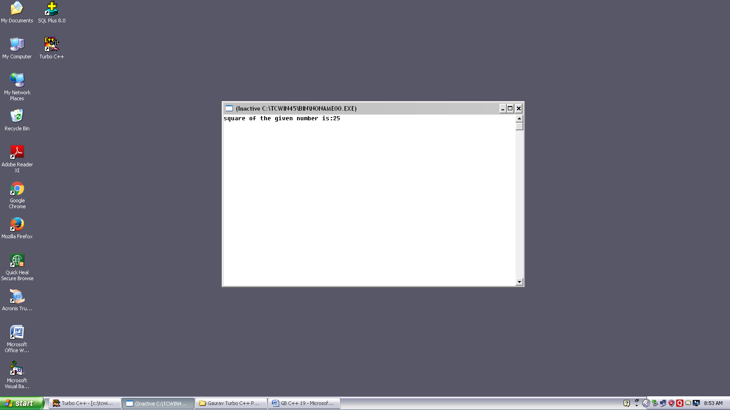
Program no. :-19
Made by :- YASH CHOUDHURY

/*to demonstrare use of inline function. */
int square (int);
#include<iostream.h>
void main()
{
int number=5;
cout<<”square of the given number is:”<<square(number);
}
inline int square(int a)
{
return (a*a);
}

