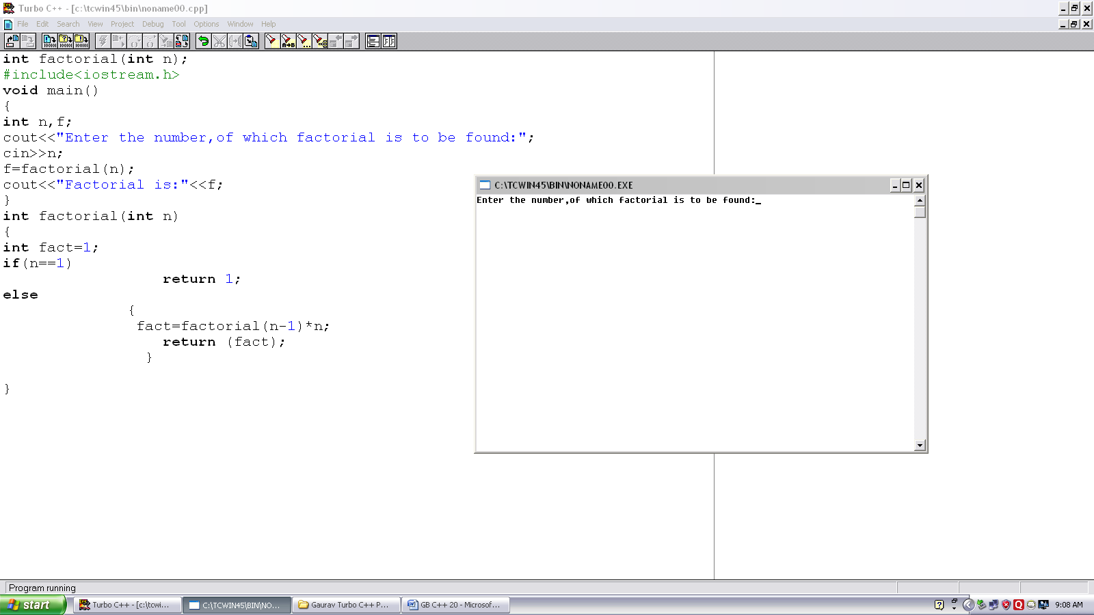
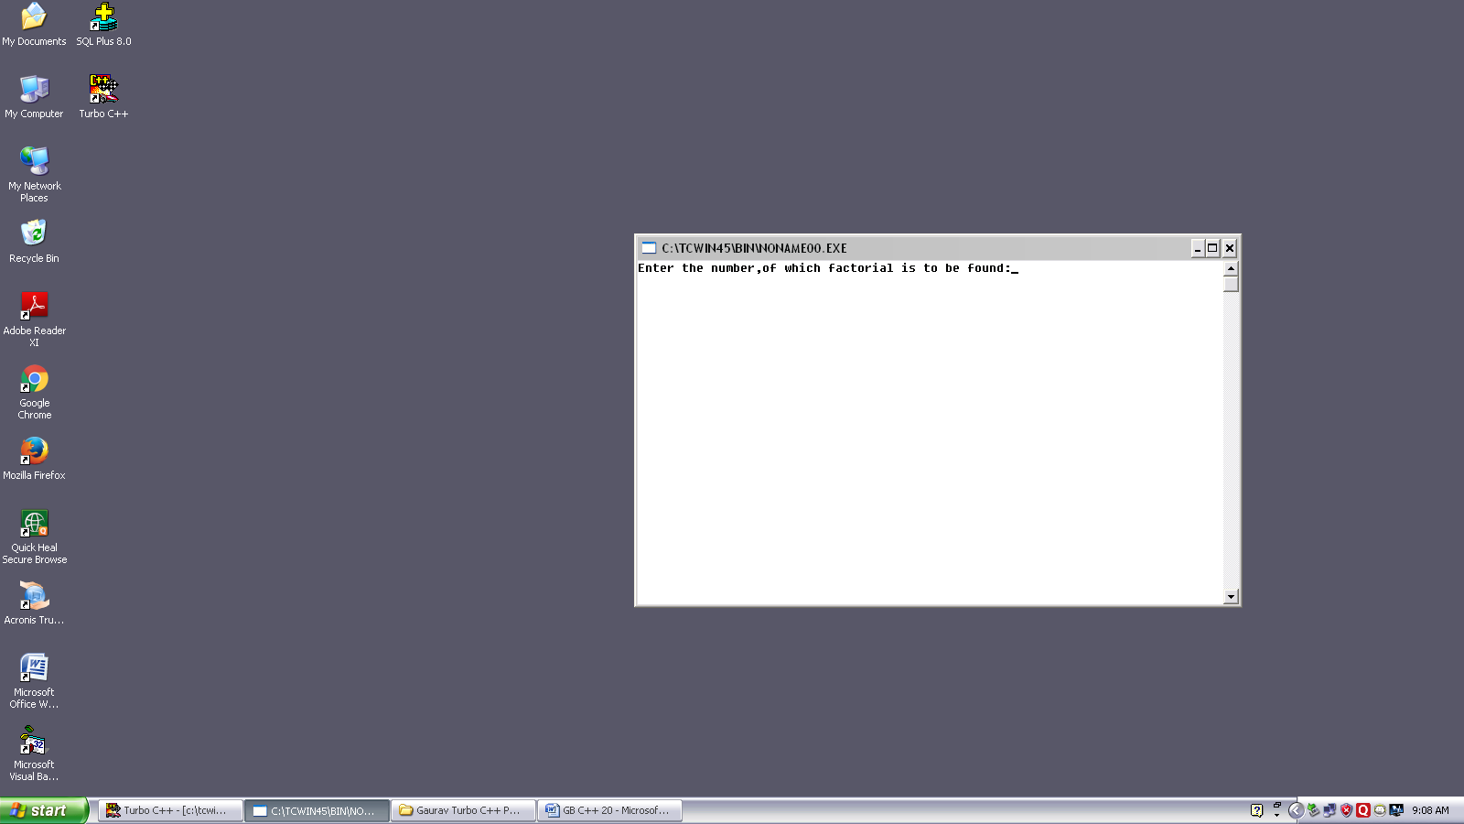
Program no. :- 20
Made by :- YASH CHOUDHURY

/*Program calculates factorial using recursion.*/
int factorial(int n);
#include<iostream.h>
void main()
{
int n,f;
cout<<”Enter the no,of which factorial is to be found:”;
cin>>n;
f=factorial(n);
cout<<”Factorial is:”<<f;
}
int factorial(int n)
{
int fact=1;
if(n==1)
return 1;
else
{
fact=factorial(n-1)*n;
return (fact);
}
}

