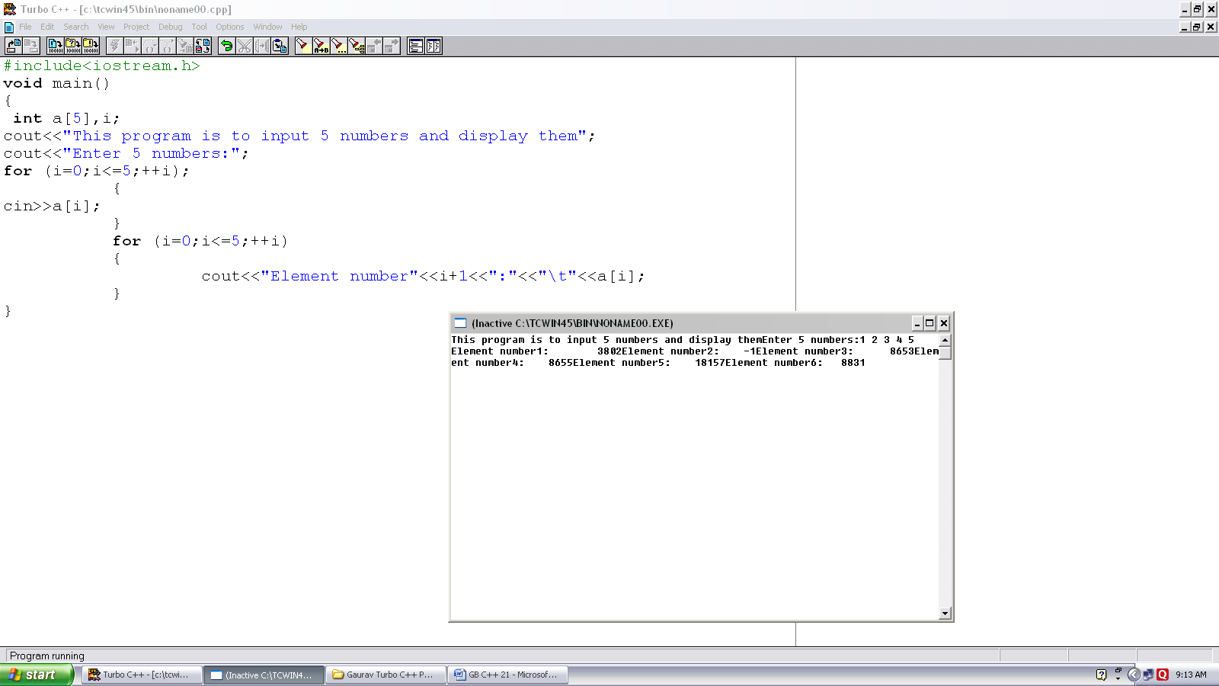
Program no. :- 21
Made by :- YASH CHOUDHURY

/* Program accepts and displays array elements.*/
#include<iostream.h>
void main()
{
int a[5],j;
cout<<”This program is to input 5 numbers and display them”;
cout<<”Enter 5 numbers:”;
for (i=0;i<5;++i)
{
cin>>a[i];
}
for (i=0; i<=5;++i)
{
cout<<”Element number”<<i+1<<”:”<<”\t”<<a[i];
}
}

