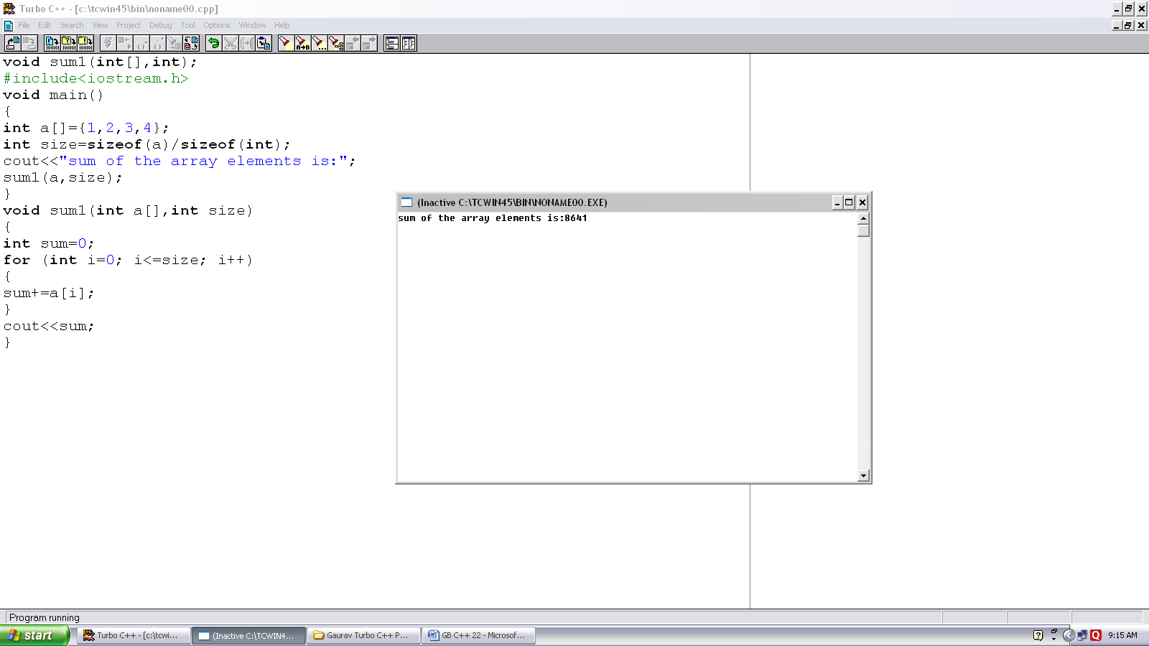
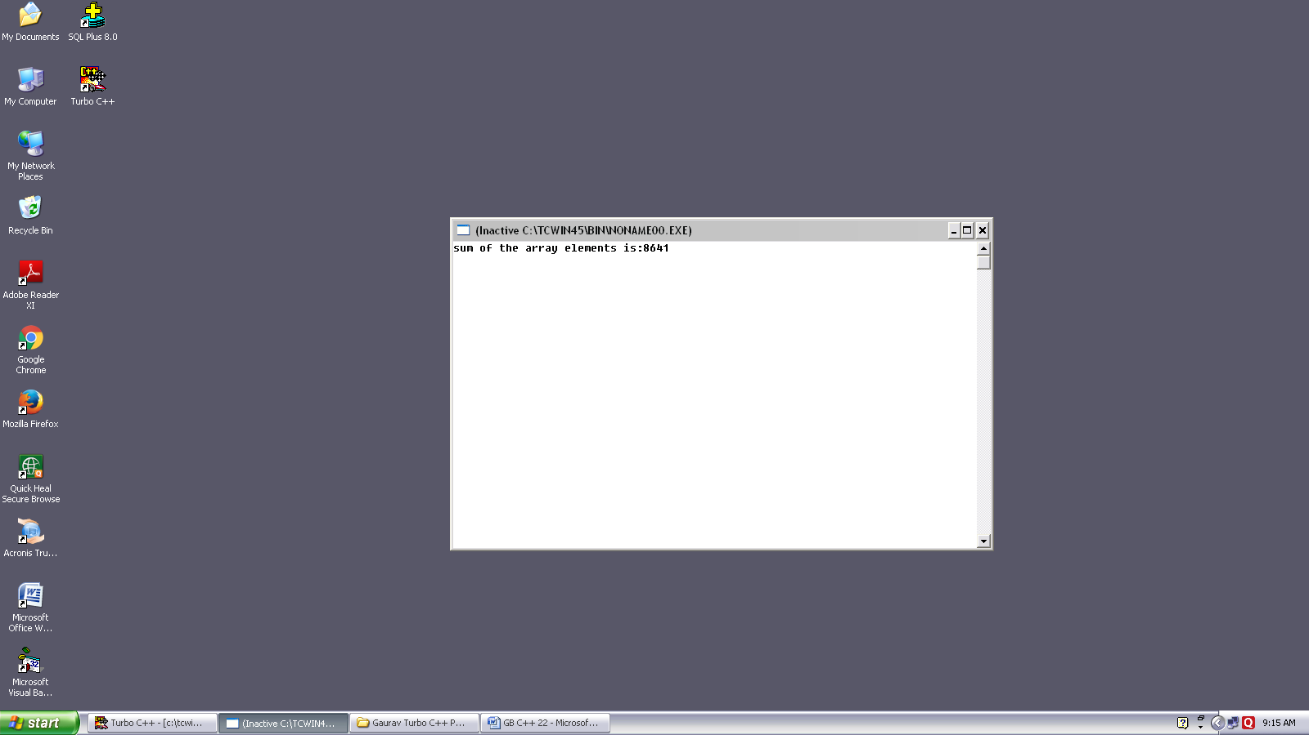
Program no. :- 22
Made by :- YASH CHOUDHURY

/* Program passes array to the function and calculate sum of its elements.*/
void sum1(int[],int);
#include<iostream.h>
void main()
{
int a[ ]={1,2,3,4};
int size=sizeof(a)/sizeof(int);
cout<<”sum of the array elements is:”;
sum1(a,size);
}
void sum 1(int a[],int size)
{
int sum=0;
for (int i=0; i<=size; i++)
{
sum+=a[i];
}
cout<<sum;
}

