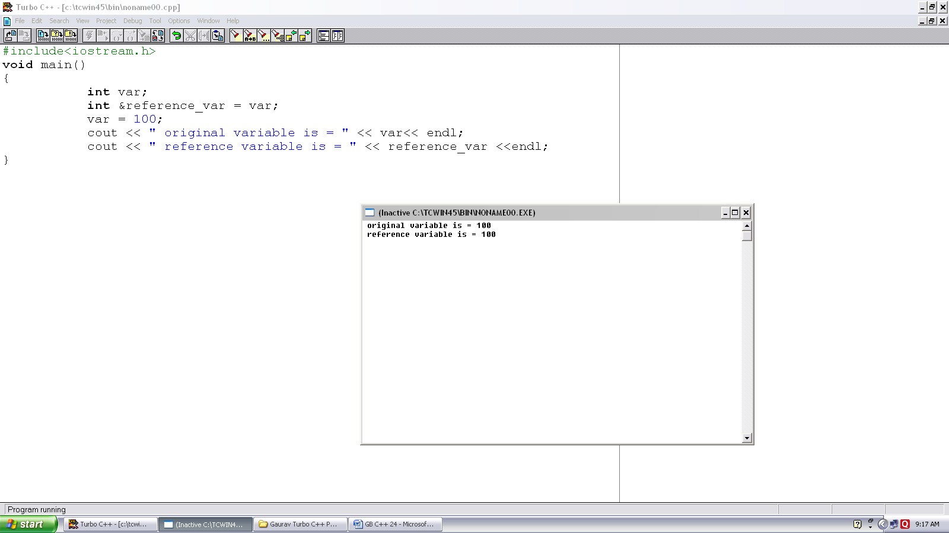
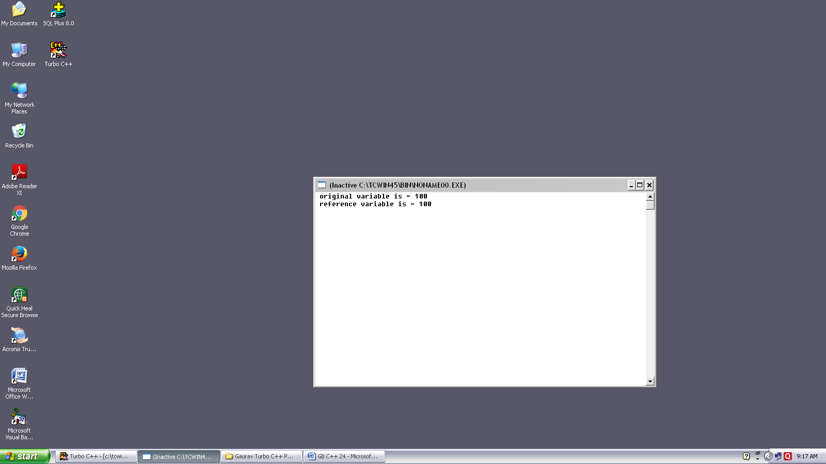
Program no. :- 24
Made by :- YASH CHOUDHURY

/*Program demonstrates use of reference variable.*/
#include<iostream.h>
Void main()
{
int var;
int &reference_var = var;
var = 100;
cout << “ original variable is = “ << var<< endl;
cout << “ reference variable is = “ << reference_var <<endl;
}

