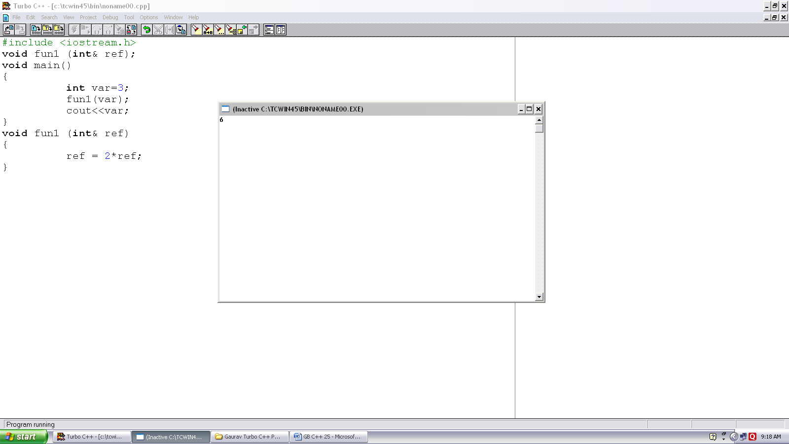
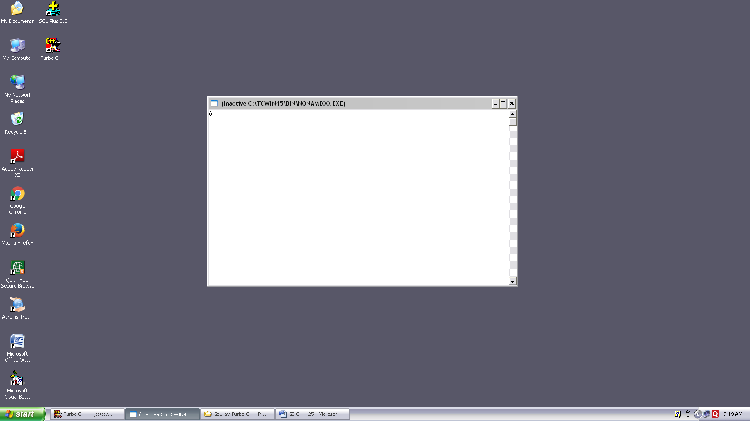
Program no. :- 25
Made by :- YASH CHOUDHURY

/*Program demonstrates passing reference variable to function.*/
#include < iostream.h>
void fun1 (int& ref);
void main()
{
int var=3;
fun1(var);
cout<<var;
}
void fun1 (int& ref)
{
ref = 2*ref;
}

