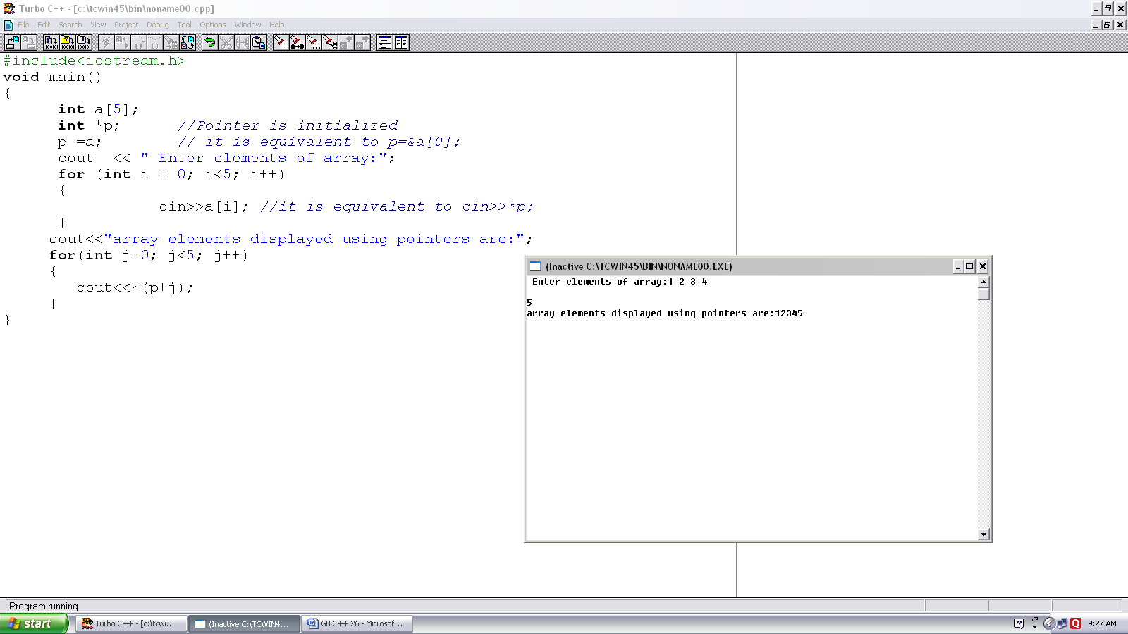
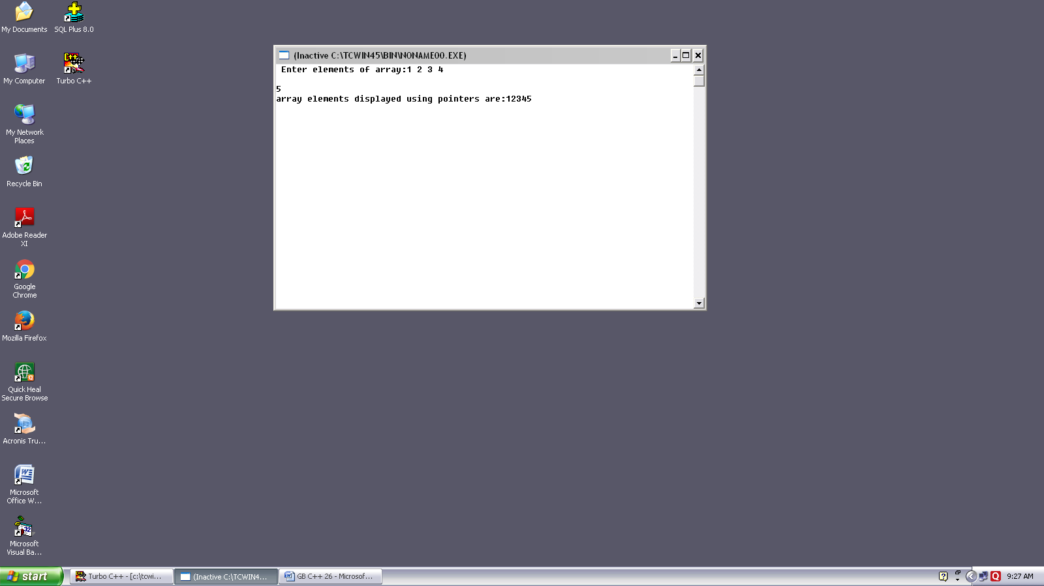
Program no. :- 26
Made by :-YASH CHOUDHURY

/*Program demonstrates traversing array with the help of pointers.*/
#include<iostream.h>
Void main()
{
int a[5];
int *p; //Pointer is initialized
p =a; // it is equivalent to p=&a[0];
cout << “ Enter elements of array:”;
for (int I = 0; i<5; i++)
{
Cin>>a[i]; //it is equivalent to cin>>*p;
}
cout<<”Array elements displayed using pointers are:”;
for (int j = 0; j<5; j++)
{
cout<<*(p+j) ;
}
}

