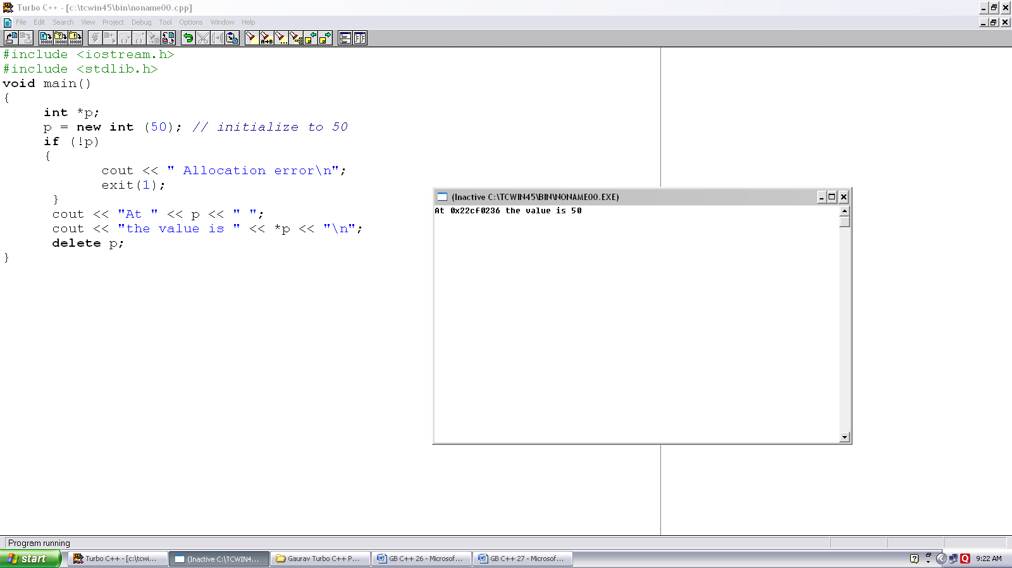
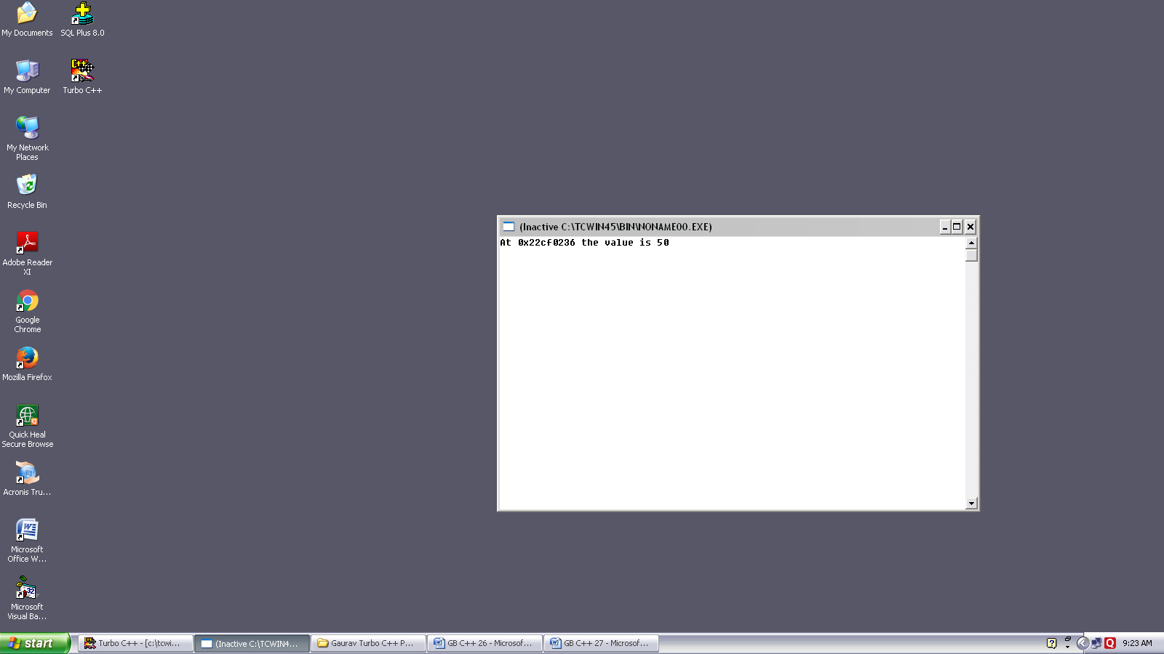
Program no. :-27
Made by :- YASH CHOUDHURY

/*Program demonstrates use of Dynamic Memory Allocation.*/
#include <iostream.h>
#include <stdlib.h>
{
int *p;
p = new int (50); // initialize to 50
if (!p)
{
cout << “ Allocation error\n”;
exit(1);
}
cout << “At “ << p << “ “;
cout << “the value is “ << *p << “\n”;
delete p;
}

