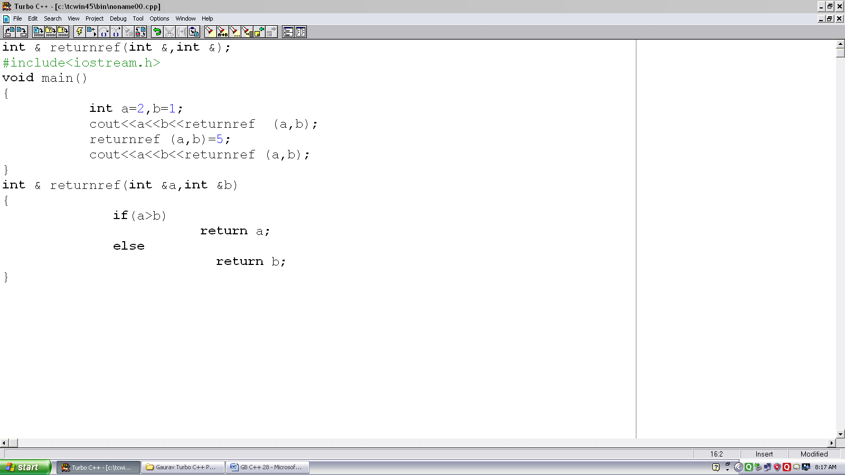
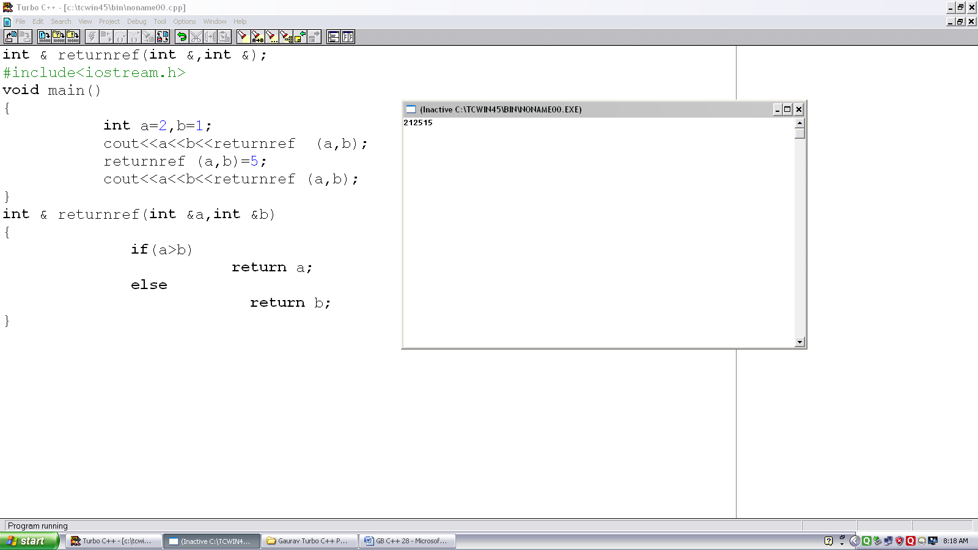

Program no. :- 28
Made by :- YASH CHOUDHURY

/*Program demonstrates returning reference from function.*/
int & returnref(int &,int &);
#include<iostream.h>
void main()
{
int a=2,b=1;
cout<<a<<b<<retunref (a,b);
returnref (a,b)=5;
cout<<a<<b<<returnref (a,b);
}
int & returnref(int &a,int &b)
{
if(a>b)
return a;
else
return b;
}

