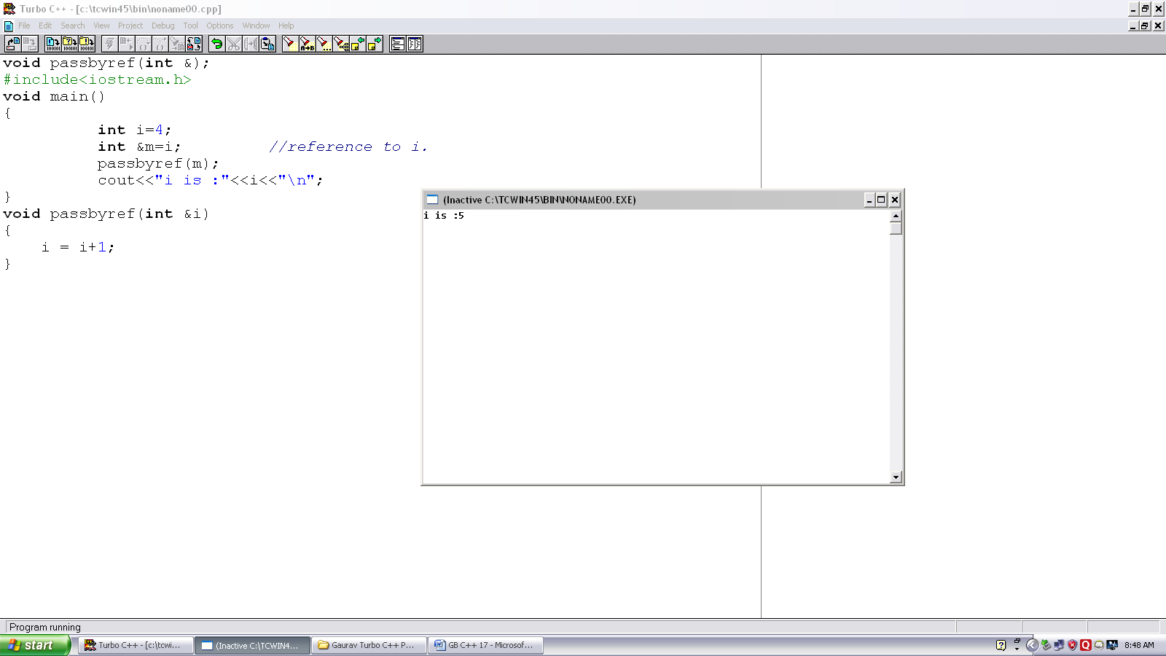
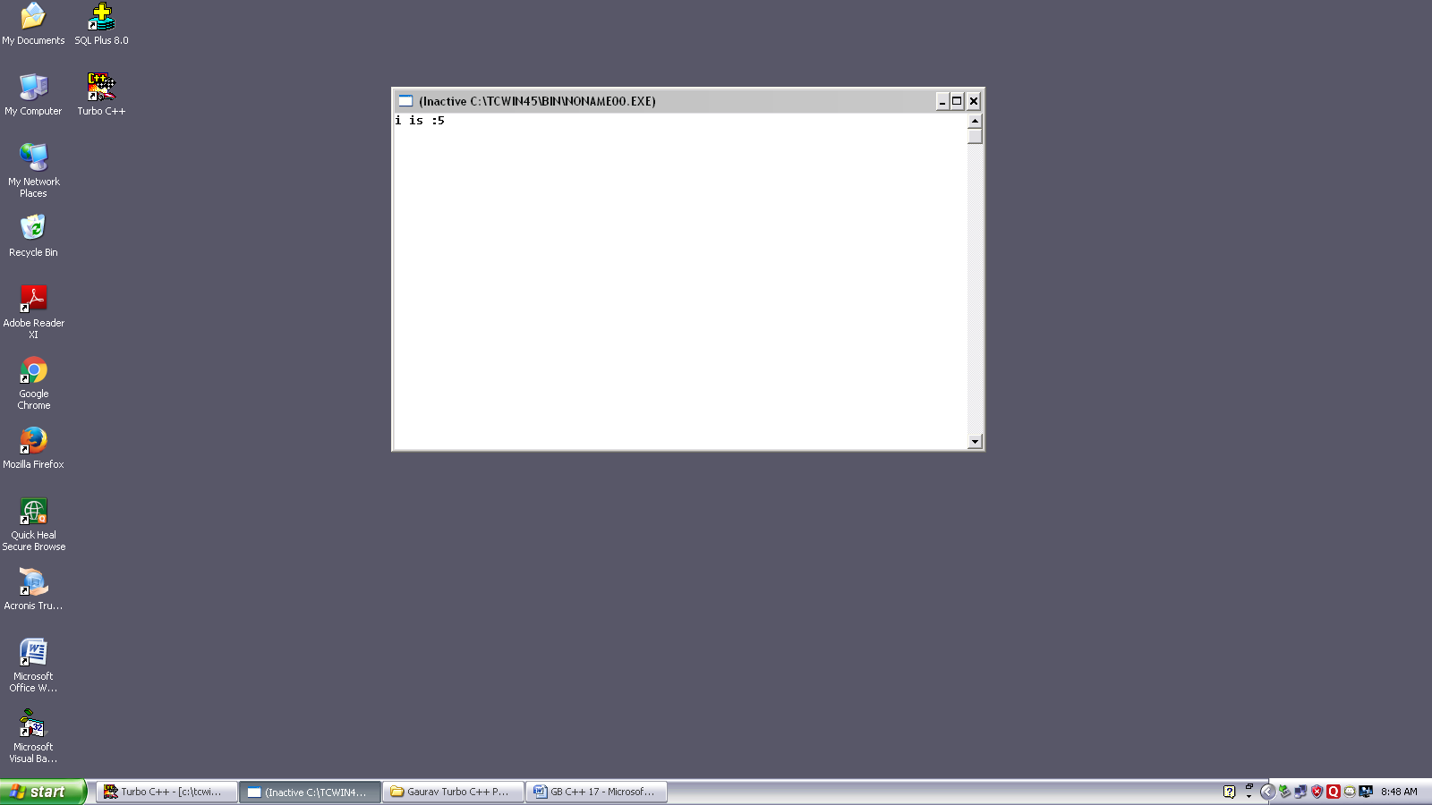
Program no. :- 17
Made by :-YASH CHOUDHURY

/* Program to demonstrate use of passing by reference using reference.*/
void passbyref(int &);
#include<iostream.h>
void main()
{
int i=4;
int &m=i; //reference to i.
passbyref(m);
cout<<”i is :”<<i<<”\n”;
}
void passbyref(int &i)
{
i = i+1;
}

