Linux Meanu Driven ---------------------------------------------------------------------------------

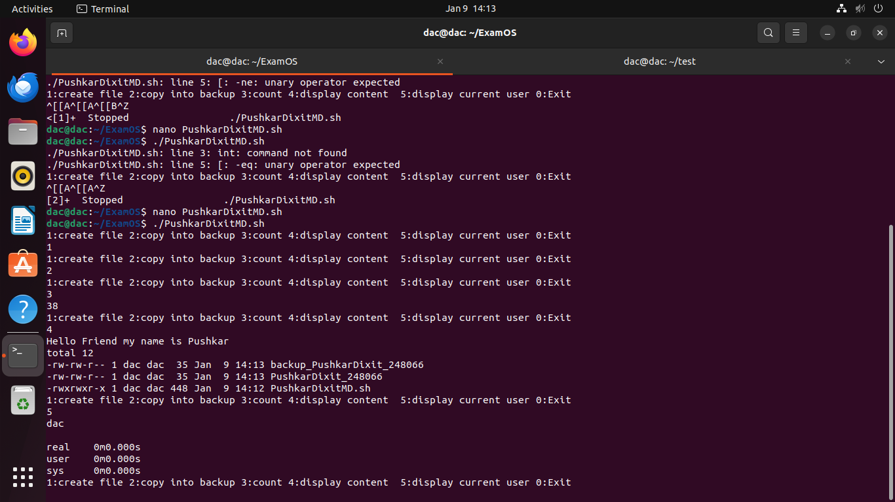
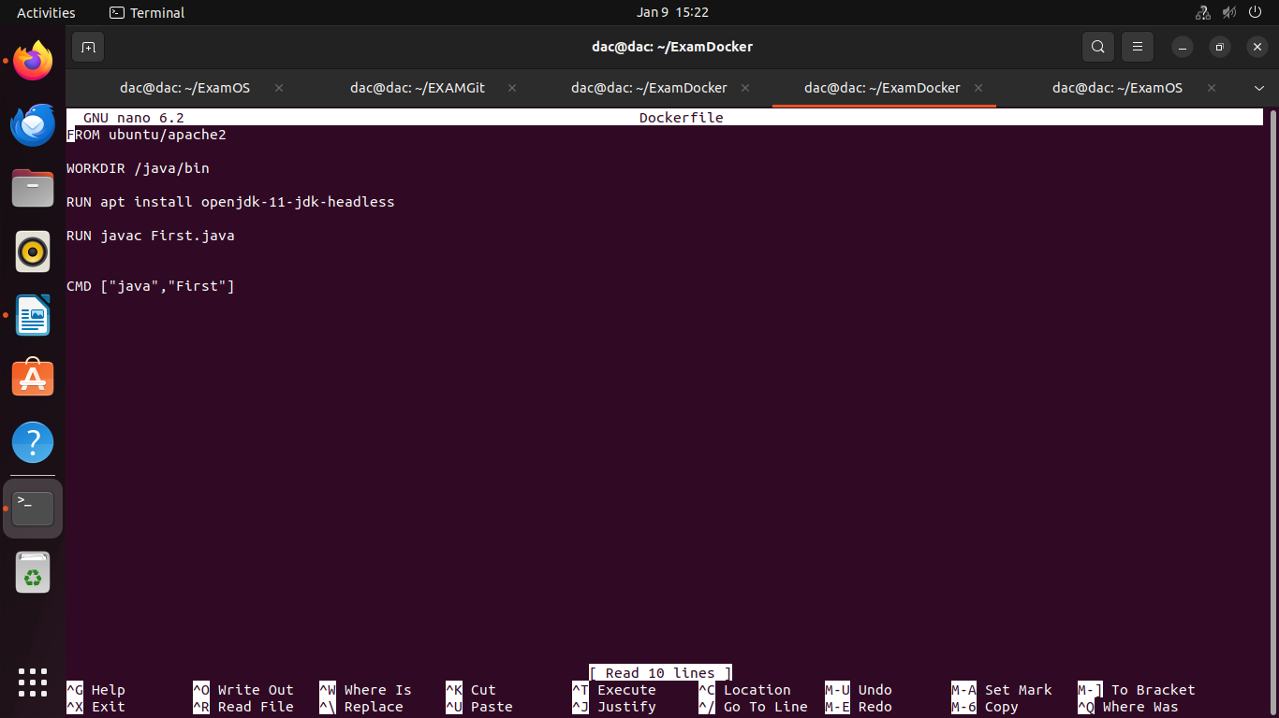

//problem2----------------------------------------------------------------------------------------------

dac@dac:~/ExamOS$ nano Problem2
dac@dac:~/ExamOS$ ls
backup_PushkarDixit_248066 Problem2.sh PushkarDixit_248066 PushkarDixitMD.sh
dac@dac:~/ExamOS$ nano Problem2.sh
dac@dac:~/ExamOS$ chmod +x Problem2.sh
dac@dac:~/ExamOS$ ./Problem2.sh
Enter the No:- 5
0
1
2
3
5
dac@dac:~/ExamOS$ chmod +x Problem2.sh
dac@dac:~/ExamOS$ ./Problem2.sh
Enter the No:- 10
0
1
2
3
5
7
dac@dac:~/ExamOS$ ./Problem2.sh
Enter the No:- 100
0
1
2
3
5
7
11
13
17
19
23
29
31
37
41
43
47
53
59
61
67
71
73
79
83
89
97
dac@dac:~/ExamOS$

Problem2.sh
#!/bin/bash
pr=0
read -p "Enter the No:- " n

for((i=0;i<=n;i++))do

pr=1

for((j=2;j*j<=i;j++))
do

if((i%j==0))
then
pr=0
break
fi
done

if((pr==1))
then
echo "$i"
fi

done

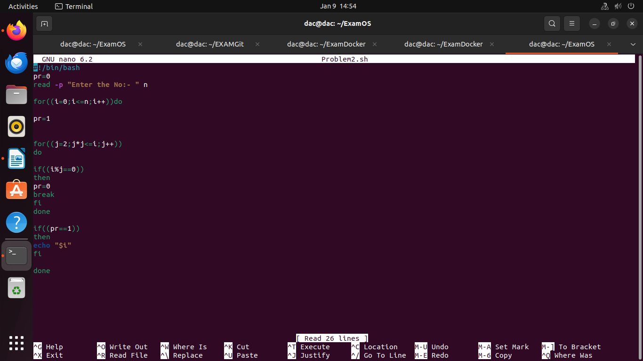

Git------------------------------------------------------------------------------------------------------------

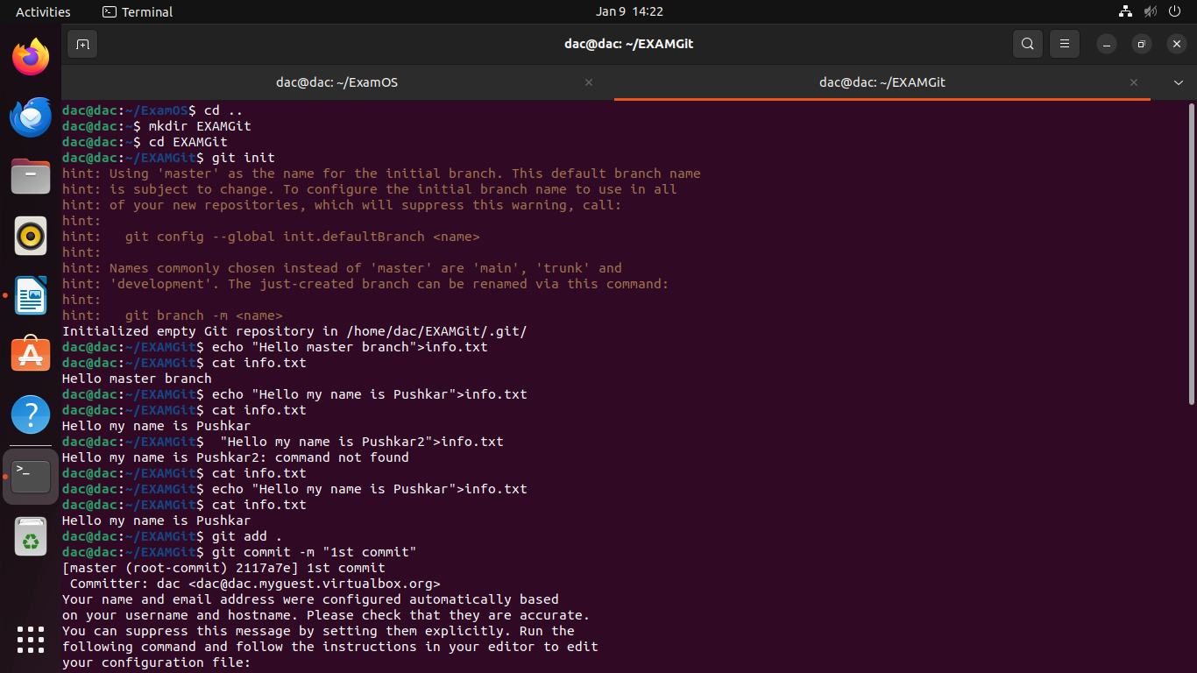

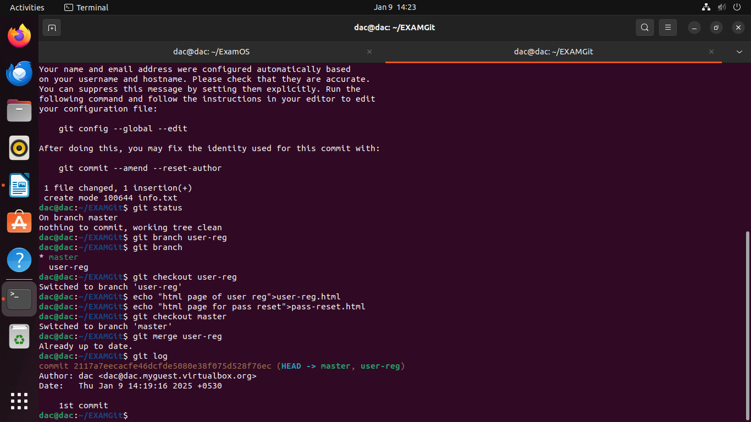

ac@dac:~/ExamOS$ cd ..
dac@dac:~$ mkdir EXAMGit
dac@dac:~$ cd EXAMGit
dac@dac:~/EXAMGit$ git init
hint: Using 'master' as the name for the initial branch. This default branch name
hint: is subject to change. To configure the initial branch name to use in all
hint: of your new repositories, which will suppress this warning, call:
hint:
hint: git config --global init.defaultBranch <name>
hint:
hint: Names commonly chosen instead of 'master' are 'main', 'trunk' and
hint: 'development'. The just-created branch can be renamed via this command:
hint:
hint: git branch -m <name>
Initialized empty Git repository in /home/dac/EXAMGit/.git/
dac@dac:~/EXAMGit$ echo "Hello my name is Pushkar">info.txt
dac@dac:~/EXAMGit$ cat info.txt
Hello my name is Pushkar
dac@dac:~/EXAMGit$ git add .

dac@dac:~/EXAMGit$ git commit -m "1st commit"
[master (root-commit) 2117a7e] 1st commit
Committer: dac <dac@dac.myguest.virtualbox.org>
Your name and email address were configured automatically based
on your username and hostname. Please check that they are accurate.
You can suppress this message by setting them explicitly. Run the
following command and follow the instructions in your editor to edit
your configuration file:

git config --global --edit

After doing this, you may fix the identity used for this commit with:

git commit --amend --reset-author

1 file changed, 1 insertion(+)
create mode 100644 info.txt
dac@dac:~/EXAMGit$ git status
On branch master
nothing to commit, working tree clean
dac@dac:~/EXAMGit$ git branch user-reg
dac@dac:~/EXAMGit$ git branch
* master
user-reg
dac@dac:~/EXAMGit$ git checkout user-reg
Switched to branch 'user-reg'
dac@dac:~/EXAMGit$ echo "html page of user reg">user-reg.html
dac@dac:~/EXAMGit$ echo "html page for pass reset">pass-reset.html
dac@dac:~/EXAMGit$ git checkout master
Switched to branch 'master'
dac@dac:~/EXAMGit$ git merge user-reg
Already up to date.
dac@dac:~/EXAMGit$ git log
commit 2117a7eecacfe46dcfde5080e38f075d528f76ec (HEAD -> master, user-reg)
Author: dac <dac@dac.myguest.virtualbox.org>
Date: Thu Jan 9 14:19:16 2025 +0530

1st commit
dac@dac:~/EXAMGit$ git status
On branch master
Untracked files:
(use "git add <file>..." to include in what will be committed)
pass-reset.html
user-reg.html

nothing added to commit but untracked files present (use "git add" to track)
dac@dac:~/EXAMGit$ git add .
dac@dac:~/EXAMGit$ git commit -m "2nd commit"
[master c275e0d] 2nd commit
Committer: dac <dac@dac.myguest.virtualbox.org>
Your name and email address were configured automatically based
on your username and hostname. Please check that they are accurate.
You can suppress this message by setting them explicitly. Run the
following command and follow the instructions in your editor to edit
your configuration file:

git config --global --edit

After doing this, you may fix the identity used for this commit with:

git commit --amend --reset-author

2 files changed, 2 insertions(+)
create mode 100644 pass-reset.html
create mode 100644 user-reg.html
dac@dac:~/EXAMGit$ git log
commit c275e0dacc23bef31eb1deea7cce722e0938ab6f (HEAD -> master)
Author: dac <dac@dac.myguest.virtualbox.org>
Date: Thu Jan 9 14:26:04 2025 +0530

2nd commit

commit 2117a7eecacfe46dcfde5080e38f075d528f76ec (user-reg)
Author: dac <dac@dac.myguest.virtualbox.org>
Date: Thu Jan 9 14:19:16 2025 +0530

1st commit
dac@dac:~/EXAMGit$

Doocker--------------------------------------------------------------------------------------------

dac@dac:~/EXAMGit$ cd ..
dac@dac:~$ mkdir ExamDocker
dac@dac:~$ cd ExamDocker

dac@dac:~/ExamDocker$ sudo docker images

dac@dac:~/ExamDocker$ nano Dockerfile

FROM ubuntu/apache2

WORKDIR /java/bin

RUN apt install openjdk-11-jdk-headless

RUN javac First.java

CMD ["java","First"]

