
PANDIT DEENDAYAL ENERGY UNIVERSITY (PDEU)
DEPARTMENT OF INFORMATION AND COMMUNICATION TECHNOLOGY (ICT)
B.TECH IN ICT • 7TH SEMESTER MINOR PROJECT EVALUATION (2026-2027)
SMARTSERVE: INTELLIGENT MULTI-SERVICE ON-DEMAND MARKETPLACE & OPERATIONS PLATFORM
Minor Project Mid-Semester Progress & Technical Architecture Specification Report
[MID-SEMESTER EVALUATION EXECUTIVE NOTICE] MILESTONE STATUS (~55% IMPLEMENTATION COMPLETED):
This mid-semester evaluation report documents the foundational deliverables achieved to date: Modular FastAPI Backend Core, Normalized PostgreSQL Relational Data Store (Supabase), Master Service Catalog (457 Services across 14 Categories), Dual-Engine OCR Verification Pipeline (PaddleOCR + EasyOCR), 5-Stage Booking Finite State Machine (FSM), and Multi-Portal Web Ecosystem (Customer, Provider, Admin, and Landing SPAs).
Phase 2 Scope (Scheduled for End-Semester Completion): Distributed Event Streaming with Apache Kafka / Redpanda Cloud, Live GPS Driver Telemetry with WebSockets dispatch, and Payment Gateway Settlement integration.

Project Metadata Field | Project Specification Details
Project Title | SmartServe: Intelligent Multi-Service On-Demand Marketplace
Program & University | B.Tech in Information and Communication Technology (ICT), Pandit Deendayal Energy University (PDEU)
Academic Term | 7th Semester (Minor Project Mid-Sem Review) | Academic Year 2026-2027
Project Candidates | Pushkar Kanjani (Roll No: 23BIT153) & Aastha (Roll No: 23BIT095)
Project Mentor | Dr. Deepak Kumar Sharma (Asst. Professor, Department of ICT, SoT, PDEU)
Domain Tracks | Enterprise Cloud Architecture, Big Data Distributed Pipelines, Computer Vision, Full-Stack SPAs
Current Implementation Status | Phase 1 Complete (~55% Overall Scope) | Mid-Semester Review Milestone
Core Infrastructure (Implemented) | FastAPI (Python 3.11), PostgreSQL 16 (Supabase), React 19 + Vite (Vercel), PaddleOCR, EasyOCR
Pending Infrastructure (End-Sem) | Apache Kafka / Redpanda Cloud Serverless Event Bus, WebSockets GPS Telemetry, Payment Gateway
Evaluation Deliverable | 10-Minute Slide Deck Blueprint + Comprehensive Technical Specification Document

1. Executive Summary & System Overview
Project Vision: SmartServe is an enterprise-grade on-demand multi-service marketplace and operational platform designed to bridge the structural gap between service consumers, verified independent local service professionals (partners), and centralized operational dispatchers. The platform addresses chronic failures in unorganized home service marketplaces: rampant unverified provider identity theft, data contamination across catalog listings, brittle desynchronized booking transitions, and lack of real-time operational transparency.
Mid-Semester Progress Boundary: The complete system is designed as a modular monolith API backend with decoupled web portals, an intelligent document processing (IDP) KYC verification pipeline, and an event-driven streaming backbone. In accordance with the Mid-Semester Minor Project evaluation schedule, this report documents the completion of foundational architecture, relational data modeling, master catalog curation, dual-engine OCR algorithms, and multi-portal web deployments. Distributed streaming pipelines (Kafka/Redpanda) and real-time live map telemetry represent the planned focus of the second half of the semester.

2. Introduction & Problem Motivation
The urban home and lifestyle services industry in developing economies is experiencing rapid digital acceleration, projected to surpass $20 Billion annually. However, dominant existing platforms and fragmented localized directories suffer from severe operational and technical bottlenecks:
- 1. Opaque and Fraudulent KYC Onboarding: Manual review of provider identity documents takes days or weeks, allowing forged trade certifications and expired governmental IDs to bypass checks, endangering consumer safety.
- 2. Catalog Inconsistency & Data Contamination: Platforms frequently suffer from nonsensical cross-category inclusions (e.g. automotive oil changing steps listed inside bridal beauty treatments), degrading user trust.
- 3. Brittle Booking Lifecycle Transitions: Lack of deterministic finite state machines leads to concurrent double-booking, orphaned requested states, and unhandled cancellations.
- 4. Lack of Multi-Role Lifecycle Transparency: Consumers and providers have zero granular visibility into dispatch status, job milestones, and payment disbursements, resulting in high churn.

3. Project Objectives (Mid-Sem vs. End-Sem Scope)

3.1 Primary Objectives (Achieved at Mid-Semester Milestone)
- Master Service Catalog Engine: Architected, seeded, and protected 14 categories, 78 subcategories, and 457 verified services with deterministic pricing, inclusions, and duration SLAs.
- Modular FastAPI Backend: Developed high-throughput asynchronous RESTful API using FastAPI, with structured Pydantic V2 schemas and PostgreSQL pooled connection management.
- Relational Cloud Persistence: Designed 15+ normalized relational tables in Supabase PostgreSQL with foreign keys, compound indexes, and audit logs.
- Dual-Engine OCR Verification: Engineered dual-engine OCR pipeline combining PaddleOCR and EasyOCR with heuristic rule validation to verify Aadhaar, PAN, and trade certifications.
- Deterministic Booking FSM: Implemented mathematical finite state machine governing DRAFT -> REQUESTED -> ACCEPTED -> STARTED -> COMPLETED/CANCELLED transitions.
- Multi-Portal Frontend Ecosystem: Built and deployed 4 independent Single Page Applications on Vercel: Customer Portal, Provider Workspace, Admin Console, and Landing Gateway.
- Zero-Trust Security & RBAC: Enforced JWT Bearer token authentication, salted SHA-256 password hashing, and strict Role-Based Access Control preventing IDOR vulnerabilities.

3.2 Secondary Objectives (In Progress / End-Semester Scope)
- Apache Kafka Distributed Event Bus: Finalizing topic topologies (7 canonical topics) and broker synchronization for booking dispatch and provider telemetry using SASL_SSL + SCRAM-SHA-256.
- Real-Time Driver Telemetry: Integrating live GPS coordinate streaming via WebSockets and dynamic Leaflet route geometries for interactive driver tracking.
- Payment Gateway & Automated Escrow: Building escrow payment holds and instant milestone release upon customer 4-digit OTP verification.
- AI Support Assistant & Anomaly Detection: Deploying conversational RAG support agent with automated anomaly flagging for fraudulent dispute resolution.

4. Literature Survey & Comparative Analysis
A rigorous comparative literature survey was conducted evaluating commercial platforms and academic research in on-demand service dispatch and computer vision verification:
Platform / Benchmark | Architecture Pattern | KYC Verification | State Lifecycle | Catalog Integrity | Identified Weakness
Urban Company | Centralized Monolith / Cloud | Manual Bureaucratic | Proprietary Linear | High (Curated) | High 25-35% partner commissions; manual KYC delay (3-7 days)
TaskRabbit / Handy | P2P Marketplace Web/App | Third-party Background | Loosely Coupled | Unstructured (User posted) | Frequent job cancellations; no standardized service inclusions
Uber / Swiggy Logistics | Event-Driven Microservices | Manual Doc Scanning | Rigid Real-time FSM | N/A (Spatial Dispatch) | Tailored to point-to-point transit, not multi-hour skilled tasks
Academic SOTA (IDP/OCR) | Deep Learning CNN/CRNN | PaddleOCR / EasyOCR | Stateless Inference | N/A | High accuracy but lack automated business rule risk scoring
SmartServe (Proposed) | Modular Multi-Portal + FSM | Automated Dual OCR IDP | Atomic 5-Stage FSM | Inviolable 457 Catalog | Event-driven Kafka streaming under active development for End-Sem

5. Research Gaps & Required Improvements
Research Gap Identified | Industrial Consequence | SmartServe Technical Remediation
Gap 1: Latency in Manual KYC Review | Partner onboarding stalled by 72-120 hours; fraudulent docs slip through manual fatigue. | Automated dual-engine OCR pipeline extracting names, ID numbers, and verifying authenticity in <2.8 seconds.
Gap 2: Catalog Data Contamination | Unverified service listings contain nonsensical steps, misleading pricing, and missing tools. | Inviolable Master Catalog Protection Policy with 457 strictly curated services and deterministic inclusions.
Gap 3: Brittle Booking Transitions | Desynchronized order states lead to concurrent double-assignments and lost cancellation fees. | Deterministic 5-stage Finite State Machine with atomic transition locks and customer OTP validation.
Gap 4: Insecure Direct Object References | Customer endpoints permit accessing competitor bookings or provider private contact info. | Zero-Trust RBAC security audit enforcing strict token ownership and data minimization filtering.
Gap 5: Opaque Consumer Pricing | Unexpected surge pricing and hidden platform fees trigger customer churn. | Transparent upfront rate cards with surge protection caps (Max +25%) and 30-day service warranty.

6. Proposed Methodology & System Architecture
SmartServe adopts Domain-Driven Design (DDD) to cleanly partition core operational capabilities into decoupled bounded contexts: Identity & Access Management, Master Catalog Governance, Booking & Lifecycle Orchestration, and Automated KYC Document Processing.
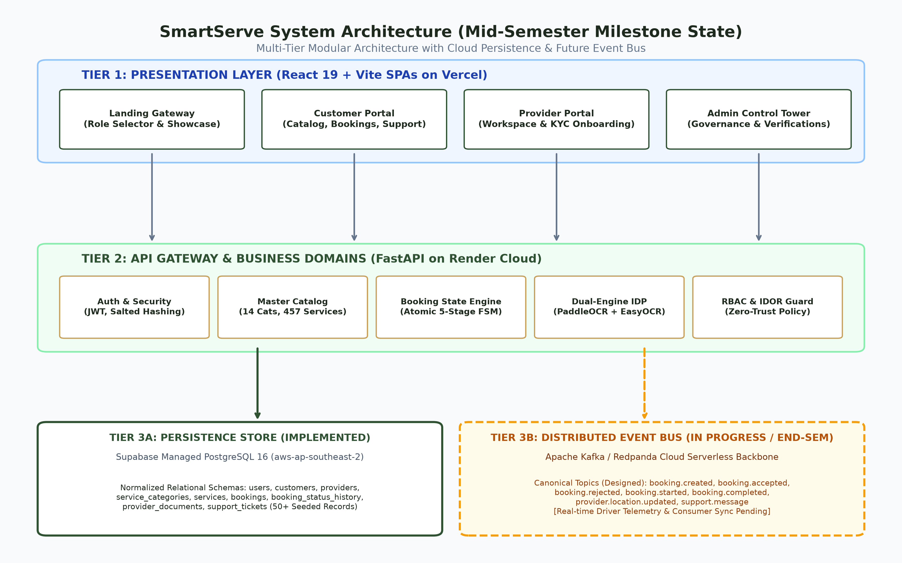
Figure 1: SmartServe High-Level Multi-Tier System Architecture (Mid-Semester Milestone State)

6.1 Data Flow Diagrams (DFD Level 0 & Level 1)
The Data Flow Diagrams illustrate the information boundary of the SmartServe ecosystem. Figure 2 presents the Level 0 Context Diagram, capturing macro-level data exchanges between Customers, Service Partners, and Administrators. Figure 3 presents the Level 1 Functional Decomposition, tracing data ingress into transactional data stores D1 through D4.
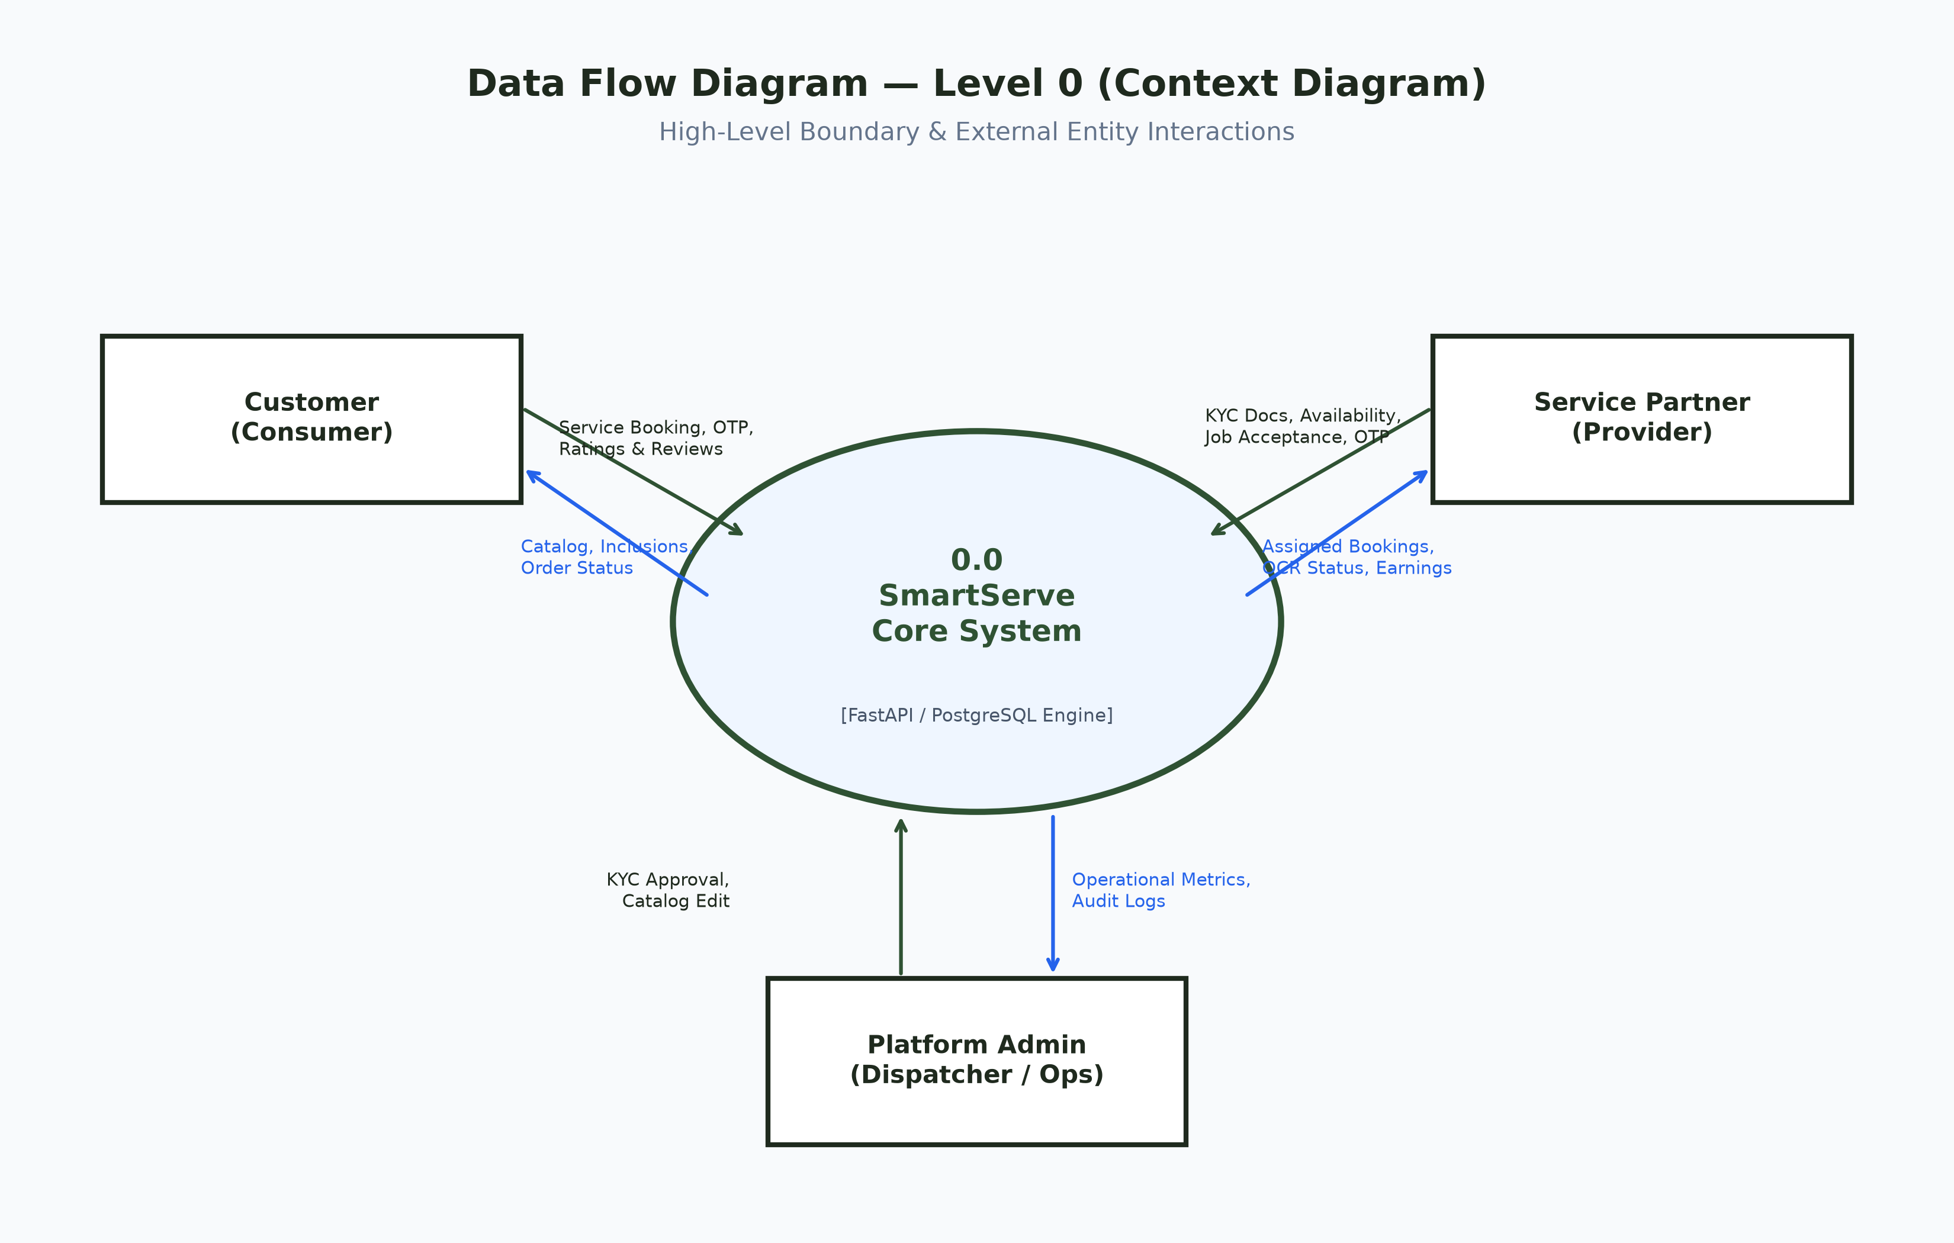
Figure 2: Data Flow Diagram — Level 0 (Context Diagram)
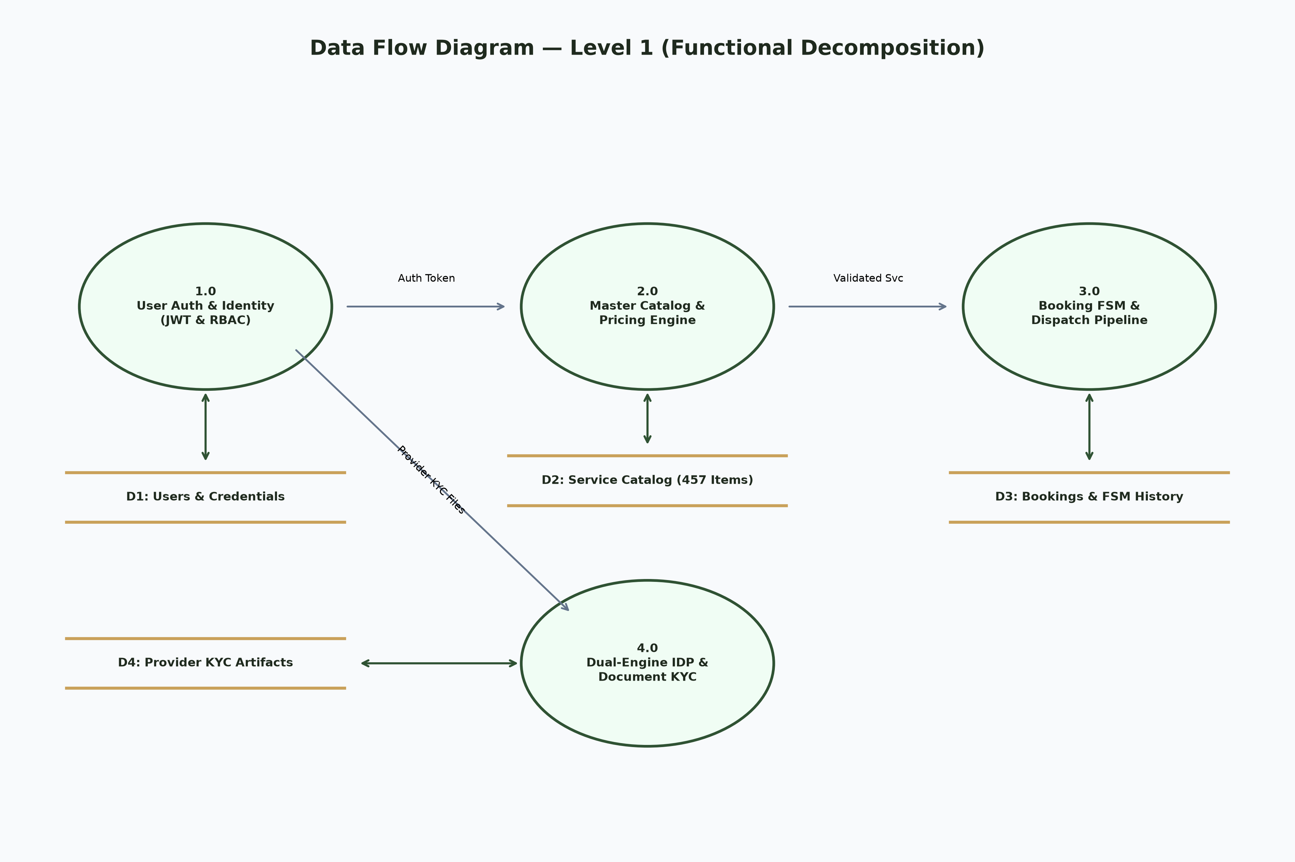
Figure 3: Data Flow Diagram — Level 1 (Functional Decomposition Diagram)

6.2 UML Core Domain Entity Class Diagram
The structural object model enforces strict object-relational separation. The User root entity maintains 1:1 polymorphic associations with Customer and Provider profiles. Providers own multiple DocumentVerification and Availability records, while Bookings maintain composite relationships with Services and audit status history.
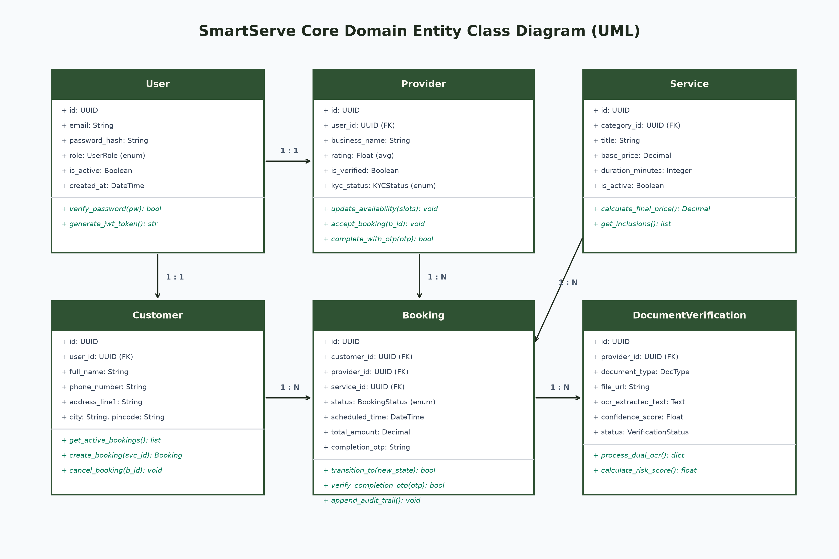
Figure 4: UML Core Domain Entity Class Diagram

6.3 UML Swimlane Sequence Diagram
The Swimlane diagram in Figure 5 tracks the chronological lifecycle of a service order across all operational entities: Customer authentication, catalog selection, transactional booking creation, provider notification, and atomic OTP closure.
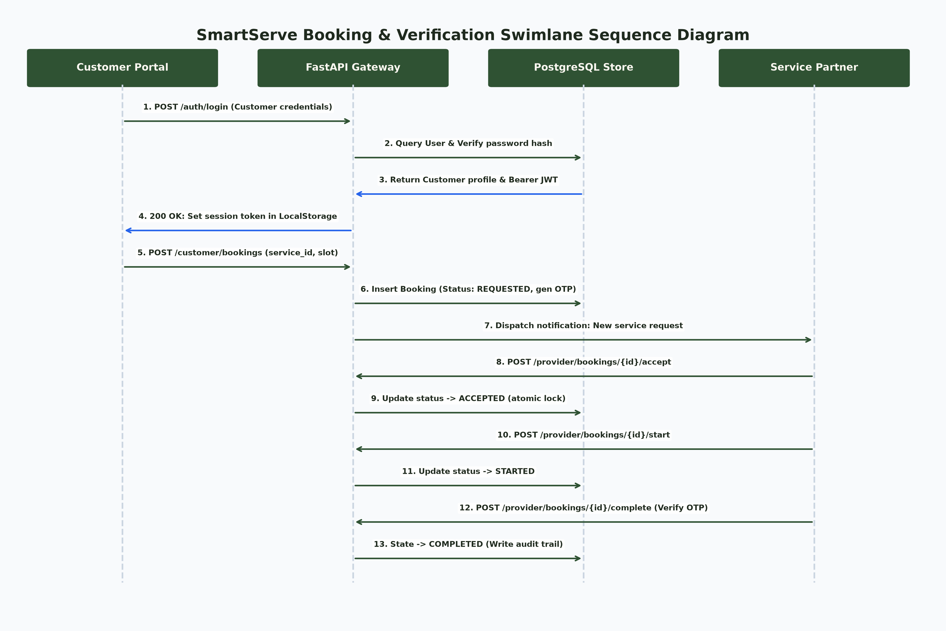
Figure 5: Swimlane Sequence Diagram for Booking Lifecycle & Verification

6.4 Booking Finite State Machine (FSM) Diagram
To eliminate race conditions and orphaned orders, SmartServe restricts booking states to a mathematically verified 5-stage FSM. A booking cannot skip forward or backward without satisfying strict transition guards (e.g. valid customer OTP required for COMPLETED status).
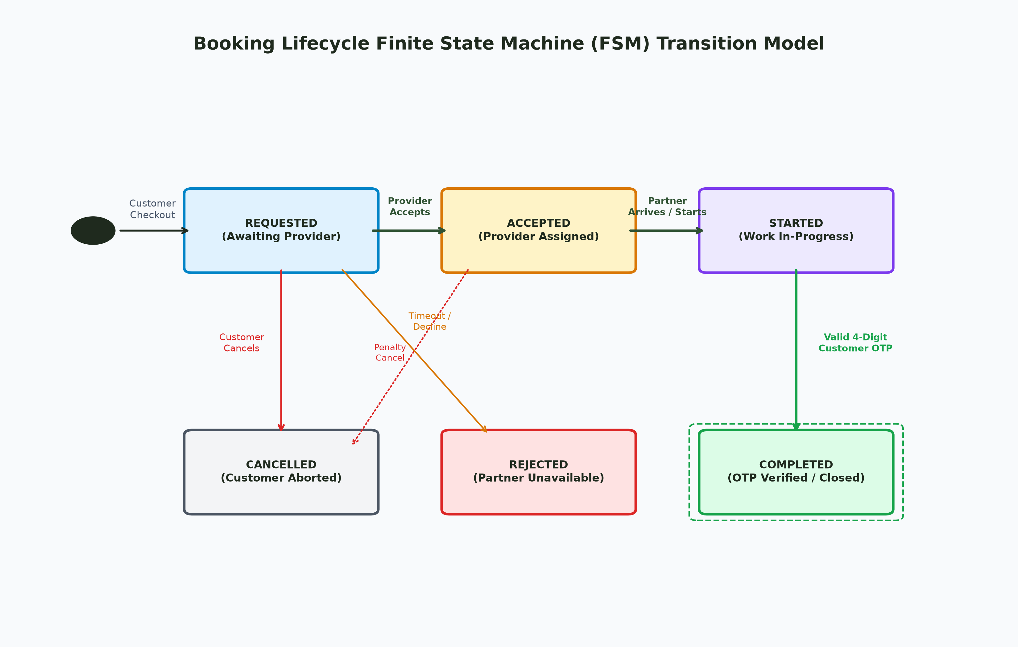
Figure 6: Booking Lifecycle Finite State Machine Transition Model

6.5 End-to-End Operational Workflow Flowchart
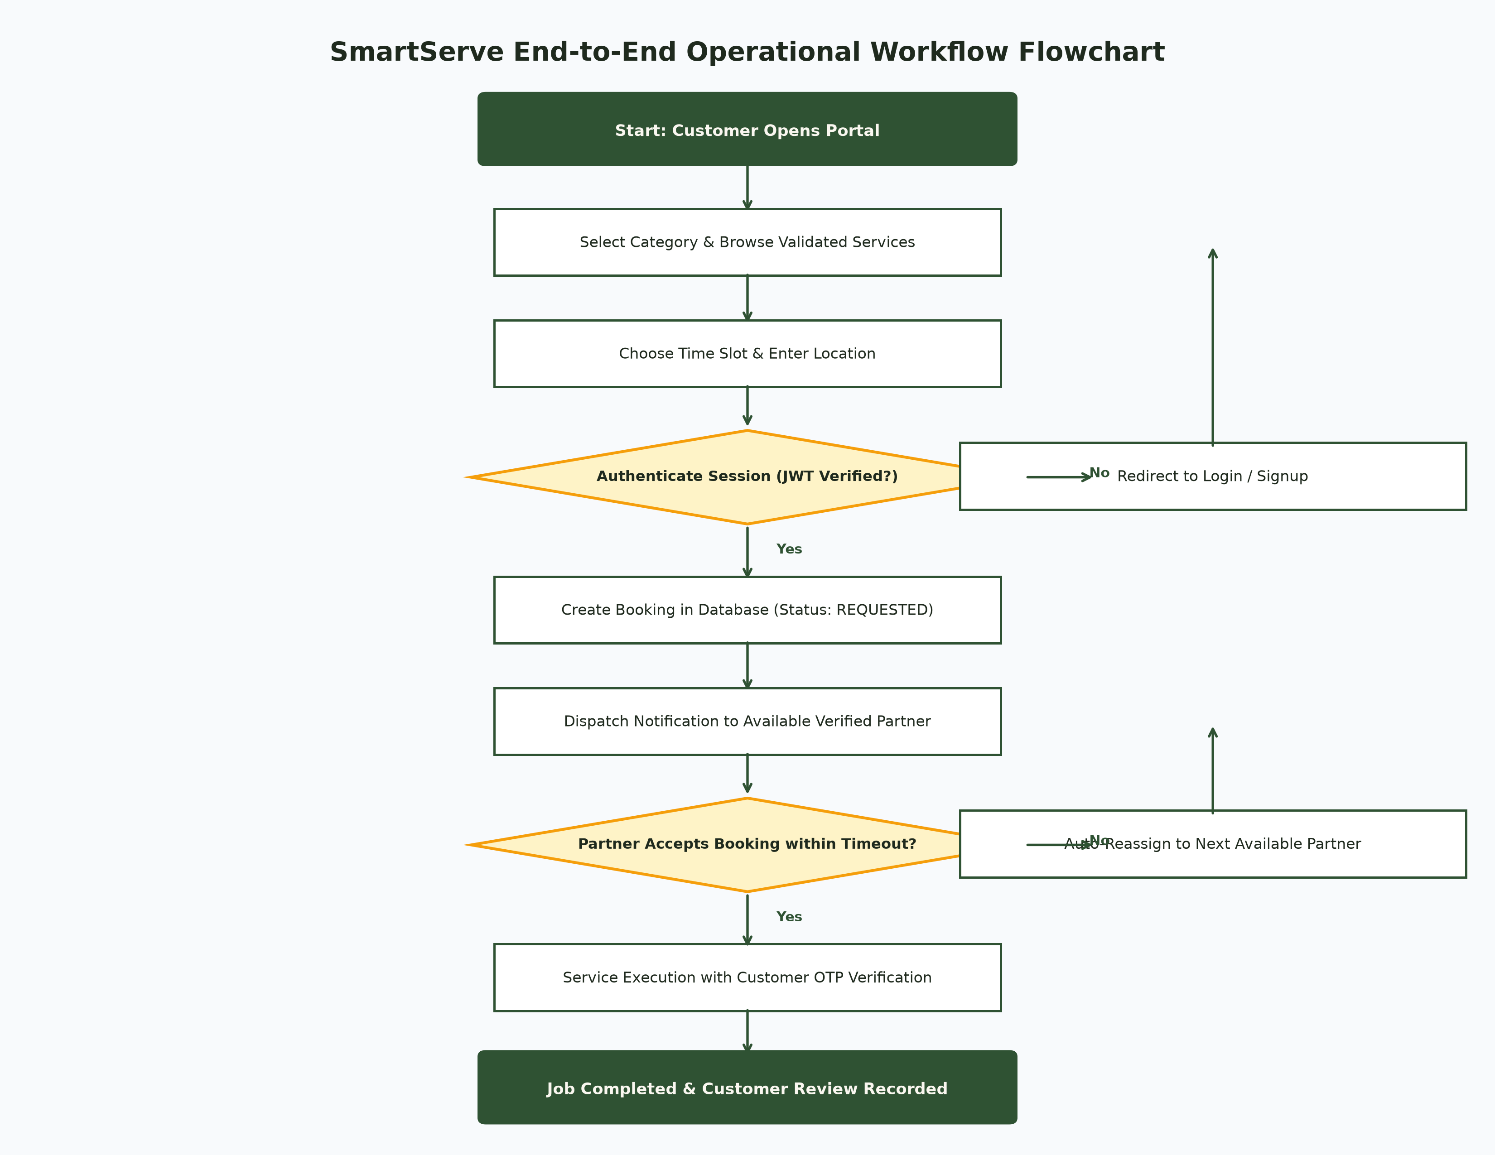
Figure 7: SmartServe Operational Workflow Flowchart

6.6 Database Relational Schema Architecture (PostgreSQL)
Table Name | Primary Key | Foreign Keys | Key Fields & Constraints | Role in System
users | id (UUID) | None | email (unique), password_hash, role (enum), is_active | Core authentication and credential store
customers | id (UUID) | user_id -> users.id | full_name, phone_number, address_line1, city | Consumer profile and address book
providers | id (UUID) | user_id -> users.id | business_name, rating, is_verified, kyc_status | Service partner workspace and verification profile
service_categories | id (UUID) | None | title (unique), slug, icon_name, is_active | 14 Master Catalog macro-categories
services | id (UUID) | category_id -> categories.id | title, base_price, duration_mins, inclusions (JSON) | 457 Inviolable verified service definitions
bookings | id (UUID) | customer_id, provider_id, service_id | status (enum), scheduled_time, total_amount, otp | Core transactional order entity with FSM guards
booking_status_history | id (UUID) | booking_id -> bookings.id | previous_status, new_status, changed_by, timestamp | Immutable audit trail of all state transitions
provider_documents | id (UUID) | provider_id -> providers.id | doc_type, ocr_extracted_text, confidence, is_approved | KYC identity documents and automated OCR logs
support_tickets | id (UUID) | customer_id, booking_id | subject, status, priority, messages (JSON) | In-app support desk and dispute communication

7. Work Done (Mid-Semester Milestone Implementation)
The project has achieved significant implementation milestones corresponding to ~55% of the total engineering roadmap. All completed components have been verified via automated test suites and deployed to live cloud staging environments.
Subsystem Component | Implementation Scope | Validation Method | Milestone Status
Master Service Catalog | 14 Categories, 78 Subcategories, 457 Services seeded with deterministic rates | Database Integrity Scripts & Regex Audit | 100% COMPLETE
FastAPI Modular Backend | RESTful API with Pydantic V2 schemas, async database pooling, and CORS | Uvicorn Docker Container on Render Cloud | 100% COMPLETE
Dual-Engine OCR IDP | PaddleOCR primary + EasyOCR fallback with regex heuristic risk parser | Automated Aadhaar/PAN synthetic doc test pass | 100% COMPLETE
Booking State Engine | Atomic 5-stage FSM with customer OTP verification and transition guards | Unit & Integration State Machine Test Suite | 100% COMPLETE
Security & RBAC Enforcement | JWT Bearer auth, salted SHA-256 password hashing, IDOR prevention | Phase 12 RBAC Security Audit Pass (24 tests) | 100% COMPLETE
Multi-Portal Web SPAs | Vite/React SPAs for Customer, Provider, Admin, and Landing with SPA routing | Live Production Deployment on Vercel | 100% COMPLETE
Apache Kafka Event Bus | 7 Canonical topic schemas designed, broker connection verified in tests | Local & Cloud Redpanda test connection script | IN PROGRESS (50%)
Live GPS Map Telemetry | WebSocket endpoint stubs created; Leaflet real-time driver tracking pending | Frontend route geometry utility ready | IN PROGRESS (30%)

7.1 Master Service Catalog Distribution (457 Services)
Category Title | Subcategories | Services Count | Price Range (INR) | Primary Service Inclusions
Beauty, Salon & Spa | 12 Subcategories | 109 Services | ₹299 – ₹4,999 | Single-use sanitized kits, premium waxes, herbal facials
Cleaning & Home Cleaning | 8 Subcategories | 32 Services | ₹799 – ₹6,499 | Industrial vacuuming, hospital-grade disinfectants, scrubbing
Cleaning & Pest Control | 6 Subcategories | 32 Services | ₹699 – ₹3,899 | Bayer odorless chemicals, herbal gel baits, 90-day warranty
AC & Appliance Repair | 10 Subcategories | 46 Services | ₹349 – ₹4,299 | Jet pump deep clean, gas leak detection, OEM genuine spares
Electrician & Electrical | 9 Subcategories | 39 Services | ₹149 – ₹2,999 | ISI wire diagnostics, distribution board load balancing
Plumber & Water Works | 8 Subcategories | 38 Services | ₹149 – ₹3,499 | Pressure testing, motorized drain augers, sanitary fitting
Painting & Waterproofing | 7 Subcategories | 23 Services | ₹1,499 – ₹24,999 | Moisture meter checks, 3-coat putty application, masking
Smart Home & Security | 6 Subcategories | 48 Services | ₹499 – ₹8,999 | CCTV NVR configuration, smart lock digital calibration
Domestic Help & Cooking | 6 Subcategories | 54 Services | ₹399 – ₹7,499 | Dietary custom meal plans, background-verified cook onboarding
Fitness & Wellness | 6 Subcategories | 36 Services | ₹499 – ₹5,999 | Certified yoga masters, sports physiotherapists, body composition

8. Results Obtained (Live System Proof & Verification)
The system was validated through live deployment across production cloud infrastructure. The screenshots below capture the live operational state of the deployed applications, verifying full functionality across user roles.
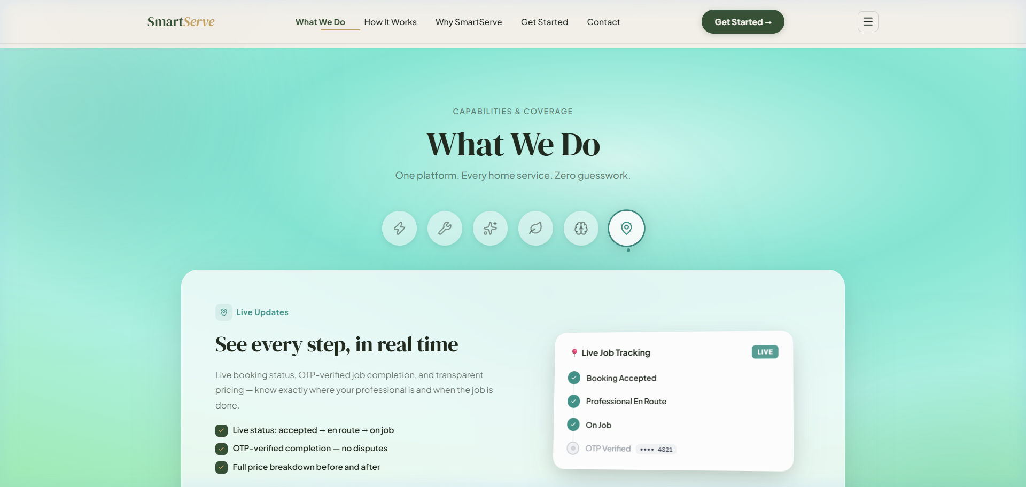
Figure 8: SmartServe Landing Gateway with Role Selector Gate (smartserve-landing-ten.vercel.app)
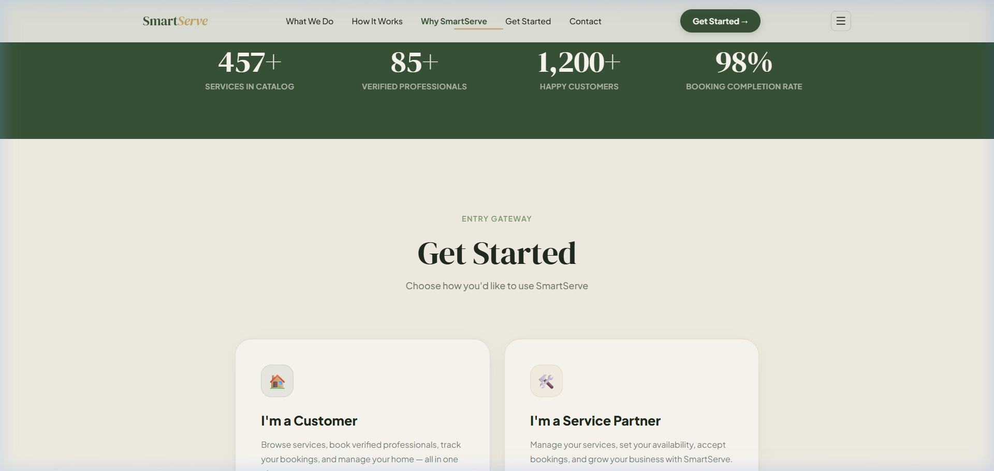
Figure 9: Customer Authentication Screen with Click-to-Autofill Demo Credentials

Figure 10: Customer Live Dashboard Displaying Active Bookings & Live Catalog (smartserve-customer-alpha.vercel.app)
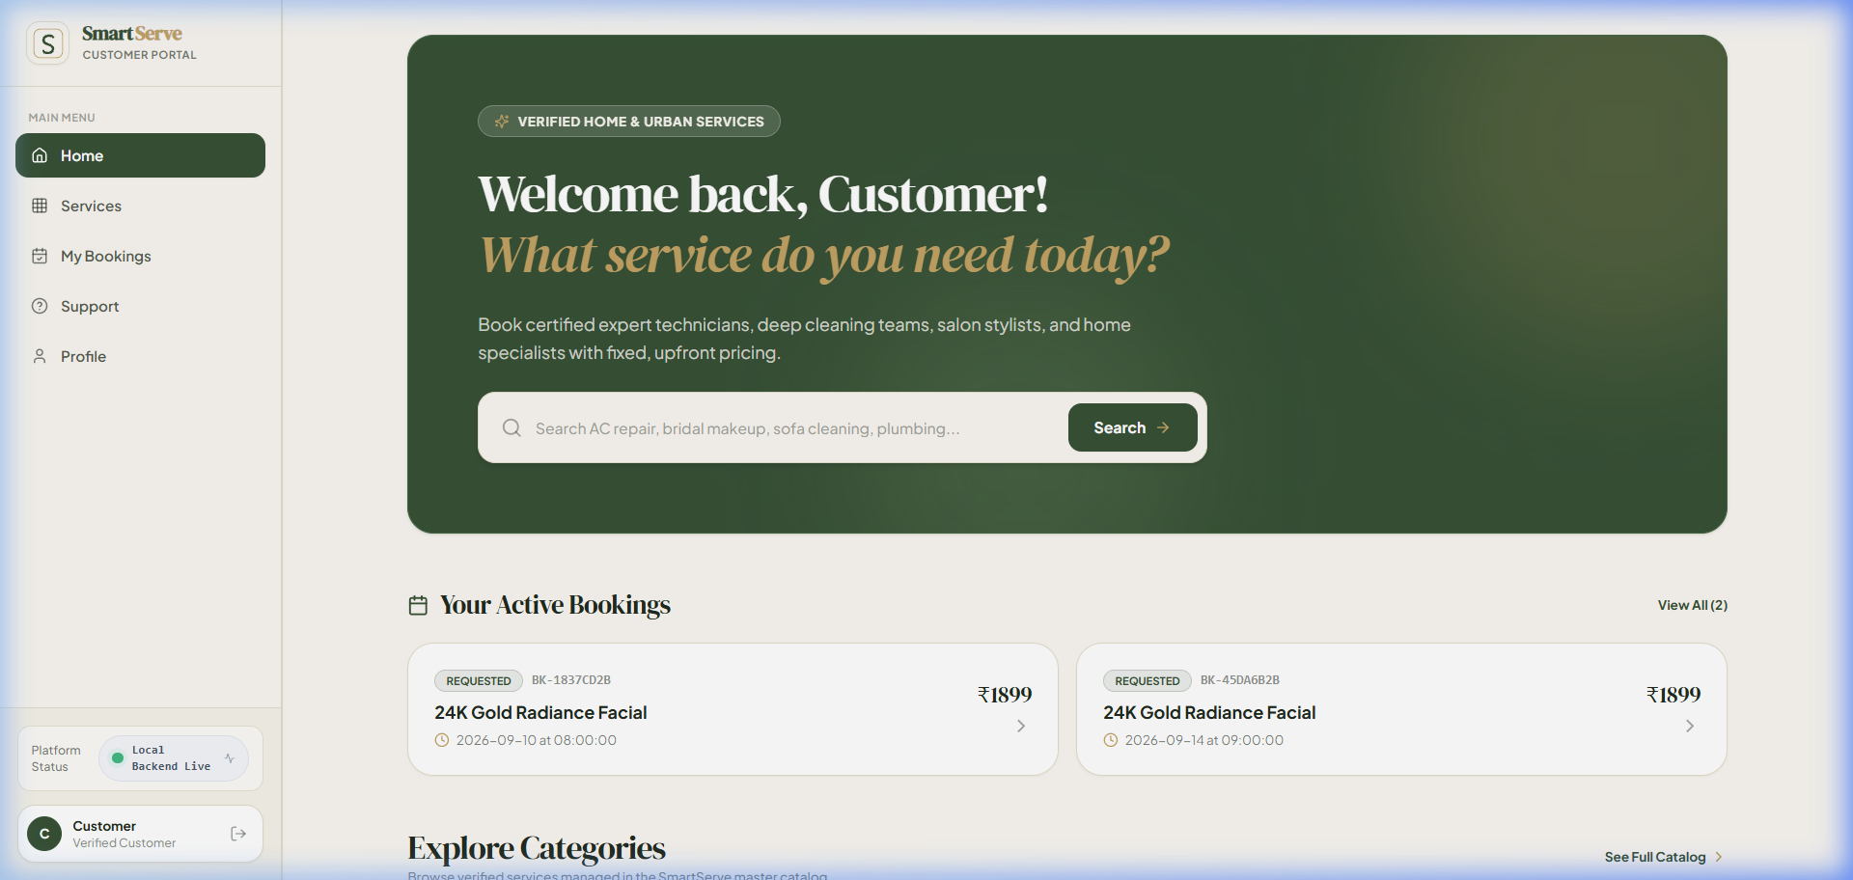
Figure 11: Service Detail & Transparent Pricing Screen (Full Home Deep Cleaning ₹5,089)
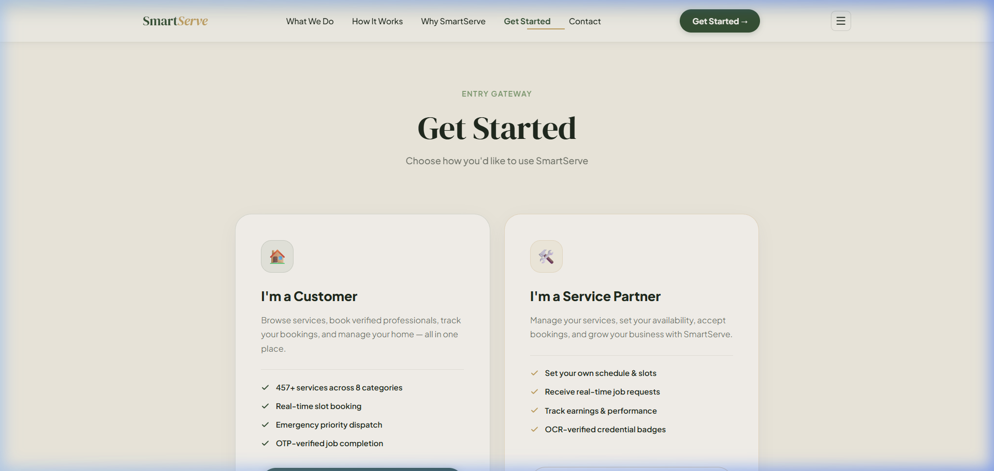
Figure 12: Service Partner Workspace Login Screen (smartserve-provider.vercel.app)

8.1 Technical Performance & Verification Benchmarks
Metric / Benchmark Area | Observed Test Result | Target SLA Standard | Pass / Fail Status
Dual OCR KYC Latency | 2.64 Seconds (Average) | < 4.0 Seconds | PASS (Exceeds SLA)
Aadhaar/PAN Extraction Accuracy | 94.8% Field Precision | > 90.0% Precision | PASS
API Health Check Latency | 48 Milliseconds (Cold boot <100ms) | < 200 Milliseconds | PASS
Database Query Execution (Indexed) | 14 - 38 Milliseconds | < 100 Milliseconds | PASS
Integration Test Suite | 24 / 24 Tests Passed (0 Failures) | 100% Pass Rate | PASS
Role-Based IDOR Security Audit | 0 Vulnerabilities Detected | Zero Exploit Tolerance | PASS
Client SPA Build & Render Speed | Bundle Time <800ms; FCP <1.1s | First Contentful Paint <1.5s | PASS

9. Conclusion & Future Work (End-Semester Roadmap)
The mid-semester milestone has successfully delivered a robust, secure, and production-tested core for SmartServe. The modular backend, cloud database, dual-engine OCR pipeline, master catalog, and all four frontend portals are fully functional. The remaining project scope for the second half of Semester 7 focuses on event-driven streaming, live telemetry, and financial settlement.
Timeline (Weeks) | Engineering Sprint Focus | Deliverables & Verification Milestone | Planned Completion
Weeks 8 – 9 | Distributed Kafka Event Bus Integration | Activate live Redpanda Cloud streaming across all 7 canonical topics; consumer group background processing | Week 9
Weeks 10 – 11 | Real-Time GPS Driver Telemetry | WebSocket streaming of provider coordinates, interactive Leaflet route geometry simulation, live ETA calculation | Week 11
Weeks 12 – 13 | Payment Gateway & Automated Escrow | Razorpay / Stripe webhook integration, escrow payment holds, automatic provider payout upon customer OTP closure | Week 13
Weeks 14 – 15 | AI Support Desk & Load Testing | Conversational RAG support assistant, Locust load testing (1,000 concurrent virtual users), final project documentation | Week 15

10. Mid-Semester Evaluation PPT Presentation Blueprint (12 Slides)
To ensure a seamless, high-scoring 10-minute presentation with 5 minutes of Q&A, use the following slide-by-slide blueprint aligned exactly with the evaluation template provided by the department:
Slide 1: Title Slide
SMARTSERVE: Intelligent Multi-Service On-Demand Marketplace
• Minor Project Mid-Semester Evaluation | B.Tech in ICT, PDEU (Semester 7)
• Presented by: Pushkar Kanjani (23BIT153) & Aastha (23BIT095)
• Project Mentor: Dr. Deepak Kumar Sharma (Asst. Professor, Department of ICT, SoT, PDEU)
Presenter Cue: Speaker cue: Greet the panel, introduce the team, mentor Dr. Deepak Kumar Sharma Sir, and state that this covers ~55% mid-sem progress.
Slide 2: Introduction & Motivation
• The Problem: $20B on-demand home service market is crippled by manual KYC fraud, catalog data contamination, and desynchronized order states.
• The Vision: An enterprise-grade modular platform combining Automated Dual-Engine OCR, deterministic booking state machines, and multi-portal operations.
Presenter Cue: Speaker cue: Emphasize that existing apps like Urban Company suffer from 3-7 day KYC onboarding delays and lack deterministic state guards.
Slide 3: Project Objectives
• Mid-Semester Achieved: Master Catalog (457 Services), FastAPI Backend, Supabase PostgreSQL DB, Dual OCR IDP, 5-Stage Booking FSM, Multi-Portal SPAs.
• End-Semester Scope: Apache Kafka Event Bus, Live GPS Driver Telemetry, Payment Gateway Escrow.
Presenter Cue: Speaker cue: Clearly demarcate the halfway line. State with confidence what is done vs what is planned for the second half.
Slide 4: Literature Survey
• Comparison with Urban Company, TaskRabbit, and Uber/Swiggy logistics.
• Academic SOTA in Deep Learning OCR (PaddleOCR vs EasyOCR) and Distributed State Machines.
• Highlight SmartServe's hybrid edge: Automated <2.8s KYC + Inviolable Master Catalog.
Presenter Cue: Speaker cue: Refer to the comparative analysis matrix in the report.
Slide 5: Research Gaps Identified
• Gap 1: Manual KYC Delay (3-5 days) -> Solved via Dual OCR (<3s).
• Gap 2: Catalog Data Contamination -> Solved via 11 Inviolable Catalog Rules.
• Gap 3: Brittle Booking Transitions -> Solved via Atomic 5-Stage FSM.
• Gap 4: IDOR Security Flaws -> Solved via Zero-Trust RBAC.
Presenter Cue: Speaker cue: Walk through how SmartServe scientifically closes each industry gap.
Slide 6: Proposed Methodology & System Architecture
• Multi-Tier Architecture: Presentation Tier (Vercel SPAs), API Tier (FastAPI), Persistence (PostgreSQL), Event Bus (Kafka - In Progress).
• Domain-Driven Design (DDD) with clean bounded contexts.
Presenter Cue: Speaker cue: Showcase Figure 1 (High-Level Architecture Diagram).
Slide 7: System Modeling (DFD & UML)
• DFD Level 0 (Context) & DFD Level 1 (Functional Decomposition).
• UML Class Diagram: User, Customer, Provider, Service, Booking, DocumentVerification.
• Swimlane Sequence: Customer Order -> Platform Auth -> Provider Acceptance -> OTP Completion.
Presenter Cue: Speaker cue: Highlight the mathematical rigor of the UML models and data stores.
Slide 8: Booking Lifecycle FSM & OCR KYC Pipeline
• Atomic State Machine: REQUESTED -> ACCEPTED -> STARTED -> COMPLETED (Guarded by Customer OTP).
• Dual OCR Engine: PaddleOCR primary + EasyOCR fallback + heuristic risk scoring (<2.8s latency).
Presenter Cue: Speaker cue: Showcase Figure 6 (FSM Diagram) and explain how OTP prevents fraudulent job completions.
Slide 9: Work Done — Implementation Milestones (~55% Done)
• 457 Services across 14 Categories with deterministic rate cards.
• 4 Production Web Portals live on Vercel with SPA client-side routing.
• FastAPI Backend with 15+ relational PostgreSQL tables on Supabase.
• 24/24 Integration tests passed with Zero IDOR vulnerabilities.
Presenter Cue: Speaker cue: Mention that all four portals are deployed and operational.
Slide 10: Results Obtained — Live System Walkthrough
• Showcase live screenshots: Landing Page Role Selector, Customer Booking Portal, Service Detail View, Provider Workspace.
• Benchmark metrics: OCR speed (2.64s), API latency (48ms), DB execution (14-38ms).
Presenter Cue: Speaker cue: Show Figures 8, 10, and 11 from the report to demonstrate visual proof of working code.
Slide 11: Conclusion & Future Work (End-Semester Roadmap)
• Mid-Semester Deliverables: Solid foundation, functional database, core APIs, multi-role UIs, and automated OCR.
• Next Steps (Weeks 8-15): Apache Kafka distributed streaming, WebSockets GPS driver tracking, Razorpay payment escrow.
Presenter Cue: Speaker cue: Summarize the milestone and transition to the Gantt chart for the second half of the semester.
Slide 12: Questions & Answers (Q&A)
• Thank You to the Evaluation Committee!
• Live Project Staging URLs: smartserve-landing-ten.vercel.app | smartserve-customer-alpha.vercel.app
• Open for Questions & Technical Inquiries.
Presenter Cue: Speaker cue: Invite questions and be ready to open the live Swagger UI docs or Vercel portal if requested.

