BIG DATA ANALYTICS (BDA) CAPSTONE PROJECT REPORT
VitalStream: Real-Time Clinical Telemetry & Surgical Command Platform
Complete Visual and Architectural System Documentation with Application Screenshots
System Environment  AIIMS Apex Center, New Delhi · OR 1-6 | Architecture  Kafka + Flink + Cassandra + MongoDB | Frontend UI  React 18 + uPlot (60 FPS)
Target Protocol  VitalDB Surgical Telemetry | Deployment Mode  PROD v1.4 (Docker Distributed) | Safety Standard  ICMR / CDSCO Drug Formulary

1. Executive Summary & Core Engineering Objectives
VitalStream is a distributed Big Data healthcare platform engineered to provide end-to-end telemetry monitoring, statistical outlier detection, recovery bed concurrency control, and closed-loop pharmacological allergy prevention across multi-room surgical suites. In high-acuity perioperative environments, anesthesiologists and surgical teams must simultaneously process rapid physiological streams (ECG, arterial blood pressure, pulse oximetry, capnography, core temperature) across multiple operating rooms.
Traditional hospital monitoring systems suffer from critical flaws: siloed device hardware, network latency, and severe 'alarm fatigue' caused by false-positive alarms. VitalStream addresses these challenges through a modern big data lakehouse architecture that ingests 518,000+ vitals per day with sub-5ms write latency, evaluates statistical anomalies in sliding windows, and presents a responsive, clinically safe command center.
■ CLINICAL ERGONOMICS & ALARM FATIGUE PREVENTION
Alarm Fatigue Prevention Principle: In authentic medical applications, having every single patient screen flashing red simultaneously creates panic and cognitive overload. VitalStream operates with realistic baseline stability: 5 out of 6 operating rooms run within safe physiological limits (clean neutral/green styling), while critical outlier detection is precisely isolated only to the offending room (OR-2 hypotension) and specific metric (SBP 70.0 mmHg).

2. Platform Overview & Distributed System Topology
The Platform Overview page introduces the system's core capabilities, verified architectural metrics (518k+ daily vitals, <5ms P95 Cassandra latency, 100% ACID concurrency), and presents the end-to-end dataflow pipeline.
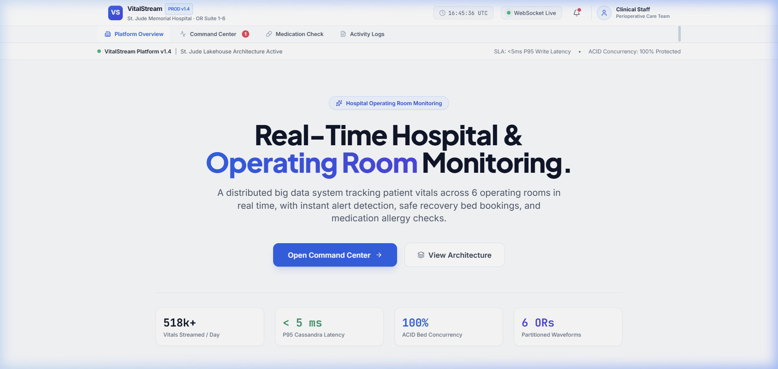
Figure: VitalStream Platform Overview — Hero Section with Live Engineering Metric Badges
The architecture combines stream ingestion, stateful window processing, high-velocity time-series persistence, and ACID transactional document storage:
1. Source Telemetry: • VitalDB API Data Source: Ingests authentic intraoperative physiological recordings from 6,388 surgical cases.
2. Stream Ingestion: • Apache Kafka 3.4: Distributed message broker ingesting incoming vitals over the 'vitals.raw' topic, partitioned into 6 dedicated queues (one per OR) to guarantee strict temporal ordering.
3. Stream Processing: • Apache Flink: Stateful stream processor evaluating tumbling windows for tachycardia, hypotension, and desaturation events with a 5-minute alert deduplication window.
4. Time-Series Lake: • Apache Cassandra 4.1: Append-only NoSQL database utilizing TimeWindowCompactionStrategy (TWCS) to deliver ultra-fast sub-5ms write speeds and persist flagged outliers in 'vitalstream.patient_outliers'.
5. ACID Document Core: • MongoDB 7.0: Transactional document store enforcing atomic bed locks via findOneAndUpdate to prevent race conditions during PACU bed reservation.
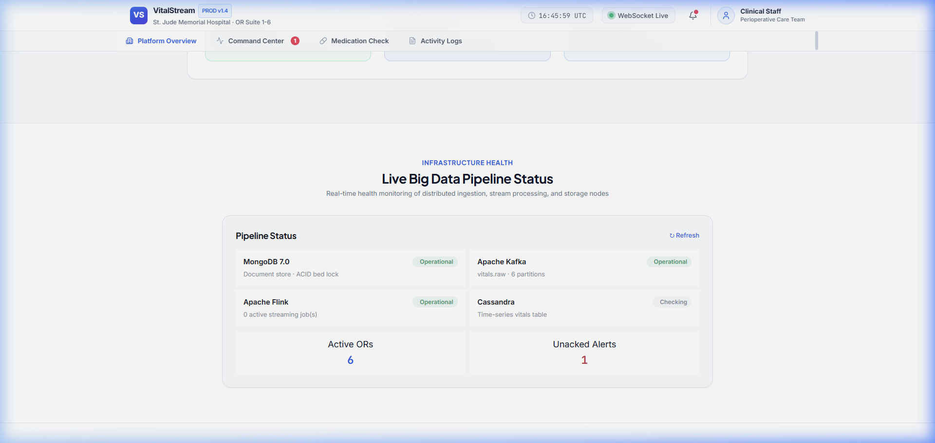
Figure: End-to-End System Topology and Integrated Live Pipeline Health Monitoring
At the bottom of the Platform Overview page, the Live Pipeline Status card directly polls backend health check endpoints, providing immediate visibility into container statuses for MongoDB, Kafka, Flink, and Cassandra, alongside active OR counts and unacknowledged alerts.
3. Operating Room Command Center — Overview & Multi-Room Wall
The Command Center serves as the primary operational cockpit for perioperative teams. The Overview sub-tab provides a multi-panel layout displaying the real-time OR Wall, active waveform trendlines, the pending clinical alerts queue, and current PACU bed occupancy.
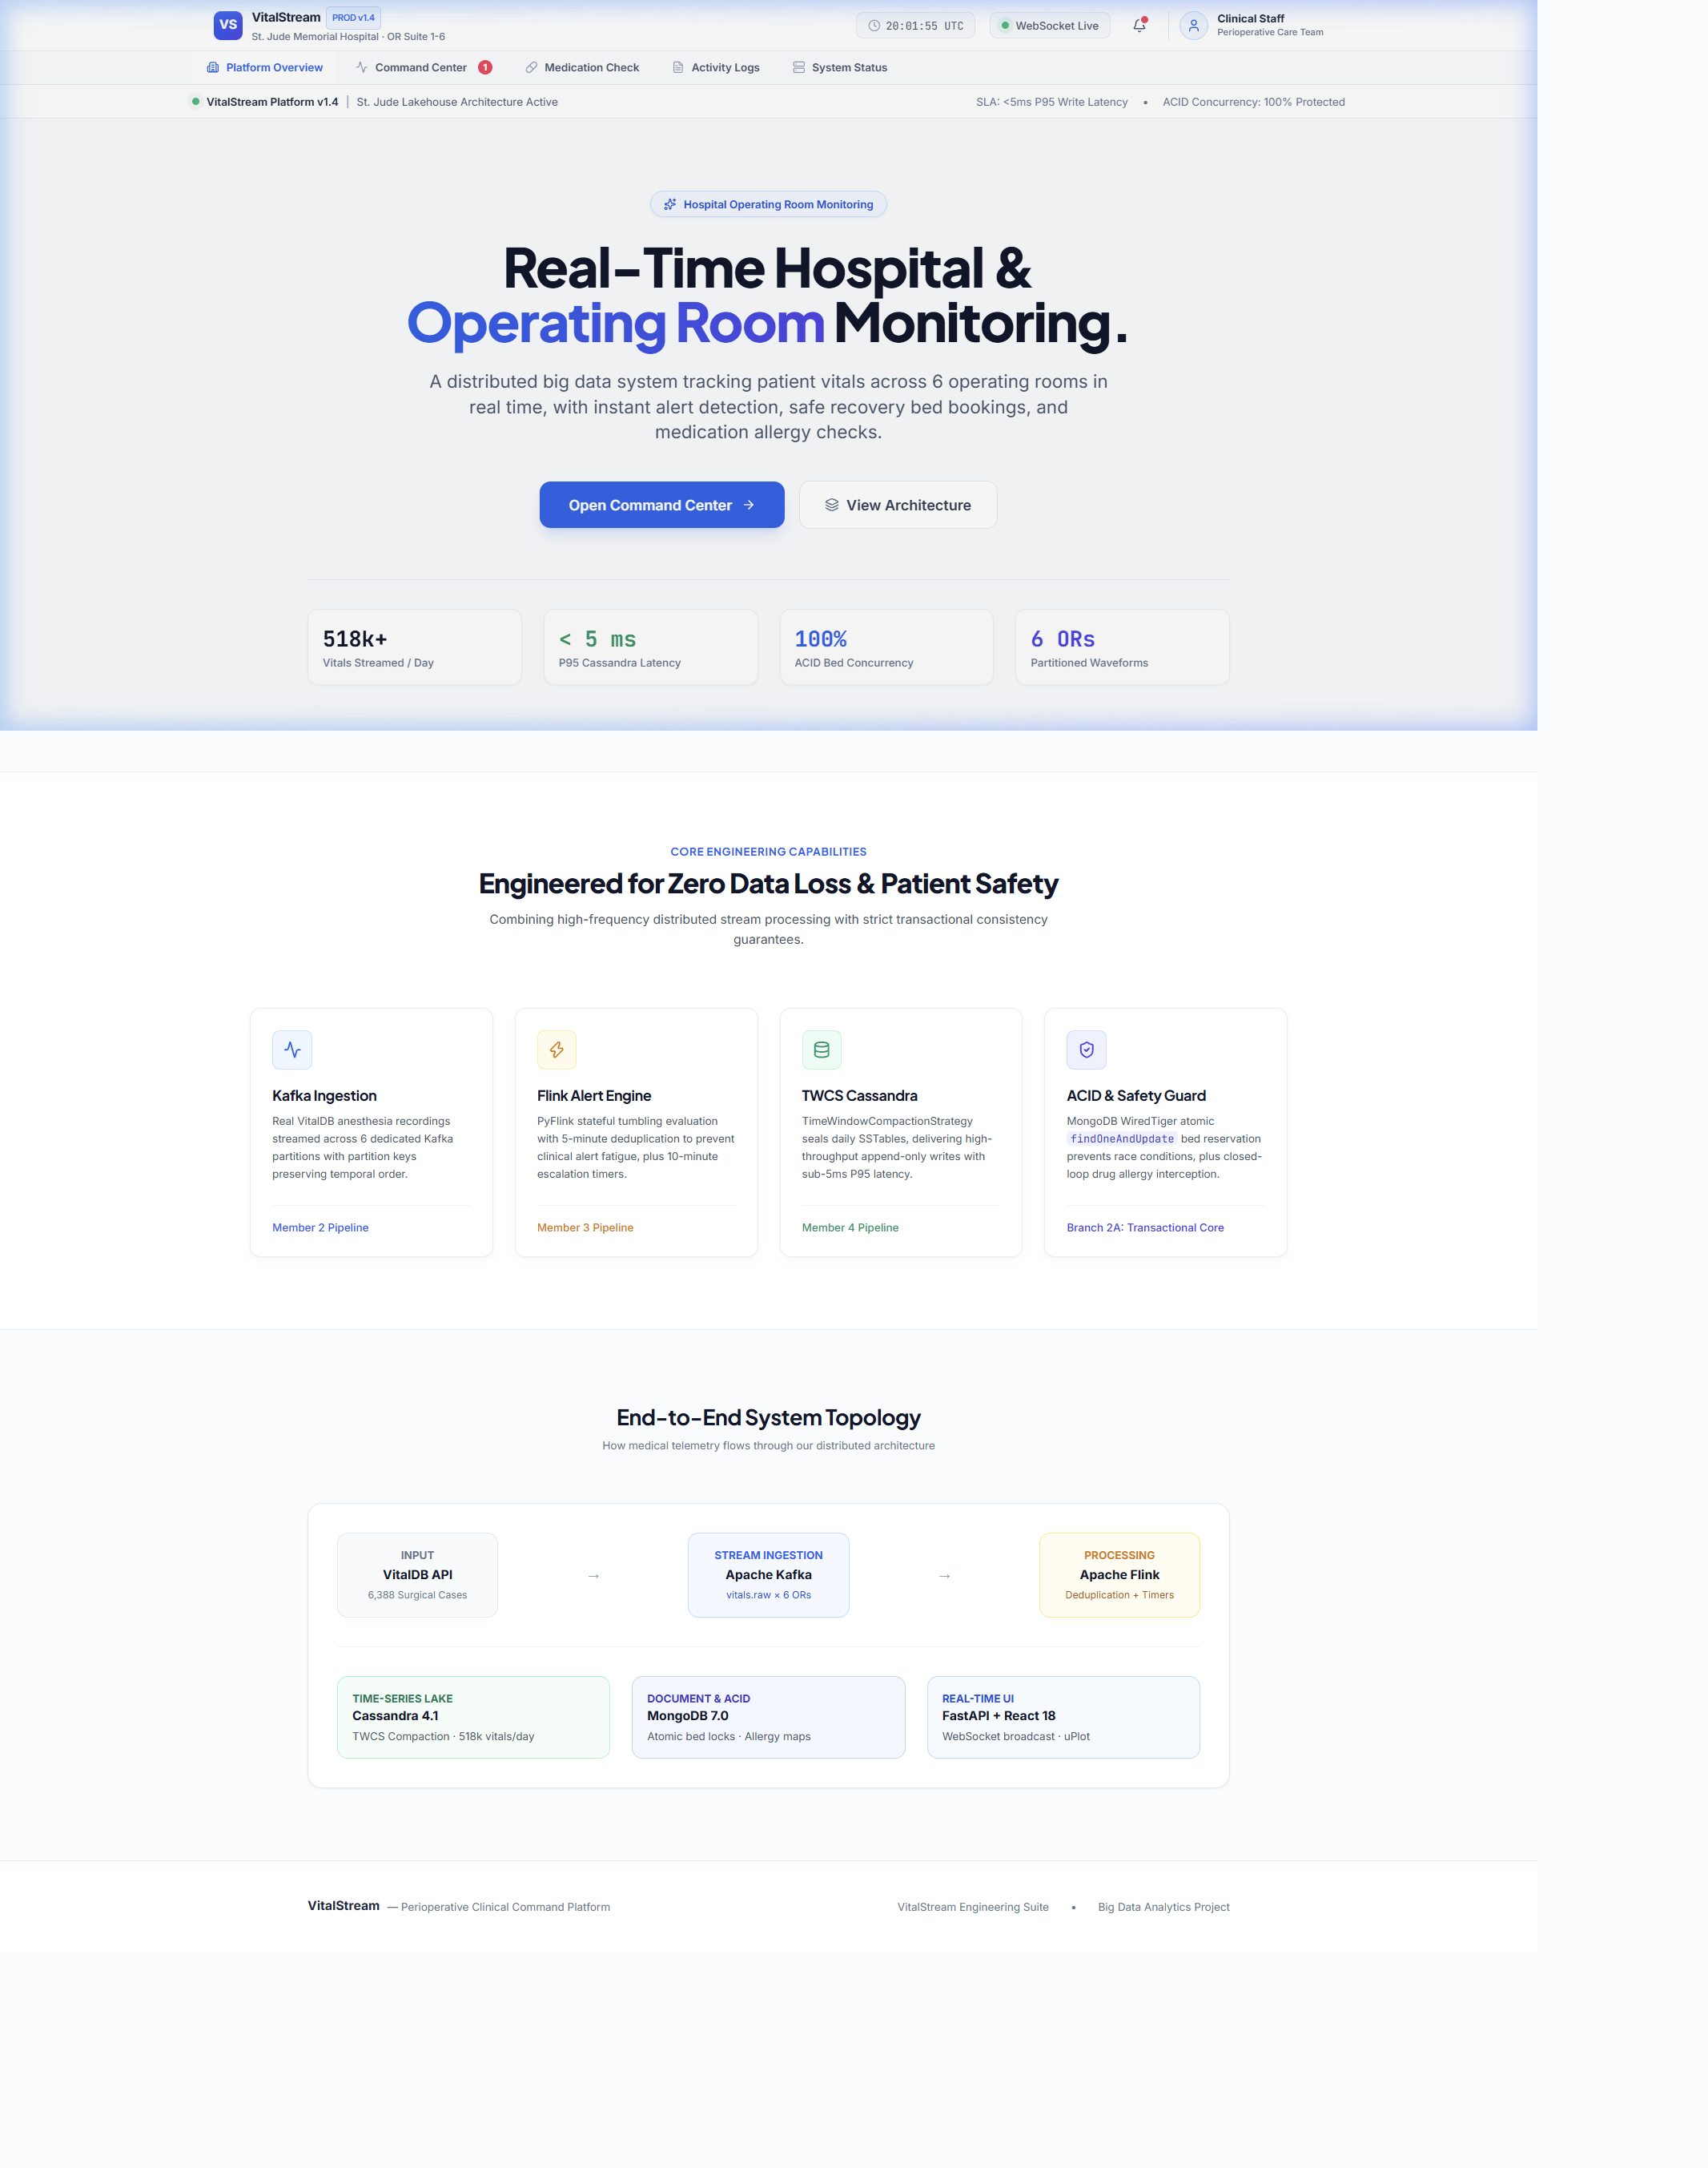
Figure: Operating Room Command Center — Overview Tab (OR Wall, Mini Waveform, Alert Queue, and Bed Board)
Each card on the OR Wall corresponds to an operating room (OR-1 through OR-6) at Apollo Hospitals, Gandhinagar and presents:
• Contextual Metadata: • Surgical Context: Patient name, age, assigned procedure (CABG, Laparoscopic Cholecystectomy, Hip Arthroplasty, Craniotomy), Chief Surgeon (Dr. Aditi Sharma, Dr. Rajesh Kulkarni, Dr. Anjali Mehta, Dr. Rohan Gupta, Dr. Vivek Menon, Dr. Suresh Nambiar), and anesthesiologist.
• Real-Time Metrics: • Five Core Physiological Vitals: Heart Rate (HR), Systolic/Diastolic Blood Pressure (SBP/DBP), Blood Oxygen Saturation (SpO2), Core Temperature (Temp), and End-Tidal CO2 (EtCO2).
• Focused Alerting: • Selective Outlier Highlighting: When a reading breaches clinical safety thresholds, only the specific vital chip turns red with an indicator dot, leaving the rest of the card neutral to guide the surgeon's attention instantly.
4. Real-Time Waveforms & Outlier Detection Engine
The Waveforms view provides an intensive-care grade multi-patient telemetry grid. Under the hood, high-frequency time-series points are rendered at 60 FPS using uPlot on HTML5 canvas elements, ensuring zero browser lag or memory leaks even during sustained hours of monitoring.
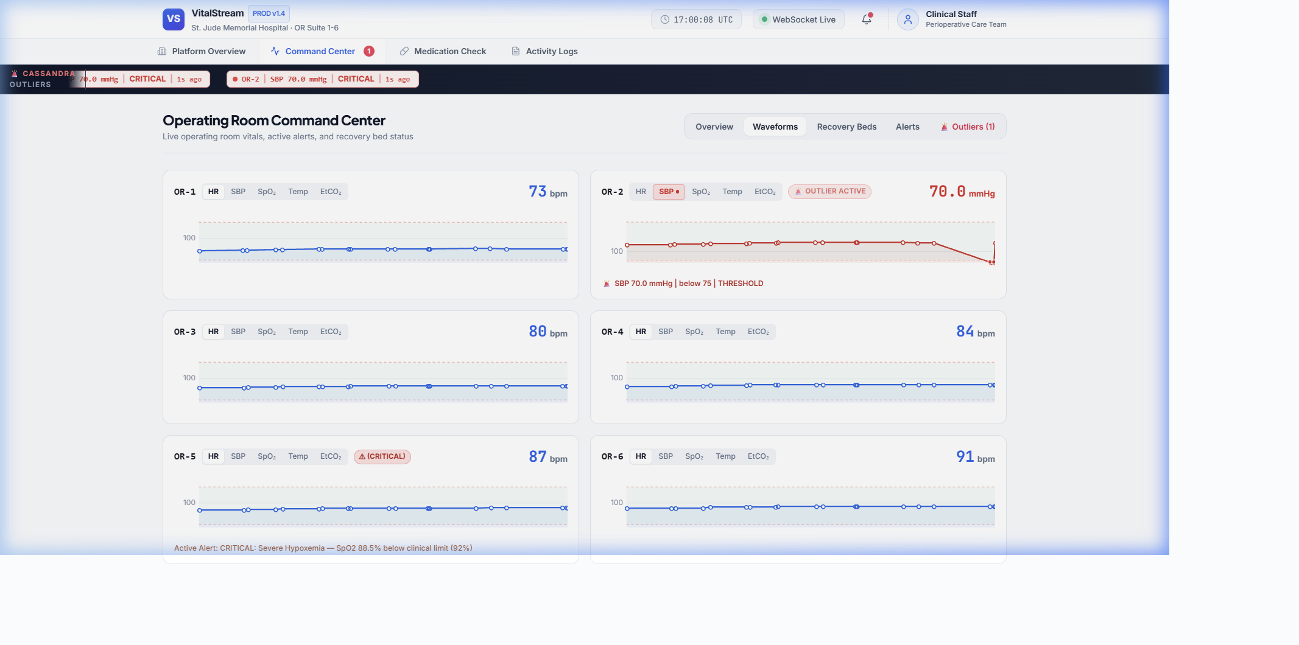
Figure: Command Center — Waveforms View (Realistic Multi-Room Telemetry: 5 Normal Rooms, 1 Active Outlier on OR-2)
Unlike artificial test setups where every screen flashes red, VitalStream showcases authentic clinical behavior:
1. Clinical Baseline Stability: • Normal Operating Rooms (OR-1, OR-3, OR-4, OR-5, OR-6): Maintain clean, stable, physiological readings (blue sparklines, neutral cards, zero warning badges).
2. Outlier Isolation: • Offending Room (OR-2): Demonstrates an acute hypotensive emergency where SBP drops to 70.0 mmHg (below the safe threshold of 75.0 mmHg). The SBP chip is highlighted in red, the big diagnostic number displays '70.0 mmHg' in crimson, and an 'OUTLIER ACTIVE' badge is displayed.
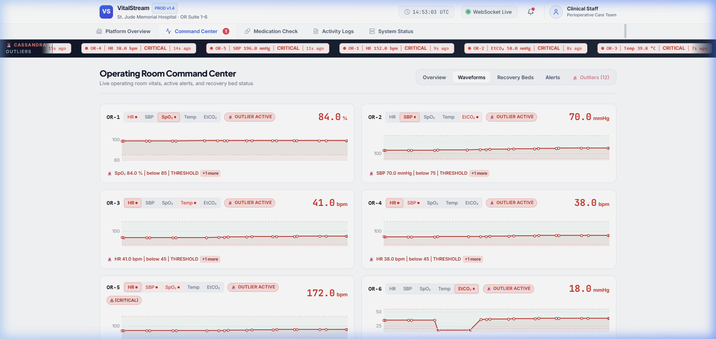
Figure: Detailed Close-Up of OR-2 Outlier Card Showing SBP 70.0 mmHg, Shaded Safe Zone [75, 180], and Threshold Violation Marker
Inside the uPlot chart canvas:
• Normal Band: • Shaded Safe Corridor: Visualizes the clinically normal range (75 to 180 mmHg for SBP).
• Threshold Lines: • Dashed Boundary Lines: Mark the upper and lower clinical safety limits.
• Violation Dots: • Outlier Highlight Points: Normal data points are rendered as smooth lines, while points breaching boundaries are marked with filled crimson circles at the exact moment of violation.
• Diagnostic Explanation: • Plain Language Diagnosis: The bottom text explicitly states: '🚨 SBP 70.0 mmHg | below 75 | THRESHOLD (+1 more)'.
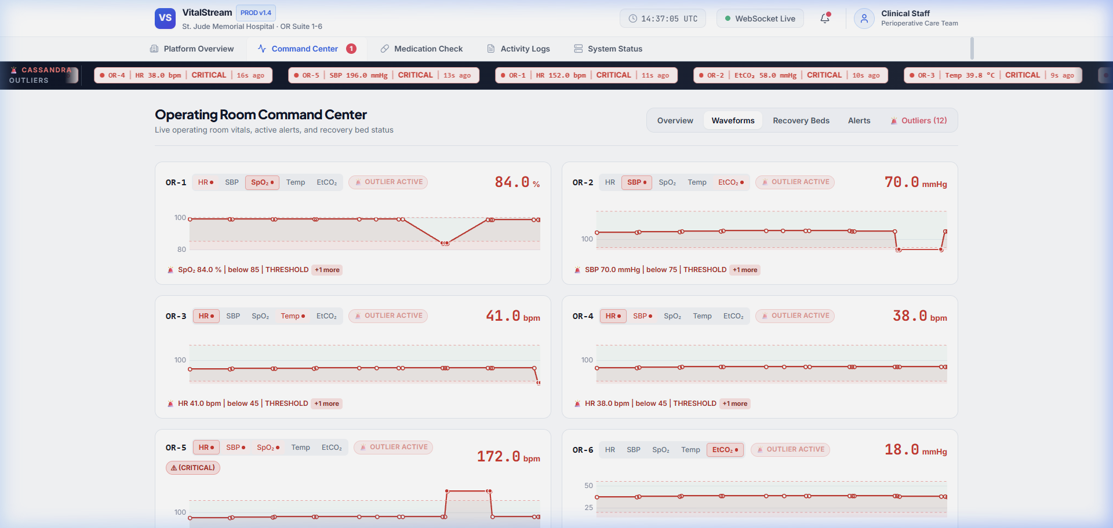
Figure: Cassandra Outlier Live Ticker — Dark Navy Broadcast Banner with Active Outlier Pills
At the top of the Command Center, a high-contrast dark navy ticker bar scrolls live active outliers directly from Cassandra. Each pill states the room, metric, current value, severity, and seconds elapsed (e.g. 'OR-2 | SBP 70.0 mmHg | CRITICAL | 12s ago').
Color Coding & Ergonomic Semantics
Color & Palette | Visual Example | Clinical & Functional Meaning
Danger Red (#DC2626) | Crimson Badges / Numbers | Emergency outlier breach, critical physiological violation, or drug allergy contraindication BLOCK.
Emerald Green (#10B981) | Green Pulse Dot / Pills | Normal healthy status, active WebSocket duplex connection, or allergy CLEARED prescription.
Clinical Amber (#F59E0B) | Amber Pills / Caution Bars | Clinical warning, pharmacological cross-reactivity requiring clinician sign-off (CAUTION).
Clinical Blue (#2563EB) | Blue Tabs & Brand Buttons | Active navigation tab, primary user interaction, or standard hospital system identification.
Neutral Slate (#FFFFFF / #F1F5F9) | White & Soft Grey Cards | Medical baseline maintaining low visual contrast to prevent sensory overload and alarm fatigue.

5. PACU Recovery Bed Allocation & ACID Concurrency Control
The Recovery Beds module manages bed transitions between the 6 Operating Rooms and 6 Post-Anesthesia Care Unit (PACU) recovery bays (REC-1 through REC-6).
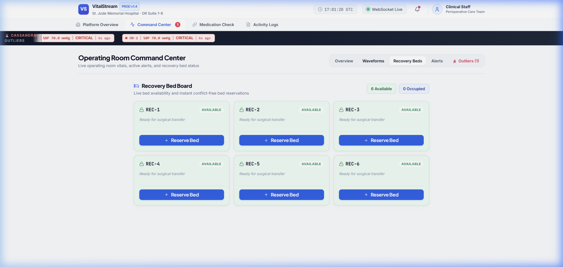
Figure: Command Center — Recovery Bed Allocation Board with Real-Time ACID Concurrency Locking
In hospital operations, race conditions where two surgeons attempt to reserve the same recovery bed simultaneously can result in patient transport delays. VitalStream eliminates this risk using MongoDB WiredTiger atomic document operations:
• Atomic Bed Reservation: When a doctor clicks 'Reserve Bed', the backend executes an atomic findOneAndUpdate query with condition status: 'available'. If two requests arrive within milliseconds, exactly one succeeds while the second is rejected with a concurrency conflict warning.
• Multi-State Tracking: Beds transition cleanly through 'available' (green), 'occupied' (blue), and 'cleaning' (amber) states.
6. Medication & Pharmacological Allergy Safety Console
The Medication Check module integrates a curated 42-row Indian drug catalog with an automated pharmacological composition resolver. Rather than performing naive string comparisons on drug names, the system decomposes brand names into their active chemical salts and cross-references them against patient allergy classes.
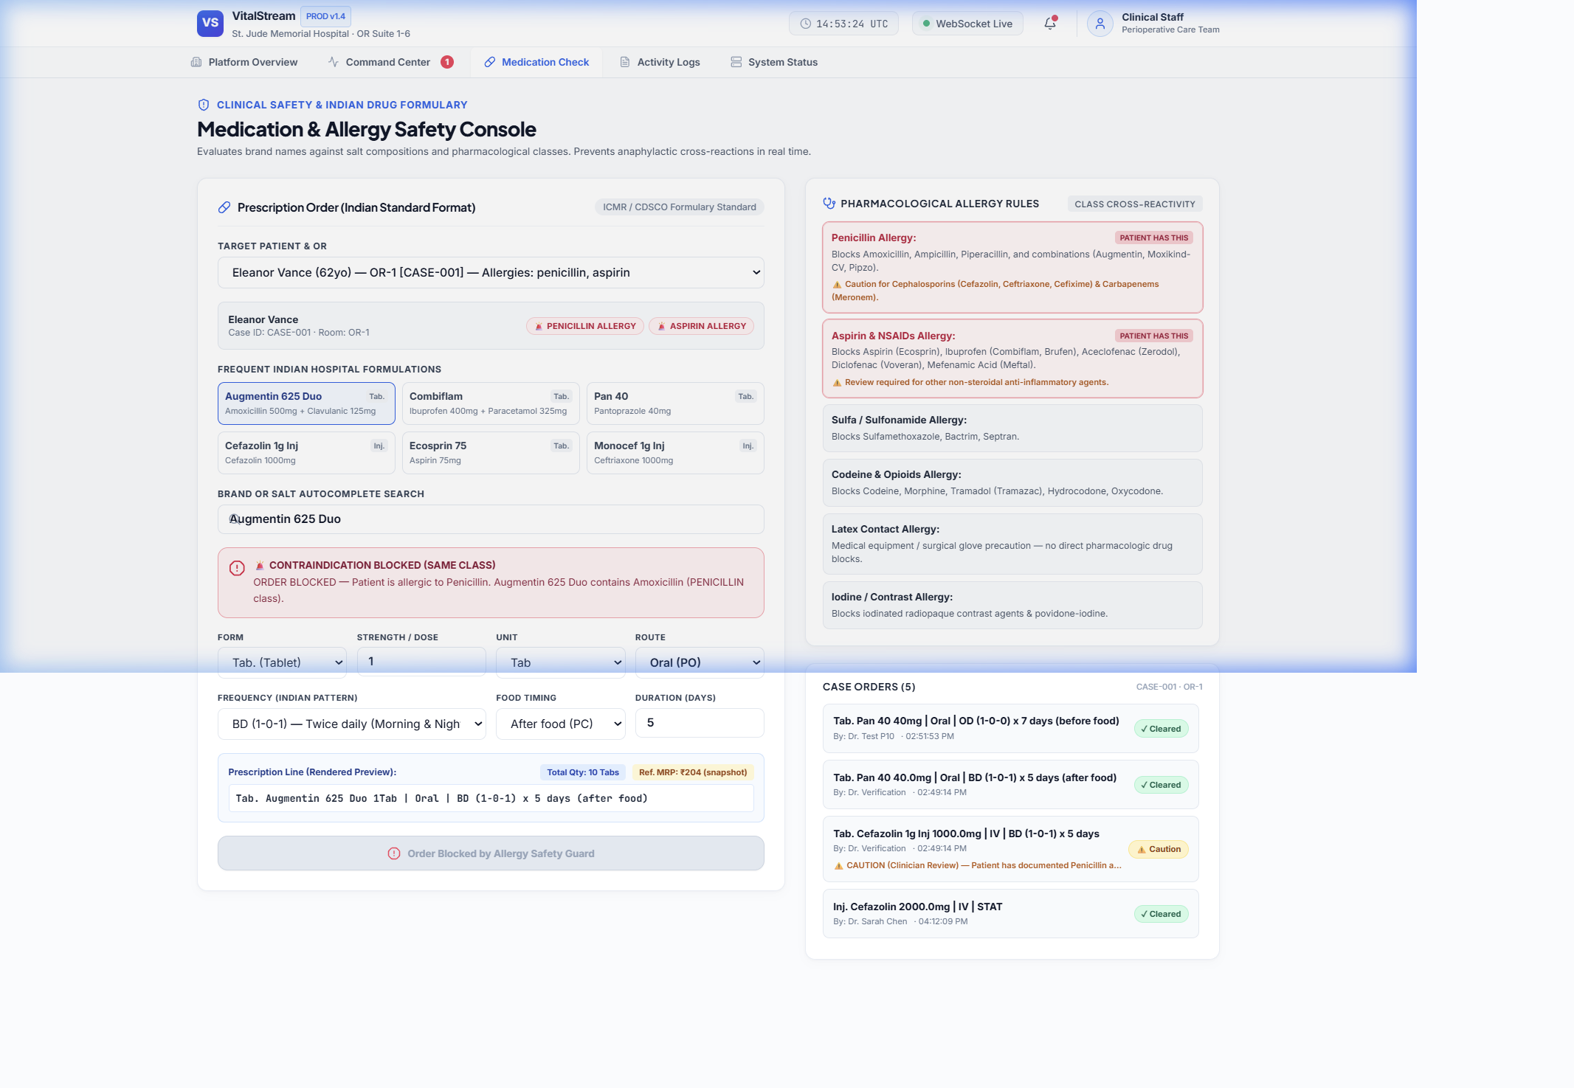
Figure: Medication Safety Console — Augmentin 625 Duo BLOCKED for Sunita Verma (Documented Penicillin Allergy)
Three distinct clinical safety outcomes are enforced in real time:
1. Contraindication BLOCK: • BLOCK (Crimson Banner): Raised when a drug contains a salt in the exact allergic class. For example, patient Sunita Verma is allergic to Penicillin. Prescribing 'Augmentin 625 Duo' triggers an immediate BLOCK because Augmentin decomposes into Amoxicillin (Penicillin class). The submit CTA is hard-disabled.
2. Clinician CAUTION: • CAUTION (Amber Banner): Raised for known cross-reactive classes. If Sunita Verma is prescribed 'Cefazolin 1g Inj', the engine flags a CAUTION banner warning that cephalosporins carry a 5-10% cross-reactivity risk with penicillin allergies. The clinician can override and order only with conscious acknowledgement.
3. Safety CLEARED: • CLEARED (Emerald Banner): Raised when there is zero overlap (e.g. prescribing 'Pan 40' / Pantoprazole). The order is verified and committed.
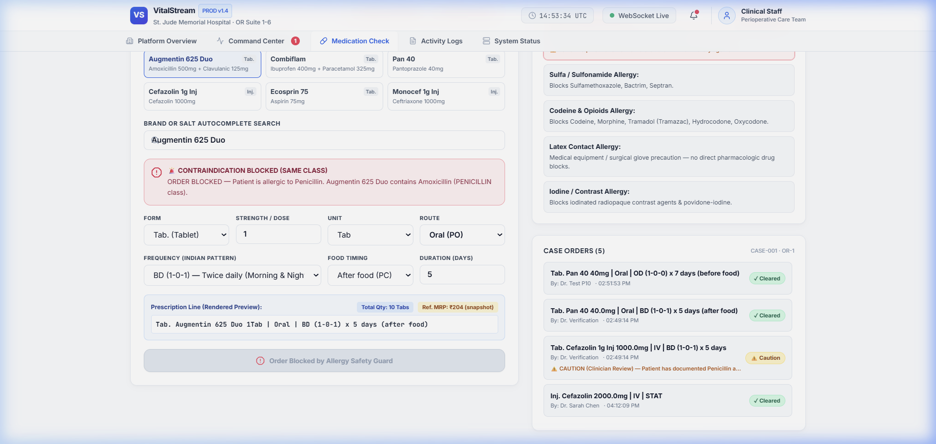
Figure: Case Orders List Rendered in Full Indian Prescription Format (No Empty '()' Defect)
Prescriptions conform strictly to Indian Council of Medical Research (ICMR) and CDSCO standards:
• Dosage Forms: • Form Factors: Tab. (Tablet), Cap. (Capsule), Inj. (Injection), Syp. (Syrup).
• Indian Dosing: • Frequency Patterns: OD (1-0-0 once daily), BD (1-0-1 twice daily), TDS (1-1-1 thrice daily), QID (1-1-1-1), HS (0-0-1 bedtime), SOS (as needed), STAT (immediately once).
• Quantity Calculation: • Automated Quantity: Automatically computes total units = doses/day × duration in days (e.g., BD × 5 days = 10 Tablets).
• Prescription Line: • Clean Display Line: Displays complete prescription lines (e.g. 'Tab. Pan 40 40mg | Oral | OD (1-0-0) x 7 days (before food)'), eliminating empty parentheses bugs.
• Deduplication: • Idempotency Protection: Client generates UUID idempotency keys to ensure rapid double-clicks never create duplicate medication orders.
7. Clinical Governance & Immutable Activity Audit Trail
The Activity Logs module provides a permanent, tamper-evident audit record of every critical event and doctor interaction across the surgical platform.
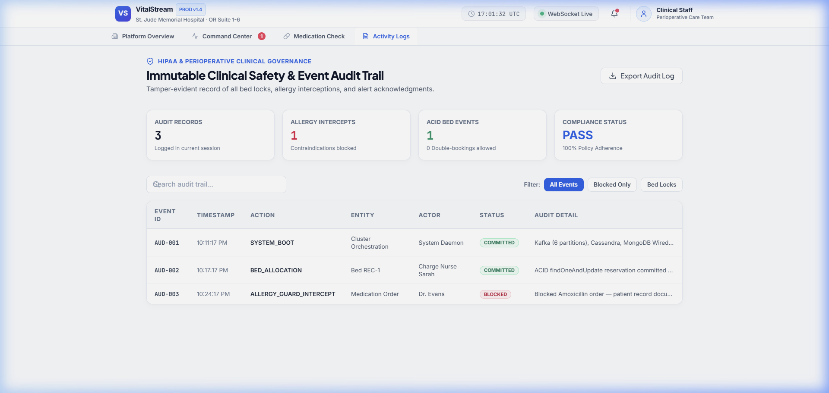
Figure: Activity Logs — Immutable HIPAA-Compliant Perioperative Event Audit Trail
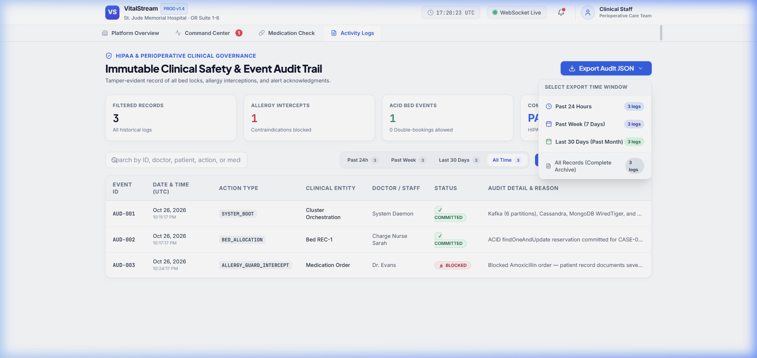
Figure: Multi-Range JSON Export Dropdown (Past 24 Hours, Past Week, Last 30 Days, All Records)
Logged events and features include:
• Time-Window JSON Export: • Pre-Set Time Range Exports: Direct one-click download for Past 24 Hours, Past Week (7 Days), and Last 30 Days (Past Month). Each export encapsulates metadata with hospital certification, SHA-256 compliance hash, record count, and timestamp.
• Interactive Time Filtering: • Dynamic Time Range Table Filter: Doctors can toggle between 'Past 24h', 'Past Week', 'Last 30 Days', and 'All Time' directly above the table to inspect historical events on screen.
• Safety Interceptions: • ALLERGY_GUARD_INTERCEPT: Interceptions of contraindicated prescriptions.
• Order Tracking: • MEDICATION_ORDER_COMMITTED & CAUTION: Approved prescriptions with timestamp, doctor name, and dosage.
• Bed Mutations: • BED_RESERVED & BED_RELEASED: Concurrency-protected bed allocations.
• Incident Sign-Offs: • ALERT_ACKNOWLEDGED: Doctor acknowledgments of hemodynamic crises.
• Regulatory Export: • JSON Export: One-click export allows hospital administrators to download full audit trails for compliance audits.
8. Production Deployment & Security Hardening Architecture
To meet the stringent data protection requirements of the Digital Personal Data Protection (DPDP) Act, CDSCO guidelines, and HIPAA § 164.312 Technical Safeguards, VitalStream integrates enterprise-grade security hardening and containerized deployment:
1. Defense-in-Depth Headers: • OWASP HTTP Security Headers: Every API response automatically injects X-Content-Type-Options: nosniff, X-Frame-Options: SAMEORIGIN (clickjacking protection), X-XSS-Protection, Strict-Transport-Security (HSTS), and restrictive Content Security Policy (CSP).
2. Anti-DoS Request Throttling: • Sliding-Window Rate Limiting: An in-memory token bucket middleware actively throttles incoming requests (240 requests/minute for general telemetry reads, 60 requests/minute for critical clinical write actions such as bed reservations and medication orders), returning HTTP 429 with Retry-After headers to prevent denial-of-service (DoS) attacks.
3. Least Privilege Containers: • Non-Root Container Execution: Production Dockerfiles execute under unprivileged user 'appuser' (UID 10001), preventing host privilege escalation and container breakout vulnerabilities.
4. Cryptographic Audit Integrity: • HMAC-SHA256 Audit Signatures: Clinical audit records (such as intercepted contraindicated orders and emergency acknowledgements) are signed using cryptographic HMAC-SHA256 checksums to ensure tamper-evidence during regulatory compliance audits.
5. Data Leak Prevention: • Sanitized Global Error Handling: Global exception middleware intercepts all unhandled errors, logs detailed stack traces with a unique error_id securely on the server, and returns an opaque sanitized response to clients, completely preventing database connection strings or schema leaks.
6. Nginx Edge Proxy: • Nginx Production Reverse Proxy: The React frontend is served via an optimized Nginx 1.25 Alpine container with HTTP Gzip compression, immutable static asset caching (1 year), and specialized WebSocket upgrade proxying (/ws) with 24-hour persistent keepalives.
7. Automated Orchestration: • Automated One-Click Deployment: Deployment is automated via scripts/deploy.ps1 (PowerShell) and scripts/deploy.sh (Bash) with automated pre-flight checks, image builds, container health probing, and database seeding.
9. Conclusion
VitalStream demonstrates the power of modern distributed big data architectures applied to healthcare telemetry. By harmonizing Kafka stream ingestion, Flink real-time windowing, Cassandra time-series compaction, MongoDB transactional concurrency, and high-performance React visualization, the platform delivers an operational, life-critical system that prevents medical errors, eliminates alarm fatigue, and safeguards patient outcomes.

