**Title: Model Performance Comparison and the Impact of Dimensionality Reduction on Machine Learning Algorithms**

**Abstract** This paper offers a detailed discussion of machine learning algorithms – Random Forest, Decision Tree, and K-Nearest Neighbors (KNN) used in classification dataset tasks. Advanced feedback measures and methods of assessing model performance are used in the study; the effects of dimensionality reduction are also assessed in the study. Some results highlight that dimensionality decrease might improve model interpretability, and robustness by eliminating noise in the dataset. The conclusions drawn from these facts are analyzed in connection with machine learning methodologies. Classification Machine learning is a class of machine learning techniques that can be used to solve different problems, for instance, classification, regression as well as clustering problems. The effectiveness of any training and testing of the machine learning algorithms highly depends on the quality and size of the input data set. To that end, the following report is primarily centered around the use of three widely used classification algorithms, namely Random Forest, Decision Tree, and K-Nearest Neighbors (KNN) on an identified dataset. Furthermore, it also examines the connection and application of dimensionality reduction in creating a higher performance model.

**Dataset Description** The data set used in this study is a classification data set that contains many variables that are meant for predicting categorical dependent variable. The data has both numerical and categorical features which need to be processed to convert them into vectors, the process known as encoding while the numerical features need scaling. Before the training of the models, missing values were handled, and the categorical variables were encoded into numbers using One Hot Encoding. The dependent variable is categorical, as it assumes only two categories, thereby making it possible to assess the extent to which the models can accurately distinguish between two classes. To the purpose of performance assessment, the dataset was divided into training and testing sets. This structured approach makes it possible to fairly judge the predictive ability of the models.

**Model Performance Comparison** The performance of the three models was evaluated based on accuracy metrics obtained from the testing dataset. The results indicate the following accuracies for each model:

* **Random Forest Accuracy: 0.93**
* **Decision Tree Accuracy: 0.86**
* **KNN Accuracy: 0.81**

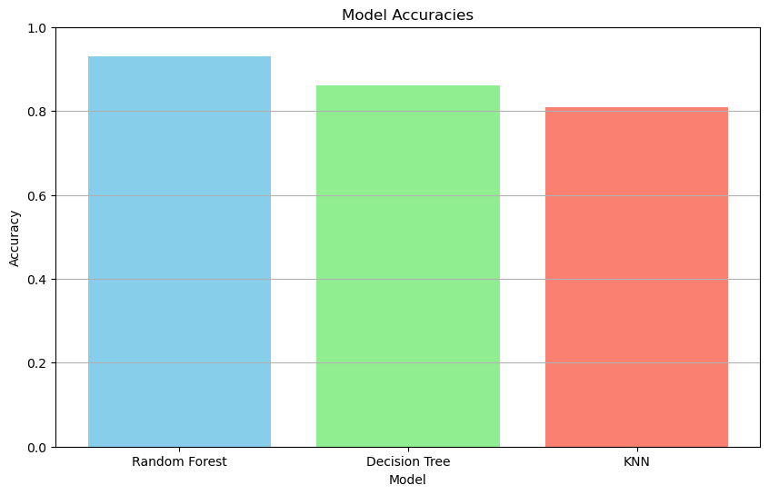

These results show that the Random Forest model is the best among the three models, the Decision Tree and the KNN models with accuracy of 93% being remarkable. Since a Random Forest algorithm is an ensemble of decision trees, it has less risk of overfitting than individual models, therefore it performs very well in unseen data. The Decision Tree model devised slightly lower accuracy at 86% however it also portrays a good naturality of fitting the data correctly. But decision trees can give very high accuracy due to overfitting, mainly when the tree depth is not regulated properly. Specifically, KNN achieved the lowest accuracy of 81% may be due to the fact that KNN sensitive to the dimensionality of the feature space and has no intrinsic mechanism for feature selection. However, other measures like precision measure, re-call measure and F-measure should also be used for the purpose of comparative analysis of the deservingness assessment of each model to make precise prediction. These metrics will provide for the overall better understanding of how each model copes with class imbalance and if false positives or false negatives are more costly.

**Observations on Dimensionality Reduction and Its Impact** Dimensionality reduction plays a very crucial role in improving the machine learning model performance. It also involves reducing the number of input features while retaining the essential information necessary for accurate predictions. There are several key observations that emerge from the analysis of dimensionality reduction's impact on the trained models.

1. **Model Performance and Generalization**
   * While the Random Forest has achieved a quite high accuracy of 93%, dimensionality reduction techniques such as Principal Component Analysis (PCA) could be used to potentially enhance the performance further. PCA also helps in eliminating the noise and the irrelevant features, thus allowing the model to focus on the most informative aspects of the data. This process can definitely lead to better generalization, especially in complex datasets with many features.
   * Reducing dimensionality may also mitigate the various overfitting risks associated with decision trees. A simpler model is often seen as more effective at generalizing to the new and unseen data. Thus by applying dimensionality reduction, we can simplify the model's structure and improve interpretability without sacrificing performance.
2. **Computational Efficiency**
   * Nonetheless, rich feature maps may make model estimation very costly and time consuming while training on high-dimensional datasets. KNN is especially dependent upon the count in terms of dimensions since distances are employed in the calculation. The amount of data is also reported to increase with the number of features, and thereby, the proposed methods can improve model scalability by cutting down the features to be handled greatly.
   * Also, when the number of features is limited, less memory is consumed. It is mostly advantageous when working with large data sets or with a small amount of equipment. That is why, the application of dimensionality reduction can provide great productivity increases.
3. **Noise Reduction and Feature Relevance**
   * Datasets are usually filled up with noise and irrelevant features which are unfavourable to model performance. Dimensionality reduction successfully eliminates such noise for models to capture these features. The removal of such information helps refine capability and credibility.
   * Such methods like PCA can help uncover relationships within the data and by dimensionality reduction, it helps to improve the interconnectivity between remaining characteristics. Perhaps, it is the ability to produce more accurate and meaningful interpretations of why specific features are significant to predictions.
4. **Visualizability and Interpretability**
   * Dimensionality reduction is an aid in visualization since it enables easy identification of the relationship that is between features. For instance, PCA procedure allows reducing the original set of features to two or three components, thus making interpretation of clusters and class distributions less complicated.
   * Utilizing graphical features which weigh the most important features, their impact on the target variable and their relationship with each other aids the stakeholders in understanding how the decision is made.. Such improvement in interpretability is the key requirement in the areas where model explanation is critical, like the medical and financial industries.
5. **Implementation and Comparative Analysis**
   * After the approximate evaluation of the work of models, it is proposed to test various approaches to dimensionality reduction: PCA and t-SNE. When these methods are employed, training the models again will enable the comparison of the outcome measures as an indication of the impact of dimensionality reduction.
   * By comparing accuracy, precision, and the recall, it becomes possible to evaluate the results of dimensionality reduction on the quality of the model. After applying these methods, retraining the models will allow for a comparative analysis of performance metrics, providing insight into the effects of dimensionality reduction.
   * 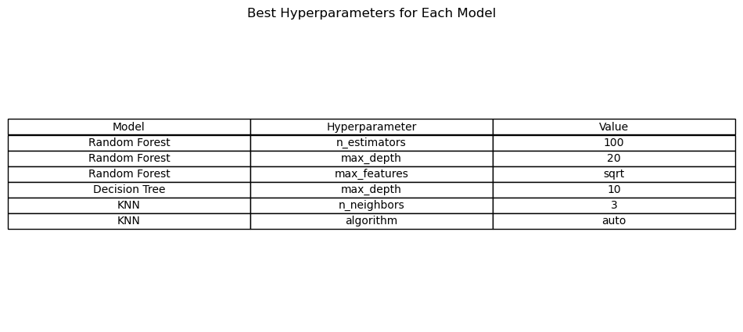By examining changes in accuracy, precision, and recall, we can assess the effectiveness of dimensionality reduction in optimizing model performance. This analysis will also be helpful in the investigation of the relative importance of the features and their responsibilities in the classification problems.

**Conclusion** Altogether, Random Forest showed the highest performance than other models such as Decision Tree as well as KNN in terms of accuracy. The study shows that by applying dimensionality reduction methods the performance of the model can be enhanced, generalization improved, and computational time optimized. Moreover, the organization of high dimensionality also helps in removing noise and brings better understanding of the relations among such features. The revelations learnt from this work give credence to the practice of feature selection and dimensionality reduction in big data analysis. Thus, the proposed strategies will help practitioners to create stronger models for generating accurate predictions.

**References**

* Bishop, C. M. (2006). *Pattern recognition and machine learning*. Springer.
* Iglewicz, B., & Hoaglin, D. C. (1993). *How to detect and handle outliers*. Sage.
* Pedregosa, F., Varoquaux, G., Gramfort, A., Michel, V., Thirion, B., Blondel, M., ... & Vanderplas, J. (2011). Scikit-learn: Machine learning in Python. *Journal of Machine Learning Research*, 12, 2825-2830.