CONTRACT MANAGEMENT SYSTEM

Pushkar Chawda (471850)

Project Design Document

1. Introduction

This document provides a brief detail about the Contract Management System (CMS) application. CMS is a system used by Marketing Admin to create a contract and for Suppliers to Unlock/lock each amenity so that they can modify a particular amenity under a selected contract and finally submitting the created and modified amenities under each contact.

2. Architecture Design

* First page will be user (Marketing Admin/Supplier) registration/Login. Marketing Admin and Supplier will have only a single interface to login.
* When the Marketing Admin logs in, he should be able to add a Contract, Approve an Amenity created under this contract and needs to accept the Terms and Conditions for each contract.
* When a Supervisor logs in, he should be able to view all the Contracts created by Marketing Admin, should be able to create Amenities for each contract and should be able to Lock/Unlock the amenities.
* Following are the modules under the Application:

1. **Marketing Admin/Supplier Registration:** New Users must be registered in the system first and their data will be entered in the User_Details Table of Schema
2. **Creating a Contract:** Only available for Marketing Admins, Contract will be created on the basis of a form to be filled by MA and the data will be entered in Contract_Details Table of Schema
3. **Terms and Conditions of a Contract:** For each amenity, T&C will be created by Supplier and would be approved by MA.
4. **Setting Amenities in each Contract:** Supplier will create or modify amenities under his contacts and that has to be approved by MA.
5. **Submitting the Contract:** Supplier will submit the contract after adding/modifying amenities and MA can approve or reject it with appropriate feedback.

**3. Database Design**

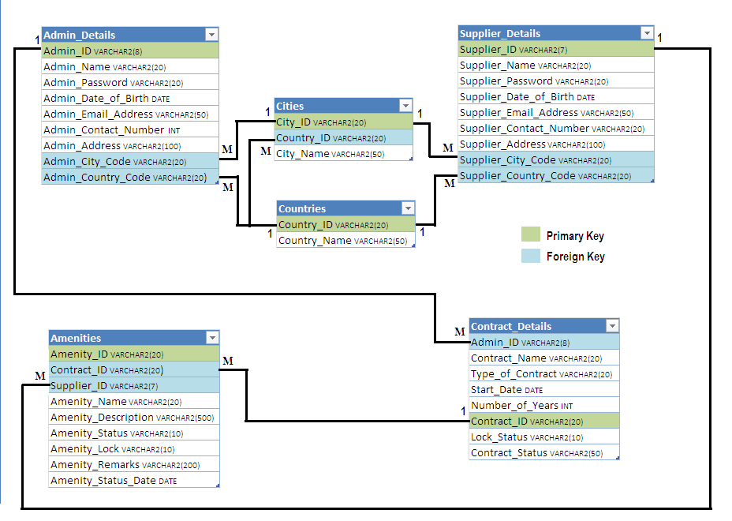

**4. Design Flow**