# HW7: Visualization

# Report

# Pushkar Singh Negi

# Ku ID: 2946319

# EECS 731: Introduction to Data Science

**Notebook:** LabProject#7_Visualization.ipynb.ipynb

**Purpose:** Deduced Additional Information and visualization.

**Input raw dataset :** test.csv

**Jupyter Notebook File name :** LabProject#7_Visualization.ipynb.ipynb

* Visualization 1: Plotted a bar chart for column and count of missing values.

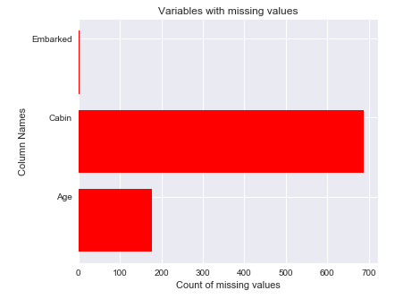

* Visualization 2: Generated a histogram chart for all the columns available in the dataset.

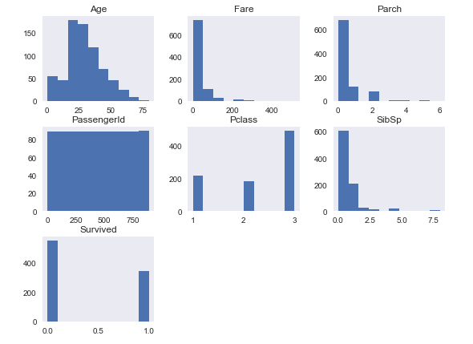

* Visualization 3: Plotted a graph for sex, age and survival.

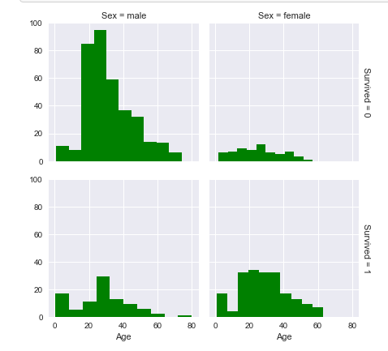

* Visualization 4: Plotted a graph for age, fare and the survival chances as per the Pclass.

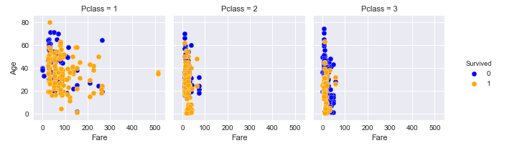

* Visualization 5: Plotted and visualized the survival by gender, age and fare.

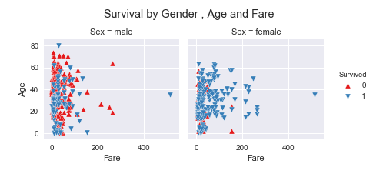

* Visualization 6: Plotted and visualized passengers per boarding locations with the help of bar chart.

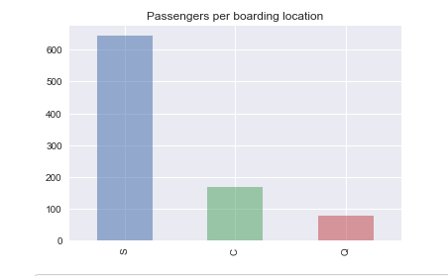

* Visualization 7: Plotted and visualized the survival rate for men and woemn for each passenger class.

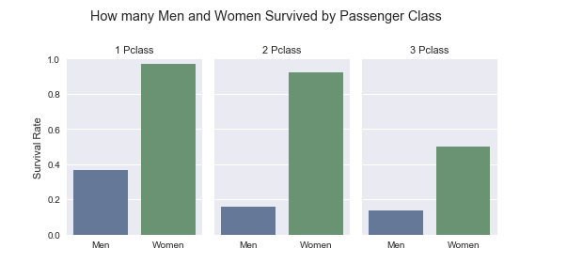

* Visualization 8: Plotted and visualized a graph to show the survival by age with the help of boxplot and stripplot

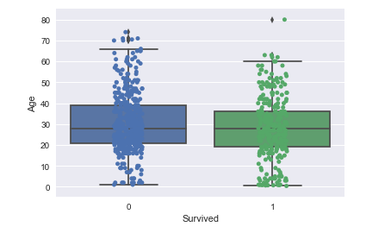

* Visualization 9: Plotted and visualized the age distribution within a class.

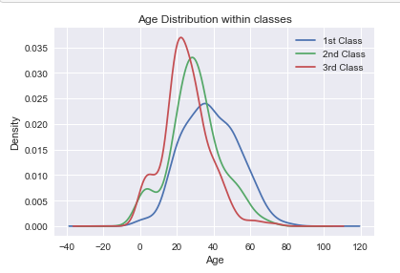

* Visualization 10: Plotted and visualized the correlation between the columns.

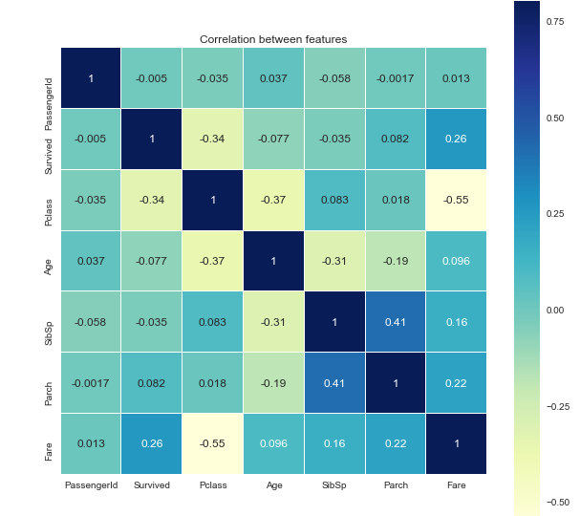

* Visualization 11: Plotted and visualized the survival count for each of the deck.

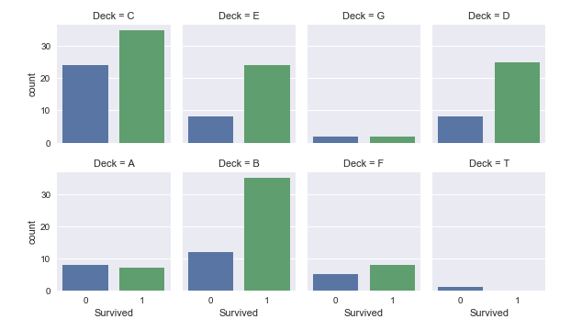

**Reference**: I searched the various approaches available on google.com and kaggle.com and took help from them in understanding and implementing the visualization .