Marketing Funnel & Conversion Analytics Dashboard

Data Science & Analytics – Task 3
Prepared By:
Pushp Jain
Submitted To:
Future Interns
Tools Used:
Python (Google Colab), Power BI, CSV Dataset
Dataset Used:
Bank Marketing Campaign Dataset

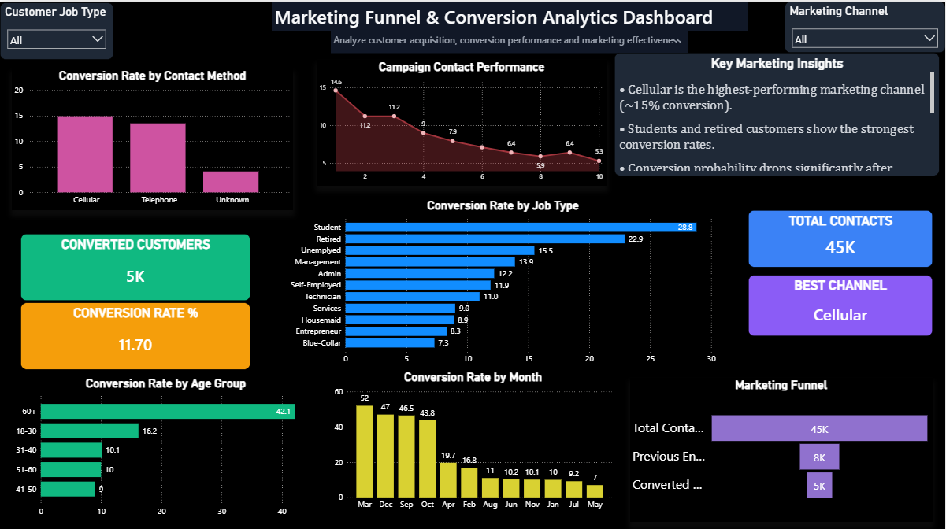

Project Overview
Marketing funnel analysis is one of the most critical areas in business analytics, growth analytics, and digital marketing. Businesses spend significant resources on campaigns to attract potential customers, but not all leads convert successfully.
A marketing funnel represents the journey customers take from initial contact to successful conversion. Understanding where customers drop off and identifying high-performing marketing channels enables organizations to improve campaign efficiency and increase revenue.
This project focuses on analysing marketing campaign performance using the Bank Marketing Campaign Dataset. The project aims to identify customer conversion behaviour, analyse campaign effectiveness, measure conversion rates, and understand customer segments that are more likely to convert.
The analysis was performed using Python for exploratory data analysis and Power BI for interactive dashboard visualization. The final dashboard provides meaningful business insights that can support marketing optimization and customer acquisition strategies.

Project Objectives
The major objectives of this project are:
1. Analyse Marketing Funnel Performance
To understand how customers move through different stages of the marketing funnel.
2. Measure Conversion Performance
To calculate customer conversion rates and identify successful marketing strategies.
3. Identify High-Performing Marketing Channels
To analyse which communication channels generate better customer responses.
4. Customer Segmentation Analysis
To identify customer groups with higher conversion probability.
5. Campaign Optimization
To determine whether repeated customer contact improves or reduces conversion success.
6. Seasonal Marketing Performance
To analyse which months deliver stronger campaign performance.
7. Build Interactive Dashboard
To create a stakeholder-friendly dashboard for business analysis and decision-making.

Dataset Information
Dataset Name:
Bank Marketing Campaign Dataset
Dataset Source:
UCI Machine Learning Repository
Total Records:
45,211 Customers
Total Features:
17 Columns
Dataset Description
The dataset contains customer and campaign-related information collected during direct marketing campaigns conducted by a banking institution.
The primary objective of the campaign was to determine whether customers would subscribe to a term deposit product.
The target variable in this dataset is:
y
Where:
- Yes = Customer Converted
- No = Customer Did Not Convert
Important Features
- Age
- Job Type
- Marital Status
- Education
- Balance
- Housing Loan
- Personal Loan
- Contact Method
- Campaign Duration
- Previous Contacts
- Campaign Month
- Previous Campaign Outcome
- Conversion Status
Data Quality
The dataset was analyzed for missing values and inconsistencies.
Observations:
- Total rows: 45,211
- Total columns: 17
- Missing values: None
- Dataset quality: Clean and suitable for analytics

Tools & Technologies Used

The following technologies were used to complete this project:
Tool | Purpose
Python | Data analysis & preprocessing
Google Colab | Development environment
Pandas | Data cleaning & manipulation
Matplotlib | Data visualization
Power BI | Interactive dashboard creation
CSV Dataset | Data source

Why These Tools Were Used
Python was used for performing exploratory data analysis and conversion rate calculations.
Pandas helped in cleaning and structuring campaign data.
Matplotlib was used to create visualizations for customer behavior analysis.
Power BI was used to develop an interactive dashboard that presents marketing insights effectively to stakeholders.

Data Cleaning & Preprocessing
Before beginning analysis, the dataset was cleaned and inspected to ensure data accuracy and consistency.
The following preprocessing steps were performed:
Step 1: Dataset Import
The Bank Marketing Dataset was imported into Google Colab using Pandas.
Step 2: Shape Analysis
The number of records and features was examined.
Results:
- Rows: 45,211
- Columns: 17
Step 3: Missing Value Analysis
The dataset was checked for missing values.
Result:
- No missing values were found.
Step 4: Data Type Inspection
All feature data types were analyzed to understand numerical and categorical variables.
Step 5: Customer Conversion Analysis
The target variable y was analyzed.
Results:
- Converted Customers: 5,289
- Non-Converted Customers: 39,922
- Conversion Rate: 11.7%
This indicates that only a small percentage of customers successfully converted.
Exploratory Data Analysis
Exploratory Data Analysis (EDA) was performed to understand customer conversion patterns and marketing effectiveness.
Customer Conversion Distribution
The dataset showed that:
- 88.3% customers did not convert
- 11.7% customers converted successfully
This reflects realistic marketing performance where only a fraction of leads convert.
Contact Method Analysis
Marketing communication channels were analysed.
Results:
- Cellular communication generated the highest conversion rate.
- Telephone communication performed moderately.
- Unknown contact records produced poor results.
Job Type Analysis
Customer occupation significantly affected conversion performance.
Top-performing segments included:
- Students
- Retired customers
- Management professionals
Lower-performing segments included:
- Blue-collar workers
- Entrepreneurs
Age Group Conversion Analysis

Customer age played an important role in conversion probability.
The analysis revealed:
Age Group | Conversion Rate
18–30 | High
31–40 | Moderate
41–50 | Low
51–60 | Moderate
60+ | Highest

The 60+ age group demonstrated the highest conversion rate.
Possible reasons include:
- Greater financial stability
- Interest in secure banking products
- Better response to financial campaigns
Younger customer groups also performed relatively well compared to middle-aged segments.

Campaign Performance Analysis
Campaign contact frequency was analyzed to understand how repeated customer outreach affects conversion.
Observations:
- First contact attempts showed the highest conversion probability.
- Conversion rates gradually declined with repeated contacts.
- Excessive outreach reduced campaign effectiveness.
This finding suggests that aggressive repeated marketing may negatively impact customer response.
Marketing teams should focus on optimizing communication quality instead of increasing contact frequency.

Marketing Funnel Analysis
A simplified marketing funnel was developed to understand customer progression.
Funnel Stages
- Total Contacts
- Engaged Leads
- Converted Customers
The funnel analysis highlighted significant drop-off between initial outreach and successful conversion.
This indicates opportunities to improve:
- Lead nurturing
- Communication quality
- Campaign personalization
- Customer targeting strategies
Businesses can use funnel insights to improve acquisition efficiency and reduce marketing waste.
Monthly Conversion Performance
Marketing performance varied significantly across different months.
Best Performing Months
- March
- December
- September
These months showed exceptionally high conversion rates.
Weak Performing Month
- May showed the lowest conversion performance.
Possible reasons may include:
- Seasonal customer behavior
- Market conditions
- Campaign timing effectiveness
This insight can help businesses allocate marketing budgets more efficiently.

Dashboard Overview
An interactive Power BI dashboard was developed to present marketing performance insights visually.
Dashboard Features
KPI Cards
- Total Contacts
- Converted Customers
- Conversion Rate
- Best Marketing Channel
Funnel Analysis
- Marketing Funnel Visualization
Conversion Insights
- Conversion Rate by Contact Method
- Conversion Rate by Age Group
- Conversion Rate by Job Type
- Conversion Rate by Month
- Campaign Contact Performance
Interactive Filters
- Job Type
- Marketing Channel
- Campaign Month
The dashboard was designed using a professional dark-themed interface to improve readability and user experience.
Key Insights
1. Cellular Communication Performs Best
Cellular marketing generated the highest conversion rate.
2. Students & Retired Customers Convert More
These customer segments showed higher campaign success.
3. Repeated Contact Lowers Conversion
Conversion rates declined after multiple contact attempts.
4. Seasonality Impacts Marketing Success
March and December performed exceptionally well.
5. Unknown Contact Records Hurt Performance
Poor contact quality reduced marketing effectiveness.
Business Recommendations
Based on the analysis, the following recommendations are suggested:
1. Focus on Cellular Campaigns
Increase investment in cellular-based outreach.
2. Improve Customer Segmentation
Target students and retired customers more strategically.
3. Reduce Over-Contacting
Avoid repeated campaign attempts that lower response rates.
4. Optimize Campaign Timing
Increase marketing activity during high-performing months.
5. Improve Contact Data Quality
Reduce unknown contact records for better campaign performance.
Conclusion
This project successfully analyzed marketing funnel performance and customer conversion behavior using the Bank Marketing Campaign Dataset.
The analysis identified high-performing marketing channels, customer segments, campaign timing, and conversion trends.
The Power BI dashboard provided interactive business insights and enabled stakeholder-friendly analysis.
This project demonstrates the practical application of marketing analytics, funnel analysis, and business intelligence in improving customer acquisition and campaign performance.
Future Scope
The project can be enhanced further by:
- Applying predictive analytics for conversion prediction
- Using machine learning for lead scoring
- Performing advanced cohort analysis
- Integrating real-time marketing campaign monitoring

