Introduction:

Student Number: 244870

Today's machine learning models, as well as many more in the future, have a direct influence on individuals and society. With so much power and influence in the hands of Data Scientists and Machine Learning Engineers, taking the time to examine and understand if model outputs are fair will become a critical component of AI/ML solutions' future success. These are important issues, and a recently introduced fairness module in the Python package provides a uniform and accessible mechanism to verify that your models stay fair. The model qualities for which the model is likely to demonstrate bias are known as fairness attributes. The fairness attribute values are divided into two categories: reference and monitored. The model's result is classified as either favorable or unfavorable. If the model is predicting whether or not a person should be granted a loan, the favorable outcome may be Loan Granted or Loan Partially Granted, whereas the unfavorable event could be Loan Denied. As a result, the Favorable outcome is considered good, but the Unfavorable outcome is considered bad. When evaluating a model, metrics calculated against an entire test or validation set don't always give an accurate picture of how fair the model is. We used two datasets, one adult and one German, to test the model-by-model behavior for accuracy and fairness.

Related works:

We looked at the Adult dataset and the German dataset, as well as the bias, and devised strategies to reduce bias and make the Machine Learning Model more fair. Let us first consider the Adult Census Income dataset is widely utilized in machine learning research. Ronny Kohavi and Barry Becker collected this information from the 1994 Census Bureau database. German dataset categorises persons as excellent or bad credit risks based on a set of characteristics. There are two versions available (one all numeric). A cost matrix is also included. There are two datasets available. The original dataset, in the form given by Prof. Hofmann, is in the file "german.data" .

Problem Statement:

You've been given an Excel spreadsheet containing 15 columns and 48842 rows. Our goal is to use a supervised machine learning model to examine the data and estimate whether an adult's annual income will exceed $50,000. Let's begin studying the excel supplied and cleaning the data after importing the dataset. It's not a good idea to

include special characters in your data since it might lead to inaccurate data analysis and prediction models. As a

result, we must eliminate them. In order to uncover patterns and generate predictions, a Machine Learning model requires numerical input data. However, not all of the information in our source dataset is numerical. Some of the data is categorical, such as Work Class, Education, Marital-Status, Occupation, Relationship, and so on, which we must convert to number notations. Data is just a characteristic that our model takes into account as an input. As a result, we use Feature Engineering to transform our data into useful numerical data. We have 15 features (columns) to work with, and our aim is to forecast the income feature, which makes income our Dependent Variable. Independent Variables are those features that impact the target feature if any of the remaining 14 features do. We may derive some relationships between our independent and dependent qualities after visualizing the data. We can see that each of our numerical qualities has an impact on our variable income objective. As a result, we should build an ML model and give it all of our numerical data as input. It's worth noting that the aforementioned models were performed using the Logistic Regression’s default settings. The model might be improved by adjusting the hyperparameters. To do so, we create a "grid" of parameters that we wish to evaluate in the model and use GridSearchCV to find the optimal model. A parameter grid made up of two dictionaries is used. The first dictionary contains all of the different types of Logistic Regression I wish to run in the model, such as regularization, penalty size, and solver type, and gives the greatest accuracy by stating the hyperparameter used to reach that result. For the Adult dataset, we simply utilized GridSearch.

The German Credit Dataset was used in this study. The loan application procedure in the financial sector is an excellent illustration of unlawful prejudice. In this example, we'll use numerous indicators from a normal credit application to forecast whether or not an applicant should be provided credit. In a data science project, exploratory data analysis is required to determine how some of the qualities are distributed. To that purpose, I build graphs using Plotly's Python graphing package, which produces interactive, publication-quality graphs such as goal value by age, age distribution, credit amount distribution, duration, credit amount by age, and so on. Below are some graphs shown for both the data sets.

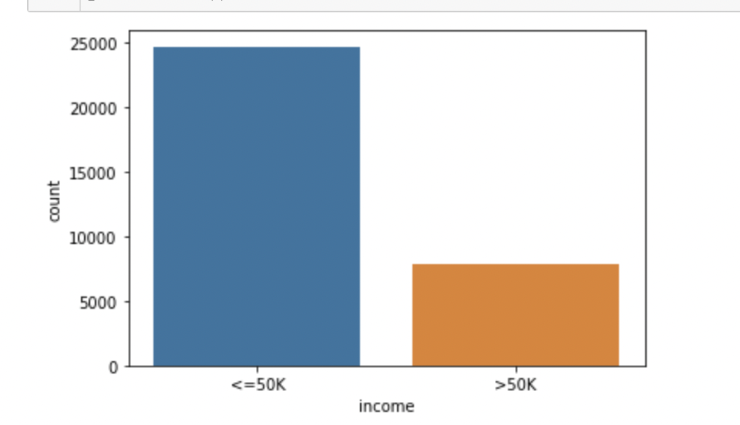

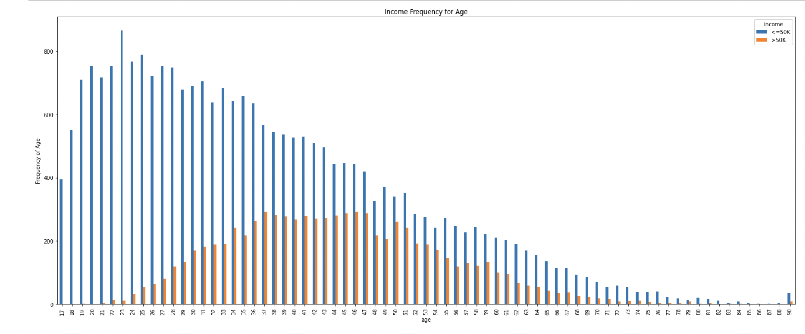

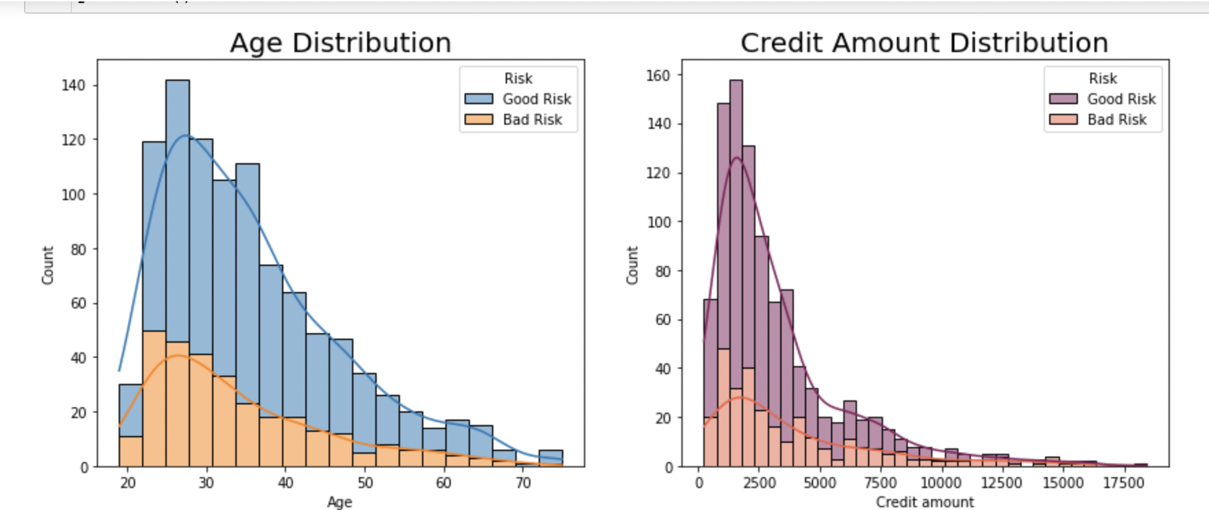
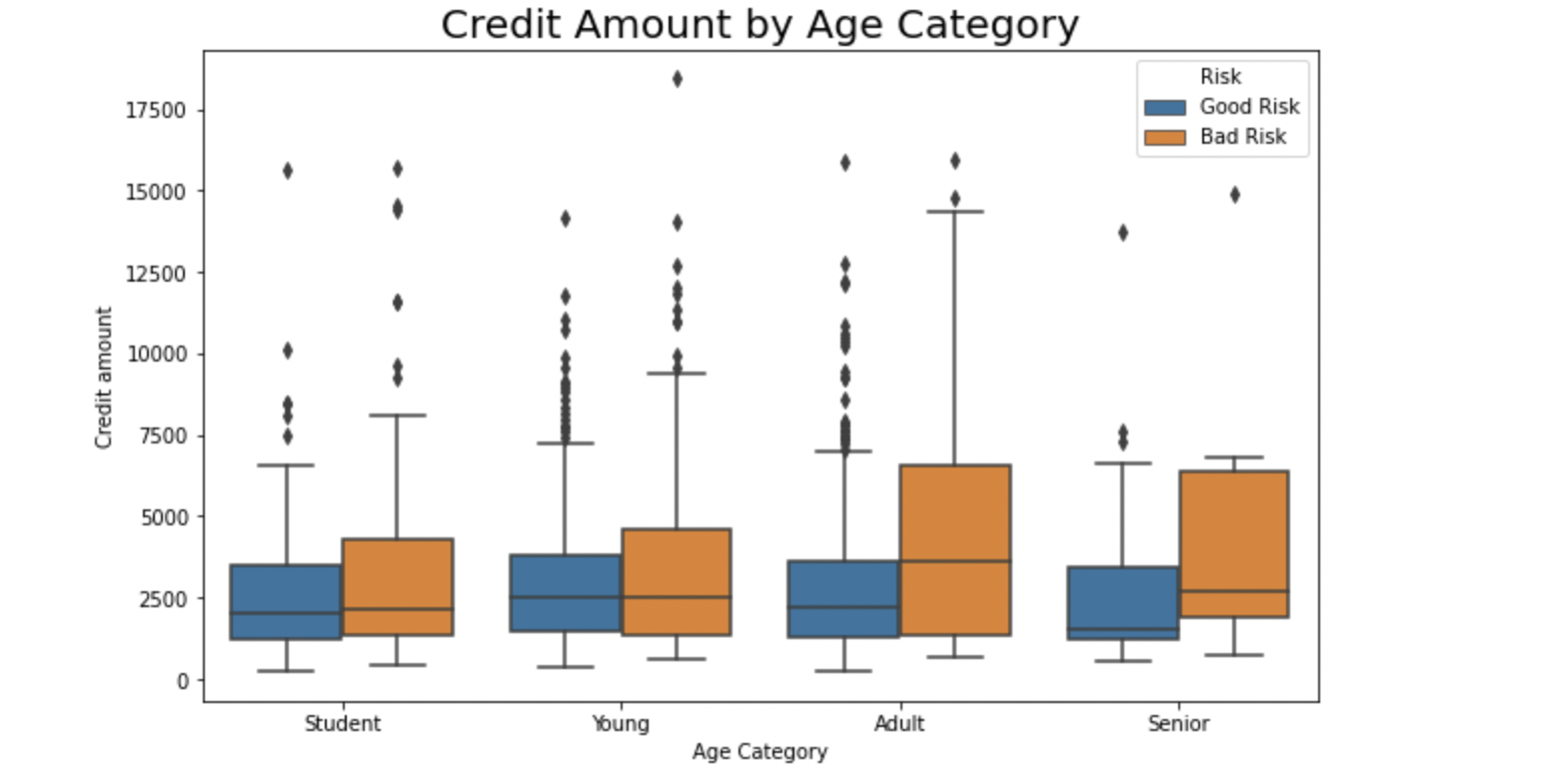
Transformations and feature engineering: Hypothesizing about the features I anticipate I'll need to add in my model is a part of the data purification stage.
Unfortunately, a machine learning model cannot deal with categorical variables (except for some models ). As a result, I'll need to figure out how to encode these variables as integers before using them in the model. This method may be completed using either one hot encoding or label encoding. The protected attribute (attributes that are of interest) will be "Age," with the values "1" (older than or equal to 25) and "0" (younger than 25) for the privileged and unprivileged groups, respectively. To begin, we'll look for bias in the first training data, correct it, and retest. Load the dataset, set the protected property to age, and split the dataset 70:30 between training and testing. Only the train data will be used in this demonstration. For the entire work flow. We can utilize aif360 to detect bias in the dataset now that we've discovered the protected property 'age' and specified privileged and unprivileged values. One easy test is to compare the percentage of positive findings for privileged and unprivileged groups, then deduct the former from the latter. A negative number indicates that the impoverished group will have a less favorable outcome.

Multilayer Perceptron:

Input and output layers, as well as one or more hidden layers with numerous neurons layered together, make up a Multilayer Perceptron. While neurons in a Perceptron must have an activation function like ReLU or sigmoid that enforces a threshold, neurons in a Multilayer Perceptron can utilise any arbitrary activation function.

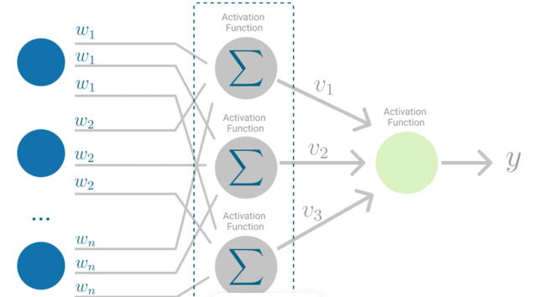

Model selection:

There are around 60+ predictive modelling algorithms to pick from. To limit down our model choices, we must first have a thorough comprehension of our data and the intended answer. Our aim is to predict income, which might be 0 or 1 (less than 50K or more than 50K), and to find a link between our output (income) and the other independent variables ( education, work class, gender, etc. ). This is a classic case of classification (classify if your income is $50,000 or greater). To train our model, we are given 48K rows of the labelled dataset with the output column "income." We use the Supervised Learning Machine Learning approach if the dataset is labelled and the output feature is known. As a result, our use-case is a challenge involving Supervised Learning and Classification. We may limit down our selection of models based on these criteria:
- Support Vector Machines
- Logistic Regression KNN
- k-Nearest Neighbors
- Decision Tree
- Random Forrest
- Naive Bayes classifier
The improvement in the fairness measures after the model was trained on the Transformed Dataset is used to evaluate the model categorization. The following are the fairness metrics that were considered:
Disparate Impact — The ratio of the likelihood of beneficial outcomes for rich and disadvantaged groups.
Average odds difference — The average difference in false positive and true positive rates between unprivileged and privileged groups is called the average odds difference. A score of 0 indicates that both groups profit equally.
Equal opportunity difference — The gap in true positive rates between rich and disadvantaged groups is known as the equal opportunity differential. A score of 0 indicates that both groups profit equally.
Statistical parity difference — This is the statistical equivalent of the law's adverse effect doctrine. It evaluates the difference in outcomes between the majority and protected classes. The classifier is considered to have "statistical parity" when the difference is modest, implying that it adheres to this idea of fairness.
Average odds difference — This is the average of the difference between unprivileged and privileged groups' false positive and true positive rates. A score of 0 indicates that both groups profit equally.
Measuring the accuracy of the test — The false positive rate is computed as FP/FP+TN, where FP stands for false positives and TN stands for true negatives (FP+TN = total number of negatives). It's the chance that a false alarm will be triggered, resulting in a positive result while the genuine value is negative. There are several more test accuracy and error rate metrics to consider.
Model Transparency— Model Transparency is another important component of our research, in which we aim to show how the Model predicts and which features contribute to the final forecast, as well as how individual data points behave.
Generalization is a machine learning term that describes how effectively a trained model can categorise or forecast unknown data. When you train a generalised machine learning model, you ensure that it works for any subset of unknown data. Data variety is a critical aspect in making accurate predictions. It should be noted that data variety is not the only factor to consider while developing a generalised model. It can be caused by the nature of a machine learning algorithm or by incorrect hyper-parameter settings. On the training set, we use the K-fold cross validation approach to pick the training set with the highest accuracy and fairness. Model performance estimation using k-fold cross-validation, in which each time the procedure is run, a different split of the dataset into k-folds is applied, resulting in a different distribution of performance scores and, as a result, a different mean estimate of model performance, here I'm using the Logistic regression model to fit the training data after passing that data into our model. For categorical classification, logistic regression is one of the most simple and widely used supervised Machine learning techniques. The basic notions of Logistic Regression are simple to grasp and may be used to any binary (0 or 1) classification issue as a baseline technique. We'll utilize Logistic Regression as our classification method for this use-case. We determine the best accuracy for the particular hyper -parameter and the best accuracy model utilizing our model and K fold, as well as testing the model's fairness. In our experiment, my highest accuracy was 80% for the adult dataset when the C value was 1 for 500 iterations and the matrix's fairness, which has an equal chance of negative values around -0.47020 and statistical parity difference, average odds difference, which also has negative values. In the German data set, I acquired a 74 percent accuracy in the K-fold cross validation model fitting with the hyper parameter values C is 1000 and the maximum iteration of 1000, and the fairness metrics has a disparate impact of 0.63 and all the other parameters are negative. Now I'm utilizing the maximum accuracy hyperparameters in the Logistic regression model for the training and testing data, and using the testing data to predict the results. Now, for the German dataset, we obtained a 74 percent accuracy with a desecrate impact of 0.79, which is virtually equal to 1, and the remaining parameters are all negative; for the adult dataset, we got an 81 percent accuracy with good fairness. Reweighing the models using F-fold cross validation because if your training data isn't a representative sample of the data you wish to apply your model to, and now verifying the best accuracy and fairness result for both datasets, which is 79.8% and 72 percent accuracy, respectively. After reweighing the model for more fairness, accuracy has been dropped somewhat. For our Logistic regression model, we are now employing the best hypermeters with C values of 0.1 and 1000.

Conclusion:

By minimizing data bias, our effort tries to make the Machine Learning model more fair. We employed tools to aid in the analysis of the dataset, which provided us with a better knowledge of the data and allowed us to uncover bias using fairness criteria. The fairness module is a centralized and easy-to-use tool for ensuring that the models are balanced. There are a variety of alternative ways to illustrate bias in models. We began by looking at the Adult and German datasets, where we discovered that the algorithm was skewed toward sex and age. They were put in a higher-risk category, but the ground reality did not match the algorithm's predictions. To analyze the distribution of data across multiple protected categories and detect bias, we utilized EDA, Machine Learning Models, AIF360 explainers, and the What-If tool. For bias reduction, this mitigation of biasness will be done before generating the model using the Reweighing Algorithm. This method will change the dataset so that the privileged and unprivileged groups have more equitable positive results on the protected characteristic. This method will change the dataset so that the privileged and unprivileged groups have more equitable positive results on the protected characteristic. After bias reduction, we noticed a considerable increase in the Fairness measures, as well as a drop in the False Positive Rate, which signifies wrong predictions. We obtained the most frequent definitions of "Mathematical Fairness" that may be used in classification models. We evaluated when each fairness indicator should be used and what factors to consider when doing so. To sum up, we have demonstrated a way for mitigating the bias of a Machine Learning Model and so improving the Fairness of the model generated. We also demonstrated Model Transparency by describing the Model in a straightforward and understandable manner.

References:

https://www.kdnuggets.com/2020/12/machine-learning-model-fair.html
https://www.ibm.com/docs/en/cloud-paks/cp-data/2.5.0?topic=openscale-fairness-metrics-
https://developers.google.com/machine-learning/crash-course/fairness/evaluating-for-bias
https://towardsdatascience.com/a-beginners-guide-to-data-analysis-machine-learning-with-python-adult-salary-dataset-e5fc028b6f0a
https://medium.com/sfu-cspmp/model-transparency-fairness-552a747b444
https://analyticsindiamag.com/guide-to-ai-fairness-360-an-open-source-toolkit-for-detection-and-mitigation-of-bias-in-ml-models/
https://archive.ics.uci.edu/ml/datasets/statlog+(german+credit+data)
https://jeremykun.com/2015/10/19/one-definition-of-algorithmic-fairness-statistical-parity/#:~:text=This%20is%20the%20statistical%20equivalent,to%20this%20notion%20of%20fairness.
https://deepai.space/what-is-generalization-in-machine-learning/#:~:text=In%20machine%20learning%2C%20generalization%20is,classify%20between%20dogs%20and%20cats.
https://arxiv.org/pdf/1810.01943.pdf
https://www.ibm.com/blogs/research/2018/09/ai-fairness-360/
https://www.technologyreview.com/2017/07/12/150510/biased-algorithms-are-everywhere-and-no-one-seems-to-care/
https://medium.com/@tonyxu_71807/ensuring-fairness-and-explainability-in-credit-default-risk-modeling-shap-ibm-tool-kit-aix-360-bfc519c191bf

