**Project Design Phase-II**

**Data Flow Diagram & User Stories**

|  |  |
| --- | --- |
| Date | 22 May 2023 |
| Team ID | PBL-NT-GP-10533-1682762877 |
| Project Name | Competitive analysis of leading travel aggregators |

**Data Flow Diagrams:**

A Data Flow Diagram (DFD) represents the flow of information within a system. In the case of leading travel aggregators , the system involves the interaction between users , travel aggregators , and travel service providers. It shows how data enters and leaves the system, what changes the information, and where data is stored.



Example: DFD Level 0 (Industry Standard)

**Example:** [**(Simplified)**](https://developer.ibm.com/patterns/visualize-unstructured-text/)

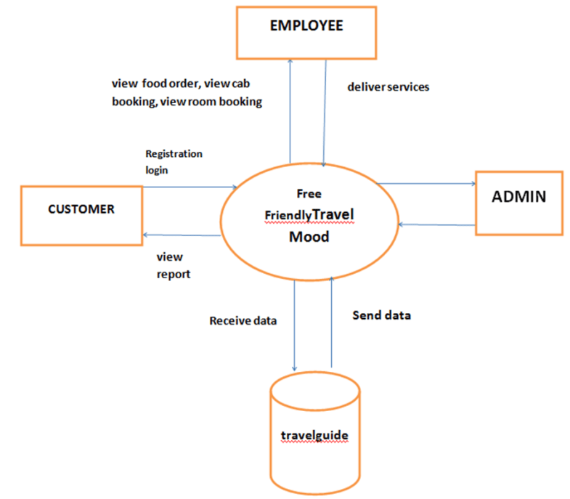

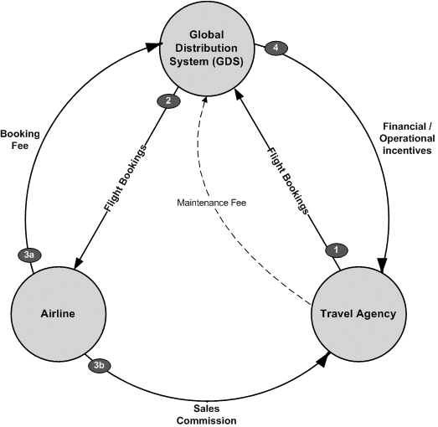

**User Stories**

Use the below template to list all the user stories for the product.

| **User Type** | **Functional Requirement (Epic)** | **User Story Number** | **User Story / Task** | **Acceptance criteria** | **Priority** | **Team Member** |
| --- | --- | --- | --- | --- | --- | --- |
| Customer (Mobile user) | Registration | USN-1 | As a user, I can register for the application by entering my email, password, and confirming my password. | I can access my account / dashboard | High | Shivam |
|  |  | USN-2 | As a user, I will receive confirmation email once I have registered for the application | I can receive confirmation email & click confirm | High | Shivani |
|  |  | USN-3 | As a user, I can register for the application through Facebook | I can register & access the dashboard with Facebook Login | Low | Shivam |
|  |  | USN-4 | As a user, I can register for the application through Gmail |  | Medium | Shivam |
|  | Login | USN-5 | As a user, I can log into the application by entering email & password |  | High | Sandeep |
|  | Dashboard |  |  |  |  |  |
| Customer (Web user) |  |  |  |  |  |  |
| Customer Care Executive |  |  |  |  |  |  |
| Administrator |  |  |  |  |  |  |
|  |  |  |  |  |  |  |
|  |  |  |  |  |  |  |
|  |  |  |  |  |  |  |