This dataset contains a list of video games with sales greater than 100,000 copies.

Fields include

Rank - Ranking of overall sales

Name - The games name

Platform - Platform of the games release (i.e. PC,PS4, etc.)

Year - Year of the game's release

Genre - Genre of the game

Publisher - Publisher of the game

NA_Sales - Sales in North America (in millions)

EU_Sales - Sales in Europe (in millions)

JP_Sales - Sales in Japan (in millions)

Other_Sales - Sales in the rest of the world (in millions)

Global_Sales - Total worldwide sales.

The script to scrape the data is available at <https://github.com/GregorUT/vgchartzScrape>.  
It is based on BeautifulSoup using Python.  
There are 16,598 records.

Description:

I took Video-Games Sales dataset from github to make dashboard and perform some queries on data, like vlookup, match, index, data validation, etc. I have used slicers and created some charts using pivot tables. In this dataset I analyzed sales of countries like Japan, North America, Europe in millions. There are other sales and global sales also.

I can see that, most of sales has occurred in year 2009.

Also, I can see most of Sales of Japan are from “Role-Playing” genre which 27% of total sales.

To see more - <https://github.com/PushpakBilaye/Excel_Project>

Some Snapshots Related my project of MS Excel.

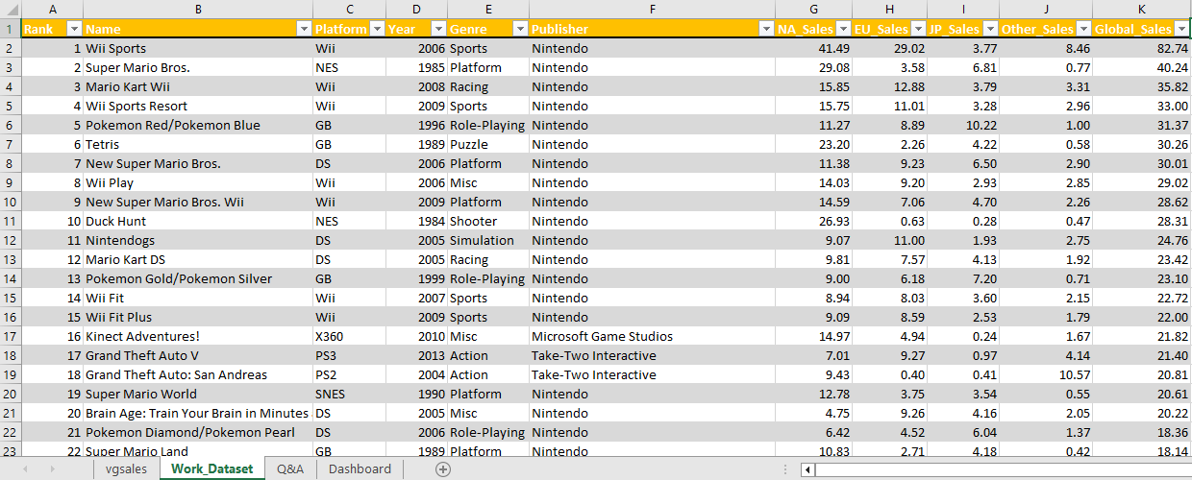

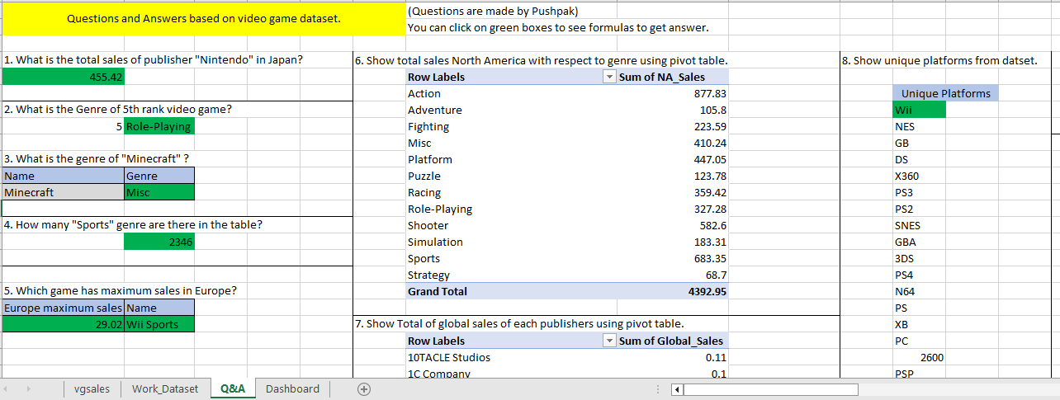





Dynamically changing dashboard using slicers.

