

**VIRGINIA COMMONWEALTH UNIVERSITY**

**Statistical analysis and modelling (SCMA 632)**

**A5: Visualization - Perceptual Mapping for Business**

**PUSHPAK DEVAKI**

**V01108254**

**Date of Submission: 15-07-2024**

**INTRODUCTION**

The data procured from NSSO is analysed, in order to determine the top and bottom three consuming districts in Haryana. To get the data we need for analysis, we will clean and alter the dataset. The dataset contains district-specific variances together with consumption-related data for both the urban and rural sectors. The dataset has been loaded into R/Python, a potent statistical programming language renowned for its effectiveness in handling and analysing big datasets.

Our goals include summarizing consumption statistics by area and district, controlling outliers, detecting and fixing missing values, and determining the significance of mean variances. We also want to standardize district and sector names. Policymakers and other stakeholders will benefit greatly from the study's findings, which will enable focused initiatives and encourage equal development throughout the state.

**Objectives:**

To Plot a histogram (to show the distribution of total consumption across different districts) and a barplot (To visualize consumption per district with district names) of the data to indicate the consumption district-wise for the state assigned.

**RESULTS & INTERPRETATION**

**a) R**

**Code:**

library(ggplot2)

library(sf) # mapping

library(dplyr)

Sys.setenv("SHAPE_RESTORE_SHX" = "YES")

data_map <- st_read("D:\VCU Bootcamp\SCMA\Data\HARYANA_DISTRICTS.geojson")

View(data_map)

data_map <- data_map %>%

rename(District = dtname)

colnames(data_map)

data_map_data <- merge(HR_consumption,data_map,by = "District")

View(data_map_data)

ggplot(data_map_data) +

geom_sf(aes(fill =total_consumption, geometry = geometry)) +

scale_fill_gradient(low = "yellow", high = "red") +

ggtitle("Total Consumption_by_District")

ggplot(data_map_data) +

geom_sf(aes(fill = total_consumption, geometry = geometry)) +

scale_fill_gradient(low = "yellow", high = "red") +

ggtitle("Total Consumption by District") +

geom_sf_text(aes(label = District, geometry = geometry), size = 3, color = "black")

**Result:**

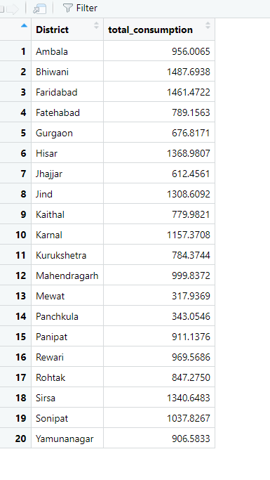

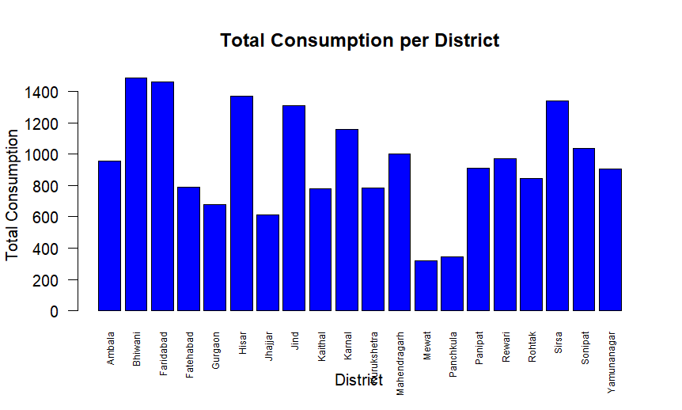

**Interpretation:**

From the above dataset, we can see the districts with the highest total consumption are Faridabad, Bhiwani, and Sonipat. The districts with the lowest total consumption are Mewat, Mahendragarh, and Panchkula.

**B) Python**

**Code:**

hrnew['total_consumption'] = hrnew[['ricepds_v', 'Wheatpds_q', 'chicken_q', 'pulsep_q', 'wheatos_q']].sum(axis=1)

def summarize_consumption(df, group_col):

summary = df.groupby(group_col)['total_consumption'].sum().reset_index().sort_values(by='total_consumption', ascending=False)

return summary

district_summary = summarize_consumption(hrnew, 'District')

region_summary = summarize_consumption(hrnew, 'Region')

print("Top Consuming Districts:")

print(district_summary.head(4))

print("Region Consumption Summary:")

print(region_summary)

Result:

Top Consuming Districts:

District total_consumption

12 13 1487.693831

18 19 1461.472232

11 12 1368.980678

10 11 1340.648296

Region Consumption Summary:

Region total_consumption

0 1 10792.293321

1 2 8264.494089

Code:

hrnew['District'] = hrnew['District'].astype(str).map(district_mapping).fillna(hrnew['District'])

hrnew['Sector'] = hrnew['Sector'].astype(str).map(sector_mapping).fillna(hrnew['Sector'])

plt.hist(hrnew['total_consumption'], bins=10, color='blue', edgecolor='black')

plt.xlabel('Consumption')

plt.ylabel('Frequency')

plt.title('Consumption Distribution in HARYANA State')

plt.show()

Result:

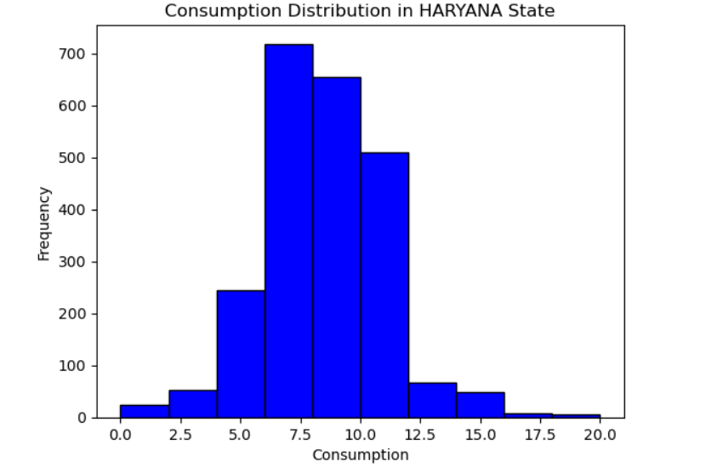

Code:

HR_consumption = hrnew.groupby('District')['total_consumption'].sum().reset_index()

plt.figure(figsize=(10, 6))

plt.bar(HR_consumption['District'], HR_consumption['total_consumption'], color='blue', edgecolor='black')

plt.xlabel('District')

plt.ylabel('Total Consumption')

plt.title('Total Consumption per District')

plt.xticks(rotation=90)

plt.show()

Result:

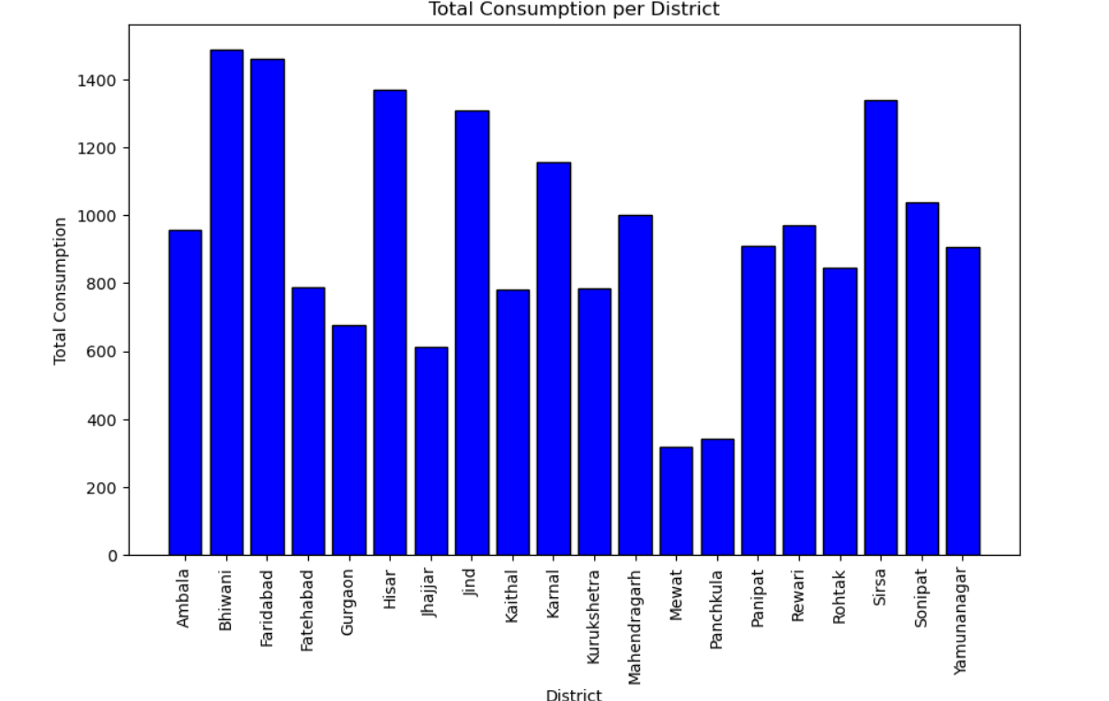

Code:

fig, ax = plt.subplots(1, 1, figsize=(10, 10))

data_map_data.plot(column='total_consumption', ax=ax, legend=True, legend_kwds={'label': "Total Consumption by District",

'orientation': "horizontal"})

data_map_data.apply(lambda x: ax.annotate(text=x.District, xy=x.geometry.centroid.coords[0], ha='center', fontsize=8, color='black'), axis=1)

plt.title("Total Consumption by District")

plt.show()

Result:

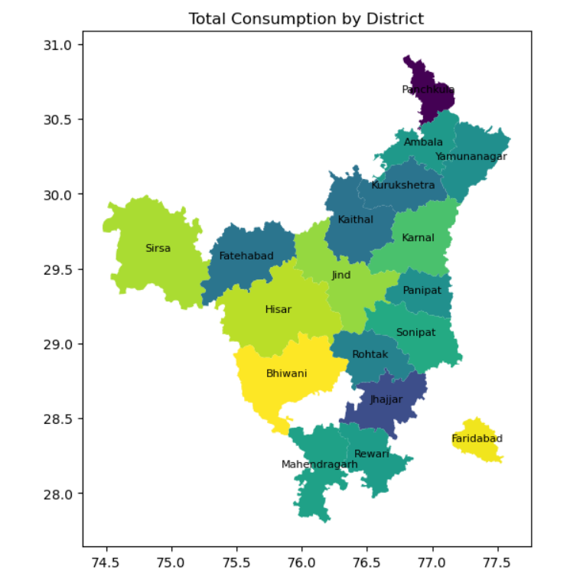

**Interpretation:**

The districts with the highest total consumption are Faridabad, Bhiwani, and Sonipat. The districts with the lowest total consumption are Mewat, Mahendragarh, and Panchkula.