**HW 02: Formulating a research hypothesis**

Brainstorming research questions to investigate

1. **Topic area statement**

Initially, after going through the metadata of the dataset, I am interested in diet and nutrition of children from various regions. Additionally, I am more interested in studying, how would diet affect the health of child and also what diet should be taken in order to keep out nutrition good. While diet and nutrition has way more to research on but I have not yet decided which variables should I work on as dataset is huge. I need to understand how is diet and nutrition dependent on each other and what happens when anyone goes less or higher in quantity. Moreover, according to regions diet needs changes which is one interesting factor to study on, which will give me more insights about how diet changes with regions and also factor that would affect is maybe environment and availability of food in respective region. I would like to see relationship between environment, diet and nutrition changes as per regions.

1. **Personal Codebook**

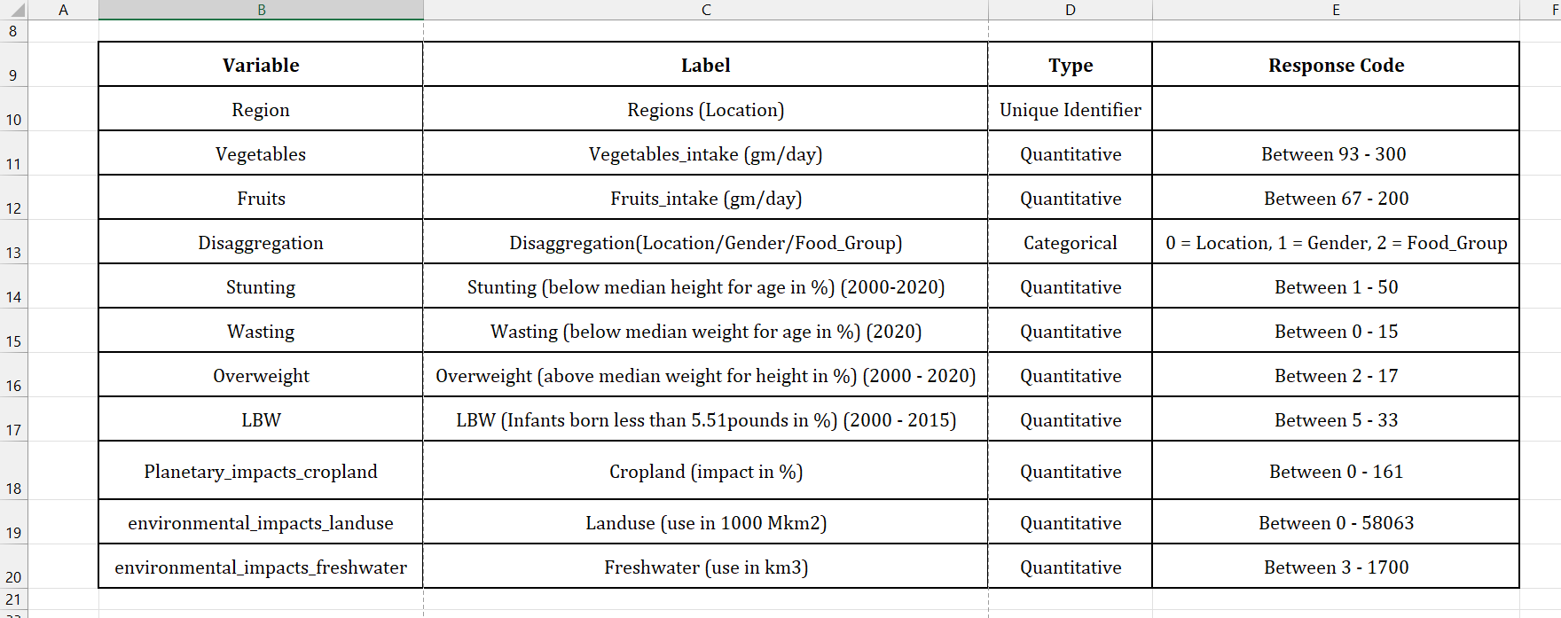

1. **Research Questions**
2. Does regional environment really affect on diet and nutrition of child from 0-59 months?
3. Is there any impact on nutrition by using freshwater?
4. Does crop land affect nutritionof a child?
5. **Literature Review**

* ***Margaret M.C. Thomas, MSW, Daniel P. Miller, PhD, Taryn W. Morrissey, PhD, “Food Insecurity and Child Health.”*** *doi:* **Paediatrics’*(2019) 144 (4): e20190397***

According to the authors, it states that food security is important problem faced by children in United States and in order to overcome this they have used propensity scoring techniques to track casual impact of food insecurity on children’s health.

Authors use PS methods to investigate effects of food insecurity on child’s health. It is used to simulate randomized treatment assignment to estimate treatment effects in observational data. This method stated that children in low-income family have worse health as compared to high income families in United State.

Also, children in insecure households are likely to take late medical care due to cost (146.5%) as they aren’t able to afford medical. There are many health issues that come along when there is less food intake.

* ***Craig Gundersen, Brent Kreider “Bounding the effects of food insecurity on children’s health outcomes. Journal of Health Economics. Volume 28, Issue 5, Sept 2009.”***

In this article, authors mainly focus on learning effects of food security on child health. It also states that it cannot be fully identified that impact of food and security on health. Additionally, it states that the survey conducted can be ambiguous as parents of child may provide wrong information. Moreover, its highlighting the statistical identification problems created using selective issues and survey of self-reported food insecurity.

The central goal of it was to gain some insights about the impact of food security on whether child is in good health and have healthy weight. SNAP is one who pursued with goal that it ensures all children stay in healthy and secure home in order to keep their health well.

* ***Jef L. Leroy, Marie Ruel, Edward A Frongillo, Jody Harris, Terri J. Ballard, “Measuring the food access dimension of food security: A critical review and mapping of indicators. Volume 36, Issue 3,******doi.org/10.1177/0379572115587274”***

In this particular article, authors have identified nine indicators and also grouped them in three categories (experience-based, coping strategies, dietary diversity) in order to analyse efficiently. They mainly recommend us to use HDDS or FCS indicator to access to sufficient food quantity.

They mainly focus on measuring reality of food security using indicators where, experience based are mostly used to identify diet quality. Moreover, authors mainly focus on accessing food at the individual and household levels. The main motive of this mapping indicators was to identify quality, quantity and safety of child food and their health which impacts due to less food intake or improper diet intake.

1. **Refined Research Questions**
2. How does child’s health affect when families have less income and high-income rates?
3. How does it impact using freshwater for cultivation of food on land from rural and urban regions?
4. To what extend does high income family have effect on children health due to high availability of food?