**CNC-based Bluetooth-operated Learning Aid for Neurodiverse Children**

P. Dasa, E. Vijayaragavanb, A. Sarkarc, S.A.R. Devaland, V.P. Dubeye, N. Aryanf, R. S. Kumarg A.D. Chatterjeeh

a Department of Electronics & Communication Engineering, SRM Institute of Science and Technology, Kattankulathur, Tamil Nadu 603203, India.

b Department of Mechanical Engineering, SRM Institute of Science and Technology, Kattankulathur, Tamil Nadu 603203, India.

c Department of Electronics & Telecommunication Engineering, Jadavpur University, Kolkata, West Bengal 700032, India.

d Department of Mechanical Engineering, SRM Institute of Science and Technology, Kattankulathur, Tamil Nadu 603203, India.

e Department of Computer Science and Engineering, SRM Institute of Science and Technology, Kattankulathur, Tamil Nadu 603203, India.

f Department of Computer Science and Engineering, SRM Institute of Science and Technology, Kattankulathur, Tamil Nadu 603203, India.

g Department of Electronics & Communication Engineering, SRM Institute of Science and Technology, Kattankulathur, Tamil Nadu 603203, India.

h Department of Computer Science and Engineering,Indian Institute of Engineering Science and Technology, Shibpur, Howrah, West Bengal 711103, India.

**Abstract**

The main objective of our team was to make an appealing learning assistant for kids who have neurodevelopmental conditions or impaired motor neuron abilities. Although many individuals with autism spectrum disorder today are able to speak, read, and live outside institutions, and some show a decrease in symptoms of the disorder by adulthood, for most of them it is difficult to work full-time or live independently. The common symptoms of such individuals are restricted social communication skills and repetitive sensory-motor behaviours. Our team surveyed some autistic care centres where the specialists said that even in the present age of digitally transforming world when it comes to the education of autistic children, a long-term effective output has not been observed and hence, it could not be predicted whether the kid is getting benefitted from the e-learning materials or not. Our vision was to make a device that will help such a child to learn writing through systematic repetition and stimulating audio-visual signals.

**Acknowledgement**

Our team would like to express our gratitude to SRM Institute of Science and Technology for the support and guidance . Our team would further express our gratitude to Dr E. Vijayaragavan, for the time, knowledge and constant encouragement she has lent us for making this project. We express our special thanks to Mr Shantanu Sinha, marketing consultant at TCS, for his genuine support and guidance in bringing the product to the market in the future.

Our team extends gratitude to Mrs [Sampada Pachaury](https://www.linkedin.com/in/ACoAAAFvnSkB4kaB5wE9D-snUe5Wi9vhkcergZw), Mr [Krishna Vedula](https://www.linkedin.com/in/ACoAAACEbJcBGnZhwTKeoU1zOtHO4xEXdkV7bjM) and Mr Aditya Bhatnagar for their diligent guidance and for their support during our research work with [Indo Universal Collaboration for Engineering Education (IUCEE)](https://www.linkedin.com/company/indo-universal-collaboration-for-engineering-education/?lipi=urn%3Ali%3Apage%3Ad_flagship3_profile_view_base_recent_activity_details_shares%3BvhH%2BgA4MT7yiQFJSD8gohA%3D%3D).

We used DigiKey Scheme-it, a free online schematic and diagramming tool, available at https://www.digikey.in/schemeit/home/ for the schematics provided in the paper. We used Inkscape v0.48.5, a free and open-source vector graphics editor primarily used for creating or editing vector graphics, for generating the g-codes. This was made possible by the MI Inkscape extension for GRBL firmware. From <https://winder.github.io/ugs_website/> the controlling software for debugging and testing named “Universal Gcode Sender” was downloaded. A similar application for mobile was “G-Code2GRBL” and was downloaded from the Google play store. And most importantly, the GRBL firmware that was programmed into the microcontroller was downloaded from https://github.com/gnea/grbl/.

**Content**

| Sl. No. | Topic | Page Number |
| --- | --- | --- |
| 1 | Introduction   * *Fig. 1: Prevalence of Autism Increased by 10%, to 1 in 54 Children by Southwest Autism Research & Resource Center* * *Fig. 2: Neurotypical Peers are Less Willing to Interact with Those with Autism based on Thin Slice Judgments* * *Fig. 3: Effect of a normal and regular classroom set up on the concentration and attentiveness of youngsters with autism spectrum disorder: an eye-tracking study* | 4  4  5  5 |
| 2 | Background | 5 |
| 3 | Design and Specification   1. Control and Power System    1. Microcontroller-ATMEGA328P    2. CNC V3 shield    3. A4988 Stepper motor driver    4. NEMA 17 Stepper motor    5. SG90 Micro Servo    6. HC-05 Bluetooth module 2. GRBL control code 3. G-code 4. Application software  * *Fig. 4: (a) Logical block of the ATMEGA328P processor; (b) ATMEGA328P pin configuration* * *Fig. 5: Pin-configuration of (a) CNC V3 shield; (b) stepper motor driver A4988* * *Fig. 6: Configuration of the motors and respective motor drivers* * *Fig. 7: (a) HC-05 Bluetooth module; (b) Connecting the Bluetooth module with the controller* * *Fig. 8: Physical connections for the entire apparatus. It is to be noted that the CNC V3 shield is inserted onto the Arduino UNO board* * *Fig. 9: How the g-code containing information of coordinates is transferred in the system* * *Fig. 10: System architecture supporting the application* * *Fig. 11: Sequence Diagram for the API* * *Fig. 12: Flowchart describing the functioning of the application* * *Fig. 13: All paired devices are displayed in the app being developed. Suppose a particular device should be connected, the relevant name must be clicked* | 6  6  6  7  8  8  8  9  10  11  11  7  8  9  10  10  11  12  12  13  14 |
| 4 | Implementation   * *Fig. 14: Perspective view of the model* * *Fig. 15: Two Dimensional Representation of the Model* | 14  15  16 |
| 5 | Result and Evaluation   * *Fig. 16: Graphically Denoted No.of Letters v/s Time by the machine* * *Fig. 17: Graphically Denoted No.of Letters v/s Temperature of the machine in (Celsius)* | 16  17  17 |
| 6 | Future Directions | 17 |
| 7 | Conclusion | 18 |
| 8 | Reflections | 18 |
| 9 | References | 19 |

**Introduction**

Autism is a term that is used to describe a particular group of people with specific neurodiverse conditions– conditions characterised by lack of ability to interact socially, communication problems and abnormal motor-neuron activity. Autistic Spectrum Disorder is observed in people around the world, irrespective of culture, background, race and ethnicity. “Spectrum” refers to the wide range and severity of symptoms shown by such individuals.

During a study period of 2009-2017, children most of the age from 3-17 were seen diagnosed with disabilities, which includes cerebral palsy, blindness, hyperactivity disorder, autism.Conditions are characterised by contrast in social interaction and communication. Over the study, it has been found that there are numerous causes. It can be due to genetic mutations, having an immediate family member who is autistic, metabolic imbalances, Exposure to heavy metals and environmental toxins, a history of viral infections, fatal exposure to the medications valproic or thalidomide. Subjects show snappy interhemispheric connections in the cerebral cortex.

Autistic kids might not get to the enlightening milestone like their fellow mates. They have difficulty sleeping, irregular food patterns and show signs of heightened anxiety. They often prefer a similar environment with a regular routine. They often show repetitive and restricted motor behaviour. The common motor deficit conditions seen in children with autism are hypotonia, which is characterised by poor muscle strength and disordered spinal reflexes, and motor apraxia, which is a defect in horizontal eye movement. Studies have also found deficits in overall fine motor gross motor development and locomotor skills for such children. These difficulties not only hamper their learning ability but also cause a great deal of anxiety to them.

*Statistical data regarding the autistic population*

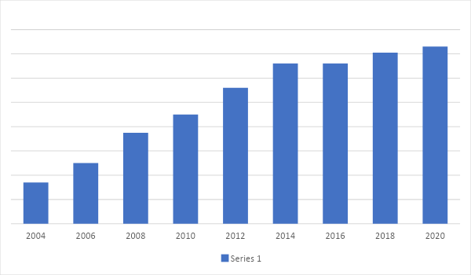

Fig. 1, Prevalence of Autism Increased by 10%, to 1 in 54 Children by Southwest Autism Research & Resource Center

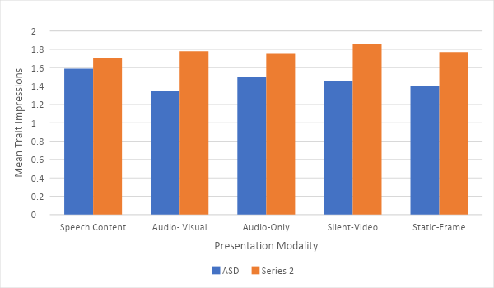

Fig. 2, Neurotypical Peers are Less Willing to Interact with Those with Autism based on Thin Slice Judgments

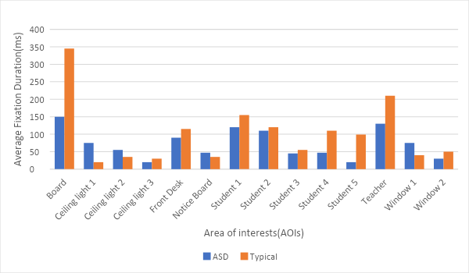

Fig. 3, Effect of a normal and regular classroom set up on the concentration and attentiveness of youngsters with autism spectrum disorder: an eye-tracking study

**Background**

The purpose of the present project is to create a link between play and physical therapy, resulting in therapy for such subjects who have writing problems from their very childhood–children who have difficulty distinguishing between 6 and 9, b and d, the alphabetical order, a step from our team to make the basics strong and solve the neurological problem in kids. From the research and surveys performed, it is understood that even in the present era of a digitally-transforming world, when it comes to e-learning platforms and persons with neurodevelopmental disabilities, a proper output is very difficult to ascertain. Given the plethora of application-based learning options, the child would still not receive physical help in actually writing what they have learnt. In special exams, such students would pronounce their answers and a helper would write for them.

**Design and Specification**

The aim of the project was to make the subject learn to write and correlate what they want to write and what their hand traces on paper by holding a robotic arm in the form of a mini CNC (Computer Numeric Control) machine. The device shall track the pattern of the letter and guide the user to move the hand in the right way to complete the pattern by interactive methods, which is basically the input given from the phone or computer in which the supporting application is installed. The application can be used easily by both the subject(person with a neurological disability) and their mentor. The principle of operation of the CNC machine is the movement of a structure about 3 degrees of freedom, namely the X, Y and Z axes, based on input fed through a computer. They are controlled by stepper motors which can be AC or DC operated. The operations and configurations of the motors like feed, speed, etc. are set with the help of coordinate-like codes.

Control and Power System

*Microcontroller-ATMEGA328P*

In today's world we have many controllers, so why ATMEGA328P?

ATMEGA328P is one of the most popular because it is cost-effective with exciting features in it. And so due to these features a controller like ATMEGA328P is used to develop Arduino boards. Features like, with a variation on power saving modes it can be used on mobile embedded systems, it has the RISC architecture, as a result of it the program executes quickly, has a timer, the watchdog timer to reset anytime under error on the system with just a human interface and so on. RISC is nothing but a reduced instruction set computer which is a type of architecture that uses a hugely optimised set of instructions than what is found in other architectures. ATMEGA is quite the same as any other microcontrollers in the market. And yes it is well known that there should be a set of instructions in the form of programs provided by us at the instant, without the program nothing is executing the way it should be. As already discussed, there should be a program present in the ATMEGA328 flash memory. This whole execution is done by the controller after the code is dumped and provides an appropriate response. This process is explained in the following steps,

* First step is listing out all the functions that the controller should execute. Functions in programming language can be run at IDE, now here we can use the Arduino IDE too to be discussed later. After the code we need to compile to look for errors.
* The IDE converts the compiled program to the HEX file. The HEX file constitutes the machine code that is executed or written in the controller flash memory.
* Choose the programming device (usually SPI programmer made for AVR controllers) which establishes communication between PC and ATMEGA328P. One can also program ATMEGA328P using the ARDUINO UNO board.
* After the execution all that is needed to do is, disconnecting the programmer, and connecting with the appropriate peripherals for the controller and running the system.

*Features*

1. The CPU used is an 8-bit AVR with a speed of 1MBPS for 1MHz .
2. There are a total 28 pins present.
3. Operating voltage ranges from +1.8 V to +5.5V.
4. There are 23 programmable I/O lines. For programming this controller, there are three types of communication interface, Master/Slave SPI Serial Interface(17,18,19 PINS).
5. Programmable Serial USART. This controller can be programmed using pins. Peripheral devices such as sensors, memory devices and servos are connected with the help of Two-wire Serial Interface pins.
6. It has ADC Module Of 6 channels, 10-bit resolution ADC. Timer module of two 8-bit counters with Separate Prescaler and compare mode. One 16-bit counter with Separate Prescaler,compare mode and capture mode.
7. There are a total of 1 analog comparator with 6 PWM channels.
8. External Oscillator with 0-4MHz in 1.8V to 5.5V, 0-10MHz in 2.7V to 5.5V, 0-20MHz in 4.5V to 5.5V and an internal oscillator with 8MHz Calibrated Internal Oscillator.
9. Program Memory Type is of flash memory with 32 kilobytes. RAM is 2kbytes Internal SRAM with an EEPROM of 1k bytes.
10. Programmable Watchdog Timer with Separate On-chip oscillator with program lock.
11. 6 major power save modules, Idle, ADC Noise Reduction, Power-save, Power-down, Standby and Extended Standby.
12. The operating temperature is -40°C to +105°C.

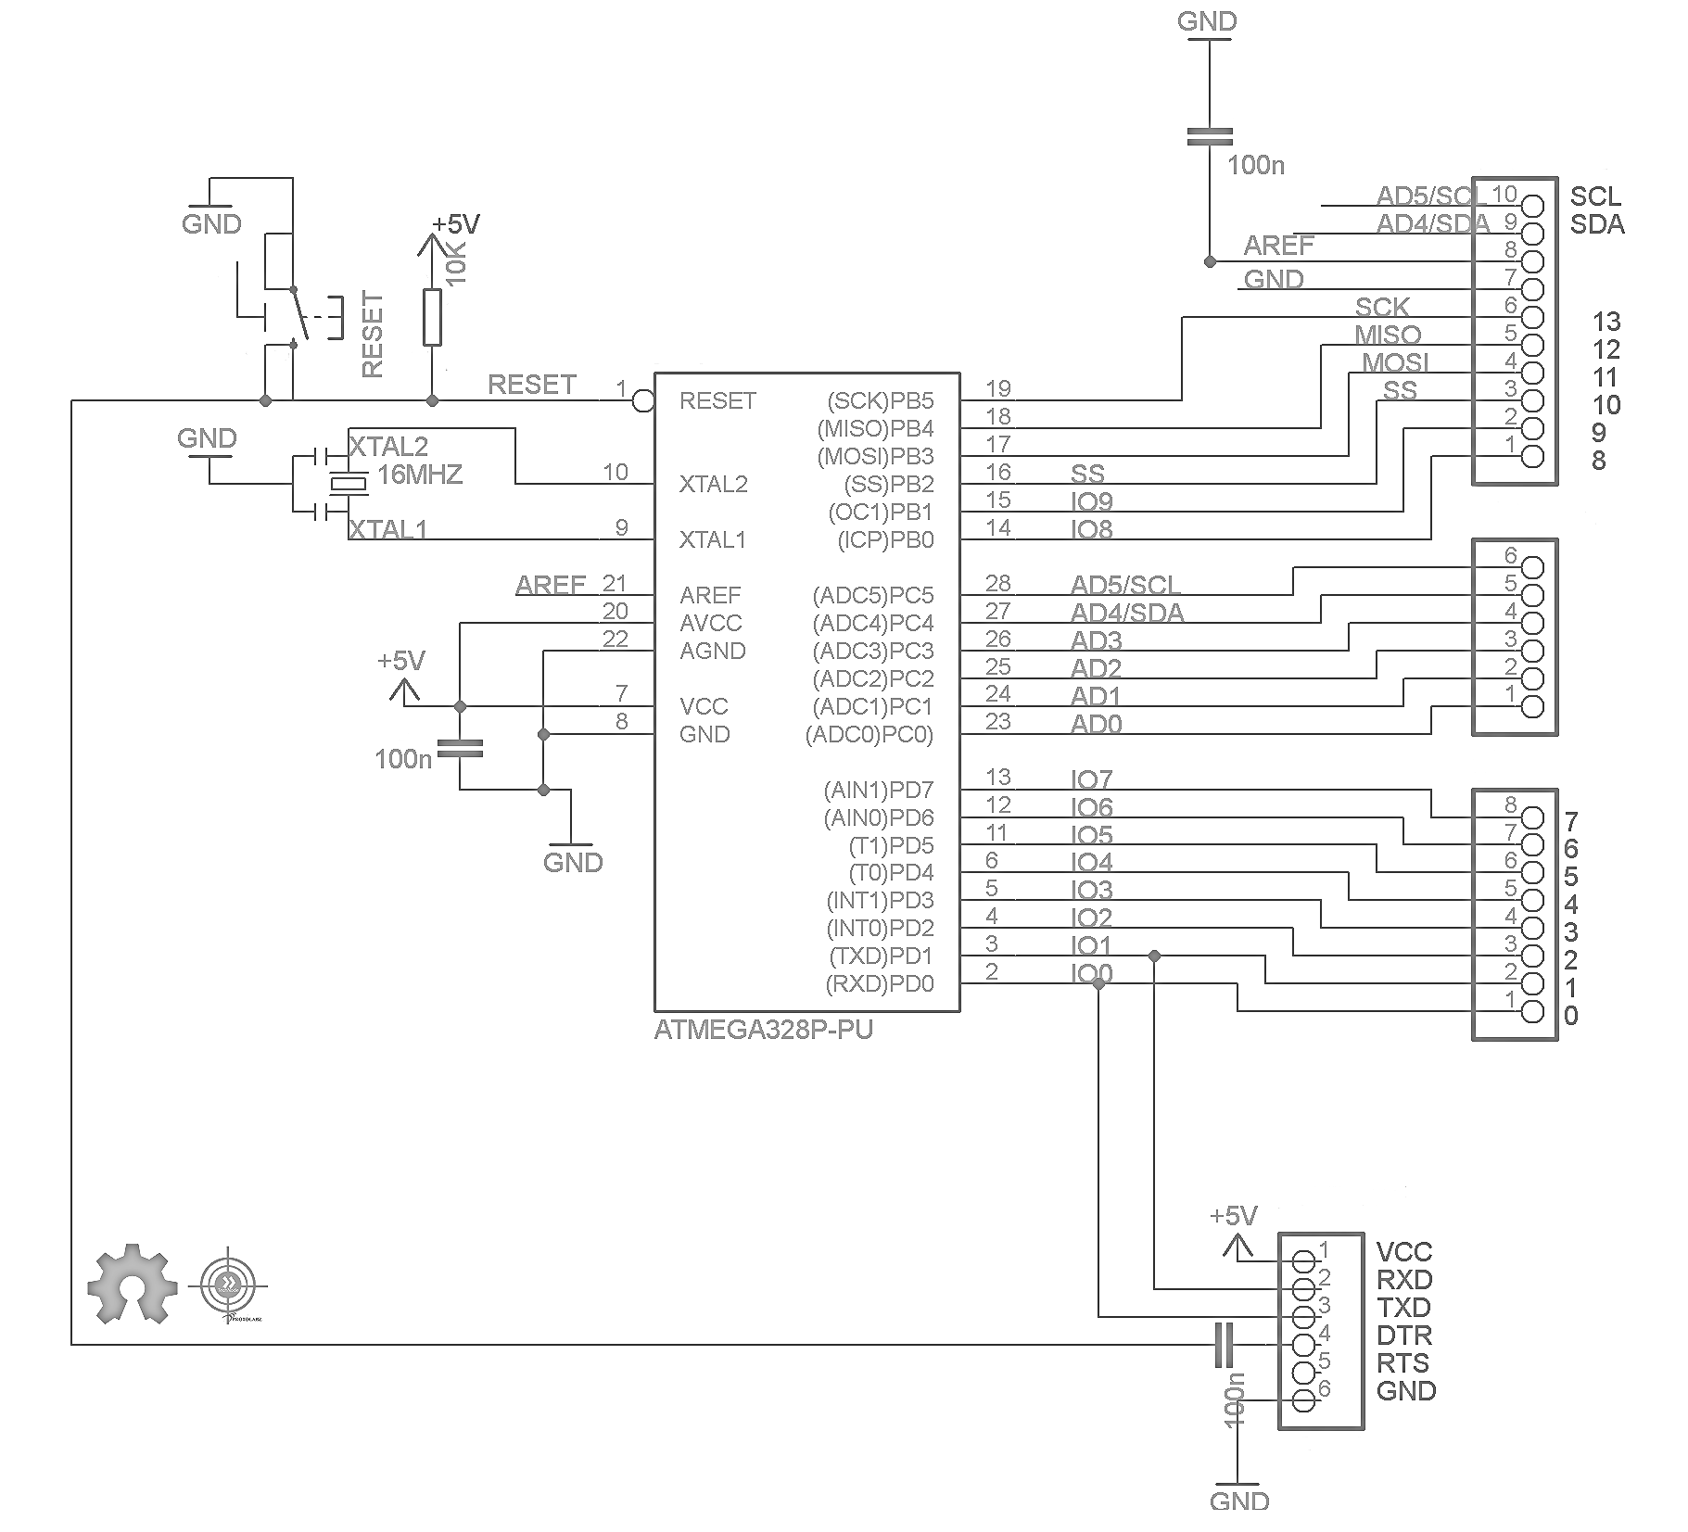 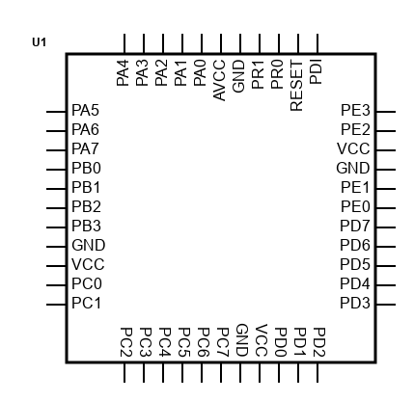

(a) (b)

Fig. 4, (a) Logical block of the ATMEGA328P processor; (b) ATMEGA328P pin configuration

*CNC V3 shield*

The CNC V3 shield is made particularly for Arduino based controllers which allows us to build such machines which are used to engrave, like a mini CNC, A 3D printer and so on. It just needs to be fitted on the top of the Arduino with no external wiring required. There are 4 slots for stepper motor drivers in the shield. It supports an input voltage of 12V to 36V. If an input of more than 36V is applied, it will damage the motor drivers.

*A4988 Stepper motor drivers*

The stepper motor driver, A4988, is a microstepping motor driver fully compatible with the CNC V3 shield. The bipolar stepper motors can be controlled in full, half, quarter, eighth and sixteenth step modes with the help of the drivers. They receive PWM signals from the Arduino and feed the required power according to the motors. The sixteenth step mode is used by inserting 3 jumper caps to cover M0, M1, M2 to improve the precision of the drawing.

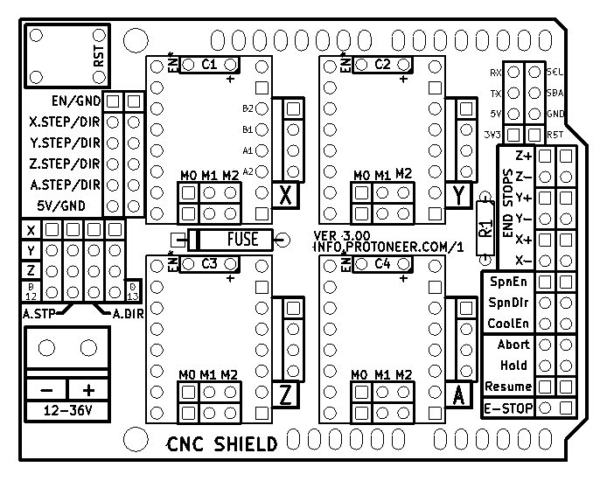 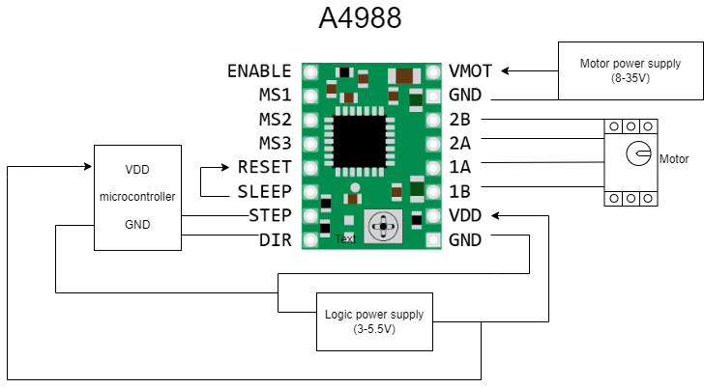

(a) (b)

Fig. 5, Pin-configuration of (a) CNC V3 shield; (b) stepper motor driver A4988

*NEMA 17 Stepper motor*

A stepper motor rotates by taking one step at a time, with the energy input given to it by DC and thereby, converts electrical energy into mechanical shaft rotation.

These motors are a vital part of the movement of the x and y axes in analog step values. “NEMA” is the measurement standard provided by the National Electrical Manufacturers Association. NEMA 17 stepper motors are used for this project. A heavier model was used because it could provide large enough torque to rotate the long and heavy metal shaft. For refined models with shorter axes lengths, smaller motors would be sufficient.

*SG90 Microservo*

Servo motor can be defined as a motor with a specific part, suitable for a closed-loop control system. Servo motors are used in robotics, CNC machining applications and so on. There is the control signal which is the input, it can be analog or digital, representing the final position for the shaft. An encoder serves the role of a sensor with speed and position.

The project deals with the principle of CNC machines and in such cases, nothing is better than the stepper motor to convert instructions into actions. Here the action is depicted as the up and down of the pen for writing and moving to the next consecutive letter.

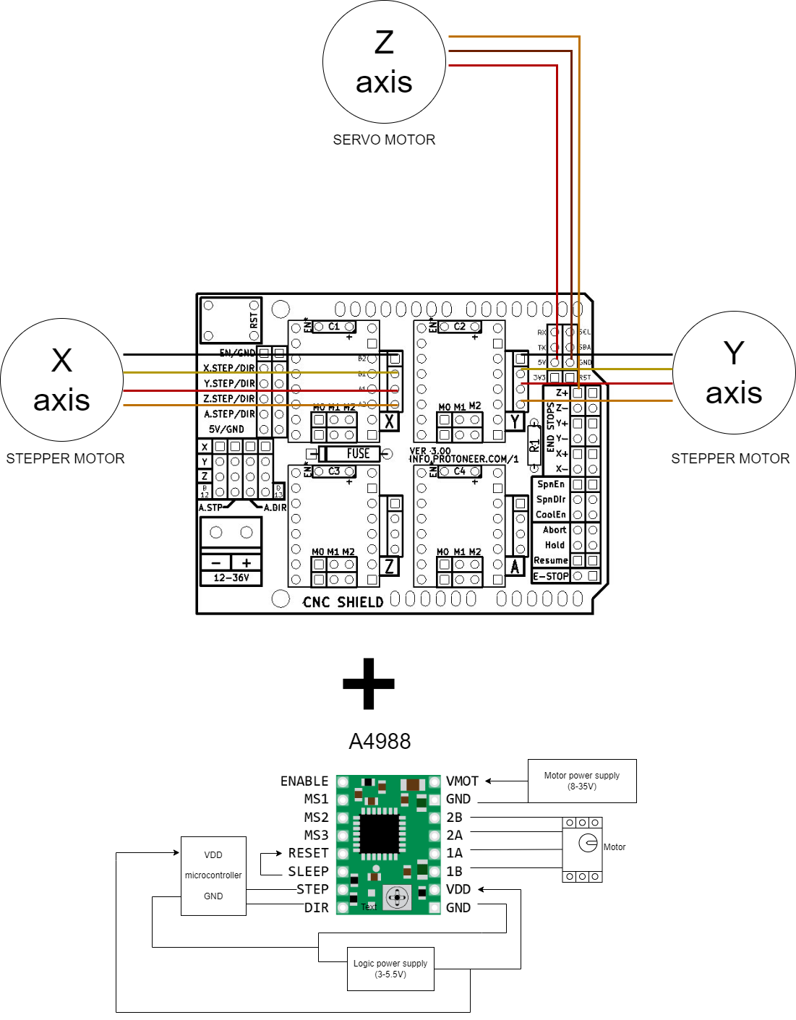

Fig. 6, Configuration of the motors and respective motor drivers

*HC-05 Bluetooth module*

Bluetooth HC-05 can be defined as serial communication to communicate with the world of electronics. Connecting to devices with short-range to exchange files. Just the way files are going to get exchanged in the project with a frequency band of 2,4 GHz. HC-05 has a transfer rate of 1Mbps within a range of 10 meters. Input power voltage is 4-6V with a baud rate of 9600, 19200, 38400, 57600, as selected by the user.

The pins of our interest are described below:

1. VCC - Pin which is connected to +5V power supply
2. Ground - Pin which is connected to the ground of the system
3. Tx (Transmitter) - Pin which transfers the wirelessly received data by UART method to the microcontroller
4. Rx (Receiver) - Pin which receives data to be broadcast from the microcontroller.

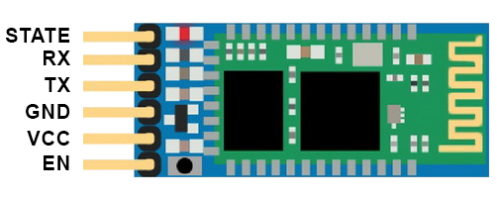 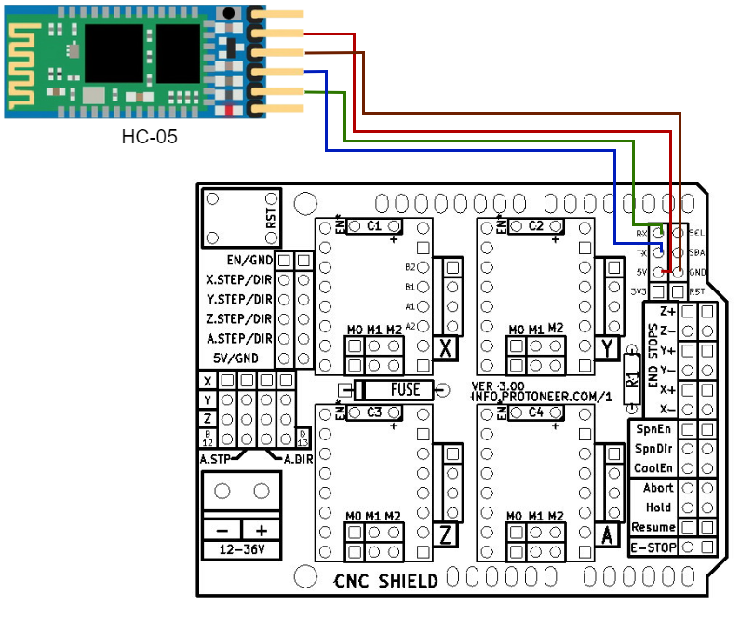

(a) (b)

Fig. 7, (a) HC-05 Bluetooth module; (b) Connecting the Bluetooth module with the controller

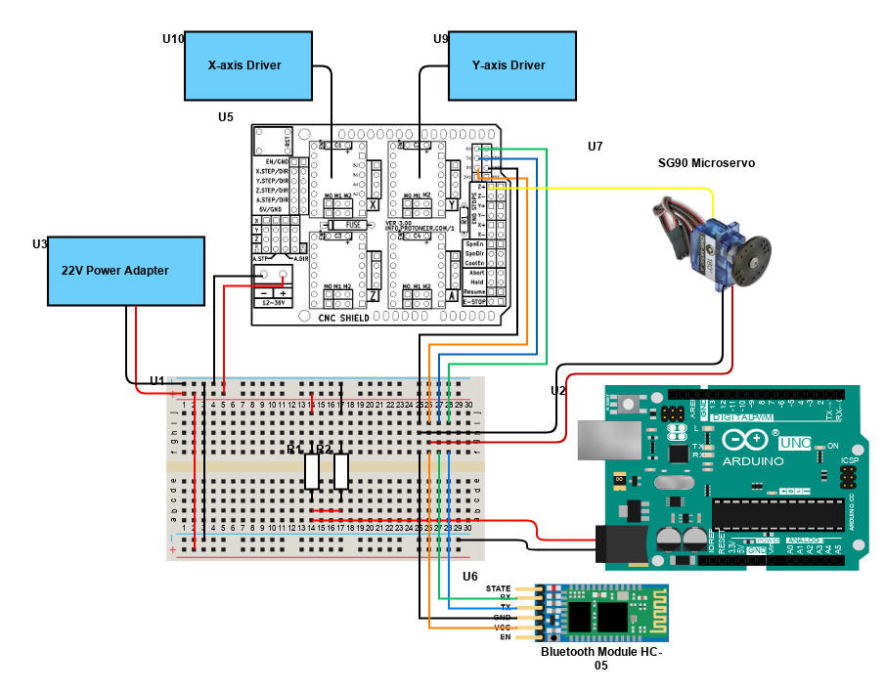

Fig. 8, Physical connections for the entire apparatus. It is to be noted that the CNC V3 shield is inserted onto the Arduino UNO board

GRBL control code

The shield is GRBL compatible. GRBL is an open-source firmware that is programmed into the Arduino and enables the g-code to be understood by the processor. For the intended purpose, the shield, before running with the stepper motors, needed to have the GRBL firmware installed in the Arduino’s memory. In simple terms , the GRBL uses the motion as the output through the motors via arduino and uses the G-code as an input to run through it.

G-code

G-code simply means “Geometric Code” that can be defined as the language of programming for a Computer Numerical Control machine, a CNC machine. This language is used to set the instruction to the machine to get operated. The speed and the path of the machine can be followed by the GRBL code. From 3D or 2D printing to manufacturing G-code runs the instruction layers formise a precise geometric shape in all dimensions.

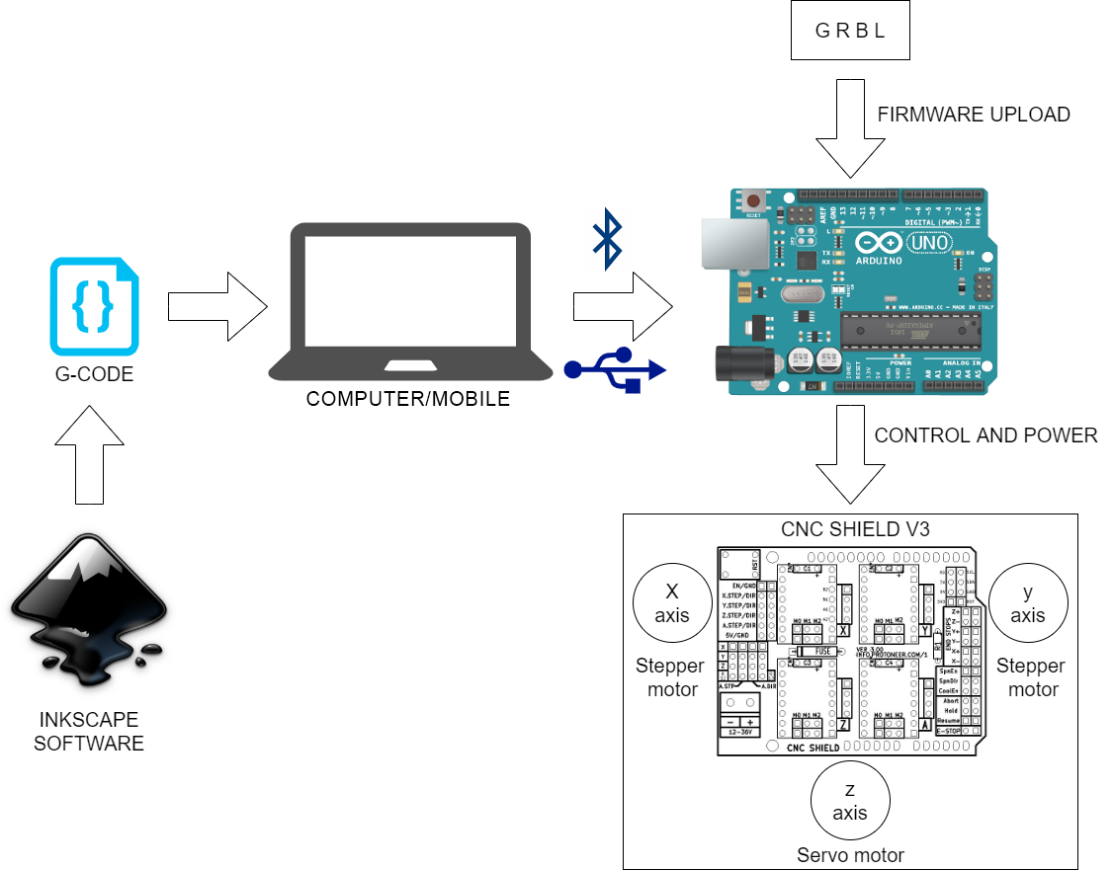

Fig. 9, How the g-code containing information of coordinates is transferred in the system

Application software

The hardware and its functioning will be controlled by an application running in the mobile phones. It has been assumed that during a teacher-student interaction the hardware is held by the individual with autism/cognitive disability while the mobile application is run by the teacher. A connection will be established over Bluetooth between the app and the actual hardware device. The mobile phone should have the capability to establish Bluetooth connections to use the app.

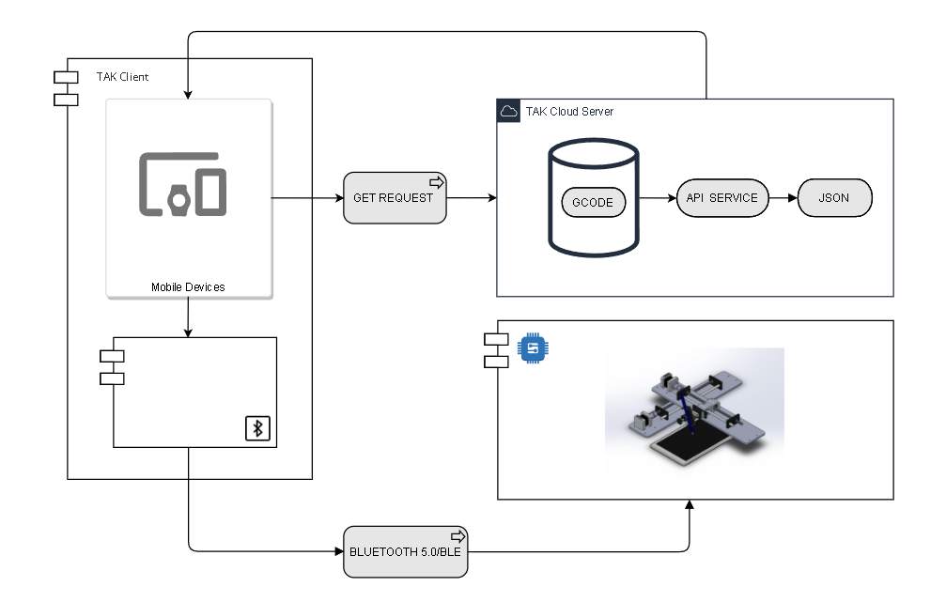

Fig. 10, System architecture supporting the application

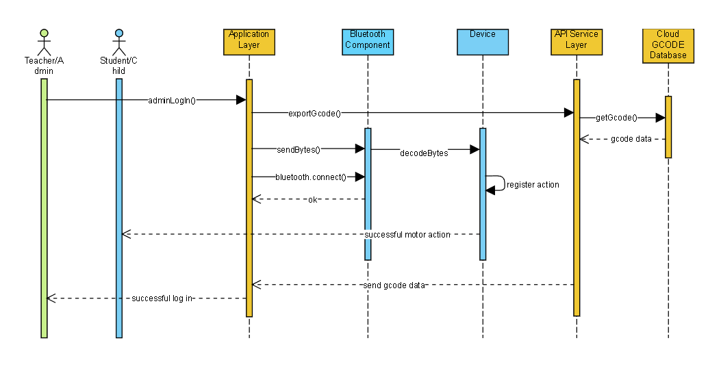

Fig. 11, Sequence Diagram for the API

*Working algorithm, simulation*

The official Google Developers site writes -

“To create a connection between two devices, you must implement both the server-side and client-side mechanisms because one device must open a server socket, and the other one must initiate the connection using the server device's MAC address. The server device and the client device each obtain the required [Bluetooth socket](https://developer.android.com/reference/android/bluetooth/BluetoothSocket) in different ways. The server receives socket information when an incoming connection is accepted. The client provides socket information when it opens an RFCOMM channel to the server.

The server and client are considered connected to each other when they each have a connected BluetoothSocket on the same RFCOMM channel. At this point, each device can obtain input and output streams, and data transfer can begin”

The hardware Bluetooth device was first paired with the device. The mobile application then scanned through all paired devices to display the paired devices. The user needs to choose the hardware Bluetooth device from them. In the instrument, the hardware Bluetooth device is on the client-side and client-side mechanisms were pre-built. So only the server-side mechanisms need to be implemented,i.e, the mobile application.

Once the Bluetooth connection was established, the next task was to exchange data. In this scenario the exchange of data should be one-way, i.e, instruction signals should be sent from the device running the mobile application to the hardware Bluetooth device.

The hardware part of the product understands only G-code(just like a computer understands only machine language, so whatever high-level programs are written are ultimately converted to sequences 0s and 1s). So the job of the mobile application is to send the G-code corresponding to the relevant action.

The application will have sections like Alphabets, Digits, short sentences, almost everything you and I have been taught when we first went to school. Suppose a kid was learning about the alphabets and the teacher wanted the student to learn “A”. The user interface has buttons corresponding to all the alphabets. When the button displaying “A” was clicked, the corresponding g-code was sent to the hardware Bluetooth device. The Bluetooth accepts the data, decrypts it and a signal is sent to the hardware to trace the alphabet “A”.

The frontend interface will be intuitive and self-explanatory, so that it becomes easy to use and navigate. The home page of the application will be divided into well demarcated sections like alphabets, numbers, etc. Each section will have contents relevant to that topic. We will be using audio visual techniques to capture the attention of the audience. It is said one should pronounce what we read, because it helps in better retention. Thus pre-recorded voices reading aloud a text or an alphabet will be used for better engagement.

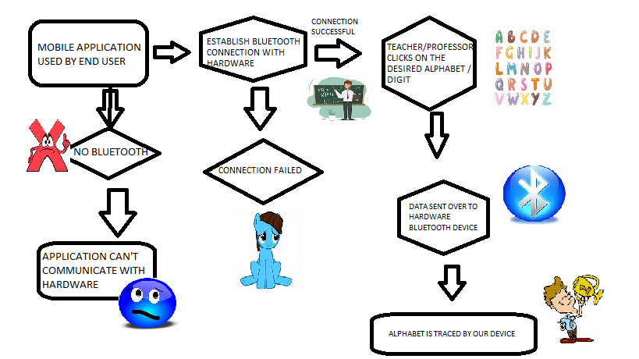

Fig. 12, Flowchart describing the functioning of the application

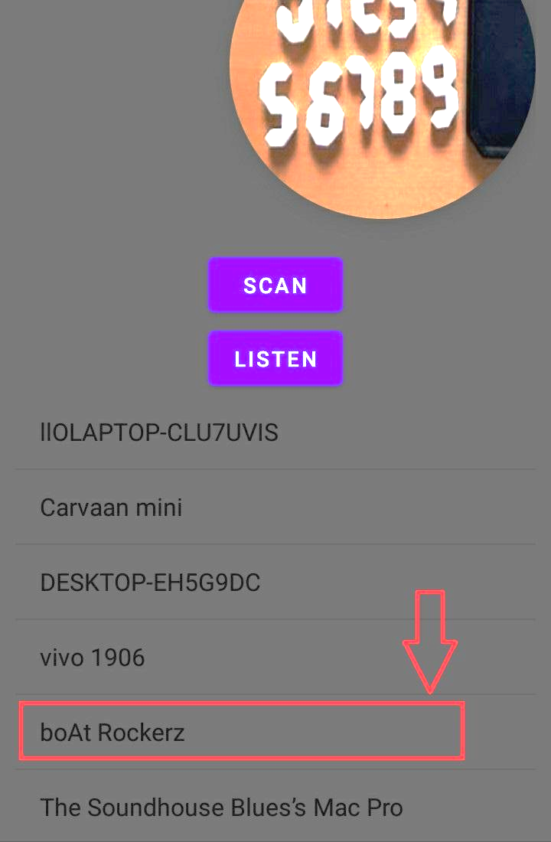

Fig. 13, All paired devices are displayed in the app being developed. Suppose a particular device should be connected, the relevant name must be clicked

*Conclusion*

While this is just a prototypic model of the software, there are a lot many improvements that can be added in course of time:

* A Local Area Network can be used for connecting the devices and exchanging data. This is more stable than Bluetooth, and also provides more flexibility. It is possible to control more devices from a single running instance of our application, unlike Bluetooth which allows one-to-one and not multiport connection.
* Speech recognition APIs like Google Translate can be used that allow users to write what they speak.
* The app can be made available in regional languages as well.

**Implementation**

For the apparatus, a wooden plank was used each for supporting the stepper motors for the x and y axes, along with the metallic shafts and gliders. The plank for the y-axis which held that of the x-axis was made slightly bigger in length to accommodate the microcontroller board and battery that would be fitted later on. Otherwise, both the axes looked similar. Each consisted of a NEMA 17 stepper motor fitted with a flexible coupling, THSL Lead Screw, EN31 Steel rod, linear motion ball bearing, linear bearing bush, radial bearings, block to hold the rod as well as bearings and the axial base. These two axes played a major role in the movement of the main module that is the pen stand. As for the z-axis which consists of a pen fitted to a vertically-moveable wooden block, it had two discrete states characterised by the position of the holder block that either stays down as the pen touches the paper or is lifted up such that there is no contact between the pen and the paper. The pen stand worked on the principle of linear motion provided by the motor and moved with the pen module attached to it. The stand was connected with the x-axis plank and consisted of a micro servo and moveable supportive parts for the rotatory motion of the pen. While the rotation of the motors for the x and y axes was analog–controlled by PWM signals from the respective motor driver (A4988) fitted to a CNC V3 shield atop the Arduino microcontroller board, the binary state of the SG-90 micro servo of the z-axis was controlled by a signal from the Z+ pin of the V3. As the Arduino UNO requires 5-12 volts DC and the CNC V3 requires up to 21 volts to supply the required power to the motors, we used a voltage divider setup using two 1 ohm-½ watt resistors organised on a breadboard. A 22V power adapter supplied regulated DC to the setup, from which 11V was fed to the Arduino UNO board from the node of the divided voltage while the original supply voltage was fed to the shield separately.

After receiving the feed execution command from the GRBL controller application through Bluetooth, the servo system drives each coordinate axis (feed mechanism) for the machine to move accurately in strict accordance with the command necessities and completes the process of the work. Throughout the displacement process, the detection feedback device quickly fed back the measured displacement numerical to the numerical control device for comparison with the command requirement, and then sent the compensation execution command to the servo system at rapid speed unless the measured value was consistent with the required command. There was a warning system to give safety reminders during various operations. In the method of axis displacement, if overtravel happened, the limiting device would send some over travel signals to the controller. Meanwhile, the numerical control system sent alarm signals through the execution and would send stop execution commands to the feed servo system to implement over travel protection. The writing machine works on this principle with the help of g-code as well as the direction of axes.

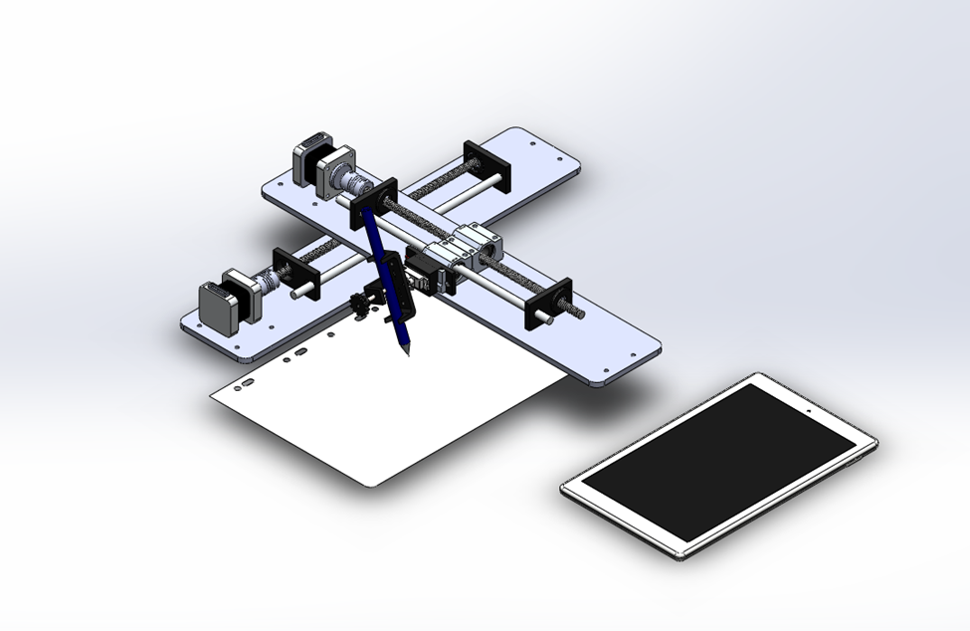

Fig. 14, Perspective view of the model

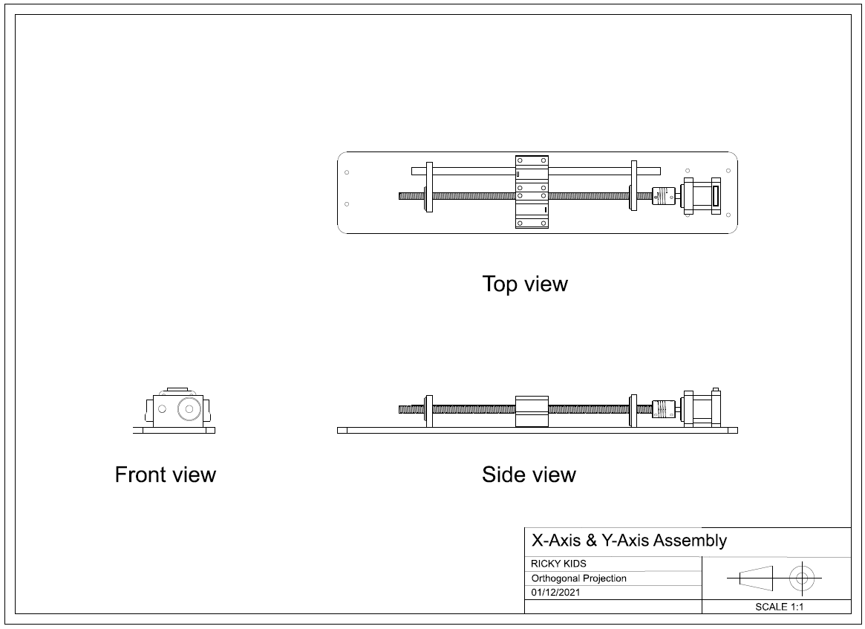Fig. 15, Two Dimensional Representation of the Model

**Result and Evaluation**

The 2-axis setup was working as intended. When a g-code was fed by the “G-Code2GRBL” application in mobile via Bluetooth or by “Universal Gcode Sender” in computer via USB to the microcontroller, the x and y-axis stepper motors rotated just as much to produce the required linear motion in the respective glider. The resolution of the drawing can be scaled up or down by placing jumpers over the appropriate pair of pins underneath the motor driver modules on the CNC V3 shield. While scaling down made the drawing smaller, it benefitted the speed with which it was drawn.

The intention of using this device would be to learn the way the hand moves while writing a specific letter as well as to be able to write words, sentences or paragraphs for people who have motor neuron deficits. The application would be presented in a very appealing manner with audio-visual cues according to inputs from experts that will make the neurodiverse child interested to learn. In institutions and care centres, the application would be linked to tablets, PCs and projectors through WLAN that would allow a single mentor or teacher to cater to multiple subjects.

The present version of the project has a few limitations. It is quite bulky and difficult to carry, even though it is planned to be modular, that is, the different parts can be dismantled and fitted with ease. Writing a single letter would not require such long shafts and heavy motors. Another problem would surface when we try to use the application in one device to control multiple writing machines since Bluetooth provides wireless point-to-point connectivity while we would require a multipoint connection. Apart from that, Bluetooth works on a 2.4 GHz radio band which is an unlicensed frequency used by various wireless devices, therefore, making it susceptible to heavy interference and has a higher chance of corrupting the data. It is also notorious for its range limitations (depending on Bluetooth versions). Those devices that are powered by a battery have an even low range thus making it slightly inconvenient to the operator.

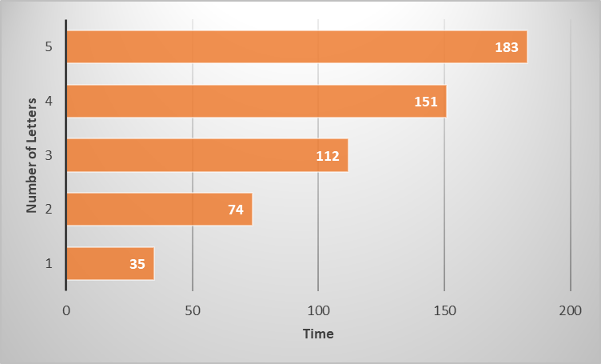

Fig. 16, Graphically Denoted No.of Letters v/s Time by the machine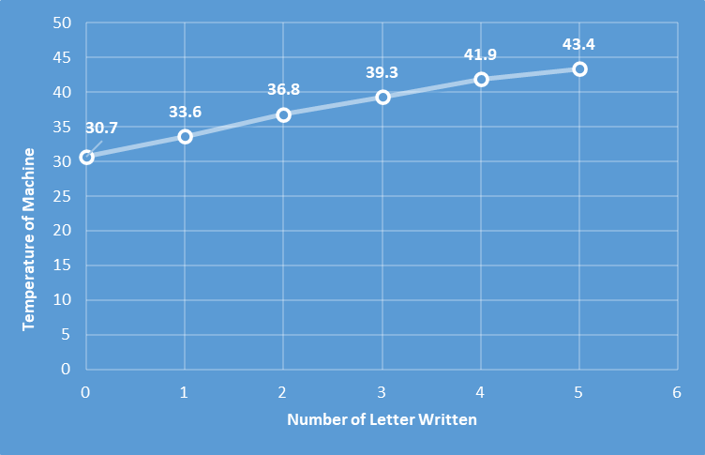

Fig. 17, Graphically Denoted No.of Letters v/s Temperature of the machine in (Celsius)

**Future Directions**

In the future, it will be extended in such a way that every single person with neurological problems can be benefitted from our machine. And when we expand and manufacture each and every single component that we are using in our project then we are able to give it in a minimal amount. And when it comes to upgrading this machine, it will be made much easier and more comfortable to be used and for carrying with the users as a portable device, and its efficiency will be enhanced by giving the software updates regularly and troubleshooting the bugs if it is reported by the users with immediate support. The connectivity with the hardware will be more advanced with LTE/WiFi connections. The device will be made compact and easily portable by using small motors, shafts, drivers and custom PCBs for the electronics.

**Conclusion**

The product could be used as study material as well as a toy for an autistic child, or for persons with impairment in their motor nerves. The automated gliders acting together as a robotic arm would help them to write what they wanted to write by specifying the input simply in the supporting application. In contrast to this topic Make neuroscience to create an impact and make learning easy for every possible human being suffering from neurological problems. This machine is made with a budgeted amount, but as creatives we cannot stop ourselves from exploring and reaching out with the latest drivers, motors and other hardware materials. It is made in such a way to utilise and to make it 100% efficient in this design, in a neat and clean manner. And as it is integrated with the learning application platform it is much easier to use and operate our robotic arm and as it is preloaded with the contents it is much easier for the users to learn from it.

**Reflections**

Living in the 21st century where children are born and brought up in the age of technologies and the digital world, we must deal with such challenging problems that impair a child’s ability to learn. Often people do have e-learning software but again, we fail to realise how it really affects the kids and also helps the kid to grow and evolve. Growth is a very essential part of life, and growing with just a digital interface is not what our duty is. To make it efficient and worth the time and money they have spent on their development. Through the surveys and the webinar, it has been found that the machine or an artificial hand has scope for neural science in future. It is known that not only autistic kids but many people face neurological problems where if they want to write they cannot do so but our machine, the robotic hand will automatically create an impact on the disabled person. The combination of the concepts of Mechatronic and neuroscience will create a huge impact and make learning very easy for every person suffering from neurological problems. Not only that, it will change the vision of a CNC handwriting machine which is only made for the purpose to print, but here many dots are connected together towards an environmental step in curing the neurological problem of an autistic kid , who has a writing problem. A highly recommended survey was made throughout the survey with a positive response for this TLM (Teaching Learning Material). Many questions were answered positively by the audience regarding the final product.

**References**

1. Catherine Lord, Mayada Elsabbagh, Gillian Baird, Jeremy Veenstra-Vanderweele. (2018). Autism spectrum disorder. *The Lancet*, 392(10146), 508-512.
2. Boria S, Fabbri-Destro M, Cattaneo L, Sparaci L, Sinigaglia C, Santelli E, et al. (2009). Intention Understanding in Autism. *PLoS ONE* 4(5): e5596.
3. Beecham, James & Seneff, Stephanie. (2016). Is there a link between autism and glyphosate-formulated herbicides?. *Journal of Autism*.
4. Michael L. Matson, Johnny L. Matson, Jennifer S. Beighley. (2011). Comorbidity of physical and motor problems in children with autism. *Research in Developmental Disabilities*, 32(6), 2304-2308.
5. Pan, C.-Y., Tsai, C.-L., & Chu, C.-H. (2009). Fundamental movement skills in children diagnosed with autism spectrum disorders and attention deficit hyperactivity disorder. *Journal of Autism and Developmental Disorders*, 39, 1694–1705.
6. Lingam R, Simmons A, Andrews N, et al. (2003). Prevalence of autism and parentally reported triggers in a north east London population. *Archives of Disease in Childhood*.
7. Scott K. (2020, April 3). *Prevalence of Autism Increases by 10%, to 1 in 54 Children*. Southwest Autism Research & Resource Center(SARRC). Retrieved February 3, 2022, from https://autismcenter.org/prevalence-autism-increases-10-1-54-children
8. Sasson, N., Faso, D., Nugent, J. *et al.* (2017). Neurotypical Peers are Less Willing to Interact with Those with Autism based on Thin Slice Judgments. *Sci Rep* 7, 40700.
9. Banire, B., Al Thani, D., Qaraqe, M. *et al.* (2021). Impact of mainstream classroom setting on attention of children with autism spectrum disorder: an eye-tracking study. *Univ Access Inf Soc* 20, 785–795.
10. *Autism and Developmental Disabilities Monitoring (ADDM) Network*. Centers for Disease Control and Prevention(CDC). Retrieved February 3, 2022, from https://www.cdc.gov/ncbddd/autism/addm.html
11. [ATMega328P Microcontroller Pinout, Pin Configuration, Features & Datasheet (components101.com)](https://components101.com/microcontrollers/atmega328p-pinout-features-datasheet)
12. *Arduino UNO + Arduino CNC Shield V3.0+A4988 Installation Guide*. (2017, April 7). <https://osoyoo.com/2017/04/07/arduino-uno-cnc-shield-v3-0-a4988/>
13. [*BluetoothSocket*](https://developer.android.com/reference/android/bluetooth/BluetoothSocket)[. (2021, June 9). Android Developers](https://developer.android.com/guide/topics/connectivity/bluetooth/transfer-data). Retrieved January 27, 2022, from https://developer.android.com/reference/android/bluetooth/BluetoothSocket
14. [*Transfer Bluetooth data*. (2021, October 27). Android Developers](https://developer.android.com/guide/topics/connectivity/bluetooth/transfer-data). Retrieved January 27, 2022, from <https://developer.android.com/guide/topics/connectivity/bluetooth/transfer-data>